# Lab8 Mongo part 1 query questions

DBS311 Lab 8

***Upload screenshots of successful run with outputs in a single document in blackboard within the deadline. Absolutely no email submission will be accepted. Capture screenshots of your code as well. Make sure the timestamp is visible in your screenshots.***

# *Due by Saturday, July 31st by 11:30pm, Late penalty is 100%.*

Extra questions

1. 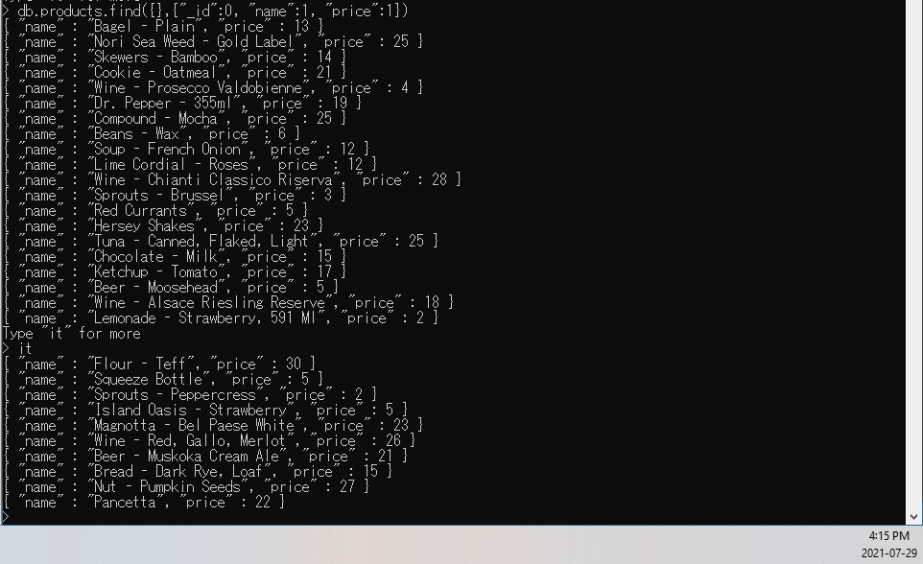Write a query to return *name* and *price* of each product in the *inventory* database.

|  |
| --- |
| db.products.find({},{"_id":0, "name":1, "price":1}) |

1. 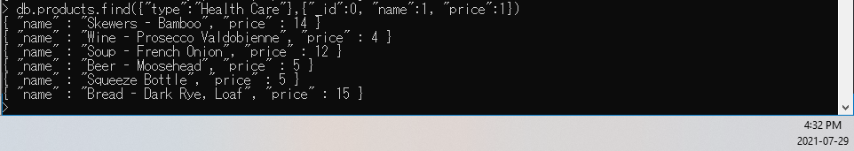Write a query to return *name* and *price* for products of type “Health Care” in the *inventory* database.

|  |
| --- |
| db .products.find({"type":"Health Care"},{“_id”: 0, "name":1, "price":1}) |

1. 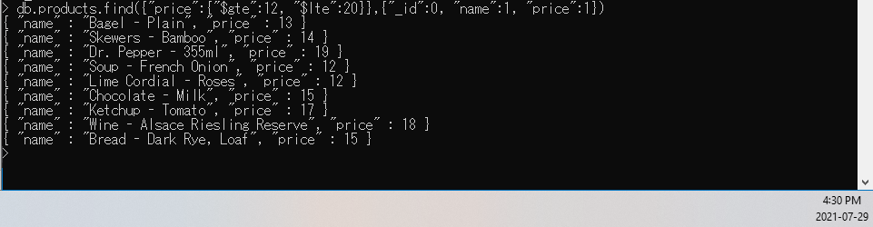Write a query to return *name* and *price* for products with price between $12 and $20 (Values *12* and *20* are included).

|  |
| --- |
| db.products.find({"price":{"$gte":12, "$lte":20}},{"_id":0, "name":1, "price":1}) |

1. 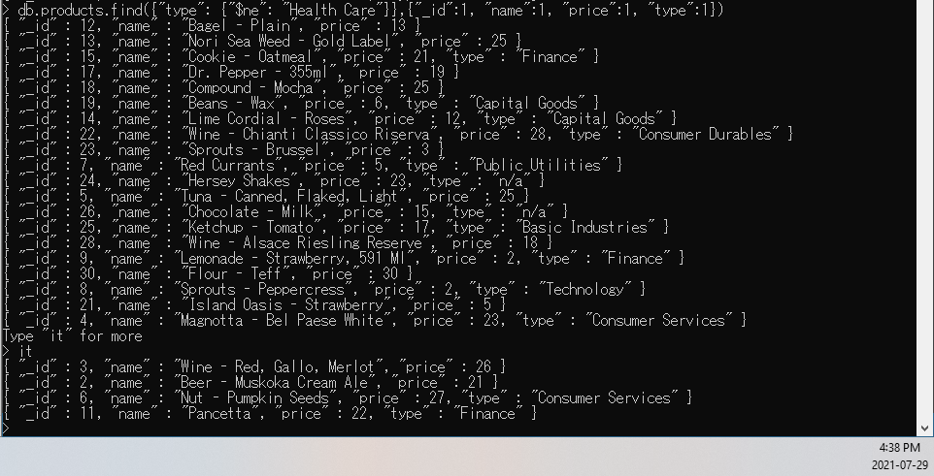Write a query to return *id*, *name*, *price*, and *type* for products that are not of type “Health Care”.

|  |
| --- |
| db.products.find({"type": {"$ne": "Health Care"}},{"_id":1, "name":1, "price":1, "type":1}) |

1. 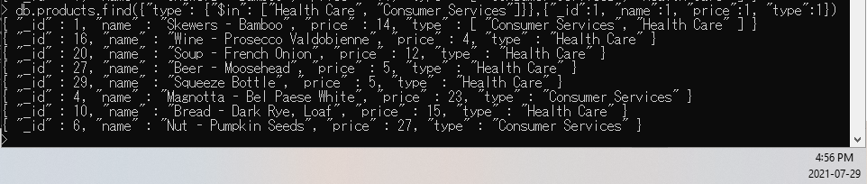Write a query to return *id*, *name*, *price*, and type for products with type “Health Care” or “Consumer Services.”

|  |
| --- |
| db.products.find({"type": {"$in": ["Health Care", "Consumer Services"]}},{"_id":1, "name":1, "price":1, "type":1}) |

1. 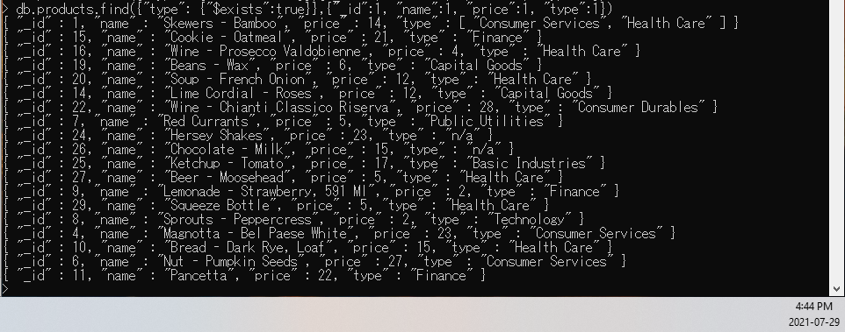Write a query to return *id*, *name*, *price*, and *type* for products that do have the *type* key.

|  |
| --- |
| db.products.find({"type": {"$exists":true}},{"_id":1, "name":1, "price":1, "type":1}) |

1. Write a query to return *id*, *name*, *price*, and *type* for products that their type is both Health Care and Consumer Services.

|  |
| --- |
| db.products.find({"type": {"$all": ["Health Care", "Consumer Services"]}},{"_id":1, "name":1, "price":1, "type":1}) |

