Lab9 Mongo part 2 Updates

# Formerly Lab 9 – Week 11

# (MongoDB – UPDATE)

***Upload screenshots of successful run with outputs in a single document in blackboard within the deadline. Absolutely no email submission will be accepted. Capture screenshots of your code as well. Make sure the timestamp is visible in your screenshots.***

# *Due by Saturday, August 7th by 11:30pm, Late penalty is 100%.*

## Tasks

1. 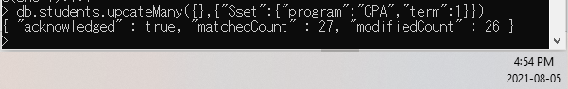Write an update statement to add new fields *program* and *term* to all documents in the *students* collection and set them to values “*CPA*” and *1*.

|  |
| --- |
| db.students.updateMany({},{"$set":{"program":"CPA","term":1}}) |

1. Write an update statement to modify the value of the *program* field to “*BTM”* for all documents in the *students* collection.

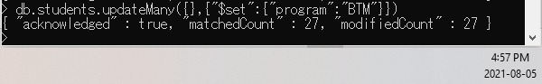

|  |
| --- |
| db.students.updateMany({},{"$set":{"program":"BTM"}}) |

1. Write an update statement to modify the value of the program field to “*CPA”* for the student named *Jonie Raby*.

Before executing an update statement or a delete statement, you can use the *find()* method with the update or delete criteria, to see how many documents will be affected.

Write the update statement in the box below.

|  |
| --- |
| db.students.update({"name":"Jonie Raby"},{"$set":{"program":"CPA"}}) |

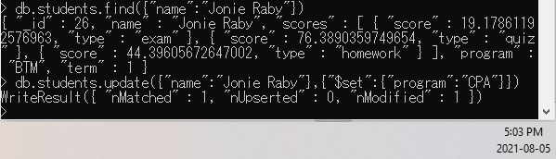

1. Write a query to show only the *program* field for the document that the value of the filed *name* is *Jonie Raby*.

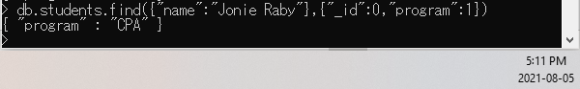

|  |
| --- |
| db.students.find({"name":"Jonie Raby"},{"_id":0,"program":1}) |

1. Write an update statement to increase the value of the *term* field by 2 for documents with *_id* 20, 22, and 24.

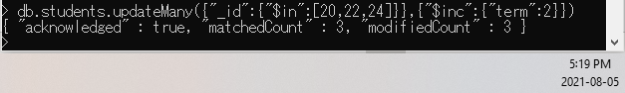

|  |
| --- |
| db.students.updateMany({"_id":{"$in":[20,22,24]}},{"$inc":{"term":2}}) |

1. Write an update statement to remove the *term* field from documents that the value of the *term* filed is 3.

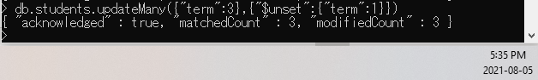

|  |
| --- |
| db.students.updateMany({"term":3},{"$unset":{"term":1}}) |