Defining Classes Labs – Part 1 and Part 2

The system that Sarah and Ted are looking for, must have the capability of categorizing his data by the following category classes:

Income source

Location

Product Type

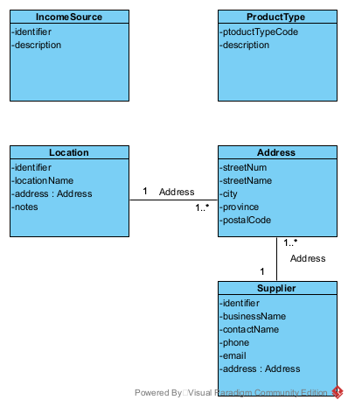

User Story

Eventually, we would like to retrieve total amounts of income paid for by credit card, debit card, paypal and cash. We call this income sources.

Acceptance Criteria:

1. Must be able to query income sources to be able to select income transactions.

|  |  |  |  |
| --- | --- | --- | --- |
| Use Case Name | Create an income source | | |
| Triggering Event | A new source of income (a new business venture) | | |
| Brief Description | Allows the Owner to create an income source | | |
| Actors | Owner | | |
| Related Use Cases |  | | |
| Preconditions | Owner has opened the Main Menu. | | |
| Post Conditions | Income source is added and available to query | | |
| Flow of activities | Actor | | System |
|  |  | Requests to add a new income source | Displays a list of income sources prompting for an income source identifier and description. |
|  |  | Enters income source identifier and description | Verifies that income source identifier and description have been entered  Prompts for confirmation |
|  |  | Confirms entry | Saves the income source and returns to the main menu |
| Exception Conditions | * Owner chooses to cancel adding income source | | |

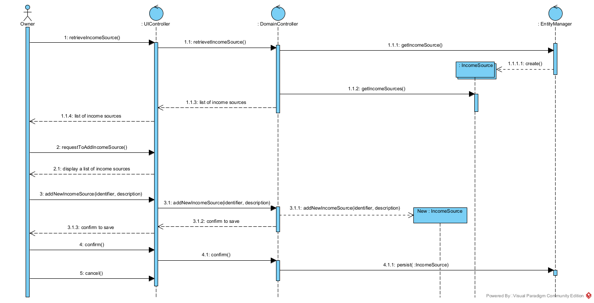

|  |  |  |  |
| --- | --- | --- | --- |
| Use Case Name | Change an Income source description | | |
| Triggering Event | Request to change an income source description | | |
| Brief Description | Allows the Owner to change an income source description | | |
| Actors | Owner | | |
| Related Use Cases |  | | |
| Preconditions | Owner has opened the Main Menu. | | |
| Post Conditions | Income source description is updated | | |
| Flow of activities | Actor | | System |
|  | 1. | Requests to query an income source | Displays a list of income sources and prompts for income source. |
|  | 2. | Selects an income source | Retrieves the income source description and prompts for updates |
|  | 3. | Updates description and requests to save | Verifies that description was entered.  Saves the data |
| Exception Conditions | * Owner chooses to cancel updating the income source description | | |

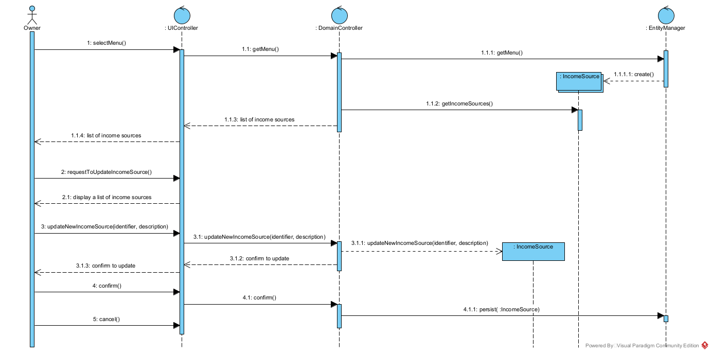

|  |  |  |  |
| --- | --- | --- | --- |
| Use Case Name | Query all income sources and their descriptions | | |
| Triggering Event | Request for income sources | | |
| Brief Description | Allows the Owner to retrieve all income sources and their descriptions. | | |
| Actors | Owner | | |
| Related Use Cases |  | | |
| Preconditions | Owner has opened the Main Menu. | | |
| Post Conditions | All income sources and their descriptions are retrieved. | | |
| Flow of activities | Actor | | System |
|  | 1. | Requests to query all income sources | Displays a list of income sources  Prompts to cancel |
|  | 2. | Chooses to cancel | returns to the main menu |
| Exception Conditions | * Owner chooses to cancel retrieving the income sources | | |

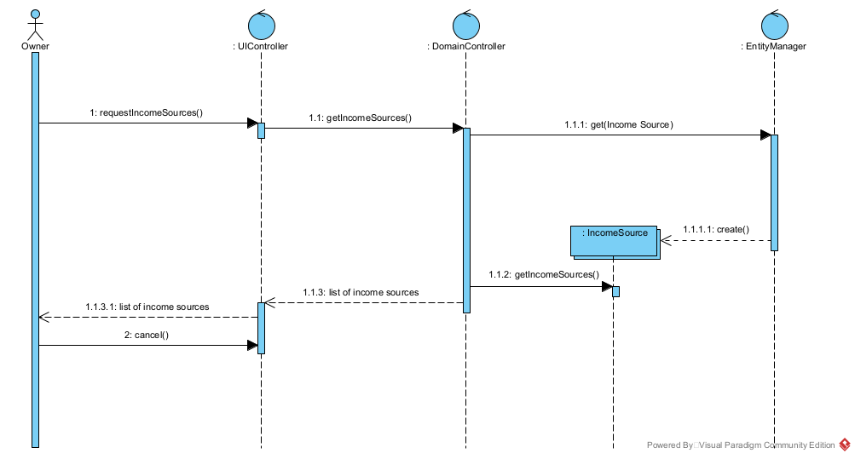

User Story

With our expansion, our list of locations is growing. We would like to record the address and notes about each location.

Acceptance Criteria:

1. Must be able to query locations.
2. 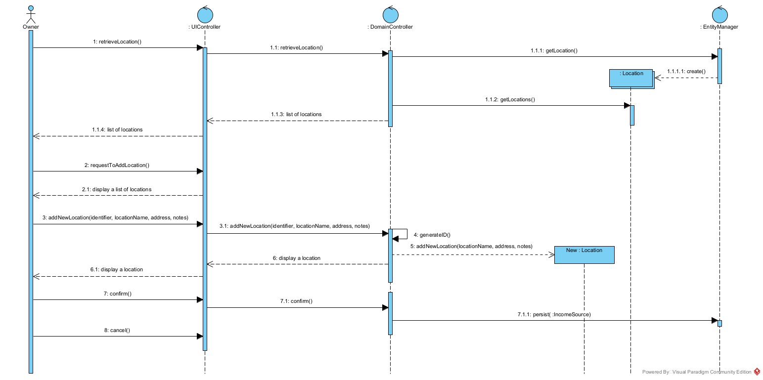Must be able to record locations.

|  |  |  |  |
| --- | --- | --- | --- |
| Use Case Name | Create a location | | |
| Triggering Event | A new location | | |
| Brief Description | Allows the Owner to create a locations | | |
| Actors | Owner | | |
| Related Use Cases |  | | |
| Preconditions | Owner has opened the Main Menu. | | |
| Post Conditions | Location is added and available to query | | |
| Flow of activities | Actor | | System |
|  | 1. | Requests to add a new location | Displays a list of locations and prompts for a location name, address and notes |
|  |  | Enters the location name, address and notes | Verifies that name and address have been enter. Generates a unique location identifier. Displays location.  Prompts for confirmation |
|  |  | Confirms entry | Saves the location and returns to the main menu |
| Exception Conditions | * Owner chooses to cancel adding the location | | |

|  |  |  |  |
| --- | --- | --- | --- |
| Use Case Name | Query all locations | | |
| Triggering Event | Request for a list of locations and their addresses | | |
| Brief Description | Allows the Owner to retrieve all locations | | |
| Actors | Owner | | |
| Related Use Cases |  | | |
| Preconditions | Owner has opened the Main Menu. | | |
| Post Conditions | All locations and addresses are displayed. | | |
| Flow of activities | Actor | | System |
|  | 1. | Requests to query all locations | Displays a list of locations.  Prompts to cancel |
|  | 2. | Chooses to cancel | returns to the main menu |
| Exception Conditions | * Owner chooses to cancel query locations | | |

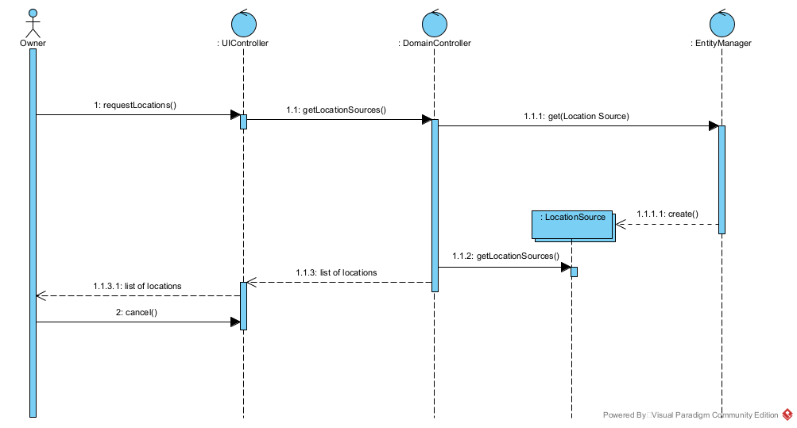

User Story

To allow for easy retrieval of products, we would like to organize our list of products by product type.

Acceptance Criteria:

1. Must be able to query product types.
2. 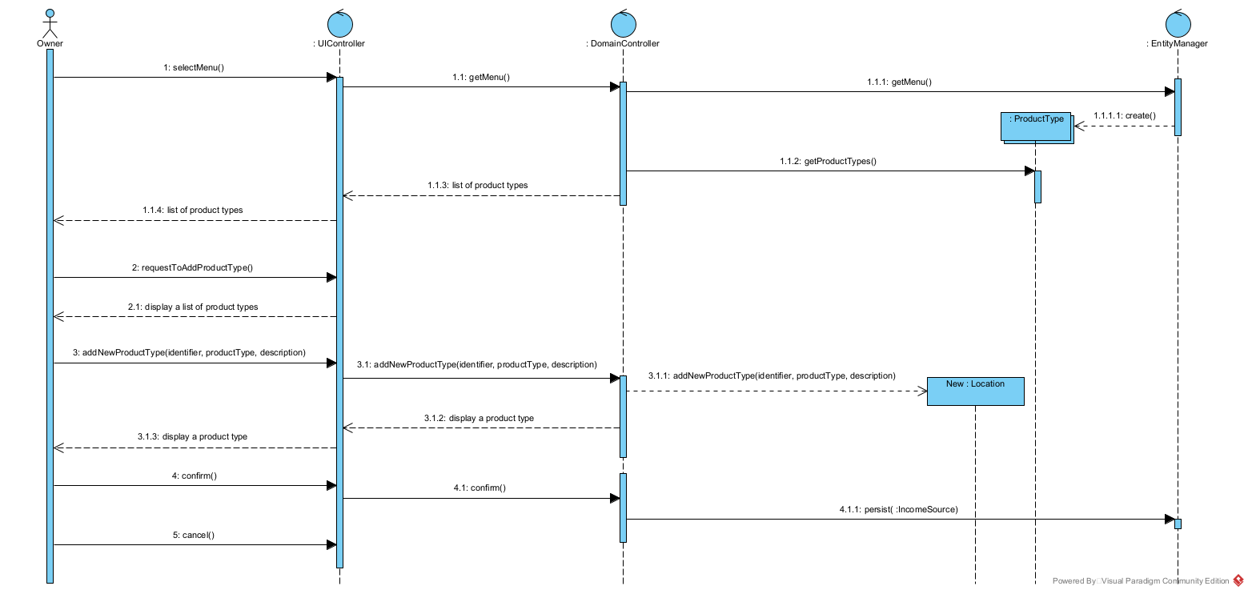Must be able to record a new product type.

|  |  |  |  |
| --- | --- | --- | --- |
| Use Case Name | Create a product type | | |
| Triggering Event | Business decides to add a new type of products | | |
| Brief Description | Allows the Owner to create a product type | | |
| Actors | Owner | | |
| Related Use Cases |  | | |
| Preconditions | Owner has opened the Main Menu. | | |
| Post Conditions | product type is added and available to query | | |
| Flow of activities | Actor | | System |
|  | 1. | Requests to add a new product type | Displays a list of product types and prompts for product type and description |
|  |  | Enters product type and description | Verifies that product type and description have been entered. Displays product type.  Prompts for confirmation |
|  |  | Confirms entry | Saves the product type and returns to the main menu |
| Exception Conditions | * Owner chooses to cancel adding the product type | | |

|  |  |  |  |
| --- | --- | --- | --- |
| Use Case Name | Query all product types. | | |
| Triggering Event | Request for product types | | |
| Brief Description | Allows the Owner to retrieve all product types. | | |
| Actors | Owner | | |
| Related Use Cases |  | | |
| Preconditions | Owner has opened the Main Menu. | | |
| Post Conditions | All product types are retrieved. | | |
| Flow of activities | Actor | | System |
|  | 1. | Requests to query all product types | Displays a list of product types  Prompts to cancel |
|  | 2. | Chooses to cancel | returns to the main menu |
| Exception Conditions | * Owner chooses to cancel query product types | | |

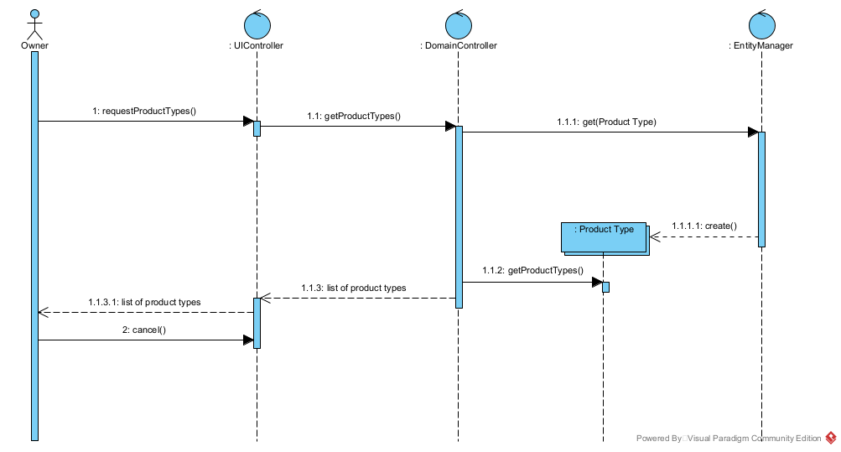

|  |  |  |  |
| --- | --- | --- | --- |
| Use Case Name | Create a supplier | | |
| Triggering Event | A new supplier | | |
| Brief Description | Allows the Owner to create a supplier | | |
| Actors | Owner | | |
| Related Use Cases |  | | |
| Preconditions | Owner has opened the Main Menu. | | |
| Post Conditions | Supplier is added and available to query | | |
| Flow of activities | Actor | | System |
|  |  | Requests to add a new supplier | Displays a list of suppliers and prompts for a business name, contact name, telephone number, email address and address. |
|  |  | Enters supplier identifier, business name, contact name, telephone number, email address and address. | Verifies that supplier identifier, business name, contact name, telephone number, email address and address have been entered.  Prompts for confirmation |
|  |  | Confirms entry | Saves the supplier and returns to the main menu |
| Exception Conditions | * Owner chooses to cancel adding supplier | | |

