**User Story**

As the owner of this business, I would like to record my financial transactions so that I can quickly see how much money I’ve made and what I owe the government in HST. For my purposes, my expenses subtracted from my income.

Acceptance Criteria:

1. Must be able to query transactions by date and provide a total profit and total HST
2. Must be able to query transactions by date and by source of the income.
3. Differentiate between expenses and income – provide a running total of income – expenses
4. Calculate the HST owed to the government by subtracting HST paid on expenses from HST collected on income.

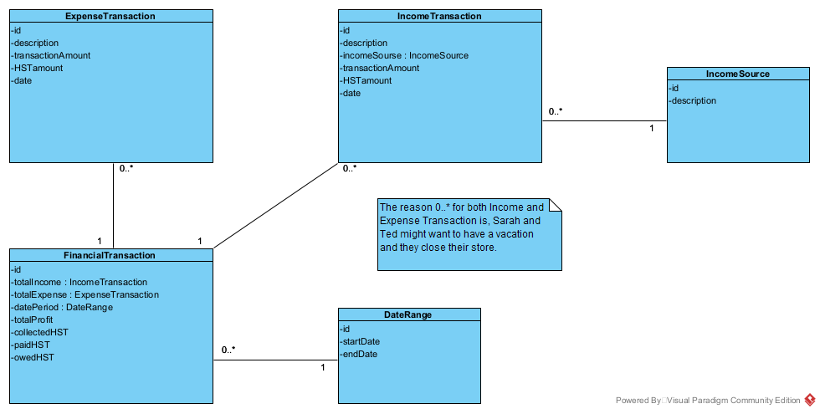

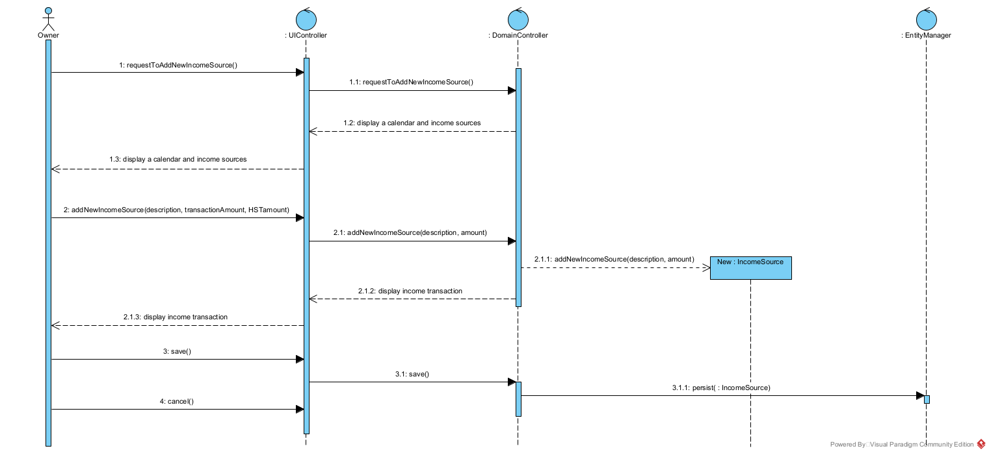**Use Case Descriptions**

|  |  |  |  |
| --- | --- | --- | --- |
| **Use Case Name** | **Create an income transaction** | | |
| Triggering Event | Money coming into the business. | | |
| Brief Description | Allows the Owner to record an income transaction. | | |
| Actors | Owner | | |
| Related Use Cases |  | | |
| Preconditions | Owner has opened the Main Menu. | | |
| Post Conditions | Income transaction is saved and added to financial totals. | | |
| Flow of activities | Actor | | System |
|  |  | Requests to add a new income transaction | Displays a calendar  Prompts for description, transaction amount and HST amount  Displays a list of income sources and prompts for selection |
|  |  | Selects the transaction Date  Selects the income source  Enters the transaction description  Enters the transaction amount | Verifies that date is selected  Verifies that description and amount have been entered  Verifies that the income source was selected.  Calculates HST  Displays income transaction  Prompts to save |
|  |  | Request to save | Saves the transaction and returns to the main menu |
| Exception Conditions | * Owner chooses to cancel adding the transaction | | |

|  |  |  |  |
| --- | --- | --- | --- |
| **Use Case Name** | **Create an expense transaction** | | |
| Triggering Event | Money leaving the business. | | |
| Brief Description | Allows the Owner to record an expense transaction. | | |
| Actors | Owner | | |
| Related Use Cases |  | | |
| Preconditions | Owner has opened the Main Menu. | | |
| Post Conditions | Expense transaction is saved and added to financial totals. | | |
| Flow of activities | Actor | | System |
|  |  | Requests to add a new expense transaction | Displays a calendar  Prompts for description, transaction amount and HST amount |
|  |  | Selects the transaction Date  Enters the transaction description  Enters the transaction amount | Verifies that date is selected  Verifies that description and amount have been entered  Calculates HST  Displays financial transaction  Prompts to save |
|  |  | Request to save | Saves the transaction and returns to the main menu |
| Exception Conditions | * Owner chooses to cancel adding the transaction | | |

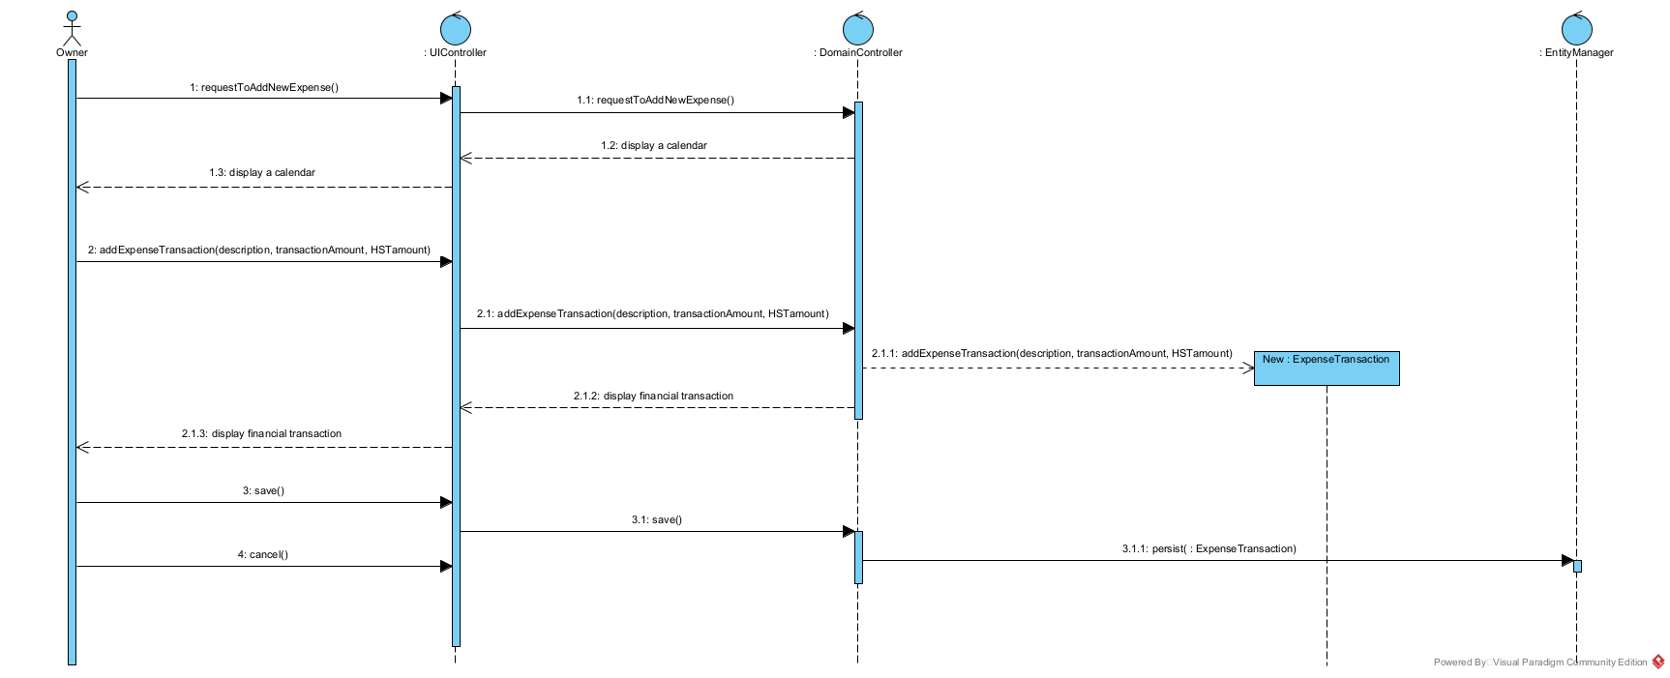

|  |  |  |  |
| --- | --- | --- | --- |
| **Use Case Name** | **Query Financial Transaction** | | |
| Triggering Event | Owner requires a list of transactions for a date period including Total Income, Total Expenses, Total Profit, Total HST collected, Total HST Paid, HST Owed | | |
| Brief Description | Allows the Owner to retrieve financial totals for a specified date range | | |
| Actors | Owner | | |
| Related Use Cases |  | | |
| Preconditions | Owner has opened the Main Menu. | | |
| Post Conditions | Financial transactions are retrieved, totaled and displayed | | |
| Flow of activities | Actor | | System |
|  | 1. | Requests to query financial transactions | Displays a calendar |
|  | 2. | Selects date range | Verifies that dates are selected  Retrieves transactions in the specified date range  Calculates and displays total income, total expenses, Profit, total HST Owed. Prompts to exit |
|  | 3. | Request to exit | returns to the main menu |
| Exception Conditions |  | | |

