# Introduction:

*MenuConstructor* is a plugin to simply create a menu, vertically or horizontally. It has many options to manage the look & feel, as well as functionality.

# Demo:

1. **Vertical Menu**

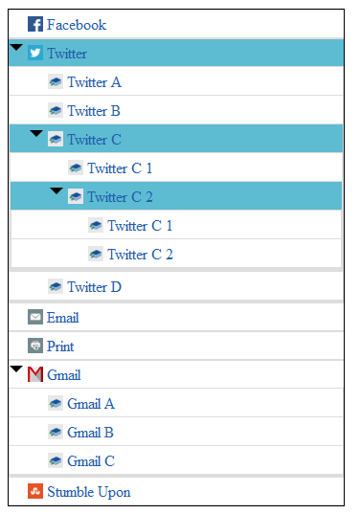

1. **Horizontal Menu**

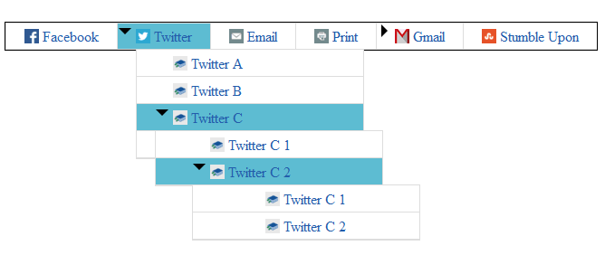

# Use MenuConstructor in a web page

1. We need to include menuConstructor.v.1.css & menuConstructor.v.1.js along with core jQuery file.

|  |
| --- |
| <link rel="stylesheet" href="css/menuConstructor.v.1.css" media="screen" />  <script src="js/jquery-1.10.1.min.js"></script>  <script src="js/menuConstructor.v.1.js"></script> |

1. Then we need to code the proper UI for the menu.

|  |
| --- |
| <div id="myMenu"> <!—we need to initialize our plugin over this element 🡪  <ul>  <li><a href="#">Facebook</a></li>  <li><a href="#">Twitter</a>  <ul>  <li><a href="#">Twitter A</a></li>  <li><a href="#">Twitter B</a></li>  <li><a href="#">Twitter C</a></li>  </ul>  </li>  <li><a href="#">Email</a></li>  <li><a href="#">Print</a></li>  </ul>  </div> |

1. Now, need to call plugin over the parent element.

|  |
| --- |
| $(document).ready( function() {  $("#myMenu").constructMenu();  }); |

## Options

By default it will create a horizontal menu with the list-items. Please go through the below options- to change over the default menu.

|  |  |  |
| --- | --- | --- |
| **Option** | **Default** | **Description** |
| menu | ‘Horizontal’ | Type: String  Constructs the menu as Horizontal or Vertical  E.g.- $("#myMenu ").constructMenu( { menu:'Vertical' } ); |
| accordion | true | Type: Boolean  Creates the menu as an accordion, i.e. opens one Item & closes the others  E.g.- $("#myMenu ").constructMenu( { accordion:false } );  *Note: for menu “Horizontal”- accordion is always false |
| childPopUp | false | Type: Boolean  Opens the child list items as pop-ups  E.g.- $("#myMenu ").constructMenu( { childPopUp:true } );  *Note: for menu “Horizontal”- accordion is always true |
| menuDefaultColors | ['#e0eaf1','#000'] | Type: Array  Sets the background & text colors of Menuitems  E.g.-  $("#myMenu ").  constructMenu( { menuDefaultColors:['#fff','#235DAB'] } ); |
| menuHoverColors | ['#ff0000','#00ff00'] | Type: Array  Sets the background & text colors of Menuitems  E.g.-  $("#myMenu ").  constructMenu( { menuHoverColors:['#5DBCD2','#fff'] } ); |
| exapandImage | ‘images/minus.png’ | Type: String  Sets the images for expand & collapse menu  E.g.-  $("#myMenu ").  constructMenu( { exapandImage: 'images/arrow_down.png' } ); |
| collapseImage | ‘images/ plus.png’ | Type: String  Sets the images for expand & collapse menu  E.g.-  $("#myMenu ").  constructMenu( { exapandImage: 'images/ /arrow_right png' } ); |

## Points to Note

* MenuConstructer Version: 1 has support for- Mozilla, Safari, Chrome & > ie7
* To open a submenu – by default, need to add class=”**activeMenu**” on the list item, in HTML code.

E.g.- <li class="**activeMenu**"><a href="#">Twitter open & select this item</a></li>

* constructMenu() returns the parent element, so we **can do method chaining**.

E.g.- $("# myMenu ").constructMenu( { menu:'Vertical',

accordion:true,

childPopUp:false} ) *.css('border', 'solid 2px RED');*