**Cloudera Navigaor Meadata & Audit Server**

1. Add Navigator Audit Server and Navigator Metadata Server to Cloudera Management services.

Only Cloudera manager enterprise version supports this feature, install and start Navigaor Audit Server and Metadata Server.

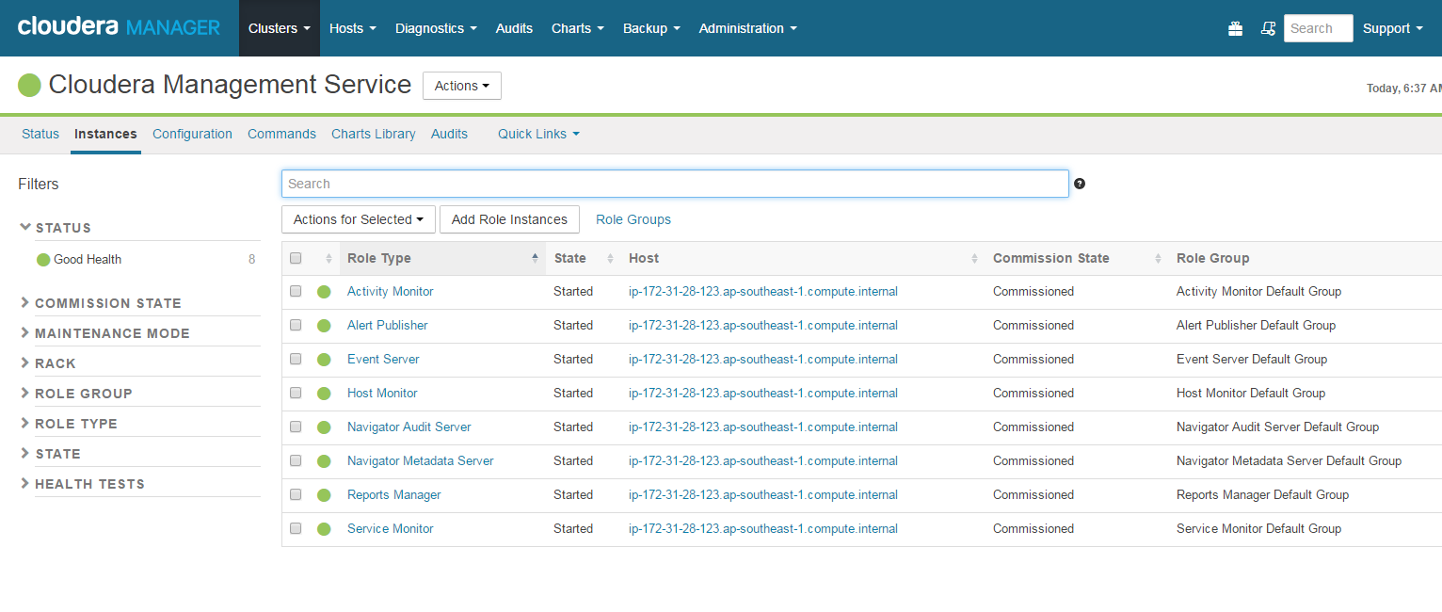

1. Open the browser and login to Navigator using default admin/admin credentials.

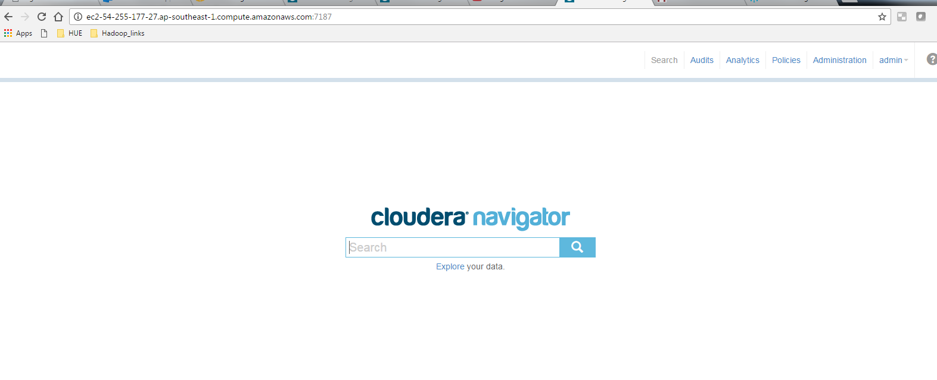

1. On the search window we can do search based on keywords.

I am doing a search based on user name apuser

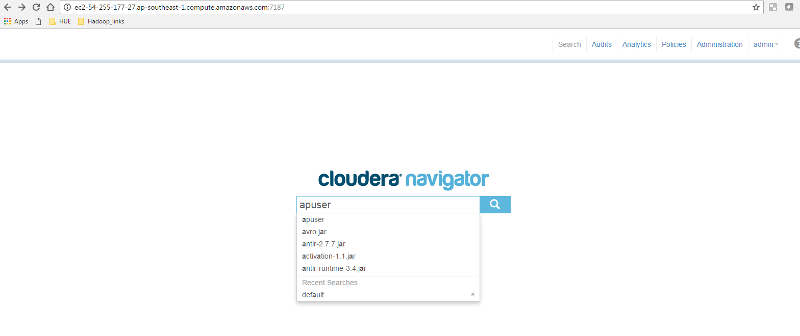

1. Listing all values which contains the keyword “apuser”

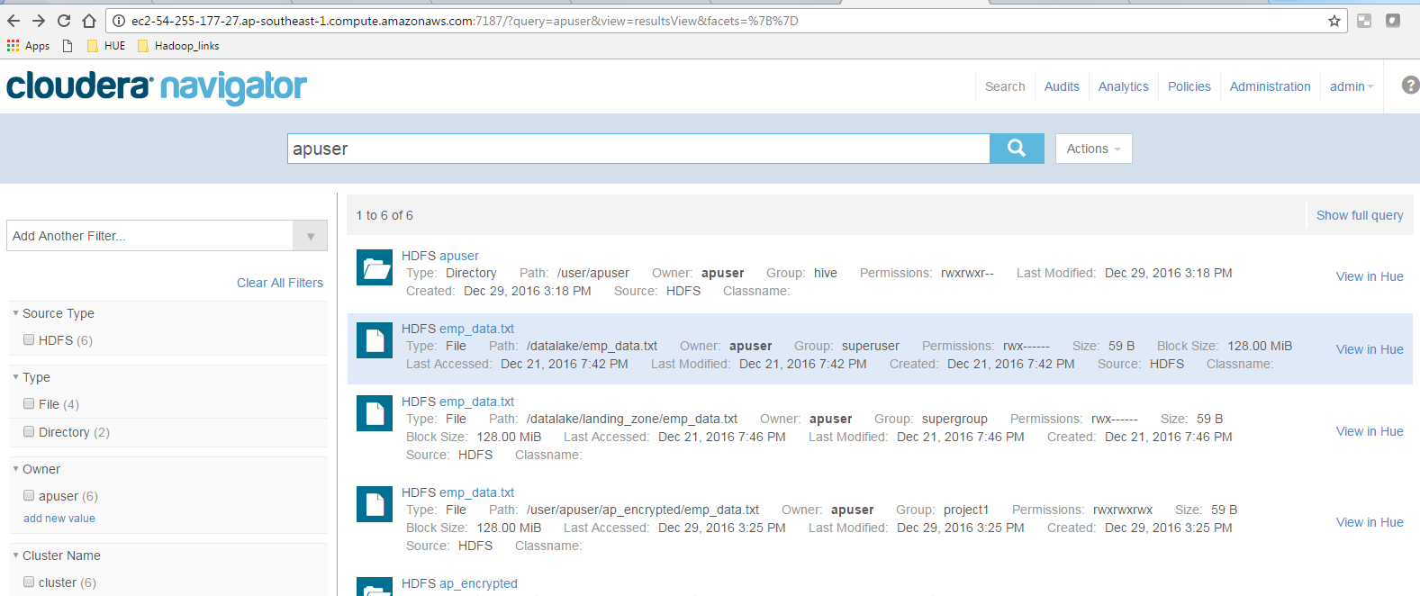

1. We can do auditing of events by clicking audit tab

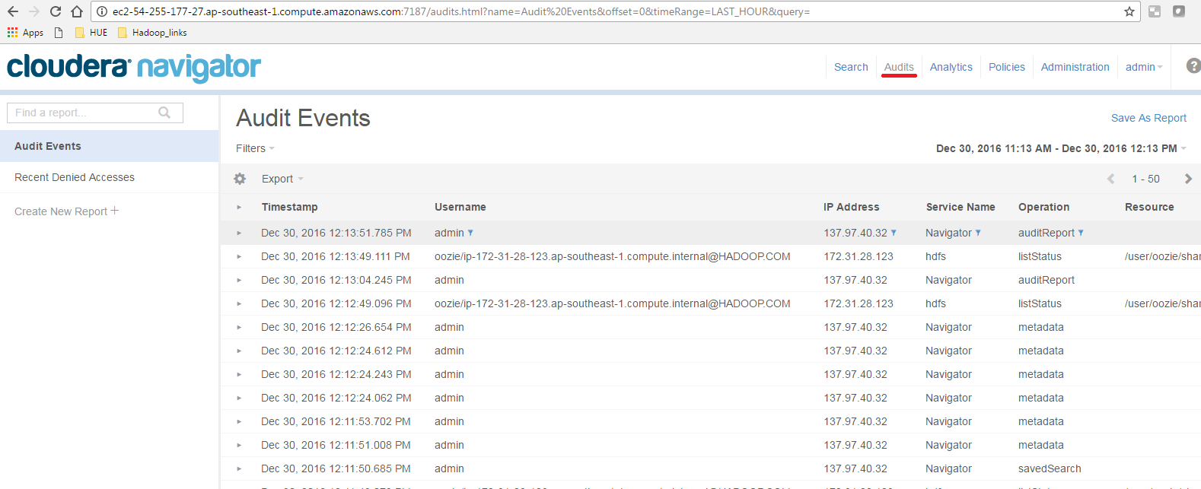

1. Filter the events based on time duration

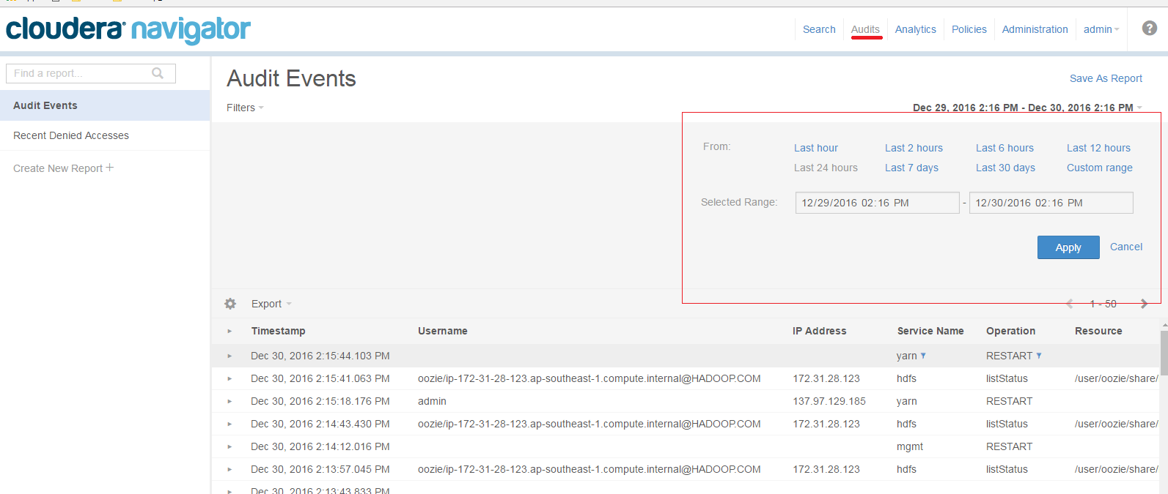

1. Supports filtering events based on conditions

I am listing all denial events by filtering with allowed equals false, we have lot more filtering conditions available

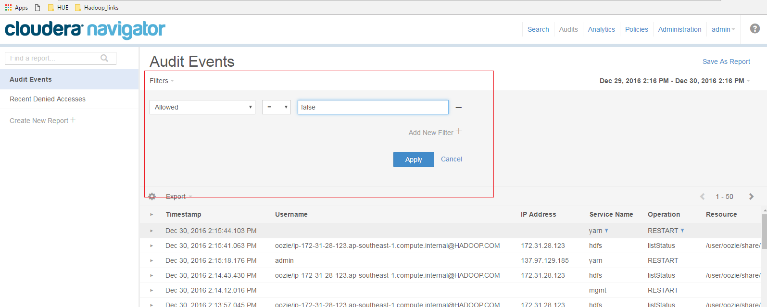

1. Listing all denied access events.

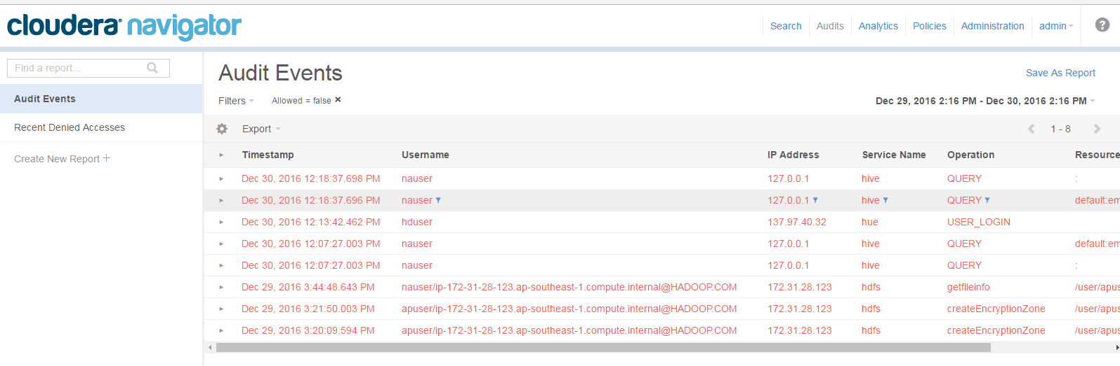

1. Auditing based on table name

Lists all events associated with table name emp_list.

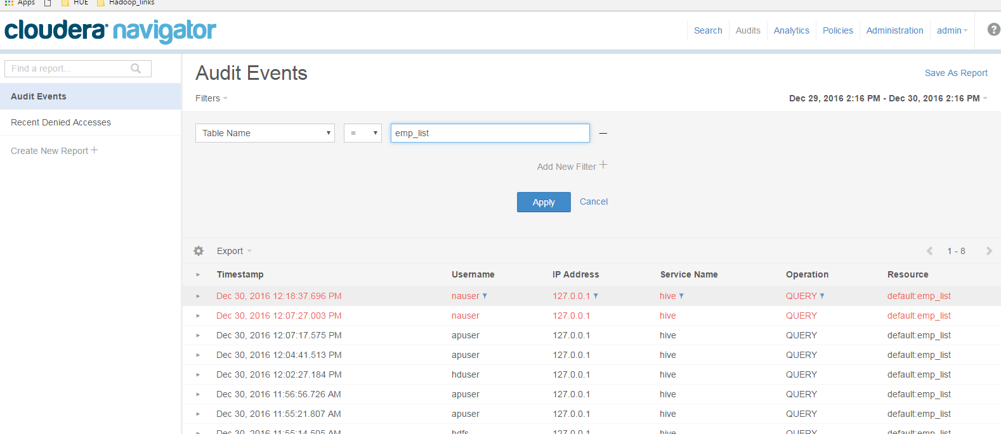

1. Searching HDFS files and directories ( filtering based on permission)

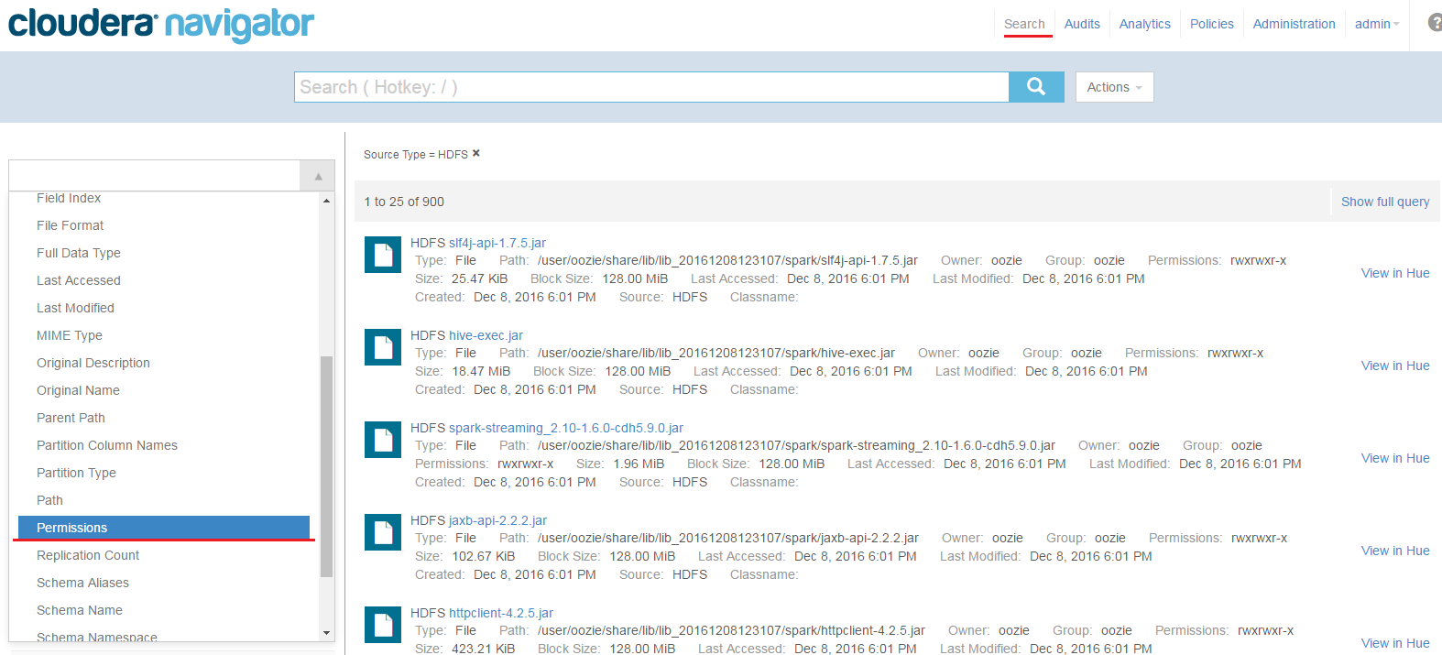

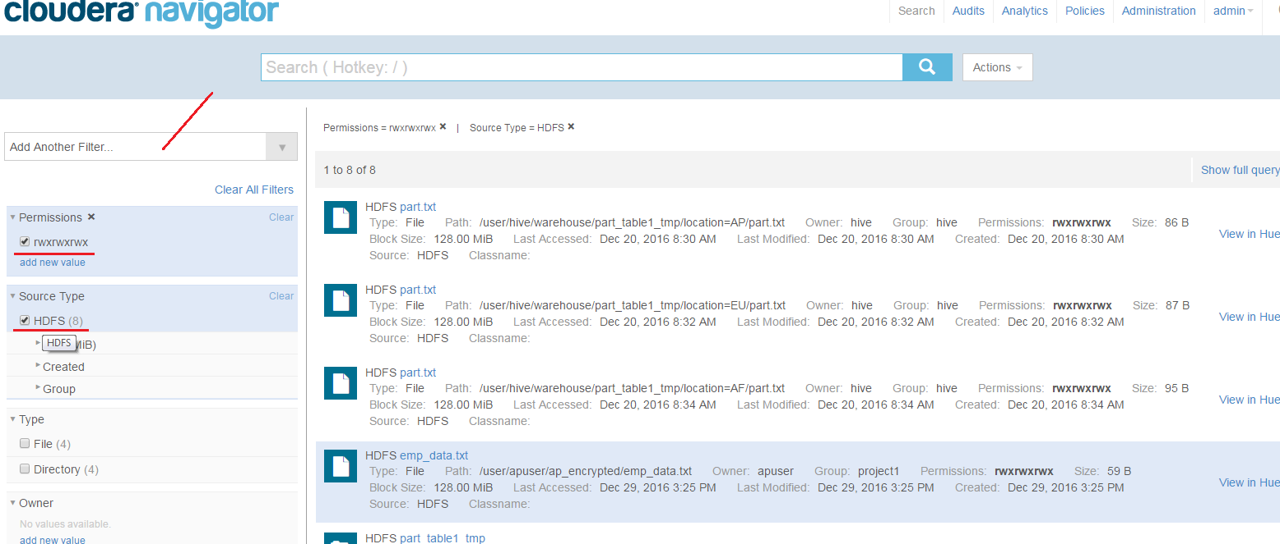

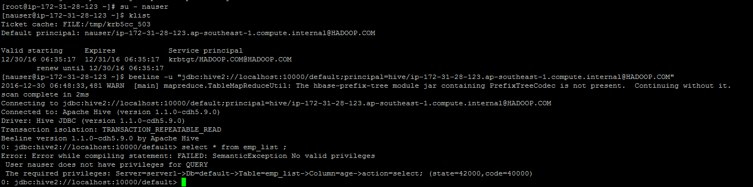

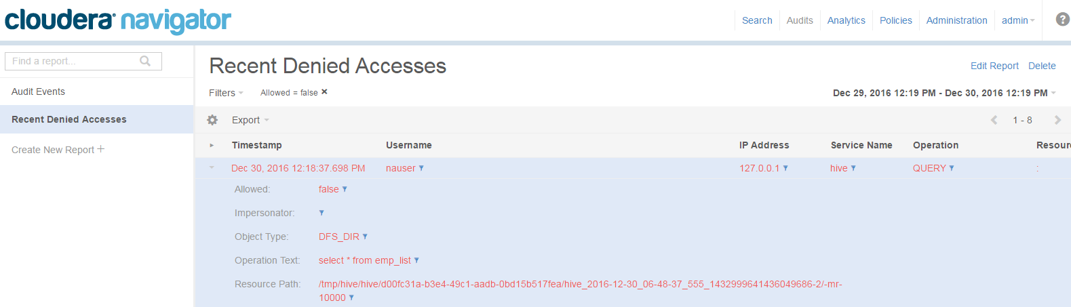

1. Lineage option available

Can track the data flow using this option.

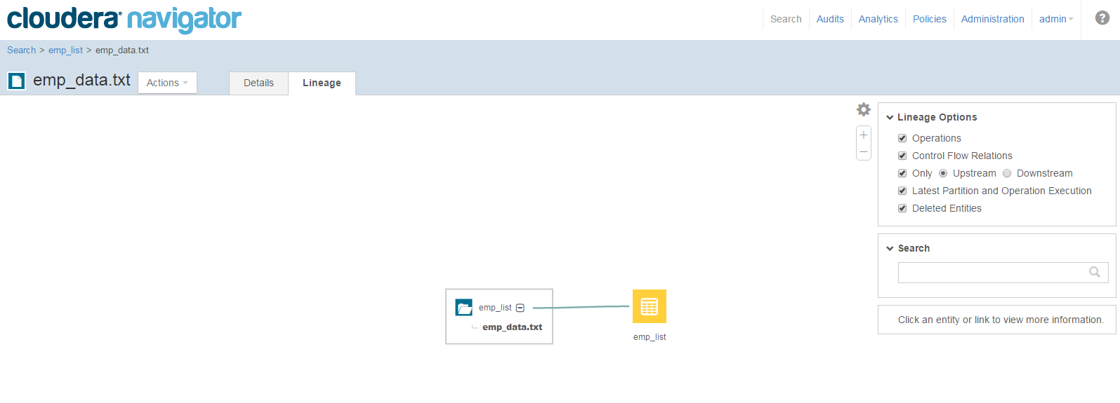

Cloudera Navigator Metadata Server

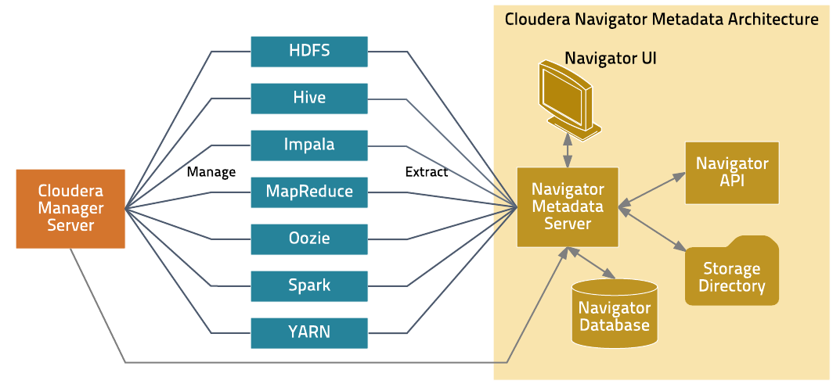

Cloudera Navigator Auditing Server  
