**Cloudera Hadoop Cluster installation**

( Manual installation Method )

Update the repo file for cloudera manager installation .Can configure own custom yum repository for cloudera manager.

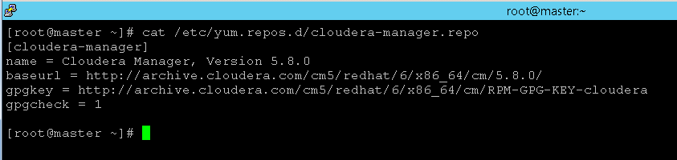

Install JDK package on Cloudera Manager server host

yum install oracle-j2sdk1.7

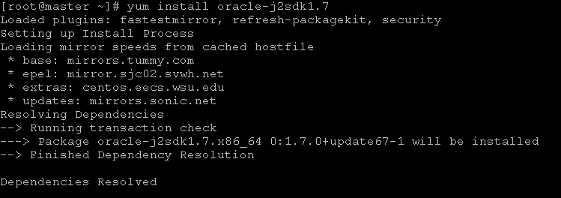

Install Cloudera Manager Server packages on master machine ( Where we are installing cloudera-manager-server packages )

yum install cloudera-manager-daemons cloudera-manager-server

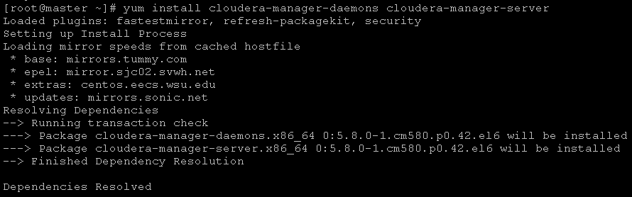

Install database needed for cloudera server ( installing MySQL server and connectivity jars here )

yum -y install mysql-server mysql-connector-java

Start Mysql database also turn it on at run level

chkconfig mysqld on

service mysqld start

Add new JAVA_HOME path to /etc/default/cloudera-scm-server file



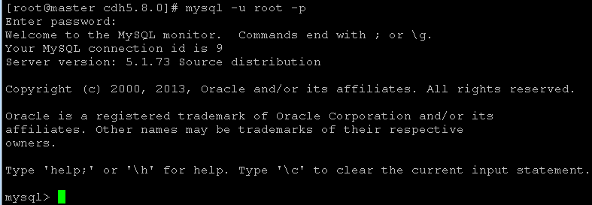

At the master MySQL prompt, create a temporary user who can connect from master with full access on databases.

mysql> grant all on *.* to 'temp'@'%' identified by 'temp' with grant option;

Remove the default db properties script.





Configure cloudera Manager server from cloudera Manager server host by executing the bellow script. It will create a new database in MySQL named scm , create a new user 'scm' with password as 'scm'

/usr/share/cmf/schema/scm_prepare_database.sh mysql -h master.hadoop.com -utemp -ptemp --scm-host master.hadoop.com scm scm scm

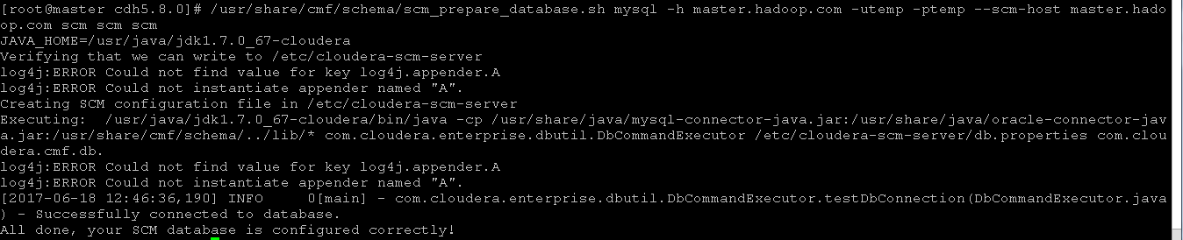

Drop the created temporary user. We need this temporary user only for configuring database in above step. Once configuration is done Cloudera uses newly created database , scm here.

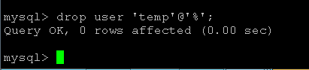

Start cloudera-scm-server service

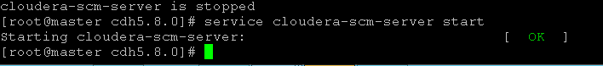

Open the Cloudera Manager web URL and continue the installation. Cloudera Manager agent installation can be done through Cloudera manager / we can do manual setup.

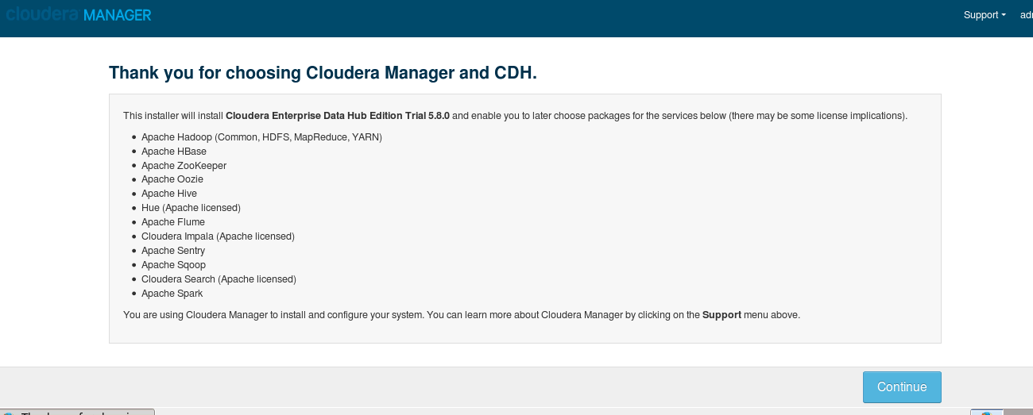

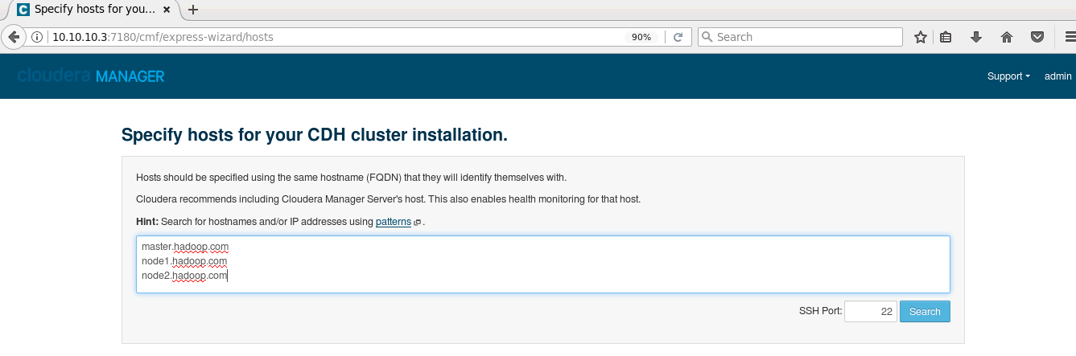

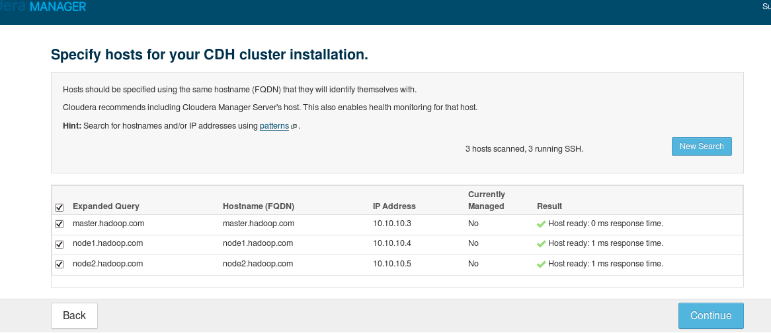

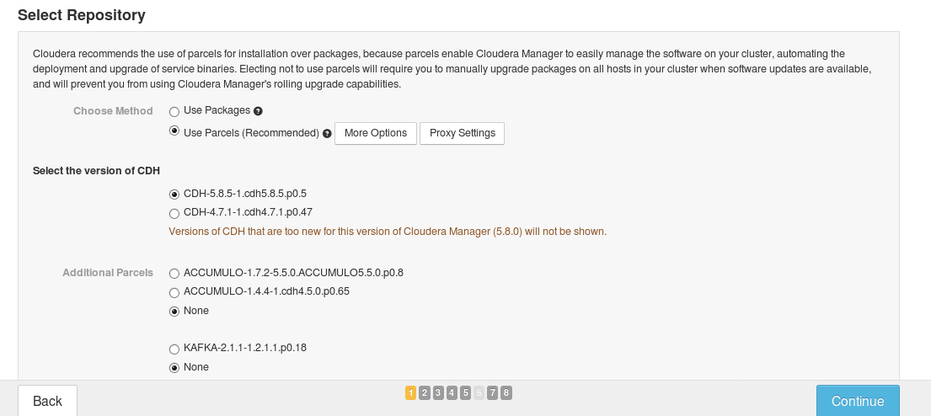

Select use parcels and click more settings

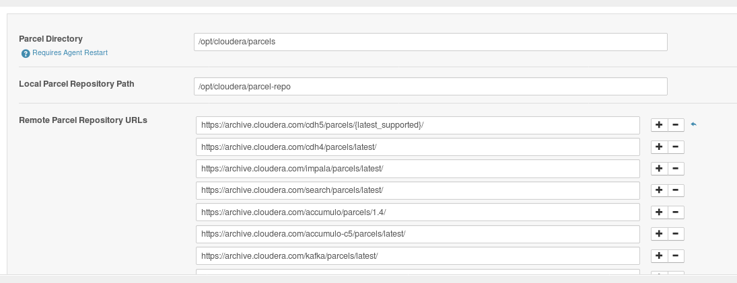

Change the location of Remote parcel repos if using local repo for parcles

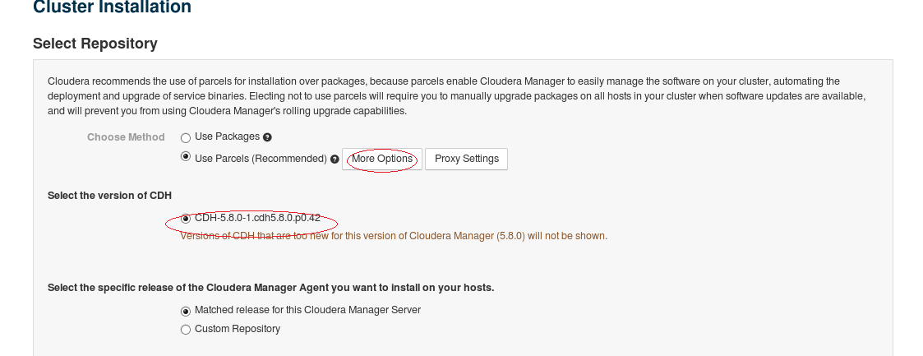

Change the repo location for cloudera manager agent installation

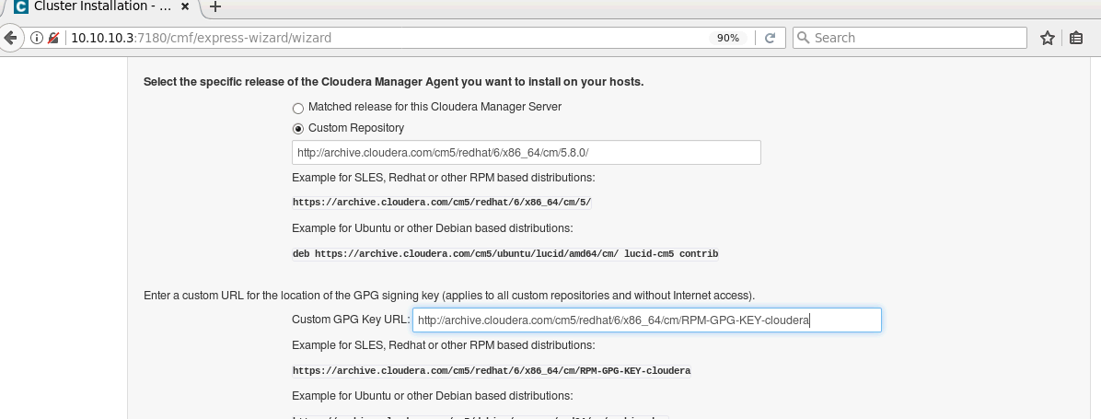

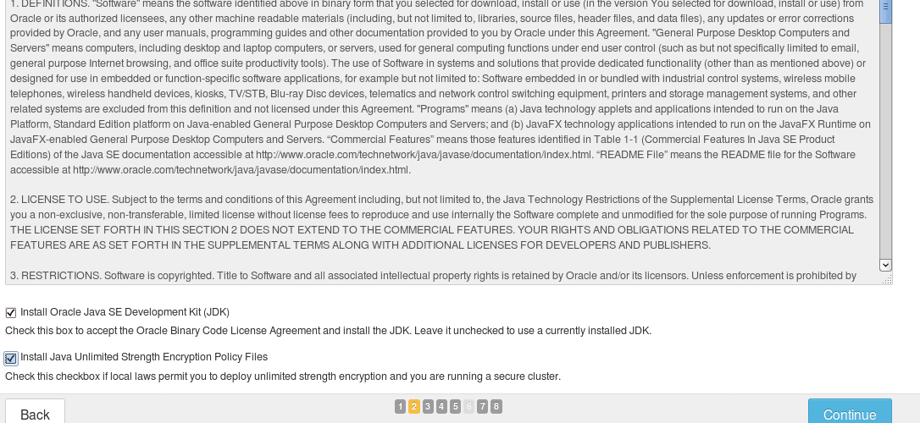

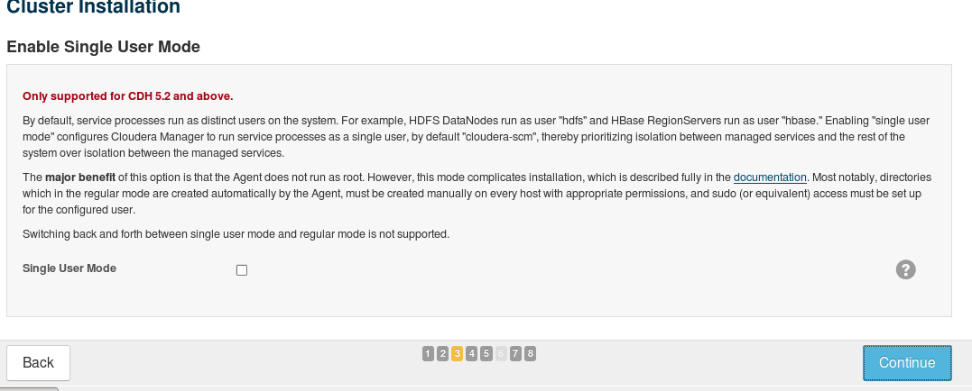

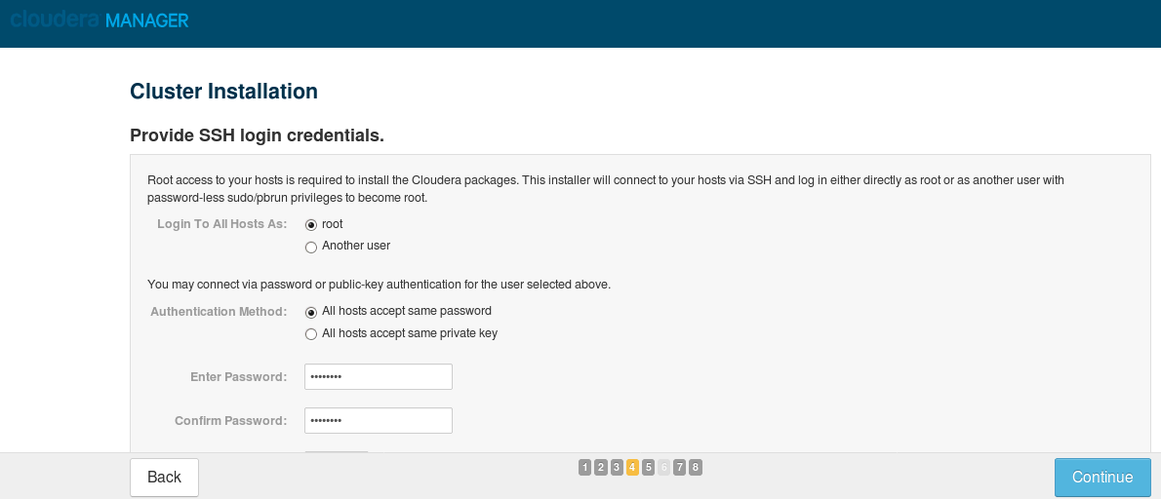

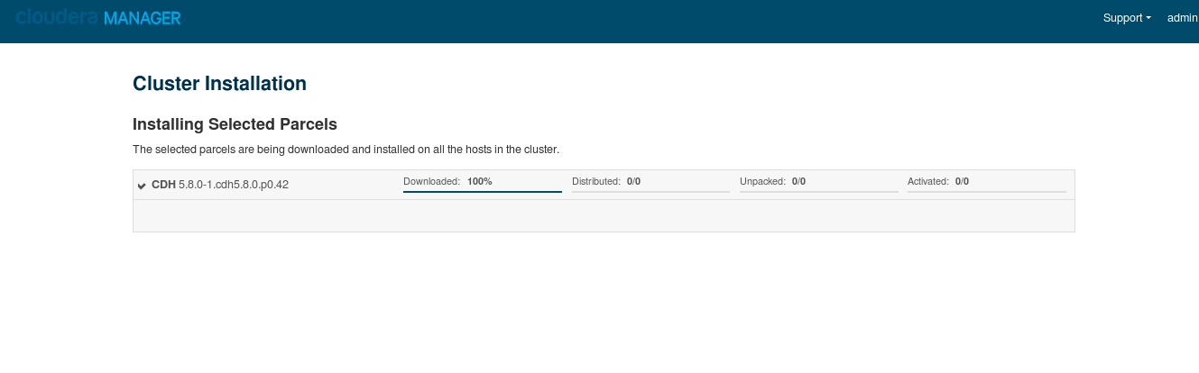

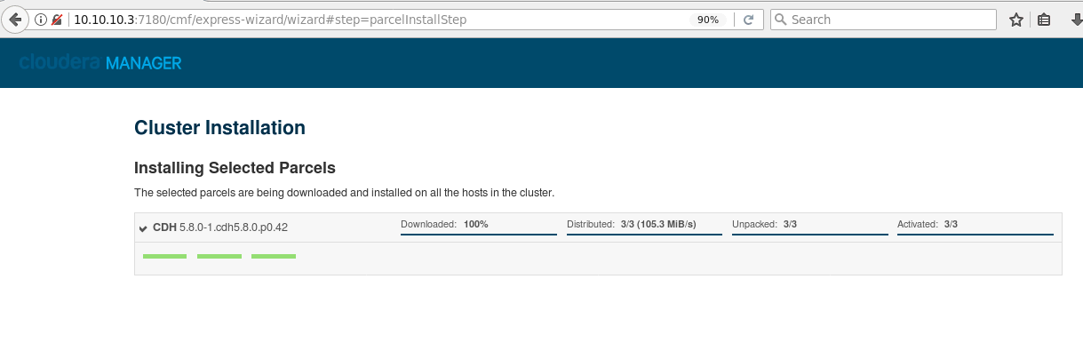

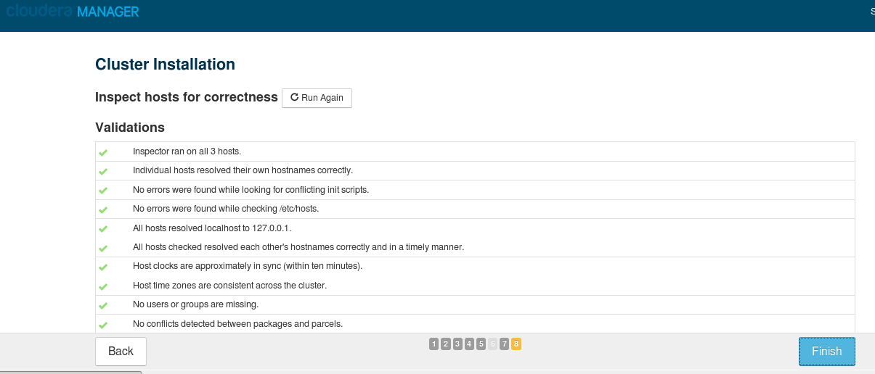

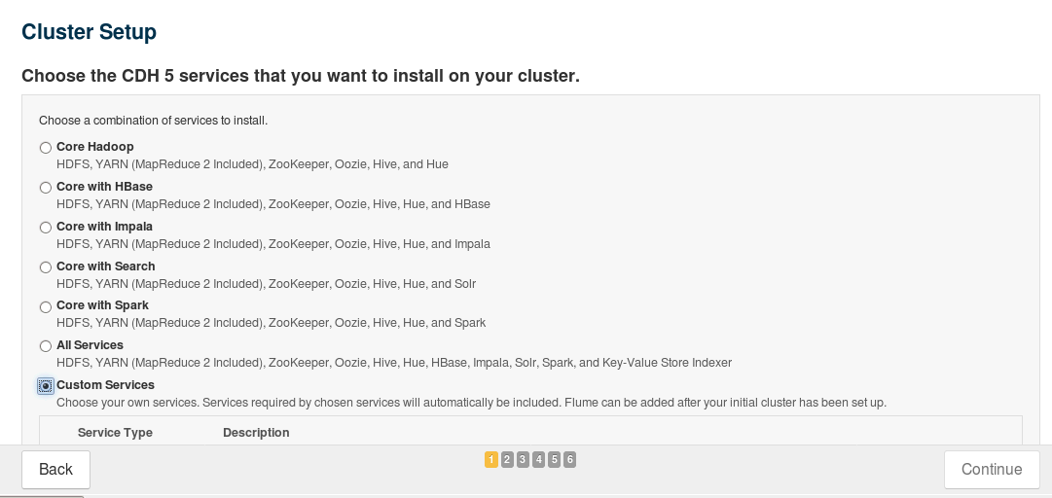

Selected custom services - selected HDFS ,YARN and Zookeeper

