**HDFS Transparent Encryption using Java KeyStore KMS**

Add Java KeyStore KMS service

Cloudera Manager Home -> Cluster _Name -> Add Service

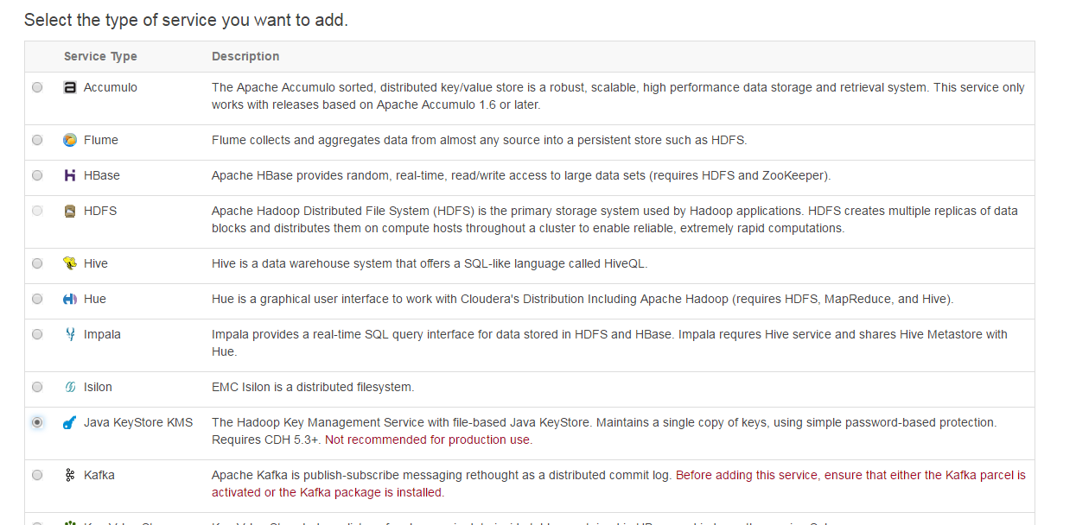

Select Java KeyStore KMS select the host name on which service need to install .

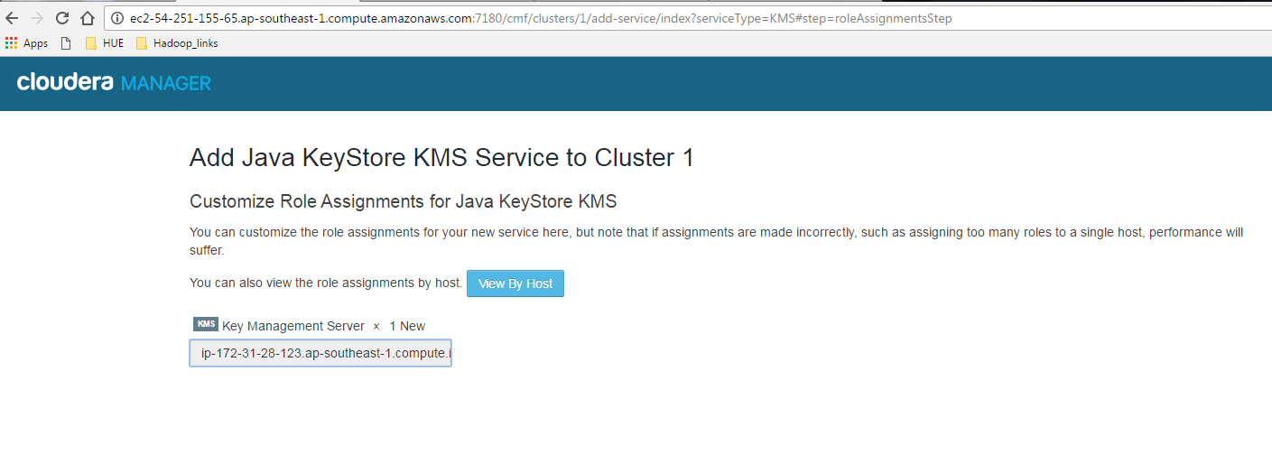

Add the list of users /groups for encryption key operations

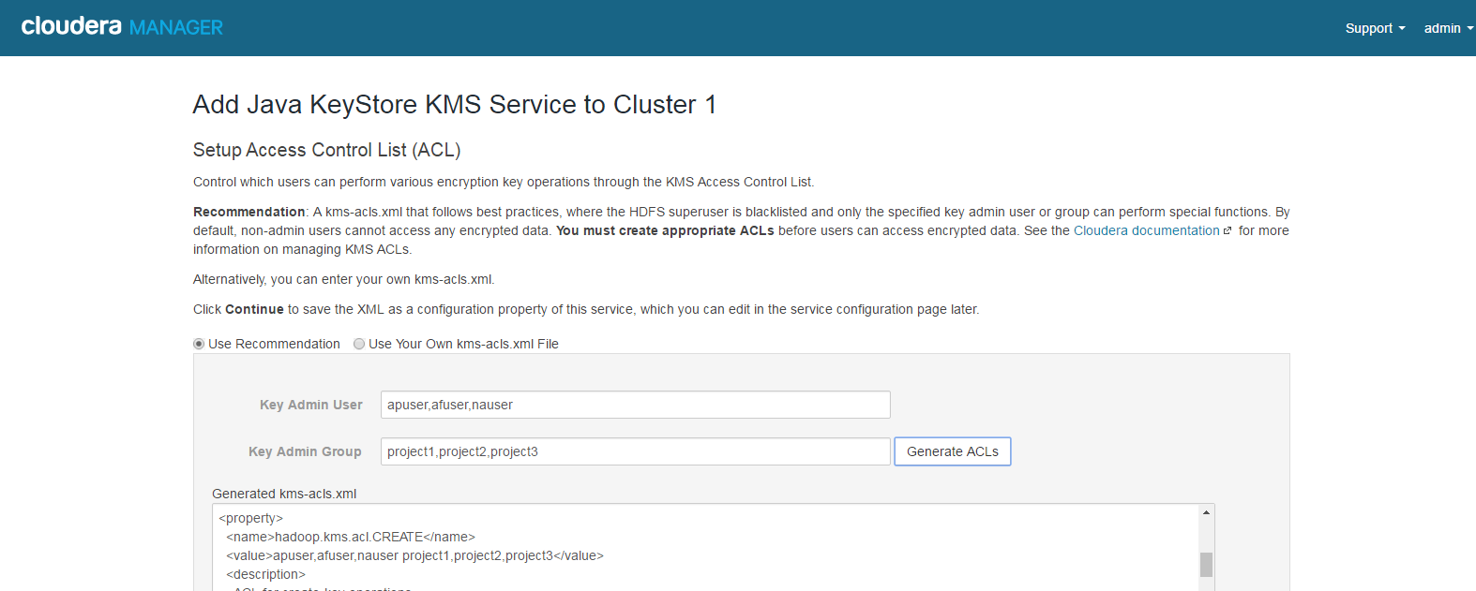

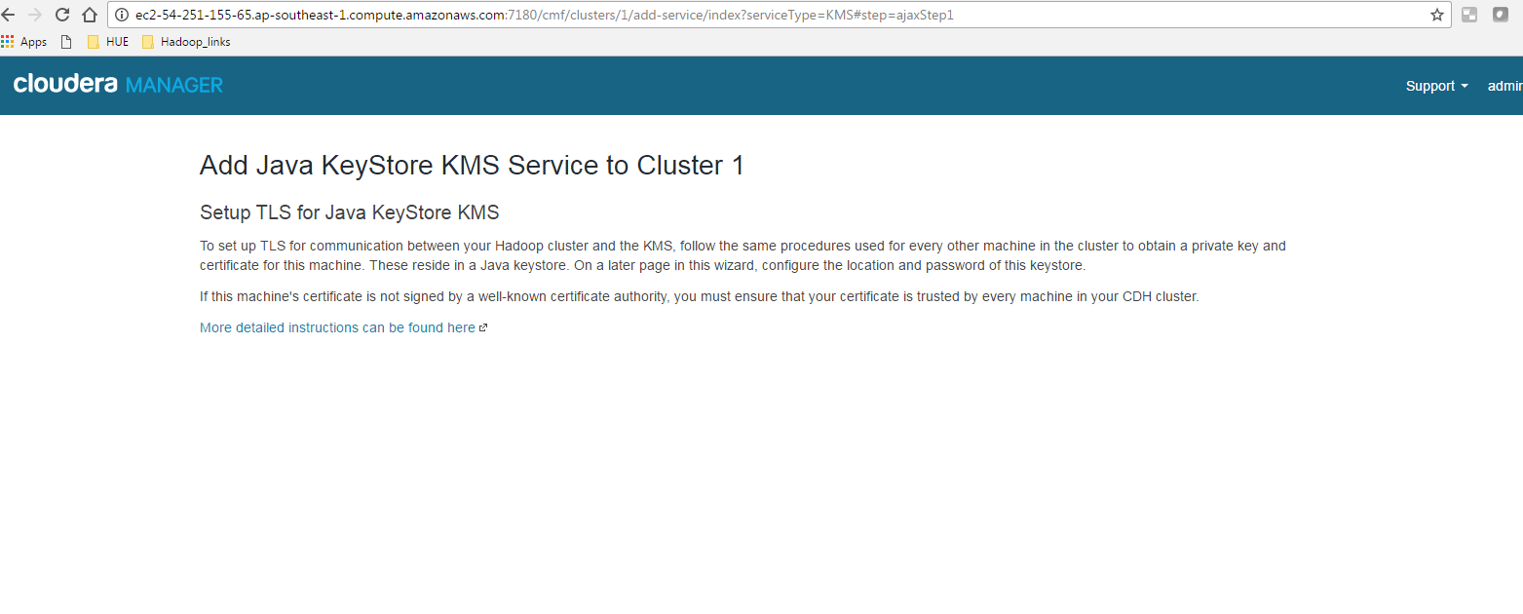

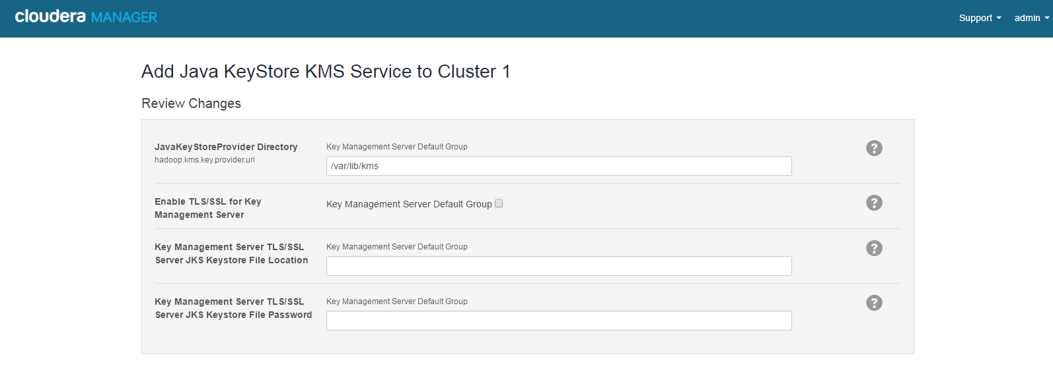

Start Java Key store Service .

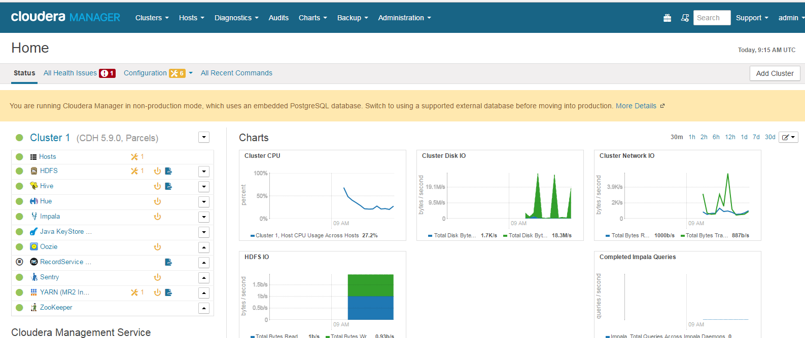

Create a new key



List the created keys



Delete existing key



Create a new directory



Login as super user ( hdfs ) and execute following command to create encryption zone.



Login as apuser(owner of the created encryption key) copy some files to encrypted zone

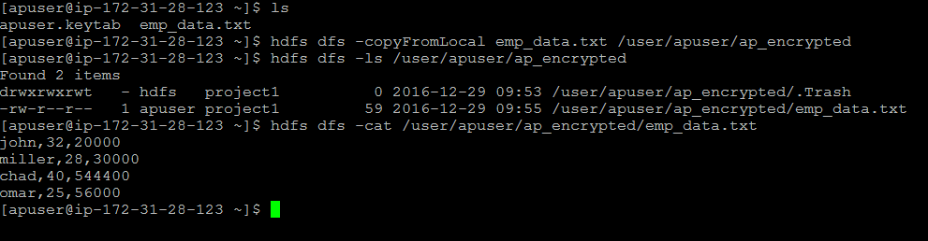

Login as admin user( hdfs ) and try to read the files from encrypted zone



Change the permission of encrypted zone to 777 , still others won’t be able to view the contents

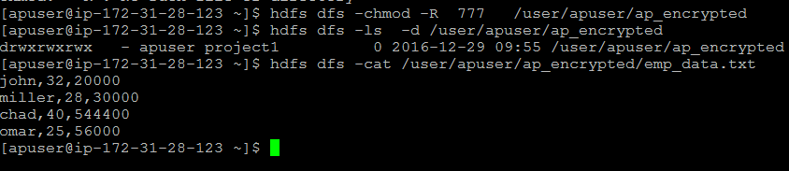

Admin user getting following error



Other user also not able to access



sijeesh.kunnotharamal@cognizant.com