COMP60022 – DECISION ANALYTICS
Individual Coursework – Answer Sheet
Student Name: ____________________ Student ID: ____________________

Part A – Exploratory Data Analysis (EDA) & Insights

A(a) Dataset Summary
The Audience dataset contains 800 records and 13 columns, while the Show dataset contains 200 records and 10 columns. Both datasets contain numerical, categorical and date-related variables. No missing values were identified in either dataset.
Table A1. Audience dataset data types and missing values
Variable | Data Type | Missing Values
Customer_ID | object | 0
Age | int64 | 0
Gender | object | 0
Country | object | 0
Visit_Date | datetime64[ns] | 0
Seating_Region | object | 0
Ticket_Price | int64 | 0
Num_Tickets | int64 | 0
Merchandise_Spend | float64 | 0
Drink_Spend | float64 | 0
Repeat_Visit | int64 | 0
Satisfaction_Score | float64 | 0
Recommendation_Likelihood | int64 | 0
Engagement_Value | float64 | 0
Table A2. Show dataset data types and missing values
Variable | Data Type | Missing Values
Show_ID | object | 0
Show_Date | datetime64[ns] | 0
Day_Type | object | 0
Region | object | 0
Attendance | int64 | 0
Avg_Ticket_Price | float64 | 0
Avg_Merch_Sales | float64 | 0
Revenue | float64 | 0
Weather_Score | float64 | 0
Guest_Performance | int64 | 0
Month | period[M] | 0
Day | object | 0
SCREENSHOT PLACEMENT: Insert screenshots of the Colab outputs for shape, data types/info(), and missing-value counts here.

A(b) Top 5 Countries
The five countries contributing the largest numbers of audience members were identified by calculating the frequency of audience records for each country.
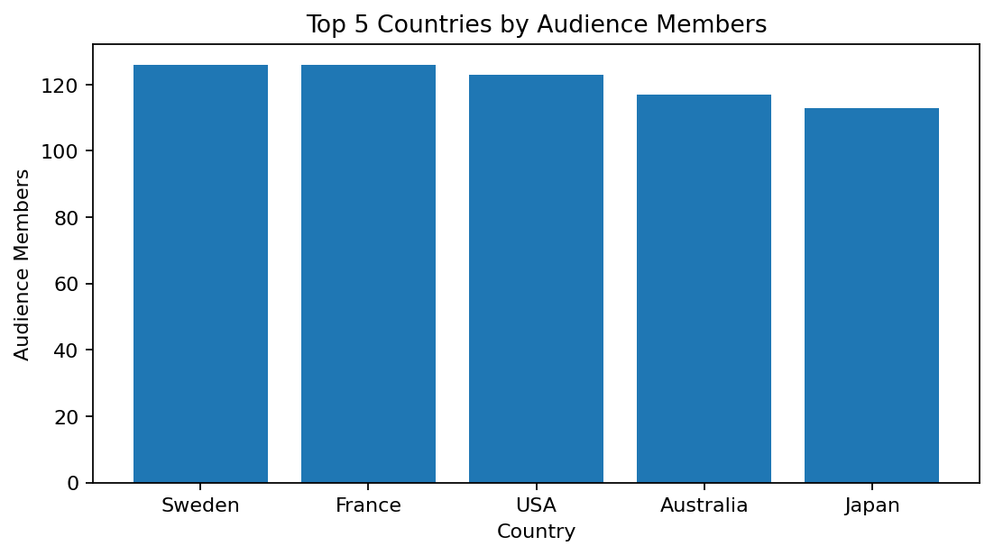
Figure A1. Top 5 countries by audience members.
Table A3. Top 5 countries
Country | Audience Members
Sweden | 126
France | 126
USA | 123
Australia | 117
Japan | 113
Sweden and France recorded the highest audience representation, with 126 audience members each. The USA followed with 123 audience members, while Australia and Japan recorded 117 and 113 respectively.
These results indicate that Sweden and France are the strongest audience markets in the supplied data. Company X could maintain targeted engagement and promotional activity in these markets.
SCREENSHOT PLACEMENT: Insert the Top-5 country bar-chart screenshot here.

A(c) Attendance Across Seating_Regions
The Audience dataset does not contain a direct Attendance field. Therefore, audience volume is represented by the number of audience records within each Seating_Region.
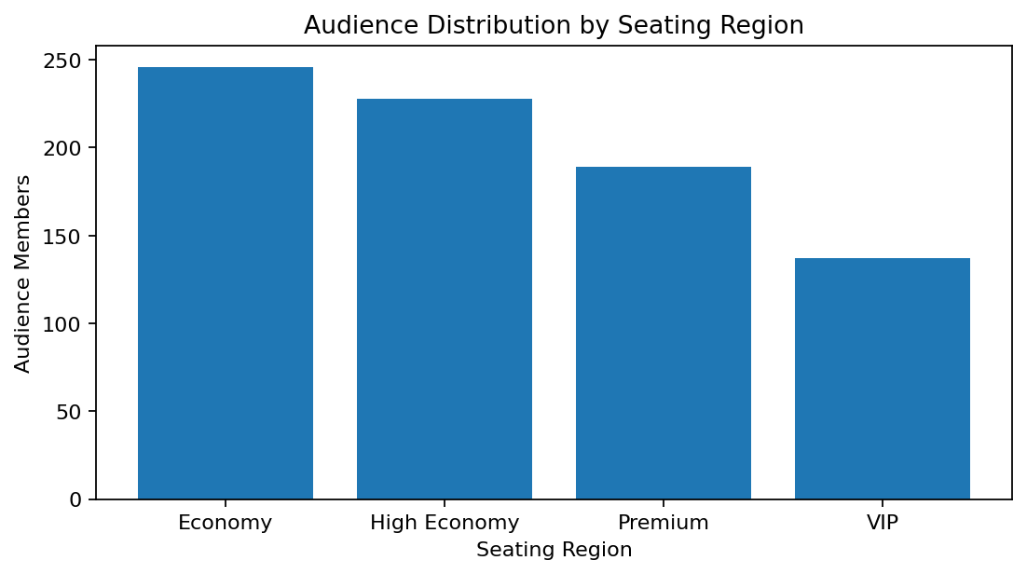
Figure A2. Audience distribution by seating region.
Table A4. Audience volume by seating region
Seating_Region | Audience Members
Economy | 246
High Economy | 228
Premium | 189
VIP | 137
Economy recorded the highest audience volume with 246 members, followed by High Economy with 228. Premium recorded 189 members, while VIP recorded 137. The distribution indicates greater audience volume in lower-priced seating categories and a smaller, more exclusive VIP segment.
SCREENSHOT PLACEMENT: Insert the seating-region bar-chart screenshot here.

A(d) Ticket_Price and Satisfaction_Score
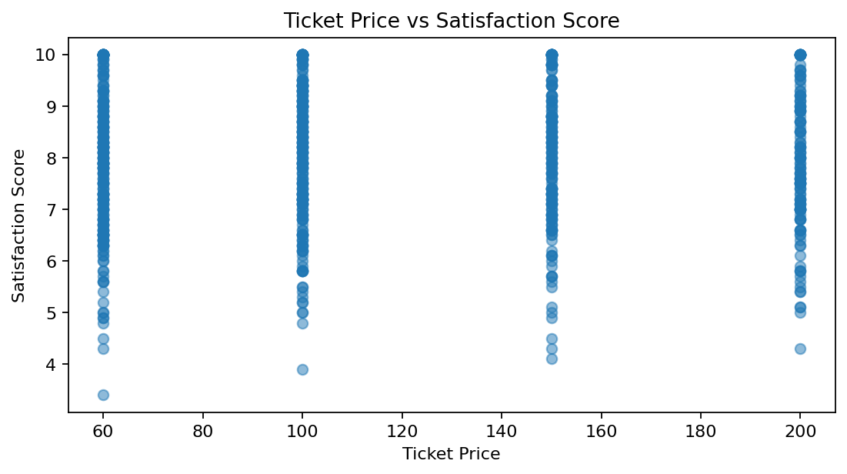
Figure A3. Ticket price versus satisfaction score.
The correlation coefficient is 0.0167, indicating a negligible linear relationship. First, higher ticket prices are not associated with consistently higher satisfaction. Second, the scatter plot does not reveal a clear linear trend.
Therefore, ticket price alone does not appear to be an important linear determinant of satisfaction in this dataset.
SCREENSHOT PLACEMENT: Insert the scatter-plot screenshot here and, directly below it, the Colab correlation output.

A(e) Repeat_Visitors and Spending
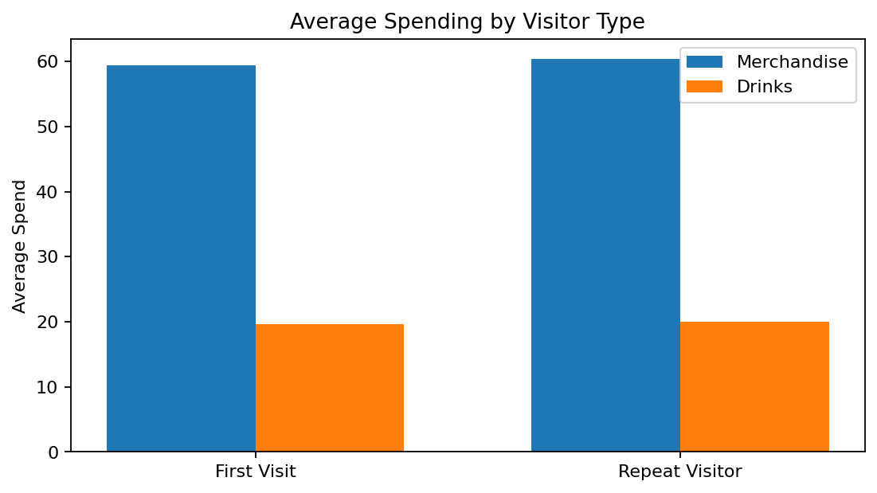
Figure A4. Average merchandise and drink spending by visitor type.
Table A5. Average spending by visitor type
Variable | Merchandise Spend | Drink Spend
First Visit | 59.41 | 19.64
Repeat Visitor | 60.40 | 20.02
Repeat visitors spent slightly more on merchandise (60.40 versus 59.41) and drinks (20.02 versus 19.64) than first-time visitors. The differences are small; therefore, repeat-visit status appears to have only a modest association with additional spending.
SCREENSHOT PLACEMENT: Insert the repeat-visitor spending chart screenshot here.

A(f) Outliers/Anomalies
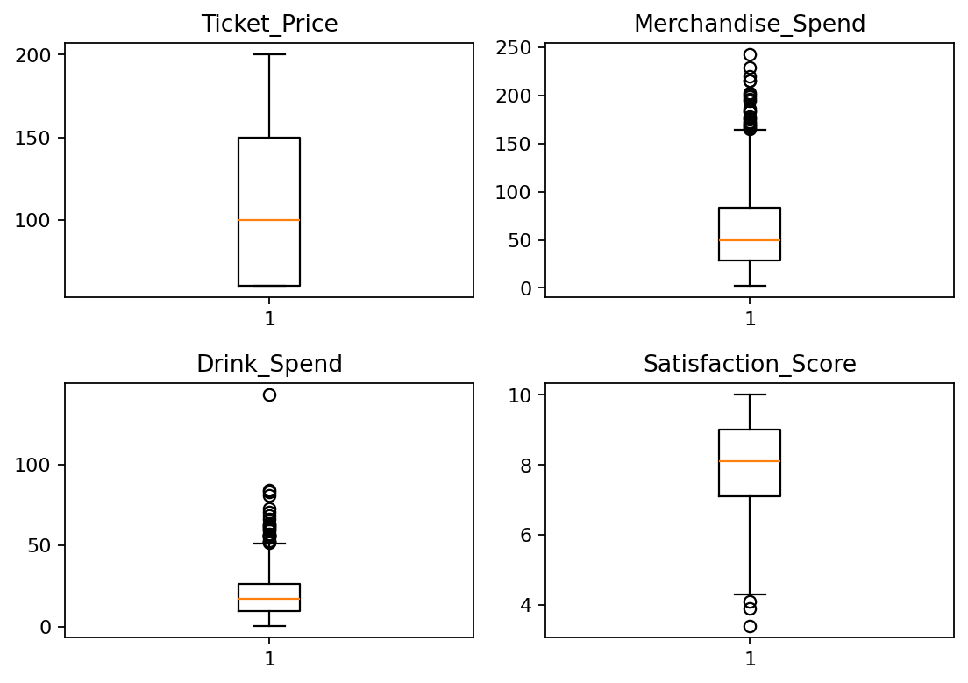
Figure A5. Boxplots for ticket price, merchandise spending, drink spending and satisfaction.
Table A6. IQR-based outlier analysis
Variable | Q1 | Q3 | Upper Limit | Outliers | Maximum
Ticket_Price | 60.00 | 150.00 | 285.00 | 0.00 | 200.00
Merchandise_Spend | 28.38 | 83.08 | 165.14 | 23.00 | 242.67
Drink_Spend | 9.77 | 26.49 | 51.58 | 26.00 | 142.82
Satisfaction_Score | 7.10 | 9.00 | 11.85 | 3.00 | 10.00
1. Merchandise_Spend contains 23 IQR-based outliers and reaches a maximum of 242.67. 2. Drink_Spend contains 26 outliers and reaches a maximum of 142.82. 3. Ticket_Price has no IQR-based outliers, indicating a comparatively controlled price range. 4. Satisfaction_Score has no IQR-based outliers under the 1.5×IQR criterion; the maximum score of 10 remains within the calculated statistical range.
SCREENSHOT PLACEMENT: Insert the four-boxplot screenshot here, followed by the IQR output if required.

A(g) Correlation Analysis
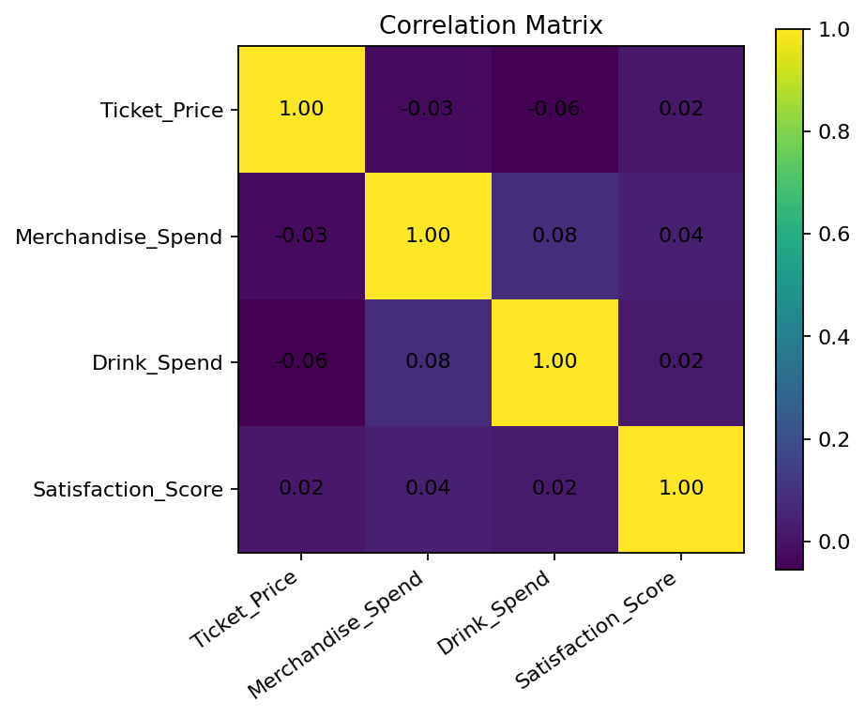
Figure A6. Correlation matrix.
Table A7. Correlation coefficients
Variable | Ticket_Price | Merchandise_Spend | Drink_Spend | Satisfaction_Score
Ticket_Price | 1.0000 | -0.0260 | -0.0552 | 0.0167
Merchandise_Spend | -0.0260 | 1.0000 | 0.0810 | 0.0394
Drink_Spend | -0.0552 | 0.0810 | 1.0000 | 0.0205
Satisfaction_Score | 0.0167 | 0.0394 | 0.0205 | 1.0000
All selected correlations are weak and close to zero. Ticket_Price correlates -0.0260 with Merchandise_Spend, -0.0552 with Drink_Spend and 0.0167 with Satisfaction_Score. Merchandise_Spend correlates 0.0394 with Satisfaction_Score, while Drink_Spend correlates 0.0205 with Satisfaction_Score. Consequently, none of these variables demonstrates a strong linear relationship with another.
SCREENSHOT PLACEMENT: Insert the correlation heatmap/matrix screenshot here.

Part B – Descriptive Statistics & Insights

B(a) Summary Statistics for Numerical Features
Table B1. Audience numerical summary statistics
Variable | min | 25% | 50% | 75% | max | std
Age | 18.00 | 31.75 | 45.00 | 56.00 | 69.00 | 14.86
Ticket_Price | 60.00 | 60.00 | 100.00 | 150.00 | 200.00 | 50.21
Num_Tickets | 1.00 | 1.00 | 2.00 | 4.00 | 4.00 | 1.14
Merchandise_Spend | 2.05 | 28.38 | 49.94 | 83.08 | 242.67 | 41.21
Drink_Spend | 0.27 | 9.77 | 17.02 | 26.49 | 142.82 | 14.16
Repeat_Visit | 0.00 | 0.00 | 0.00 | 1.00 | 1.00 | 0.46
Satisfaction_Score | 3.40 | 7.10 | 8.10 | 9.00 | 10.00 | 1.34
Recommendation_Likelihood | 4.00 | 7.00 | 8.00 | 9.00 | 10.00 | 1.43
Table B2. Show numerical summary statistics
Variable | min | 25% | 50% | 75% | max | std
Attendance | 2,045.00 | 3,296.75 | 4,303.00 | 5,606.75 | 6,964.00 | 1,396.58
Avg_Ticket_Price | 48.75 | 105.51 | 120.14 | 137.71 | 191.63 | 25.12
Avg_Merch_Sales | 2.58 | 28.16 | 34.71 | 41.90 | 64.93 | 10.42
Revenue | 243,543.53 | 461,509.82 | 674,747.32 | 855,444.14 | 1,439,371.98 | 260,405.41
Weather_Score | 1.00 | 5.70 | 7.15 | 8.60 | 10.00 | 2.02
Guest_Performance | 0.00 | 0.00 | 0.00 | 0.00 | 1.00 | 0.36
Audience age ranges from 18 to 69 and ticket price ranges from 60 to 200. Merchandise and drink spending display relatively large maximum values compared with their medians. Show attendance ranges from 2,045 to 6,964, while revenue ranges from 243,543.53 to 1,439,371.98.
SCREENSHOT PLACEMENT: Insert screenshots of the numerical summary-statistics outputs here.

B(b) Summary Statistics for Categorical Features
Table B3. Audience categorical summary – Gender
Gender | Frequency
Female | 399
Male | 321
Other | 80
Table B3. Audience categorical summary – Country
Country | Frequency
Sweden | 126
France | 126
USA | 123
Australia | 117
Japan | 113
UK | 103
Germany | 92
Table B3. Audience categorical summary – Seating_Region
Seating_Region | Frequency
Economy | 246
High Economy | 228
Premium | 189
VIP | 137
Table B4. Show categorical summary – Day_Type
Day_Type | Frequency
Weekday | 143
Weekend | 57
Table B4. Show categorical summary – Region
Region | Frequency
London | 124
Europe | 50
Global | 26
Female is the largest gender category with 399 records. Sweden and France are the largest country groups. Economy is the largest seating category. At show level, Weekday shows outnumber Weekend shows, and London is the most represented region.
SCREENSHOT PLACEMENT: Insert screenshots of the categorical frequency outputs here.

B(c) VIP Region Visitors vs Economy Visitors
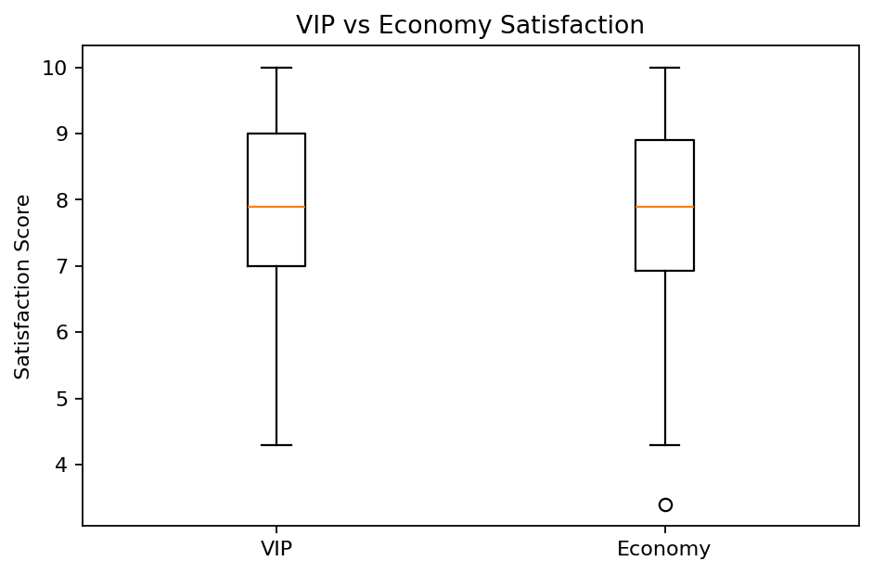
Figure B1. VIP versus Economy satisfaction scores.
Table B5. VIP and Economy satisfaction
Variable | VIP | Economy
Mean | 7.94 | 7.90
Median | 7.90 | 7.90
VIP visitors have a mean satisfaction score of 7.94, compared with 7.90 for Economy visitors. Welch's independent-samples t-test produced t = 0.2352 and p = 0.8142.
Because p > 0.05, the null hypothesis is not rejected at the 5% significance level. Thus, there is no statistically significant evidence that VIP visitors have higher Satisfaction_Score values than Economy visitors, despite the slightly higher VIP mean.
SCREENSHOT PLACEMENT: Insert the VIP-versus-Economy boxplot screenshot and the t-test output here.

B(d) Engagement_Value
Engagement_Value = (Merchandise_Spend + Drink_Spend) / Ticket_Price
Table B6. Engagement_Value summary
Variable | Value
min | 0.0326
25% | 0.3927
50% | 0.6612
75% | 1.0622
max | 3.9877
mean | 0.8342
The mean Engagement_Value is 0.8342. This indicates that average additional merchandise and drink expenditure is approximately 83.4% of ticket price. A higher value indicates stronger additional commercial engagement relative to ticket expenditure.
SCREENSHOT PLACEMENT: Insert the screenshot showing the created Engagement_Value field and its statistical output here.

B(e) Total Ticket Revenue Over Time with Regions
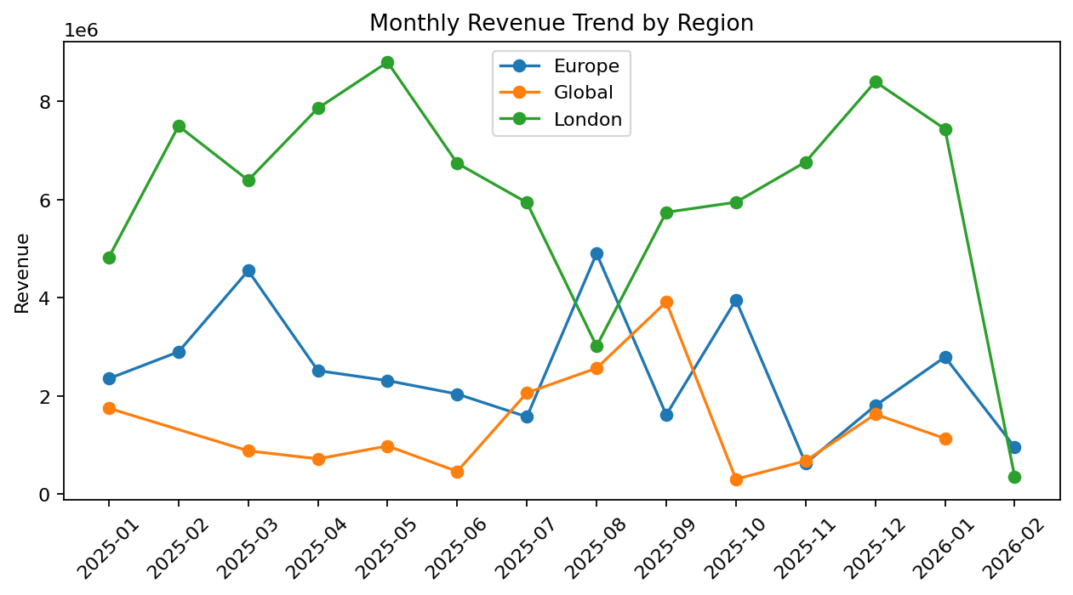
Figure B2. Monthly revenue trend by region.
Table B7. Total revenue by region
Region | Total Revenue
London | 85,731,488.68
Europe | 34,889,617.24
Global | 17,066,829.01
London generated the highest total revenue, followed by Europe and Global. The time-series visualisation also demonstrates variation in revenue across months and regions, indicating that revenue performance is not constant over time.
SCREENSHOT PLACEMENT: Insert the monthly revenue trend screenshot here.

B(f) Ticket Sales by Day of Week and Month
The Show dataset does not contain a direct Ticket_Sales field. Attendance is therefore used as the available measure of ticket demand/sales volume.
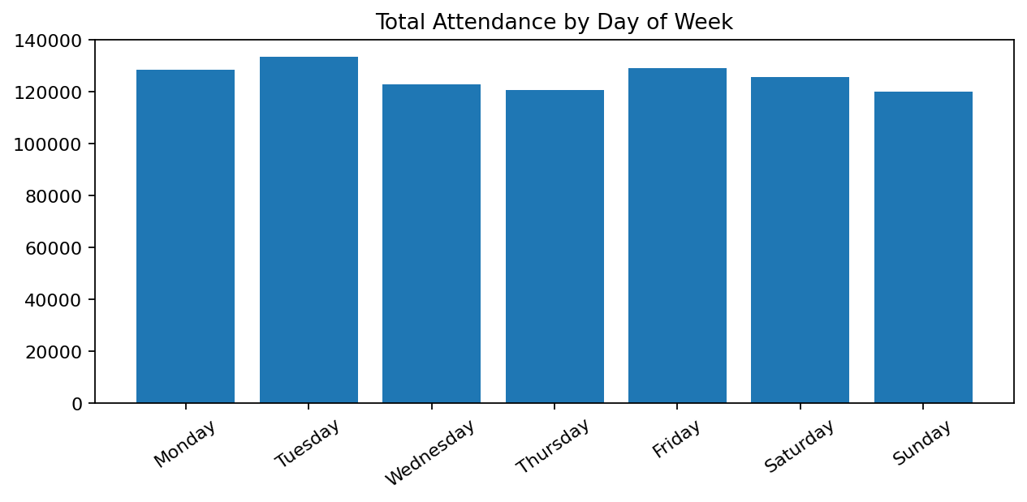
Figure B3. Total attendance by day of week.
Table B8. Attendance by day of week
Day | Total Attendance
Monday | 128,660
Tuesday | 133,541
Wednesday | 122,975
Thursday | 120,757
Friday | 129,199
Saturday | 125,622
Sunday | 119,996
Tuesday recorded the highest total attendance at 133,541, while Sunday recorded the lowest at 119,996. This indicates some variation in demand by weekday, although attendance remains distributed across the week.
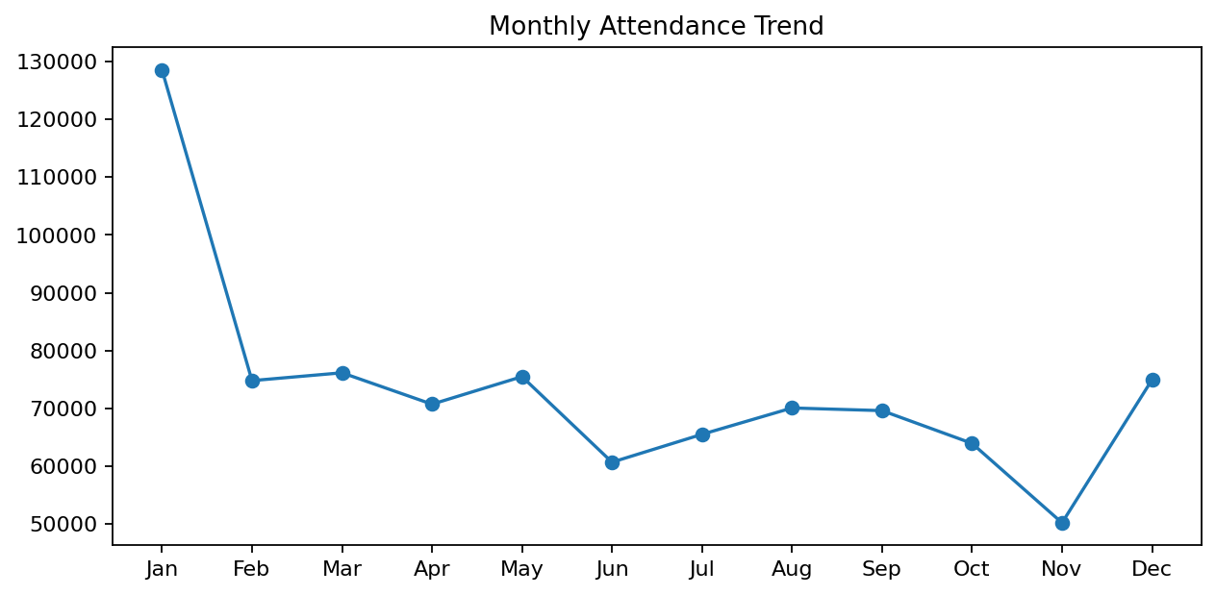
Figure B4. Monthly attendance trend.
Table B9. Attendance by month
Variable | Attendance
Jan | 128,542
Feb | 74,804
Mar | 76,157
Apr | 70,727
May | 75,494
Jun | 60,696
Jul | 65,518
Aug | 70,075
Sep | 69,614
Oct | 63,950
Nov | 50,216
Dec | 74,957
January recorded the highest attendance at 128,542, whereas November recorded the lowest at 50,216. The results indicate a clear seasonal pattern in attendance.
SCREENSHOT PLACEMENT: Insert the weekday attendance screenshot after Table B8 and the monthly attendance screenshot after Table B9.

B(g) Three Additional Key Visualisations Supporting a Business Decision

B(g)(1) Total Revenue by Region
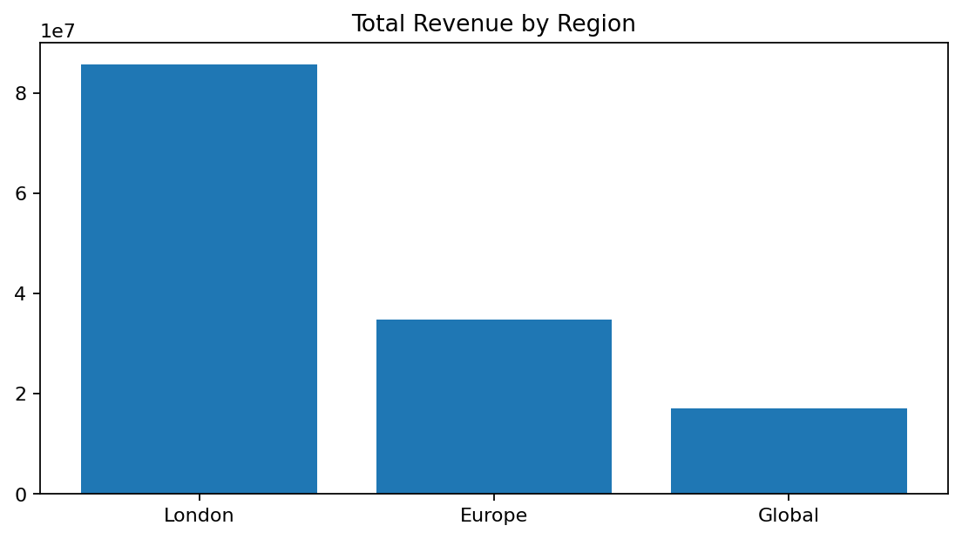
Figure B5. Total revenue by region.
Table B10. Regional revenue, attendance and show count
Region | Total_Revenue | Total_Attendance | Number_of_Shows
London | 85,731,488.68 | 547,663.00 | 124.00
Europe | 34,889,617.24 | 219,964.00 | 50.00
Global | 17,066,829.01 | 113,123.00 | 26.00
London is the strongest revenue-generating region in the supplied dataset. This visualisation supports regional performance evaluation and resource allocation.
Actionable step: Company X should maintain the London market while examining the operational and commercial factors that could improve performance in Europe and Global.

B(g)(2) Guest Performance and Attendance
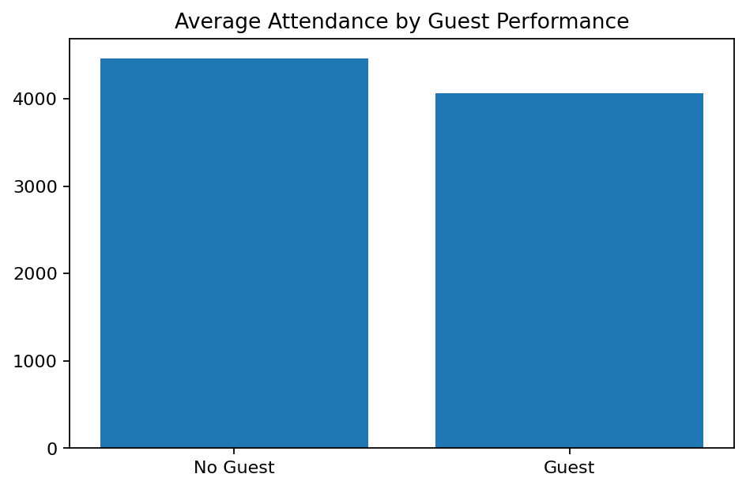
Figure B6. Average attendance by guest performance.
Table B11. Guest-performance comparison
Variable | Average_Attendance | Average_Revenue | Number_of_Shows
No Guest Performance | 4,463.76 | 690,167.17 | 170.00
Guest Performance | 4,063.67 | 678,650.55 | 30.00
Shows without guest performances have higher average attendance than shows with guest performances in this dataset. Therefore, guest performance is not demonstrably associated with increased attendance in the supplied sample.
Actionable step: Guest performances should be assessed using incremental cost and revenue evidence before being adopted as an attendance-growth strategy.

B(g)(3) Weather Score and Revenue
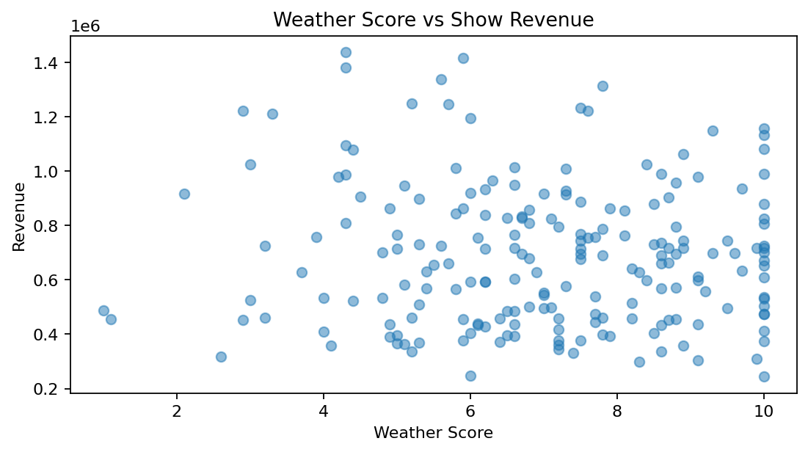
Figure B7. Weather score versus revenue.
The correlation between Weather_Score and Revenue is -0.0589, indicating a very weak linear relationship.
Actionable step: Weather should not be used as the sole basis for revenue forecasting. Company X should incorporate attendance, region, pricing and other operational factors.
SCREENSHOT PLACEMENT: Insert the three screenshots corresponding to Figures B5, B6 and B7 here.

