A PROJECT REPORT ON

IntelliFix: An Intelligent Compiler for Syntax Error Analysis, Detection, and Correction
Submitted in partial fulfilment of the requirements of the course
BCSE307P — [course title as given in the official template]
by
GOUTAM JAYASINGH (24BCE2417)
S CHARUMEENA (24BCI0238)
RAGURAMAN GOVINDASAMY (24BDS0409)
Under the guidance of
[Guide's name]
[Guide's designation]
[School / Department name]
[University name and location, as in the official template]
[Month and year of submission]

BONAFIDE CERTIFICATE
This is to certify that the project report entitled “IntelliFix: An Intelligent Compiler for Syntax Error Analysis, Detection, and Correction” submitted by Goutam Jayasingh (24BCE2417), S Charumeena (24BCI0238), Raguraman Govindasamy (24BDS0409) for the course BCSE307P is a record of work carried out by them under my supervision. [Replace this paragraph with the certificate wording of the official template.]
______________________________  [Guide's name]  [Guide's designation]  Guide | ______________________________  [Head of Department's name]  [Designation]  Head of the Department
Date: [date] Place: [place]

ACKNOWLEDGEMENT
We thank our guide, [Guide's name and designation], for guidance throughout this project, and [names and roles of others the team wishes to thank, e.g. the Head of the Department]. [The team should write this section in its own words.]
Goutam Jayasingh, S Charumeena, Raguraman Govindasamy

ABSTRACT
Compilers report a syntax error where the parser detects it, which is often not where the programmer made it, and when they suggest a fix they usually commit to a single candidate even when several are equally plausible. This project presents IntelliFix, an intelligent compiler front end for MiniC, a teaching subset of C, that detects syntax errors, analyses alternative corrections and decides how confident it can be about each one.
IntelliFix combines a re-entrant Flex lexer and a pure Bison LALR(1) parser (97 rules, 168 states, no conflicts) with lookahead correction (LAC), which gives the exact set of tokens expected at any position. When parsing fails, a bounded repair engine generates insert, delete and replace edits near the error together with layout-aware edits at line ends and indentation changes, and validates every candidate by re-parsing it and by a source round trip that rebuilds the text with the user's own spacing and comments. Accepted candidates are ranked by an interpretable model of 13 named evidence features, grouped into equivalence classes by canonical abstract syntax tree, and extended by hypothesis lanes that repair later errors. A decision policy with seven explicit outcomes recommends a repair only when the best structurally distinct alternative leads by a margin τ = 1.5 chosen on development data; otherwise it reports multiple plausible repairs, low confidence, an unsupported C construct or no safe repair. A FastAPI backend runs the native compiler for every request, and a React workbench displays each stage using real compiler output only.
The system was evaluated on 900 seeded synthetic error cases derived from 30 programs, split by program into a development set (360 cases) and a held-out test set (540 cases). On the test set, the top-ranked repair restored the original program's syntax tree in 71.5% of cases (95% CI [67.5, 75.1]), against 55.2% for a least-cost repair baseline over the same candidates (paired difference +16.3 points) and 47.4–49.1% for the first repair of CPCT+. With abstention, 6.1% of all cases received a wrong recommendation presented as confident, against 28.5% without abstention, at 50.7% coverage. Layout evidence contributed +8.9 points, while follow-on stability evidence showed no measurable gain, and the selective risk on test (12.0%) exceeded the 10% development target. A robustness suite of 88 hand-written cases and 800 seeded random inputs found and fixed two defects. The results hold for synthetic mutations only; a study with real student errors remains future work.
Keywords: syntax error repair, LR parsing, Bison, LAC, error recovery, abstention, compiler construction, MiniC

TABLE OF CONTENTS
1. INTRODUCTION
1.1 Background
1.2 Motivation
1.3 Problem Statement
1.4 Objectives
1.5 Scope
1.6 Organisation of the Report
2. LITERATURE SURVEY
2.1 Panic-Mode Recovery
2.2 Minimum-Distance Correction
2.3 Local Repair in LR Parsers
2.4 CPCT+
2.5 Exact Expected Tokens and Error Diagnosis
2.6 Learned Repair
2.7 Selective Prediction
2.8 Summary and Research Gap
3. SYSTEM REQUIREMENTS AND ANALYSIS
3.1 Functional Requirements
3.2 Non-Functional Requirements
3.3 Hardware and Software Requirements
3.4 The MiniC Language
4. SYSTEM DESIGN
4.1 Architecture
4.2 Processing Pipeline
4.3 Data Design
4.4 Interface Design
4.5 Module Design
5. IMPLEMENTATION
5.1 Lexical Analysis
5.2 Syntax Analysis
5.3 Candidate Generation and Validation
5.4 Evidence Ranking
5.5 AST Grouping and Hypothesis Lanes
5.6 Decision Policy
5.7 Backend and Web Interface
5.8 Portability
6. TESTING
6.1 Test Strategy
6.2 Error Catalog
6.3 Professor-Style Random-Input Suite
6.4 Defects Found and Fixed
7. RESULTS AND DISCUSSION
7.1 Evaluation Setup
7.2 Main Results
7.3 Abstention
7.4 Localisation and Diagnostics
7.5 Discussion and Threats to Validity
8. CONCLUSION AND FUTURE WORK
8.1 Conclusion
8.2 Future Work
REFERENCES
APPENDIX A: REPRODUCING THE RESULTS
A.1 Build and Run
A.2 Tests and Evaluation
A.3 Sample Compiler Output

LIST OF FIGURES

LIST OF TABLES

1. INTRODUCTION

1.1 Background
A compiler front end turns source text into a structured representation in two classical steps. Lexical analysis groups characters into tokens such as keywords, identifiers, literals and operators; syntax analysis checks the order of those tokens against a context-free grammar and builds a tree [1]. When the input is not a valid program, the parser must report the problem, and a useful front end goes further: it explains where the mistake is and how it might be corrected.
LR parsers, including the LALR(1) parsers generated by GNU Bison, have the correct-prefix property: they stop at the first token that cannot extend any valid program. This makes error detection as early as possible, but it does not make error localisation precise. The classic example is a missing semicolon: the parser cannot know that the statement has ended until it reads the first token of the next line, so the error is reported one line too late.

1.2 Motivation
Two observations motivate this project. First, the detection point and the mistake differ for many common slips (missing semicolons, missing closing parentheses or braces), which confuses learners. Second, many different edits can make a broken program parse. In the program of Figure 1 both “insert ';' at the end of line 3” and “replace 'int' on line 4 with ','” produce valid programs at almost the same cost. A tool that silently picks one of them can be confidently wrong, and a learner has no way to tell.
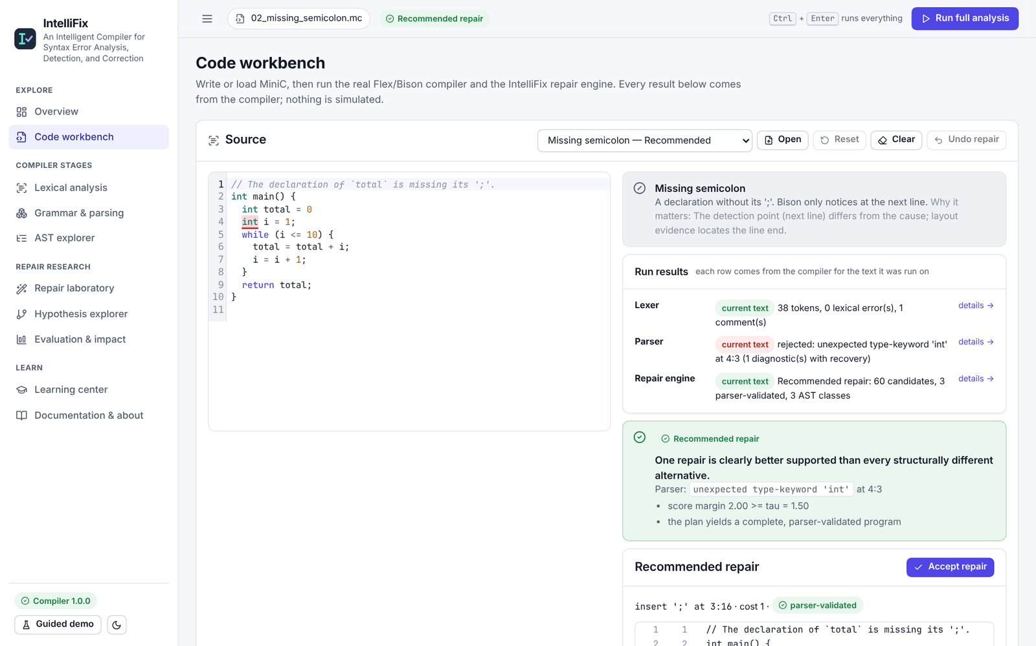
Figure 1. The IntelliFix workbench after a full analysis of a program with a missing semicolon (real output)

1.3 Problem Statement
Given a MiniC program that fails to parse, the problem is to (i) detect and report every lexical and syntax error with exact positions, (ii) find candidate corrections that a real parser accepts, (iii) rank them by how likely they are to match the programmer's intent, and (iv) decide whether the evidence is strong enough to recommend one, reporting the alternatives or the reason for abstaining otherwise. The solution must be inspectable, deterministic and measurable on held-out data.

1.4 Objectives
- Implement a complete MiniC front end with Flex and Bison that reports lexical and syntax errors with exact positions and the exact set of expected tokens.
- Implement a bounded repair engine whose every suggested repair is validated by the real parser and by a source round trip.
- Rank candidate repairs with interpretable, named evidence instead of edit cost alone, and group repairs that produce the same syntax tree.
- Handle several errors in one program and report how stable later diagnostics are under different first repairs.
- Recommend a repair only when the evidence clearly favours it, with explicit statuses for every other situation.
- Provide a web workbench that shows every stage with real compiler output, and an evaluation with baselines, ablations and confidence intervals.

1.5 Scope
IntelliFix covers lexical analysis, syntax analysis, abstract syntax trees, name and scope resolution (used only as repair evidence) and syntax repair for MiniC. Semantic analysis such as type checking, code generation and execution are out of scope. C constructs that MiniC omits (for example ++, compound assignment, switch, strings and the preprocessor) are recognised and reported as unsupported rather than repaired. The evaluation uses synthetic mutations; no claim is made about real student programs.

1.6 Organisation of the Report
Chapter 2 surveys related work. Chapter 3 states the requirements and defines MiniC. Chapter 4 presents the system design and Chapter 5 the implementation. Chapter 6 describes testing, Chapter 7 the evaluation results and their discussion, and Chapter 8 concludes. Appendix A gives commands to reproduce every result.

2. LITERATURE SURVEY

2.1 Panic-Mode Recovery
Panic-mode recovery discards input until a synchronising token such as ';' or '}' and then resumes parsing [1]. Bison supports it through the special error token in grammar rules [6]. It is simple and finds later errors, but it frequently reports spurious diagnostics caused by the recovery itself, and it never proposes a correction.

2.2 Minimum-Distance Correction
Aho and Peterson described an error-correcting parser that finds a valid string at minimum edit distance from the input, using insertions, deletions and substitutions [2]. Minimum distance gives a principled cost model, but the cheapest correction is not necessarily the intended one, and many corrections often share the minimum cost.

2.3 Local Repair in LR Parsers
Burke and Fisher proposed a practical method for LR and LL parsers that tries bounded edits close to the error and accepts those after which parsing can continue for a number of tokens [3]. Corchuelo et al. described an insertion, deletion and shift search at the error point for LR parsers [4]. IntelliFix inherits the local-repair idea and its progress criterion from this line of work.

2.4 CPCT+
Diekmann and Tratt presented CPCT+, which computes the complete set of minimum-cost repair sequences at each error location and is implemented in the grmtools Rust library [5], [15]. Reporting all minimum-cost repairs reduces cascading errors and is designed for error recovery. When a single repair must be applied, CPCT+ chooses among equal-cost sequences without further evidence.

2.5 Exact Expected Tokens and Error Diagnosis
LALR(1) parsers use default reductions and merged states, which can make the list of expected tokens at an error inaccurate. Bison's lookahead correction (LAC) checks the lookahead before performing default reductions, so the expected-token set reported at an error is exact [6]. Pottier studied reachability and error diagnosis in LR(1) automata, enumerating error states and inputs that reach them [7].

2.6 Learned Repair
DeepFix used a sequence-to-sequence neural network to fix common C errors iteratively, checking each fix with the compiler [8]. Seq2Parse combined a neural model that selects error-correction rules with a symbolic error-correcting parser [9]. Learned approaches need large corpora of real errors, which were not available for this project.

2.7 Selective Prediction
Selective classification allows a model to abstain when it is unsure and evaluates the trade-off with risk–coverage curves [10], [11]. IntelliFix applies the same idea to repair: it recommends only when a margin exceeds a threshold chosen on development data, and its evaluation reports coverage, selective risk and the area under the risk–coverage curve.

2.8 Summary and Research Gap
Table 1. Summary of related approaches
Approach | Strength | Limitation addressed by IntelliFix
Panic mode [1], [6] | simple; finds later errors | spurious diagnostics; no correction
Minimum distance [2] | principled edit cost | cheapest is not always intended; ties
Local LR repair [3], [4] | bounded, practical, near the error | one candidate chosen by cost; no confidence
CPCT+ [5] | all minimum-cost repairs; fewer cascades | arbitrary choice among equal-cost repairs; no abstention
Learned repair [8], [9] | learns typical fixes | needs large real-error corpora; less inspectable
Selective prediction [10], [11] | principled abstention | not previously combined with this repair pipeline in our setting

None of the surveyed parser-based approaches combines layout and name evidence with structural grouping and an explicit abstention policy, evaluated with ablations on held-out data. IntelliFix does not introduce a new algorithm. It integrates and evaluates these known ideas in one inspectable pipeline.

3. SYSTEM REQUIREMENTS AND ANALYSIS

3.1 Functional Requirements
Table 2. Functional requirements
ID | Requirement | Verified by
FR1 | Tokenise MiniC with exact line, column and byte-offset spans; report lexical errors as tokens with messages | lexer unit tests; catalog L01–L16
FR2 | Parse MiniC with an LALR(1) parser; report the first error, the exact expected tokens and all panic-mode diagnostics | parser tests; catalog S01–S35
FR3 | Build an abstract syntax tree with a canonical form for valid programs | parser tests
FR4 | Generate bounded repair candidates and validate each with the parser and a source round trip | repair tests; fuzzing invariants
FR5 | Rank candidates with named evidence; group by canonical AST; repair later errors | repair tests; Repair laboratory
FR6 | Decide among seven statuses and explain the reasons | catalog; professor-style cases
FR7 | Expose all stages through an HTTP API and a web workbench; never show simulated results | API tests; UI tests; E2E
FR8 | Reproduce the evaluation from a seed with baselines, ablations and intervals | evaluation tests; audit

3.2 Non-Functional Requirements
- Correctness: every claim that a repair is valid must come from a real parse.
- Determinism: the same input gives the same output (ties are broken by cost, then generation order).
- Bounded cost: at most 30,000 parser invocations or 4 s per request; input at most 64 KB; a per-call timeout in the backend.
- Robustness: no crash on any input, including binary data and pathological nesting.
- Portability: C++17 and portable Python and JavaScript; Linux tested natively, Windows cross-compiled and tested under Wine.
- Inspectability: every stage, feature contribution and decision reason is visible.

3.3 Hardware and Software Requirements
Table 3. Software used and tested versions
Component | Tested version | Purpose
C++17 compiler (g++) | 13.3 | native compiler
CMake | 3.28 | build
GNU Bison | 3.8.2 (≥ 3.6) | parser generator
Flex | 2.6.4 | lexer generator
Python, FastAPI | 3.13 | backend, evaluation
Node.js, React, Vite | 22.x | web interface
grmtools nimbleparse (optional) | 0.15.0 | CPCT+ baseline
MinGW-w64, Wine (Windows check) | posix toolchain, Wine 9.0 | cross-compilation test

Any machine able to run these tools is sufficient; the full evaluation of 900 cases took about 30–40 seconds on 4 CPU cores.

3.4 The MiniC Language
MiniC is a C subset designed so that every feature is implemented consistently in the lexer, grammar, AST and tests. Assignment is a statement rather than an expression; this keeps the grammar LALR(1) without precedence tricks and makes =/== confusions detectable.
Table 4. MiniC: supported and unsupported features
Supported | Not supported (reported as unsupported)
int, float, char, bool, void; globals and locals; multiple declarators | pointers, structs, unions, enums, strings, double, long, qualifiers
1-D arrays with constant size; array parameters | multi-dimensional arrays; initialiser lists
functions with parameters; f(void) | prototypes without bodies
if/else, while, for (with declaration), break, continue, return | do-while, switch, goto
+ - * / %, comparisons, && || !, unary minus | ++ --, compound assignment, ?:, bitwise operators, casts

4. SYSTEM DESIGN

4.1 Architecture
IntelliFix has three components (Figure 2). The native compiler parallaxc is written in C++17 with a Flex lexer and a Bison parser; it reads source text on standard input and writes one JSON document. The FastAPI backend validates requests, enforces size limits, timeouts and concurrency limits, runs the compiler in a worker thread for every request and adds LR-state descriptions from Bison's report. The React and TypeScript web interface calls the API and displays the results. The backend never computes or simulates a result.
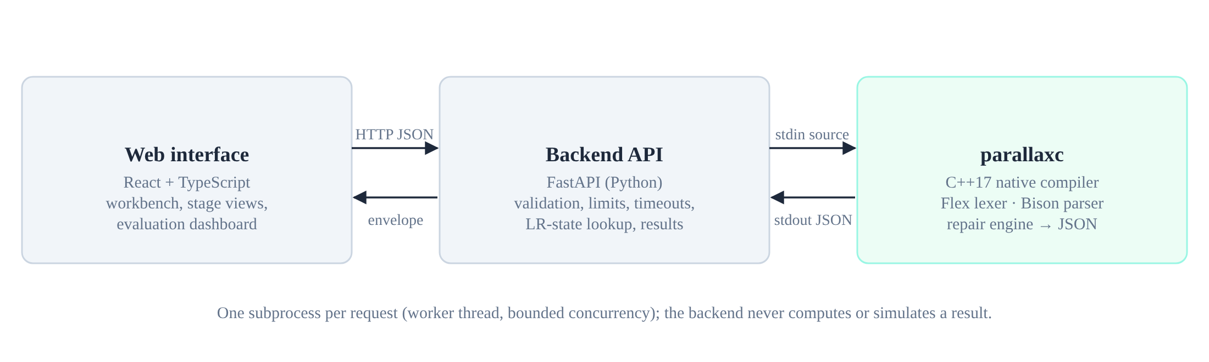
Figure 2. System architecture

4.2 Processing Pipeline
The compiler processes input in eight stages (Figure 3), each of which records its status and running time.
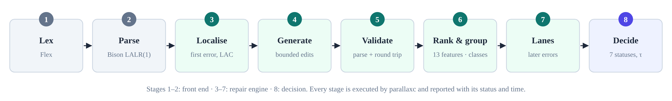
Figure 3. The IntelliFix processing pipeline

4.3 Data Design
Tokens carry a kind, the exact lexeme and a span (line, column in Unicode code points, byte offsets). Comments are kept as trivia so that repaired programs preserve them. AST nodes are stored in an arena with a kind, attributes and children; the canonical form is a string of kinds, length-prefixed attributes and children without positions, used for equality and grouping. A repair candidate holds its edits, its parser outcome, its evidence vector and its score; a decision holds the status, reasons, margin and up to three plans.

4.4 Interface Design
Table 5. Main API endpoints
Endpoint | Purpose
GET /api/health | compiler availability, version and an exact build hint when missing
POST /api/lex | tokens, comments and lexical errors
POST /api/parse | parse result, diagnostics, expected tokens, LR state, optional trace
POST /api/repair | candidates, classes, lanes and the decision (τ from the stored evaluation)
POST /api/repair/compare | structural difference between two programs
GET /api/grammar, /api/grammar/state/{n} | the grammar and one LR state from Bison's report
GET /api/evaluation/results | stored evaluation results

Errors are explicit: HTTP 413 for input over 64 KB, 422 for malformed requests, 503 when the compiler is not built, 504 on timeout and 500 for a compiler failure. In every case the interface shows the error instead of a result.

4.5 Module Design
Table 6. Modules and their responsibilities
Module (file) | Responsibility
compiler/grammar/minic.l | Flex lexer: tokens, positions, lexical and unsupported tokens
compiler/grammar/minic.y | Bison grammar: LAC, custom errors, panic-mode rules, AST actions
compiler/src/ast.cpp, names.cpp | AST, canonical form; names, scopes and arity warnings
compiler/src/repair_engine.cpp | candidate generation, validation, evidence, grouping, lanes, decision
compiler/src/repair_stream.cpp | rebuilding source text from an edited token stream
compiler/src/serialize.cpp, main.cpp | JSON output and the command-line interface
backend/app | API, compiler runner, configuration, AST diff
frontend/src | workbench and stage pages
evaluation/ | dataset generator, baselines, metrics, catalog, professor-style suite

5. IMPLEMENTATION

5.1 Lexical Analysis
The lexer is a re-entrant Flex [13] scanner (%option reentrant, nodefault, nounistd for Windows) driven by longest match. Lexical problems become ERROR tokens with messages, so scanning never aborts: invalid characters, malformed numbers such as 12abc or .5, integers above 2,147,483,647, unterminated comments or character literals, non-ASCII characters outside comments and identifiers over 255 characters. C constructs that MiniC omits are emitted as UNSUPPORTED tokens with an explanation, for example “increment/decrement operator '++' is not part of MiniC; write x = x + 1”. On Windows the compiler switches standard input and output to binary mode, so CRLF line endings keep exact byte offsets.

5.2 Syntax Analysis
The parser is a pure Bison parser with parse.error custom for precise messages, parse.lac full for exact expected tokens and %expect 0, which makes the build fail on any grammar conflict. The dangling else is resolved by precedence. Error productions on ';' and '}' provide panic-mode recovery for reporting further diagnostics. To query the exact expected set at an arbitrary position, the engine re-parses with a probe that forces an error there. The parser stack is limited to 5000 entries; deeper input is reported as a resource limit. For the program of Figure 1 the parser stops at int on line 4 in LR state 47, with 15 expected tokens.
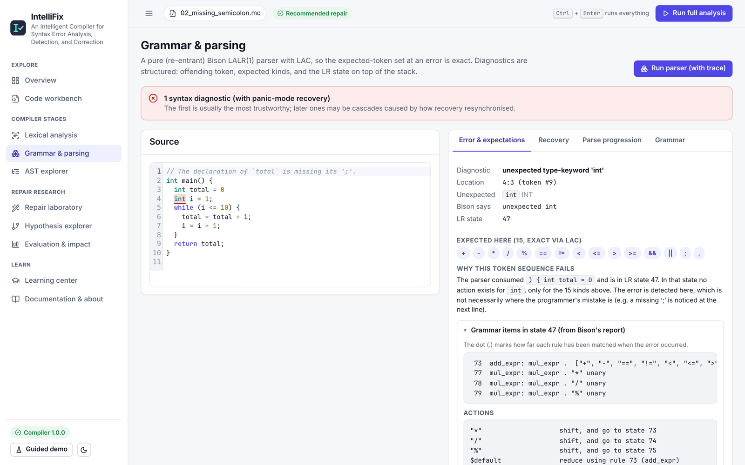
Figure 4. The Grammar & parsing view: diagnostic, exact expected tokens and LR state from Bison's report

5.3 Candidate Generation and Validation
An edit inserts, deletes or replaces one token, at cost 1, 1 and 1.5. The window generator proposes every edit allowed by the LAC expected set at the error token and the three tokens before it. Layout generators propose ';' at line ends, '{' after ')' or 'else' when the next line is indented, '}' before a dedent and deletion of a doubled delimiter. Two-edit candidates are tried only if no single edit is accepted. Each candidate is applied to a copy of the token stream and parsed. It is accepted if the program parses completely, or if the parser advances at least three tokens past the edit. Accepted candidates are turned back into text using the user's whitespace and comments, re-lexed (the tokens must match exactly) and re-parsed. For Figure 1, 60 candidates were generated and 3 accepted.

5.4 Evidence Ranking
Each accepted candidate receives score = Σ value × weight over 13 features (Table 7). The weights were set by hand on the development split and frozen before the test run. The score ranks candidates; it is not a probability.
Table 7. Evidence features and weights
Feature | Value | Weight
edit_cost | total edit cost | −1.0
resolves_all_errors | 1 if the whole program parses | +2.0
placeholder_tokens | invented identifiers or literals | −1.5
deleted_content | user names, literals or keywords removed | −0.75
distance_from_error | min(5, distance of the edit from the error) | −0.2
line_end_semicolon | ';' inserted exactly at a line break | +0.75
indentation_brace | brace inserted where indentation changes | +0.75
duplicate_deletion | deleting a doubled delimiter | +0.5
indentation_mismatch | statements or braces misaligned in the repaired AST (relative) | −0.5
name_warnings | undeclared, duplicate or arity warnings (relative) | −0.75
residual_errors | panic-mode diagnostics left (cap 6) | −0.5
cascade | 1 if the diagnostic count did not decrease | −1.0
completion | extra cost to repair later errors on this lane | −0.5 per unit

Table 8. Evidence for the three valid candidates of Figure 1 (live compiler output)
Feature | insert ';' | replace 'int' with ',' | replace 'int' with ';'
edit_cost | −1.00 | −1.50 | −1.50
resolves_all_errors | +2.00 | +2.00 | +2.00
deleted_content | 0 | −0.75 | −0.75
line_end_semicolon | +0.75 | 0 | 0
name_warnings | 0 | 0 | −3.75
other 8 features | 0 | 0 | 0
score | +1.75 | −0.25 | −4.00

5.5 AST Grouping and Hypothesis Lanes
Candidates whose repaired programs have the same canonical AST form one class. For int b = (a + 2;, inserting ')' after a or after 2 yields (a) + 2 and (a + 2), which share one AST, so they do not compete. For programs with several errors, the engine takes the top three first-error classes and, for each, repairs the next error, keeping two alternatives per step, up to depth four and twelve leaves. The best complete path is the plan. A stability report lists later error sites that appear under every explored hypothesis.
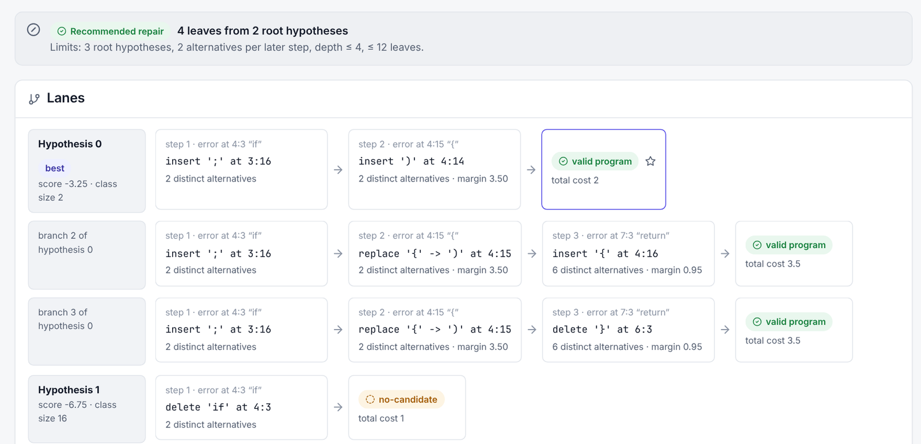
Figure 5. Hypothesis lanes for a program with two errors (real output)

5.6 Decision Policy
Table 9. Decision statuses (checked in this order)
Status | Condition
NO_REPAIR_NEEDED | the program parses
UNSUPPORTED_CONSTRUCT | the first error is a C construct MiniC omits, or the parser stack limit was reached
NO_SAFE_REPAIR / BUDGET_EXHAUSTED | no candidate is accepted (or the search budget ran out)
LOW_CONFIDENCE | no complete plan; the plan inserts a placeholder; or it discards a multi-line lexical-error token
MULTIPLE_PLAUSIBLE | margin between the best and second-best AST class below τ = 1.5
RECOMMENDED | otherwise

τ was chosen on the development split as the value in {0, 0.25, …, 4} with the largest coverage whose selective risk was at most 10% (development coverage 45.6%, risk 5.5%).

5.7 Backend and Web Interface
The backend runs parallaxc with subprocess.run in a worker thread, limited by a bounded semaphore, which works with every event loop including those used on Windows. It locates parallaxc.exe in the CMake build folder or its Release sub-folder. The web interface has a code workbench (editor, samples, Run lexer, Run parser, Repair suggestions, Full analysis, Accept and Undo) with one result row per run marked as belonging to the current or an earlier text, and pages for lexical analysis, grammar and parsing, the AST, the repair laboratory, the hypothesis explorer, evaluation results, learning material and documentation. When the compiler is missing, every row shows COMPILER_UNAVAILABLE and a banner gives the build command.
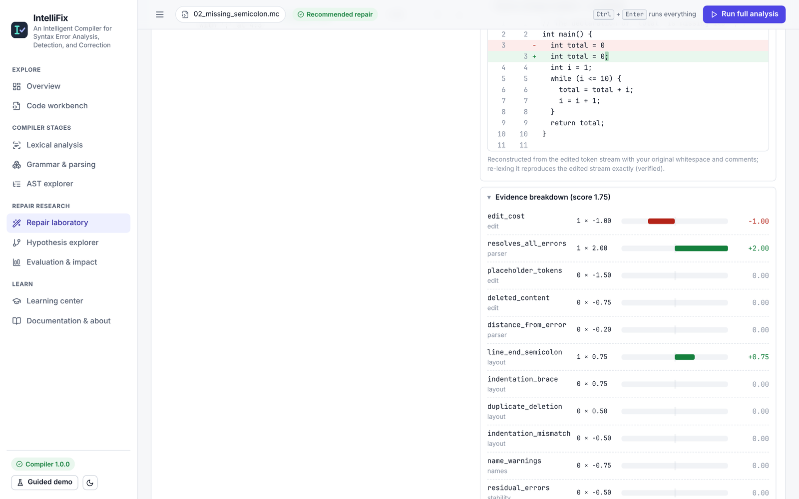
Figure 6. Repair laboratory: reconstructed diff and per-feature evidence (real output)

5.8 Portability
The C++ code avoids POSIX-only headers, CMake adds MSVC flags, and a MinGW-w64 toolchain file links the runtime statically. PowerShell scripts check prerequisites and build the system on Windows. The Windows build was cross-compiled and tested under Wine; it has not been executed on a physical Windows machine or built with MSVC.

6. TESTING

6.1 Test Strategy
Testing has five layers, all runnable with one script (scripts/test_all.sh). Tests use the real compiler; none replaces compiler output with mocks except the frontend unit tests, which check user-interface behaviour against recorded API responses.
Table 10. Test layers and results of the final run
Layer | What it checks | Result
Compiler unit tests (C++) | lexer, parser, AST, repair engine; 2 regression tests for defects found in this audit | 68 / 68
Backend API tests (pytest) | all endpoints, limits, timeouts, crashes, garbage output, Windows binary lookup, static-file safety | 33 / 33
Evaluation tests (pytest) | metrics, dataset split, 61-case error catalog, 88 professor-style cases, fuzzing, HTTP sequences | 161 / 161
Frontend unit tests (Vitest) | workbench buttons and result rows, error states, stale results, documentation links | 27 / 27
End-to-end (Playwright, Chromium) | real browser against the real backend and compiler | 12 / 12

6.2 Error Catalog
An executable catalog of 61 hand-written cases (lexical, syntax and repair) states the expected behaviour of each case and compares it with the compiler's output; all 61 cases behave as expected on Linux and, with identical output, under Wine with the Windows build.

6.3 Professor-Style Random-Input Suite
To emulate an examiner typing unfamiliar input, 88 hand-written cases across 26 categories (valid programs, missing and extra delimiters, misspelt keywords, invalid characters, C and C++ constructs, Unicode, empty input, deep nesting, very long input) state their expected lexer, parser and repair behaviour before execution. Seeded fuzzing adds 800 inputs (grammar-generated valid programs, single-token mutants, random token sequences and random characters) checked against hard invariants: no crash, ordered token spans that match the source exactly, valid programs reported as needing no repair, and every parser-valid candidate re-parsing on its own. Seven HTTP sequences test failures followed by valid requests, oversized and malformed input and concurrency.
Table 11. Professor-style suite results
Part | Executed | Passed
Hand-written cases | 88 | 88
Seeded fuzz inputs | 800 | 800
HTTP sequences | 7 | 7

6.4 Defects Found and Fixed
- Deep nesting. A valid program nested 3000 blocks deep exceeded the parser stack; the engine searched for about 3.5 s and proposed brace deletions that did not parse. It now reports the capacity limit as UNSUPPORTED_CONSTRUCT without searching.
- Unterminated comment. The engine recommended replacing an unterminated '/*' with '}', which parses but discards the code inside the comment. Such plans are now capped at LOW_CONFIDENCE.
- Windows compiler lookup. The backend looked only for build/parallaxc and missed parallaxc.exe in build\Release, so the interface reported “Compiler not built”.
- Interface. Lexer and parser results were not shown on the workbench; code ligatures rendered '<=' as '≤'; mixed-case documentation pages could not be opened.
- Evaluation harness. A variable reuse overwrote the stored τ re-threshold check with CPCT+ data; the corrected re-run records 25 of 25 identical statuses.
Two confident but unintended repairs were found and deliberately left unchanged, because re-weighting the model after seeing them would amount to tuning on test data: whlie (i < 3) { receives an inserted ';' (a call to an undeclared function), and a loop with its while deleted receives the same edit.

7. RESULTS AND DISCUSSION

7.1 Evaluation Setup
Thirty valid MiniC programs (15–35 lines each) were mutated with seed 20261024: 24 single-error and 6 two-error mutations per program, 900 cases in total. Mutations that still parsed, duplicates and draws without an eligible token were discarded. The split is by program: 12 programs (360 cases) for development and 18 programs (540 cases) for test, so near-duplicate mutations cannot leak. The evidence weights and τ were fixed on development data and the model was frozen before the first test run. Table 12 lists the systems.
Table 12. Systems compared
ID | System | Description
A | Raw parser diagnostics | first Bison error; localisation only
B | Panic-mode recovery | all diagnostics; no repair
C | Least-cost local repair | same candidates; cost-only ranking; never abstains
D | IntelliFix without AST grouping | margin between candidates
E | IntelliFix without stability evidence | no residual, cascade or completion features
F | IntelliFix without abstention | always returns the top plan
L | IntelliFix without layout evidence | no layout generators or features
P | IntelliFix (full) | τ = 1.5
G | CPCT+ (grmtools nimbleparse 0.15.0) | first repair sequence; two replicates (non-deterministic ties)

The primary metric is top-1 AST match: the first plan parses and its canonical AST equals the original program's. Coverage is the share of cases with a RECOMMENDED status; selective accuracy is the share of recommendations that are correct; the wrong-but-confident rate divides wrong recommendations by all cases. Proportions have 95% Wilson intervals [12]; differences use a paired bootstrap with 2000 resamples [14].

7.2 Main Results
Table 13. Results on the held-out test split (540 cases)
System | Top-1 AST | Top-3 | Coverage | Sel. acc. | Wrong & conf.
IntelliFix (P) | 71.5% [67.5, 75.1] | 74.8% | 50.7% | 88.0% | 6.1%
No abstention (F) | 71.5% | 74.8% | 100.0% | 71.5% | 28.5%
No stability (E) | 71.3% | 74.8% | 49.3% | 88.3% | 5.7%
No grouping (D) | 71.5% | 74.8% | 48.9% | 87.5% | 6.1%
No layout (L) | 62.6% | 64.8% | 45.2% | 79.1% | 9.4%
Least-cost (C) | 55.2% | 58.7% | 99.8% | 55.3% | 44.6%
CPCT+ (G), runs 1 / 2 | 48.0 / 48.7% | 52.4 / 51.9% | 100% | = top-1 | ≈ 1 − top-1

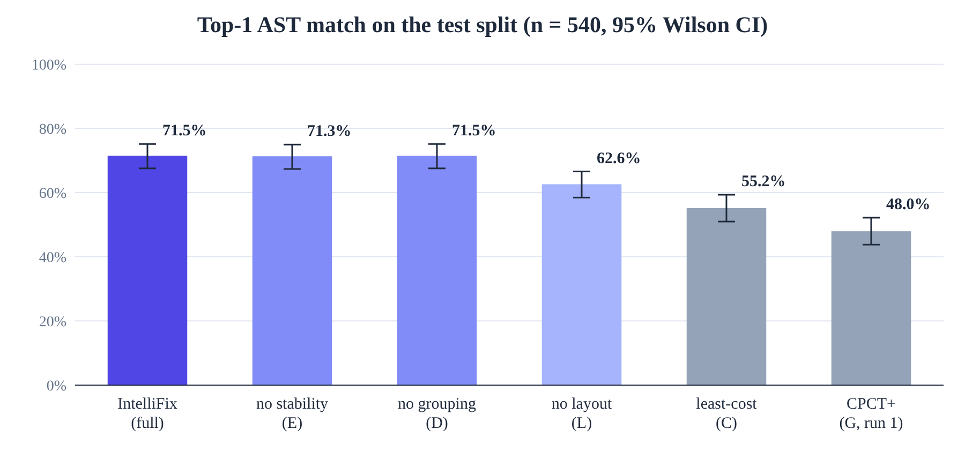
Figure 7. Top-1 AST match with 95% Wilson intervals
Evidence ranking improves top-1 over least-cost repair on the same candidates by +16.3 points (95% CI [13.1, 19.4]). Removing layout evidence costs 8.9 points (CI [6.7, 11.3]). Removing the stability evidence changes top-1 by only +0.2 points (CI [-0.4, 0.9]), so no benefit was shown. CPCT+'s first repair reached 47.4–49.1% over three full runs; its two replicates in the latest run agreed on 68.6% of cases.

7.3 Abstention
Abstention does not change the ranking, so forced top-1 (F) has the same accuracy as IntelliFix. It changes which answers are presented as confident: the wrong-but-confident rate falls from 28.5% to 6.1% (difference -22.4 points, CI [-25.9, -18.9]) at 50.7% coverage, with 88.0% selective accuracy. The selective risk of 12.0% exceeded the 10% target set on development data, so the threshold did not fully transfer. The area under the risk–coverage curve is 0.139 for IntelliFix against 0.378 for least-cost repair (Figure 9).
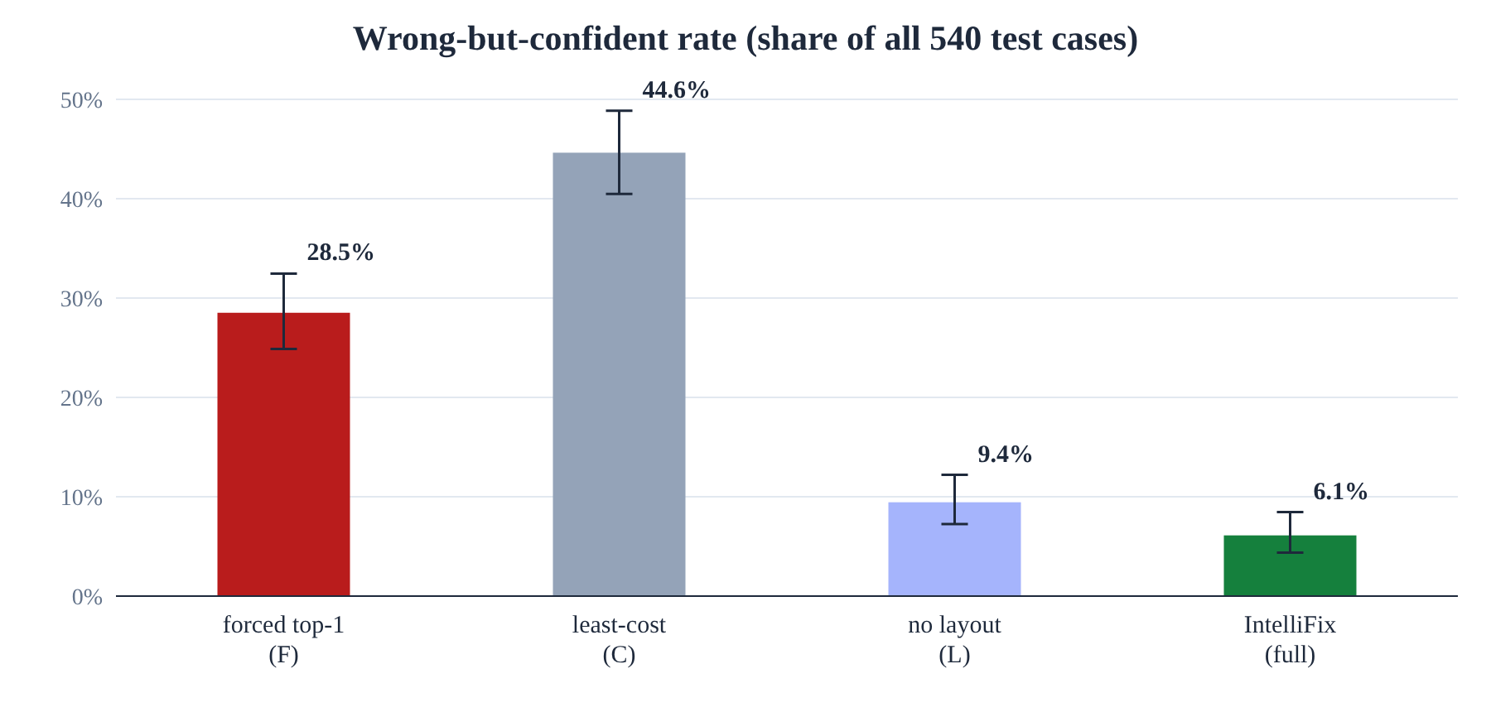
Figure 8. Wrong-but-confident rate as a share of all test cases
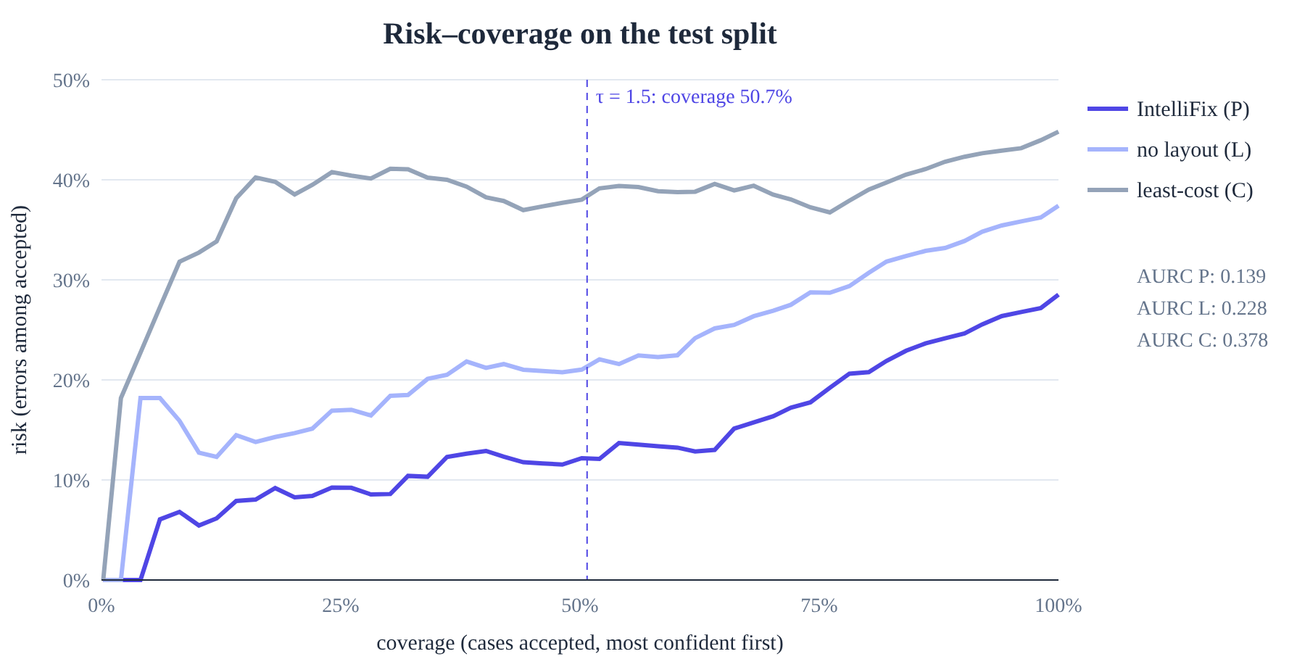
Figure 9. Risk–coverage curves on the test split

7.4 Localisation and Diagnostics
The first edit of IntelliFix's plan was at the exact mutated token in 86.7% of test cases, against 76.3% for the raw parser's detection point. Panic-mode recovery reported 3.85 diagnostics per case on average, and 61.1% of cases had at least one spurious diagnostic. The repair engine used 306 parser invocations per case on average (median 153); mean engine time was about 10–14 ms depending on machine load.

7.5 Discussion and Threats to Validity
- Synthetic errors. Single-token mutations over-represent simple slips; real novice errors include misunderstood syntax and many interacting errors.
- Small program pool. Thirty programs by one author share a consistent indentation style, which flatters the layout evidence.
- Hand-set weights. The development split was used repeatedly, so development results are optimistic; only test results are reported as estimates.
- AST match as correctness. It cannot be achieved when the mutation removed a name, and it treats a+b and b+a as different.
- Baseline fairness. CPCT+ optimises a different objective (recovery); our comparison measures only how often its first repair restores the original program.

8. CONCLUSION AND FUTURE WORK

8.1 Conclusion
IntelliFix shows that a parser-based syntax repair tool can be both more accurate and more honest than cost-only repair. On held-out synthetic cases, interpretable evidence raised top-1 recovery from 55.2% to 71.5%, layout evidence was the largest single contributor, and abstention reduced wrong confident recommendations from 28.5% to 6.1% of cases while still recommending in about half of them. Negative results are reported as well: stability evidence gave no measurable gain, grouping had a small effect, and the risk target was not met on test. Every result can be reproduced from a seed, and every stage can be inspected in the workbench using real compiler output.

8.2 Future Work
- Evaluate on real, anonymised student error snapshots collected with consent.
- Learn the evidence weights from real data and calibrate the margin to probabilities.
- Add type-aware evidence and a wider search for causes far from the detection point.
- Run IntelliFix natively on Windows (MSVC and MSYS2) and study usability with learners.

REFERENCES
[1] A. V. Aho, M. S. Lam, R. Sethi, and J. D. Ullman, Compilers: Principles, Techniques, and Tools, 2nd ed. Boston, MA, USA: Addison-Wesley, 2006.
[2] A. V. Aho and T. G. Peterson, “A minimum distance error-correcting parser for context-free languages,” SIAM J. Comput., vol. 1, no. 4, pp. 305–312, 1972, doi: 10.1137/0201022.
[3] M. G. Burke and G. A. Fisher, “A practical method for LR and LL syntactic error diagnosis and recovery,” ACM Trans. Program. Lang. Syst., vol. 9, no. 2, pp. 164–197, 1987.
[4] R. Corchuelo, J. A. Pérez, A. Ruiz-Cortés, and M. Toro, “Repairing syntax errors in LR parsers,” ACM Trans. Program. Lang. Syst., vol. 24, no. 6, pp. 698–710, 2002.
[5] L. Diekmann and L. Tratt, “Don't panic! Better, fewer, syntax errors for LR parsers,” in Proc. 34th Eur. Conf. Object-Oriented Program. (ECOOP 2020), LIPIcs, vol. 166, 2020, pp. 6:1–6:32, doi: 10.4230/LIPIcs.ECOOP.2020.6.
[6] Free Software Foundation, “LAC,” in GNU Bison Manual. [Online]. Available: https://www.gnu.org/software/bison/manual/html_node/LAC.html
[7] F. Pottier, “Reachability and error diagnosis in LR(1) automata,” in Journées Francophones des Langages Applicatifs (JFLA), 2016.
[8] R. Gupta, S. Pal, A. Kanade, and S. Shevade, “DeepFix: Fixing common C language errors by deep learning,” in Proc. AAAI Conf. Artif. Intell., vol. 31, no. 1, 2017, doi: 10.1609/aaai.v31i1.10742.
[9] G. Sakkas et al., “Seq2Parse: Neurosymbolic parse error repair,” Proc. ACM Program. Lang., vol. 6, no. OOPSLA2, 2022, doi: 10.1145/3563330.
[10] R. El-Yaniv and Y. Wiener, “On the foundations of noise-free selective classification,” J. Mach. Learn. Res., vol. 11, pp. 1605–1641, 2010.
[11] Y. Geifman and R. El-Yaniv, “Selective classification for deep neural networks,” in Adv. Neural Inf. Process. Syst. (NeurIPS), 2017, arXiv: 1705.08500.
[12] E. B. Wilson, “Probable inference, the law of succession, and statistical inference,” J. Amer. Statist. Assoc., vol. 22, no. 158, pp. 209–212, 1927.
[13] The Flex Project, “flex: The fast lexical analyzer.” [Online]. Available: https://github.com/westes/flex
[14] B. Efron and R. J. Tibshirani, An Introduction to the Bootstrap. New York, NY, USA: Chapman & Hall, 1993.
[15] softdevteam, “grmtools: Rust grammar tools (lrpar, nimbleparse),” GitHub repository. [Online]. Available: https://github.com/softdevteam/grmtools

APPENDIX A: REPRODUCING THE RESULTS

A.1 Build and Run
cd parallax
cmake -S compiler -B compiler/build -DCMAKE_BUILD_TYPE=Release
cmake --build compiler/build -j
python3 -m pip install -r backend/requirements.txt
(cd frontend && npm ci && npm run build)
./scripts/run_backend.sh # then open http://127.0.0.1:8000
On Windows, install MSYS2 MinGW-w64 or Visual Studio Build Tools with the “Desktop development with C++” workload and win_flex/win_bison, then run scripts\windows\build.ps1 and scripts\windows\run_backend.ps1 (written but not executed by the authors).

A.2 Tests and Evaluation
# all test layers (add PARALLAX_E2E=1 with the backend running for the browser tests)
./scripts/test_all.sh
# regenerate the dataset and run every system
./scripts/run_evaluation.sh
# 61-case error catalog and professor-style suite
python3 -m evaluation.catalog.catalog
python3 -m evaluation.professor.run_professor_tests

A.3 Sample Compiler Output
Excerpt of parallaxc repair --tau 1.5 for the program of Figure 1 (abridged):
{
"parse": {
"ok": false,
"first_error": {
"message": "unexpected type-keyword 'int'",
"at": "4:3",
"parser_state": 47
}
},
"repair": {
"counts": {
"generated": 60,
"accepted": 3,
"classes": 3
},
"decision": {
"status": "RECOMMENDED",
"margin": 2,
"reasons": [
"score margin 2.00 >= tau = 1.50",
"the plan yields a complete, parser-validated program"
],
"plan": "insert ';' at 3:16"
}
}
}

