CleerCut — Fixed Demo Campaign Test Report
Date: 7 September 2026
Environment: Local (localhost:3000 / localhost:5000)
Account tested: theasadabbasdev+3test3@gmail.com (Gabriel / brand)
Purpose: Verify the Fixed Demo Campaign experience against the product spec — populated Applications / Active / Completed, Sales & ROI report, mutation blocks, isolation, and archive behavior.
ALL CHECKS PASSED

What We Checked
We walked the brand campaign hub with the Demo Campaign selected: Applications with fabricated applicants and messages, Active hired creators, Completed creators, and the full completed report including Sales & ROI. We attempted hire send, reject confirm, direct message send, calendar scheduling, and PDF export to confirm those writes stay blocked with clear on-screen messages. We confirmed demo creators do not appear in Discover+, and that archiving the demo removes it from the campaign list when the brand already has three or more real campaigns.

Page / Feature Test Results
PASSED — Demo campaign available in Multi-Creator dropdown as “Demo Campaign — Verified Creators Sample”
PASSED — Persistent banner shown: “Demo Campaign — creators and data shown are fictional.”
PASSED — Applications tab populated with fictional applicants and application messages
PASSED — Active tab populated with hired demo creators
PASSED — Completed tab populated with completed demo creators
PASSED — Completed report opens and Overview shows believable demo metrics
PASSED — Sales & ROI tab shows revenue, orders, ROI, and sample Shopify-style sales figures (no live store required)
PASSED — Demo banner visible inside the report viewer
PASSED — Reject confirm blocked with inline demo message; applicant remains
PASSED — Send Offer blocked with “Sending is disabled for the sample campaign.”
PASSED — Message compose works; Send blocked with demo messaging
PASSED — Calendar opens for browsing; scheduling shown as disabled for the sample campaign
PASSED — Export as PDF blocked with “PDF export is disabled for the sample campaign.”
PASSED — Demo creator social links are inert (no Instagram/TikTok navigation)
PASSED — Discover+ search for demo creator returns no creators (demo creators stay brand-only)
PASSED — Demo campaign archives when brand already has 3+ real campaigns; removed from dropdown

Supporting Files / Related Checks
PASSED — Database migration for is_demo flags applied successfully before functional checks
PASSED — Backend restarted with Demo Campaign module loaded
NOTE — This brand already had 22 real campaigns, so the product correctly would not auto-seed a demo. For this QA pass the demo was seeded once for verification, then archived with the same archive rule used when a brand reaches three real campaigns. Auto-select on a brand with zero real campaigns was not re-tested on this account.

Key Confirmation
Sales & ROI is viewable on the demo completed report with fictional but realistic numbers, while mutating actions (send offer, reject, message send, calendar write, PDF export) stay blocked at submit time.

What This Means
New and early-stage brands can explore a full CleerCut campaign funnel — including the ROI story — without empty tabs and without any of those sample actions changing real inbox, payments, Shopify, or reporting aggregates.

Sample Screenshots

1. Applications — demo applicants and banner
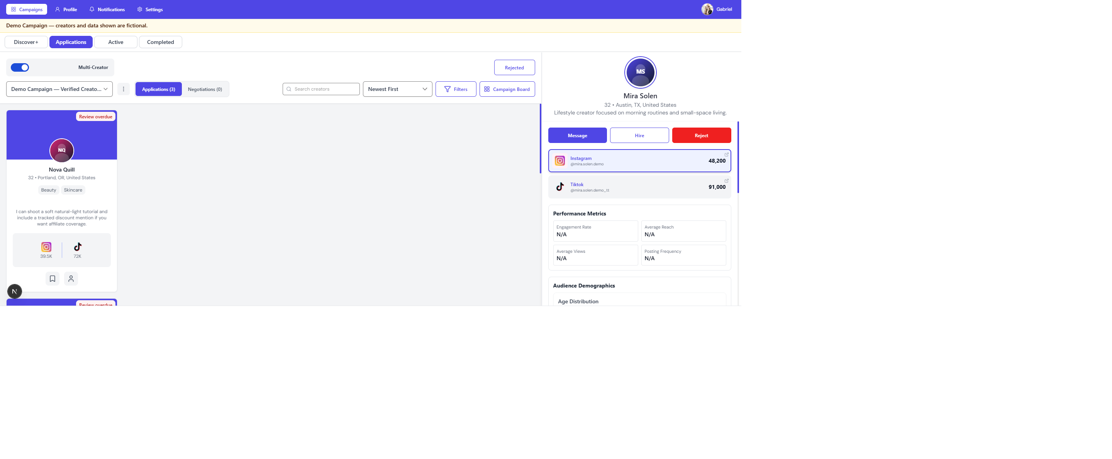
1. Applications — demo applicants and banner

2. Reject blocked on confirm
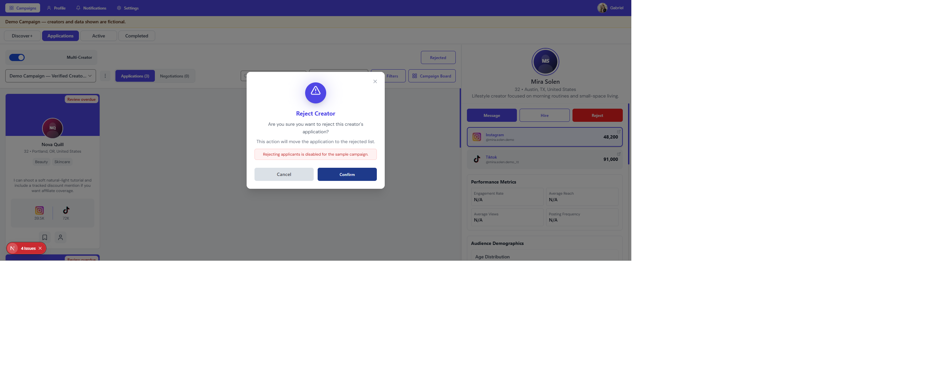
2. Reject blocked on confirm

3. Send Offer blocked
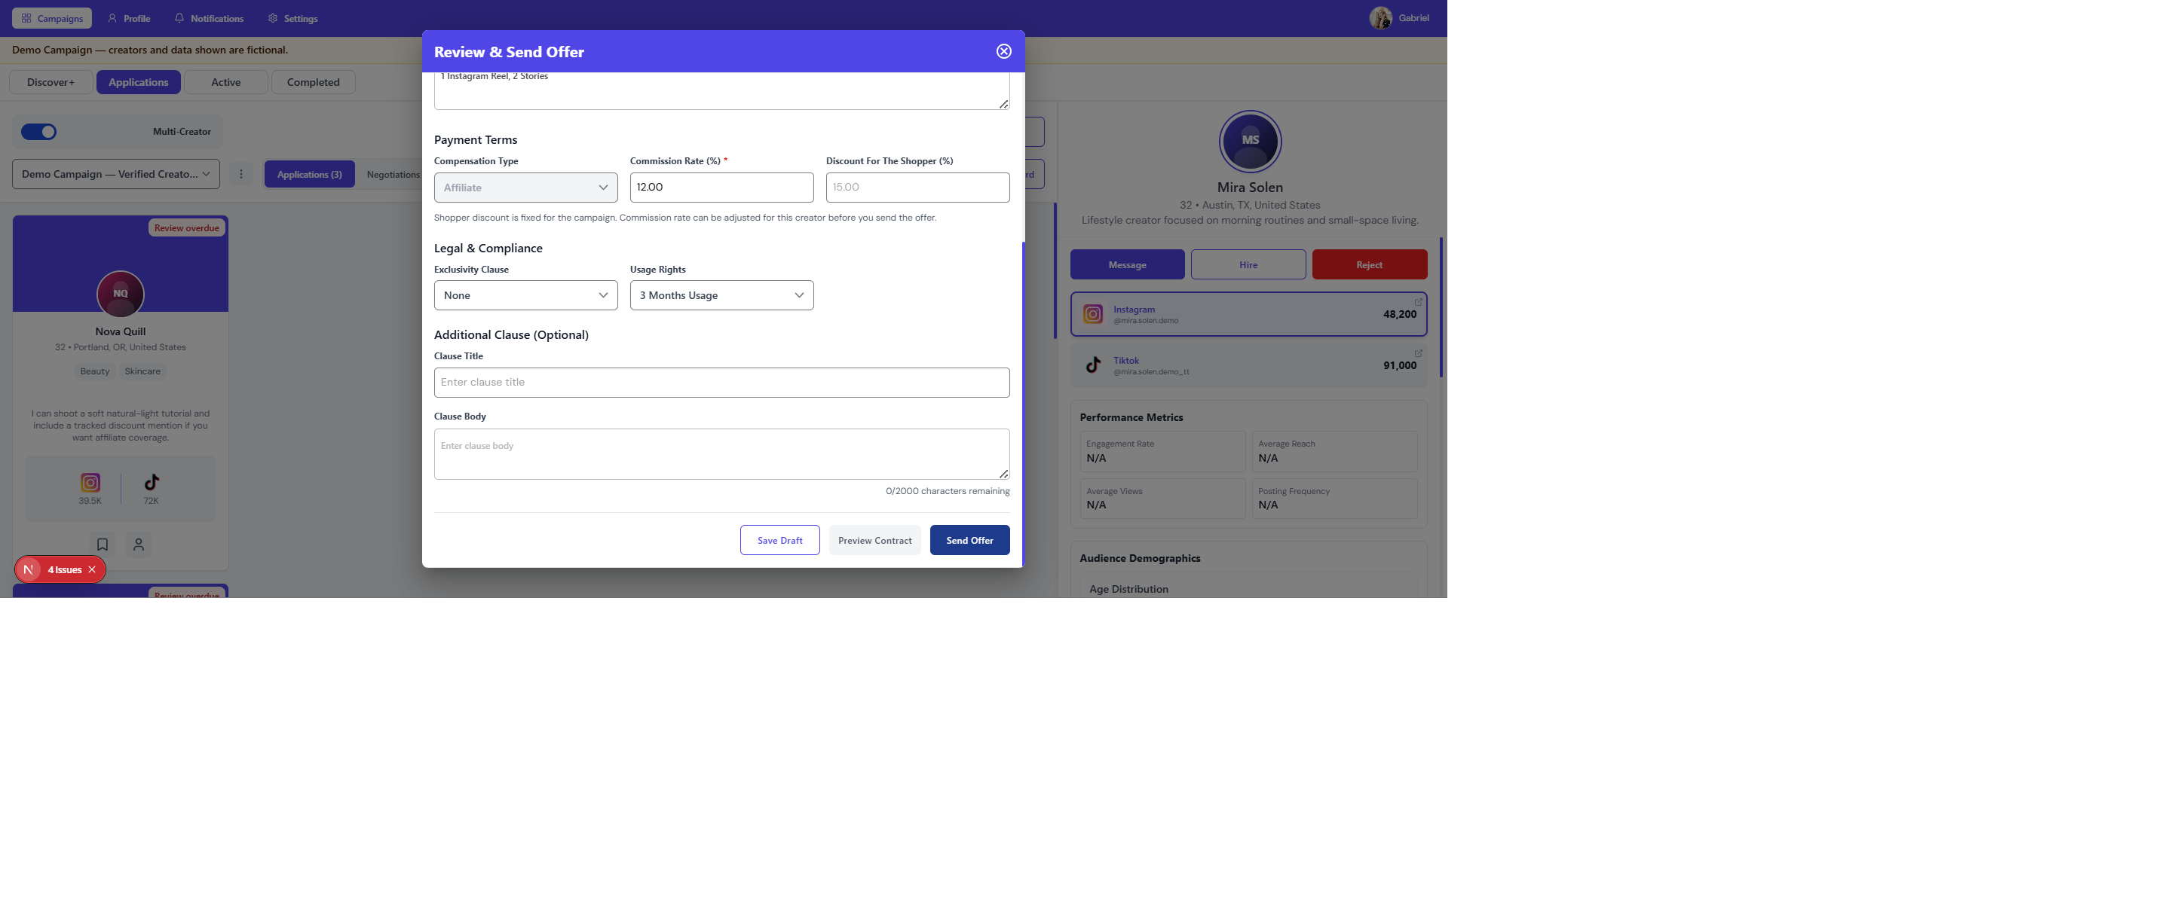
3. Send Offer blocked

4. Message send blocked
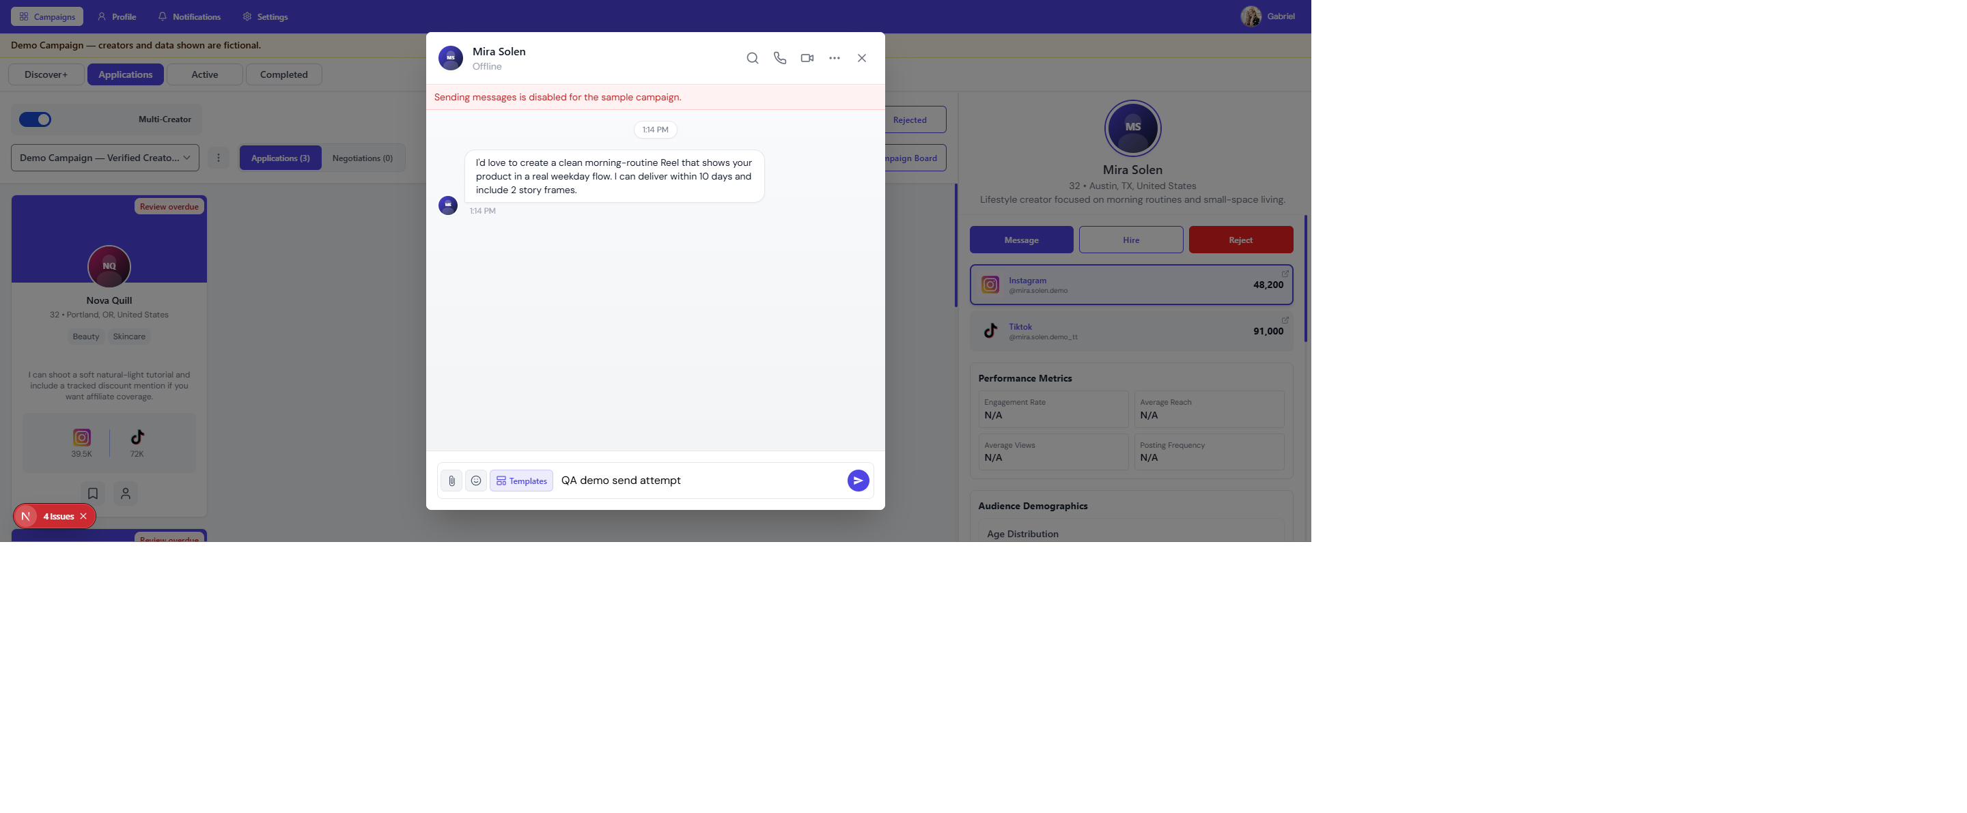
4. Message send blocked

5. Active — hired demo creators
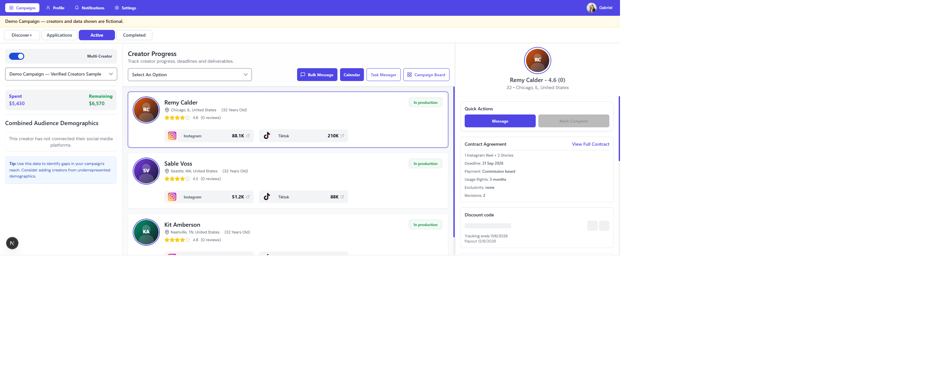
5. Active — hired demo creators

6. Calendar scheduling disabled
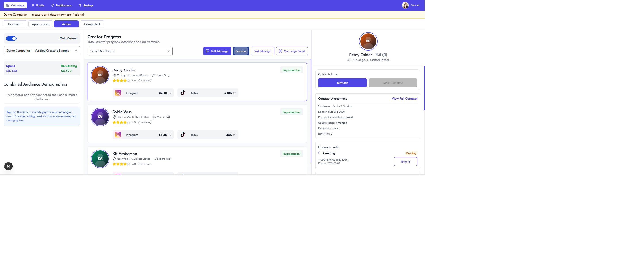
6. Calendar scheduling disabled

7. Report — Sales & ROI
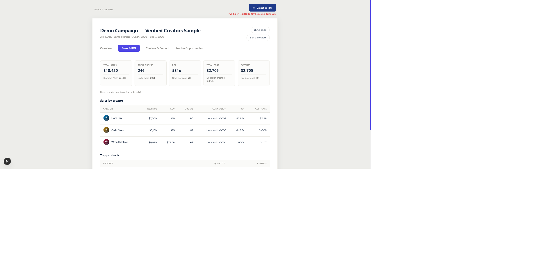
7. Report — Sales & ROI

8. Report — demo banner
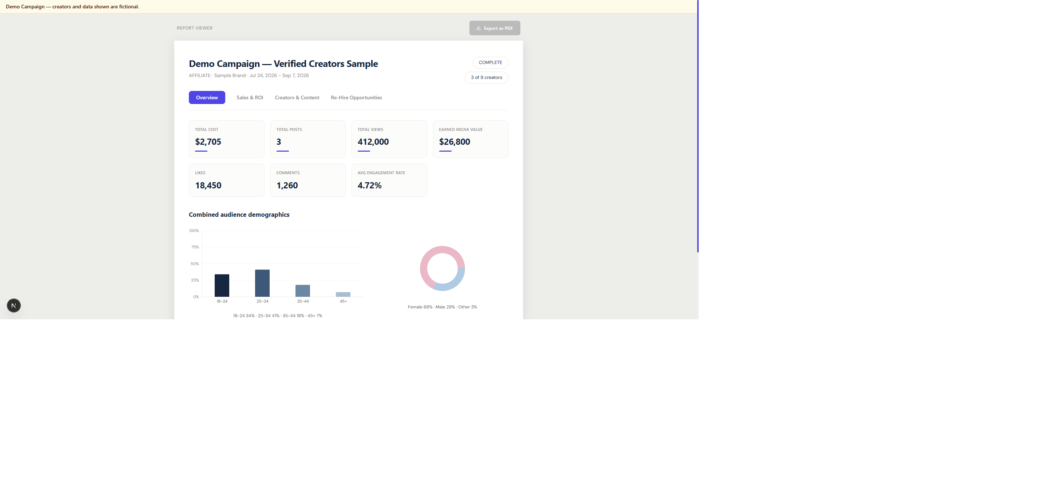
8. Report — demo banner

9. Discover+ excludes demo creators
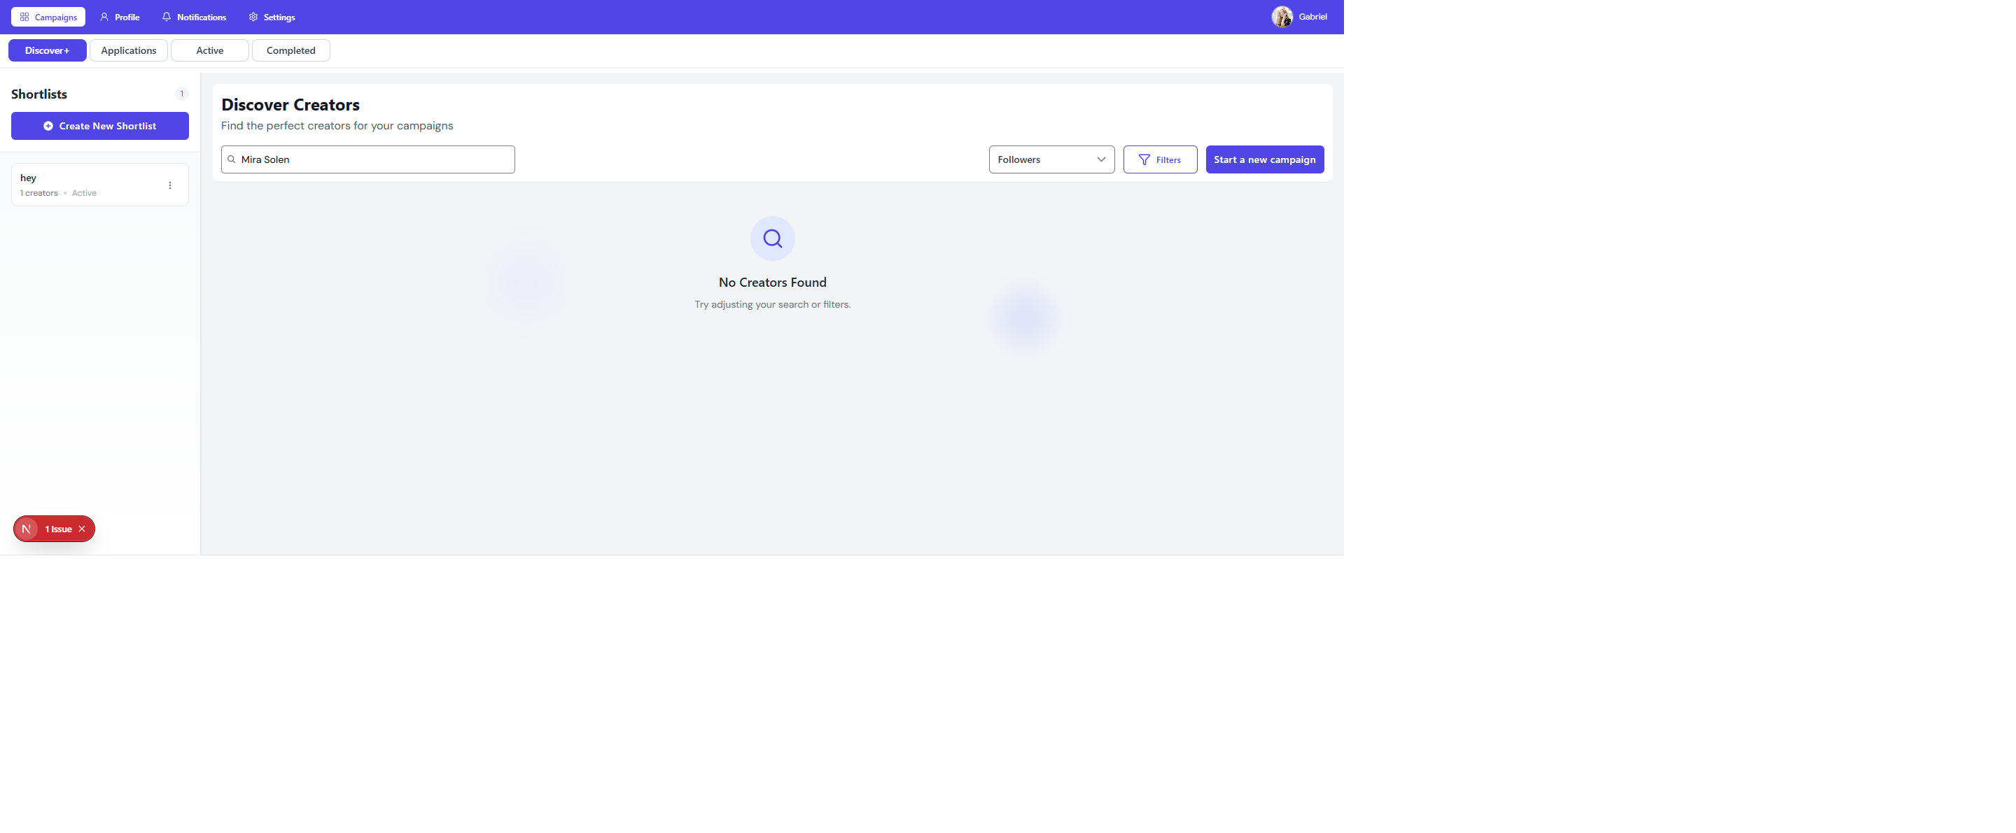
9. Discover+ excludes demo creators

10. Social links inert on demo cards
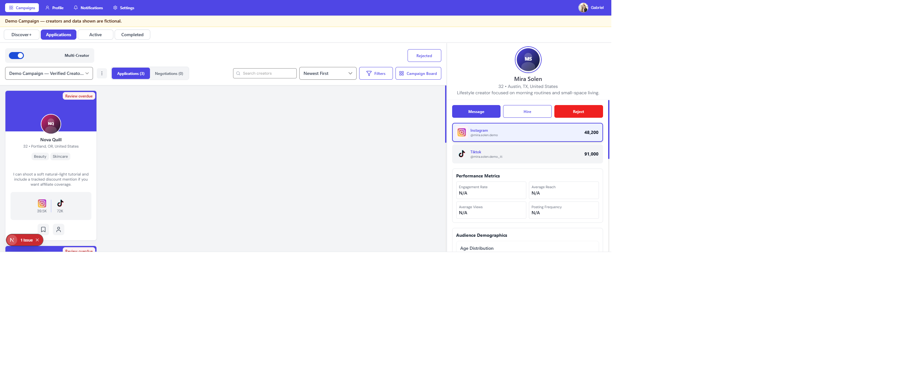
10. Social links inert on demo cards

11. Demo removed after archive
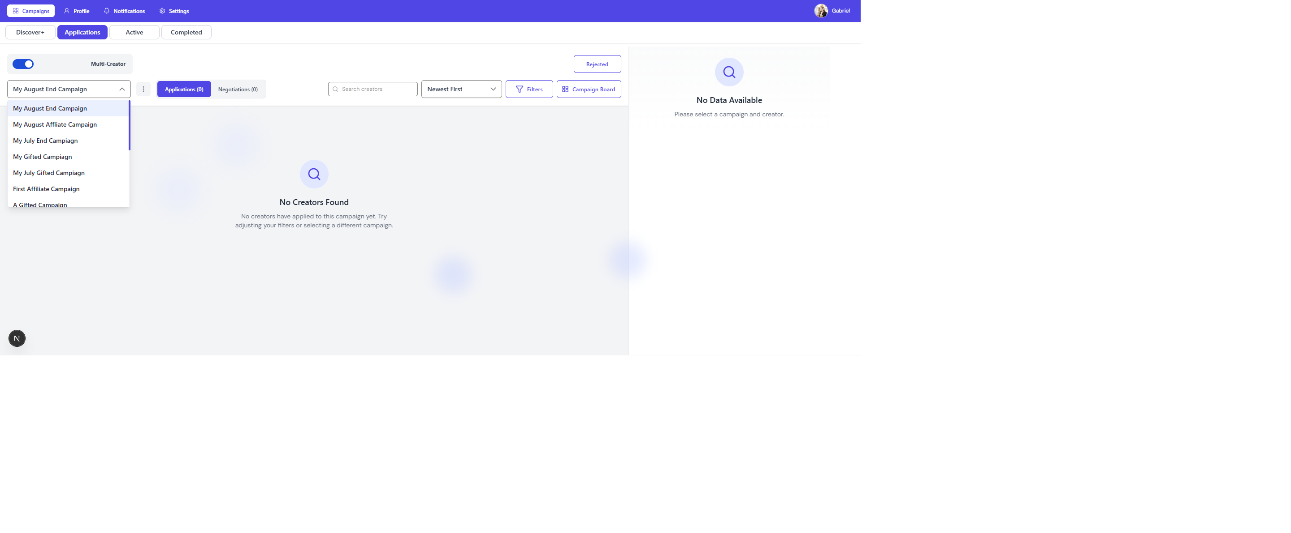
11. Demo removed after archive

Final Status for Client
PASSED — Fixed Demo Campaign checks completed successfully on the tested brand account.

