**DESIGN AND ANALYSIS OF MICROWAVE COMPONENTS USING AI**

A report submitted in partial fulfillment of the requirements for

the award of the degree of

**Bachelor of Technology**

in

**Department of Electronics and Communication Engineering**

by

**Madhusudhanan K (EC20B1025)**

**Mufeed M (EC20B1030)**

**Vadivazhagi S (EC19B1056)**



**DEPARTMENT OF**

**ELECTRONICS AND COMMUNICATION ENGINEERING NATIONAL INSTITUTE OF TECHNOLOGY PUDUCHERRY**

**KARAIKAL – 609 609**

**NOVEMBER 2023**

**BONAFIDE CERTIFICATE**

This is to certify that the project work entitled “Design and Analysis of Microwave Components using AI”is a bonafide record of the work done by

**Madhusudhanan K (EC20B1025)**

**Mufeed M (EC20B1030)**

**Vadivazhagi S (EC19B1056)**

in partial fulfillment of the requirements for the award of the degree of **Bachelor of Technology** in **Electronics and Communication Engineering** of the **NATIONAL INSTITUTE OF TECHNOLOGY PUDUCHERRY** during the year 2023 - 2024.

**Dr. Boopathi Rani R Dr. Harigovindan V P**

Assistant Professor Head of the Department

Project Guide

Project viva-voce held on 08-11-2023

**Internal Examiner External Examiner**

**ABSTRACT**

**ACKNOWLEDGEMENTS**

We would like to express our deep sense of gratitude to the Lord Almighty for giving us an opportunity to do this project and showering his blessing in the due course of the project.

Dr. Usha Natesan, Director In-Charge

Dr. Sundaravarathan S, Registrar-dean

Dr. Suresh Balanethiram, Assistant Professor, Project Co-ordinator, ECE

Dr. Harigovindan VP, HoD, ECE

Dr. Boopathi Rani R, Assistant Professor, Project Guide, ECE

Last but not the least, we thank our families and friends whose support and suggestions helped us mould this project.

**TABLE OF CONTENTS**

|  |  |  |
| --- | --- | --- |
| **CHAPTER NO** | **TITLE** | **PAGE NO** |
|  | ABSTRACT  ACKNOWLEDGEMENT  TABLE OF CONTENTS  LIST OF TABLES  LIST OF FIGURES  LIST OF SYMBOLS AND ABBREVIATIONS | i  ii  iii  v  vi  viii |
| 1 | INTRODUCTION   * 1. General Introduction   2. Objectives of the thesis   3. Organization of the thesis | 1  2  2 |
| 2 | LITERATURE REVIEW  2.1 Level Process  2.2 Blood Glucose Regulation in Type I Diabetics  2.3 Biochemical Reactor | 3  3  4 |
| 3 | FRACTIONAL PI  3.1 General Introduction  3.2 FO PI Controller practical tuning rules  3.3 Need for FOC  3.4 Implementation of Fractional Order Transfer Function (FOTF) using MATLAB  3.5 Analysis of FOTF-Objects  3.6 Conclusion | 5  6  7  8  11  14 |
| 4 | CASE STUDY 1: LEVEL PROCESS  4.1 General Introduction  4.2 Mathematical modeling of the system  4.3 Identification of system parameters  4.4 Controller tuning  4.4.1 Open loop oscillation based tuning  4.4.2 Ziegler Nichols open loop method  4.5 Simulation studies  4.6 Performance Indices  4.7 FO-PI Controller  4.8 Conclusion | 15  15  16  16  16  17  18  20  20  22 |
| 5 | CASE STUDY 2: BLOOD GLUCOSE LEVEL REGULATION  5.1 General Introduction  5.2 Problem formulation  5.3 Blood glucose model  5.4 Design of controller  5.5 Simulation Studies  5.6 Conclusion | 23  23  24  26  28  30 |
| 6 | CASE STUDY 3: BIOCHEMICAL REACTOR  6.1 General Introduction  6.2 Process description  6.3 Modeling of the process  6.4 Controller design  6.5 Simulation studies  6.6 Performance Indices  6.7 Conclusion | 31  32  33  35  35  37  38 |
| 7 | CONCLUSION  7.1 Summary  7.2 Conclusion  7.3 Directions for future work | 39  40  40 |
|  | REFERENCES | 41 |

**LIST OF TABLES**

|  |  |  |
| --- | --- | --- |
| **Table No** | **Title** | **Page No** |
| 4.1 | Ziegler Nichols open loop tuning parameters | 17 |
| 4.2 | Performance Indices- PI v/s PID | 20 |
| 5.1 | Performance Indices PID v/s FO-PI | 29 |
| 6.1 | Nominal process parameters of biochemical reactor | 33 |
| 6.2 | Variation of Settling Time with α | 37 |
| 6.3 | Performance Indices PI v/s FO-PI | 37 |

**LIST OF FIGURES**

|  |  |  |
| --- | --- | --- |
| **Figure No.** | **Title** | **Page No** |
| 3.1 | Closed loop system | 5 |
| 3.2 | Stability region for FOC | 8 |
| 3.3 | Pole Positions | 12 |
| 3.4 | Step response | 13 |
| 3.5 | Step response validations | 13 |
| 3.6 | Bode and Nyquist plot | 14 |
| 4.1 | System model of water level control in a tank | 16 |
| 4.2 | Simulink model of PI Controller for set point tracking | 18 |
| 4.3 | Servo Response of level process for PI and PID | 19 |
| 4.4 | Simulink model of PI Controller for disturbance rejection | 19 |
| 4.5 | Regulatory Response of level process for PI and PID | 20 |
| 4.6 | Simulink model of FOPI Controller for set point tracking | 21 |
| 4.7 | Servo Response of level process for FO-PI | 21 |
| 4.8 | Simulink model of FOPI Controller for disturbance rejection | 22 |
| 4.9 | Regulatory Response for level process for FO-PI | 22 |
| 5.1 | Block diagram of feedback control system | 24 |
| 5.2 | Schematic representations of compartments to model the glucose and insulin | 24 |
| 5.3 | Responses of some patient models to a step change in insulin to 0 mU/min | 25 |
| 5.4 | Response of patient model with step change in insulin from its nominal | 26 |
| 5.5 | Simulink model for blood glucose level regulation in a Type I diabetic patient | 27 |
| 5.6 | Subsystem | 27 |
| 5.7 | Servo response of patient model | 28 |
| 5.8 | Regulatory response of patient model | 29 |
| 6.1 | Instrumentation diagram for a Bioreactor | 31 |
| 6.2 | Effect of the dilution rate on the productivity | 34 |
| 6.3 | Open loop for ±10% change in dilution rate | 34 |
| 6.4 | Simulink block diagram of Biochemical Reactor | 35 |
| 6.5 | Subsystem of Biochemical Reactor | 36 |
| 6.6 | Servo response of Biomass Concentration | 36 |
| 6.7 | Servo response of Dilution Rate | 37 |

**LIST OF SYMBOLS**

K – Process Gain

τ – Time Constant

θ – Time Delay

Kp – Proportional Gain

Ki – Integral Gain

Kd – Derivative Gain

**LIST OF ABBREVIATIONS**

IO – Integer Order

IOC – Integer Order Controller

FO – Fractional order

FOC – Fractional Order Controller

P – Proportional

PI – Proportional Integral

PID – Proportional Integral Derivative

FO-PI – Fractional Order Proportional Integral

FO-PID - Fractional Order Proportional Integral Derivative

ISE – Integral Square Error

IAE – Integral Absolute value Error

SISO – Single Input Single Output

**CHAPTER 1**

**INTRODUCTION**

* 1. **GENERAL INTRODUCTION**

The realm of electrical and electronic engineering, microstrip lines play a pivotal role as fundamental components of high-frequency circuits. These miniature transmission lines are widely employed for their simplicity, cost-effectiveness, and versatility. A microstrip line typically consists of a thin conductor trace positioned on a dielectric substrate and a ground plane. This structure supports the propagation of electromagnetic waves and has been a cornerstone in various applications, including antennas, filters, and interconnects. Despite the widespread use of microstrip lines, certain challenges persist when it comes to predicting and optimizing their electrical performance. Traditionally, engineers have relied on mathematical manipulations and formulas to calculate parameters like the s-parameters. However, these calculations are often based on idealized assumptions, and they may not accurately represent real-world scenarios. Communication engineers often find themselves in a perplexing situation. They possess real-world electrical response data from microstrip lines, and they seek to infer crucial physical parameters like dielectric constant, trace width, and substrate thickness. Unfortunately, a direct, closed-form mathematical equation to achieve this does not exist. This disparity between empirical data and physical parameters presents a formidable challenge in microstrip line design and analysis. Enter the realm of artificial intelligence and machine learning (AI/ML). To bridge the gap between data and physical parameters, machine learning offers a promising solution. By harnessing the power of neural networks, we can model complex relationships between input data and the sought-after parameters. AI/ML enables us to decipher the intricate patterns and nuances that evade conventional mathematical expressions. While it may appear that applying machine learning techniques should make this task straightforward, the reality is more intricate. The challenge stems from the inherent difficulty of establishing a one-to-one mapping between the characteristics of microstrip lines and their electrical responses. Building an effective neural network model necessitates careful selection of hyperparameters and an understanding of the underlying complexities involved in microstrip line behavior.

* 1. **OBJECTIVES OF THE THESIS**

**In this project, we embark on a journey to explore the potential of AI/ML in the design and analysis of microstrip lines. We aim to tackle the "one-to-one mapping" issue and harness the capabilities of advanced neural networks to unlock the secrets hidden within the electrical responses of microstrip lines. Through this endeavor, we endeavor to offer insights and methodologies that can enhance the accuracy and efficiency of microstrip line design and analysis.**

**CHAPTER 2**

**LITERATURE REVIEW**

**2 LITERATURE REVIEW**

In the realm of microwave engineering, the challenge of inverse modelling has long perplexed researchers. Inverse modelling entails extracting physical or geometrical parameters from electrical responses, while forward modelling predicts electrical parameters from physical inputs. Bridging this gap lies the potential of artificial intelligence and neural networks.

A foundational paper by Feng et al. [1] outlines the state of the art in microwave computer-aided design, showcasing the immense promise of neural networks. It leads us to explore three pivotal neural network-based techniques:

* The **Derivative-Based Training Method**: leverages derivatives to categorize data, creating sub models to handle contradictory output values.
* The **Multivalued Neural Network Inverse Modelling Technique*:*** introduces the concept of multiple parameters sets for a single set of electrical parameters, solving non-uniqueness.
* **Invertible Neural Nets**: consisting of reversible blocks, excel in bidirectional training and efficiently resolve non-uniqueness.

Shifting the focus to Frequency Selective Surfaces (FSS), these structures play a crucial role in electromagnetic applications. Traditionally, FSS design relied on analytical and numerical methods, but they struggled with complex structures and electrical parameters. This led to the integration of neural networks and generative models. Various papers, including works by Kabir et al. [3], Wu et al. [4], and Zhang et al. [2], underscore the potential of neural networks in unraveling intricate relationships in FSS design. However, their effectiveness hinges on data quality and network architecture.

In parallel, generative models, notably Generative Adversarial Networks (GANs), have emerged as potent tools for addressing the one-to-one mapping challenge. Papers by Gu et al. [1] and Zhou et al. [6] showcase their capability in generating FSS designs that meet electromagnetic specifications, offering a promising solution for efficient design exploration.

In summation, the integration of Generative Networks and Deep Neural Networks for FSS design marks a transformative era in overcoming challenges of inverse modelling and parameter mapping. This literature review forms the foundation of our research, aiming to harness generative models and neural networks for a future where electromagnetic design complexities are conquered with innovation and accuracy.

**CHAPTER 3**

**STAGE 1 : DESIGN AND ANALYSIS OF MICROSTRIP LINE**

**3.1 INTRODUCTION**

A microstrip line is a transmission line used in microwave and high-frequency circuits. It consists of a thin conductor on the surface of a dielectric substrate, with a ground plane underneath. The line's geometry and dielectric properties determine its electrical characteristics. Microstrip lines are cost-effective and versatile, used in various high-frequency applications. We have designed a microstrip line using ANSYS, and we have exported the data of widths, lengths and the s-parameters and we have used this simulated dataset for training our model. The design for the microstrip line is shown in the below figure (figure 1)

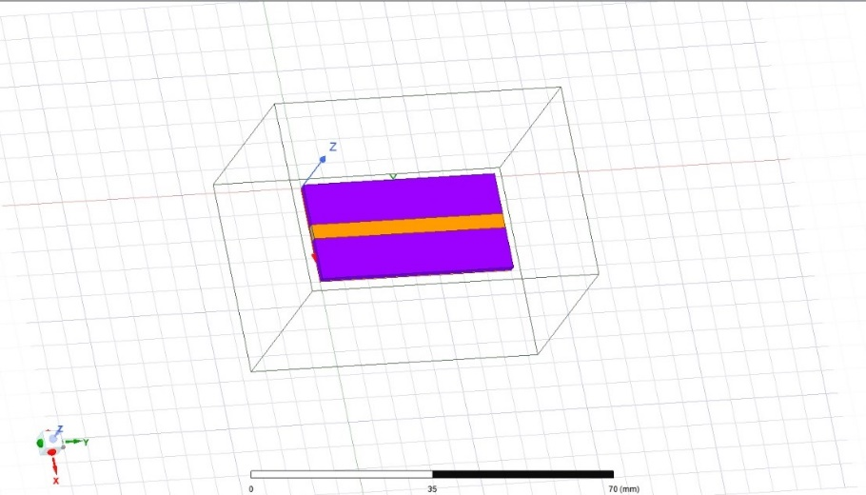

Figure 1 - Design of Microstrip line

.

**3.2 FORWARD MODELLING:**

In the domain of electromagnetic design, neural networks have risen as indispensable tools for forward modelling, a process where known physical parameters, such as dimensions, materials, and configurations, serve as inputs to predict specific electrical responses, often represented as S-parameters in the realm of microwave and RF engineering.

This approach serves a dual purpose: efficiency and accuracy. Neural networks streamline the process, reducing computational complexity and enabling real-time or near-real-time predictions. Moreover, their unique ability to capture intricate relationships and non-linear patterns enhances precision. In applications where minor deviations can yield substantial real-world consequences, such as optimizing antenna designs, enhancing communication systems' performance, and expediting microwave component development, the value of such precision becomes evident.

We have taken a proactive stance in this regard by developing a dedicated neural network (figure 2) for the explicit purpose of forward modelling. The accompanying image illustrates the architecture of this neural network, underscoring our commitment to transparency and innovation in the field. The prediction results also have been plotted as a plot, where the S(2,1) values are predicted (figure 3)

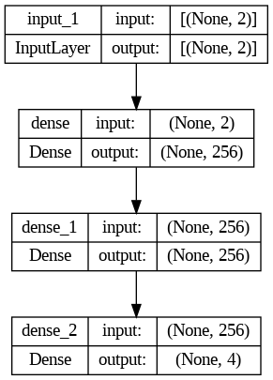

Figure 2 - Forward Modelling

The integration of neural network-driven forward modelling is undeniably reshaping the landscape of high-frequency electronics and microwave engineering. It holds the potential to redefine the efficiency and precision standards of electromagnetic design, unlocking novel possibilities and setting the stage for a future where intricate complexities are conquered with innovation and accuracy.

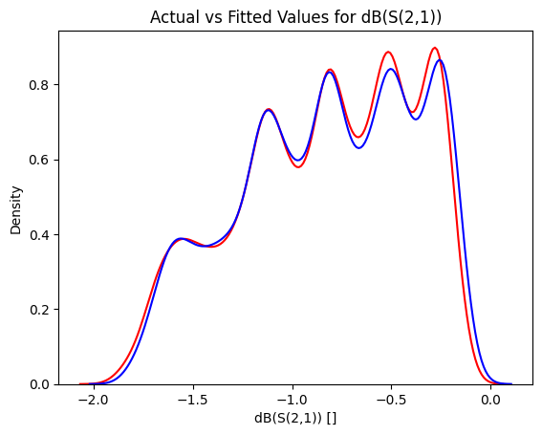

Figure 3 - Actual vs Predicted S(2,1) values

**3.3 REVERSE MODELLING:**

In electromagnetic design, reverse modelling is characterized by the utilization of known electrical responses, typically represented as S-parameters, as inputs to predict the corresponding physical parameters, including dimensions and materials. This process is accomplished efficiently and accurately with the aid of neural networks.

The primary objective of reverse modelling is the extraction of physical parameters from observed electrical responses, and this challenging task is adeptly handled by neural networks, which excel in recognizing complex patterns and relationships. In applications where the direct measurement or calculation of physical parameters presents challenges, neural networks offer a valuable solution.

It is noteworthy that a dedicated neural network for the purpose of inverse modelling (figure 4) has been built. In addition, comprehensive graphs (figure 5, 6) illustrating the model's outputs have been meticulously plotted, providing a comprehensive understanding of the achieved results.

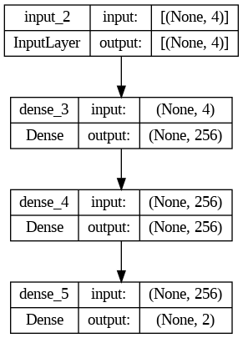

Figure 4 - Inverse Modelling

Through the strategic leverage of neural networks for reverse modelling, we unveil the potential to streamline the characterization and optimization of electromagnetic systems. This transformative approach enhances the precision and efficiency of design processes within the realms of high-frequency electronics and microwave engineering, marking a significant step forward in the evolution of electromagnetic design.

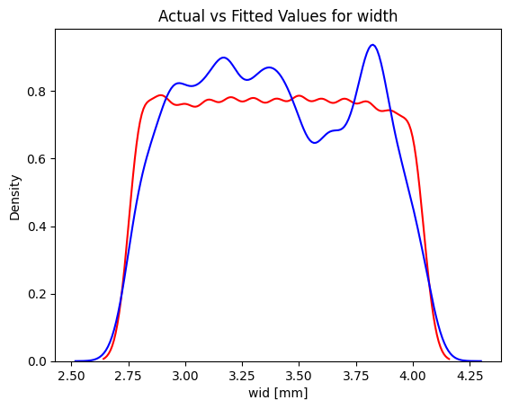

Figure 5 - Actual vs Predicted values for width

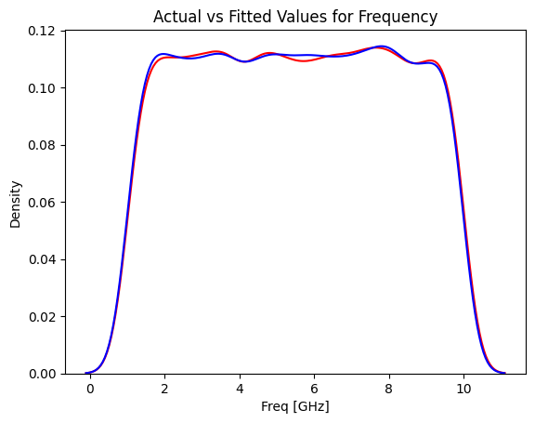

Figure 6 - Actual vs Predicted values for Frequency

**3.4 CONCLUSION**

Before delving into the modelling of larger and more complex microwave components, we chose to master the art of understanding the microstrip line. This choice proved to be invaluable, for it was here that we honed our skills in predicting not only the electrical responses, with forward modelling, but also the physical parameters, through reverse modelling.

The success we achieved in this endeavour was a testament to the power of neural networks in efficiently bridging the gap between physical parameters and electrical responses. It showcased that in the realm of high-frequency electronics and microwave engineering, precision and efficiency go hand in hand.

As we move forward to tackle more intricate and challenging electromagnetic systems, we carry with us the lessons learned from the microstrip line—a reminder that mastering the fundamentals is the key to conquering complexity. The journey continues, and the applications are vast, but the principles of forward and reverse modelling will remain our guiding light in the pursuit of innovation and precision.

**CHAPTER 4**

**STAGE 2: FSS INVERSE DESIGN AND GAN**

**4.1 INTRODUCTION**

In the continuum of our electromagnetic design endeavours, Frequency Selective Surfaces (FSS) (figure 7) emerge as a focal point, steering our trajectory toward innovation and precision. Having fortified the foundation by mastering the intricacies of modelling a microstrip line, the exploration into the realm of FSS marks a pivotal stride forward. These passive components, characterized by their adeptness at selectively filtering electromagnetic waves based on frequency, hold the key to a myriad of applications spanning communication, radar, stealth technology, and beyond.

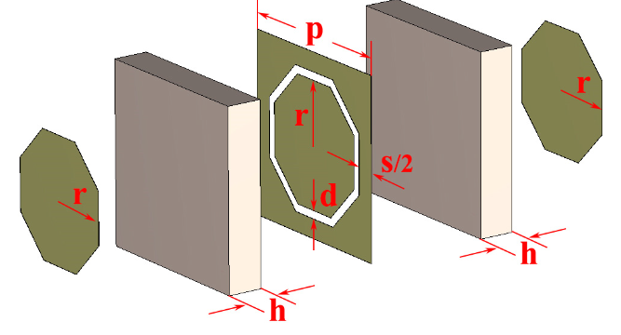

Figure 7 - 3 layered FSS

FSS components, while unpowered, wield a powerful influence over electromagnetic wave propagation. Their ability to precisely transmit, reflect, or absorb electromagnetic energy at specific frequencies offers immense potential for compact and efficient system design. However, the design of these surfaces is nuanced, demanding meticulous attention to geometry, materials, and configurations.

In the context of the project, delving into the intricacies of FSS design becomes not just a pursuit but a commitment. Armed with the knowledge and expertise garnered from modelling a microstrip line, the focus now shifts to unravelling the complexities of FSS. The forthcoming endeavours will centre on modelling these surfaces, leveraging advanced techniques and methodologies to enhance understanding and control of electromagnetic wave interactions.

As this new phase is ventured into, the resonance of FSS in the project underscores the dedication to pushing the boundaries of electromagnetic design. It propels toward a future where precision and innovation harmonize seamlessly, opening doors to unprecedented possibilities in the realm of high-frequency electronics and microwave engineering.

**4.2 GENERATIVE ADVERSARIAL NETWORK:**

Generative Adversarial Networks, or GANs, have established themselves as pioneering tools in the realm of machine learning and artificial intelligence. These networks are characterized by a unique dual structure (figure 8), consisting of a generator and a discriminator, engaged in an adversarial training process.

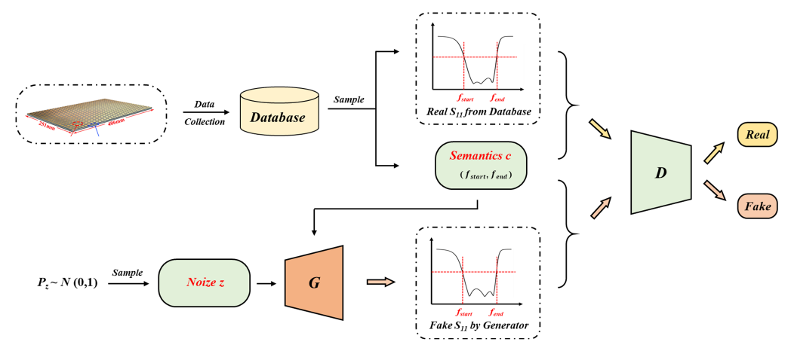

Figure 8 – GAN

One of the remarkable capabilities of GANs is their capacity to model joint probability distributions. This implies that GANs can learn and replicate complex relationships within data, providing a foundation for the generation of new, highly realistic data samples. This transformative feature has found applications in a multitude of domains, from image generation to data augmentation and anomaly detection.

In the context of our project, GANs assume a pivotal role. We have strategically incorporated an image illustrating the architecture of our GAN model, further enhancing the transparency and comprehensibility of our research. This image serves as a visual aid in understanding the intricacies of GAN-based data generation.

Moving forward, our project will harness the potential of GANs to address the one-to-one mapping issue encountered in the modelling of Frequency Selective Surfaces (FSS). By utilizing the joint probability modelling capabilities of GANs, we aim to overcome the challenges associated with FSS design, paving the way for more efficient and precise electromagnetic systems.

**4.3 ONE TO ONE MAPPING ISSUE:**

In the intricate world of microstrip line design, a challenging dilemma often arises—one that stems from the inherent complexity of electromagnetic interactions. The issue at hand pertains to the fact that different combinations of width and length for a microstrip line can yield identical S-parameters. In other words, there exists a multitude of diverse physical parameters that could lead to the same electrical response. This phenomenon introduces a critical challenge in the context of neural network (NN) modelling.

For a neural network to perform efficiently and accurately, it relies on the establishment of a clear one-to-one mapping between input (physical parameters) and output (S-parameters). When this mapping is compromised, the network encounters difficulty in distinguishing between the myriad input combinations that produce identical outputs. This inherent ambiguity results in a larger margin of error, diminishing the model's precision and reliability.

To overcome this one-to-one mapping challenge, our project seeks refuge in the capabilities of Generative Adversarial Networks (GANs). GANs, as alluded to earlier, have the unique ability to model joint probability distributions. In the context of microstrip line design, GANs can effectively capture the intricate relationships between physical parameters and S-parameters, regardless of the non-uniqueness issue. By generating data samples that encapsulate this inherent complexity, GANs offer a solution to the ambiguous mapping problem, ultimately enhancing the efficiency and accuracy of our modelling efforts. This strategic incorporation of GANs as generative models holds the promise of a transformative solution to address the challenges faced in the intricate world of electromagnetic design.

**4.5 MODEL CREATION:**

In the pursuit of advancing our project and addressing the challenges of electromagnetic design, we have meticulously developed two crucial components: the Generator and the Discriminator models. These models, while distinct in their roles, play a pivotal part in the Generative Adversarial Network (GAN) framework.

The Generator model (figure 9) serves as the creative force within the GAN, tasked with generating data samples that closely resemble real data. Its architecture has been meticulously crafted to ensure the generation of data samples that capture the intricate relationships between physical parameters and S-parameters in electromagnetic systems.

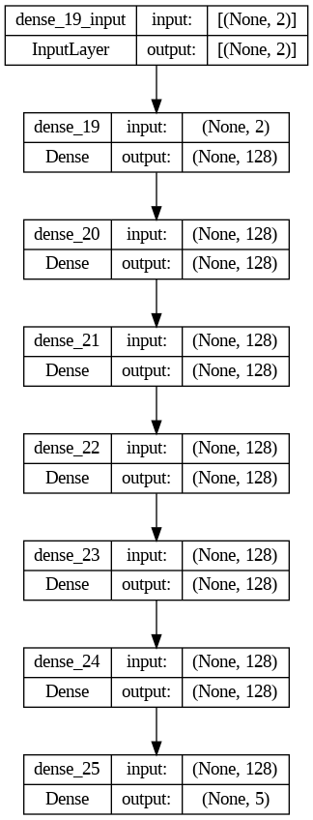

Figure 9 - Generator

On the other hand, the Discriminator model (figure 10) acts as the critical evaluator, discerning between real and generated data. Its sophisticated design allows it to scrutinize data samples with precision, detecting even the most subtle differences between real and generated data.

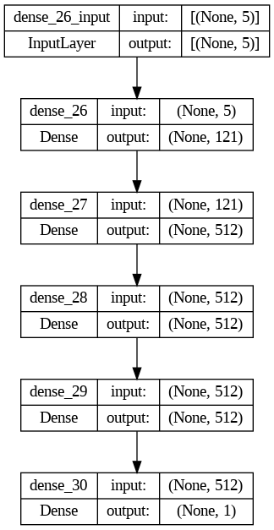

Figure 10 – Discriminator

Furthermore, these individual models, the Generator and the Discriminator, are seamlessly integrated to form a comprehensive GAN framework. The amalgamation of these components represents a significant step in our journey towards enhancing the efficiency and precision of electromagnetic system design. It is through this synergistic combination that our project aims to overcome the challenges of non-uniqueness in data mapping, and we anticipate that the GAN will emerge as a transformative solution in our pursuit of innovative electromagnetic design.

**4.6 CONCLUSION:**

In our relentless quest to harness the power of Generative Adversarial Networks (GANs) for electromagnetic design, we embarked with a vision of achieving unparalleled accuracy and efficiency. Yet, as our journey unfolded, it became evident that the path we had chosen did not yield the expected outcomes.

The GAN network, though a powerful tool, did not align with our intended goals. It presented challenges in providing the level of precision and accuracy we had sought in our electromagnetic system predictions. The results (figure 11) generated by the GAN network exhibited a significant margin of error, which became evident through the comprehensive graphs that we have thoughtfully included as reference points.

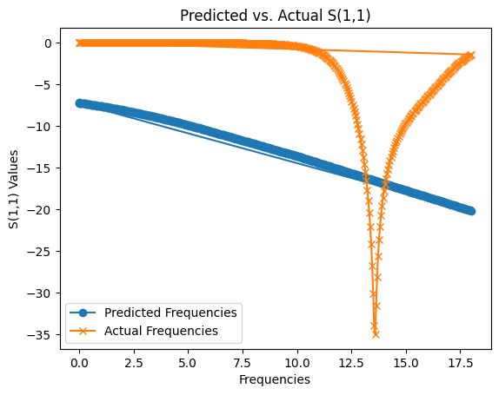

Figure 11 - Actual vs Predicted S (1,1) using GAN

Considering these findings, it is clear that a different direction must be charted. Our commitment to innovation and precision remains unwavering, and while the GAN network did not offer the solution, we had initially envisioned, it serves as a valuable stepping stone. This project is a testament to the dynamic nature of research, where setbacks merely signify opportunities for growth and evolution.

As we reflect on this chapter of our project, we look to the future with renewed determination. Our aim is to build a more robust and refined model that will surmount the challenges we have encountered, and propel us towards a future of electromagnetic design marked by precision, efficiency, and innovation. The journey continues, guided by the lessons learned, and the promise of groundbreaking solutions yet to be unveiled.

**CHAPTER 5**

**STAGE 3: ANN FOR INVERSE MODELLING OF MICROWAVE COMPONENTS**

**5.1 INTRODUCTION:**

In our unyielding pursuit of precision and efficiency in electromagnetic system design, we stand at a critical juncture, poised to embark on a different trajectory. This marks a departure from the intricate landscape of Generative Adversarial Networks (GANs) and a leap toward a more straightforward, yet innovative, Neural Network model.

Our initial journey carried the lofty ambition of harnessing GANs to unravel the intricate web of connections between physical parameters and S-parameters, with the aim of addressing the elusive one-to-one mapping challenge. However, we soon encountered the intricacies and inherent uncertainties entwined with GANs, prompting us to seek an alternative path.

The fresh direction we now traverse centres around the notion of utilizing percentage differences or alterations in physical parameters, instead of the raw parameters themselves. This strategic pivot holds the promise of resolving the cryptic non-uniqueness issue that has lingered as a formidable obstacle. Analysing the dynamics of how physical parameters change offers invaluable insights into their influence on the behaviour of electromagnetic systems.

With this innovative approach, we are poised to construct a Neural Network model that not only offers greater transparency and interpretability but also holds the potential for heightened precision and reliability. The forthcoming pages will illuminate our voyage as we navigate this uncharted territory, armed with a novel perspective and a steadfast commitment to pushing the boundaries of electromagnetic system design.

**5.2 NEURAL NETWORK MODEL:**

The Neural Network model is structured to take frequency and S-parameters as inputs and predict the percentage change in width and length values. The model's architecture has been meticulously designed to address the one-to-one mapping issue efficiently and with precision.

**5.3 EVALUATION:**

Our validation process involves a critical step aimed at ensuring the accuracy and reliability of our predictions. After providing the Neural Network model with frequency and S-parameters as inputs, we obtain a set of physical parameters as outputs. These predicted physical parameters are then meticulously input into the ANSYS software, a renowned tool for electromagnetic simulation and analysis.

Using the input data from the model, we initiate simulations within the ANSYS software, and the results obtained serve as a crucial benchmark. Specifically, we focus on the resonating frequency, a pivotal characteristic in electromagnetic system design. The objective is to verify whether the resonating frequency obtained from our model aligns with the actual behavior of the system as simulated in ANSYS.

Through the plotting of graphs and a rigorous cross-checking process, we meticulously scrutinize the results. This critical evaluation ensures that the resonating frequency matches the input frequency we provided. In doing so, we ascertain the accuracy and reliability of our predictions and the effectiveness of our novel Neural Network model in electromagnetic system design. This validation process serves as a cornerstone in our pursuit of precision and efficiency in this complex domain.

**5.6 CONCLUSION:**

**CHAPTER 6**

**SUMMARY AND CONCLUSION**

In this thesis, Microwave components are designed and analyzed. This chapter summarizes the overall work done, conclusions obtained and the directions for the future work.

**6.1 SUMMARY**

Throughout this project, we embarked on a transformative journey in the realm of electromagnetic system design. Our initial endeavors led us to explore the capabilities of Generative Adversarial Networks (GANs) in addressing the intricate challenges associated with one-to-one mapping issues and the non-uniqueness problem in the prediction of physical parameters. While GANs provided valuable insights, they revealed their limitations in delivering the desired precision and accuracy.

In response to these findings, we embraced a new approach, shifting our focus to a Neural Network model that predicts the percentage change in physical parameters based on frequency and S-parameters. This innovative model allowed us to gain deeper insights into the intricate relationships between electromagnetic system behavior and parameter adjustments, setting a course for enhanced precision and efficiency.

Our validation process, which involved cross-checking our model's predictions with ANSYS simulations, was a crucial step in ensuring the reliability of our results. The accuracy of the resonating frequency predictions, derived from the input parameters, serves as a testament to the effectiveness of our novel approach.

**6.2 CONCLUSION:**

As we conclude this chapter of our project, we acknowledge the dynamic nature of research and innovation. Our journey has been marked by both challenges and breakthroughs, ultimately leading us to a more refined and efficient approach in electromagnetic system design.

While GANs offered valuable insights, our transition to a Neural Network model that predicts percentage changes in physical parameters has ushered in a new era of precision and accuracy. We have learned that adaptability and innovation are the cornerstones of progress in this complex field.

The lessons we have gleaned, and the solutions we have uncovered, set the stage for the next phase of our research. We are resolute in our commitment to advancing the frontiers of electromagnetic design, pushing the boundaries of innovation, and unlocking new possibilities.

With a newfound perspective and unwavering determination, we look to the future with a clear vision, poised to build a better model that will continue to propel us towards precision, efficiency, and groundbreaking advancements in electromagnetic system design.

**6.3 DIRECTION FOR FUTURE WORK**

**REFERENCES**

**APPENDIX**