A+ Computer Science BLACKJACK PART I

Lab Goal : This lab was designed to teach you more object oriented programming and how to write a larger game.

Lab Description : Write a generic Card class. Show that Card works as intended by completing the BlackJackCard class. Finally, test your code by constructing two BlackJackCards in the main and displaying each one in the debug window. Aces will count as 11 for now.

public class Card
{
public static final String FACES[] = {"ZERO","ACE","TWO","THREE","FOUR",
"FIVE","SIX","SEVEN","EIGHT","NINE","TEN","JACK","QUEEN","KING"};
Files Needed ::
Card.java
BlackJackCard.java
CardTestOne.java
private String suit;
private int face;

//constructors

//set methods

//get methods
Sample Output ( CardTestOne.java )
ZERO of | value = 0
ACE of DIAMONDS | value = 11
FOUR of CLUBS | value = 4
QUEEN of SPADES | value = 10
QUEEN of HEARTS | value = 10
NINE of SPADES | value = 9
false
true
false
false

public int getValue()
{
return face;
}

//equals method

public String toString()
{
return FACES[face] + " of " + getSuit() + " | value = " + getValue();
}
}
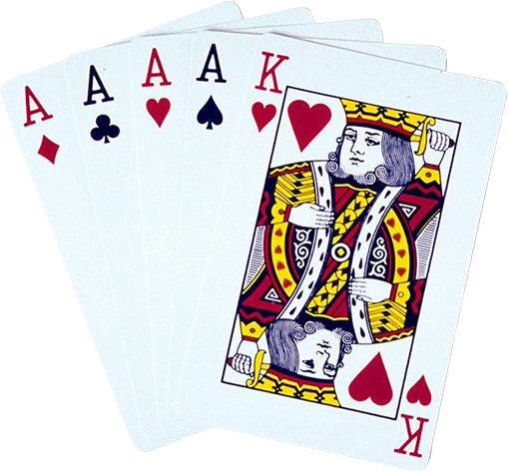

public class BlackJackCard extends Card
{

//constructors

public int getValue()
{
//override the Card getValue to build BlackJack logic
//enables you to build the value for the game into the card
//this makes writing the whole program a little easier
return 0;
}
}

