A+ Computer Science BLACKJACK PART III

Lab Goal : This lab was designed to teach you more object oriented programming and how to write a larger game.

Lab Description : Write a Player class shown below. Show that Player works as intended by instantiating a Player in the main and displaying the Player information.

Files Needed ::
Card.java
BlackJackCard.java
Deck.java
Player.java
PlayerTestOne.java
public class Player
{
private ArrayList<Card> hand;
private int winCount;

public Player ()
{
}
Sample Output ( PlayerTestOne.java )
toString
hand = [FOUR of HEARTS | value = 4
FIVE of SPADES | value = 5] - 9

handValue
9

toString
hand = [FOUR of HEARTS | value = 4
FIVE of SPADES | value = 5
TWO of SPADES | value = 2
TEN of HEARTS | value = 10] - 21

handValue
21
public Player (int score)
{
}

public void addCardToHand( Card temp )
{
}

public void resetHand( )
{
}

public void setWinCount( int numwins )
{
}

public int getWinCount() { return 0; }

public int getHandSize() { return 0; }

public int getHandValue()
{
return 0;
}

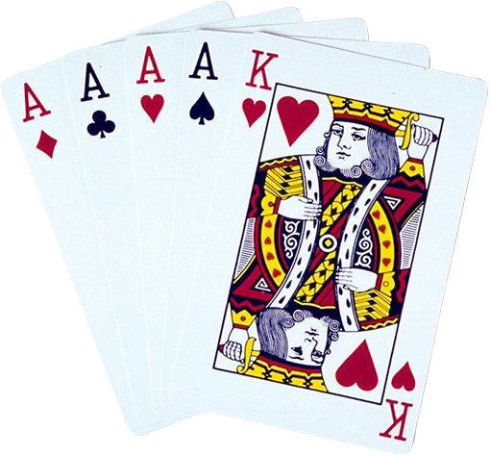 public boolean hit( )
{
return false;
}

public String toString()
{
return "";
}
}

