A+ Computer Science BLACKJACK PART IV

Lab Goal : This lab was designed to teach you more object oriented programming and how to write a larger game.

Lab Description : Write a Dealer class that extends the Player class. Show that Dealer works as intended by instantiating a Dealer in the game class and using the Dealer to play a game of BlackJack.

public class Dealer extends Player
{
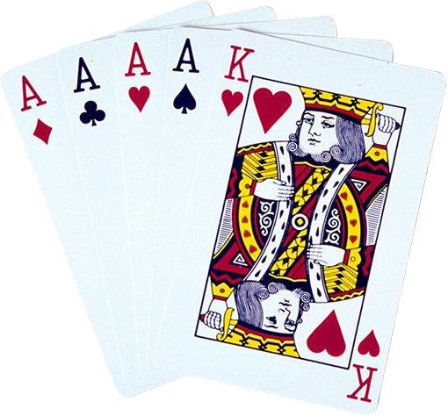 //define a deck of cards

public Dealer() {
}

public void shuffle()
{
//shuffle the deck
}

public Card deal(){
return null;
}

public int numCardsLeftInDeck()
{
return 0;
}

public boolean hit()
{
return false;
}
}

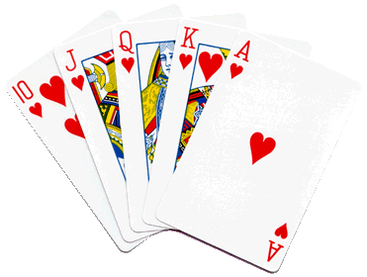
Sample Output ( DealerTestOne.java )

PLAYER
Hand Value :: 16
Hand Size :: 2
Cards in Hand :: hand = [ACE of SPADES | value = 11
FIVE of SPADES | value = 5] - 16

DEALER
Hand Value :: 17
Hand Size :: 2
Cards in Hand :: hand = [ACE of CLUBS | value = 11
SIX of DIAMONDS | value = 6] - 17

Dealer has bigger hand value!

