A+ Computer Science BLACKJACK PART V

Lab Goal : This lab was designed to teach you more object oriented programming and how to write a larger game.

Lab Description : Write the complete game logic for BlackJack. At this point, Card, BlackJackCard, Deck, Player, and Dealer have been tested thoroughly. Put all of the pieces together to make a complete game of BlackJack.

Files Needed ::
Card.java
BlackJackCard.java
Deck.java
Player.java
Dealer.java
BlackJack.java
public class BlackJack
{
private Dealer dealer;
private Player player;

public BlackJack()
{
// instantiate all of your instance variables
}

public void playGame() {
//all game code goes in here
}

public static void main( String args[ ] ) {
BlackJack game = new BlackJack();
game.playGame();
}
}

How do you play the game of BlackJack?
dealer shuffles the deck of cards
do{
1st – deal the player two cards one at a time
dealer deals himself two cards

2nd – print out player’s hand value and cards
while(hand value < 21 and the player wants to hit)
deal the player the next card
print out player’s hand value and cards

3rd – print out dealer’s hand value and cards
while(dealer wants to hit)
code to add cards should be in dealer hit method print out dealer’s hand value and cards

4th – determine which player won

5th – update the win total for the winner

6th – dealer shuffles the deck of Cards if needed

}while another game is to be played

Sample Output :
Current hand hand = [NINE of HEARTS
JACK of SPADES] - 19
Do you want to hit? [Y/N] n

PLAYER
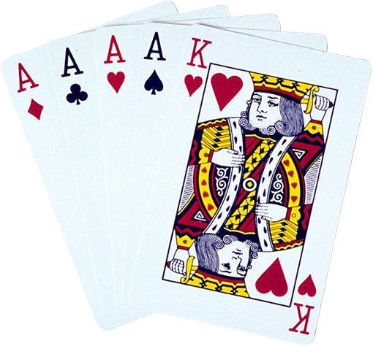Hand Value :: 19
Hand Size :: 2
Cards in Hand :: hand = [NINE of HEARTS
JACK of SPADES] - 19

DEALER
Hand Value :: 17
Hand Size :: 3
Cards in Hand :: hand = [EIGHT of CLUBS
FOUR of DIAMONDS
FIVE of HEARTS] - 17

Player has bigger hand value!

Dealer has won 0 times.
Player has won 1 times.

Do you want to play again? [Y,y,N,n] :: y

Current hand hand = [JACK of HEARTS
JACK of DIAMONDS] - 20
Do you want to hit? [Y/N] n

PLAYER
Hand Value :: 20
Hand Size :: 2
Cards in Hand :: hand = [JACK of HEARTS
JACK of DIAMONDS] - 20

DEALER
Hand Value :: 17
Hand Size :: 3
Cards in Hand :: hand = [QUEEN of SPADES
TWO of DIAMONDS
FIVE of CLUBS] - 17

Player has bigger hand value!

Dealer has won 0 times.
Player has won 2 times.

Do you want to play again? [Y,y,N,n] :: y

Current hand hand = [SEVEN of DIAMONDS
KING of DIAMONDS] - 17
Do you want to hit? [Y/N] n

PLAYER
Hand Value :: 17
Hand Size :: 2
Cards in Hand :: hand = [SEVEN of DIAMONDS
KING of DIAMONDS] - 17

DEALER
Hand Value :: 25
Hand Size :: 3
Cards in Hand :: hand = [QUEEN of CLUBS
FIVE of SPADES
TEN of DIAMONDS] - 25

Player wins - Dealer busted!

Dealer has won 0 times.
Player has won 3 times.

Do you want to play again? [Y,y,N,n] :: n

