Lab Goal : This lab was designed to teach you more object oriented programming and how to write a larger game.
A+ Computer Science BLACKJACK PART VI

Lab Description : Write the game logic for multi-player BlackJack. At this point, Card, , BlackJackCard, Deck, Player, and Dealer have been tested thoroughly. Now, put all of the pieces together for a complete BlackJack game with multiple players. All players including the dealer will be accessed through the players ArrayList. The dealer will be spot 0 and all other players will be in spots 1 through x.

public class BlackJack
{
private ArrayList<Player> players; //you cannot have any other instance variables

public BlackJack()
{
// instantiate all of your instance variables
}

public void playGame() {
//all game code goes in here
}

public static void main( String args[ ] ) {
BlackJack game = new BlackJack();
game.playGame();
}
}

Game logic for multiplayer Black Jack
do{
1st – dealer shuffles the deck of cards

2nd – loop through all of the players including the dealer
deal each player two cards one at a time
deal to the dealer last

3rd – loop through the players - hit the dealer last
print out player’s hand value and cards
while( the player wants to hit and hand value < 21 )
deal the player the next card
print out player’s hand value and cards

4th – loop through all of the players including the dealer
print out each player’s cards and hand value

5th – loop through all of the players including the dealer
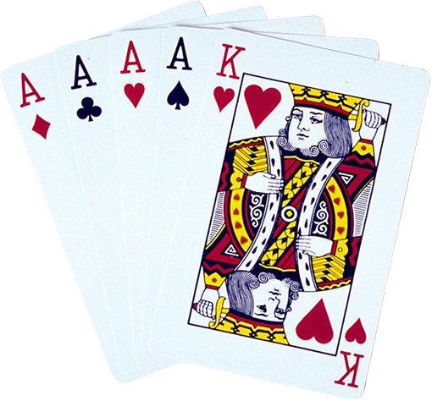 determine which player won
v
6th – update the win total for the winners

}while another game is to be played

