Hi, this Doc file is to tell you what I have done in this project.

Scenario 1

Get the JWT Token,

To get the JWT Token we need to hit like this.

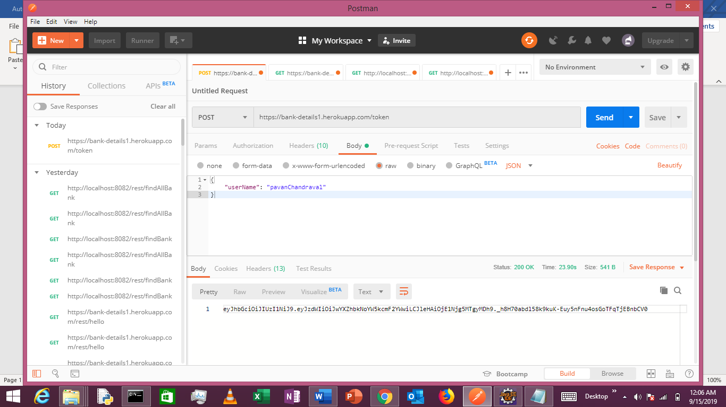

After this we can test it Like this.

Case 1

If we don’t give JWT Token in the time of hitting to <https://bank-details1.herokuapp.com/rest/hello>.

(in body there is nothing)

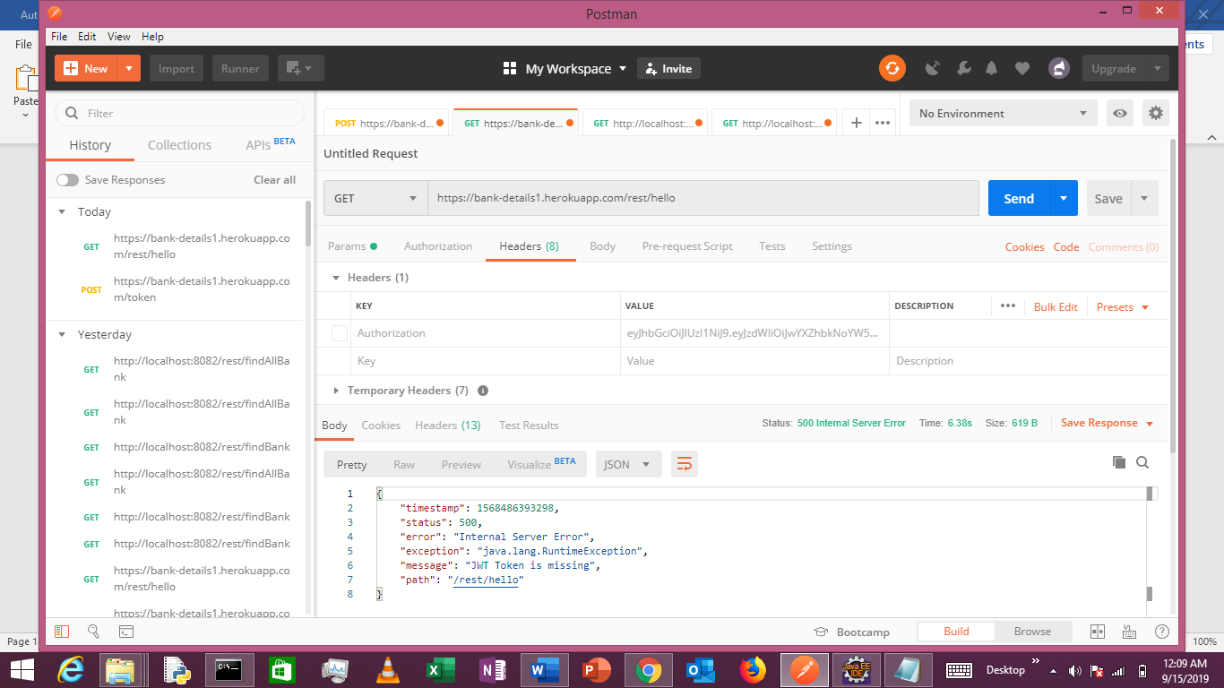

Case 2

If we give the incorrect JWT Token

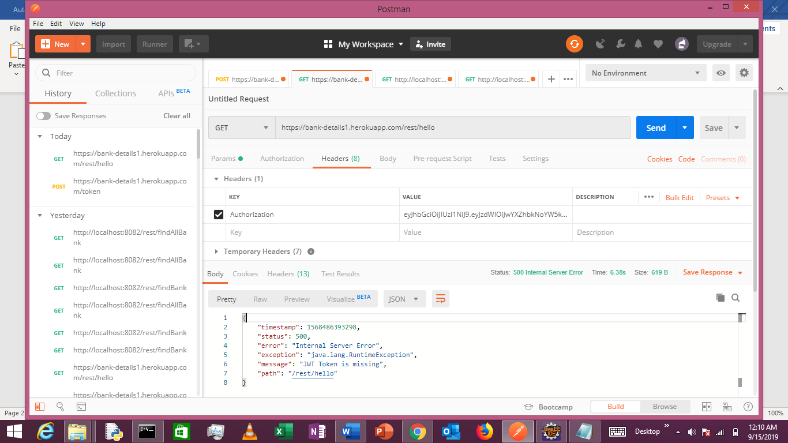

Case 3

If we give the correct JWT Token

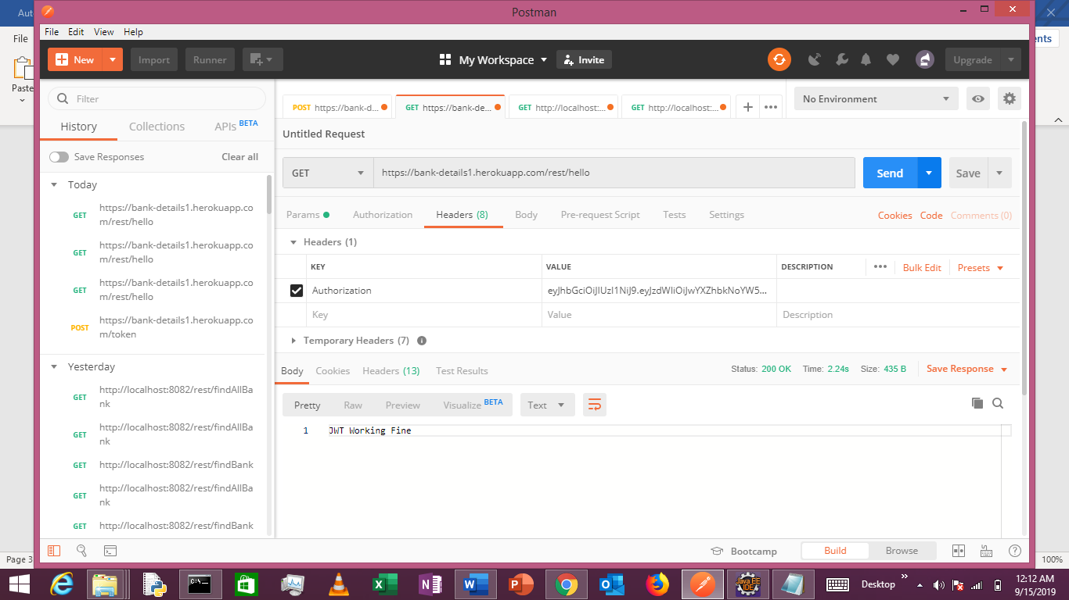

I Tried a lot to Dump data on Heroku Data base, but I could not able to do that, but in my local It got successfully Worked.

Case 1 with Ifsc Code get the data.

Case 2

With bank Name and city and given limit and offset get the list of banks details.

If I Change the limit and offset then,

