[Step-By-Step: Creating an Azure Point-to-Site VPN](https://techcommunity.microsoft.com/t5/itops-talk-blog/step-by-step-creating-an-azure-point-to-site-vpn/ba-p/326264)

Site-to-Site VPN is the most common method organizations use to connect on-premises network to Azure vNet. This VPN connection is initiated in your edge firewall or router level. But what if you connecting from remote location such as home? We can use point-to-site method to do that. In this method it will use certificates to do the authentication between end point and azure virtual network.

So,

let’s go ahead and see how we can do that,

**Create Resource Group**

In this exercise, I like to use separate resource group for virtual network and other components.

1. Log in to **Azure portal** as global administrator
2. Launch Cloud Shell

p2s1.jpg

1. Then run **New-AzureRmResourceGroup -Name REBELVPNRG -Location "East US".**In here **REBELVPNRG** is resource group name and **East US** is the location.

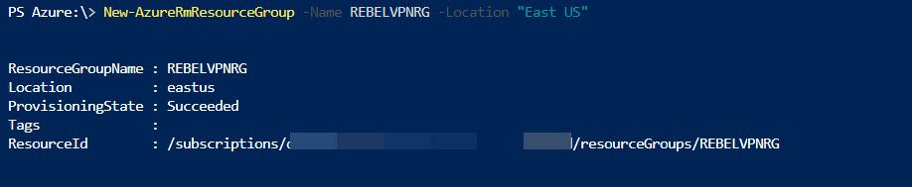

**Create Virtual Network**

Now we need to create new virtual network. We can create virtual network using,

**New-AzureRmVirtualNetwork -ResourceGroupName REBELVPNRG -Name REBEL-VNET -AddressPrefix 192.168.0.0/16 -Location "East US"**

In above, **REBEL-VNET** is the virtual network name. it uses **192.168.0.0/16** IP address range.

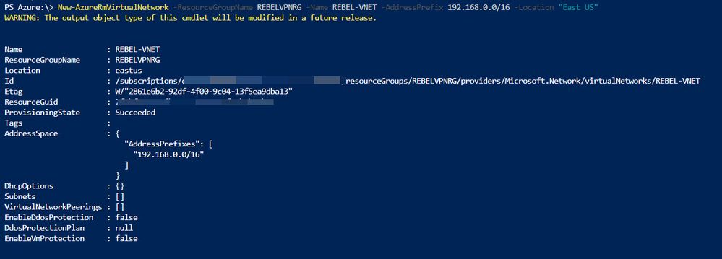

**Create Subnets**

Under the virtual network I am going to create a subnet for my servers. To create subnet use,

**$vn = Get-AzureRmVirtualNetwork -ResourceGroupName REBELVPNRG -Name REBEL-VNET**

**Add-AzureRmVirtualNetworkSubnetConfig -Name REBEL-SVR-SUB -VirtualNetwork $vn -AddressPrefix 192.168.100.0/24**

**Set-AzureRmVirtualNetwork -VirtualNetwork $vn**

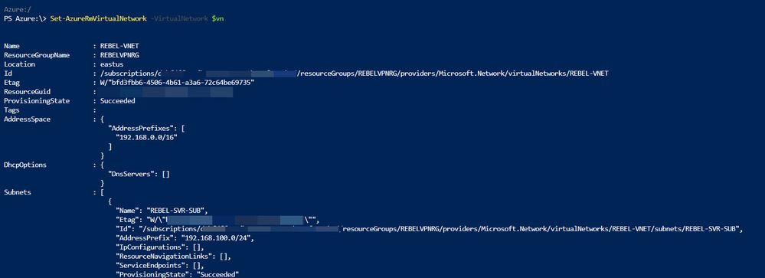

**Create Gateway Subnet**

Before we create VN gateway, we need to create gateway subnet for it. so gateway will use ip addresses assigned in this subnet.

To do that,

* Log in to Azure portal as global administrator
* Go to **Virtual Networks | REBEL-VNET** (VNet created on previous steps) **| Subnets**

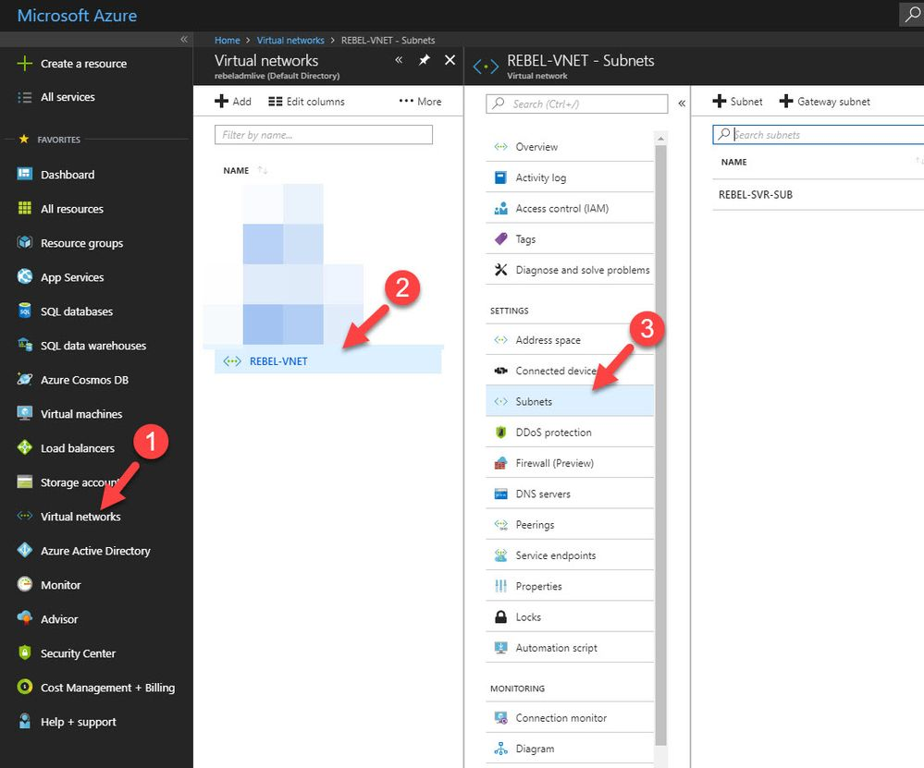

* Click on **Gateway Subnet**

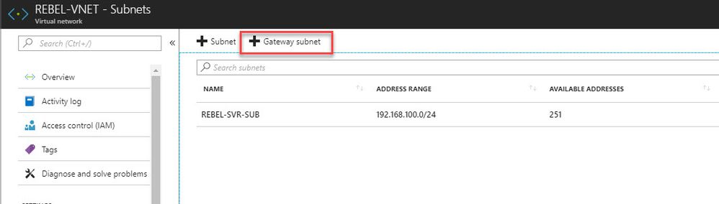

* In new window, define the ip range for gateway subnet and click **Ok**

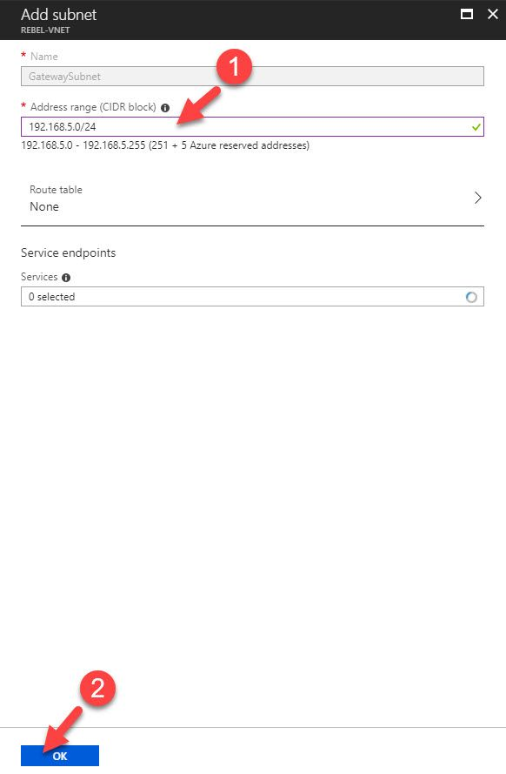

**Create Virtual Network Gateway**

Now we have all the things needed to create new VN gateway. To do that,

* Log in to Azure portal as global administrator
* Go to **All Services** and search for virtual network gateway. Once it is in list, click on it.

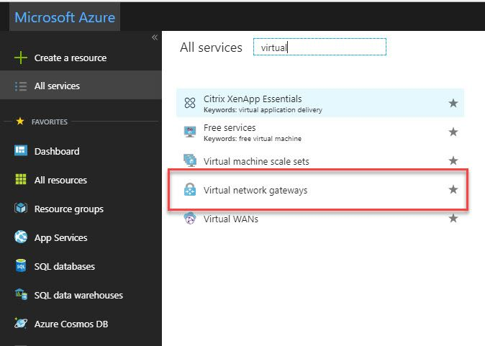

* Then click on **Create virtual network gateway**

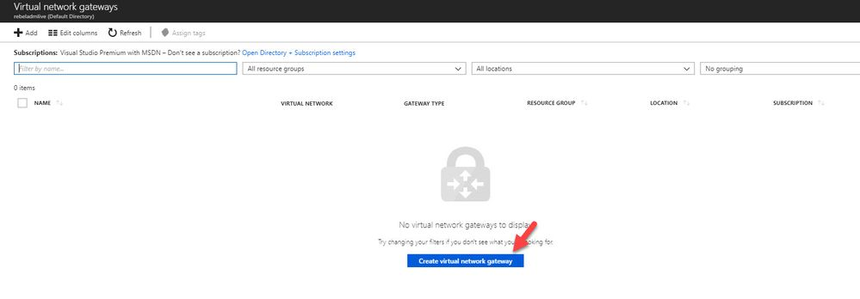

* In new window fill relevant info and click on**Create**

 In here, **REBEL-VPN-GW** is the gateway name. I have selected **REBEL-VNET** as the virtual network. I am also creating public ip called **REBEL-PUB1**. This is only supported with dynamic mode. This doesn’t mean it is going to change randomly. It will only happen when gateway is deleted or read.

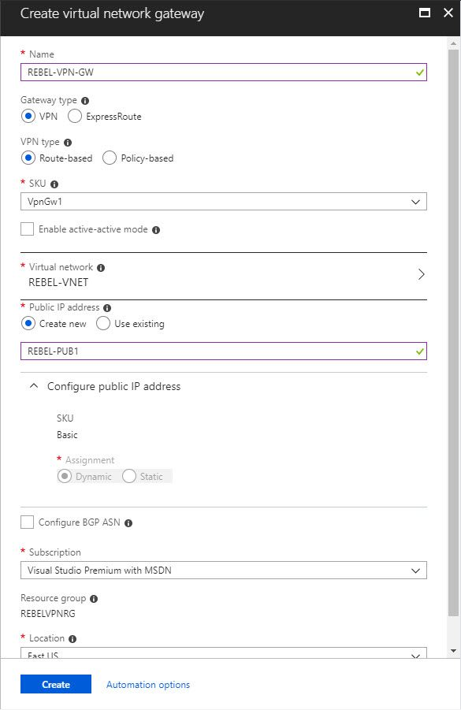

**Create Self-sign root & client certificate**

If your organization using internal CA, you always can use it to generate relevant certificates for this exercise. If you do not have internal CA, we still can use self-sign certs to do the job.

As first step I am going to create root certificate. In Windows 10 machine I can run this to create root cert first.

**$cert = New-SelfSignedCertificate -Type Custom -KeySpec Signature `**

**-Subject "CN=REBELROOT" -KeyExportPolicy Exportable `**

**-HashAlgorithm sha256 -KeyLength 2048 `**

**-CertStoreLocation "Cert:\CurrentUser\My" -KeyUsageProperty Sign -KeyUsage CertSign**

This will create root cert and install it under current user cert store.

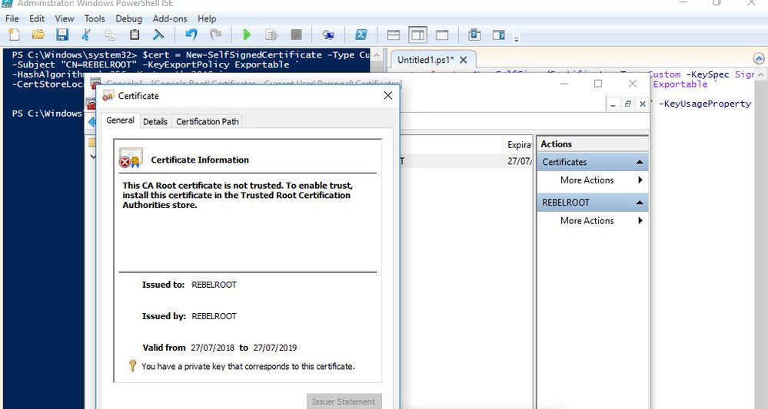

Then we need to create client certificate. We can do this using

**New-SelfSignedCertificate -Type Custom -DnsName REBELCLIENT -KeySpec Signature `**

**-Subject "CN=REBELCLIENT" -KeyExportPolicy Exportable `**

**-HashAlgorithm sha256 -KeyLength 2048 `**

**-CertStoreLocation "Cert:\CurrentUser\My" `**

**-Signer $cert -TextExtension @("2.5.29.37={text}1.3.6.1.5.5.7.3.2")**

This will create cert called **REBELCLIENT** and install in same store location.

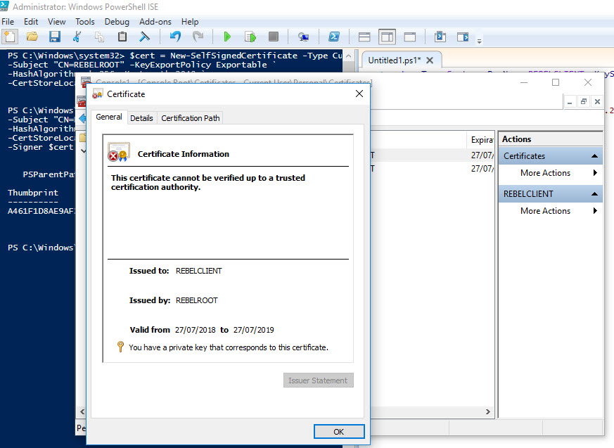

Now we have certs in place. But we need to export these so we can upload it to Azure.

To export root certificate,

* Right click on root cert inside certificate mmc.
* Click on **Export**
* In private key page, select not to export private key

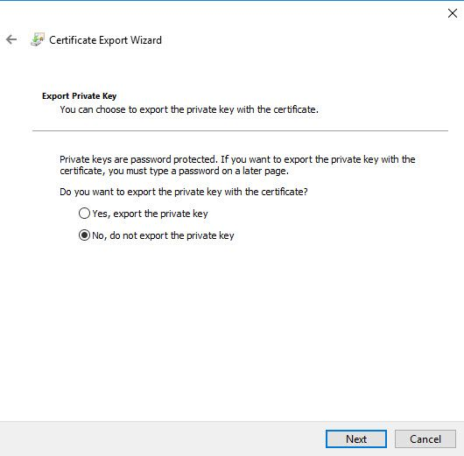

* Select Base-64 encoded X.509 as export file format.

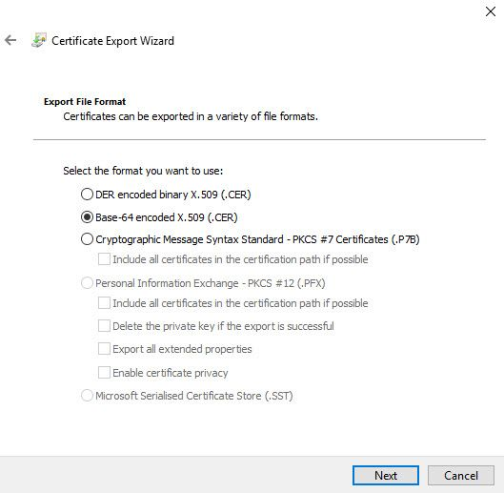

* Complete the wizard and save the cert in pc.

 To export client certificate,

* Use same method to export as root cert, but this time under private key page, select option to export private key.

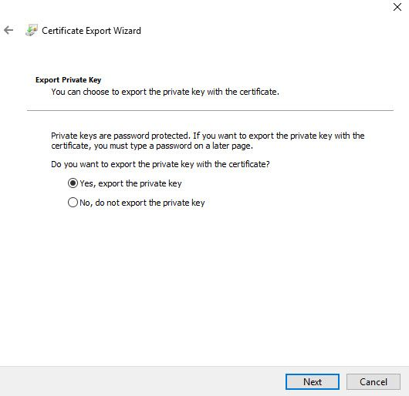

* In file format page, leave the default as following and click **Next**

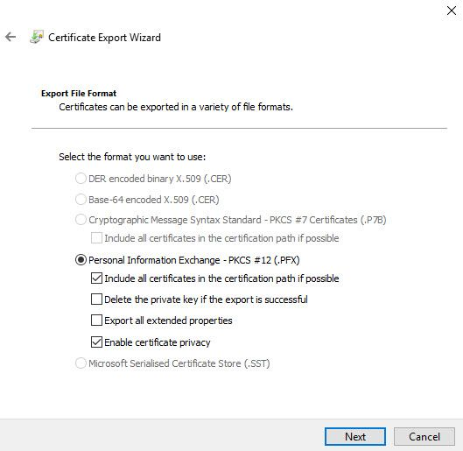

* Define password for the pfx file and complete the wizard.

**Note** – Only root cert will use in Azure VPN, client certificate can install on other computers which need P2S connections.

**Configure Point-to-Site Connection**

Next step of this configuration is to configure the point-to-site connection. In here we will define client ip address pool as well. It is for VPN clients.

* Click on newly created VPN gateway connection.
* Then in new window click on **Point-to-site configuration**

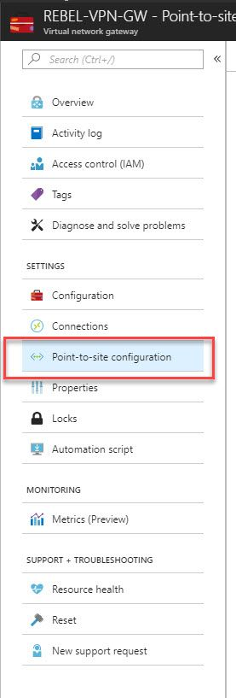

* After that, click on **Configure Now**

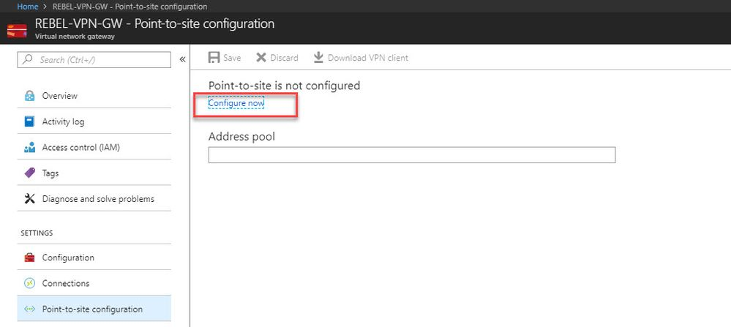

* In new window type IP address range for VPN address pool. In this demo I will be using **172.16.25.0/24**. For tunnel type use both **SSTP & IKEv2**. Linux and other mobile clients by default use **IKEv2** to connect. Windows also use **IKEv2** first and then try **SSTP**. For authentication type use **Azure Certificates**.

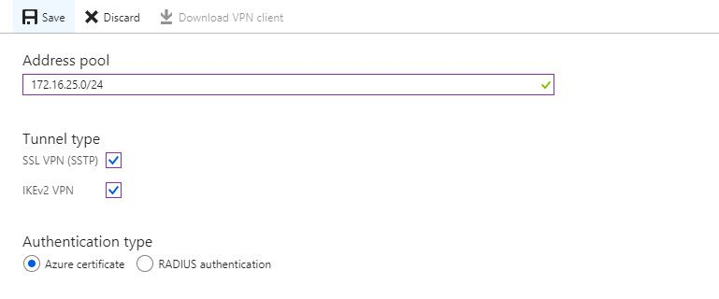

* In same window there is place to define root certificate. Under root certificate name type the cert name and under public certificate data, paste the root certificate data ( you can open cert in notepad to get data).

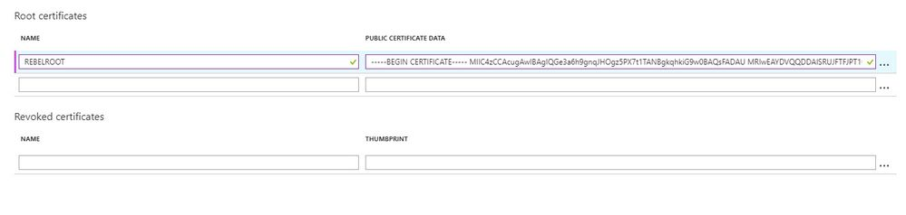

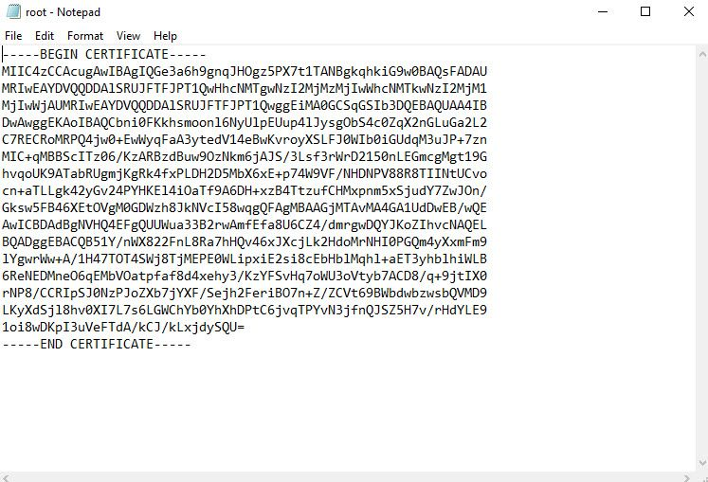

* Then click on **Save**to complete the process.

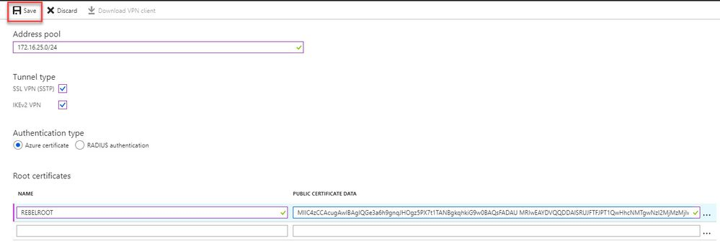

**Note** : when you paste certificate data, do not copy -----BEGIN CERTIFICATE----- & -----END CERTIFICATE----- text.

**Testing VPN connection**

Now we have finished with configuration. As next step, we need to test the connection. To do that log in to the same pc where we generate certificates. If you going to use different PC, first you need to import root cert & client certificate we exported.

* Log in to Azure portal from machine and go to VPN gateway config page.
* In that page, click on **Point-to-site configuration**
* After that, click on **Download VPN client**

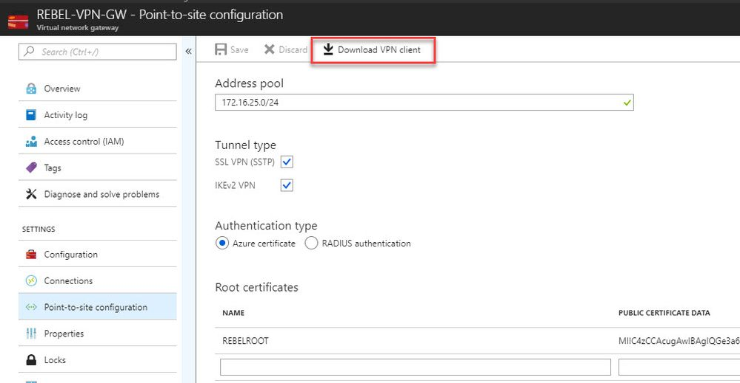

* Then double click on the VPN client setup. In my case I am using 64bit vpn client.

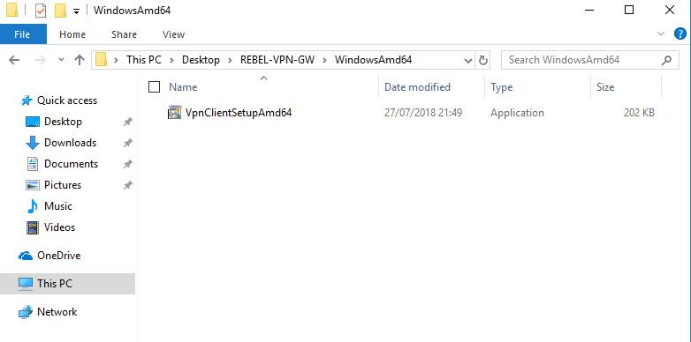

* After that, we can see new connection under windows 10 VPN page.

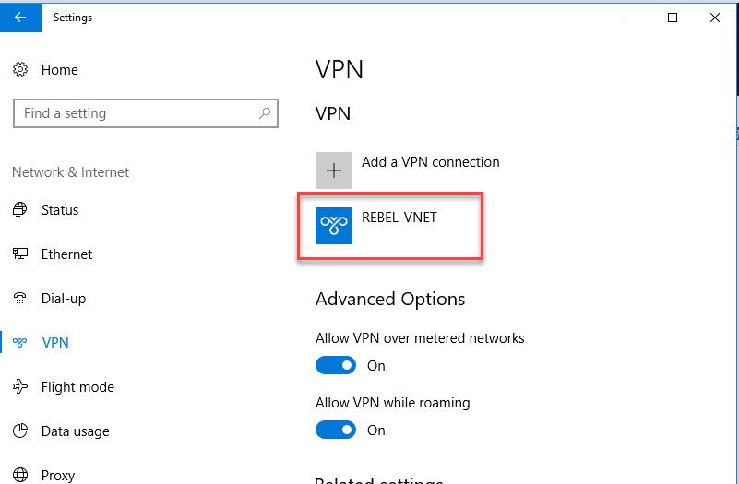

* Click on connect to VPN. Then it will open up this new window. Click on **Connect** in there.

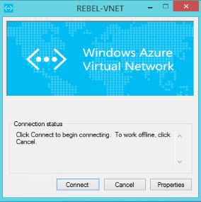

* Then run ip config to verify ip allocation from VPN address pool.

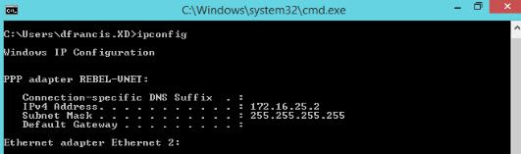

* In VPN gateway page also, I can see one connection is made.

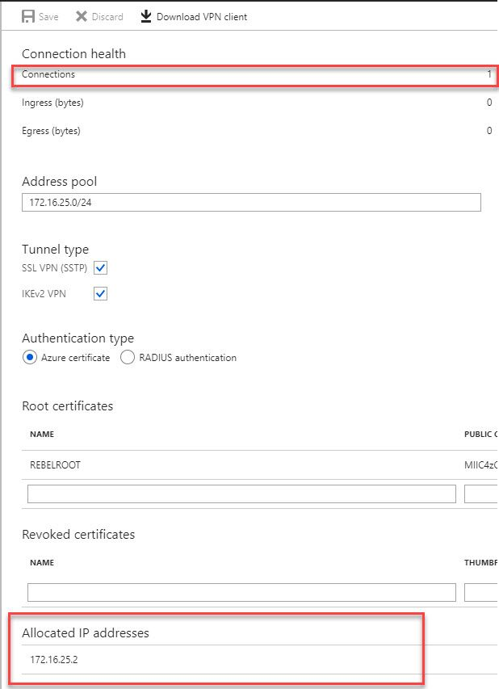

* I have a server setup under new virtual network we created. This server only has private ip and its 192.168.100.4

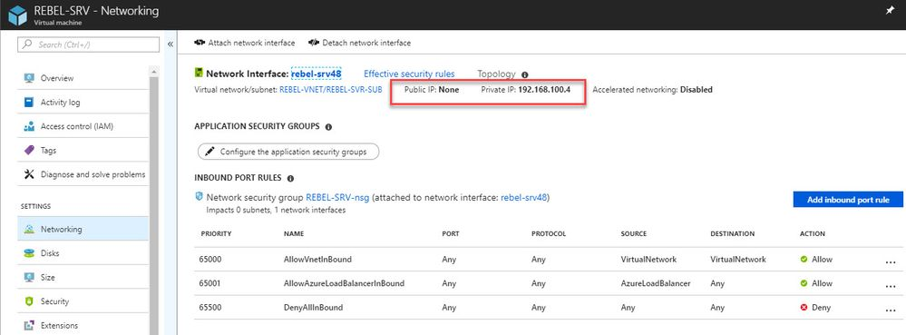

* As expected, I can RDP to this via VPN.

