Chris Anderson
CPSC 473
1/30/2017
Assignment 1

GitHub URL: https://github.com/codepoetchris/ottergram

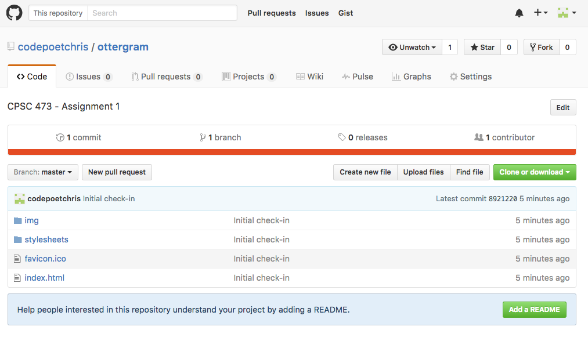

Installed Atom packages as the book requested. I also changed the HTML beautifier to use 2 spaced instead of 4:
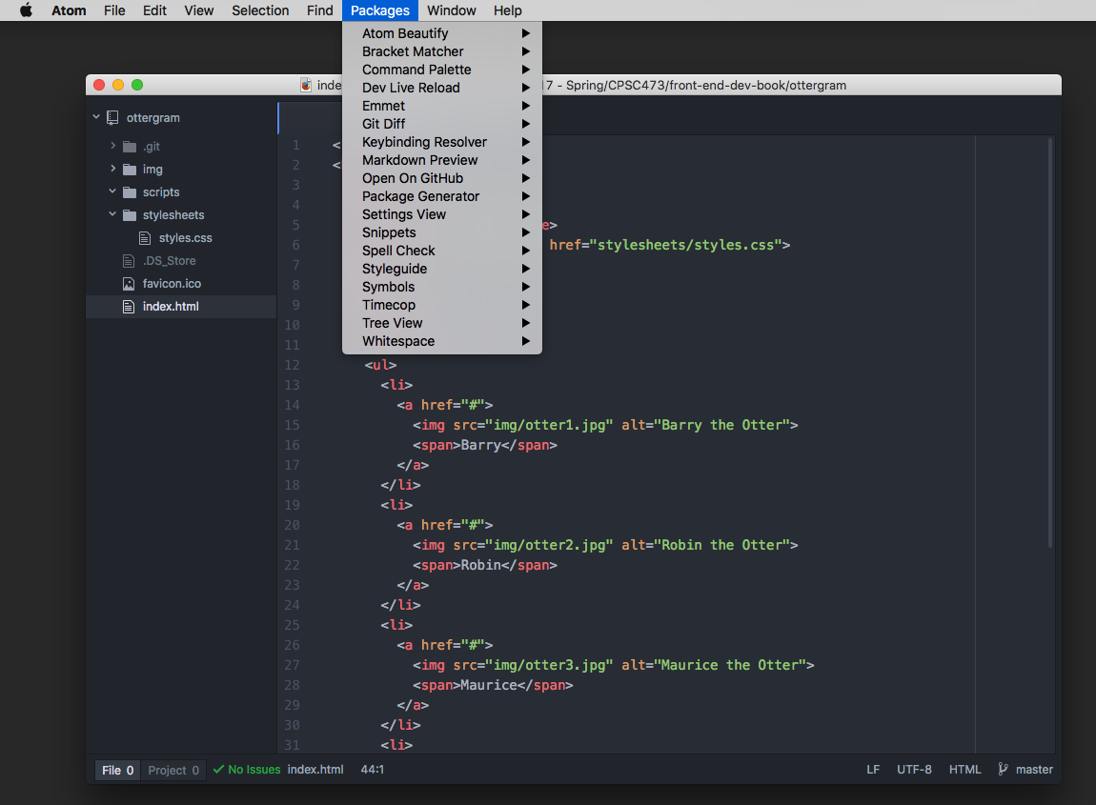

Browser Sync Running
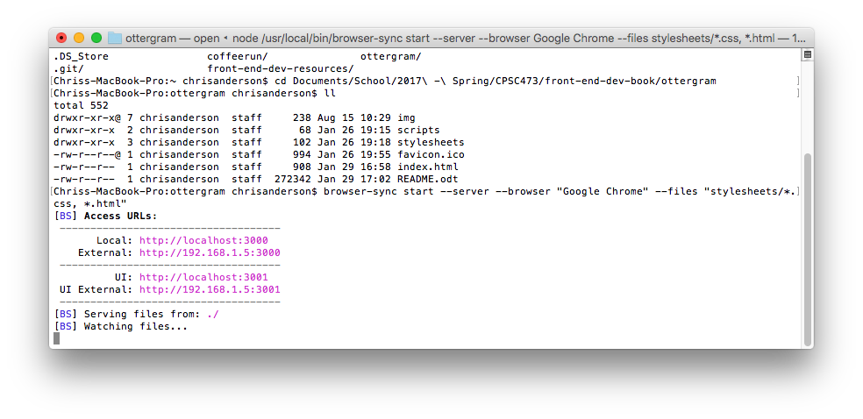
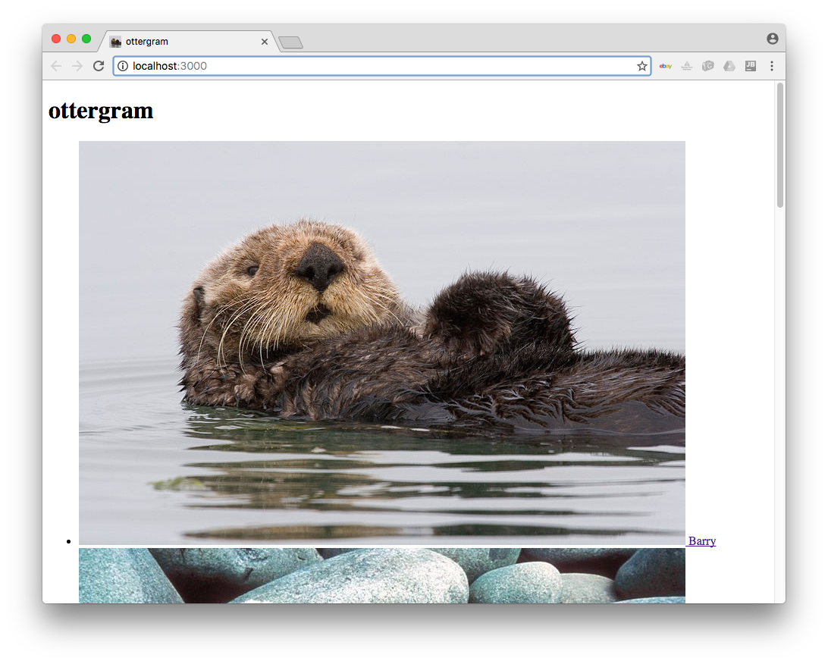
Ottergram page with favicon.ico displaying

