 | Title : Project Registration & Progress Review |  | FF No. 180
Department: Computer |  | Academic Year: 2026-27
Semester : VII |  | Group No. : 21
Project Title: Machine Learning-Based Early Detection of Temporal Anomalies in B2B Procurement Using Customer–Part Purchase Patterns

Project Area: Machine Learning
Group Members Details:

Sr. No. | Class & Div. | Roll No. | G.R.No. | Name of Student | Contact No. | Email ID
1 | BTech A | 421036 | 22310805 | Kaushal Borude | 8788331389 | kaushal.22310805@viit.ac.in
2 | BTech A | 421084 | 22310913 | Jaydip Chavan | 8591981125 | jaydip.22310913@viit.ac.in
3 | BTech A | 421134 | 22311223 | Anuj Khaire | 9644063337 | anuj.22311223@viit.ac.in
4 | BTech A | 421159 | 22311264 | Devanshu Nirmal | 8793029837 | devanshu.22311264@viit.ac.in

Name of Internal Guide: Prof. (Dr.) Rahul B. Diwate
Contact No. & Email ID: +91 8087748493 & rahul.diwate2@vit.edu

Project approved / Not approved

Dr. Vijayendra S. Gaikwad Prof.(Dr.) Sandip R. Shinde
Guide Project Coordinator Head,
Department of Computer Engineering

T

Project Synopsis (Revised – Implementation Completed)

Project Title
Machine Learning-Based Early Detection of Temporal Anomalies in B2B Procurement Using Customer–Part Purchase Patterns

Introduction
B2B procurement involves repeated purchasing of materials and spare parts, making historical purchasing patterns important for effective procurement management. Machine learning has been widely applied to spare-parts demand forecasting and procurement analytics. However, limited attention is given to detecting unusually early reorders based on customer–part purchase intervals. This project has developed a customer–part-specific screening system that calculates inter-purchase intervals (IPIs), builds historical features using only past data, and flags unusually short intervals as candidates for human review. An interpretable median-threshold rule is used for alert membership, a median absolute deviation (MAD)-based score supports ranking, and Isolation Forest and Local Outlier Factor (LOF) are evaluated as unsupervised benchmarks. The system is delivered with a reproducible Python pipeline and a Streamlit early-warning dashboard.
Review of Literature
Recent research has extensively explored machine learning for intermittent spare-parts demand forecasting, feature engineering, and inventory planning. Studies have also applied machine learning to procurement decision support, supplier selection, order allocation, and procurement anomaly detection. Research on supply-chain anomaly detection and early-warning systems has further examined supplier delays, operational risks, and forecasting anomalies.
Customer purchase behaviour and purchase-timing prediction have been investigated using machine learning and probabilistic approaches. However, existing studies primarily focus on demand quantity, customer behaviour, fraud, supplier risks, or general anomalies. The proposed work focuses specifically on detecting unusually short inter-purchase intervals for individual customer–part combinations in B2B procurement. The literature review has since been extended to 29 references covering spare-part demand forecasting, procurement analytics and anomaly detection, customer purchase behaviour, and public-procurement analytics in India (Government e-Marketplace); the identified research gap is unchanged.

Problem Statement and Objectives
Problem Statement: Existing B2B procurement analytics primarily focus on demand forecasting, supplier performance, fraud detection, and general procurement anomalies. There is a need for a system that can identify unusually early reorders for a specific customer–part combination by analysing historical inter-purchase intervals.
Objectives:
- To analyse historical B2B procurement data and derive customer–part purchase patterns and inter-purchase intervals. Status – Achieved: 285,941 raw records were converted into 136,372 temporal purchase events across 34,664 customer–part groups.
- To develop and evaluate suitable machine learning models for detecting unusually short inter-purchase intervals. Status – Achieved: a median-threshold rule, a median–MAD rule, Isolation Forest and LOF were evaluated on a chronological holdout with controlled synthetic cases; the interpretable median rule performed best in this controlled setting.
- To classify customer–part purchase events as normal or unusually early based on their historical inter-purchase intervals. Status – Achieved: each of the 64,892 eligible events is classified as a potential early reorder (13,861 events, 21.36%) or not. Flagged events are review candidates, not confirmed anomalies, because no ground-truth labels exist.
- To provide an early-warning interface displaying detected unusually early reorders and their corresponding customer–part details. Status – Achieved: a Streamlit dashboard with Overview, Alerts & Investigation and Event Inspector tabs, filters, ranked alert table and CSV export is implemented and validated.
System Architecture
The implemented system is a machine learning-assisted early-warning pipeline that analyses historical B2B procurement patterns to identify unusually early reorders for specific customer–part combinations. Operational screening (components 1–7) is kept separate from offline experimental evaluation (component 8). The overall architecture is shown in Fig. 1.
The architecture consists of the following major components:
- B2B Procurement Data: The public, anonymised B2B-Parts-Rec dataset (Zenodo) is used: six yearly semicolon-delimited files (2024–2029) with 285,941 raw records. Customer ID, part ID and request date are the fields used for temporal analysis; the dataset contains no order quantities, and the price field is not used.
- Data Preprocessing: Files are loaded and validated, dates parsed, records missing required keys removed, and multiple lines for the same customer, part and date collapsed to one purchase date. The raw files are never modified; inspection reports (missing values, duplicates, repeat-purchase profile) are saved.
- Customer–Part Purchase History: Purchases are grouped per customer–part pair (34,664 groups) and ordered chronologically.
- Temporal Feature Extraction: The inter-purchase interval (IPI) is computed between consecutive purchase dates (136,372 events). Historical median, MAD and recent median (last three intervals) use past intervals only, so an event never contributes to its own baseline. Events need at least three prior intervals, giving 64,892 eligible events.
- Detection: The primary detector flags an event when IPI ≤ 0.30 × historical median (interpretable and auditable). A median–MAD robust score, Isolation Forest (200 trees) and LOF (35 neighbours) are implemented as comparison methods.
- Ranking and Classification: Flagged events are ranked by a heuristic score (0.70 × earlyness + 0.30 × capped robust deviation) and labelled Moderate, High or Very High from the interval ratio (≤ 30%, ≤ 20%, ≤ 10% of the median), with a text reason for each alert. 13,861 events (21.36% of eligible events) are flagged.
- Early Warning / Dashboard: A Streamlit dashboard presents KPIs, alert distributions, a filterable and sortable alert table (customer, part, severity, date), CSV export, alert details with the pair’s interval history, and an Event Inspector tab. Alerts are shown as screening candidates for human review.
- Offline Evaluation: A chronological 80/20 split (51,913 training and 12,979 holdout events) is used. Synthetic early-reorder cases are created by replacing the holdout interval with 0.5, 0.3, 0.2 or 0.1 of its historical median. Threshold sensitivity, detector comparison and a ranking ablation are reported.
Overall, the system identifies unusually short purchase intervals for each customer–part pair and presents them as ranked, explainable alerts for procurement teams, while the separate evaluation module tests the detectors under controlled conditions.
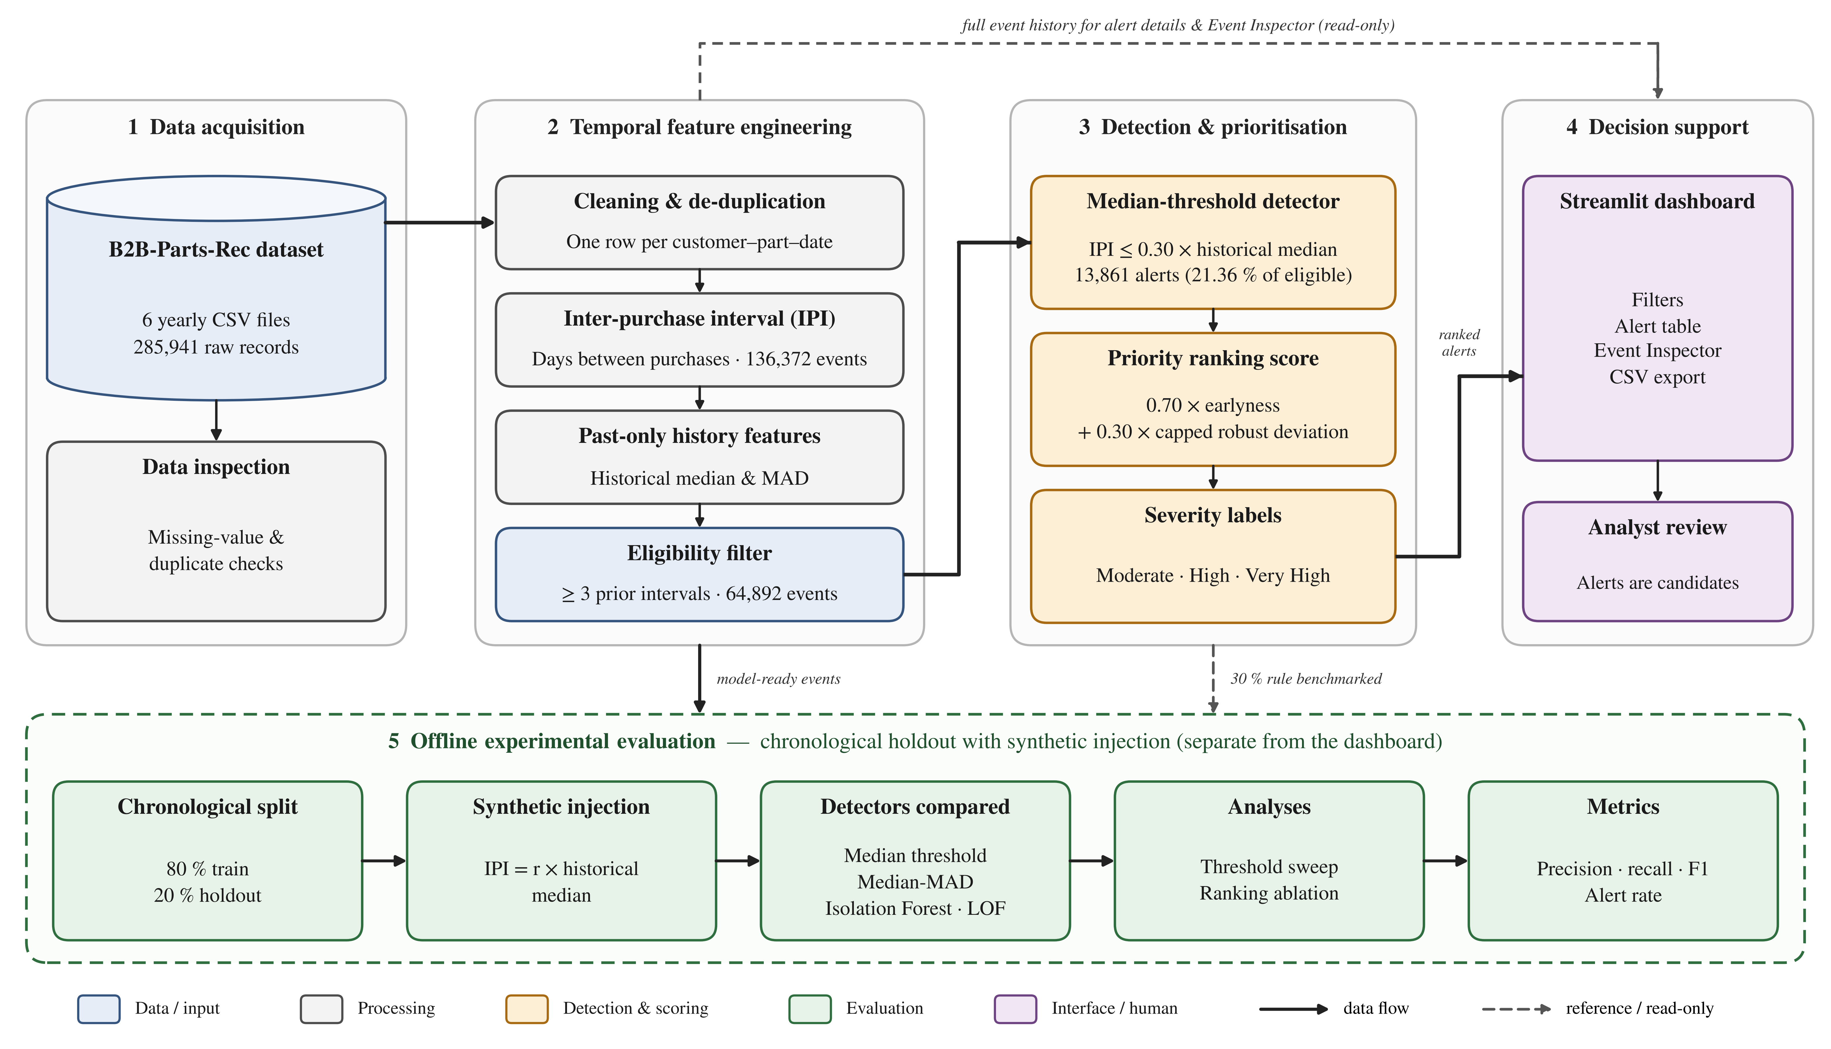
Fig. 1. System architecture of the implemented system: data acquisition, temporal feature engineering, detection and prioritisation, decision support (dashboard) and offline experimental evaluation.
Implementation Status and Results
All planned modules (data inspection, feature engineering, detection, ranking, dashboard and experimental evaluation) have been implemented and the full pipeline has been re-run end to end; the reported figures were reproduced from the retained result files. The main outcomes are summarised below.
Measure | Result | Basis / note
Raw records processed | 285,941 | Six yearly files, 2024–2029
Temporal purchase events | 136,372 | 34,664 customer–part groups
Eligible events (≥ 3 prior intervals) | 64,892 | Population used for screening
Alerts, 30% rule (operating point) | 13,861 (21.36%) | Of 64,892 eligible events
Alerts, 50% / 40% / 20% rule | 19,983 / 17,217 / 10,234 | 30.79% / 26.53% / 15.77% of eligible events
Review volume, 30% vs 50% rule | 6,122 fewer (30.64%) | Fewer alerts; not proof of fewer false positives
Median rule (30%), synthetic 30% injection | 100% detection, 83.78% precision | Controlled test; same ratio as the rule, so near-perfect by construction
Median–MAD (z ≥ 3) | 8.67% detection, 72.67% precision | Controlled test, 12,979 holdout events
Isolation Forest | 7.24% detection, 52.31% precision | Controlled test; 5% contamination setting
Local Outlier Factor | 12.03% detection, 57.45% precision | Controlled test; 35 neighbours
Ranking ablation, Recall@150 | Robust-only 0.92%; combined 70/30 0.00% | Maximum possible is 1.16%; 70/30 score is a heuristic
These metrics come from controlled synthetic cases compared against a natural reference group; no verified real-world anomaly labels are available, so they must not be read as real-world accuracy. Source code: github.com/codepool1437/Major_Project. A research paper in IEEE conference format has been prepared from these results.
Environment
The project considers environmental sustainability through computational efficiency. The system uses a small set of temporal features (seven numeric features for the machine learning benchmarks) and lightweight models, and runs on a CPU without a GPU. Measured resource use of the implemented system is given below.
Parameter | Manual Analysis | Implemented ML System
Processing time | Not measured (no manual baseline available) | 1.4 s to score and rank all 64,892 eligible events; 21.6 s for the full detector comparison (Isolation Forest and LOF at four injection ratios)
CPU utilization | Not measured (no manual baseline available) | 0.9 s CPU time (scoring); 22.3 s CPU time (detector comparison); CPU only
Memory usage | Not measured (no manual baseline available) | Peak 133 MB (scoring); 303 MB (detector comparison)
Measured on a 2-vCPU, 8 GB Linux container (Python 3.13, pandas 3.0.5, scikit-learn 1.9.1). The one-time feature-engineering step is slower because of expanding historical MAD calculations. No manual-analysis baseline was recorded, so no time saving is claimed.

Sustainability:
Sustainability addresses both technical longevity and operational efficiency. The implemented system is a modular framework in which new procurement datasets, temporal features and machine learning models can be incorporated without redesigning the complete system.
Project-specific considerations: the system is implemented to be:
- Modular: separate scripts for data inspection, interval and feature construction, scoring, evaluation, reporting and the dashboard.
- Maintainable: version-controlled on GitHub with a README, pinned requirements and an artifact manifest listing every retained output.
- Reproducible: the full pipeline can be re-run from the raw files, and a clean-environment install and dashboard start-up check passed.
- Adaptable: new detectors and additional temporal features can be added to the same feature table.
- Reusable across B2B procurement datasets that provide customer, part and date fields.
Safety and Security:
The system focuses on careful handling of procurement data and on avoiding misleading alerts. The prototype runs locally on file-backed data; user authentication and access control have not been implemented and are listed as future work for any deployment.
Project-specific Safety and Security considerations:
- Privacy: the dataset is anonymised, and only customer ID, part ID and request date are used for analysis.
- Input validation: required-column checks, date parsing, removal of incomplete records and eligibility rules; the dashboard stops with a clear message if required files or columns are missing.
- Misleading alerts: alerts are labelled as screening candidates, each carries a text reason, and cases with zero historical MAD are explicitly flagged for cautious interpretation.
- Data protection: original raw files are never modified; derived data and results are stored separately.
- Traceability: ranked alerts, summaries and evaluation outputs are retained as files for verification.
Ethical Considerations
The project addresses data privacy and responsible use of machine learning-based procurement anomaly detection.
Important considerations:
- Data Privacy: the public dataset is anonymised; only the fields required for temporal analysis are used and the price field is not used.
- Algorithmic Fairness: a systematic analysis of alert rates across customer or part groups was not performed in this phase and is identified as future work.
- Responsible Alerts: predictions are treated as early warnings for human review, not automatic decisions; the dashboard states that alerts are not confirmed anomalies.
- Data Integrity: missing values and duplicates were checked, and edge cases (zero intervals, missing history, zero historical MAD) were verified before reporting results.
Cost and Economic Feasibility:
The system was built with open-source software and a public dataset, so there are no licence or paid-cloud costs; however, the project is not cost-free. Its cost consists mainly of team labour, supervision, use of personal computing devices and utilities. An estimate of the development cost is given below, together with a projected yearly operating cost if the system were deployed. All amounts are estimates based on the stated assumptions, not audited expenses. The economic benefit has not been measured: the dataset has no quantities, outcomes or expert labels, so no cost, waste or inventory saving is claimed. The only measured quantity is review volume: the 30% rule produces 6,122 (30.64%) fewer alerts than the 50% rule.
Cost factors
- Dataset preparation and storage (local files).
- Model development and evaluation (completed).
- Computing infrastructure (standard CPU; no GPU).
- Early-warning dashboard development (completed).
- Database and data storage (file-based; no database server).
- Hosting and deployment (not deployed; runs locally).
- System maintenance.
- Model retraining and updates.
Estimated development cost
Cost item | Basis / assumption | Estimated cost (INR)
Student labour (4 members) | 4 × 112 h (about 8 h/week for 14 weeks) × INR 200/h notional rate | 89,600
Guide supervision (notional) | 14 h (about 1 h/week) × INR 1000/h | 14,000
Laptops / computing devices | 4 laptops at INR 60,000 each, 3-year life, 4 months of use (depreciation) | 26,667
Electricity | About 27 kWh (4 laptops × 60 W × 112 h) at INR 8/kWh | 215
Internet connectivity | INR 600/month × 4 months × 4 members × 50% project share | 4,800
Software, tools and dataset | Python, pandas, scikit-learn, Streamlit, Git/GitHub, LaTeX and the public Zenodo dataset are free / open source | 0
Miscellaneous | Printing, report binding, stationery, backup storage | 2,500
Total estimated development cost | Sum of the items above | 137,782
Labour is valued at a notional entry-level engineering rate; no money was actually paid to team members or the guide. Laptops were already owned, so only depreciation for the project period is counted.
Projected operating cost if deployed (not incurred)
Cost item | Basis / assumption | Projected cost per year (INR)
Hosting | Small cloud VM (2 vCPU, 4 GB) at about INR 1,200/month; CPU-only workload | 14,400
Maintenance and retraining | 40 h/year (data refresh, threshold review, retraining) × INR 400/h | 16,000
Storage and backup | Processed data and result files (under 1 GB) | 1,200
Total projected operating cost | Sum of the items above | 31,600
Deployment is not part of this project; these figures only indicate the order of magnitude of running the prototype for one organisation.
Potential economic benefits (not yet measured)
With field validation, the system could potentially reduce:
- Manual procurement analysis time.
- Effort required for identifying unusual reorder patterns.
- Repeated analysis of historical transactions.
- Time required for generating anomaly reports.
- Procurement monitoring effort.
Limitations and Future Work
- No verified labels for genuine early-reorder anomalies exist, so real-world precision and recall cannot be estimated; synthetic cases are constructed from the same interval ratio the rule tests.
- Only one chronological split was evaluated; the 70/30 ranking weights are heuristic and were not shown to beat robust-only ranking.
- A global fixed-day reorder baseline has not been compared, and the 30% operating point flags about one fifth of eligible events.
- Future work: expert review of sampled alerts, a global-rule baseline, repeated rolling evaluations, authentication for deployment and a fairness analysis across customers and parts.
SDG Project Mappings
The project aligns with the following Sustainable Development Goals (SDGs):
- SDG 9 – Industry, Innovation and Infrastructure:
A working, reproducible machine learning and statistical screening pipeline and dashboard for B2B procurement analytics was developed and tested (285,941 records processed; 64,892 events screened). This is a prototype and not an industrial deployment.
- SDG 12 – Responsible Consumption and Production:
The system gives analysts a repeatable signal for unusually early replenishment (13,861 candidate events). This is a potential contribution to more informed purchasing; reductions in waste, cost, inventory or emissions have not been measured.
SDG | Project Contribution
SDG 9 – Industry, Innovation and Infrastructure | Reproducible procurement analytics pipeline and early-warning dashboard (prototype)
SDG 12 – Responsible Consumption and Production | Ranked early-reorder candidates for review (13,861 alerts, 21.36% of eligible events); impact not measured

FF No 180

Group No.
Activity | Review Schedule | Progress Review Report submitted | Signature of Guide
Review 1 | Mid Sem. Semester | Yes / No
Review 2 | End of Semester | Yes / No

Format of Progress Review Report:

Review No.: 1 Group No.: Date:

Progress Review Report

Signature of Guide:

Review No.: 2 Group No.: Date:

Progress Review Report

Signature of Guide:

