 | Title : Project Registration & Progress Review |  | FF No. 180
Department: Computer |  | Academic Year: 2026-27
Semester : VII |  | Group No. : 21
Project Title: Predictive SLA-Aware API Gateway Scheduling Using Hybrid DRR-EDF
Project Area: Cloud Computing & Machine Learning
Group Members Details:

Sr. No. | Class & Div. | Roll No. | G.R.No. | Name of Student | Contact No. | Email ID
1 | BTech A | 421036 | 22310805 | Kaushal Borude | 8788331389 | kaushal.22310805@viit.ac.in
2 | BTech A | 421084 | 22310913 | Jaydip Chavan | 8591981125 | jaydip.22310913@viit.ac.in
3 | BTech A | 421134 | 22311223 | Anuj Khaire | 9644063337 | anuj.22311223@viit.ac.in
4 | BTech A | 421159 | 22311264 | Devanshu Nirmal | 8793029837 | devanshu.22311264@viit.ac.in

Name of Internal Guide: Prof. (Dr.) Rahul B. Diwate
Contact No. & Email ID:

Project approved / Not approved

Dr. Vijayendra S. Gaikwad Prof.(Dr.) Sandip R. Shinde
Guide Project Coordinator Head,
Department of Computer Engineering

T

FF No 180

Project Synopsis

Project Title
Predictive SLA-Aware API Gateway Scheduling Using Hybrid DRR-EDF

Introduction
Modern cloud computing relies heavily on API Gateways to route traffic, making queue management and Service Level Agreement (SLA) enforcement critical. When traffic surges occur, conventional reactive traffic-management mechanisms may struggle to maintain SLA requirements, leading to increased latency, timeouts, and resource exhaustion. This project introduces a predictive, AI-driven heuristic scheduler for API gateways. By combining the tier-based fairness of Deficit Round Robin (DRR), the strict deadline sorting of Earliest Deadline First (EDF), and proactive traffic forecasting using XGBoost, the system aims to honor enterprise SLAs while preventing server collapse during peak loads.
Review of Literature
Existing cloud schedulers primarily rely on static rate limiting or reactive algorithms. While Deficit Round Robin (DRR) provides efficient O(1)-style per-packet scheduling in typical implementations and provides fairness across traffic classes, it lacks strict time-based sorting. Many conventional gateway scheduling and rate-limiting approaches are primarily reactive, responding to traffic conditions after congestion has developed. The literature highlights a gap in integrating proactive workload forecasting using XGBoost with hybrid SLA-aware scheduling, and in rigorously evaluating such heuristics against optimization-based approaches such as MILP (Mixed-Integer Linear Programming).
Problem Statement and Objectives
Problem Statement: Unpredictable API traffic spikes overwhelm reactive gateways, causing congestion, high latency, SLA violations, and inefficient resource utilization.
Objectives:
- Develop a hybrid DRR-EDF scheduling algorithm and formally analyze its fairness and starvation properties.
- Integrate an AI forecasting model (XGBoost) to dynamically adjust DRR token allocations according to predicted demand, tier priority, and available system capacity.
- Maximize the Useful Work Ratio (completed non-expired requests / total processed requests) by dropping expired workloads.
- Benchmark the heuristic’s performance against a MILP. MILP will be used as an optimization oracle on smaller benchmark instances where exact optimization is computationally feasible.
System Architecture
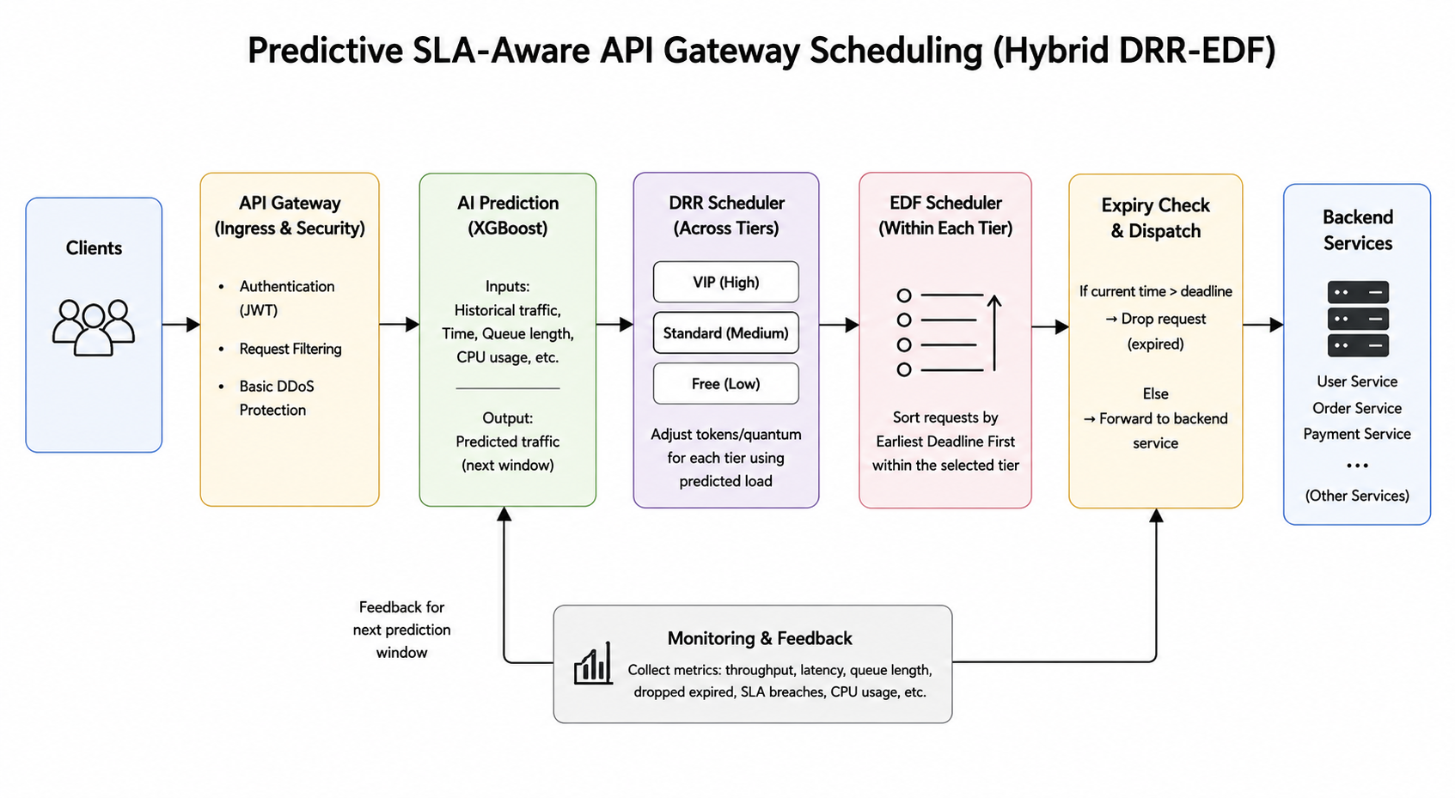
The proposed system is designed as a predictive API Gateway that combines workload forecasting with hybrid DRR-EDF scheduling to efficiently manage incoming API requests.
The architecture consists of the following major components:
- Clients: Clients send API requests to the gateway.
- API Gateway – Ingress & Security: The gateway receives and filters incoming requests. It performs basic authentication using JWT and request filtering before allowing requests into the scheduling system.
- AI Prediction – XGBoost: The XGBoost model forecasts the expected traffic for the upcoming time window using features such as historical request rate, time information, queue length, and CPU utilization.
- DRR Scheduler: Based on the predicted workload, the gateway dynamically adjusts the token/quantum allocation for different SLA tiers such as VIP, Standard, and Free. DRR ensures fair distribution of gateway resources across these tiers.
- EDF Scheduler: After DRR selects an SLA tier, requests within that tier are ordered according to their deadlines using Earliest Deadline First (EDF). This ensures that requests with more urgent SLA deadlines are processed first.
- Expiry Check & Dispatch: Before forwarding a request, the system checks whether its deadline has already expired. Expired requests are dropped to prevent unnecessary processing or phantom work. Valid requests are forwarded to the appropriate backend service.
- Backend Services: Valid requests are routed to the required backend microservices, such as User, Order, and Payment services.
- Monitoring & Feedback: The system continuously monitors metrics such as throughput, latency, queue length, CPU usage, dropped requests, and SLA breaches. These measurements provide feedback to the prediction component for subsequent forecasting windows.
Overall, the architecture aims to maximize useful work, minimize SLA breaches and wasted computation, maintain fairness between SLA tiers, and improve system resilience during traffic spikes.
Environment
The project considers environmental sustainability by focusing on computational efficiency. By proactively dropping expired requests and sorting active ones, the system aims to reduce wasted CPU cycles associated with processing requests that have already exceeded their deadlines. By minimizing unnecessary request processing and optimizing CPU utilization, the architecture may contribute to reduced energy consumption and cooling requirements during overload conditions.
Parameter | Legacy FIFO Gateway (Baseline) | Proposed Predictive DRR-EDF (Target)
Useful Work Ratio | Baseline | Significant Increase
CPU Thrashing During Spikes | High (Potential Crash) | Regulated (Graceful Degradation)
Dropped Expired Requests | Processed Unnecessarily | Discarded Proactively
SLA Breach Rate | Baseline | Minimized
P95/P99 Latency | High During Spikes | Reduced
Resource Utilization | Inefficient During Overload | Optimized
Fairness Across SLA Tiers | Limited | Controlled via DRR
Deadline-Aware Processing | No | EDF-Based

Actual experimental results and numerical data will be appended to the final report following benchmark testing.
Sustainability:
Sustainability addresses both technical longevity and operational efficiency. The Predictive Gateway is designed as a modular testbed, ensuring the scheduling research can accommodate new SLA tiers, datasets, and advanced AI models.
Project-specific considerations: The system is architected to be:
- Modular (strictly separating the AI, queuing, and routing layers).
- Maintainable and version-controlled.
- Scalable via containerized microservices.
- Capable of incorporating new user tiers/classes.
Student will submit the following in their final project report for Sustainability:
- Modular system architecture diagram.
- Formal algorithm analysis report.
- Version-controlled codebase.
Safety and Security:
While the gateway implements basic security, the core focus of the safety profile is on system resilience. The project ensures safety by preventing catastrophic server failures (such as Out-of-Memory crashes) during extreme traffic anomalies.
Project-specific Safety considerations:
- Prevention of OOM crashes via strict token-based rate limiting.
- Graceful degradation of service by reducing resource allocation to lower-priority tiers while maintaining minimum service guarantees where applicable.
- Mitigation of retry storms through rate limiting and controlled request rejection.
Student will include a System Resilience Test report (Load/Stress Testing) in their final project report
Ethical Considerations
The project addresses algorithmic fairness and data privacy.
Important considerations:
- Algorithmic Fairness: The interaction between dynamic DRR allocation and EDF will be evaluated to determine whether higher-priority SLA tiers cause unacceptable starvation of lower-priority tiers.
- Data Privacy: The scheduling layer will avoid inspecting application payloads and will minimize the collection and storage of request metadata. Only metadata necessary for routing, scheduling, and performance measurement will be processed.
Students will include data privacy and algorithmic fairness declarations in their final report
Cost and Economic Feasibility:
The economic feasibility of the Predictive Gateway is evaluated by comparing the cost of traditional infrastructure auto-scaling against the operational efficiency of the proposed system.
Potential economic benefits:
- Reduction in SLA Penalty payouts to enterprise clients.
- Minimization of unnecessary cloud auto-scaling costs (spinning up servers reactively to handle phantom work).
Conventional Reactive Scaling vs. Predictive Gateway:
Parameter | Reactive Auto-Scaling | Predictive DRR-EDF Gateway
Primary response | Changes infrastructure capacity | Controls request scheduling
Response | Typically slower infrastructure scaling | Fast scheduling adjustment
Main purpose | Increase/decrease compute capacity | Manage available capacity efficiently
  SLA protection
  May react after congestion begins
  Can proactively prioritize and control traffic

FF No 180

Group No.
Activity | Review Schedule | Progress Review Report submitted | Signature of Guide
Review 1 | Mid Sem. Semester | Yes / No
Review 2 | End of Semester | Yes / No

Format of Progress Review Report:

Review No.: 1 Group No.: Date:

Progress Review Report

Signature of Guide:

Review No.: 2 Group No.: Date:

Progress Review Report

Signature of Guide:

