Department: Computer Engineering | Academic Year: 2026-27
Semester : VII | Group No. : 04
Project Title: Predictive SLA-Aware API Gateway Scheduling Using Hybrid DRR-EDF
Subject : Operation Research
Group Members Details:

Sr. No. | Class & Div. | Roll No. | G.R. No. | Name of Student | Contact No. | Email ID
1 | BTech A | 421036 | 22310805 | Kaushal Borude | 8788331389 | kaushal.22310805@viit.ac.in
2 | BTech A | 421084 | 22310913 | Jaydip Chavan | 8591981125 | jaydip.22310913@viit.ac.in
3 | BTech A | 421134 | 22311223 | Anuj Khaire | 9644063337 | anuj.22311223@viit.ac.in
4 | BTech A | 421159 | 22311264 | Devanshu Nirmal | 8793029837 | devanshu.22311264@viit.ac.in

Name of Guide: Dr. Shweta Aditya Tiwaskar

Project Title
Predictive SLA-Aware API Gateway Scheduling Using Hybrid DRR-EDF

Introduction
API gateways manage incoming requests between clients and backend services in cloud-based applications. As request traffic fluctuates, efficient request scheduling becomes essential to maintain response times, ensure fair resource allocation, and satisfy Service Level Agreement (SLA) requirements [1], [2].
Deficit Round Robin (DRR) promotes fair resource allocation among different traffic classes [3], while Earliest Deadline First (EDF) prioritizes requests according to their deadlines [4]. This project proposes investigating a hybrid DRR–EDF scheduling approach that combines fairness across traffic classes with deadline-aware request prioritization. In addition, a machine learning (ML) component will be explored to predict workload conditions and dynamically adjust selected scheduling parameters, enabling the scheduler to adapt to changing traffic patterns.
The proposed approach will be implemented and compared with baseline scheduling methods under different workload conditions. Its performance will be evaluated using response time, throughput, SLA violation rate, and fairness to assess its effectiveness in managing API requests while balancing service quality and resource allocation.
Problem Statement
Unpredictable variations in API request traffic can contribute to queue congestion, increased response times, and violations of Service Level Agreements (SLAs). Related studies on cloud queueing and SLA-aware task scheduling have examined these challenges under dynamic workload conditions [5], [6], [7]. Conventional scheduling approaches may struggle to balance fair resource allocation across traffic classes with the deadline requirements of individual requests. Therefore, this project aims to investigate a hybrid Deficit Round Robin (DRR) and Earliest Deadline First (EDF) scheduling approach for SLA-aware API gateway management, incorporating machine learning to predict workload conditions and dynamically adjust selected scheduling parameters.
Objectives
- To study Deficit Round Robin (DRR) and Earliest Deadline First (EDF) scheduling techniques for API request scheduling.
- To develop a hybrid DRR–EDF scheduling approach that considers fairness across traffic classes and the deadlines of individual requests.
- To investigate the use of machine learning for predicting workload conditions and dynamically adjusting selected scheduling parameters in response to variations in API traffic.
- To compare the proposed scheduling approach with baseline scheduling methods under different workload conditions.
- To evaluate the performance of the proposed approach using response time, throughput, SLA violation rate, and fairness.
Review of Literature
Research on cloud workload forecasting has highlighted the importance of predicting resource demand to improve resource allocation and service quality. Studies have explored Bayesian deep learning and probabilistic Long Short-Term Memory (LSTM) models to forecast cloud workloads while accounting for prediction uncertainty. Findings indicate that uncertainty-aware forecasting and transfer learning can support more effective resource management under changing workload conditions [8], [9], [10], [11]. These studies highlight the potential of workload prediction as a foundation for adaptive scheduling.
Research on cloud task scheduling has investigated techniques that incorporate task priorities and deadline requirements into scheduling decisions. Fuzzy logic controllers and heuristic-based task scheduling methods have been explored to prioritize tasks according to their importance and deadlines [12], [5], [6], [7], [13], [14]. Such approaches demonstrate the relevance of deadline-aware scheduling in cloud environments. However, scheduling cloud computing tasks differs from managing individual API requests while maintaining fair service allocation across multiple traffic classes [1], [2].
Studies on cloud load balancing have also examined probabilistic models and optimization algorithms for distributing workloads across heterogeneous cloud environments. These approaches consider resource-related factors such as CPU utilization, memory, bandwidth, and latency to improve load distribution and resource utilization [15]-[21]. Simulation-based evaluations have reported improvements in metrics such as makespan, response time, and resource utilization [15], [16], [17], [19]. However, resource allocation across cloud platforms differs from request-level scheduling within an API gateway, where fairness and individual request deadlines must also be considered [1], [2], [6], [7].
The existing research provides useful insights into workload prediction, deadline-aware scheduling, and adaptive load balancing. However, combining these aspects into a unified approach for SLA-aware API gateway scheduling remains an area for further investigation. The proposed work aims to investigate a hybrid Deficit Round Robin (DRR) and Earliest Deadline First (EDF) scheduling approach, where DRR manages fair service allocation across traffic classes and EDF prioritizes requests according to their defined deadlines. A machine learning component will be explored to predict workload conditions and dynamically adjust selected DRR scheduling parameters in response to changing traffic patterns. The proposed approach will be compared with baseline scheduling methods under different workload conditions and evaluated using response time, throughput, SLA violation rate, and fairness.

Research Gap
Existing research has investigated cloud workload prediction, fair scheduling, deadline-aware task scheduling, and SLA-aware resource management [8], [12], [9], [1], [6], [7], [16]. Related work has also explored DRR-based priority-aware scheduling for API gateways to support service differentiation and SLA requirements [22]. However, the integration of DRR-based fair service allocation across API traffic classes, EDF-based deadline prioritization within the selected class, and machine learning-based adaptation of selected DRR scheduling parameters warrants further investigation. This project aims to investigate this combination and compare its performance with baseline scheduling methods under different workload conditions.
Novelty of the Proposed Work
The proposed work investigates a hybrid Deficit Round Robin (DRR) and Earliest Deadline First (EDF) scheduling approach for SLA-aware API gateway management. It focuses on combining fair resource allocation across traffic classes with deadline-based prioritization of individual requests. Additionally, it incorporates a machine learning component to predict workload conditions and dynamically adjust selected DRR scheduling parameters in response to changing traffic patterns. The approach will be evaluated under different workload scenarios to examine its effectiveness in balancing fairness, response time, throughput, and SLA compliance.
Proposed Methodology
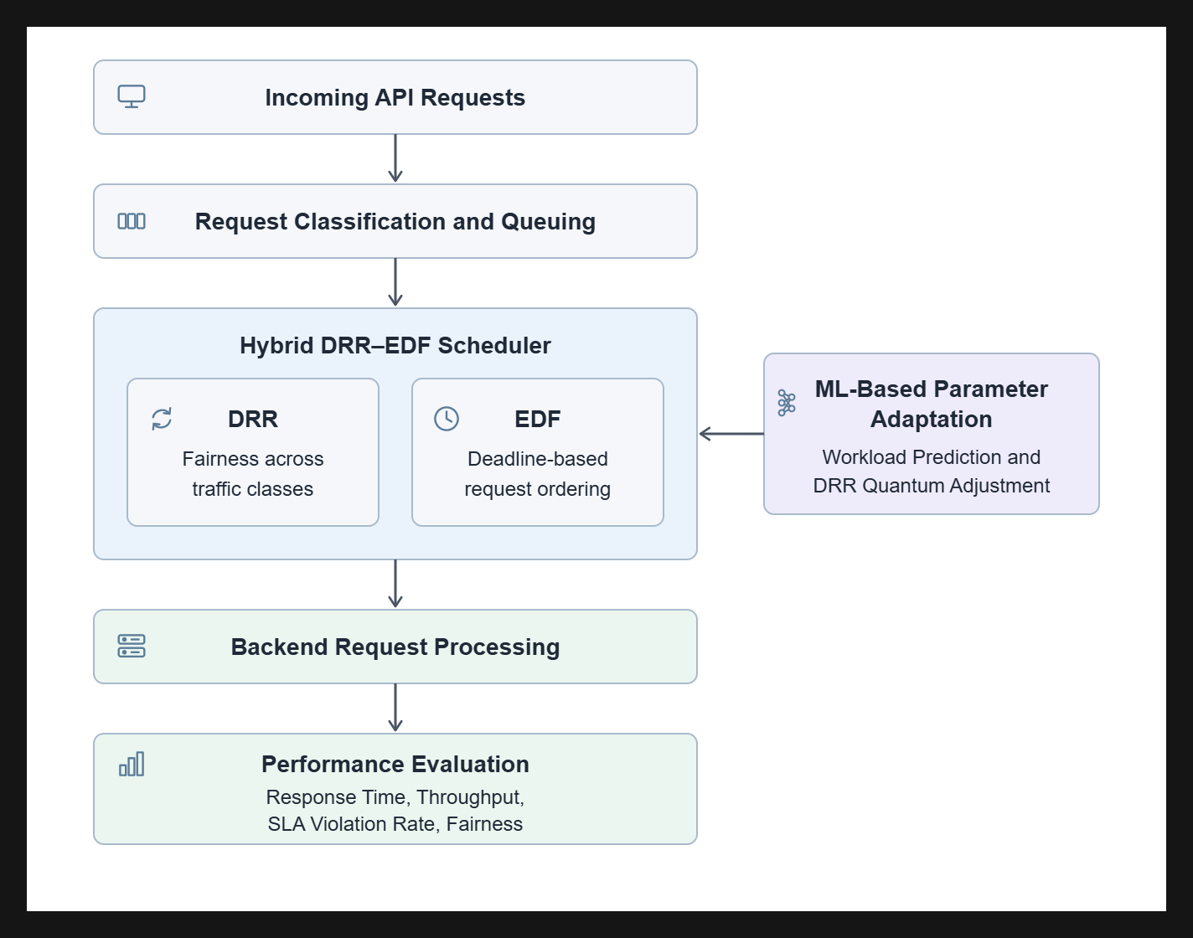Figure 1: Proposed System Architecture
The proposed system will combine Deficit Round Robin (DRR) and Earliest Deadline First (EDF) scheduling with a machine learning component to investigate SLA-aware API request scheduling under varying workload conditions. The methodology will consist of the following stages:
- Request Classification and Queuing: Incoming API requests will be classified into traffic classes based on their service-level requirements. Each request will be assigned a deadline according to the applicable SLA or request policy and placed in the corresponding queue.
- Hybrid DRR–EDF Scheduling: DRR will be used to manage fair service allocation across traffic classes through deficit-based scheduling. Once a traffic class is selected for service, EDF will prioritize requests within that class according to their deadlines. This combination will be investigated to balance fairness and deadline-aware request processing.
- ML-Based Parameter Adaptation: A machine learning component will analyze workload information and predict incoming traffic conditions. Based on these predictions, the system will dynamically adjust selected DRR scheduling parameters, such as the quantum allocated to different traffic classes. The adjustment mechanism will be designed to respond to workload variations while maintaining the scheduling policy and predefined request deadlines.
- Request Processing and Performance Monitoring: Selected requests will be forwarded for backend processing, while relevant performance information will be collected. The proposed scheduler will be compared with baseline scheduling methods under different workload conditions.
- Performance Evaluation: The system will be evaluated using response time, throughput, SLA violation rate, and fairness. The results will be analyzed to understand the trade-offs between fair resource allocation, deadline compliance, and scheduling performance.
The overall system architecture will consist of an API request input layer, request classification and queue management, the hybrid DRR–EDF scheduling mechanism, an ML-based parameter adaptation component, and backend request processing. A performance monitoring component will collect evaluation metrics to assess the effectiveness of the proposed approach under different workload scenarios.
Expected Outcomes
The project is expected to develop and evaluate a hybrid DRR–EDF scheduling approach for SLA-aware API gateway management. The proposed system will incorporate workload prediction to support dynamic adjustment of selected scheduling parameters under varying traffic conditions. Through experimental evaluation, the project aims to analyze the trade-offs between fairness, request deadlines, response time, throughput, and SLA violations. The results will provide insights into the effectiveness and practical suitability of the proposed scheduling approach compared with baseline scheduling methods.
Conclusion
The proposed project aims to investigate a predictive, SLA-aware API gateway scheduling approach by combining Deficit Round Robin (DRR) and Earliest Deadline First (EDF) scheduling techniques with machine learning-based workload prediction. DRR will support fair service allocation across traffic classes, while EDF will prioritize individual requests according to their defined deadlines. The machine learning component will be explored to predict workload variations and dynamically adjust selected DRR scheduling parameters. The proposed approach will be evaluated against baseline scheduling methods under different workload conditions using response time, throughput, SLA violation rate, and fairness. The project is expected to provide insights into the effectiveness of combining fair scheduling, deadline-based prioritization, and workload prediction to improve API request management while balancing service quality and resource allocation.
References
[1] P. Zhang, L. Xiang, Z. Song, et al., “Adaptive Load Balancing and Fault-Tolerant Microservices Architecture for High-Availability Web Systems Using Docker and Spring Cloud,” Discover Applied Sciences, vol. 7, Art. no. 705, 2025. https://doi.org/10.1007/s42452-025-07320-7
[2] N. G. Axak and Yu. O. Shelikhov, “Intelligent Load Balancing in Microservice Architecture,” Systems and Technologies, vol. 70, no. 2, pp. 210–218, 2025. https://doi.org/10.32782/2521-6643-2025-2-70.23
[3] M. Shreedhar and G. Varghese, “Efficient Fair Queueing Using Deficit Round Robin,” in Proceedings of the ACM SIGCOMM Conference, 1995, pp. 231–242. https://doi.org/10.1145/217382.217453
[4] C. L. Liu and J. W. Layland, “Scheduling Algorithms for Multiprogramming in a Hard-Real-Time Environment,” Journal of the ACM, vol. 20, no. 1, pp. 46–61, 1973. https://doi.org/10.1145/321738.321743
[5] H. Chaudhary, G. Sharma, D. K. Nishad, et al., “AI-Enhanced Modelling of Queueing and Scheduling Systems in Cloud Computing,” Discover Applied Sciences, vol. 7, Art. no. 276, 2025. https://doi.org/10.1007/s42452-025-06755-2
[6] B. Narsimhulu and T. Sampath Kumar, “A Hybrid RL–GA–LSTM–AE Framework for Energy-Aware and SLA-Driven Task Scheduling in Cloud Computing Environments,” Scientific Reports, vol. 16, Art. no. 14961, 2026. https://doi.org/10.1038/s41598-026-43108-4
[7] N. Yamsani and C. Reddy P., “SLA-Aware Deep Reinforcement Learning for Adaptive Edge-Cloud Task Scheduling,” Scientific Reports, vol. 16, Art. no. 10037, 2026. https://doi.org/10.1038/s41598-026-40237-8
[8] A. Rossi, A. Visentin, D. Carraro, S. Prestwich, et al., “Forecasting Workload in Cloud Computing: Towards Uncertainty-Aware Predictions and Transfer Learning,” Cluster Computing, vol. 28, Art. no. 258, 2025. https://doi.org/10.1007/s10586-024-04933-2
[9] G. Zhang, X. He, and X. Wang, “PCL-RC: A Parallel Cloud Resource Load Prediction Model Based on Feature Optimization,” Journal of Cloud Computing, vol. 14, Art. no. 45, 2025. https://doi.org/10.1186/s13677-025-00770-9
[10] S. S. Sefati, M. Keymasi, R. Craciunescu, S. Maiduc, M. Bayram, et al., “Adaptive Resource Scheduling in Multi-Cloud Computing Using Recurrent Neural Forecasting and Memory-Based Metaheuristic Optimization,” Journal of Grid Computing, vol. 23, Art. no. 26, 2025. https://doi.org/10.1007/s10723-025-09812-7
[11] F. Agulló, A. Gutiérrez-Torre, J. Torres, and J. Ll. Berral, “Enhancing the Output of Time Series Forecasting Algorithms for Cloud Resource Provisioning,” Future Generation Computer Systems, vol. 170, Art. no. 107833, 2025. https://doi.org/10.1016/j.future.2025.107833
[12] S. Qamar, N. Ahmad, and P. M. Khan, “Task Scheduling for Public Clouds Using a Fuzzy Controller-Based Priority- and Deadline-Aware Approach,” Future Internet, vol. 17, no. 4, Art. no. 148, 2025. https://doi.org/10.3390/fi17040148
[13] F. Naaz, A. Chinmay, and A. Pattanaik, “QoS-Aware Deep Reinforcement Learning Technique for Task Scheduling in Cloud Computing,” Discover Computing, vol. 29, Art. no. 185, 2026. https://doi.org/10.1007/s10791-026-09996-w
[14] P. Lin and L. Wang, “Hierarchical SLA-Aware Multi-Objective Task Scheduling in Multi-Access Edge Computing Using Fuzzy-AHP and Queue Stability Modeling,” Journal of Cloud Computing, 2026. https://doi.org/10.1186/s13677-026-00967-6
[15] A. Rathee, S. Dalal, and K. B. Adem, “Optimizing Cloud Resource Allocation with an Integrated XGBoost–RFOA Model,” Journal of Cloud Computing, vol. 15, Art. no. 45, 2026. https://doi.org/10.1186/s13677-026-00850-4
[16] S. S. Sefati, A. M. Nor, B. Arasteh, R. Craciunescu, et al., “A Probabilistic Approach to Load Balancing in Multi-Cloud Environments via Machine Learning and Optimization Algorithms,” Journal of Grid Computing, vol. 23, Art. no. 16, 2025. https://doi.org/10.1007/s10723-025-09805-6
[17] N. S. Albalawi, “Dynamic Scheduling Strategies for Cloud-Based Load Balancing in Parallel and Distributed Systems,” Journal of Cloud Computing, vol. 14, Art. no. 33, 2025. https://doi.org/10.1186/s13677-025-00757-6
[18] Z. Bouflous, F. Haraka, M. Ouzzif, and K. Bouragba, “An Optimized Bias-Resilient Double-Indexed Throttled Scheduling Algorithm for Fair and Efficient Load Balancing in Cloud Datacenters,” Journal of Cloud Computing, vol. 15, Art. no. 101, 2026. https://doi.org/10.1186/s13677-026-00924-3
[19] T. Hagras and G. A. El-Sayed, “A Fault-Tolerant and Load-Balancing Scheduler for Independent Tasks on Cloud-Based Virtual Machines,” Cluster Computing, vol. 29, Art. no. 61, 2026. https://doi.org/10.1007/s10586-025-05857-1
[20] U. K. Lilhore, S. Simaiya, K. B. V. Brahma Rao, et al., “Hybrid DRL-Enhanced ACO-WWO for Efficient Resource Allocation and Load-Balancing in Cloud Computing,” International Journal of Computational Intelligence Systems, vol. 18, Art. no. 148, 2025. https://doi.org/10.1007/s44196-025-00882-9
[21] U. K. Lilhore, S. Alex, V. Paul, et al., “QHRMOF: A Quantum-Inspired Hybrid Multi-Objective Framework for Energy-Efficient Task Scheduling and Load Balancing in Cloud Computing,” Journal of Cloud Computing, vol. 14, Art. no. 54, 2025. https://doi.org/10.1186/s13677-025-00777-2
[22] A. B. Lalam, “Priority-Aware Fair Queuing for Multi-Tier Cloud API Gateways,” SSRN, 2026. https://doi.org/10.2139/ssrn.6519598

