**CHAPTER 1**

**INTRODUCTION**

This project involves thorough research into various methods for anonymous crime tip submission by witnesses. In today's world, crime rates are escalating alongside advancements in crime-fighting technology. However, a significant number of people worldwide still hesitate to report crimes they witness, fearing complex procedures and interrogations. Our project aims to encourage citizens to fulfill their social responsibility by reporting crimes they witness without fearing reprisals. Additionally, the project seeks to incentivize anonymous tip providers to increase their engagement. The system's operation also simplifies and reduces the cost of crime documentation by utilizing decentralized storage methods. This not only enhances information security but also minimizes server costs. The platform is particularly valuable to crime investigators, especially undercover agents relying on insider information.

**1.1 Motivation**

Overall, the title effectively conveys the purpose and functionality of the platform, highlighting its emphasis on anonymity, broad scope, and its role in facilitating the reporting of suspicious activities or crimes to the authorities.

**Core Functionality:** The title indicates that the platform serves as a means for individuals to report suspicious activities or crimes to the authorities. This suggests that the platform provides a specific mechanism or channel for submitting such reports, which may include features such as online forms, chat support, or dedicated hotlines.

**Anonymity:** The title emphasizes that the reporting process is anonymous, meaning that individuals can submit reports without revealing their identity. This is crucial for encouraging people to come forward with information, as it helps alleviate concerns about potential reprisals or retaliation from those involved in the reported activities.

**Reassurance:** By highlighting the anonymity of the reporting process, the title aims to reassure potential users that their identity will be protected. This reassurance is essential for building trust in the platform and encouraging more people to use it to report suspicious activities or crimes.

**Scope:** The use of the term "suspicious activity/crime" in the title indicates that the platform is not limited to reporting only serious crimes. Instead, it is designed to accommodate reports of any behavior that may raise concerns or suspicions.

**1.2 Our Mission**

The mission of this project is to provide a secure and accessible platform for individuals to report suspicious activities or crimes to the authorities. The project aims to empower citizens to fulfill their social responsibility by enabling them to report such incidents without fear of reprisal. By emphasizing anonymity and providing a user-friendly interface, the project seeks to encourage more people to come forward with information, thereby helping authorities detect and prevent criminal activities. Additionally, the project aims to enhance the efficiency of crime documentation and reduce costs through the use of decentralized storage methods. Ultimately, the mission is to create a platform that not only promotes social responsibility but also facilitates effective collaboration between citizens and law enforcement agencies to ensure safer communities.

**CHAPTER 2**

**LITERATURE REVIEW**

Recent advancements in machine learning, mobile edge computing (MEC), and the Internet of Things (IoT) have propelled artificial intelligence (AI) to the forefront of emerging technologies. Traditionally, machine learning relied on centralized servers for collecting and processing training data. However, decentralized machine learning approaches and MEC now enable on-device data training within the IoT. This allows AI to be implemented at the edge of the network, with IoT devices offloading training tasks to MEC servers. Despite these benefits, the distributed frameworks of edge intelligence present new challenges, such as user privacy and data security. To address these challenges, blockchain technology is being explored as a promising solution.

Blockchain is widely recognized as a distributed smart ledger, known for its high scalability, privacy preservation, and decentralization. It features automated script execution and maintains immutable data records in a trusted manner. However, with the increasing promise of quantum computers in recent years, blockchain also faces potential threats from quantum algorithms.

In [1], the authors provide an overview of the current state-of-the-art in cutting-edge technologies by summarizing the available literature in the research fields of blockchain-based Mobile Edge Computing (MEC), machine learning, secure data sharing, and a basic introduction to post-quantum blockchain. The advancement of web technology has led to a vast amount of data on the internet, with a significant volume being generated continuously. The internet has evolved into a platform for online learning, idea exchange, and opinion sharing. Social networking sites such as Twitter, Facebook, and Google+ are increasingly popular, enabling users to share views, engage in discussions with various communities, and post messages globally. There has been significant research in sentiment analysis of Twitter data, focusing on analyzing opinions in tweets, which are often unstructured, heterogeneous, and either positive, negative, or neutral.

[2] Presents a survey and comparative analysis of existing techniques for opinion mining, including machine learning and lexicon-based approaches, along with evaluation metrics. The research focuses on Twitter data streams, employing various machine learning algorithms such as Naive Bayes, Max Entropy, and Support Vector Machine. The study also discusses general challenges and applications of sentiment analysis on Twitter.

In today's information age, many documents in different Indian languages are available in digital form. To facilitate the easy retrieval of these digitized documents, they must be classified according to their content. Text Classification, a subfield of Text Mining, addresses this challenge by assigning classes to documents. [3] analyzes Text Classification works conducted on Indian language content, highlighting the challenges posed by text in Indian languages. The study indicates that supervised learning algorithms (such as Naive Bayes, Support Vector Machine, Artificial Neural Network, and N-gram) perform well for Text Classification tasks.

Police researchers have often argued that positive evaluations of the police lead to increased citizen cooperation. However, this assumption has received little empirical study. [6] examines the association between attitudes toward the police and crime reporting behavior of victims. Using field data collected in Ghana, the study reveals that victims' confidence in and satisfaction with the police positively influence their decisions to report sexual assault and robbery. Additionally, the study identifies age, marital status, and employment status as predictors of victims' reporting behavior, highlighting practical and theoretical implications.

Non-fungible tokens (NFTs) are a unique type of blockchain-based tokens introduced in late 2017. While fungible tokens have enabled new use cases such as Initial Coin Offerings, the potential of NFTs remains unclear. [8] addresses this gap by demonstrating the efficacy of NFTs in event ticketing. The study follows a design science research approach, designing, building, and evaluating a prototype event ticketing system based on NFTs. The authors show how NFTs can tokenize digital goods, prevent fraud, and improve control over secondary market transactions. The study contributes generalizable knowledge on the benefits and challenges of NFTs, proposing managerial recommendations for building applications utilizing NFTs.

**CHAPTER 3**

**ANALYSIS OF PROBLEM**

**PROBLEM STATEMENT**

Solving crimes poses significant challenges for law enforcement, with one of the key hurdles being the need for witnesses and callers to provide reliable information about suspects. Without such crucial details, solving crimes becomes exceedingly difficult. Many individuals hesitate to report crimes, fearing involvement in legal processes. This reluctance is a global phenomenon, with people often preferring to avoid court appearances or putting themselves or their families at risk.

To address these challenges, a system is proposed where users can upload details of crimes anonymously through a guest account. The system includes a super admin account for overseeing reports nationwide, state admin accounts for managing reports from specific cities, and khabri (agent) accounts for providing tips to the relevant admin. Additionally, there is a guest page for public messages, eliminating the need for login credentials.

**CHAPTER 4**

**PROPOSED WORK**

* 1. **PROPOSED WORK**

There may be a number of reasons why people hesitate to come forward and report crimes, some of them include the following:

• There is a lack of trust in the police force. Individuals are concerned that reporting an incident to the police may lead to an investigation of their own circumstances.

• Interactions with police officers are often cumbersome and unpleasant. Reporting individuals may be repeatedly contacted, adding to the hassle.

• Fear of potential consequences is a significant deterrent. Even if law enforcement promises anonymity, individuals worry that their names may still be accessible through records.

To avoid such type of problem we proposed a tip off system which is related to crime activity. In the Tip-off system we have introduced 4 modules:

* Guest Module: In this module, users can upload details of a crime without revealing their personal identity.
* Super Admin Module: This module enables the system to access reports from all over India.
* State Admin Module: This module allows the system to access reports from specific cities within a state.
* Agent (Khabari) Module: Users with this module have login credentials to provide tips to the relevant admin. They can also post public messages on the guest page without the need for login.
  1. **OBJECTIVES**

The main objectives of our project include:

* Ensure Anonymity of users who give tips about a crime
* To Increased Response from citizens
* Reward users who have given a valid tip
* Provide Better insights to law enforcement for Investigation
* Establishing a platform to access proofs and documentation of crime
* Reduce Paperwork

**CHAPTER 5**

**SYSTEM ARCHITECTURE**

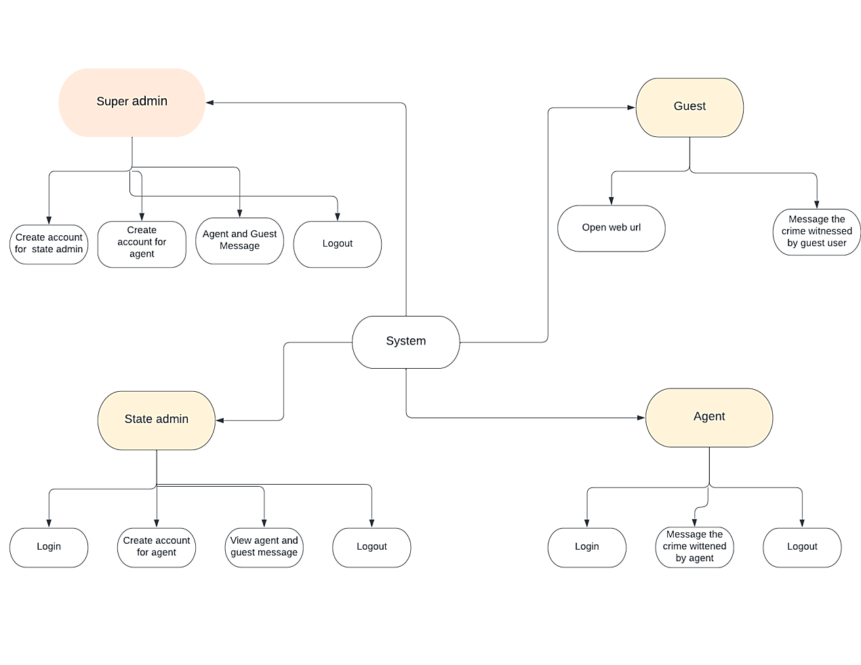

**Figure5.1 :System Architecture**

The Tip off Project is related to crime activity Where normal people witnessed the crime but fear to report in police station as other process might user get involved.. So to solution we have introduced this project as there is guest account where user can directly upload details of crime without showing his or her personal identity. We have super admin account they can get all over India reports,, we have state admin account they get all the reports from specific city in state one account is of khabri(agent)...where they have login details and they can give tip off to the relate admin from their account and one guest page they can directly message publically as they don’t need any login.

**CHAPTER 6**

**REQUIREMENT ANALYSIS**

**6.1 HARDWARE REQUIREMENT**

System: Core i3 1.80 GHz Processor

A processor is the logic circuitry that responds to and processes the basic instructions that drive a computer.

Hard Disk: 500 GB.

The main function of hard disk is to store data for long term and data can be computer's operating systems, applications, documents, personal files and so on.

Ram: 4 GB.

Computer random access memory (RAM) is one of the most important components in determining your system's performance. RAM gives applications a place to store and access data on a short-term basis. It stores the information your computer is actively using so that it can be accessed quickly.

* 1. **SOFTWARE REQUIREMENT**

Operating System : Windows 7

An operating system (OS) is system software that manages computer hardware, software resources, and provides common services for computer programs.

Technology Used: PHP

PHP is a general-purpose scripting language especially suited to web development.

Database Used : Mysql

MySQL Database Service is a fully managed database service to deploy cloud-​native applications.

Library: jQuery

Query is a JavaScript library designed to simplify HTML DOM tree traversal and manipulation, as well as event handling, CSS animation, and Ajax.

**CHAPTER 7**

**SYSTEM DESIGN**

1. **DATA FLOW DIAGRAM OF GUEST MODULE**

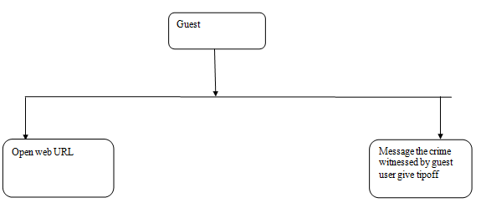

**Fig 7.1: Guest Module DFD**

1. **DATA FLOW DIAGRAM OF SUPER ADMIN MODULE**

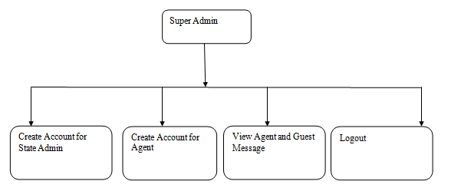

**Fig. 7.2 : Super Admin Module DFD**

1. **DATA FLOW DIAGRAM OF STATE ADMIN MODULE**

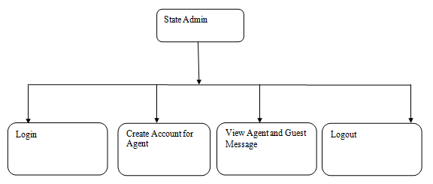

**Fig. 7.3 : State Admin Module DFD**

1. **DATA FLOW DIAGRAM OF AGENT(KHABARI) MODULE**

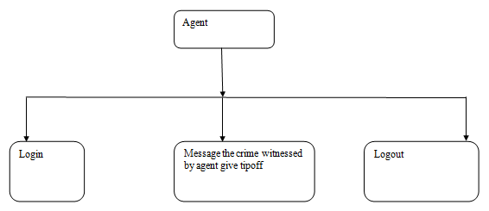

**Fig.7.4 : Agent Module DFD**

**CHAPTER 8**

**IMPLEMENTATION**

* 1. **SYSTEM CONFIGURATION**
* **Install XAMPP.**

**Steps :**

1. **Download :**XAMPP is a release made available by the non-profit project Apache Friends. Versions with PHP 5.5, 5.6, or 7 are available for download on the Apache Friends website.
2. **Run .exe file :**Once the software bundle has been downloaded, you can start the installation by double clicking on the file with the ending .exe.
3. **Deactivate any Antivirus Software :**Since an active antivirus program can negatively affect the installation process, it’s recommended to temporarily pause any antivirus software until all XAMPP components have successfully been installed.
4. **Deactivate UAC :**User Account Control (UAC) can interfere with the XAMPP installation because it limits writing access to the C: drive, so we recommend you deactivate this too for the duration of the installation process. To find out how to turn off your UAC, head to the Microsoft Windows support pages.
5. **Start The Setup Wizard :**After you’ve opened the .exe file (after deactivating your antivirus program(s) and taken note of the User Account Control, the start screen of the XAMPP setup wizard should appear automatically. Click on ‘Next’ to configure the installation settings.
6. **Choose Software Components :**Under ‘Select Components’, you have the option to exclude individual components of the XAMPP software bundle from the installation. But for a full local test server, we recommend you install using the standard setup and all available components. After making your choice, click ‘Next’.
7. **Choose The Installation Directory:**In this next step, you have the chance to choose where you’d like the XAMPP software packet to be installed. If you opt for the standard setup, then a folder with the name XAMPP will be created under C:\ for you. After you’ve chosen a location, click ‘Next’.
8. **Start The Installation Process :**Once all the aforementioned preferences have been decided, click to start the installation. The setup wizard will unpack and install the selected components and save them to the designated directory. This process can take several minutes in total. You can follow the progress of this installation by keeping an eye on the green loading bar in the middle of the screen.
9. **Windows Firewall Blocking :**Your Firewall may interrupt the installation process to block the some components of the XAMPP. Use the corresponding check box to enable communication between the Apache server and your private network or work network. Remember that making your XAMPP server available for public networks isn’t recommended.
10. **Complete Installation :**Once all the components are unpacked and installed, you can close the setup wizard by clicking on ‘Finish’. Click to tick the corresponding check box and open the XAMPP Control Panel once the installation process is finished.

* **Import dump sql file into php my admin**

1. Log into phpMyAdmin.
2. Select the destination database on the left pane.
3. Click on the Import tab in the top center pane.
4. Under the File to import section, click Browse and locate the file with the .
5. Check or uncheck the boxes for 'Partial import' and 'Other options'.
6. From the Format dropdown menu choose 'SQL'.
7. Click the **Go** button at the bottom to import the database.

* **Create your project folder in XAMPP.>>Htdocs>> and copy all the files in it.**

Find an open space in the right pane and right click or on newer versions of Windows, Click the drop down arrow beside Organize top left, and choose New Folder. Either method, Type htdocs to replace the blue New Folder text. Then click beside it. Then double click the htdocs folder to open it.

* **Start apache server and execute the project on local host.**

1. In order to get the dashboard for localhost: search http://localhost in any browser.
2. Now to run your code, open localhost/file.php then it gets executed.
   1. **IMPLEMENTATION DETAILS**

Our system is implemented by using :

1. **HTML**

HTML stands for Hyper Text Markup Language, which is the most widely used language on Web to develop web pages. HTML was created by Berners-Lee in late 1991 but "HTML 2.0" was the first standard HTML specification which was published in 1995. HTML 4.01 was a major version of HTML and it was published in late 1999. Though HTML 4.01 version is widely used but currently we are having HTML-5 version which is an extension to HTML 4.01, and this version was published in 2012.

HTML stands for Hypertext Markup Language, and it is the most widely used language to write Web Pages.

1. **CSS**

CSS is used to control the style of a web document in a simple and easy way.CSS is the acronym for "Cascading Style Sheet".Cascading **S**tyle **S**heets, fondly referred to as CSS, is a simple design language intended to simplify the process of making web pages presentable.CSS handles the look and feel part of a web page. Using CSS, you can control the color of the text, the style of fonts, the spacing between paragraphs, how columns are sized and laid out, what background images or colors are used, layout designs, variations in display for different devices and screen sizes as well as a variety of other effects.CSS is easy to learn and understand but it provides powerful control over the presentation of an HTML document. Most commonly, CSS is combined with the markup languages HTML or XHTML.

1. **JAVASCRIPT**

JavaScript is a lightweight, interpreted programming language.It is designed forcreating network-centric applications. It is complimentary to and integrated with Java. JavaScript is very easy to implement because it is integrated with HTML. It is open and cross-platform. JavaScript is a dynamic computer programming language. It is lightweight and most commonly used as a part of web pages, whose implementations allow client-side script to interact with the user and make dynamic pages. It is an interpreted programming language with object-oriented capabilities. JavaScript was first known as LiveScript, but Netscape changed its name to JavaScript, possibly because of the excitement being generated by Java. JavaScript made its first appearance in Netscape 2.0 in 1995 with the name LiveScript. The general-purpose core of the language has been embedded in Netscape, Internet Explorer, and other web browsers.

1. **BOOTSTRAP**

Bootstrap is a free and open-source front-end web framework. It contains HTML and CSS-based design templates for typography, forms, buttons, navigation and other interface components, as well as optional JavaScript extensions. Unlike many earlier web frameworks, it concerns itself with front-end development only.Bootstrap is the third-most-starred project on GitHub, with more than 131,000 stars, behind only freeCodeCamp (almost 300,000 stars) and marginally behind Vue.js framework. According to Alexa Rank, Bootstrapgetbootstrap.com is in the top-2000 in US while vuejs.org is in top-7000 in US.

1. **PHP**

The PHP Hypertext Preprocessor (PHP) is a programming language that allows wed developers to create dynamic content that interacts with databases. PHP is basically used for developing web based software applications. PHP started out as a small open source project that evolved as more and more people found out how useful it was. RasmusLerdorf unleashed the first version of PHP way back in 1994.

1. **XAMPP**

XAMPP is a free and open source cross-platform web server solution stack package, consisting mainly of the Apache HTTP Server, MySQL database, and interpreters for scripts written in the PHP and Perl programming languagesXAMPP's name is an acronym for:

* + - X (to be read as "cross", meaning cross-platform)
    - Apache HTTP Server
    - MySQL
    - PHP
    - Perl

XAMPP requires only one zip, tar, 7z, or exe file to be downloaded and run, and little or no configuration of the various components that make up the web server is required. XAMPP is regularly updated to incorporate the latest releases of Apache, MySQL, PHP and Perl. It also comes with a number of other modules including OpenSSL and phpMyAdmin.Self-contained, multiple instances of XAMPP can exist on a single computer, and any given instance can be copied from one computer to another. It is offered in both a full, standard version and a smaller version. Officially, XAMPP's designers intended it for use only as a development tool, to allow website designers and programmers to test their work on their own computers without any access to the Internet. To make this as easy as possible, many important security features are disabled by default. In practice, however, XAMPP is sometimes used to actually serve web pages on the World Wide Web A special tool is provided.

**CHAPTER 9**

**TESTING**

Once the software is ready, it will undergo deployment in a test environment, where the testing team will begin comprehensive testing of the entire system. This is a critical phase aimed at ensuring that the application functions precisely according to the customer's specified requirements. Testing plays a pivotal role in the software development process, serving to validate both the functional and non-functional aspects and requirements of the project.

The introduction of new features can potentially impact the functionality of existing features. Testing helps to uncover and rectify such issues before they have a chance to affect the final product. Moreover, conducting tests early in the project lifecycle facilitates the early detection of hidden errors, minimizing the cost of fixing these issues compared to addressing them in later stages.

The testing process is instrumental in eliminating significant software defects, ultimately leading to a final product that outperforms its competitors. Various types of software tests exist, each with its own set of objectives and strategies, all aimed at ensuring the software's quality and reliability.

**User Acceptance Testing:** Ensuring that the entire system functions correctly according to its intended purpose.

**Integration Testing:** Verifying that different software components or features work together seamlessly.

**Unit Testing:** Checking that each individual software unit performs its designated function correctly. A unit refers to the smallest testable part of an application.

**Functional Testing:** Testing the functions of the software by simulating real business scenarios based on functional requirements. Black-box testing is commonly used to test functions.

**Performance Testing:** Evaluating how well the software performs under various workloads. For example, load testing is used to assess performance under typical load conditions.

**Regression Testing:** Checking whether the introduction of new features has caused any existing functionality to break or degrade. Sanity testing can be employed to quickly verify the surface-level functionality of menus, functions, and commands when a full regression test is not feasible.

**Stress Testing:** Assessing the system's ability to withstand high levels of stress before failing. This type of testing falls under non-functional testing.

**Usability Testing:** Evaluating how easily and effectively a customer can use a system or web application to accomplish a task. In all these cases, validating the core requirements is crucial. Exploratory testing is also important as it helps testers uncover unforeseen scenarios that can lead to software errors. Even a seemingly simple application can undergo a variety of tests. A well-thought-out test management plan is essential for prioritizing tests based on their value, considering the available time and resources. Maximizing testing effectiveness involves running the fewest number of tests to uncover the most defects.

**CHAPTER 10**

**RESULTS**



**Screenshot 10.1: Home page**

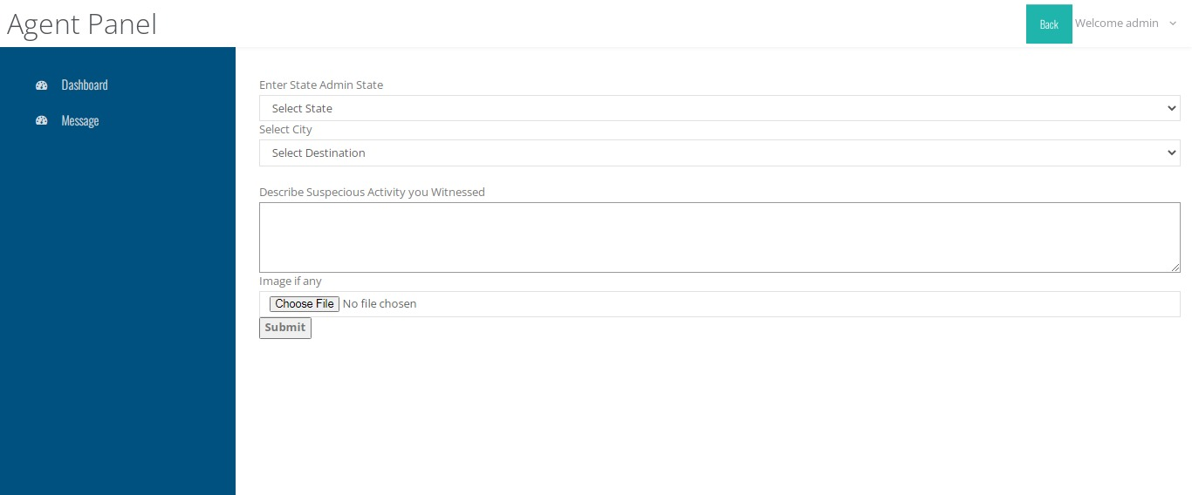

**Screenshot 10.2: Form in Agent Panel**

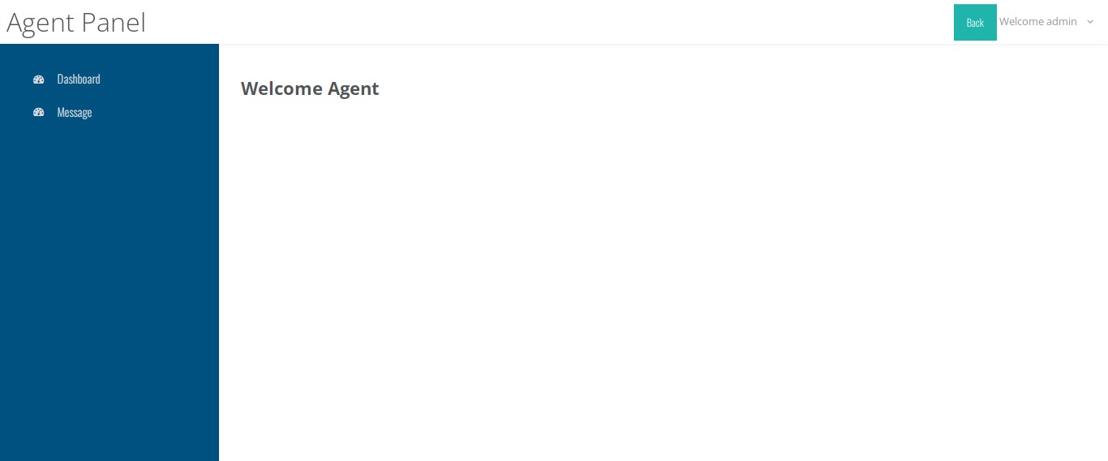

**Screenshot 10.3: Agent Panel Dashboard**

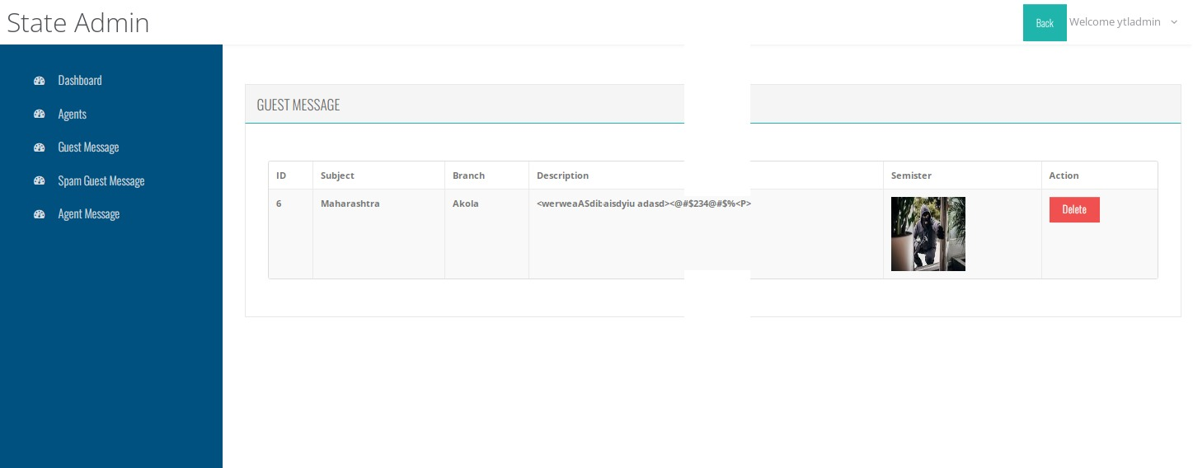

**Screenshot 10.4: Guest message**

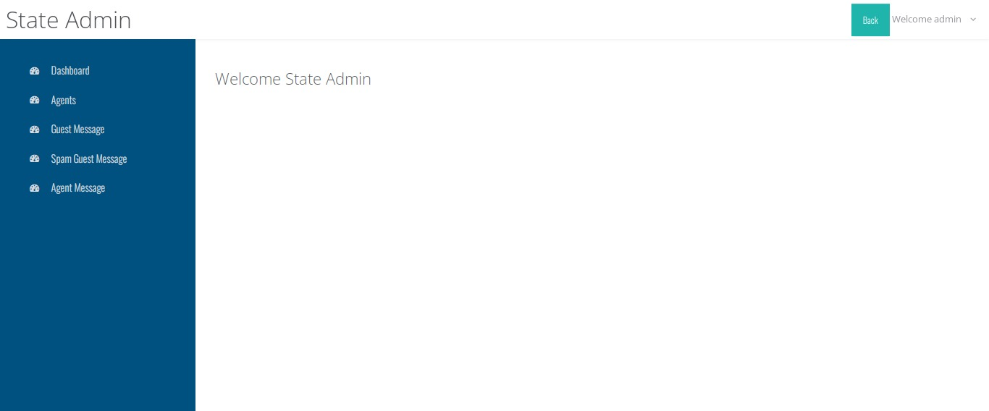

**Screenshot 10.5: State Admin page**

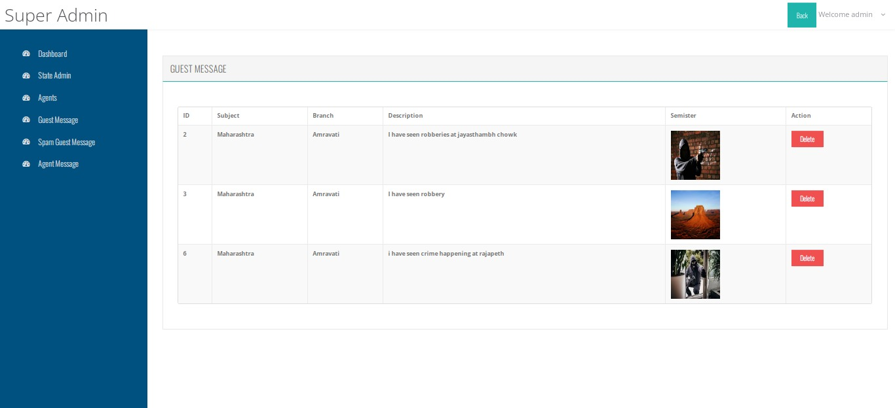

**Screenshot 10.6: Guest Message in Super Admin**

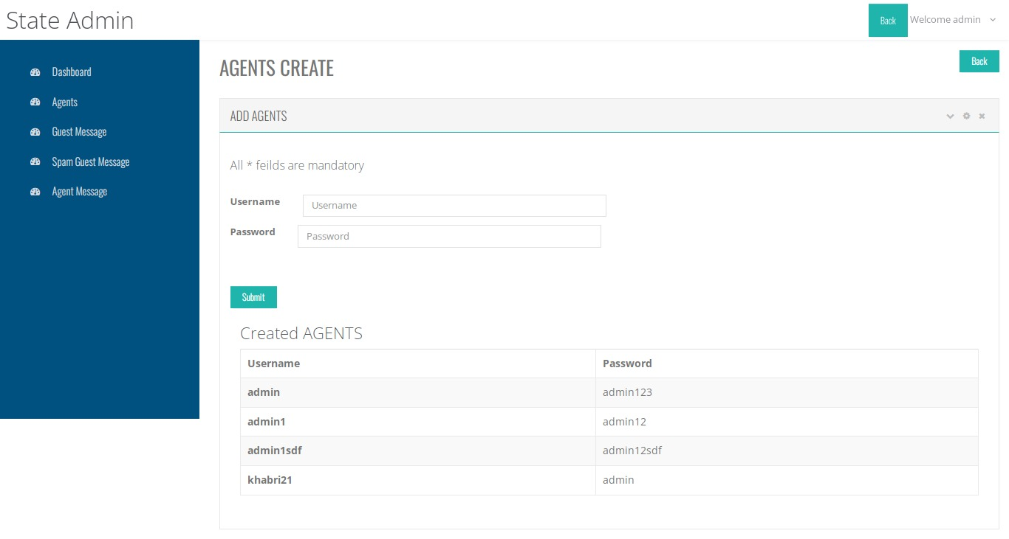

**Screenshot 10.7: Agent Create form in state admin**

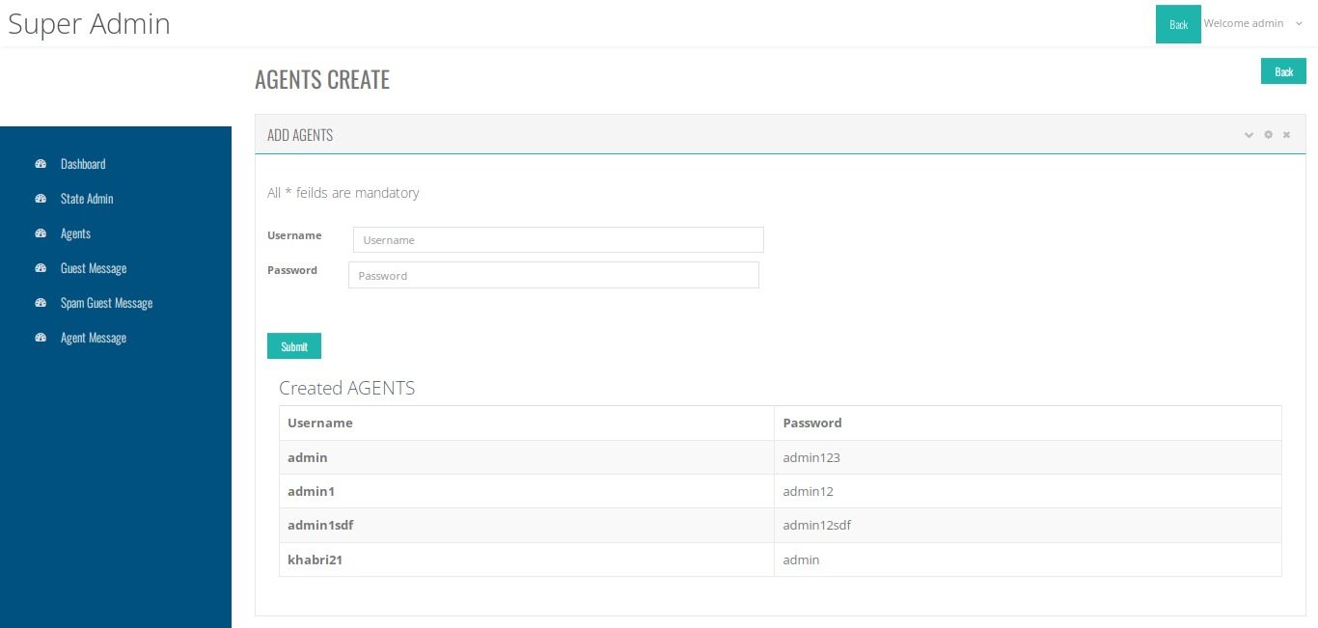

**Screenshot 10.8: Agent Create form in state admin**

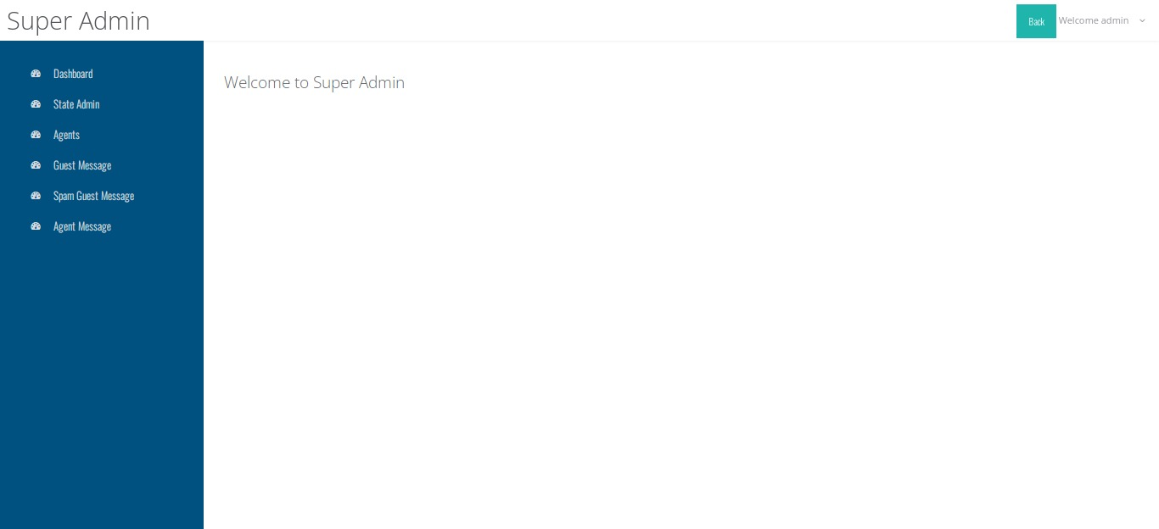

**Screenshot 10.9: dashboard of super admin**

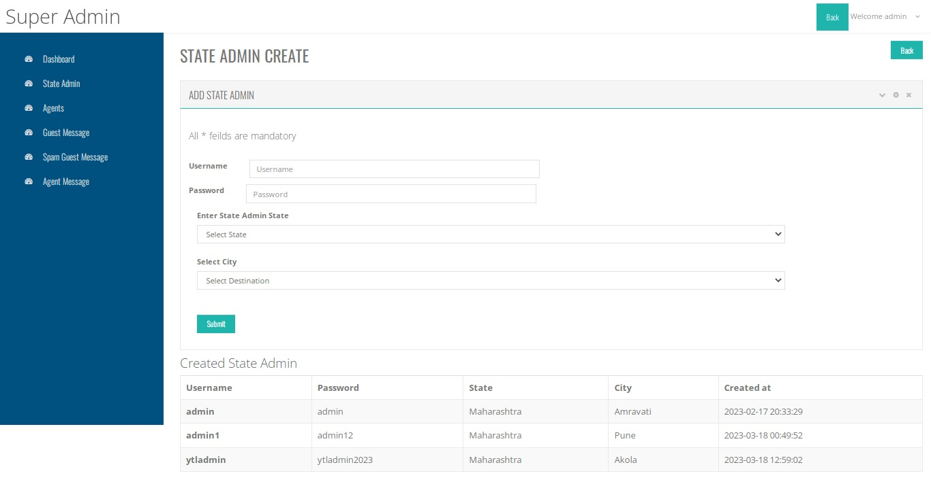

**Screenshot 10.10: state admin addition form in super admin panel**

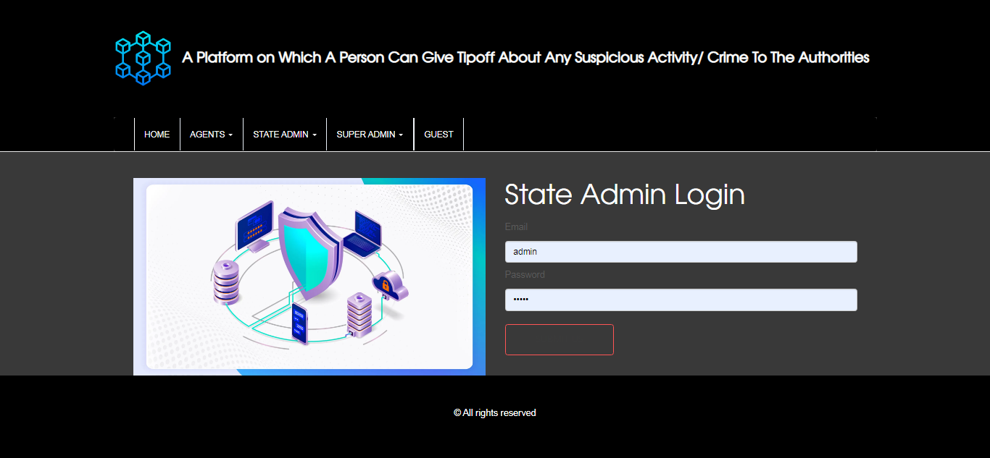

**Screenshot 10.11: Authentication form of state admin**

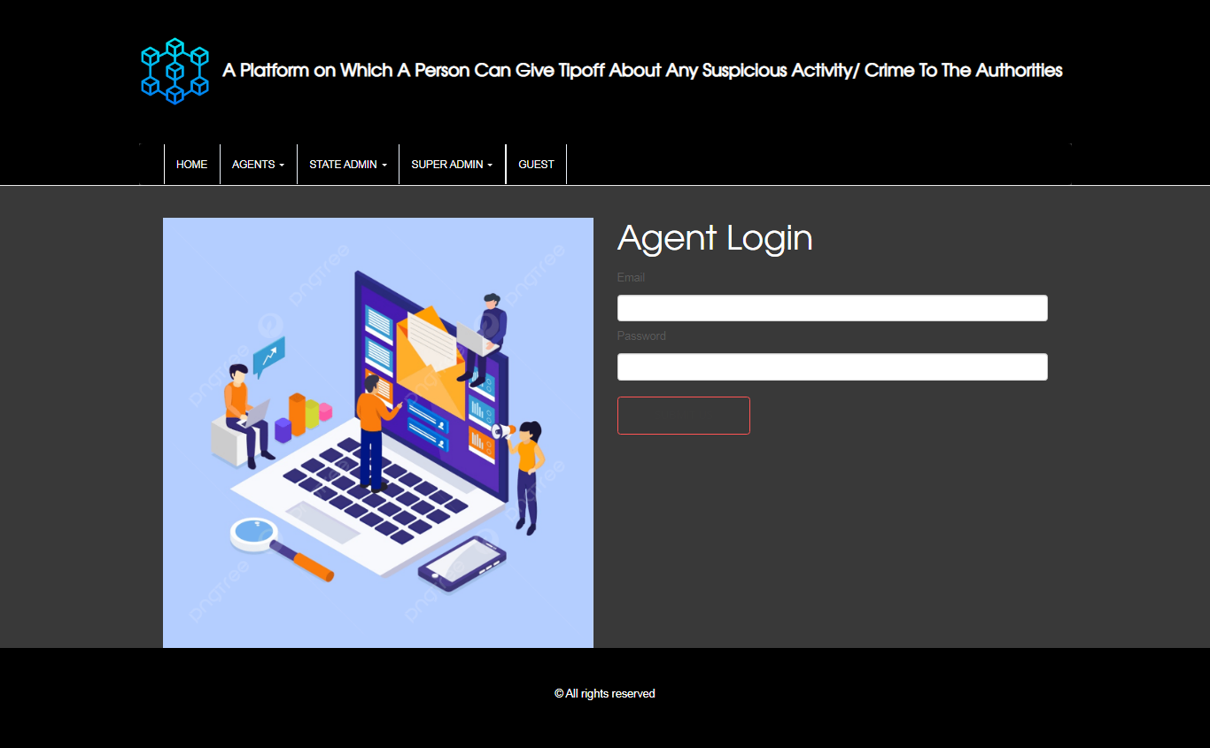

**Screenshot 10.12: Authentication form of Agent**

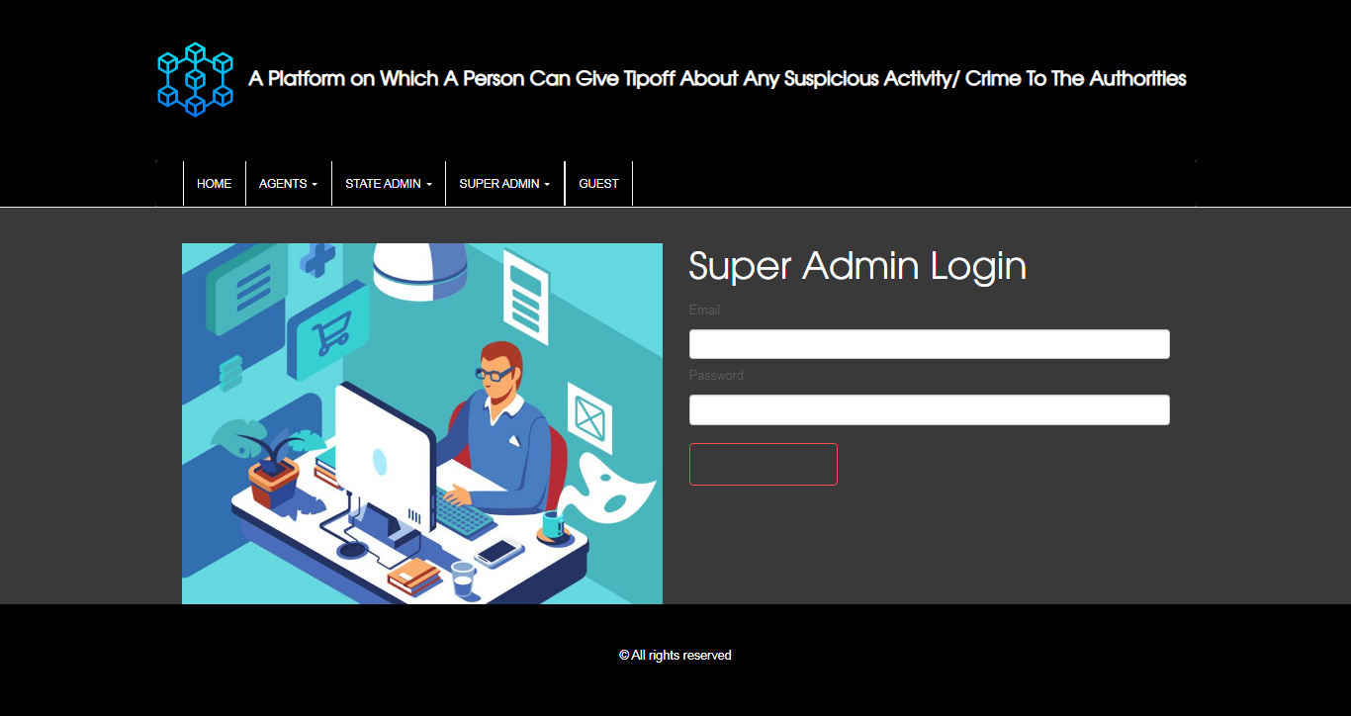

**Screenshot 10.13: Authentication form of super admin**

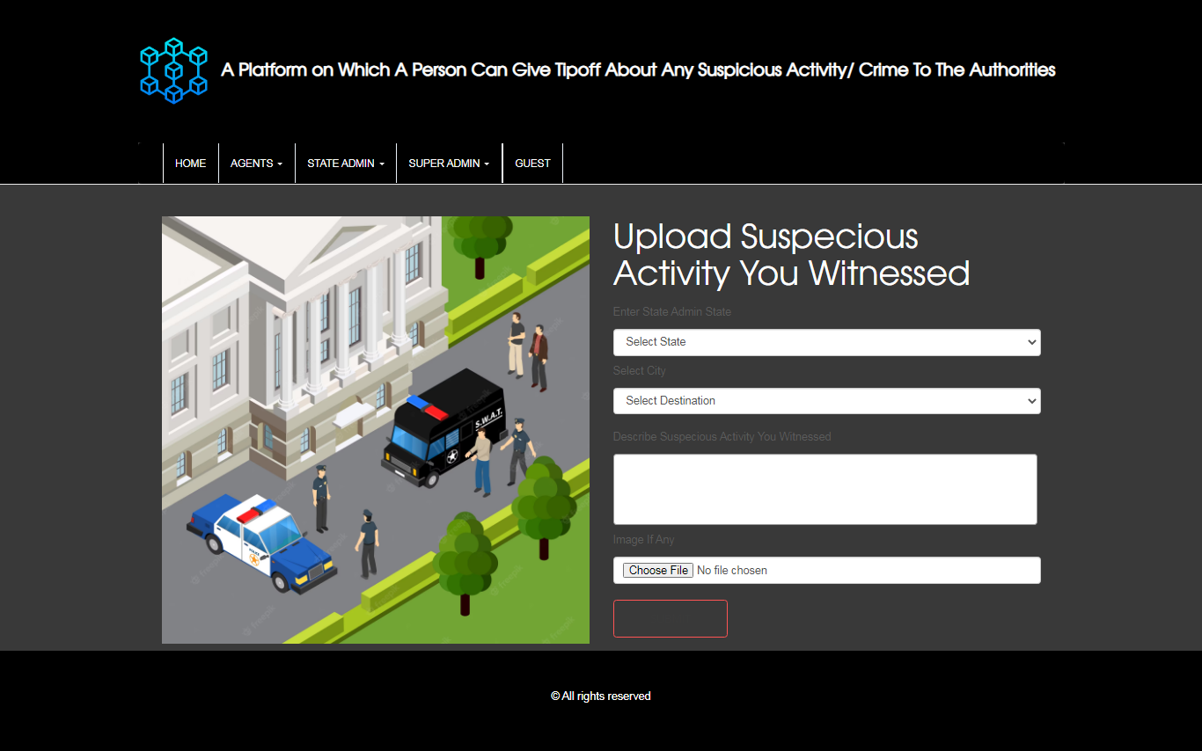

**Screenshot 10.14: suspicious activity upload form**

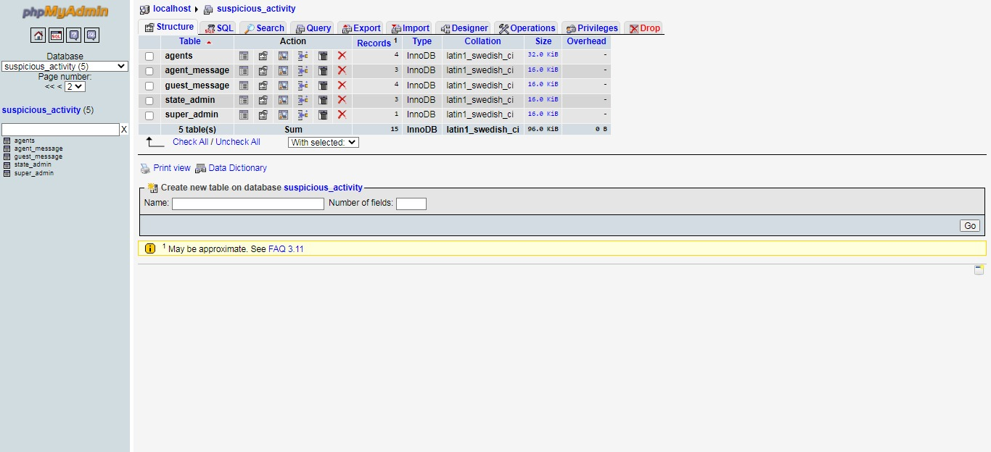

**Screenshot 10.15: Database Tables**

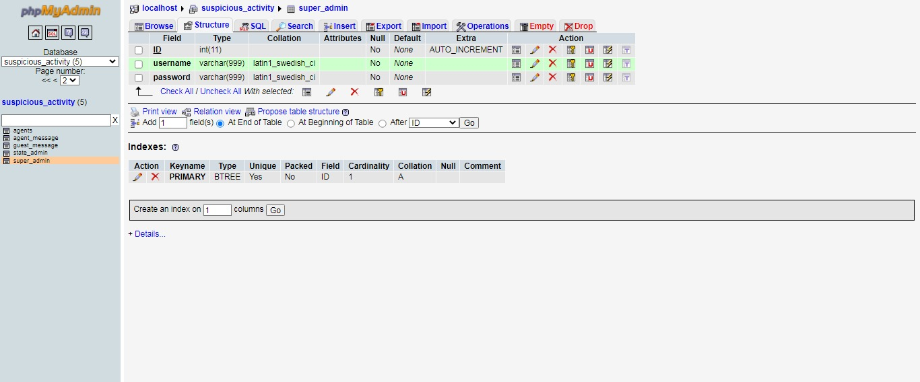

**Screenshot 10.16: table super admin**

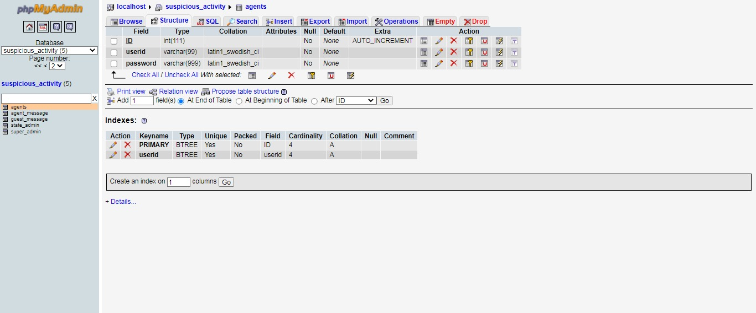

**Screenshot 10.17: Table Agent**

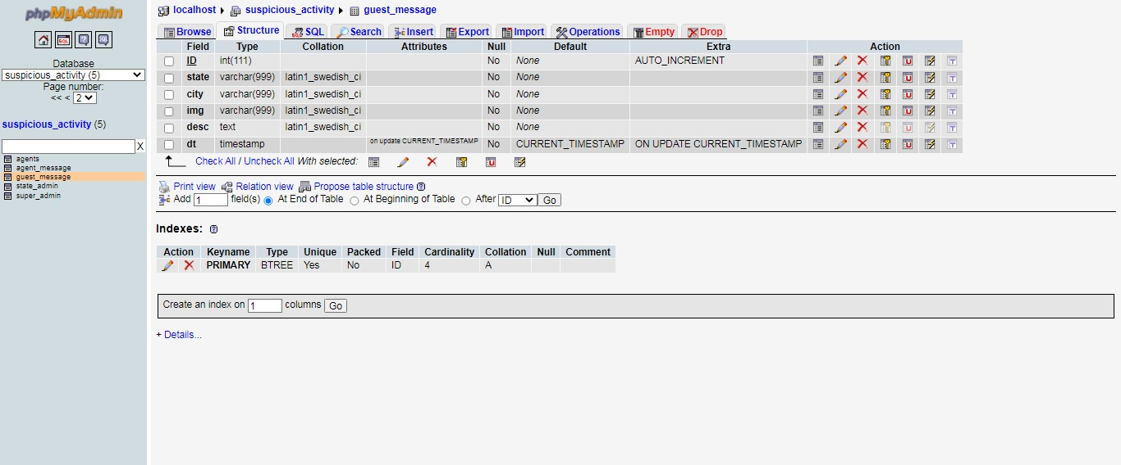

**Screenshot 10.18: Table Guest Message**

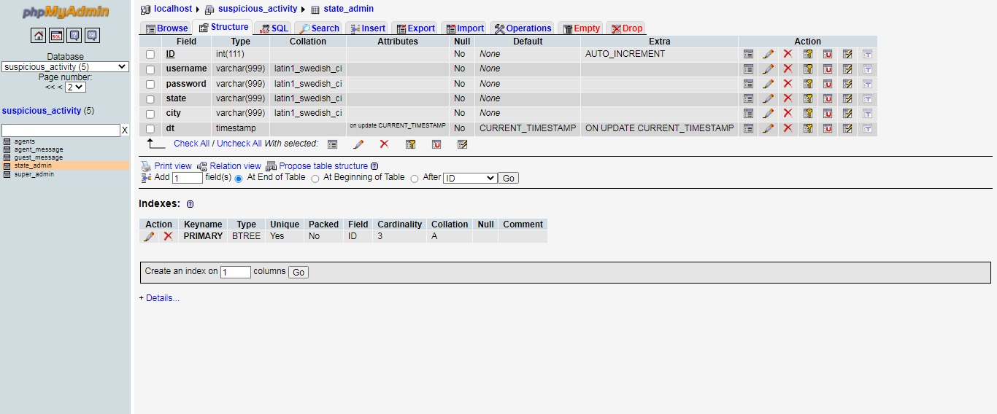

**Screenshot 10.19: table State Admin**

**CHAPTER 11**

**CONCLUSION AND FUTURE SCOPE**

Our implementation highlights the importance of providing an anonymous means for reporting crimes, ensuring the protection of witnesses. While victims are typically prioritized in crime reporting, the role of witnesses is often overlooked unless their identities are known. However, not every statement can be considered reliable, and an algorithm that can differentiate genuine tip-offs would greatly aid police investigations, as insider information is highly valuable. We believe in giving every witness a voice and that true justice lies in allowing each individual to share their story without fear of reprisal. By leveraging available technology, it is feasible to create an anonymous crime tip-off system. Through this research, we aim to address all the critical aspects of crime reporting and contribute to society through innovation.

Additionally, a roadmap for supporting students in non-traditional career paths can be developed. Talent management based on performance evaluation could be incorporated, along with features such as online exams, resume builders, and virtual classroom functionality.

**REFERENCES**

1. “Blockchain-Empowered Mobile Edge Intelligence, Machine Learning and Secure Data Sharing” - Paper published on March 12th, 2021 by Yao Du, Shuxiao Miao, Zitian Tong, Victoria Lemieux &Zehua Wang - <https://www.intechopen.com/online-first/75695>
2. “Sentiment Analysis of Twitter Data: A Survey of Techniques” - Published in April 2016 by Vishal A. Kharde& S.S. Sonawane - <https://arxiv.org/ftp/arxiv/papers/1601/1601.06971.pdf>
3. “A Study of Text Classification Natural Language Processing Algorithms for Indian Languages” - Published in July 2015, by JasleenKaur and Dr.Jatinderkumar R. Saini - https://www.researchgate.net/publication/281965343_A_Study_of_Text_Classification_Natural_Language_P rocessing_Algorithms_for_Indian_Languages
4. “Ethereum | Whitepaper” - Published in 2013 by VitalikButerin - the Founder of Ethereum - <https://ethereum.org/en/whitepaper/>
5. “An anonymous platform for tip-offs on market manipulation” - Article published on 1st October, 2014 by Sachin P Mampatta – <https://www.businessstandard.com/article/markets/now-an-anonymousplatform-for-tip-offs-on-market-manipulation114100100577_1.html>
6. “Crime Reporting Behavior: Do Attitudes Toward the Police Matter?” - Published in February 2016 by Francis D. Boateng - https://www.researchgate.net/publication/295855033_ Crime_Reporting_Behavior_Do_Attitudes_Toward_the_Police_Matter
7. “Why do more than 90% thefts in India’s metro cities go unreported” - Article published on 27th September, 2017 by Avanti Durani and NehaSinha - <https://www.hindustantimes.com/india-news/why-domore-than-90-thefts-in-india-s-metro-cities-gounreported/story-FR6WZKAZiqzTRgN7LCilLI.html>
8. “NFTs in Practice - Non-Fungible Tokens as Core Component of a Blockchain-based Event Ticketing Application” - Published in December 2019 by Ferdinand Regner, André Schweizer& Nils Urbach - https://www.researchgate.net/publication/336057493_ NFTs_in_Practice_-_NonFungible_Tokens_as_Core_Component_of_a_Blockch ain-based_Event_Ticketing_Application
9. “NFTs: Digital things and their criminal lives” - Published on 19th August, 2021 by Simon Mackenzie &DiānaBērziņa - https://journals.sagepub.com/doi/abs/10.1177/1741659 0211039797?journalCode=cmca
10. “Anonymous reporting: Why companies should allow it” - Article published by Moritz Homann on 7 th December, 2021 - https://www.integrityline.com/engb/expertise/blog/anonymous-reporting-companies/