Spring Boot

1. What is spring boot?

Spring boot is a way in which we can bootstrap or quickly start-up a simple spring-based java applications. The main idea behind spring boot is to have an easy to start spring application and build it up to something that is production ready.

Spring boot makes it easy to create stand-alone, production-grade spring-based application that you can just run.

Some advantages of using spring boot

* Supports convention over configuration
* Standalone – It helps in creating a standalone application which is ready to run
* It’s a production ready application

1. Creating a spring boot application using Maven

To convert this simple maven project to a spring boot app, we need to follow the below steps:

* Add the spring boot parent configuration

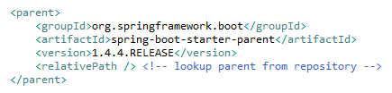

* Contains bootstrapped configuration of jars that are required for building a web application using JPA.
* These configurations below are a meta dependencies of all jars that a spring web application would need.

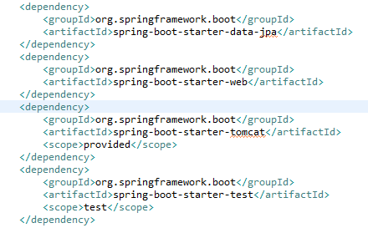

1. Create a class with a main method and annotate that class with

@SpringBootApplication

This tells spring that this is the start of the application.

