**API: Accessing Codeproof device name and group name programmatically in the Android device.**

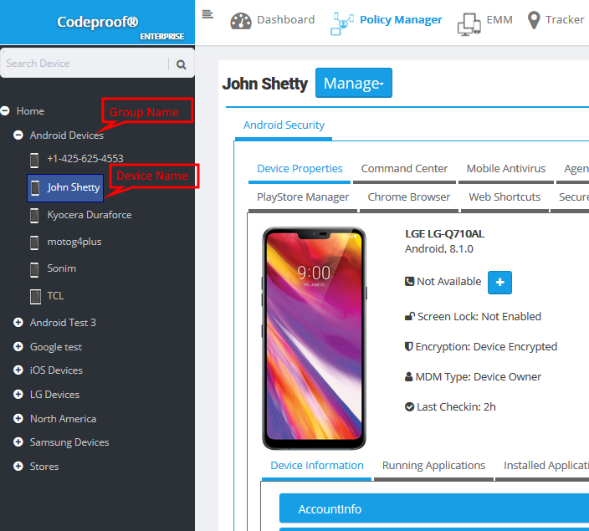 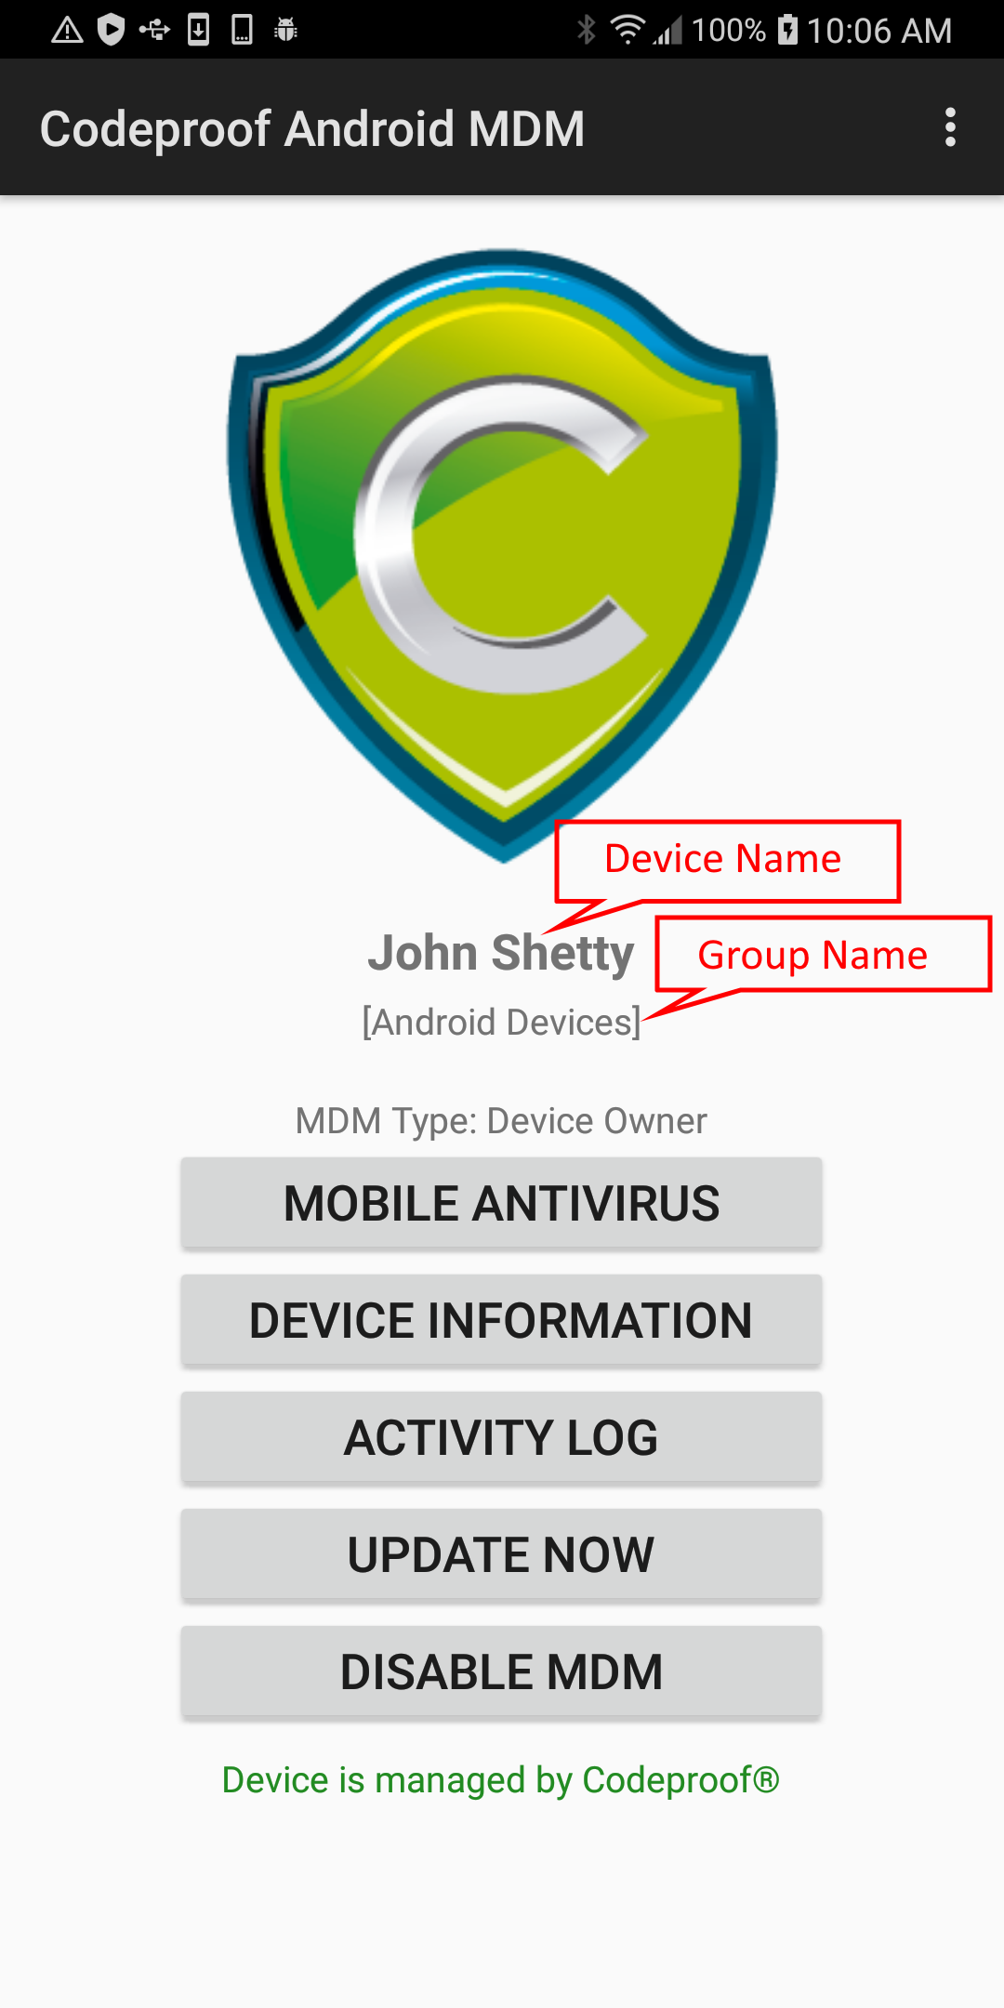

API Usage:



Source Code:

API source code is available here on Github:

<https://github.com/codeproof/sdk/blob/master/android/appconfig/appConfigDataAPI.java>