State Street Enterprise Planning Transformation
Project note — Enamala Harshith, Apprentice, State Street | Sep 2025 – Present
What this project is about
State Street has been rolling out a planning transformation on Oracle EPM Cloud, moving several business units onto a common PBCS and Hyperion Planning setup. Before this, different business units were running planning on a mix of older tools and spreadsheets, which made it hard to get a consistent view across the organisation and slowed down every budgeting cycle. The transformation is meant to bring everyone onto one platform with a shared structure, so forecasting and reporting work the same way regardless of which business unit is submitting numbers.
I joined this as an apprentice on the EPM support team, working alongside senior consultants and the onshore team. My part has been on the operational side — keeping the planning applications configured correctly and running smoothly as the rollout expands to more business units. I was not involved in the original design of the platform; my role started once the core application existed and needed ongoing maintenance and support as more teams came on board.
What I actually work on
My day-to-day sits across three areas. None of them are especially glamorous on their own, but together they keep a planning application usable for the people who actually depend on it every month.
- Metadata — I maintain dimensions, hierarchies, and member properties as business requirements change. When a business unit adds a new cost center or restructures a reporting line, that change has to flow into the planning model correctly, or the numbers downstream stop making sense. This usually means understanding what the business is actually trying to report before touching the hierarchy, not just making the requested change blindly.
- Security — I handle user provisioning, run access reviews, and maintain role-based security. Planning data is sensitive, so getting access right (not too open, not too locked down) is something I check carefully rather than rush through. Access reviews in particular take patience — going through who has what access and confirming it still makes sense for their current role.
- Automation — I write EPM Automate and batch scripts to handle metadata loads, data loads, backups, and migrations between environments. A lot of this used to be manual, so scripting it has cut down on repetitive work and reduced the chance of someone missing a step during a busy planning cycle.
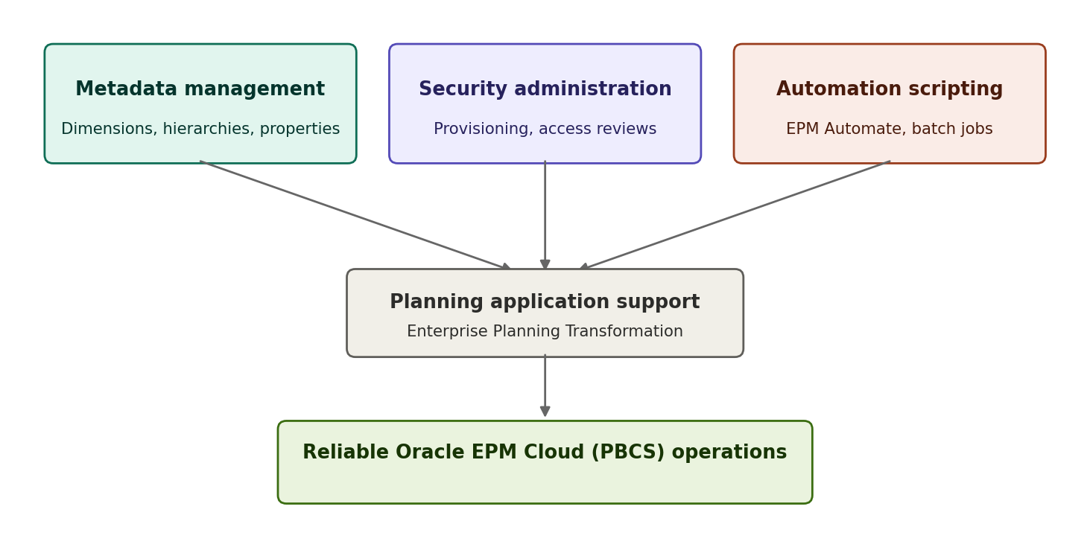
How the three areas fit together
Moving changes through environments
Nothing goes straight into production. Metadata and configuration changes are built and tested in the Dev environment first, then pushed to Test where the business can validate them, and only then migrated to Production for the live planning cycle. I use EPM Automate scripts to move metadata and data between these environments and to take a backup at each step, so there is always something to roll back to if a migration does not go as expected.
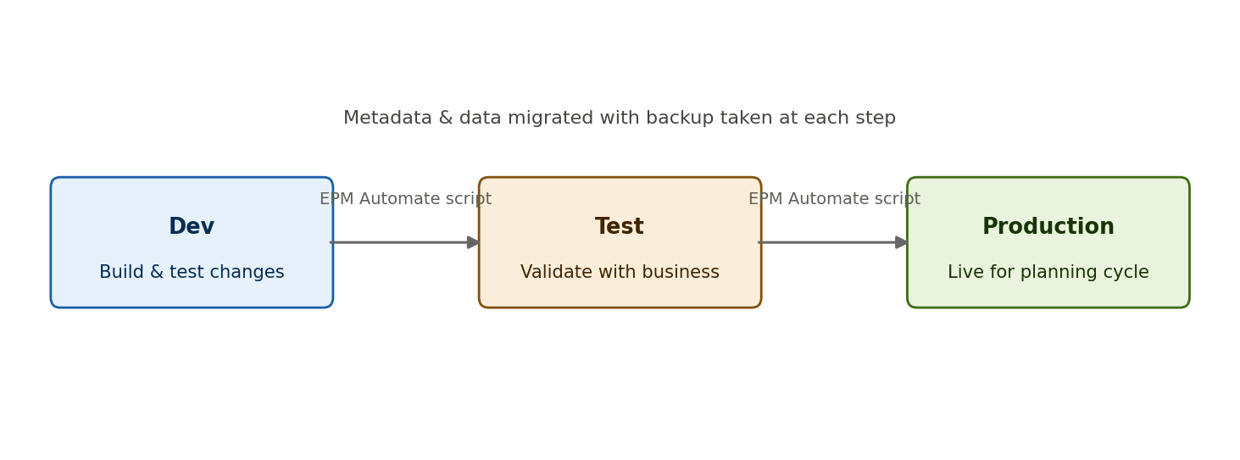
Dev to Test to Production, with backup at each step
Tools and technologies
Oracle EPM Cloud (PBCS / EPBCS), Hyperion Planning, Essbase, Smart View, EPM Automate, Groovy scripting, Business Rules, and batch scripting for automation. I also use Qlik Sense for some of the reporting side of the same applications.
How I go about the work
Most weeks start with checking what changed on the business side — a new hierarchy, a role change, an access request — and working out what that means for the model. Metadata and security changes go through review before they touch production, so I test them in a lower environment first. The automation work came out of noticing the same manual steps happening every cycle; scripting them was less about being clever and more about not wanting to repeat the same load process by hand every time. Below is roughly what a metadata or data load looked like before and after scripting it.
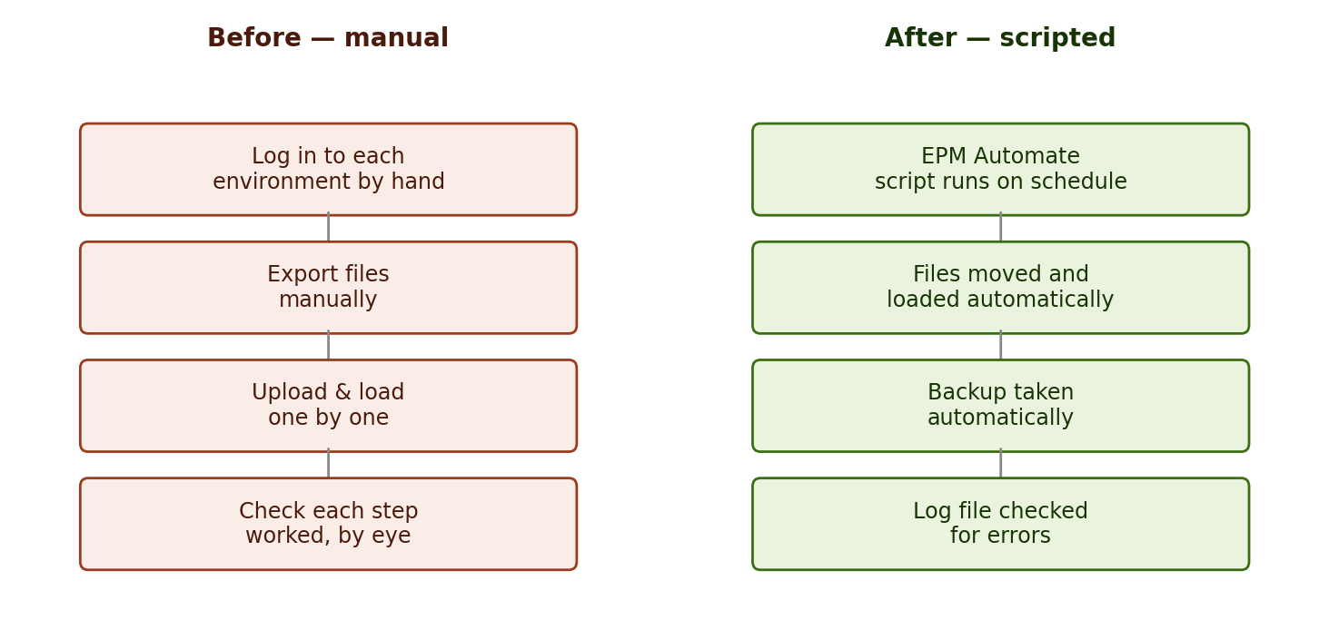
A typical load process, before and after automation
What this has taught me
This is my first real exposure to how a planning application is actually kept running once it is live, not just how it is built. I have a better sense now of why metadata discipline matters, how access control decisions can quietly cause problems later if they are not handled carefully, and how much smoother a planning cycle runs when the repetitive parts are automated instead of done by hand. It has also been useful working alongside the onshore team and picking up how they think about priorities and risk during a live transformation, rather than just learning the tool in isolation.
Skills this project has built
- Working knowledge of Oracle EPM Cloud (PBCS) and Hyperion Planning administration, not just the reporting side of the tool.
- Comfort writing EPM Automate and batch scripts for real operational tasks, not tutorial exercises.
- A better instinct for security and access control, especially around financial data.
- Getting used to how change is managed on a live, business-critical system — testing first, having a rollback plan, and not assuming a change is safe just because it looks small.

