**TASK 1**

**Aim :** Write a program to demonstrate different number data types in Python.

**Program:**

# Integer

int_num = 10

print("Integer value:", int_num)  # Output: Integer value: 10

print("Type of integer:", type(int_num))  # Output: Type of integer: <class 'int'>

# Float

float_num = 10.5

print("\nFloat value:", float_num)  # Output: Float value: 10.5

print("Type of float:", type(float_num))  # Output: Type of float: <class 'float'>

# Complex

complex_num = 2 + 3j

print("\nComplex number:", complex_num)  # Output: Complex number: (2+3j)

print("Type of complex number:", type(complex_num))  # Output: Type of complex number: <class 'complex'>

# Boolean

bool_value = True

print("\nBoolean value:", bool_value)  # Output: Boolean value: True

print("Type of boolean:", type(bool_value))  # Output: Type of boolean: <class 'bool'>

**Output:**

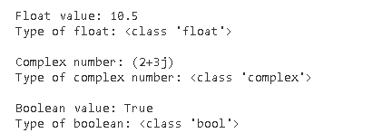

**TASK 2**

**Aim :** Write a program to perform different Arithmetic Operations on numbers in

Python.

**Program:**

a = 15

b = 4

# Addition

add = a + b

print("Addition of", a, "and", b, "is:", add)  # Output: Addition of 15 and 4 is: 19

# Subtraction

subtract = a - b

print("Subtraction of", b, "from", a, "is:", subtract)  # Output: Subtraction of 4 from 15 is: 11

# Multiplication

multiply = a * b

print("Multiplication of", a, "and", b, "is:", multiply)  # Output: Multiplication of 15 and 4 is: 60

# Division (float)

divide = a / b

print("Division of", a, "by", b, "(float) is:", divide)  # Output: Division of 15 by 4 (float) is: 3.75

# Division (floor)

floor_divide = a // b

print("Division of", a, "by", b, "(floor) is:", floor_divide)  # Output: Division of 15 by 4 (floor) is: 3

# Modulus

modulus = a % b

print("Modulus of", a, "and", b, "is:", modulus)  # Output: Modulus of 15 and 4 is: 3

# Exponentiation

exponent = a ** b

print(a, "raised to the power", b, "is:", exponent)  # Output: 15 raised to the power 4 is: 50625

**Output:**

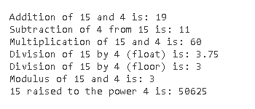

**TASK 3**

**Aim :** Write a program to create, concatenate and print a string and accessing sub-string

**Program:**

# 1. Single quotes

str1 = 'Hello'

print("String using single quotes:", str1)  # Output: String using single quotes: Hello

# 2. Double quotes

str2 = "World"

print("String using double quotes:", str2)  # Output: String using double quotes: World

# 3. Multi-line string using triple quotes

str3 = """This is a

multi-line string"""

print("String using triple quotes:", str3)

# Output:

# String using triple quotes: This is a

# multi-line string

# Concatenating strings

concat_str = str1 + " " + str2

print("\nConcatenated string:", concat_str)  # Output: Concatenated string: Hello World

# Accessing sub-string (positive indexing)

sub_str_pos = concat_str[0:5]

print("Sub-string from the concatenated string (positive indexing):", sub_str_pos)

# Output: Sub-string from the concatenated string (positive indexing): Hello

# Accessing sub-string (negative indexing)

sub_str_neg = concat_str[-5:]

print("Sub-string from the concatenated string (negative indexing):", sub_str_neg)

# Output: Sub-string from the concatenated string (negative indexing): World

**Output:**

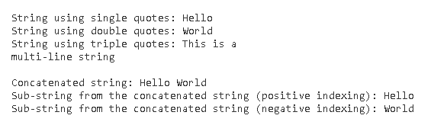

**TASK 4**

**Aim**: Write a python script to print the current date in the following format “Sun May 29 02:26:23 IST 2017”

**Program:**

import time

# Formatting date and time

formatted_time = time.strftime("%a %b %d %H:%M:%S %Z %Y")

print("Current date and time:", formatted_time)

# Output example: Current date and time: Thu Aug 29 07:43:33 India Standard Time 2024

**Output:**

