**PROJECT REPORT**

**18CSC202J - OBJECT ORIENTED DESIGN AND PROGRAMMING LABORATORY**

**(2018 Regulation)**

**II Year/ III Semester**

**Academic Year: 2022 -2023**

By

**DEBASHISH JENA (RA2111026010438)**

Under the guidance of

**Dr. Omm Prakash**

**Assistant Professor**

**Department of Computational Intelligence**



**FACULTY OF ENGINEERING AND TECHNOLOGY**

**SCHOOL OF COMPUTING**

**SRM INSTITUTE OF SCIENCE AND TECHNOLOGY**

**Kattankulathur, Kancheepuram**

**NOVEMBER 2022**



**BONAFIDE**

This is to certify that **18CSC202J - OBJECT ORIENTED DESIGN AND PROGRAMMING LABORATORY project report** titled **“CAR RENTAL SYSTEM”** is the bonafide work of **DEBASHISH JENA (RA2111026010438)** who undertook the task of completing the project within the allotted time.

**Signature of the Guide**

Dr. Omm Prakash

**Assistant Professor**

Department of CINTEL,

SRM Institute of Science and Technology

**About the course**

18CSC202J - Object Oriented Design and Programming are 4 credit courses with

**L T P C as 3-0-2-4** (Tutorial modified as Practical from 2018 Curriculum onwards)

**Objectives:**

The student should be made to:

* Learn the basics of OOP concepts in C++
* Learn the basics of OOP analysis and design skills.
* Be exposed to the UML design diagrams.
* Be familiar with the various testing techniques

**Course Learning Rationale (CLR): The purpose of learning this course is to:**

1. Utilize class and build domain model for real-time programs
2. Utilize method overloading and operator overloading for real-time application development programs
3. Utilize inline, friend and virtual functions and create application development programs
4. Utilize exceptional handling and collections for real-time object-oriented programming applications
5. Construct UML component diagram and deployment diagram for design of applications
6. Create programs using object-oriented approach and design methodologies for real-time application development

**Course Learning Outcomes (CLO): At the end of this course, learners will be able to:**

1. Identify the class and build domain model
2. Construct programs using method overloading and operator overloading
3. Create programs using inline, friend and virtual functions, construct programs using

standard templates

1. Construct programs using exceptional handling and collections
2. Create UML component diagram and deployment diagram
3. Create programs using object oriented approach and design methodologies

**Table 1: Rubrics for Laboratory Exercises**

(Internal Mark Splitup:- As per Curriculum)

| **CLAP-1** | 5=(2(E-lab Completion) + 2(Simple Exercises)( from CodeZinger, and any other coding platform) + 1(HackerRank/Code chef/LeetCode Weekend Challenge) | Elab test |
| --- | --- | --- |
| **CLAP-2** | 7.5=(2.0(E-lab Completion)+  2.0 (Simple Exercises)( from CodeZinger, and any other coding platform) + 3.5 (HackerRank/Code chef/LeetCode Weekend Challenge) | Elab test |
| **CLAP-3** | 7.5=(2.0(E-lab Completion(80 Pgms)+  2.0 (Simple Exercises)( from CodeZinger, and any other coding platform) + 3.5 (HackerRank/Code chef/LeetCode Weekend Challenge) | **2 Mark -** E-lab Completion **80 Program** Completion from 10 Session (Each session min 8 program)  **2 Mark -** Code to UML conversion GCR Exercises  **3.5 Mark - Hacker Rank** Coding challenge completion |
| **CLAP-4** | 5= 3 ( Model Practical) + 2( Oral Viva) | * **3 Mark** – Model Test * **2 Mark** – Oral Viva |
| **Total** | 25 |  |

**COURSE ASSESSMENT PLAN FOR OODP LAB**

| **S.No** | **List of Experiments** | **Course Learning Outcomes (CLO)** | **Blooms Level** | **PI** | **No of Programs in each session** |
| --- | --- | --- | --- | --- | --- |
| 1. | Implementation of I/O Operations in C++ | CLO-1 | Understand | 2.8.1 | 10 |
| 2. | Implementation of Classes and Objects in C++ | CLO-1 | Apply | 2.6.1 | 10 |
| 3, | To develop a problem statement. 1. From the problem statement, Identify Use Cases and develop the Use Case model. 2. From the problem statement, Identify the conceptual classes and develop a domain model with a UML Class diagram. | CLO-1 | Analysis | 4.6.1 | Mini Project Given |
| 4. | Implementation of Constructor Overloading and Method Overloading in C++ | CLO-2 | Apply | 2.6.1 | 10 |
| 5. | Implementation of Operator Overloading in C++ | CLO-2 | Apply | 2.6.1 | 10 |
| 6. | Using the identified scenarios, find the interaction between objects and represent them using UML Sequence diagrams and Collaboration diagrams | CLO-2 | Analysis | 4.6.1 | Mini Project Given |
| 7. | Implementation of Inheritance concepts in C++ | CLO-3 | Apply | 2.6.1 | 10 |
| 8. | Implementation of Virtual function & interface concepts in C++ | CLO-3 | Apply | 2.6.1 | 10 |
| 9. | Using the identified scenarios in your project, draw relevant state charts and activity diagrams. | CLO-3 | Analysis | 4.6.1 | Mini Project Given |
| 10. | Implementation of Templates in C++ | CLO-3 | Apply | 2.6.1 | 10 |
| 11. | Implementation of Exception of Handling in C++ | CLO-4 | Apply | 2.6.1 | 10 |
| 12. | Identify the User Interface, Domain objects, and Technical Services. Draw the partial layered, logical architecture diagram with UML package diagram notation such as Component Diagram, Deployment Diagram. | CLO-5 | Analysis | 4.6.1 | Mini Project Given |
| 13. | Implementation of STL Containers in C++ | CLO-6 | Apply | 2.6.1 | 10 |
| 14. | Implementation of STL associate containers and algorithms in C++ | CLO-6 | Apply | 2.6.1 | 10 |
| 15. | Implementation of Streams and File Handling in C++ | CLO-6 | Apply | 2.6.1 | 10 |

**LIST OF EXPERIMNENTS FOR UML DESIGN AND MODELLING:**

**To develop a mini-project by following the exercises listed below.**

1. To develop a problem statement.

2. Identify Use Cases and develop the Use Case model.

3. Identify the conceptual classes and develop a domain model with UML Class diagram.

4. Using the identified scenarios, find the interaction between objects and represent them

using UML Sequence diagrams.

5. Draw relevant state charts and activity diagrams.

6. Identify the User Interface, Domain objects, and Technical services. Draw the partial

layered, logical architecture diagram with UML package diagram notation.

**Suggested Software Tools for UML:**

StarUML, Rational Suite, Argo UML (or) equivalent, Eclipse IDE and Junit

**ABSTRACT**

This Car Rental System project is designed to aid the car rental company to enable renting of cars through an online system. It helps the users to search for available cars view profile and book the cars for the time period. It has a user-friendly interface which helps the user to check for cars and rent them for the period specified. They could also make payment online. The rental cars shall be categorized into economy, premium etc. Based on the type of car required by the customer, the user shall be able to make bookings. The use of internet technology has made it easy for the customers to rent a car any time. This Car Rental System makes the bookings easy. It saves time and labor. The tool shall ask the user for information such as the date and time of journey, type of car etc. Also, it will need an identification number. Using these details, the tool shall help the customer to book a car for the journey.

**INTRODUCTION TO ONLINE CAR RENTAL SYSTEM**

**1.1 Introduction**

This project is designed so as to be used by Car Rental Company specializing in renting

cars to customers. It is an online system through which customers can view available

cars, register, view profile and book car.

**1.2 Reason for the Project**

The advancement in Information Technology and internet penetration has greatly

enhanced various business processes and communication between companies (services

provider) and their customers of which car rental industry is not left out. This E-Car

Rental System is developed to provide the following services:

• **Enhance Business Processes:** To be able to use internet technology to project the

rental company to the global world instead of limiting their services to their local

domain alone, thus increase their return on investment (ROI).

• **Online Vehicle Reservation:** A tools through which customers can reserve available

cars online prior to their expected pick-up date or time.

• **Customer’s registration:** A registration portal to hold customer’s details, monitor their

transaction and used same to offer better and improve services to them.

• **Group bookings:** Allows the customer to book space for a group in the case of

weddings or corporate meetings (Event management).

**1.3 Problem Statement**

A car rental is a vehicle that can be used temporarily for a fee during a specified period.

Getting a rental car helps people get around despite the fact they do not have access to

their own personal vehicle or don't own a vehicle at all. The individual who needs a car

must contact a rental car company and contract out for a vehicle. This system increases

customer retention and simplify vehicle and staff management.

**1.4 Aims & Objectives**

• To produce a web-based system that allow customer to register and reserve car online

and for the company to effectively manage their car rental business.

• To ease customer’s task whenever they need to rent a car.

**1.5 Scope**

This project traverses a lot of areas ranging from business concept to computing field,

and required to perform several researches to be able to achieve the project objectives.

The area covers include:

• **Car rental industry:** This includes study on how the car rental business is being done,

process involved and opportunity that exist for improvement.

• General customers as well as the company’s staff will be able to use the system

effectively.

**FUNCTIONAL AND NON-FUNCTIONAL**

**REQUIREMENTS**

**Functional Requirements**

Requirement analysis is a software engineering technique that is composed of the various

tasks that determine the needs or conditions that are to be met for a new or altered

product, taking into consideration the possible conflicting requirements of the various

users.

Functional requirements are those requirements that are used to illustrate the internal

working nature of the system, the description of the system, and explanation of each

subsystem. It consists of what task the system should perform, the processes involved,

which data should the system holds and the interfaces with the user. The functional

requirements identified are:

**a. Customer’s registration:** The system should allow new users to register online and

generate membership card.

**b. Online reservation of cars:** Customers should be able to use the system to make

booking and online reservation.

**c. Automatic update to database once reservation is made or new customer registered:**

Whenever there’s new reservation or new registration, the system should be able

update the database without any additional efforts from the admin.

**d. Feedbacks to customers:** It should provide means for customers to leave feedback.

**Non-Functional Requirements**

It describes aspects of the system that are concerned with how the system provides the

functional requirements. They are:

**a. Security:** The subsystem should provide a high level of security and integrity of the

data held by the system, only authorized personnel of the company can gain access to

the company’s secured page on the system; and only users with valid password and

username can login to view user’s page.

**b. Performance and Response time:** The system should have high performance rate

when executing user’s input and should be able to provide feedback or response

within a short time span usually 50 seconds for highly complicated task and 20 to 25

seconds for less complicated task.

**c. Error handling:** Error should be considerably minimized and an appropriate error

message that guides the user to recover from an error should be provided. Validation

of user’s input is highly essential. Also the standard time taken to recover from an

error should be 15 to 20 seconds.

**d. Availability:** This system should always be available for access at 24 hours, 7 days a

week. Also in the occurrence of any major system malfunctioning, the system should

be available in 1 to 2 working days, so that the business process is not severely

affected.

**e. Ease of use:** Considered the level of knowledge possessed by the users of this system,

a simple but quality user interface should be developed to make it easy to understand

and required less training.

**How Car Rental Services Work**

A car rental is a vehicle that can be used temporarily for a period of time with a fee.

Renting a car assists people to get around even when they do not have access to their own

personal vehicle or don't own a vehicle at all. The individual who want to rent a car must

first contact the car rental company for the desire vehicle. This can be done online. At

this point, this person has to supply some information such as; dates of rental, and type of

car. After these details are worked out, the individual renting the car must present a valid

Identification Card.

Most companies throughout the industry make a profit based of the type of cars that are

rented. The rental cars are categorized into economy, compact, compact premium,

premium and luxury. And customers are free to choose any car of their choice based on

their purse and availability of such car at the time of reservation.

**Benefits of Online Car Rental Services**

• This online car rental solution is fully functional and flexible.

• It is very easy to use.

• This online car rental system helps in back office administration by streamlining and

standardizing the procedures.

• It saves a lot of time, money and labour.

• Eco-friendly: The monitoring of the vehicle activity and the overall business becomes

easy and includes the least of paper work.

• The software acts as an office that is open 24/7.

• It increases the efficiency of the management at offering quality services to the

customers.

• It provides custom features development and support with the software.

**USE CASE DIAGRAM**

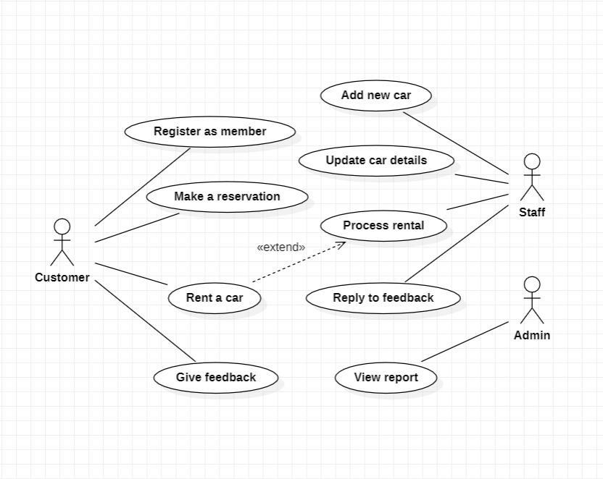

**CLASS DIAGRAM**

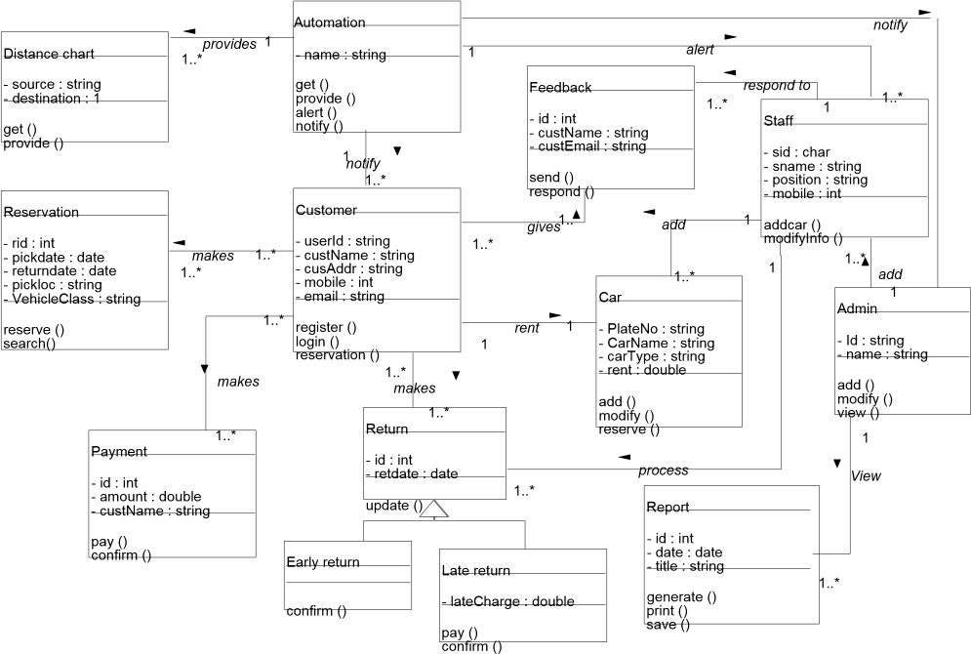

**SEQUENCE DIAGRAM**

**Member registration :-**

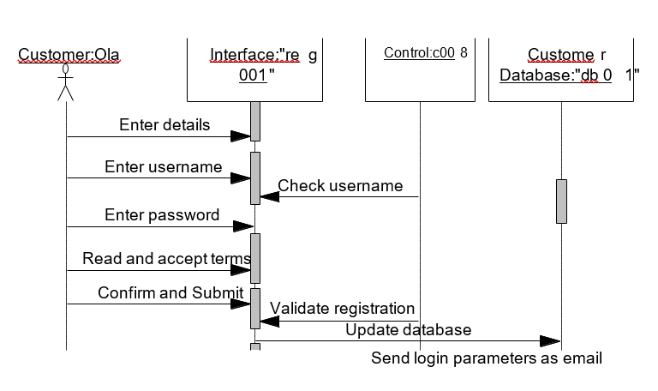

**Reservation of car :-**

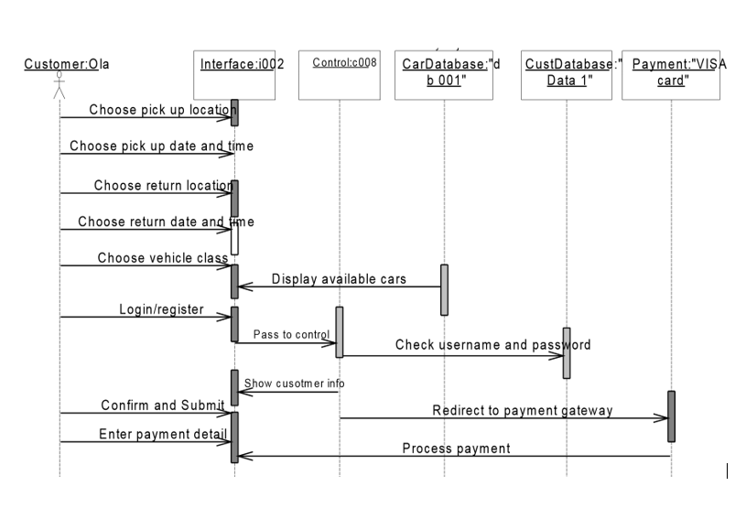

**Customer feedback :-**

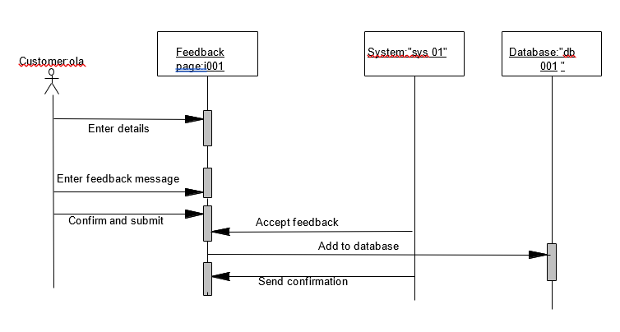

**Adding a new car :-**

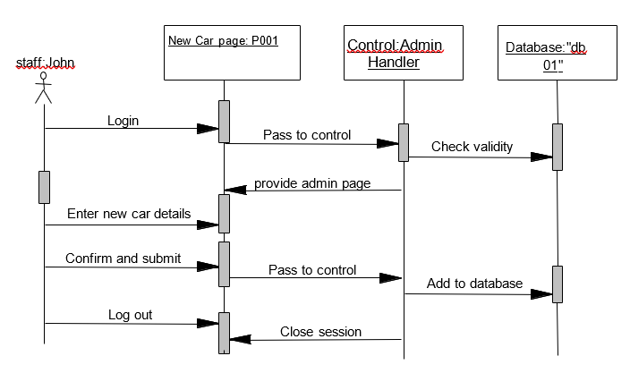

**Feedback response :-**

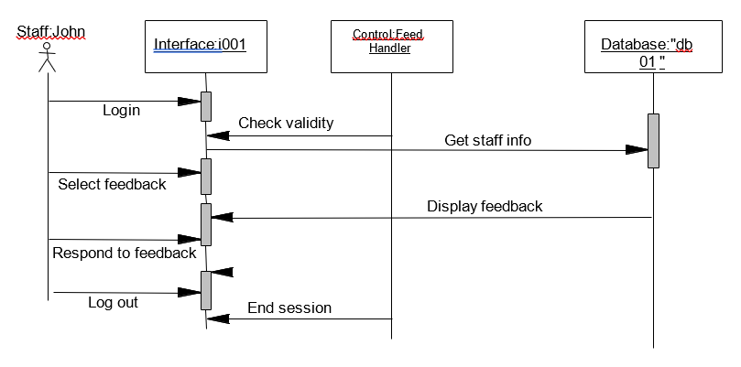

**Return car and check rental details :-**

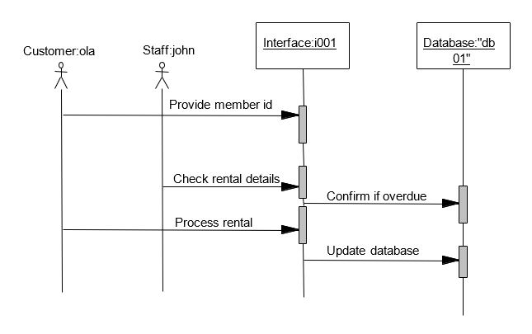

**View report :-**

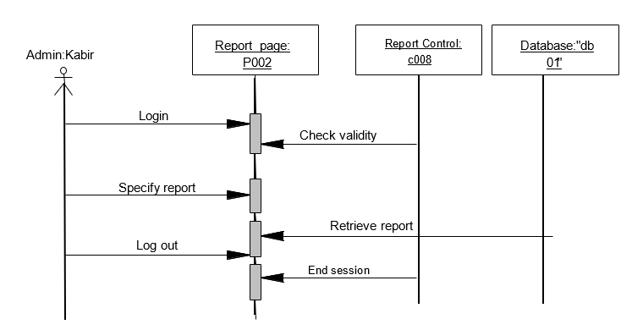

**COMMUNICATION DIAGRAM**

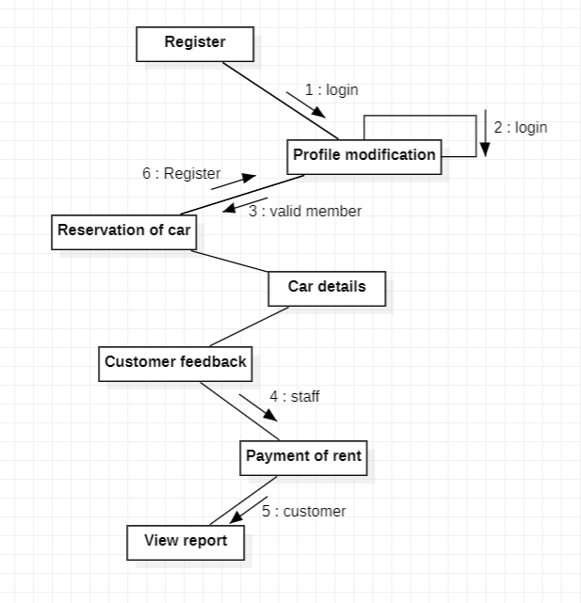

**STATE CHART DIAGRAM**

**Member registration :-**

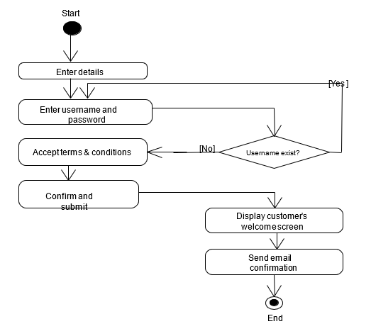

**Profile modification :-**

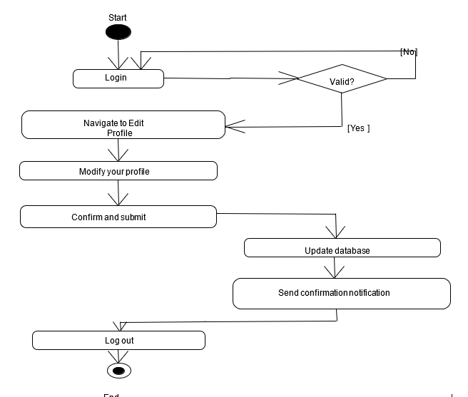

**Reservation of car :-**

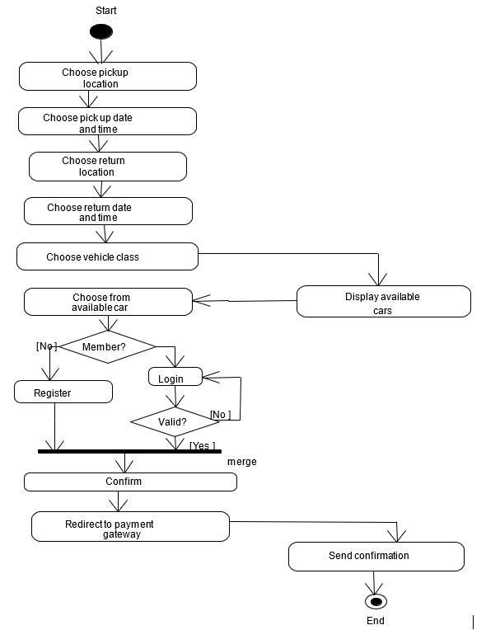

**Customer feedback :-**

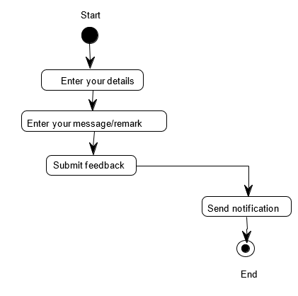

**Payment of car rent :-**

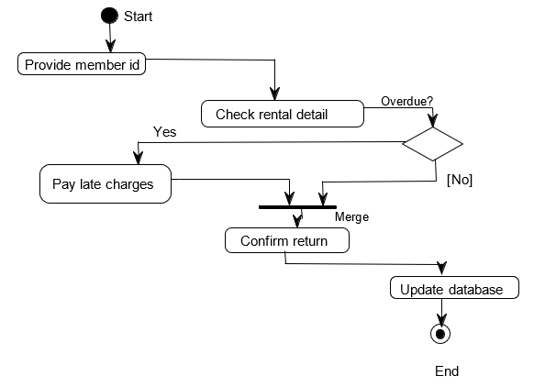

**Adding new car :-**

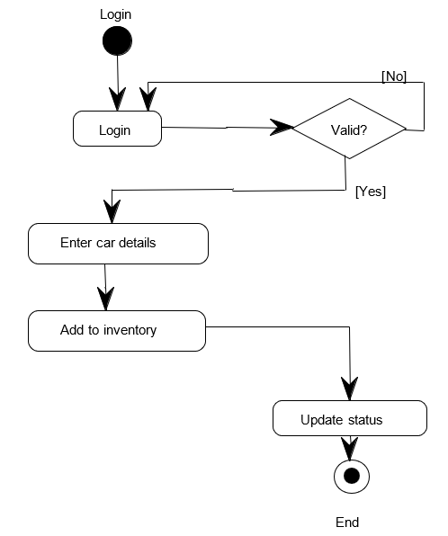

**View report :-**

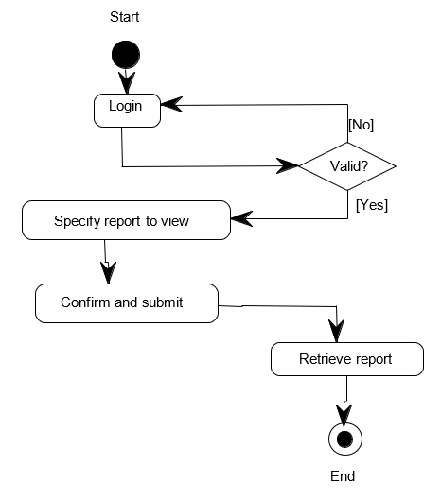

**ACTIVITY DIAGRAM**

**Member Registration :-**

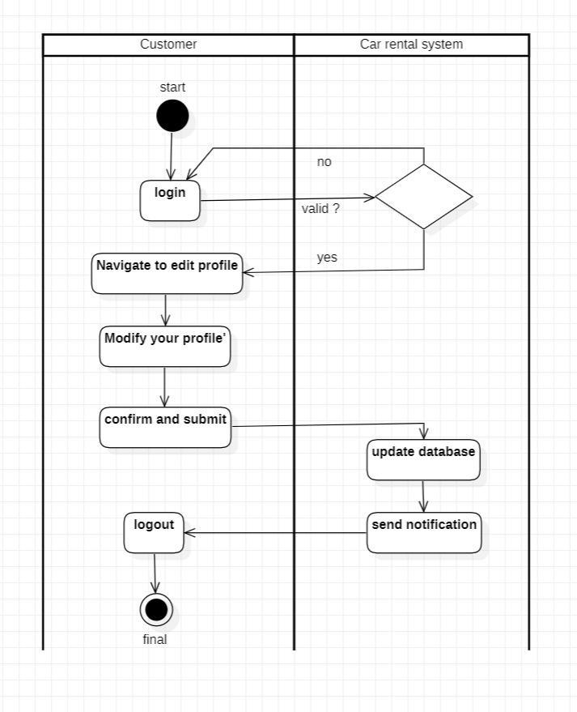

**Modification in profile :-**



**Reservation of Car :-**

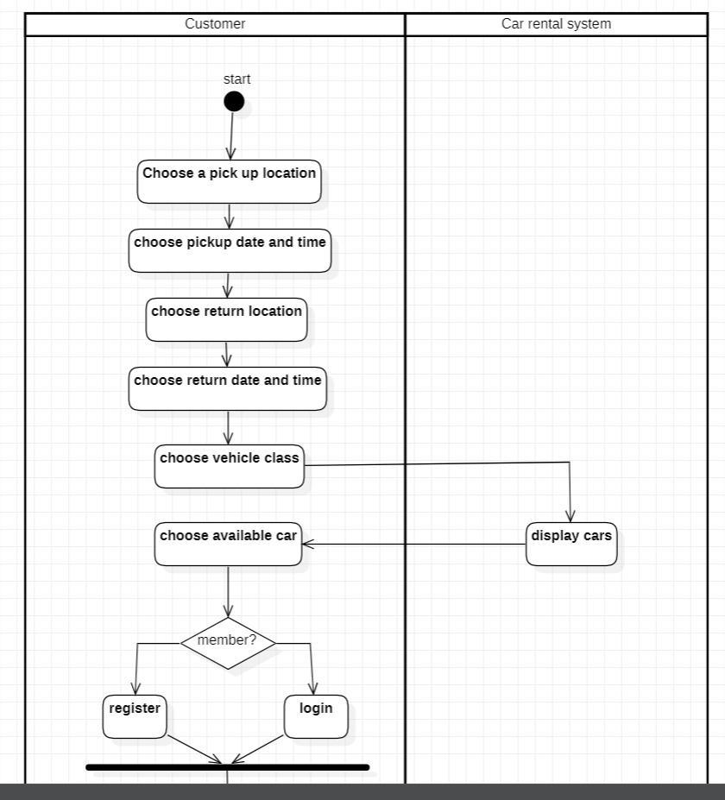

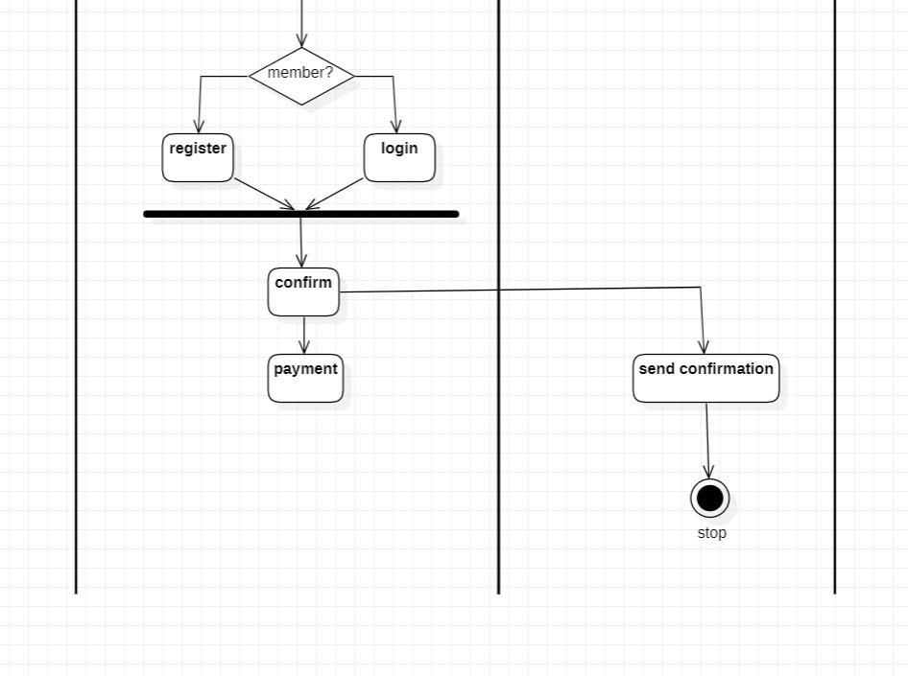

**Customer feedback :-**

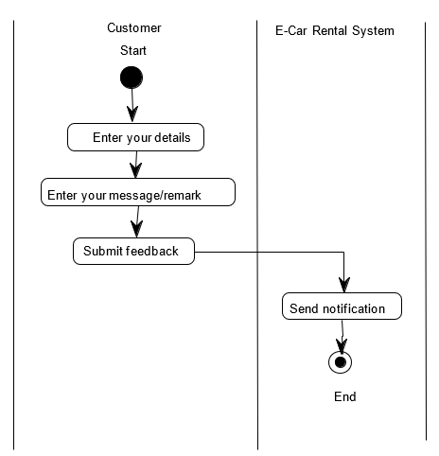

**Payment of car rent :-**

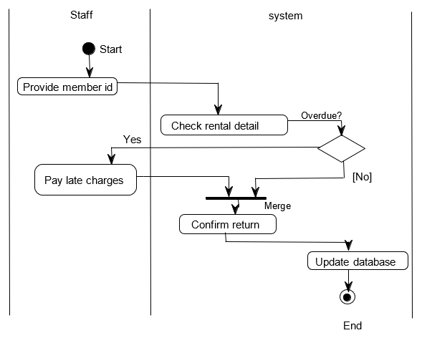

**Adding new car :-**

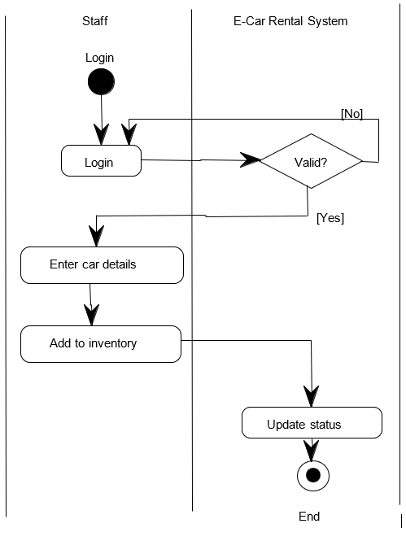

**View report :-**

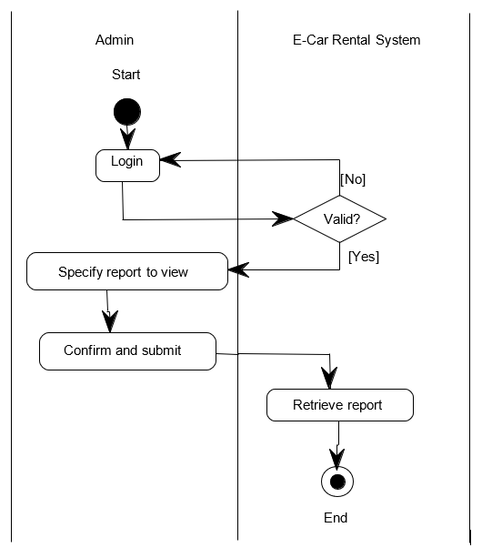

**PACKAGE DIAGRAM**

**COMPONENT DIAGRAM**

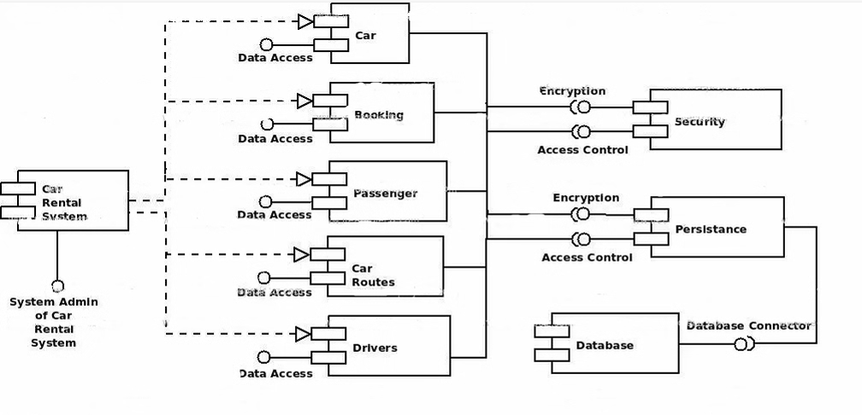

**CODE**

#include <iostream>

#include <conio.h>

#include <stdlib.h>

#include <string.h>

using namespace std;

class customer

{

public : string name1,name2,sex,dl,phone;

void customerdetails()

{

cout<<"\033[1;34m"<<"ENTER YOUR FIRST NAME IN CAPITAL LETTERS : ";

cout<<"\033[1;37m";

cin>>name1;

cout<<"\033[1;34m"<<"\nENTER YOUR LAST NAME IN CAPITAL LETTERS : ";

cout<<"\033[1;37m";

cin>>name2;

cout<<"\033[1;34m"<<"\nENTER YOUR SEX (IF FEMALE ENTER 'F' AND IF MALE ENTER 'M' OTHERWISE 'O') : ";

cout<<"\033[1;37m";

cin>>sex;

enterph :

cout<<"\033[1;34m"<<"\nENTER YOUR MOBILE NUMBER (ENTER 10 DIGIT NUMBER ONLY) : ";

cout<<"\033[1;37m";

cin>>phone;

if(phone.length()!=10)

{

cout<<"\033[1;31m"<<"INVALID MOBILE NUMBER !!! PLEASE ENTER AGAIN !!!"<<endl;

goto enterph;

}

enterdl :

cout<<"\033[1;34m"<<"\nENTER YOUR DRIVING LICENCE NUMBER : ";

cout<<"\033[1;37m";

cin>>dl;

if(dl.length()!=16)

{

cout<<"\033[1;31m"<<"INVALID DRIVING LICENCE NUMBER !!! PLEASE ENTER AGAIN !!!"<<endl;

goto enterdl;

}

}

};

class car

{

public : string carname,carno;

int x,petrol,adv;

void cardetails()

{

cout<<"\033[1;36m"<<"\nSELECT THE CAR YOU WANT TO RENT : ";

cout<<"\033[1;31m";

cin>>x;

switch(x)

{

case 1:

carname = "Ferrari 296 GTB";

carno = "TN 75 AA 7106";

break;

case 2:

carname = "McLaren 765LT";

carno = "AP 21 BP 7331";

break;

case 3:

carname = "Porsche 911 GT3";

carno = "UP 19 D 0343";

break;

case 4:

carname = "Ferrari F8 Tributo";

carno = "MH 12 RN 1289";

break;

case 5:

carname = "Lamborghini Huracan Evo";

carno = "03D 153874H";

break;

case 6:

carname = "Ferrari 812 GTS";

carno = "HR 26 TC 7174";

break;

case 7:

carname = "Maserati MC20";

carno = "TS 07 D TR 2020";

break;

case 8:

carname = "Audi R8";

carno = "KA 08 J 9192";

break;

case 9:

carname = "Ford GT";

carno = "MH 12 RN 1289";

break;

case 10:

carname = "Aston Martin DBS Superleggera";

carno = "MH 12 RN 1289";

break;

}

cout<<"\033[1;34m"<<"\nENTER PETROL CHARGES (ENTER 0 FOR NO CHARGES) : ";

cout<<"\033[1;31m";

cin>>petrol;

cout<<"\033[1;34m"<<"\nENTER ADVANCE CHARGES (ENTER 0 FOR NO CHARGES) : ";

cout<<"\033[1;31m";

cin>>adv;

}

void carmodels()

{

cout<<"\033[1;33m"<<"\nCAR MODELS AVAILABLE : \n";

cout<<"\033[1;31m"<<"1. "<<"\033[1;35m"<<"Ferrari 296 GTB"<<endl;

cout<<"\033[1;31m"<<"2. "<<"\033[1;35m"<<"McLaren 765LT"<<endl;

cout<<"\033[1;31m"<<"3. "<<"\033[1;35m"<<"Porsche 911 GT3"<<endl;

cout<<"\033[1;31m"<<"4. "<<"\033[1;35m"<<"Ferrari F8 Tributo"<<endl;

cout<<"\033[1;31m"<<"5. "<<"\033[1;35m"<<"Lamborghini Huracan Evo"<<endl;

cout<<"\033[1;31m"<<"6. "<<"\033[1;35m"<<"Ferrari 812 GTS"<<endl;

cout<<"\033[1;31m"<<"7. "<<"\033[1;35m"<<"Maserati MC20"<<endl;

cout<<"\033[1;31m"<<"8. "<<"\033[1;35m"<<"Audi R8"<<endl;

cout<<"\033[1;31m"<<"9. "<<"\033[1;35m"<<"Ford GT"<<endl;

cout<<"\033[1;31m"<<"10. "<<"\033[1;35m"<<"Aston Martin DBS Superleggera"<<endl;

}

};

class rent

{

public : int rentpay,y;

void rentdetails()

{

cout<<"\033[1;33m"<<"\nTHE MODE OF RENT : \n"<<"\033[1;31m1. \033[1;35mCALCULATE IN HOURS\n"<<"\033[1;31m2. \033[1;35mCALCULATE IN KM"<<endl;

cout<<"\033[1;34m"<<"\nSELECT THE MODE OF RENT : ";

cout<<"\033[1;31m";

cin>>y;

if(y==2)

{

int a,c,b,km;

cout<<"\033[1;34m"<<"\nENTER DISTANCE IN KM : ";

cout<<"\033[1;31m";

cin>>km;

a=km*7;

b=(km-30)*6;

c=(km-100)*5;

if(km<=30)

{

rentpay=a;

}

else if(km<=100&&km>30)

{

rentpay=210+b;

}

else

{

rentpay=560+c;

}

}

else

{

int hr;

cout<<"\033[1;34m"<<"\nENTER TIME IN HOURS : ";

cout<<"\033[1;31m";

cin>>hr;

if(hr<=12)

{

rentpay=hr*250;

}

else if(hr<=24&&hr>12)

{

rentpay=(hr/12)*2500;

}

else

{

rentpay=(hr/24)*4000;

}

}

}

};

class Invoice : public customer,public car,public rent

{

public : int invono;

void generate()

{

invono=rand()%10000000;

cout<<"\033[1;34m"<<"\n\n SRM CAR RENTAL - CUSTOMER INVOICE\n";

cout<<"\033[1;35m"<<" ////////////////////////////////////////////////////////////////////////////////////\n";

cout<<"\033[1;35m"<<" |\033[1;36m INVOICE NUMBER \033[1;33m:--------------------------------->\033[1;35m| "<<"\033[1;32m"<<invono<<"\n";

cout<<"\033[1;35m"<<" |\033[1;36m CUSTOMER NAME \033[1;33m:---------------------------------->\033[1;35m| "<<"\033[1;32m"<<name1<<" "<<name2<<"\n";

cout<<"\033[1;35m"<<" |\033[1;36m CAR MODEL \033[1;33m:-------------------------------------->\033[1;35m| "<<"\033[1;32m"<<carname<<"\n";

cout<<"\033[1;35m"<<" |\033[1;36m CAR NUMBER \033[1;33m:------------------------------------->\033[1;35m| "<<"\033[1;32m"<<carno<<"\n";

cout<<"\033[1;35m"<<" |\033[1;36m RENTAL AMOUNT \033[1;33m:---------------------------------->\033[1;35m| "<<"\033[1;32m"<<rentpay<<"\n";

cout<<"\033[1;35m"<<" |\033[1;36m CAUTION MONEY \033[1;33m:---------------------------------->\033[1;35m| "<<"\033[1;31m"<<adv<<"\n";

cout<<"\033[1;35m"<<" |\033[1;36m ADVANCE MONEY \033[1;33m:---------------------------------->\033[1;35m| "<<"\033[1;31m"<<petrol<<"\n";

cout<<"\033[1;35m"<<" ------------------------------------------------------------------------------------\n";

cout<<"\033[1;35m"<<" |\033[1;36m TOTAL AMOUNT \033[1;33m:----------------------------------->\033[1;35m| "<<"\033[1;31m"<<rentpay+adv+petrol<<"\n";

cout<<"\033[1;35m"<<" ------------------------------------------------------------------------------------\n";

cout<<"\033[1;35m"<<" ////////////////////////////////////////////////////////////////////////////////////\n";

}

};

int main()

{

int z=1;

while(z!=0)

{

system("clear");

Invoice i;

i.customerdetails();

i.carmodels();

i.cardetails();

i.rentdetails();

i.generate();

cout<<"\n"<<"\033[1;36mWANT TO RENT ANOTHER CAR (ENTER \033[1;35m1 \033[1;36mTO CONTINUE AND \033[1;35m0 \033[1;36mTO EXIT) : ";

cin>>z;

}

return 0;

}

**SAMPLE OUTPUT**

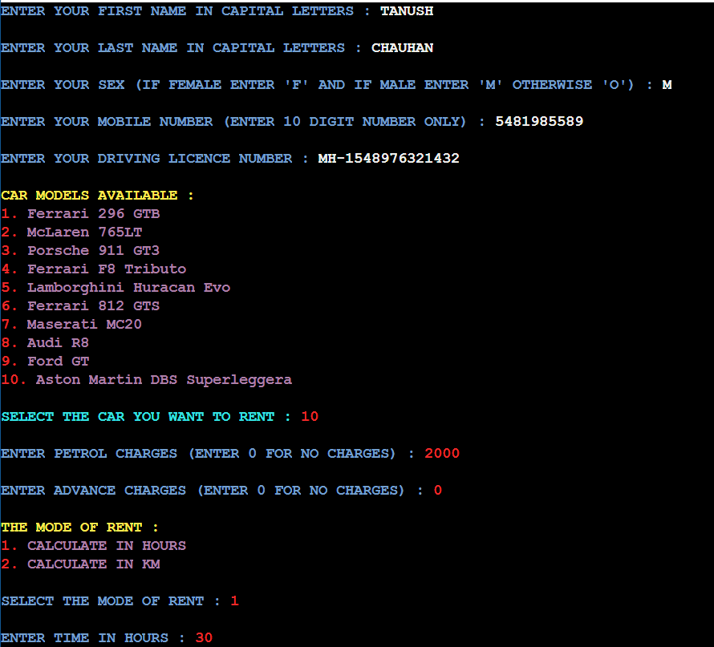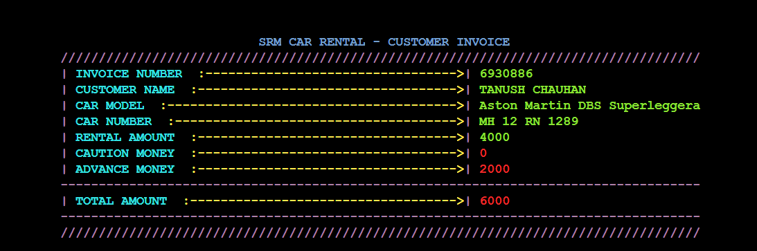

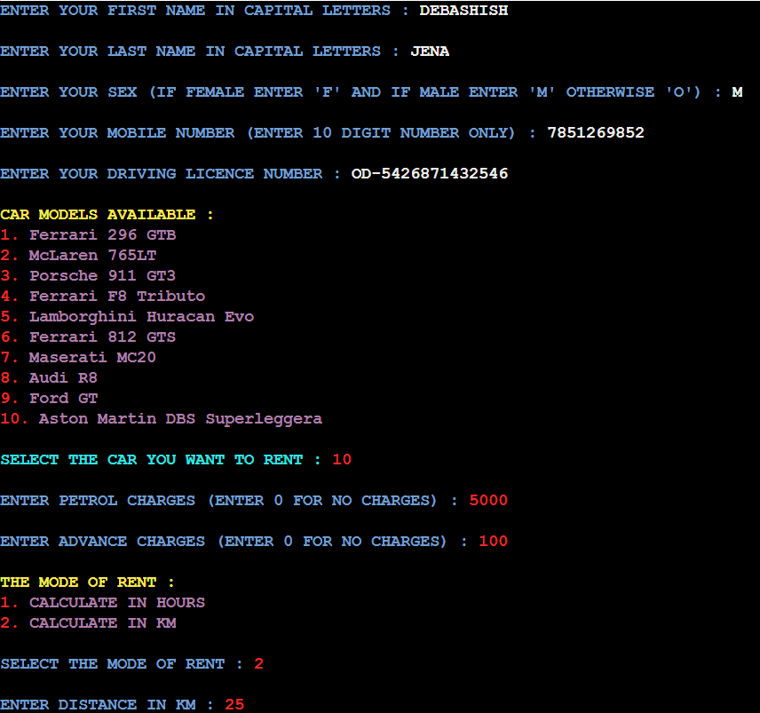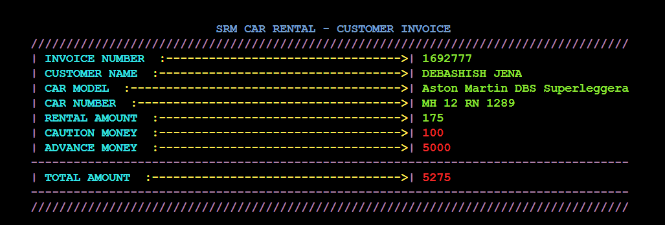

**CONCLUSION**

Car rental business has emerged with a new goodies compared to the past experience where every activity concerning car rental business is limited to a physical location only.

Even though the physical location has not been totally eradicated; the nature of functions and how these functions are achieved has been reshaped by the power of internet.

Nowadays, customers can reserve cars online, rent car online, and have the car brought to their door step once the customer is a registered member or go to the office to pick the car.

The web based car rental system has offered an advantage to both customers as well as Car Rental Company to efficiently and effectively manage the business and satisfies customers’ need at the click of a button.



SCAN THIS QR TO GET INFORMATION OF CODE