Cricket Score Management System
  - CREASE Web Technology Assignment 7
CREASE is a working cricket score management application built with Spring Boot and React. It simulates live T20 matches, persists each delivery, streams score changes to the dashboard, and exposes match and player information through REST APIs. This report provides the submission link, execution instructions, verified test results, and screenshots of the completed application.

Source repository
https://github.com/coder-crypt0/wtassign/tree/assign7
Branch: assign7. The repository includes the backend, frontend, tests, README, and root run.ps1 evaluation launcher.

Technology stack
Layer | Implementation
Backend | Java 21, Spring Boot 3.5, Spring MVC and Bean Validation
Frontend | React 19, TypeScript and Vite 8 with responsive custom CSS
Persistence | H2 database and Spring Data JPA with transactional delivery logs
Live updates | Server sent events, heartbeat messages and reconnect recovery
Testing | JUnit and MockMvc integration tests plus Playwright browser tests

Run and evaluate
Prerequisites: Java 21, Maven 3.9 or newer, and Node.js 22.12 or newer LTS. Open PowerShell in the project root and run:
powershell -ExecutionPolicy Bypass -File .\run.ps1
The script builds both applications and opens http://127.0.0.1:8087. Keep the terminal open and press Ctrl+C to stop. Use .\run.ps1 -Test to execute the complete test suite, or -FreshDemo for a temporary session.
Verified results: 24 backend tests and 18 browser tests passed. The browser suite covers desktop and mobile layouts, scoring, free hits, undo, live updates, search, bookmarks, scorecards, player leaders, and fixture navigation.

Desktop dashboard
The match centre combines live fixture cards, a large scoreboard, innings comparison, player statistics, and recent deliveries. These screenshots were captured from the application served by Spring Boot.
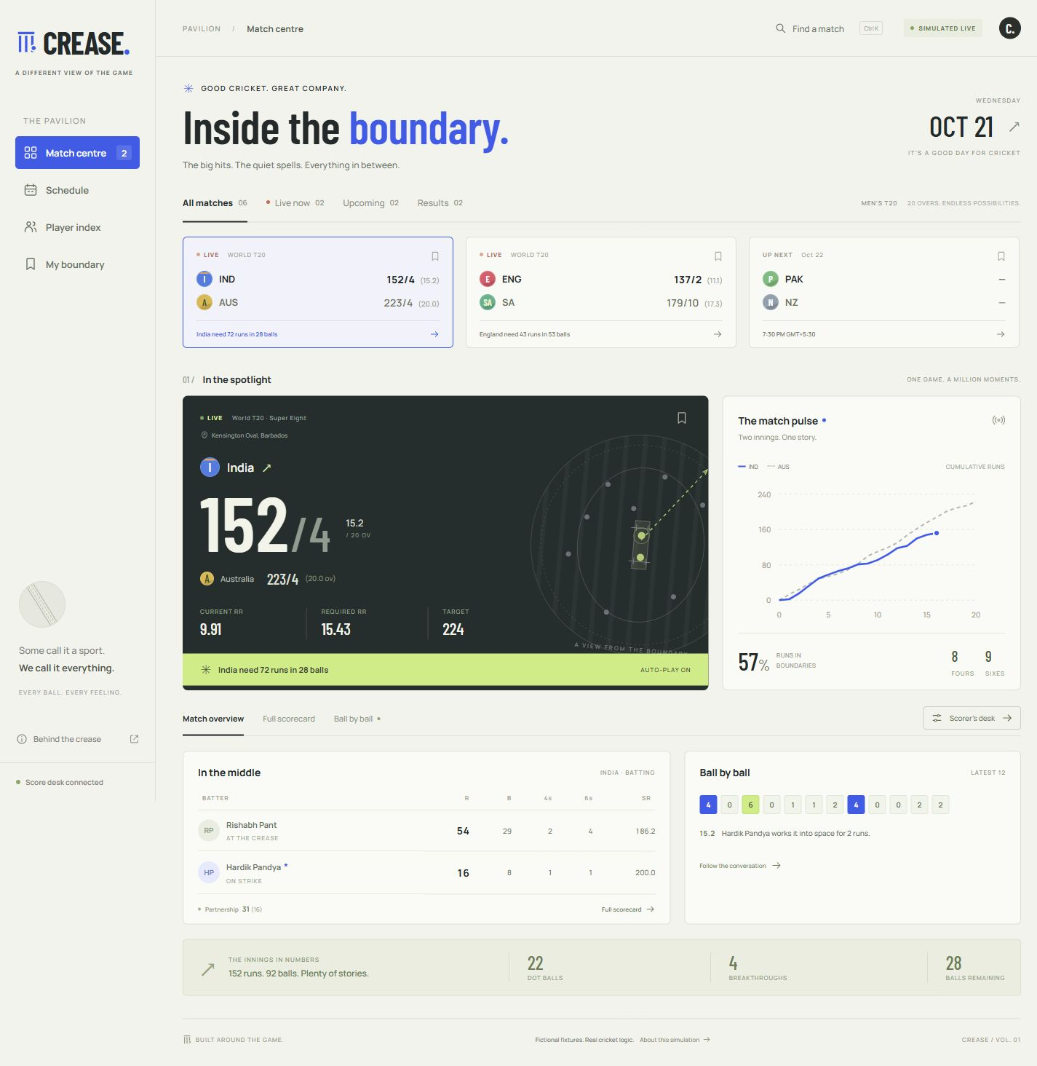
Figure 1 Desktop match centre with a live simulated India versus Australia fixture

Scoring controls and mobile interface
The scorer can pause auto play, record runs and extras, protect a free hit, undo the latest delivery, or restart the demo. On a phone, the match centre becomes a single column with bottom navigation.
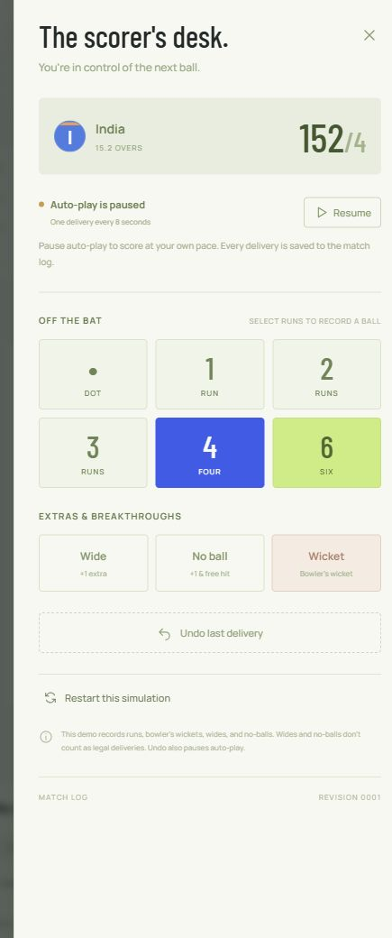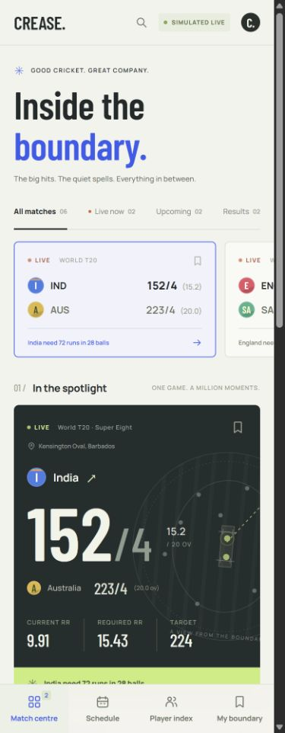
Figure 2 Scorer controls and the responsive phone dashboard

Implementation scope
Fixtures and statistics are fictional. The application supports runs, bowler wickets, wides, no balls, strike rotation, targets and match completion. Delivery UUIDs and revision checks prevent duplicate or conflicting writes. This locally bound academic demo uses one database and scheduler; production deployment would require authentication and shared infrastructure for multiple instances.

