**Sanjivani Rural Education Society’s**

# SANJIVANI K.B.P. POLYTECHNIC, KOPARGAON



A

PROJECT REPORT

ON

**“LIGHT SWITCH ON/OFF PROJECT USING JAVASCRIPT”**

**SUBJECT:** Client side Scripting[22519]

**SUBMITTED BY:-**

* **Shinde Mahesh T. [145]**

**Guided by: Prof. S.A. Patil**

***DEPARTMENT OF COMPUTER TECHNOLOGY, SANJIVANI K.B.P POLYTECHNIC, KOPARGAON.***

***(2023-24)***

**Sanjivani Rural Education Society’s**

# SANJIVANI K.B.P. POLYTECHNIC, KOPARGAON



CERTIFICATE

This is to certify that the Project report entitled

**“LIGHT SWITCH ON/OFF PROJECT USING JAVASCRIPT”**

## SUBMITTED BY :-

* **Shinde Mahesh T. [145]**

***Under our supervision and guidance for partial fulfillment of the requirement for diploma in Computer Technology affiliated to Maharashtra State Board of Technical Education, Mumbai.***

Project Guide H.O.D

Prof. S.A. Patil Prof. G.N. Jorvekar

**INDEX**

|  |  |  |
| --- | --- | --- |
| **Sr. No.** | **Title** | **Page no.** |
| **1.** | Introduction | 04 |
| **2.** | Algorithm | 05 |
| **3.** | Flowchart | 06 |
| **4.** | Project Code | 07 |
| **5.** | Outputs | 09 |
| **6.** | Conclusion | 10 |
| **7.** | References | 10 |

# ***

**Introduction**

This project will teach you how to create a simple light switch on and off project using JavaScript. You will learn how to use JavaScript to change the image of a light bulb to turn it on and off.

In order to complete this project, you will need to have a basic understanding of HTML, CSS, and JavaScript. You will also need to have a text editor and a web browser installed on your computer.

Once you have completed this project, you will be able to create your own simple JavaScript applications. You will also be able to understand how to use JavaScript to interact with HTML elements.

**ALGORITHM**

1. Create an html element for light switch such as image.
2. Assign id attribute to <img> element.
3. Create two buttons ON and OFF using <button> element.
4. Write a javascript for switching the img.

* If user clicks on ON button then show the "light_on.png" on <img> element.
* If user clicks on OFF button the show "light_off.png" on <img> element.

1. If user clicked on ON then set background color to 'yellow' else If user clicked on OFF then set background color to 'black'.
2. Stop.

**FLOWCHART**

.

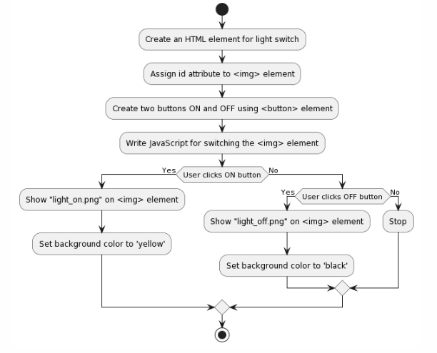

**PROJECT CODE :**

<html>

<head>

<title>145 CSS micro_project</title>

<style>

.container {

width: 1000px;

height: 400px;

text-align: center;

margin: 50px auto;

padding:10px;

border: 2px solid black;

border-radius: 100px;

}

.switch_btn {

height: fit-content;

width: 100px;

margin: 20px;

font-size: 20px;

box-shadow: 10px 10px 10px 10px;

border-radius: 10px;

}

#light_status {

font-family: 'Arial';

font-style: bold;

}

</style>

</head>

<body>

<div class="container">

<div class="light_div">

<img id="light" src="light_off.png" />

</div>

<br>

<div class="switch_div">

<button class="switch_btn" id="light_off" value="OFF" onclick="btn_clicked(this)">OFF</button>

<button class="switch_btn" id="light_on" value="ON" onclick="btn_clicked(this)">ON</button>

</div> <br>

<label id="light_status"></label>

</div>

</body>

<script>

document.getElementById("light_on").style.backgroundColor = "green";

document.getElementById("light_off").style.backgroundColor = "red";

document.getElementById("light_status").innerHTML = "LIGHT IS : OFF";

function btn_clicked(obj) {

if (obj.value == "OFF") {

document.getElementById("light").src = "light_off.png";

document.getElementById("light_status").innerHTML = "LIGHT IS : OFF"

}

if (obj.value == "ON") {

document.getElementById("light").src = "light_on.png";

document.getElementById("light_status").innerHTML = "LIGHT IS : ON"

}

}

const toggleSun = document.getElementById('light_on');

const toggleMoon = document.getElementById('light_off');

const body = document.querySelector('body');

body.style.background = 'black';

body.style.color = 'white';

toggleSun.addEventListener('click',function(){

body.style.background = 'white';

body.style.color = 'black';

body.style.transition = '2s'

})

toggleMoon.addEventListener('click',function(){

body.style.background = 'black';

body.style.color = 'white';

body.style.transition = '2s'

})

</script> </html>

**OUTPUTS**

**# If you clicked on ‘ON’ button :**

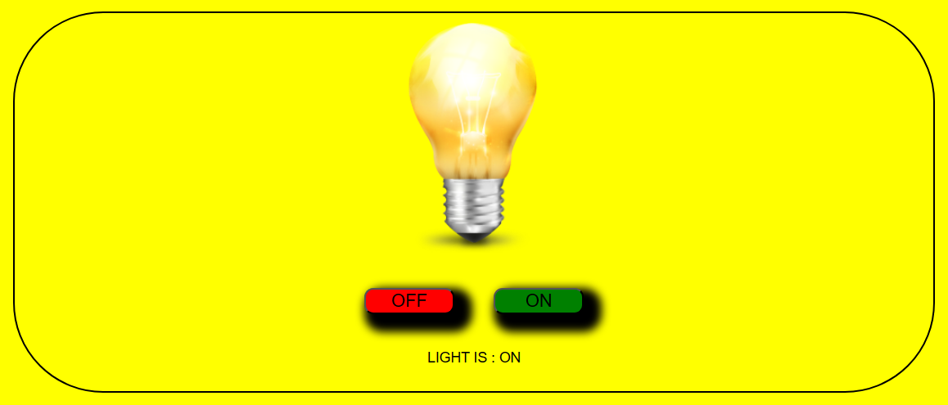

**# If you clicked on ‘OFF’ button :**

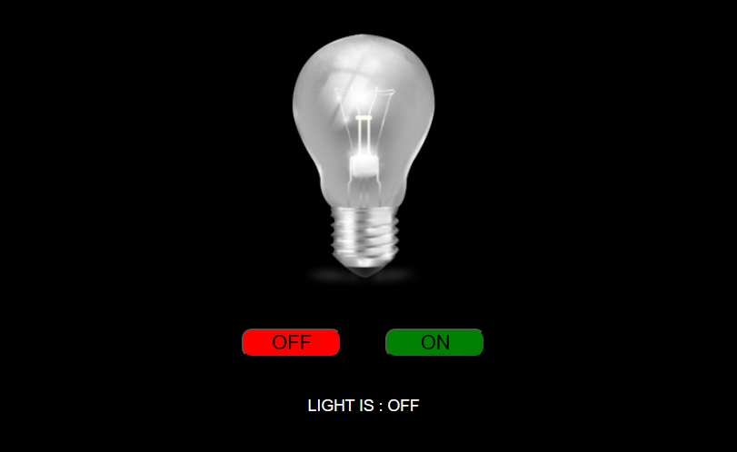

**Conclusion**

In conclusion, we have built a simple light switch on and off project using JavaScript. This project demonstrates how to use JavaScript to control physical devices, such as a light bulb. The project is also a good example of how to use event listeners to respond to user interactions.

The project can be extended in a number of ways. For example, you could add a button to turn the light on and off, or you could use a sensor to turn the light on when someone enters a room. You could also use the project to build a more complex system, such as a smart home system.

**References**

* [**https://practice.geeksforgeeks.org**](https://practice.geeksforgeeks.org)
* [**https://www.w3schools.com**](https://www.w3schools.com)
* **https://www.tutorialspoint.com**