**Sanjivani Rural Education Society’s**

# SANJIVANI KBP POLYTECHNIC

DEPARTMENT OF COMPUTER TECHNOLOGY



A PROJECT REPORT

ON

## “MOVIE TICKET RESERVATION SYSTEM”

*(Advanced Java Programming(22517))*

*Submitted by*

|  |  |  |
| --- | --- | --- |
| Roll No. | Name | Enrollment No. |
| 145 | Mst. Shinde Mahesh T | 2100340265 |

### Under the Guidance of Prof. K. P. Jadhav

**DEPARTMENT OF COMPUTER TECHNOLOGY SANJIVANI KBP POLYTECHNIC KOPARGAON** KOPARGAON, AHMEDNAGAR - 423601

2023-24



**Sanjivani Rural Education Society’s**

# SANJIVANI KBP POLYTECHNIC

DEPARTMENT OF COMPUTER TECHNOLOGY



***CERTIFICATE***

## “MOVIE TICKET RESERVATION SYSTEM”

*(Advanced Java Programming(22517))*

*Submitted by*

|  |  |  |
| --- | --- | --- |
| Roll No. | Name | Enrollment No. |
| 145 | Mst.Shinde Mahesh T | 2100340265 |

Under our supervision and guidence for partial fulfillment of the Final Individual Project Report Of ***AJP(22517).***

For Academic Year 2023-24

### Prof. K. P. Jadhav Prof. G. N. Jorvekar

(Project Guide) (Head Of Department)

### Prof. A. R. MIRIKAR

(Principal)



# ACKNOWLEDGMENT

I express my deepest thanks to **Prof. K. P. Jadhav** sir, for taking part in useful decision giving necessary advices and guidance and arranged all facilities to make life easier. We choose this moment to acknowledge his contribution gratefully.

### 145 Mst. Shinde Mahesh T.

**Diploma in Computer Technology. Sanjivani K. B. P. Polytechnic, Kopargaon.**

# *INDEX*



|  |  |  |
| --- | --- | --- |
| **Sr. No.** | **CONTENTS** | **Page No.** |
| 1 | INTRODUCTION | 5 |
| 2 | ALGORITHM FOR ATM MANAGEMENT SYSTEM CODE | 6 |
| 3 | FLOWCHART FOR ATM MANAGEMENT SYSTEM CODE | 7 |
| 4 | CODE FOR ATM MANAGEMENT SYSTEM IN JAVA | 8 |
| 5 | OUTPUTS OF PROGRAM | 10 |
| 6 | VIEW BALANCE | 10 |
| 7 | WITHDRAW MONEY | 10 |
| 8 | DEPOSIT MONEY | 11 |
| 9 | EXIT | 11 |
| 9 | ABSTRACTION | 12 |
| 10 | CONCLUSION | 13 |
| 11 | REFERENCE | 14 |

**INTRODUCTION**



In Java, we can create an ATM program for representing ATM transection. In the ATM program, the user has to select an option from the options displayed on the screen. The options are related to withdraw the money, deposit the money, check the balance, and exit.

To withdraw the money, we simply get the withdrawal amount from the user and remove that amount from the total balance and print the successful message.

To deposit the money, we simply get the deposit amount from the user, add it to the total balance and print the successful message.

To check balance, we simply print the total balance of the user.

We use the exit(0) method to exit from the current Transaction mode and return the user to the home page or initial screen.

**ALGORITHM FOR MOVIE TICKET RESERVATION SYSTEM :**

1. Initialize balance to 1000.0 and create a new Scanner object.

2. Display a menu with options for the user.

3. Read the user's choice using the Scanner object.

4. Use a switch statement to execute the corresponding function based on the user's choice:

a. If the user chooses "Withdraw money", call the withdraw() function.

b. If the user chooses "Deposit money", call the deposit() function.

c. If the user chooses "Check account balance", call the checkBalance() function.

d. If the user chooses "Exit", display a goodbye message and end the program.

e. If the user enters an invalid choice, display an error message and return to the menu.

5. If the user selected "Withdraw money":

a. Prompt the user to enter the amount to withdraw.

b. If the user's balance is less than the amount to withdraw, display an error message.

c. Otherwise, subtract the amount to withdraw from the balance and display a success message with the new balance.

6. If the user selected "Deposit money":

a. Prompt the user to enter the amount to deposit.

b. Add the amount to deposit to the balance and display a success message with the new balance.

7. If the user selected "Check account balance", display the current balance.

8. Repeat steps 2-7 until the user selects "Exit".

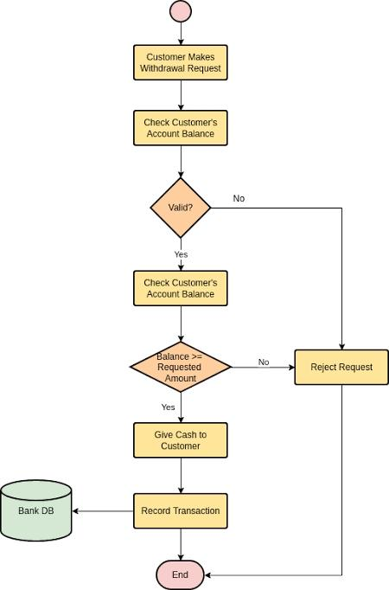 **FLOWCHART FOR MOVIE TICKET RESERVATION SYSTEM:**

# CODE FOR MOVIE TICKET RESERVATION SYSTEM :



package microproject145;

import java.sql.*;

import javax.swing.*;

import java.awt.*;

import java.awt.event.*;

import javax.swing.table.DefaultTableModel;

public class MTRS extends JFrame{

public MTRS(){

setTitle("Movie Ticket Reservation System: 145");

setSize(1280,720);

setVisible(true);

setLayout(null);

setBackground(Color.BLACK);

JTabbedPane tp=new JTabbedPane();

tp.setBounds(350,20,700,600);

JPanel bookpanel=new JPanel();

bookpanel.setBackground(Color.GREEN);

bookpanel.setLayout(null);

JPanel viewpanel=new JPanel();

viewpanel.setBackground(Color.ORANGE);

viewpanel.setLayout(null);

JPanel cancelpanel=new JPanel();

cancelpanel.setBackground(Color.RED);

cancelpanel.setLayout(null);

tp.add("Book_Seats",bookpanel);

tp.add("View_Seats",viewpanel);

tp.add("Cancel_Reservation",cancelpanel);

add(tp);

BookSeats b = new BookSeats(bookpanel);

ViewReservedSeats v = new ViewReservedSeats(viewpanel);

CancelReservation c = new CancelReservation(cancelpanel);

}

public static void main(String args[]){

MTRS obj = new MTRS();

}

}

class BookSeats implements ActionListener{

private JLabel header1,header2,l1,l2,l3,l4,l5,l6,labelStatus;

private JTextField in_name,in_mob_no,in_email_id;

private JComboBox movies,seatNo;

ButtonGroup radiogrp;

JRadioButton r1,r2,r3,r4,r5;

JButton submitBtn;

String movies_arr[] = {"LEO","JAWAN","JAILER","AVATAR","TIGER3"};

String seats_arr[] = {

"1","2","3","4","5","6","7","8","9","10",

"11","12","13","14","15","16","17","18","19","20",

"21","22","23","24","25","26","27","28","29","30",

"31","32","33","34","35","36","37","38","39","40",

"41","42","43","44","45","46","47","48","49","50",

"51","52","53","54","55","56","57","58","59","60",

"61","62","63","64","65","66","67","68","69","70",

"71","72","73","74","75","76","77","78","79","80",

"81","82","83","84","85","86","87","88","89","90",

"91","92","93","94","95","96","97","98","99","100"};

public BookSeats(JPanel panel1){

header1 = new JLabel("## Movie Ticket Reservation Sytem ##");

header2 = new JLabel("Enter Your Details Here :");

l1 = new JLabel("Enter Your Name :");

l2 = new JLabel("Enter Your Email ID :");

l3 = new JLabel("Enter Your Mob No :");

l4 = new JLabel("No of Tickets you want to buy :");

l5 = new JLabel("Select Movie :");

l6 = new JLabel("Choose Your Seat Number :");

labelStatus = new JLabel("Reservation Status :");

in_name = new JTextField();

in_email_id = new JTextField();

in_mob_no = new JTextField();

submitBtn = new JButton("SUBMIT >");

movies = new JComboBox(movies_arr);

seatNo = new JComboBox(seats_arr);

r1 = new JRadioButton("1",true);

r2 = new JRadioButton("2");

r3 = new JRadioButton("3");

r4 = new JRadioButton("4");

r5 = new JRadioButton("5");

radiogrp = new ButtonGroup();

radiogrp.add(r1);

radiogrp.add(r2);

radiogrp.add(r3);

radiogrp.add(r4);

radiogrp.add(r5);

header1.setBounds(250,20,300,40);

header2.setBounds(280,70,300,40);

l1.setBounds(150,130,150,40);

l2.setBounds(150,180,150,40);

l3.setBounds(150,230,150,40);

l4.setBounds(150,280,200,40);

l5.setBounds(150,330,200,40);

l6.setBounds(150,380,200,40);

panel1.add(header1);

panel1.add(header2);

panel1.add(l1);

panel1.add(l2);

panel1.add(l3);

panel1.add(l4);

panel1.add(l5);

panel1.add(l6);

in_name.setBounds(350,130,200,30);

in_email_id.setBounds(350,180,200,30);

in_mob_no.setBounds(350,230,200,30);

r1.setBounds(350,280,50,30);

r2.setBounds(400,280,50,30);

r3.setBounds(450,280,50,30);

r4.setBounds(500,280,50,30);

r5.setBounds(550,280,100,30);

movies.setBounds(350,330,100,30);

seatNo.setBounds(350,380,100,30);

submitBtn.setBounds(300,450,100,50);

labelStatus.setBounds(150,500,300,50);

panel1.add(in_name);

panel1.add(in_email_id);

panel1.add(in_mob_no);

panel1.add(r1);

panel1.add(r2);

panel1.add(r3);

panel1.add(r4);

panel1.add(r5);

panel1.add(movies);

panel1.add(seatNo);

panel1.add(submitBtn);

panel1.add(labelStatus);

submitBtn.addActionListener(this);

}

public void actionPerformed(ActionEvent e){

String username = in_name.getText();

String emailid = in_email_id.getText();

int mobno = Integer.parseInt(in_mob_no.getText());

String selectedMovie = (String) movies.getSelectedItem();

int selectedSeatNo = (int) seatNo.getSelectedItem();

String selectedTickets = radiogrp.getSelection().getActionCommand();

try{

Class.forName("oracle.jdbc.driver.OracleDriver");

Connection con = DriverManager.getConnection("jdbc:oracle:thin:@localhost:1521:xe","system","system");

PreparedStatement stmt = con.prepareStatement("insert into movie_ticket_reservation values (?,?,?,?,?,?)");

stmt.setString(1,username);

stmt.setString(2,emailid);

stmt.setInt(3,mobno);

stmt.setInt(4,Integer.parseInt(selectedTickets));

stmt.setString(5,selectedMovie);

stmt.setInt(6,selectedSeatNo);

int rs=stmt.executeUpdate();

if(rs>0){

labelStatus.setText("Reservation Status : Seat Reserved Successfully..!");

}

else{

labelStatus.setText("Reservation Status : Seat Is Already Reserved..!");

}

con.close();

}catch(Exception ex){System.out.println(ex);}

}

// }

}

class ViewReservedSeats implements ActionListener

{

JButton showSeats;

JTable table;

JScrollPane scrollpane;

ViewReservedSeats(JPanel panel2){

showSeats = new JButton("CLICK HERE TO VIEW RESERVED SEATS");

table = new JTable();

scrollpane = new JScrollPane(table);

showSeats.setBounds(200,20,300,30);

scrollpane.setBounds(50,100,600,300);

panel2.add(scrollpane);

panel2.add(showSeats);

showSeats.addActionListener(this);

}

public void actionPerformed(ActionEvent e){

try

{

DefaultTableModel model = new DefaultTableModel();

String []col={"Name","Email_Address","Mobile_No","Tickets","Movie_Name", "Seat_No"};

model.setColumnIdentifiers(col);

table.setModel(model);

Class.forName("oracle.jdbc.driver.OracleDriver");

Connection con = DriverManager.getConnection("jdbc:oracle:thin:@localhost:1521:xe","system","system");

Statement stmt = con.createStatement();

ResultSet rs=stmt.executeQuery("select * from movie_ticket_reservation");

// ResultSetMetaData rsmd = rs.getMetaData();

// DefaultTableModel tb1 = (DefaultTableModel) table.getModel();

// model = (DefaultTableModel) table.getModel();

// int column = rsmd.getColumnCount();

// String[] colName = new String[column];

// for(int i=1; i<column; i++){

// colName[i] = rsmd.getColumnName(i + 1);

// }

// model.setColumnIdentifiers(colName);

// String []row1={"Shinde Mahesh T","maheshshinde9100@gmail.com","9529544681","1","LEO","45"};

// model.addRow(row1);

while(rs.next()){

String value1 = rs.getString(1);

String value2 = rs.getString(2);

String value3 = String.valueOf(rs.getInt(3));

String value4 = String.valueOf(rs.getInt(4));

String value5 = rs.getString(5);

String value6 = String.valueOf(rs.getInt(6));

String tdata[] = {value1,value2,value3,value4,value5,value6};

model.addRow(tdata);

}

con.close();

}catch(Exception ex){System.out.println(ex.getMessage());}

}

}

class CancelReservation implements ActionListener{

JLabel cancel_res1,cancel_res2,cancel_status;

JTextField seat_no_for_cancel_res,movie_name_for_cancel_res;

JButton cancel_res_button;

CancelReservation(JPanel panel3){

cancel_res1 = new JLabel("Enter Your Reserved Seat No. For Cancel Reservation :");

cancel_res2 = new JLabel("Enter Movie Name :");

cancel_status = new JLabel("Reservation cancelation status :");

seat_no_for_cancel_res = new JTextField();

movie_name_for_cancel_res = new JTextField();

cancel_res_button = new JButton("CANCEL RESERVATION");

cancel_res1.setBounds(100,130,400,30);

cancel_res2.setBounds(100,180,150,30);

cancel_status.setBounds(150,500,300,50);

seat_no_for_cancel_res.setBounds(450,130,100,30);

movie_name_for_cancel_res.setBounds(450,180,100,30);

cancel_res_button.setBounds(400,300,200,30);

panel3.add(cancel_res1);

panel3.add(cancel_res2);

panel3.add(movie_name_for_cancel_res);

panel3.add(seat_no_for_cancel_res);

panel3.add(cancel_res_button);

cancel_res_button.addActionListener(this);

}

public void actionPerformed(ActionEvent e){

try

{

Class.forName("oracle.jdbc.driver.OracleDriver");

Connection con = DriverManager.getConnection("jdbc:oracle:thin:@localhost:1521:xe","system","system");

PreparedStatement stmt = con.prepareStatement("delete from movie_ticket_reservation where Seat_No=? and Movie_Name=?");

stmt.setString(1,seat_no_for_cancel_res.getText());

stmt.setString(2,movie_name_for_cancel_res.getText());

int rs=stmt.executeUpdate();

if(rs>0){

cancel_status.setText("Seat Unreserved Succeesfully....!");

}

else{

cancel_status.setText("Seat Not Reserved...!");

}

System.out.println("Deleted Record");

con.close();

}catch(Exception ex){

System.out.println(ex);

}

}

}



**OUTPUTS OF PROGRAM**

### I] Reserve Seat :

To reserve a seat for user have to enter all the details and then just have to click on SUBMIT button. After clicking on submit all the details will store into the Database Table (table name : *movie_ticket_reservation ).*

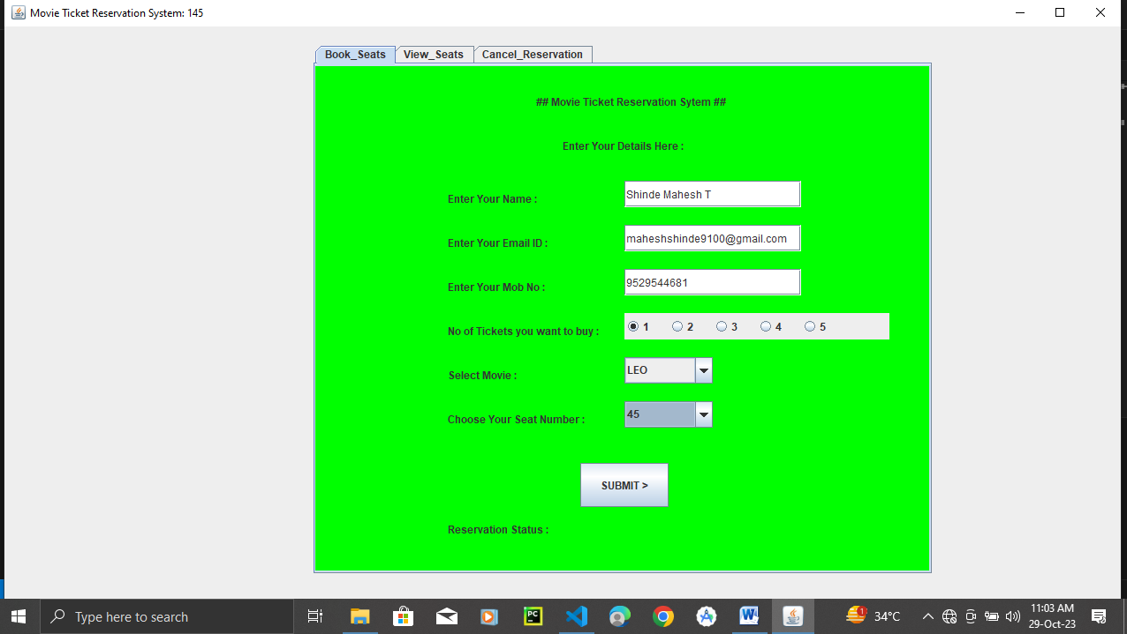

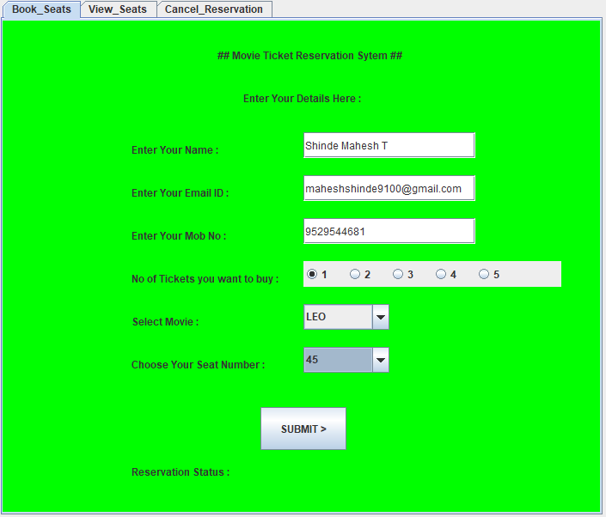

### ii] View Reserved Seats :

To view the reserved seats “view seats” menu present on JTabbedpanne. By clicking on view seats menu new user interface for view booked seats will be opened on JPanel. User just have to click on “CLICK HERE TO VIEW RESERVED SEATS” button and the reserved seats are shown on the JTable in JPanel.

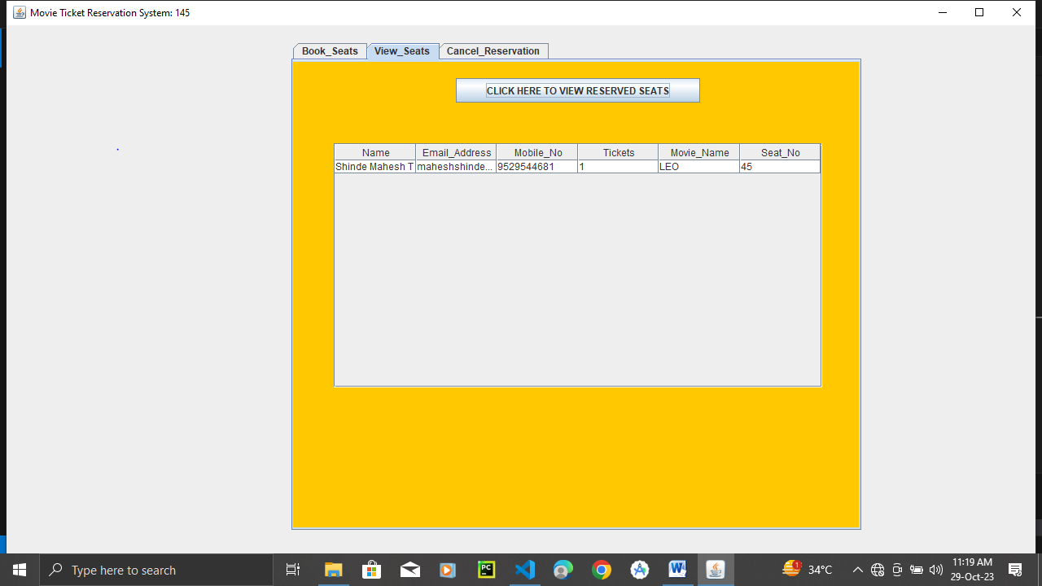

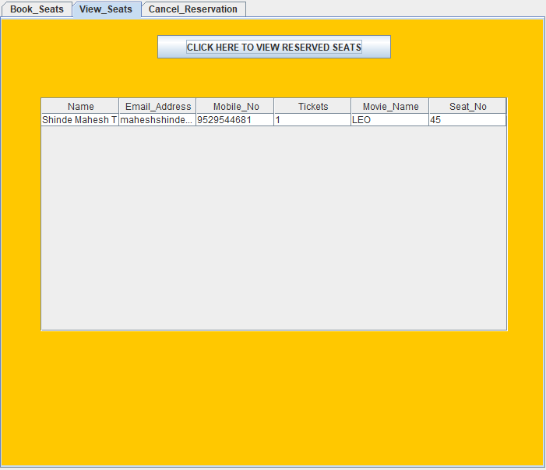

### iii] Cancel Reservation :



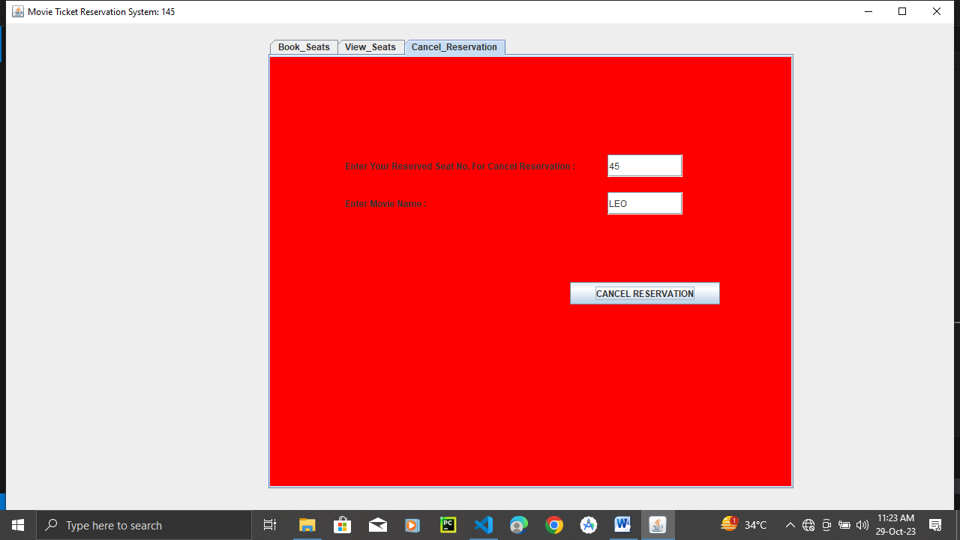By clicking on JTabbedPanne’s 3rd menu which is **“Cancel Reservation”** , user interface for cancelling reservation will visible on to the **JPanel**. User will have to enter their reserved seat number in textfield and then record of their reservation will be deleted.

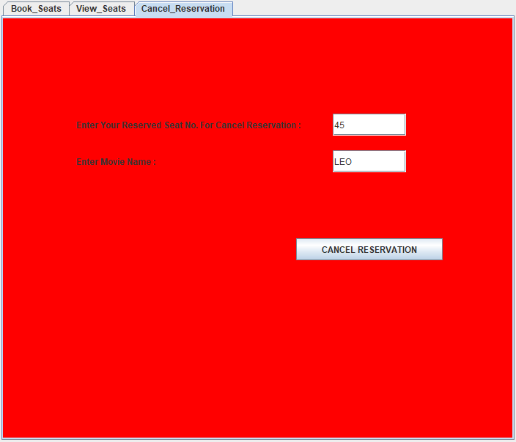

**ABSTRACTION**



Abstraction here

# CONCLUSION



* From

# REFERENCES



## REFERENCE LINKS :

1. http://