## CoderDojo Navan HTML Beginners - Lesson 4

### Graphics Editing using GIMP

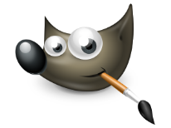Download GIMP - <https://www.gimp.org/downloads/>

GIMP is a free cross-platform image editor available for GNU/Linux, OS X, Windows and more operating systems.

Whether you are a graphic designer, photographer, illustrator, or developer, GIMP provides you with sophisticated tools to get your job done. You can further enhance your productivity with GIMP thanks to many customization options and 3rd party plugins.