JOSEPH SARWUAN TARKA UNIVERSITY, MAKURDI
COLLEGE OF FORESTRY AND FISHERIES
DEPARTMENT OF SOCIAL AND ENVIRONMENTAL FORESTRY

STUDENTS INDUSTRIAL WORK EXPERIENCE SCHEME (SIWES)
REPORT

BY
OKOH, ESTHER
22/60235/UE

OCTOBER 2026

STUDENTS INDUSTRIAL WORK EXPERIENCE SCHEME (SIWES) REPORT

BY
OKOH, ESTHER
22/60235/UE

SUBMITTED TO THE DEPARTMENT OF SOCIAL AND ENVIRONMENTAL FORESTRY, COLLEGE OF FORESTRY AND FISHERIES, JOSEPH SARWUAN TARKA UNIVERSITY, MAKURDI, IN PARTIAL FULFILMENT OF THE REQUIREMENTS FOR THE AWARD OF B. FORESTRY (SOCIAL AND ENVIRONMENTAL FORESTRY) DEGREE.

OCTOBER 2026

DECLARATION
I declare that this SIWES report is original and has not been submitted before to any University or similar institution for the award of any degree or certificate.
Name of Candidate: ______________________________________
Signature: ______________________________________________
Date: __________________________________________________

CERTIFICATION
We the undersigned hereby certify that this SIWES report presented by OKOH, ESTHER (22/60235/UE) has been accepted as fulfilling part of the requirements for the award of B. FORESTRY (SOCIAL AND ENVIRONMENTAL FORESTRY) degree of the Joseph Sarwuan Tarka University, Makurdi.

_______________________________ _______________________________
SIWES Coordinator Signature / Date

_______________________________ _______________________________
Head of Department Signature / Date

_______________________________ _______________________________
Dean of College Signature / Date

DEDICATION
This report is dedicated to God Almighty, who gave the strength and the health to start this training and to finish it.

ACKNOWLEDGEMENT
I thank the management of Joseph Sarwuan Tarka University, Makurdi, and the College of Forestry and Fisheries for giving the chance for this industrial training to take place.
I am grateful to the Head of Department of Social and Environmental Forestry and to the SIWES Coordinator of the College for the arrangements that made the placement possible and for the supervision during the exercise. I also thank the lecturers in the department, especially those who handled FPP 402, WRM 404, WRM 406, SEF 408, FPP 412 and FPP 414, because the practical work only made sense because of what was taught in class.
I thank the management and the staff of Ultra Modern Timber Market, Makurdi, for receiving us and for the patience with which the sawyers and the timber sellers explained their work to us. I thank the manager and staff of EL Moringa Investment Resources, Igbor, Gwer East, for the chance to visit the sawmill in October 2026, and Mr Agbebee Joseph, the wood technologist, who explained the machines, the blade repairs and the timber species to us. I also thank the officers and rangers of Cross River National Park for the drilling, the teaching on the park and the botanical walk.
Finally, I thank my family for the support, and my colleagues in Batch E, who made the field work easier and safer.

ABSTRACT
This report is on the Students Industrial Work Experience Scheme attachment carried out from June to October 2026. The training was done to connect what was learnt in class with the real work of forestry and wood processing, and to fulfil the practical requirement for the award of B. Forestry (Social and Environmental Forestry) degree. Six course areas were covered. Forest operations were done at the forestry nursery of the College, where beds were prepared, a potting mixture of four parts topsoil, one part manure and one part river sand was used, and wildlings and seeds were raised. Museum and herbarium techniques were done at the laboratory, where a rabbit was taxidermised, and at Cross River National Park, where plants were identified and pressed. A wildlife ecological survey was done at the park, using a transect and a sample plot. Aerial and ground survey was learnt through remote sensing and the geographic information system. Sawmilling and wood seasoning were studied at the market and at a sawmill at Igbor, where machines, blade repair, wood species and the Certificate of Hammering were examined. Park interpretation, drill, fire safety, ballistics, marksmanship, sanitation, ecotourism and botanical rambling were also covered at the park. The main experiences gained were nursery practice, specimen preparation, survey work, timber conversion, seasoning and preservation, and the reading of forestry documents. It was concluded that practical work, and not more theory, is what closes the gap between the classroom and the field. It is recommended that the market keep a written register of timber received, that students be taken round the units of the market in a fixed order, and that the College fix the field visits at the beginning of each session so that practicals follow the lectures.

TABLE OF CONTENTS
Contents
DECLARATION iii
CERTIFICATION iv
DEDICATION v
ACKNOWLEDGEMENT vi
ABSTRACT vii
TABLE OF CONTENTS viii
LIST OF TABLES xii
LIST OF FIGURES AND PLATES xii
LIST OF ABBREVIATIONS AND ACRONYMS xiv
LIST OF APPENDICES xv
CHAPTER ONE: INTRODUCTION 1
1.0 Students Industrial Work Experience Scheme (SIWES) 1
1.1 Historical Background of the SIWES Programme 1
1.2 Industrial Training Fund (ITF) 1
1.3 Scope of SIWES 2
1.4 Bodies Involved in the Management of SIWES 2
1.5 Functions of the Agencies 2
1.5.1 Federal Government of Nigeria 2
1.5.2 The Industrial Training Fund 2
1.5.3 National Universities Commission 3
1.5.4 National Board for Technical Education 3
1.5.5 National Commission for Colleges of Education 3
1.5.6 The Institutions 3
1.5.7 Employers of Labour 4
1.6 Objectives of SIWES 4
1.7 Benefits of Industrial Training to Students 4
CHAPTER TWO: INSIGHT INTO THE HOST ORGANIZATION 5
2.1 Introduction to the Organization/Units 5
2.1.1 Overview of the Organization/Units 5
2.1.2 Organogram of the Organization 6
2.1.3 Mission, Vision and Mandate or Core Values of the Organization 7
2.1.4 Overview of Tasks and Projects Carried Out 7
2.2 Challenges and Solutions 8
2.3 Technical Skills Development 9
2.3.1 Identification of Acquired Skills and Knowledge 9
2.3.2 Tools, Technologies or Methodologies Learned 9
2.3.3 Application Examples 10
2.3.4 Relevance to Future Career Aspirations 11
CHAPTER THREE: REPORT PER COURSE 12
3.0 Main Report 12
3.1 FPP402 – FOREST OPERATIONS 12
3.1.1 Introduction 12
3.1.2 Activities Related to the Course 12
3.1.3 Conclusion 15
3.2 WRM404 – MUSEUM AND HERBARIUM TECHNIQUES 15
3.2.1 Introduction 15
3.2.2 Activities Related to the Course 15
3.2.3 Conclusion 20
3.3 WRM406 – WILDLIFE ECOLOGICAL SURVEY 20
3.3.1 Introduction 20
3.3.2 Activities Related to the Course 21
3.3.3 Conclusion 21
3.4 SEF408 – AERIAL AND GROUND SURVEY 21
3.4.1 Introduction 21
3.4.2 Activities Related to the Course 22
3.4.3 Conclusion 25
3.5 FPP412 – SAWMILLING 25
3.5.1 Introduction 25
3.5.2 Activities Related to the Course 26
3.5.3 Conclusion 33
3.6 FPP414 – WOOD SEASONING AND PRESERVATION 33
3.6.1 Introduction 33
3.6.2 Activities Related to the Course 34
3.6.3 Conclusion 37
3.7 OTHER EXPERIENCE GAINED 37
3.7.1 Cross River National Park (Cross River National Park, Akamkpa, Cross River State) 37
CHAPTER FOUR: SUMMARY, CONCLUSION AND RECOMMENDATIONS 46
4.1 Summary 46
4.1.1 Summary of Activities 46
4.1.2 Summary of Challenges Encountered 47
4.1.3 Summary of Skills Acquired 47
4.1.4 Essence of the Training 48
4.2 Conclusion 48
4.2.1 Reflection on the SIWES Experience 48
4.2.2 Insights from Activities, Challenges and Skills Development 48
4.2.3 Analysis of Personal and Professional Growth 49
4.2.4 Highlights of Significant Achievements or Milestones 49
4.3 Recommendations 50
4.3.1 Clear and Feasible Actionable Suggestions 50
4.3.2 Addressing Identified Challenges or Areas for Improvement 51
4.3.3 Strategies for Enhancing Training Programmes 51
4.3.4 Improving Organizational Processes 51
REFERENCES 53
APPENDICES 55
Appendix I: Certificate of Hammering 55
Appendix II: Summary of Plant Species Identified During the Attachment 55
Appendix III: Index of Plates 56

LIST OF TABLES
Table 1: Operational units of Ultra Modern Timber Market, Makurdi, and their functions ?
Table 2: Tools, technologies and methods in which instruction was received ?
Table 3: Tools used in forest operations at the JOSTUM forestry nursery and their functions ?
Table 4: Particulars recorded for the specimen taxidermised at the Wildlife and Range Management Laboratory ?
Table 5: Materials and equipment used in the taxidermy practical ?
Table 6: Main plant species collected, identified and pressed during the herbarium practical ?
Table 7: Coordinates of the corners of the sample plot established for the ecological survey (Cross River National Park; WGS84, decimal degrees; approximately 20 m × 20 m, 400 m²) ?
Table 8: Remote sensing platforms and sensors studied during the course ?
Table 9: Comparison of the vector and raster data models in a geographic information system ?
Table 10: Machines and machine parts examined at EL Moringa Investment Resources, Igbor ?
Table 11: Machine faults and the safety precautions given at the sawmill ?
Table 12: Wood species identified at EL Moringa Investment Resources, Igbor, and their characters ?
Table 13: What was recorded on the Certificate of Hammering examined at EL Moringa Investment Resources, Igbor ?
Table 14: Methods of seasoning timber studied during the course ?
Table 15: Classes of wood preservatives and how they are applied ?
Table 16: Plant species identified during the botanical rambling at Cross River National Park ?
Table 17: Index of plates reproduced in the report ?

LIST OF FIGURES AND PLATES
Figure 1: Organogram of Ultra Modern Timber Market, Makurdi ?
Plate 1: Watering nursery stock at the JOSTUM forestry nursery ?
Plate 2: Mounted specimen from the taxidermy practical ?
Plate 3: Sawmill machinery during the sawmill visit ?
Plate 4: Botanical walk at Cross River National Park ?
Plate 5: Field exercise at Cross River National Park ?
Plate 6: Field visit to Cross River National Park ?

LIST OF ABBREVIATIONS AND ACRONYMS
AGB | Above-Ground Biomass
CCA | Chromated Copper Arsenate
FPP | Forest Production and Products
GIS | Geographic Information System
GPS | Global Positioning System
ITF | Industrial Training Fund
JOSTUM | Joseph Sarwuan Tarka University, Makurdi
LiDAR | Light Detection and Ranging
MC | Moisture Content
NBTE | National Board for Technical Education
NCCE | National Commission for Colleges of Education
NDVI | Normalised Difference Vegetation Index
NIR | Near-Infrared
NUC | National Universities Commission
PCP | Pentachlorophenol
PPE | Personal Protective Equipment
RH | Relative Humidity
SAR | Synthetic Aperture Radar
SEF | Social and Environmental Forestry
SIWES | Students Industrial Work Experience Scheme
UAV | Unmanned Aerial Vehicle
WRM | Wildlife and Range Management

LIST OF APPENDICES
Appendix I | Certificate of Hammering examined at EL Moringa Investment Resources, Igbor ?
Appendix II | Summary of plant species identified during the attachment ?
Appendix III | Index of plates reproduced in the report ?

CHAPTER ONE: INTRODUCTION

1.0 Students Industrial Work Experience Scheme (SIWES)
SIWES means Students Industrial Work Experience Scheme. It is the programme the Federal Government of Nigeria uses to send students of universities, polytechnics and colleges of education to industries and to the field for some months before they graduate. It is handled by the Industrial Training Fund on behalf of the supervising agencies, and it is a requirement for graduation in the courses covered (Agbidye, 2026).
The idea behind it is simple. A student who has only read about a nursery, a survey plot or a sawmill cannot yet do the work, no matter how well that student passed the examinations. So SIWES is not there to add to what is taught in class, but to expose the student to the machines, the methods and the discipline of the workplace. The guidelines put it plainly: a report is the evidence that a certain work was done, and no report means no work done (Agbidye, 2026).

1.1 Historical Background of the SIWES Programme
The scheme was started in 1973 by the Industrial Training Fund, because employers were complaining that graduates had plenty of theory but could not handle the work in industry. The scheme was the answer to that complaint, since it puts the student in the industry before graduation instead of after (Rivers State University, n.d.).
The Industrial Training Fund withdrew from managing SIWES in 1978. In 1979 the Federal Government transferred management to the National Universities Commission and the National Board for Technical Education (Rivers State University, n.d.).

1.2 Industrial Training Fund (ITF)
The Fund was established in 1971 under the Industrial Training Fund Act (Federal Republic of Nigeria, 1971), and it works under the Federal Ministry of Industry, Trade and Investment. Its duty is to build a pool of skilled Nigerian manpower for industry and for the economy, and it does this by funding and running skills acquisition programmes for artisans, technicians and students.
The Fund gets its money from employers, who are required by law to pay a percentage of their payroll, and the money is used for training and to pay back employers for training already done. SIWES is one of its biggest programmes, because it reaches every accredited course in the country.

1.3 Scope of SIWES
The scheme covers students in accredited universities, polytechnics and colleges of education, in courses of engineering, technology, applied science, applied arts, business and management, and in the agriculture and natural resource courses that forestry belongs to. For the student, the scope is set by the job specification of the course, which shows the skills the attachment should develop and the credit units that go with it. For the institution, it goes as far as placing every student, supervising them where they are attached and signing their log books. For the employer, it goes as far as providing the facilities, the supervision and the welfare of the student. This wide coverage is the strength of the scheme and also its difficulty, because it has to be coordinated in thousands of establishments at the same time.

1.4 Bodies Involved in the Management of SIWES
Six groups manage the scheme: the Federal Government of Nigeria through the Federal Ministry of Industry, Trade and Investment; the Industrial Training Fund, which runs it; the three supervising agencies, which are the National Universities Commission, the National Board for Technical Education and the National Commission for Colleges of Education; the participating institutions; and the employers of labour where students are placed. Each has duties given by the guidelines, and each depends on the others for the scheme to work.

1.5 Functions of the Agencies

1.5.1 Federal Government of Nigeria
The Federal Government releases the money for the scheme through the Ministry of Industry, Trade and Investment. It also makes it compulsory for ministries, companies and parastatals to accept students for attachment, as provided in the Industrial Training Fund Act of 1971 as amended.

1.5.2 The Industrial Training Fund
The Fund makes the policies and guidelines for the scheme and sends them to the bodies, institutions and companies taking part. It organises orientation for students before attachment, receives and processes the master and placement lists through the supervising agencies, and supervises and monitors students while they are attached. It pays the supervisory and students' allowances by e-payment, provides insurance cover, and provides the logistics and materials needed to run the scheme. It also visits the agencies, institutions, employers and students; gives information on companies and helps in placement; organises the biennial SIWES national conference and review meetings; keeps reviewing and researching into the scheme; and vets, processes and verifies students' log books and the ITF form 8.

1.5.3 National Universities Commission
The Commission makes sure the scheme is established and accredited in Nigerian universities, appoints full-time SIWES coordinators for them, approves the master and placement lists and forwards them to the Fund, works with the Fund on federal government policy, and keeps the national minimum academic standard for the university programmes that take part.

1.5.4 National Board for Technical Education
The Board does the same work for polytechnics and other technical institutions. It sees to the establishment and accreditation of SIWES units, makes sure full-time coordinators are appointed, vets and approves the master and placement lists before sending them to the Fund, and works with the Fund on national policy.

1.5.5 National Commission for Colleges of Education
The Commission handles the establishment and accreditation of SIWES units in colleges of education and makes sure full-time coordinators are appointed. It reviews and approves the master and placement lists before sending them to the Fund, and works with the Fund to see that federal government policy is applied in the colleges.

1.5.6 The Institutions
The institution sets up a SIWES coordination unit with enough staff and money and with a separate account, and it takes the matriculation numbers, telephone numbers and bank details of students at registration. It submits the master and placement lists to the Fund not later than 31 March of each SIWES year, applies the approved job specifications to accredited courses and awards credit units following the federal minimum academic guidelines. It also supervises students where they are attached, signs their log books, and submits the completed ITF form 8 to the nearest office of the Fund.

1.5.7 Employers of Labour
Employers work with the institutions to prepare job specifications, and accept students for attachment as the Act provides. They provide welfare such as medication and hospitalisation while the student is attached, take part in assessment by filling the ITF form 8 and the log books, allow students to use their facilities, and appoint an industry-based supervisor.

1.6 Objectives of SIWES
The objectives of the scheme, as given in the guidelines, are as follows (Agbidye, 2026).
- To give students practical skills and experience clearly related to their course of study.
- To close the gap between theory and practice by letting students use class work in a real situation.
- To expose students to work methods, equipment and machines by hands-on experience.
- To make the move from the institution to the world of work easier.
- To help students build the contacts that can lead to better job placement.
- To strengthen the involvement of employers, and so the partnership between institutions and industry.

1.7 Benefits of Industrial Training to Students
- Students gain practical skills and handle equipment and machines that are not available in the institution.
- Technical skill is developed together with communication, teamwork and leadership, and none of these can be learnt properly from a textbook.
- Students meet real problems in real conditions and must find answers that will work instead of answers that will score marks.
- Students build relationships with people already working in the field, and this helps at the point of employment.
- Students see current technology and practice, and so they learn where their class work is current and where it is behind.
- Students gain confidence from having worked, and they see their own strengths and weaknesses in a working place.
These benefits do not come just because the student spent time at a place of attachment. They come from doing the work under supervision, from keeping a record as the work goes on, and from looking back at that record afterwards, which is why the scheme asks for a log book and a written report.

CHAPTER TWO: INSIGHT INTO THE HOST ORGANIZATION

2.1 Introduction to the Organisation/Units
The College organised the attachment, which included a visit to Ultra Modern Timber Market, Makurdi, in Benue State, and a visit to EL Moringa Investment Resources, Igbor. It is a large site where timber sellers, sawyers and wood processors work side by side, and it is the meeting point between the sawmills of Benue State and the builders, carpenters and furniture makers of Makurdi and the towns around it. Timber that leaves the sawmills is brought here to be cut into the sizes people buy, and from here it goes into roofing, doors, windows, beds and chairs.
A market like this is important in the forestry business of the state even though it does not look important. Benue is a state with plenty of trees, and it is called the food basket of the nation because of its farm produce. A good part of the hardwood timber, and the timber that comes with farm clearing, gets its final cutting at a market of this kind before it reaches the person who will use it. So the market is a business place, a workshop and a point where the papers for timber are supposed to be checked, all at once, and the attachment was served across these three duties.

2.1.1 Overview of the Organisation/Units
The market works through four operational units, each with its own job in the chain from log to finished timber, together with the stalls where timber is displayed and sold. They are shown in Table 1.
Table 1 : Operational units of Ultra Modern Timber Market, Makurdi, and their functions
Unit | Main function | Work observed
Processing unit | Cutting logs and rough timber into the sizes wanted | Feeding timber to the saw bench; cutting to length, width and thickness; separating offcuts
Maintenance unit | Taking care of the machines and the blades | Sharpening and setting blades; joining broken blades; servicing motors, belts and bearings
Finished product unit | Sorting, dressing and sending out the timber | Sorting by species and size; surface dressing; stacking for collection
Storage section | Protecting the timber before it is sold | Stacking with spacers; covering against rain and sun; arranging for air to pass
Source: Field observation, Ultra Modern Timber Market, Makurdi, 2026.
The division of work is not just for show. Each unit is also a place where a fault can be caused or stopped. If a blade is badly kept, the board that comes out will not be straight, and the finished product unit will either reject it or sell it as a lower grade. So the money the market makes is decided before the timber is sold, in the maintenance and processing units, and it was mostly in those two units that the attachment was spent.

2.1.2 Organogram of the Organisation
The market is run as an association of traders under a management committee, and the units answer to the committee. The line of authority is shown in Figure 1.
MARKET MANAGEMENT COMMITTEE
↓
Market Chairman | Secretary | Treasurer
↓
Processing Unit | Maintenance Unit | Finished Product Unit | Storage Section
↓
Sawyers, Bench Operators | Saw Doctors, Mechanics | Graders, Loaders | Stackers, Watchmen
Figure : Organogram of Ultra Modern Timber Market, Makurdi
Authority runs from the committee down to the heads of units and from them to the workers, but instructions on technical matters move sideways between operators. The setting of a blade, the order in which to cut a log, or the grade to give a board is settled there and then at the bench. This is common in small and medium wood businesses in this part of the country, and it has one effect on a trainee: instruction comes from working beside somebody who has done the work for years, and not from reading a book, because in most of the units there is no written procedure at all.

2.1.3 Mission, Vision and Mandate or Core Values of the Organisation
The market has no written mission or vision statement like a company or a government office. What it is there to do is still clear from the way it works. It exists to give one central and easy place where timber from the sawmills of Benue State and the states around can be cut into the sizes the building and furniture trade of Makurdi needs, and sold in a way that is fair to both the seller and the buyer. Three values were seen working, and they can be recorded as the values of the place.
- Accurate sizes, because a board sold as two inches by four inches must be two inches by four inches. The name of a stall depends on this.
- Correct identification of wood species, because timber is bought and sold by common names and the buyer depends on the seller to know what he is selling.
- Proper stacking and storage, because timber badly stored after cutting loses value to warping, splitting and stain before anybody buys it.
The third value is not followed as strictly as the first two, and that comes up again in the challenges in 2.2 and in the recommendations in 4.3.

2.1.4 Overview of Tasks and Projects Carried Out
The work done at the market during the attachment fell into six groups, given here in the order encountered.
Receiving, measuring and classifying timber came first. Timber coming in was checked for species, number, length, diameter and visible defect, measured to estimate the volume and the value, and sorted by species, diameter class, length and condition. Timber sizes in the Nigerian market are given in inches and feet, so a board can be one inch by ten inches by twelve feet, which means one inch thick, ten inches wide and twelve feet long. The common sizes met were two inches by two inches and two inches by four inches, with boards and battens of other sizes.
Identifying the species came second. Species were separated by the colour of the heartwood, the weight and density, the texture of the grain and the smell where it is different, and each was then matched to the work it can do, whether furniture, building or carving. This is the work everything else depends on, because a timber wrongly identified is a timber sold for a use it cannot serve.
The cutting came third. Logs and rough timber were fed to the saw bench and cut to the length, width and thickness the buyer asked for, and the planks and offcuts were separated as they came off the machine. Seasoning and storage came fourth, and that is reported in full in section 3.6. Preservative chemicals came fifth, where the correct chemical was chosen for the species and for the work the timber is meant for. Maintenance of the machines came last, in the maintenance unit, and it consisted of sharpening and setting blades, joining blades that had broken, and servicing motors, belts, pulleys and bearings. Of all the work seen, this one looked the least important and had the most effect, because the quality of every board in the market is decided by the condition of the blade that cut it.

2.2 Challenges and Solutions
The problems seen were of two kinds: those caused by the way people work, and those caused by the condition of the machines and the site. Each is stated with the measure that can answer it.
The worst is theft and the removal of timber without permission. Timber is costly, easy to carry and easy to sell again, and when timber leaves a yard unrecorded it defeats both the revenue and the control of forest use, because timber that is not recorded has, for accounting purposes, never existed. The answer is proper stock records in each stall, with timber entered when it comes in and taken out when it is sold, so that any shortage is noticed at once, together with security of the yard after working hours.
The second is irregular power supply. The saw benches, dressing machines and sharpening equipment all need electricity, and when the light goes it stops production without warning and costs the operator money he cannot recover. It also spoils the machines, because a motor that is interrupted again and again is likely to burn. The answer is a standby generator that can carry the bench, protective devices against supply changes, and planning the heaviest cutting for the time of day when light is usually steady.
The third is machine fault, especially blade fault. A blade that is blunt, badly set, wrongly mounted or turning the wrong way gives a poor cut, takes a wider kerf and so wastes more wood, overworks the motor, and puts the operator in danger of kickback. The answer is to check the machine before use, sharpen and set the blade on a schedule in the maintenance unit rather than anyhow at the bench, and withdraw any machine from work until a fault has been corrected by somebody who knows the work.
The fourth is handling heavy logs. A log of commercial size cannot be lifted by hand, and where winches, hooks, levers and rods are too small, handling becomes a source of injury as well as of delay. The answer is lifting equipment that matches the size of timber handled, training in its use, and the rule that nobody stands where a log would move if it rolled. The fifth is the lack of written records, because where the species, size and treatment of a batch are kept only in the head of one worker, that information is not available to the buyer, to the government officer or to the next student. A written register in each stall would answer this, and it is a cheap thing to do.

2.3 Technical Skills Development

2.3.1 Identification of Acquired Skills and Knowledge
The skills gained are stated as what can now be done, not in general words.
- Nursery practice: preparing beds, mixing the potting mixture to a given ratio, collecting and potting wildlings, broadcasting seed, and watering and weeding nursery stock.
- Specimen preparation: taxidermy of a small mammal from recording the data through dissection, stuffing, preservation and mounting, and the pressing of plant specimens.
- Plant identification: classifying plants by leaf arrangement, branch arrangement and venation pattern.
- Ecological survey: reconnaissance, laying a transect, setting and geo-referencing a sample plot, and recording animals by sighting and by sign.
- Spatial data: reading satellite and aerial images, understanding a vegetation index, and understanding the geographic information system as layers on one coordinate system.
- Timber conversion: naming the parts of the machines and their work, following the order of log breakdown, cutting to size, and separating timber by grade.
- Seasoning and preservation: stacking with spacers, telling air drying from kiln drying, and choosing a preservative that suits the species and the work.
- Reading forestry papers: reading a Certificate of Hammering and knowing where it fits in the papers that control the harvest and movement of timber.

2.3.2 Tools, Technologies or Methodologies Learned
The tools and technologies in which instruction was received are in Table 2, with what each was used for.
Table 2: Tools, technologies and methods in which instruction was received
Group | Tool, technology or method | Use during the attachment
Nursery and field | Hand trowel, hoe, rake, shovel, perforator, watering can, wheelbarrow | Bed preparation, filling poly pots, watering stock, carrying potting materials
Specimen work | Surgical knife, razor, needle and thread, syringe, measuring tape, formalin, cotton wool, plant press, newsprint | Taxidermy of the specimen; pressing of herbarium material
Survey | GPS receiver, transect line, quadrat frame, plot pegs | Geo-referencing plot corners; laying out the sample plot
Remote sensing and GIS | Landsat, Sentinel and MODIS images; LiDAR; drones; ArcGIS and QGIS; NDVI and SAVI | Reading land cover, estimating vegetation vigour, layered spatial analysis
Sawmilling | Circular saw bench, breakdown saw, log carriage and rails, push stick, measuring tape, winch and hooks | Watching the cutting; measuring timber to size
Maintenance | Brazing machine, brazing iron, burner, clamping equipment, grinding set, hand plane, sandpaper | Watching and practising blade repair and tool care
Preservation | Creosote, pentachlorophenol, chromated copper arsenate, ACQ, borates, brush and dipping tank | Choosing and applying preservative treatment
Source: field observation and course material, 2026.

2.3.3 Application Examples
In the nursery, the ratio of the potting mixture decides how water drains and how much food the seedling gets, so the correct mixture gives seedlings big enough for the field in the time expected. In the herbarium, the way a specimen is arranged on the press decides whether the characters needed for identification can still be seen after drying. In the survey, the placing of the transect across the boundary of two vegetation types is what allows the survey to notice the change it was meant to notice. In remote sensing, a vegetation index worked out for two dates shows loss of vigour before the eye can see it. In sawmilling, the setting of the blade decides the width of the kerf, and the kerf decides how much of each log becomes timber and how much becomes sawdust. Each is a small technical decision with money attached to it, and that is how professional judgement in forestry works.

2.3.4 Relevance to Future Career Aspirations
Social and environmental forestry is about the relationship between the forest and the people who use it, and that relationship is clearer at a timber market than anywhere else, because the market is where the forest turns into money and where a standing tree, which belongs to a community and to the state, becomes a commodity that belongs to one buyer. The skills gained are useful in forest resource assessment, where working out volume from measured sizes is the basic job; in checking the timber trade, where reading a Certificate of Hammering against the timber in front of you is the working skill; in extension and community forestry, where explaining to a sawyer why a sticker between the planks saves the value of the whole stack is worth more than a written law; and in environmental monitoring, where reading satellite images and handling spatial data are now normal requirements.

CHAPTER THREE: REPORT PER COURSE

3.0 Main Report
This chapter reports the six course areas and the extra experience gained at Cross River National Park, with the location of each in brackets. Every course follows the same pattern: what the subject is, what was done, and what it showed.

3.1 FPP402 – FOREST OPERATIONS
(Forestry Nursery, Joseph Sarwuan Tarka University, Makurdi, Benue State)

3.1.1 Introduction
Forest operations are all the work done to raise, care for, protect and harvest a forest, from silviculture and nursery work up to logging. The nursery is where the work begins and where the quality of the future forest is already decided. A forest nursery is a place where seedlings are raised until they are big enough for the field, whether for a plantation, for filling gaps in a forest or for beautifying a place.
Nurseries are classified by size, by water supply, by the type of stock, by ownership and by how long they will be used (Agbidye, 2026). The one where this work was done is an institutional nursery of the permanent, container type, raising stock in poly pots for the planting programmes of the College and for buyers.
Nursery work depends on a few jobs done correctly: the soil mixture must hold water without becoming waterlogged, the stock must be watered and weeded without a break, and the site must be clear because the same work is repeated many times in a day.

3.1.2 Activities Related to the Course
The work was done over several practical sessions, in the order a nursery cycle needs.
Clearing came first. Weeds, undergrowth and rubbish were removed from the outside of the nursery and from the paths inside, which also removes the hiding place of rodents. Pruning came second: branches and lower limbs were cut back so that sunlight could reach the beds, because a seedling raised in deep shade grows tall and thin and does badly in the field.
The reservoir was desilted third, because over a season it gathers mud, silt and leaves which cut down its storage and spoil the water. The nursery beds were laid out fourth. There are two kinds: the bed where the poly pots are arranged, and the germination bed where seed is broadcast before the seedlings are lifted into pots. Both were measured and levelled, because a bed that holds water will rot the seed and a bed that drains too fast will not let it germinate.
The potting mixture was prepared fifth, and the other operations depend on it. It is a blend of materials put in a container to give the plant a good place to grow, and according to the briefing given by the nursery instructors the ratio used here is four parts of topsoil to one part of organic manure to one part of river-bed sand, that is 4:1:1. It was mixed and filled into poly pots, and the pots were perforated first so that excess water could run out.
Each part does a job. The topsoil supplies the minerals and the structure the roots grow in. The manure supplies plant food and helps the mixture hold water. The river-bed sand reduces the stickiness of the loam and lets water enter and leave freely, which is what stops waterlogging and damping-off.
Wildlings were collected and potted sixth. Wildlings are seedlings that germinated on their own under or near a mother tree; they were lifted with enough soil around the roots and potted into the prepared pots, which were set on the beds. The species were Azadirachta indica (neem), Gmelina arborea (white teak), Khaya senegalensis (Senegal mahogany) and Tectona grandis (teak). Collecting wildlings is cheaper than raising seed and the plants are already used to the local soil, but it works only for species that germinate on their own in the area.
Seed was broadcast seventh. Seed of Gmelina arborea and Tectona grandis was sown by hand on the germination beds and covered lightly, which is faster than drilling but uses more seed and gives an uneven stand. Routine care came last: the seed on the beds and the wildlings in the pots were watered every day and weeded regularly, because one day of water stress at the seedling stage reduces the number that survive in the field.
The tools used, and what each was used for, are in Table 3.
Table 3: Tools used in forest operations at the JOSTUM forestry nursery and their functions
Tool | Use during the exercise
Wheelbarrow | Carrying the potting materials to the mixing point, and rubbish to the dump
Hand trowel | Filling the poly pots with the potting mixture
Small and large hoe | Removing weeds with the small hoe; preparing the beds with the large hoe
Rake | Gathering rubbish and levelling the beds
Shovel | Loading the wheelbarrow and turning the mixture before filling
Perforator | Making the drainage holes in the poly pots
Watering can | Watering the wildlings in pots and the seed on the beds
Cutlass | Cutting undergrowth and light clearing of the site
Measuring tape | Measuring and laying out the nursery beds
Source: Field observation, JOSTUM forestry nursery, 2026.
The nursery also keeps other species for teaching, among them Polyalthia longifolia, Delonix regia, Elaeis guineensis, Ceiba pentandra, Irvingia gabonensis, Terminalia catappa, Dacryodes edulis, Afzelia africana, Carica papaya, Mangifera indica, Moringa oleifera and Jatropha curcas, all raised from seed, and Bougainvillea spectabilis and Euphorbia milii, raised from stem cuttings.
Plate 1 shows the instruction given on the watering of nursery stock, with the watering cans used.
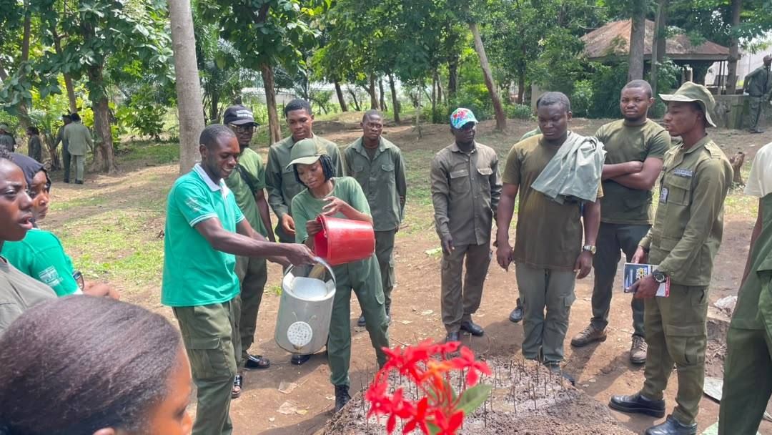
Plate 1: Watering nursery stock at the JOSTUM forestry nursery

3.1.3 Conclusion
The exercise showed that a nursery is where the quality of the future forest is fixed. Every operation done is a technical decision whose result shows months later in the field, where it can no longer be corrected: the clearing that lets in light, the 4:1:1 ratio that controls drainage and feeding, and the daily watering.
It was also seen that nursery work is learnt by doing it. The ratio of the mixture and the depth at which a seedling is set are judgements of the hand, and they come from repeating the job under somebody who knows it.

3.2 WRM404 – MUSEUM AND HERBARIUM TECHNIQUES
(Wildlife and Range Management Laboratory, Joseph Sarwuan Tarka University, Makurdi, Benue State; and Cross River National Park, Akamkpa, Cross River State)

3.2.1 Introduction
Museum and herbarium techniques are the methods used to keep specimens so that they can be studied after the animal or the plant is gone. The museum keeps the shape and look of an animal for exhibition, teaching and reference; the herbarium keeps the characters of a plant in a form small enough to be filed, compared and sent to another institution.
The main museum technique is taxidermy, which is keeping an animal's body by removing the flesh, treating the skin, building up the shape with a filling and mounting the result to look as it looked when alive. A well prepared specimen is a record, not a decoration, because it keeps the outside characters of the animal in a way a written description cannot.
The herbarium technique is the pressing and drying of plant material so that the characters used in identification can still be seen after drying: leaf arrangement, leaf shape and margin, venation pattern, branch arrangement and whether the plant is hairy. A sheet is filed by species and its value is in comparison. Both techniques depend on taking out water, because water is what allows the bacteria and fungi that destroy material to grow.

3.2.2 Activities Related to the Course

3.2.2.1 Taxidermy
The practical was done at the Wildlife and Range Management Laboratory with a domestic rabbit. Its particulars were written down before work started, because a specimen without data has no scientific value. They are in Table 4.
Table 4: Particulars recorded for the specimen taxidermised at the Wildlife and Range Management Laboratory
Particular | Record
Common name | Domestic rabbit
Scientific name | Oryctolagus cuniculus
Breed | Standard Chinchilla
Sex | Male
Age | 9 months
Status when collected | Alive
Ear length | 10 cm
Shoulder height | 22 cm
Tail length | 8 cm
Head and body length | 37 cm
Source: laboratory record, 2026.
Specimens for taxidermy are got by direct capture, by buying, as a gift, by seizing an animal from somebody keeping it unlawfully, or as an animal found dead. Here a live animal was killed by holding cotton wool soaked in formalin against its nose, which made it lose consciousness and die within minutes without spoiling the skin. The materials used are in Table 5.
Table 5: Materials and equipment used in the taxidermy practical
Material or equipment | What it was used for
Specimen (domestic rabbit) | The animal used for the practical
Cotton wool | Stuffing the prepared skin.
Formalin | Preservation of the specimen.
Nose mask | Protecting the operator from formalin vapour
Hand gloves | Protecting the operator from formalin and from blood
Measuring tape | Taking the body measurements before skinning
Surgical knife and razor blade | Opening the belly and separating the skin from the flesh
Needle and thread | Sewing the opening after stuffing
Syringe and needle | Injecting preservative between the skin and the flesh
Wooden board and nails | Mounting the finished specimen
Detergent | Washing the skin and removing blood
Petrol or kerosene | Removing fat from the skin
Source: laboratory record, 2026.
The work was done in seven stages: the particulars were recorded first, since measurements cannot be taken later; the animal was killed; the belly was opened with a new razor blade and the skin separated from the flesh, with the organs removed and blood cleaned off so it would not stain; the skin was stuffed with cotton wool soaked in formalin and sewn up as the stuffing went on; formalin was injected between skin and flesh to stop decay; the specimen was mounted on a board in a running position; and it was taken back to the laboratory and added to the teaching collection.
Taxidermy is used for museum exhibition, personal trophies, scientific study and reference, and for art. Its importance in wildlife management is in the study and reference, because a collection of prepared specimens is what allows a ranger or a customs officer to identify an animal or its parts when the living animal cannot be examined.
Plate 2 shows the finished specimen held up for inspection at the end of the taxidermy practical.
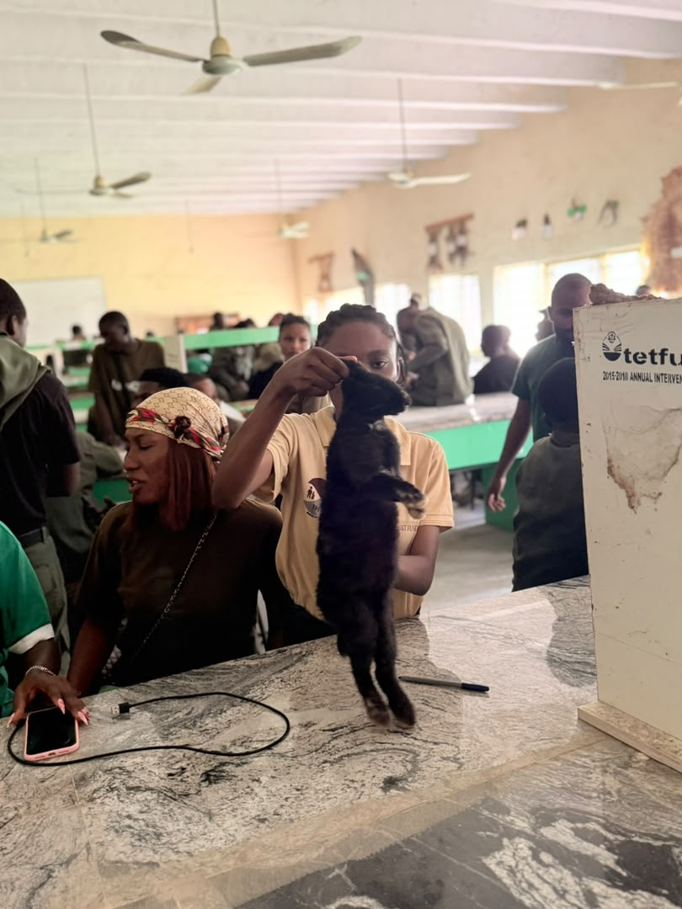
Plate 2: Mounted specimen from the taxidermy practical

3.2.2.2 Herbarium Technique
The herbarium practical was done partly at the laboratory and partly in the field at Cross River National Park, and collection came after classification. Plants were identified with three sets of characters: leaf arrangement, whether alternate, opposite or in whorls; branch arrangement, whether monopodial or sympodial; and venation pattern, whether pinnate, palmate or parallel. These allow a plant with no flower and no fruit to be placed in its family with fair confidence, and that is the skill the exercise was meant to build.
Material was cut with a cutlass or sharp knife at about the third leaf from the growing tip, so the stem carries the young leaves at the tip and the older ones below. The cut end was left sticking out a little beyond the folded newspaper so the specimen is held in place and the leaves are not crushed when the press closes. The specimens were laid between sheets of newspaper, some leaves showing the top surface and others the under surface, then put in the press between boards tied with rope to dry. The main species are in Table 6.
Table 6: Main plant species collected, identified and pressed during the herbarium practical
Botanical name | Family | Main uses recorded
Diospyros crassiflora | Ebenaceae | Ebony; very strong dark wood for musical instruments, carving and fine furniture
Piptadeniastrum africanum | Fabaceae | Timber for building, flooring and canoes; bark used for stomach problems
Alstonia boonei | Apocynaceae | Light timber for furniture and carving; bark used for fever and malaria
Anthocleista djalonensis | Gentianaceae | Used for constipation, diarrhoea, stomach pain and malaria
Carpolobia lutea | Polygalaceae | Root and stem used for stomach trouble and fertility problems; chewing stick
Harungana madagascariensis | Hypericaceae | Source of red and yellow dye; timber for building; medicine
Lophira alata | Ochnaceae | Red ironwood; heavy building work, bridges and railway sleepers
Milicia excelsa | Moraceae | Iroko; building, furniture and boat building
Source: field collection at Cross River National Park, 2026; nomenclature per Keay (1989).
The practical showed the point on which the herbarium stands: a specimen is a record, not a souvenir of a walk, and its value depends on the information written with it, which is where it was collected, when, by who and what it was thought to be. A well pressed specimen with no label is worth less than a badly pressed one that carries a label.

3.2.3 Conclusion
The two techniques are the same idea used on different material: take out the water so that the shape stays for comparison after the plant or animal is gone. The taxidermy practical forced a fixed order, because measurements cannot be taken after the skin is off; the herbarium practical forced identification to come before collection.
Both are of real value in the field and not only for teaching. The prepared specimen and the pressed sheet are the reference against which things are checked in the field, in the market and at the point of export, and being able to prepare and read them protects both the species and the money the state should earn.

3.3 WRM406 – WILDLIFE ECOLOGICAL SURVEY
(Cross River National Park, Akamkpa, Cross River State)

3.3.1 Introduction
An ecological survey is the careful watching, measuring and recording of the living things in an area and of how they relate to their surroundings, so that the condition of the place can be known and decisions taken on fact instead of guesswork. It answers two questions: what is in the area, and how much of it is there and in what condition.
Surveys differ by the question asked. Biodiversity surveys check species richness and follow populations; habitat surveys check the condition of the place and notice change over time; wildlife surveys check species diversity and habitat quality. The exercise here was a habitat and wildlife survey of a small area. Three sets of methods are available: field observation, which includes direct sighting and signs such as footprints, droppings, burrows and calls; sampling, where a part of the area is studied instead of the whole; and remote sensing, which looks at the area from above. The exercise used the first two directly and the third in principle, as reported in 3.4.
A transect line was then laid across the area and a sample plot set on it, so that what is recorded in the plot can stand for the wider area. The corners of the plot were fixed with a GPS receiver and are given in Table 7.
The reconnaissance came first, by walking the area to find its boundaries, its vegetation type, its condition, the animals and plants in it and the problems affecting it. It showed that the habitat is grassland, that part of it is used for farming, and that the woody part is badly reduced, with one mature tree inside the sampled area.
A transect line was then laid across the area and a sample plot set on it, so that what is recorded in the plot can stand for the wider area.
Table 7: Coordinates of the corners of the sample plot established for the ecological survey (Cross River National Park; WGS84, decimal degrees; approximately 20 m × 20 m, 400 m²)
Corner | Latitude (°N) | Longitude (°E) | Altitude (m)
1 (NW) | 5.417000 | 8.583000 | 150
2 (NE) | 5.417000 | 8.583180 | 150
3 (SE) | 5.416820 | 8.583180 | 150
4 (SW) | 5.416820 | 8.583000 | 150
Source: Field survey (2026)

3.3.2 Activities Related to the Course

3.3.3 Conclusion
The exercise showed that a survey is a management tool and not just a list of what is in a place. The information from one plot was enough to say what condition the place is in and what should be done about it, and a survey repeated after some time would show whether those measures work. The reconnaissance is not something done before the survey but the first part of it.

3.4 SEF408 – AERIAL AND GROUND SURVEY
(College of Forestry and Fisheries, Joseph Sarwuan Tarka University, Makurdi, Benue State)

3.4.1 Introduction
Surveying is the finding of the position of points on the surface of the earth, and of the distances, angles and heights that join them, so that what is on the ground can be drawn correctly on a map or kept in a computer. Aerial survey collects data from above, using aeroplanes, helicopters, drones or satellites, and the measurements are worked out from the pictures. Ground survey is done on the surface by measuring distances, angles and heights between points.
Ground survey is divided into two. In geodetic survey the curve of the earth is taken into account when the levels, angles, bearings and distances are worked out, and it is used for work above about 260 square kilometres. In plane survey the surface is treated as flat, and it is used for work of small size where the error this brings is below the accuracy needed. The types of plane survey are cadastral survey, which fixes and records land boundaries for registration; engineering survey, done before, during and after a work such as a road; and mining survey, which finds the position and size of underground workings. Surveying matters in forestry because every management decision is a decision about a place.

3.4.2 Activities Related to the Course
The course was taught by lecture and demonstration in two parts: remote sensing, which provides the data from above, and the geographic information system, which receives, stores and analyses it.

3.4.2.1 Remote Sensing
Remote sensing is getting information about the surface of the earth from energy that is reflected or given off, without touching the thing being looked at. Passive sensors pick up sunlight reflected from the surface, and include ordinary photography and the scanners on satellites such as Landsat and MODIS. Active sensors send out their own signal and measure the echo, and include radar, LiDAR and sonar. The camera on a phone is passive, because it needs light; the LiDAR scanner on some phones is active, because it fires its own pulses. Remote sensing is better than field survey in three ways: it is cheap for large areas, it covers the same ground at fixed intervals, and it reaches places that cannot be walked. The platforms studied are in Table 8.
Table 8: Remote sensing platforms and sensors studied during the course
Platform | System | Resolution and repeat time | Main use in forestry and wildlife
Space | Landsat series (since 1972) | 30 m, every 16 days | Long term land cover and deforestation change; sensors TM, ETM+ and OLI
Space | MODIS (1999) | 250 m to 1 km, daily to 2 days | Regional vegetation health and detection of burning
Space | Sentinel-2 (2014) | 10 to 60 m, about 5 days | Vegetation indices and land cover
Space | Sentinel-1 radar | About 20 m, 6 to 12 days | Imaging through cloud; seeing the canopy in cloudy weather
Air | Airborne LiDAR | Less than 1 m | Canopy height and forest structure; biomass estimation
Close range | Drones (UAV) | Centimetre level, on demand | Counting animals, plant density, small area mapping
Source: Course material, SEF 408, 2026.
The uses in forestry were studied under five heads: resource inventories, where species, age distribution and stand density are mapped; biomass and carbon, where above-ground biomass is estimated from vegetation indices, LiDAR and radar; forest health and stress, where pest attack, disease and drought damage are noticed from the way the trees reflect light; disturbance and fire, where burning spots are detected as they happen; and deforestation and illegal logging.
The index on which most of this rests is the Normalised Difference Vegetation Index, worked out as NDVI = (NIR − Red) / (NIR + Red). Healthy plants reflect a lot in the near-infrared and take in red light, giving figures of about 0.6 to 0.9; bare soil gives about 0.1 to 0.2 and water gives less than zero. A stand under stress shows a falling NDVI before the damage can be seen, so something can be done early. In wildlife management the uses are habitat mapping, population and density, where a thermal sensor flown at dawn makes warm animals stand out against cold ground, connectivity, where corridors and barriers are found, and biodiversity and disease.
The limits of the technology were studied too: many forestry people are slow to move to digital work, which is answered by training; high resolution images and LiDAR need money and special skill, which is answered by free Landsat and Sentinel data and cloud platforms; cloud cover, which blocks optical sensors for months, is answered by radar; and any result taken from an image must be checked on the ground, which is answered by doing field survey alongside remote sensing and not instead of it. This last point joins the course to 3.3.

3.4.2.2 Geographic Information Systems
A geographic information system joins location data, which says where things are, with attribute data, which says what those things are like, and it captures, stores, manages, analyses and displays that information. It is more than map making software, because its main job is to answer the question of what is happening where. It stands on five parts: hardware, the computers, GPS receivers and field devices; software, the programs such as ArcGIS, QGIS or Google Earth; data, both spatial and tabular; people, who are the analysts and planners; and methods, the procedures used to get answers. People and methods are the most underrated of the five, because a system with plenty of machines and data but few trained operators produces nothing.
The idea that holds the system together is the layer idea. The real world is broken into digital layers that can be stacked, such as roads, water bodies, elevation and vegetation type, and each layer is georeferenced, that is tied to real latitude and longitude, so that the layers line up when put on top of each other. Any question that can be put as a combination of layers can then be answered. Two data models are compared in Table 9.
Table 9: Comparison of the vector and raster data models in a geographic information system
Feature | Vector model | Raster model
What it uses | Points, lines and polygons | A grid of cells or pixels
Kind of thing shown | Things that are separate and can be pointed at | Things that flow continuously
Examples | Wells as points; roads as lines; land parcels and forest reserves as polygons | Satellite images, aerial photographs and elevation models
Boundary accuracy | Exact, because it is set by coordinates | Limited by the size of the cell
Data size | Usually smaller for the same area | Large, and larger still as the cell gets smaller
Source: Course material, SEF 408, 2026.
Four abilities were demonstrated: visualisation, where moving multi-layer maps are made instead of fixed drawings; measuring and calculating, where distances, areas and slopes are worked out; analysis and query, such as which houses fall inside a flood zone; and modelling and forecasting. Remote sensing supplies the observations and the system supplies the frame in which observations from different sources and dates are brought into one space and compared. An NDVI map placed on a roads layer, for instance, shows where forest loss gathers near roads, which neither the image nor the road map could give alone.

3.4.3 Conclusion
The course showed how the two halves fit together. Remote sensing answers the question of what an area looks like and how it has changed, over sizes and at intervals that field survey cannot manage. Ground survey answers the question of exactly where a point lies, at a precision that images cannot give, and it supplies the ground checks against which any result from an image must be tested. Neither replaces the other.
It was also seen that the geographic information system makes the combination possible, because it is the only frame in which observations of different kinds and dates are brought to one space reference and compared. For a student of social and environmental forestry, the study of land use and of the link between forest cover and the people who depend on it is now done in that frame.

3.5 FPP412 – SAWMILLING
(Ultra Modern Timber Market, Makurdi, Benue State; and EL Moringa Investment Resources, Igbor, Gwer East, Benue State)

3.5.1 Introduction
Sawmilling is the operation in which logs are cut into timber of the sizes and quality wanted. It is where a harvested tree stops being a log and becomes a product, so it sits between the forest that grew the tree, the builder who will use it, and the papers by which the state accounts for what was removed.
The aims are to turn round wood into usable timber, get the most saleable timber out of every log, waste as little as possible while cutting, produce timber of the sizes and quality needed, add value to the harvested wood, get something useful out of the sawdust and slabs, and so make forest industry pay. A sawmill that does well keeps log quality, cutting method, machine performance, operator skill, grading, drying and maintenance working together.
Sawmills are classified by size as small, medium or large; by movement as portable, which can be set up near the timber, or fixed, which stays in one place with a log yard, a cutting area and a store; and by power as electric, diesel or petrol. The mill visited here is a medium sized, fixed, electric mill. In live sawing the log is cut straight through in parallel cuts without turning it, which wastes little; in plain sawing the log is turned between cuts so that the growth rings lie at less than 45 degrees to the face, which gives the cathedral pattern wanted for furniture and doors.

3.5.2 Activities Related to the Course
Instruction was received at Ultra Modern Timber Market over several sessions on timber sizes, species identification, machine parts and preservation. The visit to the market took place on September 2026, and the instruction was consolidated by a visit to a sawmill at Igbor, Gwer East, in October 2026.

3.5.2.1 Timber Sizes and Classification at the Market
In Nigeria, lumber sizes are given in inches and feet, so a board can be one inch by ten inches by twelve feet. The common sizes met were two inches by two inches and two inches by four inches, with boards and battens of other sizes, and timber was classified by size because the size decides the use: the batten for the roof, the small size for the stud, the board for the door and the plank for the floor.

3.5.2.2 Species Identification at the Market
Species were identified by the colour of the heartwood, the weight and density, the texture and figure of the grain, and the smell where it is distinct, and each was matched to what it can be used for. Correct identification is not a small matter at the point of sale, because timber is sold mostly by common names, and a buyer given the wrong species has no way of getting back the difference.

3.5.2.3 Timber Transport and Log Handling
Logs are brought to the mill by road, and the vehicle mentioned was a Bedford truck. Loading is a matter of leverage and tying down more than of lifting. Winches, hooks, levers and rods were named as the equipment used to raise logs too heavy to lift by hand, and rafters as what holds them in place, because proper arrangement and firm fastening are what stop a load of round timber from shifting on the road.

3.5.2.4 Pre-Sawing Operations at the Sawmill
The visit of October 2026 was to EL Moringa Investment Resources, a medium sized sawmill at Igbor in Gwer East Local Government Area, which operated in Makurdi from 2007 and moved to Igbor in 2015. The manager, Mr Olatunde Davida, received the students, and Mr Agbebee Joseph, a wood technologist, gave the technical explanation.
Log reception and inspection was the first operation studied. Logs are checked for species, number, length, diameter, visible defect and condition, they are looked at for the product intended, and the legal papers are checked. The check on the log covers taper, curvature, knots, cracks, splits and rot, because each of these cuts down the volume of timber it will give. Logs are then measured to estimate volume and value, using the cylinder approximation, and sorted by species, diameter class, length and quality before storage. The legal check is reported in 3.5.2.9, because the document seen on the site is its working example.

3.5.2.5 Sawmill Machinery and Its Parts
Sawmill machinery is grouped by its work in the cutting line: log preparation, primary sawing, secondary sawing, edging and trimming, finishing, and auxiliary and maintenance equipment. Primary sawing machines were the main thing seen: the chainsaw, used in small work where the log cannot be moved; the bandsaw, in horizontal form for high volume cutting and vertical form for re-sawing; and the circular saw, used in first breakdown and very widely in secondary cutting. The machines seen, and what each part does, are in Table 10.
Table 10: Machines and machine parts examined at EL Moringa Investment Resources, Igbor
Machine | Part | What the part does
Circular sawing machine | Electric motor | Supplies the power to drive the machine
 | On/off switch | Controls the supply of electricity to the machine
 | Pulley and V-belt | Carry the turning force from the motor to the blade
 | Shaft or arbor | Holds the blade and passes the turning force to it
 | Circular blade | Cuts logs and timber to the sizes wanted
 | Infeed and outfeed | Where timber enters the machine and where it leaves
 | Push stick | Keeps the operator's hands away from the blade when feeding short pieces
Log breakdown machine | Blade adjustment and saw pads | Sets the depth and position of the cut; cushions the parts around the blade
 | Supporting frame and wheels | Carries the machine, holds it steady and allows it to be moved into position
Installation and travel | Vertical pillars, side rails and pit | Support the rails, guide the machine and take the log and the lower part of the blade
 | Gear selector and chain | Move the machine forward or backward along its run
Source: field observation and on-site explanation, October 2026.
Two things followed. The circular saw needs two people working together when long planks are cut, one feeding and the other steadying the run out, while short pieces can be handled by one person where the machine is guarded for it, and that is what the push stick is for. And the travel arrangement of rails, pit and carriage is what allows one saw to cut a log too big to be moved by hand.

3.5.2.6 Safety Practices and Machine Faults
The faults described come from the way the machine is used and not from the way it was built, and each one has a precaution that answers it. They are in Table 1
Table 11 presents the information described in this section.
Table 11: Machine faults and the safety precautions given at the sawmill
Fault | Danger that follows | Precaution
Blade not properly fixed | The blade can shift and cut the operator | Corrected by somebody who knows the work before the machine is used
Poor power supply | Rough cutting, damage to the motor, stalling | Electrical faults given to a qualified person
Kickback | Timber thrown backwards at the operator | Correct blade height and direction, steady feeding, operator out of the line of return
Blade turning the wrong way | Bad cut and violent snatching of the wood | Blade fitted and run as the maker specified
Machine not inspected | Faults carried into production unnoticed | Machine checked before every use
Unsafe feeding | Contact with the moving blade | Guards and feeding devices, including the push stick
Personal exposure | Cuts, eye and ear injury, breathing in dust | Personal protective equipment and the safety rules of the mill
Source: on-site explanation, October 2026.
Kickback needs a note of its own, because it was described as the most serious danger. It happens when the blade catches the timber against the direction of feed, caused by a blunt chain, a pinched cut, a badly set blade or an unsteady hand, and it throws the timber back at speed at the operator. No guard stops it; only the right technique and a sharp blade do.

3.5.2.7 Saw Doctoring
Saw doctoring is the care, repair, sharpening and setting of blades, and it is the unit least noticed and most important in a mill, because a blunt or badly set blade lowers the recovery of timber, widens the kerf, overworks the motor and raises the danger of kickback. The equipment recorded was a brazing machine, a brazing iron, a burner, brazing powder as the filler, and clamping equipment.
The repair of a broken blade was described in six steps: the broken ends are prepared and chamfered to take the joint; the joining powder is put on them; the ends are lined up so that the tooth pitch runs evenly across the joint; the blade is held with the clamping equipment; heat is applied with the brazing iron until the joint is made; and the finished joint is left to cool and checked. The heating time was given as about fifteen to thirty minutes, depending on the blade material. The lining up at the third step decides the quality of the repair, because a joint out by a small amount changes the pitch of every turn of the blade.

3.5.2.8 Wood Species Processed
Eight timbers were identified at the mill and are in Table 12 by their botanical names, because common names change from market to market.
Table 12: Wood species identified at EL Moringa Investment Resources, Igbor, and their characters
S/N | Botanical name | Family | Characters recorded | Uses that follow
1 | Khaya ivorensis | Meliaceae | Reddish to dark heartwood; moderate weight | Furniture, joinery, veneer
2 | Khaya senegalensis | Meliaceae | Whitish to pale wood | Building, furniture, carving
3 | Khaya sp. | Meliaceae | Paler wood, kept apart from the two mahoganies above | As for the other Khaya species
4 | Daniellia oliveri | Fabaceae | Light and easy to work | Building, furniture, plywood
5 | Mangifera indica | Anacardiaceae | Pale and fairly hard | Furniture, light building work, carving
6 | Vitellaria paradoxa | Sapotaceae | Hard, heavy and lasting | Carving, tool handles, furniture, charcoal
7 | Diospyros sp. | Ebenaceae | Very heavy, hard, dark heartwood; resists decay well | Carving, inlay, parts of musical instruments
8 | Triplochiton scleroxylon | Malvaceae | Very light, soft and easy to work | Veneer, plywood core, formwork, light furniture
Source: Field identification and on-site explanation, October 2026; nomenclature per Keay (1989).
Colour helps to identify a timber but does not settle it, because the heartwood of Khaya ivorensis is reddish while that of Khaya senegalensis is pale, and colour changes with the age of the tree. Density, and with it how long the timber lasts, is what gives Vitellaria paradoxa and Diospyros their value.

3.5.2.9 Forestry Law and the Certificate of Hammering
A document titled Certificate of Hammering was examined during the visit. It is issued under the forestry law of Benue State and refers to the Forestry Law, Chapter 44, and the Forestry Regulations of 1953. The details recorded on the certificate examined during the visit are presented in Table 13.
Table 13: What was recorded on the Certificate of Hammering examined at EL Moringa Investment Resources, Igbor
Particular | What was written on the certificate
Name of document | Certificate of Hammering
Law behind it | Forestry Law, Chapter 44; Forestry Regulations, 1953
Place | Mbaikyu, Igbor, Gwer East
Number of trees | 36
Number of planks produced | 68
Date hammered | October 2026
Hammered number | 07
Source: details recorded in the report from the document examined during the visit, October 2026.
The certificate is the paper that goes with the hammer mark, and the recorded figures are thirty-six trees from a named place and sixty-eight planks, on a dated paper with a serial number. These details are relevant to tracking timber from the source to the sawmill. In the context of the course, the document illustrates the role of forestry records in timber reception and traceability.
Reading the certificate on the site therefore changed the idea of what a sawmill is. It is not only a place where wood is cut but a check point in the management of a public resource, and the ordinary paperwork in the yard is where forest law either holds or fails. A sawmill with the right felling papers turns a forest into something that can be renewed; without them it turns it into a one-time harvest.
Plate 3 shows a log on the saw bench during the visit, with cut timber stacked behind.
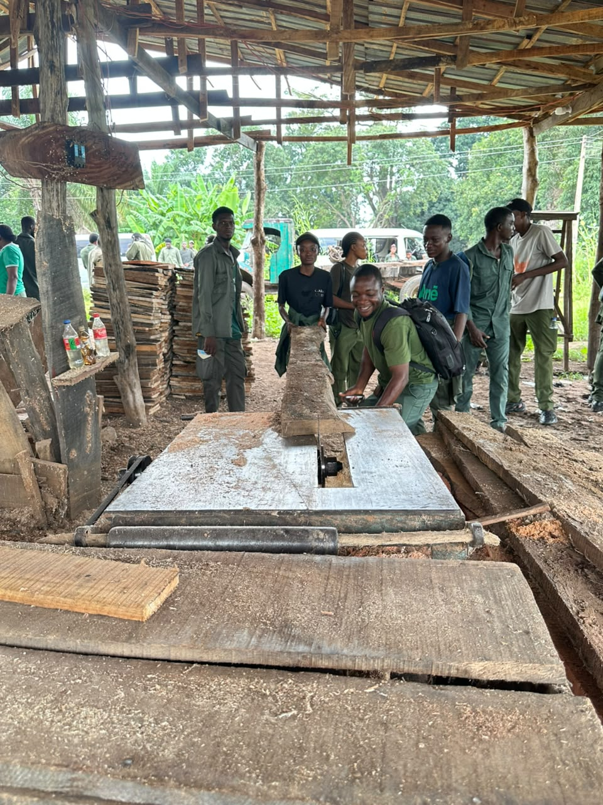
Plate 3: Sawmill machinery during the sawmill visit

3.5.2.10 Maintenance Practice
Two kinds of difficulty were found. The first was theft and the removal of timber without permission, which defeats both the money the state should earn and the control of what is cut; the second concerned the machines and the power supply, with the danger of handling heavy logs. The measures given were supervision, keeping the machines in order, good security, training of staff and following the regulations.
Maintenance was described under the four types taught. Routine maintenance is the daily and weekly attention that keeps a machine fit. Preventive maintenance is work done at fixed intervals so a part is changed before it fails, and the scheduled sharpening and setting of blades belongs here. Corrective maintenance is the repair of a fault that has already happened, such as brazing a broken blade. Predictive maintenance is watching the condition of a machine so failure can be seen coming, and the mill worked on the first three.

3.5.3 Conclusion
The course showed the order in which a log becomes a product, from the log being lifted by winch and carried by truck, through reception, inspection and measurement, to breakdown, edging, trimming, sizing and storage. It showed that the quality of what comes out depends less on how the machine was built than on how it is kept and used, because a blade that is blunt, badly set or wrongly mounted gives a poor cut, eats up timber in a wider kerf and puts the workers in danger.
Above all, the Certificate of Hammering discussion illustrated the link between sawmill operations and forestry regulation. It showed how forestry documentation can support timber traceability and regulatory oversight.

3.6 FPP414 – WOOD SEASONING AND PRESERVATION
(Ultra Modern Timber Market, Makurdi, Benue State)

3.6.1 Introduction
Wood seasoning is the removal of water from timber before it is used. A living tree holds a lot of water, and as the wood dries most of it goes, with the small amount left coming to balance with the dampness of the air around it. Drying, handling and storing the wood correctly keeps the moisture from changing again while the wood is in use.
The reason it is needed is that wet wood changes shape as it dries, and it will do so in the house or in the roof if it was not dried before. The defects that follow from using unseasoned timber are shrinkage, warping, checking, splitting and cracking, and attack by stain and decay fungi. These are not disadvantages of seasoning; they are what happens when seasoning is not done.
The advantages of well dried timber are both technical and commercial. It is lighter, which cuts the cost of carrying and handling; it shrinks and swells less in use; it is stronger and a better insulator, because most strength properties go up as wood dries; it can be cut to exact sizes and worked more easily; its parts hold better with nails, screws and glue; and paint and varnish go on better and last longer.
Wood preservation is the treating of timber with chemicals so that it resists the organisms that would destroy it. Many common species spoil if exposed to conditions that allow decay organisms to grow, and protection against decay fungi, insects and marine borers greatly lengthens the life of wood in building. How much protection is got depends on the preservative and on how well it soaks in, and this differs between heartwood, which usually resists treatment, and sapwood, which takes it easily.

3.6.2 Activities Related to the Course
The practical work was done at Ultra Modern Timber Market over several sessions, covering the arrangement of timber for drying, the methods of seasoning and how to choose between them, the defects that come from poor drying, and the choice and use of preservatives.

3.6.2.1 Methods of Seasoning
Four methods were studied, and they differ in how much control is kept over the drying conditions. They are compared in Table 14.
Table 14: Methods of seasoning timber studied during the course
Method | How it works | Moisture reached | Good side and bad side
Air drying | Timber stacked in the open where air moves freely, so water escapes by evaporation | Usually 20–25% moisture content | Cheap and needs no power; but slow, uncontrolled, and open to surface checking, end splitting and fungal stain
Accelerated air drying | Fans push air through the stack inside a shed, and heat is sometimes added | Faster than air drying, and better quality | Better air movement and quality; needs power and a shed
Pre-drying | Air forced through with temperature and humidity both controlled in a closed room | Usually 27–38 °C and 65–85% relative humidity | Controlled and even; needs equipment and money
Kiln drying | Higher temperatures and faster air movement in an insulated chamber on a schedule | Final moisture set by the schedule to suit the work | Fast and controllable and it reduces defects; but costs a lot to build and run
Source: Course material, FPP 414, 2026; field observation, Ultra Modern Timber Market.

3.6.2.2 Arrangement of Timber for Seasoning
How timber is arranged while drying was studied closely, because it decides the quality of the result more than anything else. The pieces are stacked with spacers called stickers between the layers so air can move through, and the stack is built level with the stickers standing one above the other so the weight passes down through them and not through the timber. Air passing through takes water from every surface at about the same rate, so the board dries evenly. A stack built without stickers, or with them out of line, dries unevenly: the open surfaces lose water faster than the inside, the difference in shrinkage sets up stress, and the board case-hardens, checks or warps. That is the point made in 2.1.3, that the value lost through bad stacking is lost before the timber is put up for sale.

3.6.2.3 Defects of Unseasoned and Badly Seasoned Timber
Shrinkage happens as water leaves the cell walls, and it is not the same in the radial and tangential direction, which is the root cause of the others. Warping is a board bending out of its plane, as bow, crook, cup and twist. Checking is the fibres pulling apart along the grain at the surface, and splitting is the piece coming apart completely, usually at the ends where drying is fastest. Cracking follows when the stress inside the wood is more than it can bear.

3.6.2.4 Preservation of Timber
Preservatives were studied in the two classes into which they have always been divided. The comparison is in Table 15.
Table 15: Classes of wood preservatives and how they are applied
Class | Preservatives studied | Carrier | Note on use
Oil type | Creosote; petroleum solutions of pentachlorophenol | Oil | Creosote is the standard where marine borers must be kept off; its smell and colour keep it to heavy structural and outdoor timber
Waterborne | Chromated copper arsenate; alkaline copper quaternary; copper azole; borates; zinc chloride | Water | Leave the timber clean and able to take paint, so they are used for timber inside houses and for interior work
Source: Course material, FPP 414, 2026; field observation, Ultra Modern Timber Market.
Two families of application were distinguished. In pressure processes the wood is soaked in a closed vessel at pressure above the atmosphere. The full-cell process keeps the most preservative possible in the wood and is the standard way of treating with creosote where marine borers must be kept off; the empty-cell process aims at deep penetration with less preservative left in. In non-pressure processes the preservative is put on without a vessel, by brushing, a short dip, soaking, steeping or diffusion, and these give less even penetration and suit timber in light service. At the market the work seen was of the non-pressure kind: preservative was brushed on and dipped, with extra care on the ends and edges of the boards, because it is through the end grain that water enters and leaves fastest and so it is there that decay starts first.
Two more things were noticed. The right chemical must be chosen for the species and for the work the timber is meant for, because a waterborne preservative that leaves timber clean will not do for timber going into the ground. And timber must be seasoned before it is treated, because a preservative put on wet timber cannot enter it.

3.6.3 Conclusion
The exercise showed that seasoning and preservation are not finishing jobs done after the real work. They are the jobs that decide whether the real work survives, because timber cut to size and sold is worth what somebody will pay for it, while timber that is also properly dried, stacked and treated is a building material that will still be in use in another generation.
It was also seen that the two are joined in a fixed order. Preservative cannot enter wood that is full of water, so preservation follows seasoning; stickers must be put in before the stack settles; and the method chosen decides how dry the timber will become. Order matters here as in the nursery, because each operation shuts off some of the choices for the next.

3.7 OTHER EXPERIENCE GAINED
What is reported here was in addition to the six course areas and was gained at Cross River National Park, in the same pattern of introduction, activities and conclusion.

3.7.1 Cross River National Park (Cross River National Park, Akamkpa, Cross River State)

3.7.1.1 Introduction
Cross River National Park is in Akamkpa Local Government Area and was established in 1991. It protects one of the largest areas of moist tropical lowland rainforest left in Nigeria, and it is important for its plants and animals, which include primates, forest elephant, duiker and hornbills. The student visit began on August 2026, and the group returned about two weeks later; the exact return date is not specified here.
The difference between a national park and a game reserve was explained at the start, and it is a difference in the law and not in what lives there. A national park is land set aside mainly to protect the ecosystem, where people may not live, animals may not be hunted and natural resources may not be taken. A game reserve is land set aside for the conservation and management of wildlife, where controlled use, including hunting under licence, may be allowed, and where people may live. The park is the stricter of the two, and the difference decides what a ranger may allow and what a village at the boundary may do.
Park interpretation was treated as part of management and not as politeness to visitors. It is the explaining of the meaning of a place, which means its ecology, its history, its rules and its value, and it is how a park wins the agreement of the villages around it. A park that cannot explain itself depends only on enforcement, which is costly and does not last.

3.7.1.2 Activities Carried Out
Orientation and interpretation came first, with an orientation on the park and its management, teaching on park interpretation and on the difference between the park and the game reserve, and the ecology of the lowland rainforest.
Physical exercise and drill followed, with jogging, press-ups, squats and parade work in which the squad was formed, marched and moved on command. The aim was fitness, but the real purpose was discipline, because drill teaches that an order given once is obeyed at once, and that is what a patrol in thick forest depends on.
Fires were demonstrated and fire safety explained. Fire management is at the centre of managing a protected area here, because a fire that is not controlled destroys new growth, kills soil organisms and burns off the litter on which the nutrient cycle depends, while controlled early burning reduces the fuel on the ground. The precautions were clearing a fire break before lighting, choosing a time when wind allows control, and keeping water and beating tools ready.
Ammunition and cartridges were identified, with the identification of cartridges by calibre and type. This is useful in enforcement, because the ammunition taken from a poacher tells the type of weapon used, and the record of that type often leads to the person.
Ballistics was taught as a subject, with its types. Internal ballistics is what happens inside the barrel, from ignition to the moment the bullet leaves the muzzle; external ballistics is the movement after that, including speed, gravity, air resistance and wind; and terminal ballistics is what happens when it reaches the target. A ranger needs all three, because the second decides whether the shot will land where it is aimed.
The firearm was stripped and assembled, the aim being to know its working and the order in which the parts are separated and returned. A weapon that has been stripped many times can be cleared, checked and cleaned in the field, and most accidents with firearms come from a mechanism that is not understood.
Marksmanship was tested, with sighting, breathing, trigger control and follow-through applied to firing the weapon. What is required of a ranger is not competition accuracy but the ability to put a shot where it is intended in field conditions, and just as much the sense to refuse a shot that cannot be placed.
Sanitation work was done in the park area, which meant clearing and disposing of refuse. The point goes beyond tidiness: refuse draws scavenging animals and changes the way wildlife behaves, it creates a disease risk where animals and people meet, and it spoils the visitor experience on which the park depends for money.
Ecotourism was taught and its importance explained. It is travel to natural areas done in a way that conserves the environment, supports local people and includes interpretation and education. It brings in money that reduces dependence on government funding; it creates work and income for the villages at the boundary; and it gives the park the public support it needs to be kept.
A botanical walk was made through the park, during which plants were identified using the characters taught in WRM 404, that is leaf arrangement, branch arrangement and venation pattern, and their uses recorded. Twenty of the species identified are in Table 16.
Table 16: Plant species identified during the botanical rambling at Cross River National Park
S/N | Botanical name | Family | Common name | Main uses recorded
1 | Alstonia boonei | Apocynaceae | Stool wood | Timber for furniture and carving; bark used for fever and malaria
2 | Baphia nitida | Fabaceae | Camwood | Red heartwood gives a dye; tool handles; ornamental
3 | Calamus deerratus | Arecaceae | Rattan palm | Stems used for baskets, mats, furniture and tying
4 | Carpolobia lutea | Polygalaceae | Cattle stick | Root and stem used for stomach trouble and fertility; chewing stick
5 | Ceiba pentandra | Malvaceae | Silk cotton tree | Kapok fibre from the fruit; light timber for canoes and boxes
6 | Chromolaena odorata | Asteraceae | Siam weed | Green manure and pest repellent; medicine; a strong invader of farmland
7 | Ficus capensis | Moraceae | Cape fig | Young leaves eaten as a vegetable; medicine; shade tree
8 | Funtumia elastica | Apocynaceae | West African rubber tree | Latex used for rubber; light timber for building
9 | Gongronema latifolium | Apocynaceae | Amaranth vine | Leafy vegetable; used for diabetes and high blood pressure
10 | Harungana madagascariensis | Hypericaceae | African iodine tree | Red and yellow dye; timber for building; traditional medicine
11 | Irvingia gabonensis | Irvingiaceae | African bush mango | Fruit and seed eaten; timber for building
12 | Lophira alata | Ochnaceae | Red ironwood | Heavy building work, bridges, railway sleepers and ship building
13 | Milicia excelsa | Moraceae | Iroko | Building, furniture and boat building
14 | Musanga cecropioides | Urticaceae | Umbrella tree | Very light wood for rafts and floats; first tree on cleared forest
15 | Parkia bicolor | Fabaceae | African locust bean | Seed used as a condiment; timber for planks and canoes
16 | Pentaclethra macrophylla | Fabaceae | African oil bean | Seed fermented as food; timber; medicine
17 | Piper guineense | Piperaceae | West African black pepper | Spice; medicine; climber of the forest undergrowth
18 | Piptadeniastrum africanum | Fabaceae | African greenheart | Building, flooring, furniture and canoes; bark used in medicine
19 | Thaumatococcus daniellii | Marantaceae | Sweet prayer plant | Large leaves used for wrapping food, especially moi moi
20 | Xylopia aethiopica | Annonaceae | Grains of Selim | Spice; medicine; light timber for building
Source: Field identification, Cross River National Park, 2026; nomenclature per Keay (1989).
The list shows how a lowland rainforest is built up: the first trees that come up on cleared ground, such as Musanga cecropioides and Chromolaena odorata; the climbers of the undergrowth, such as Piper guineense and Gongronema latifolium; the rattans and marantas; and the big timber trees of the canopy, such as Milicia excelsa, Lophira alata and Ceiba pentandra. The number of species with food and medicine use is also striking, and that is the practical reason for protecting forest of this kind.
Plate 4 shows the group on the botanical rambling through the lowland rainforest.
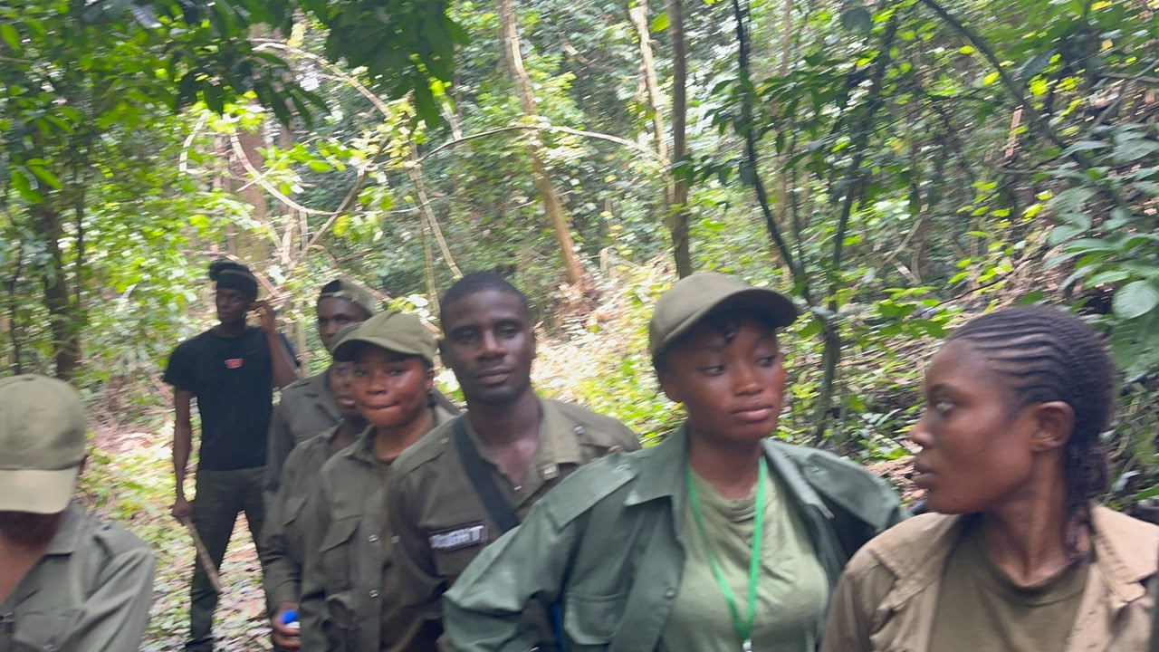
Plate 4: Botanical walk at Cross River National Park
Plate 5 shows a student climbing the bamboo observation structure used for viewing the forest from above.
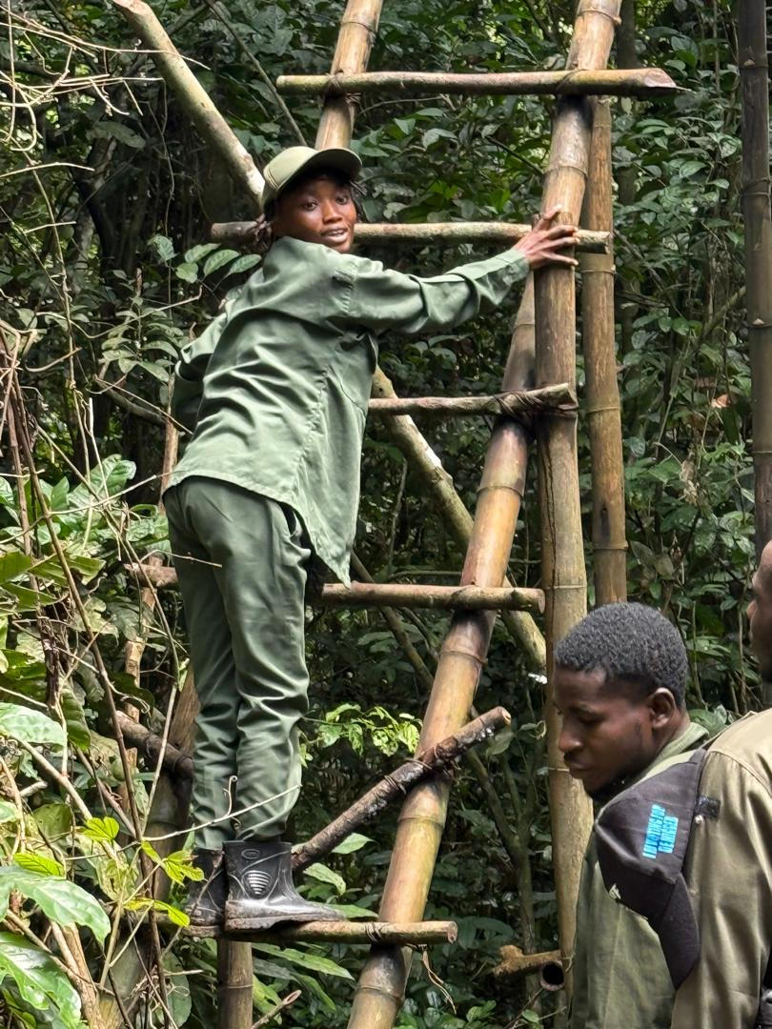
Plate 5: Field exercise at Cross River National Park
Plate 6 shows field visit to Cross River National Park.
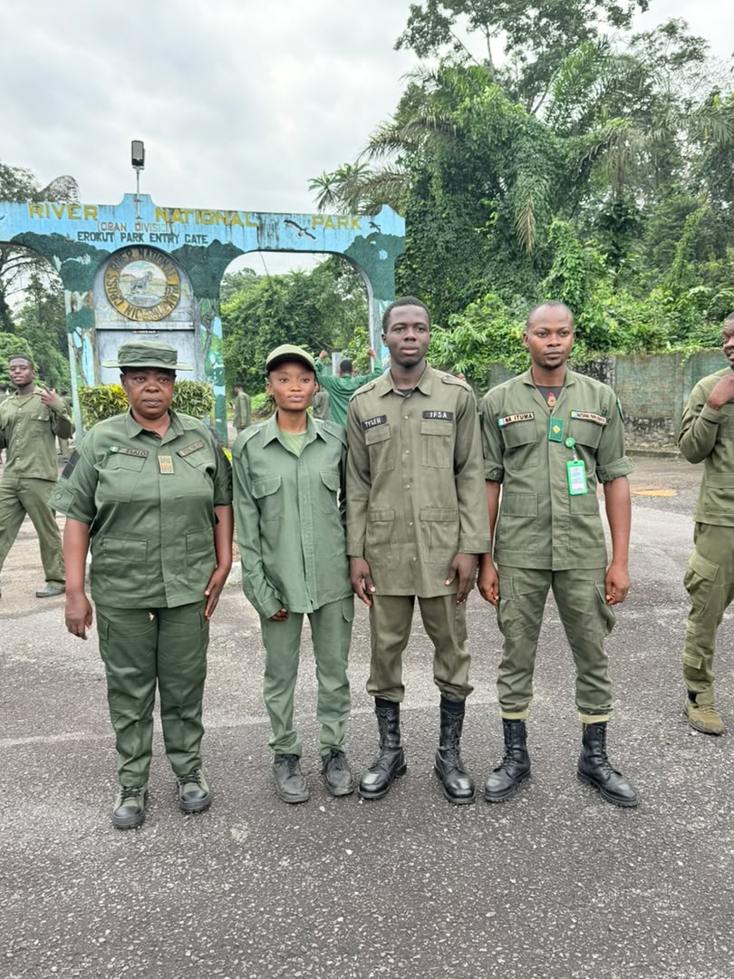
Plate 6: Field visit to Cross River National Park

3.7.1.3 Conclusion
The experience showed what a protected area is in practice, as different from what it is on paper. A national park is not a fence round a forest but an institution with four jobs that must be done at the same time: protection, which needs patrol, discipline and the lawful use of force; interpretation, which wins the agreement of the public and of the villages at the boundary; science, which shows what is in the place and whether it is being kept; and money, without which the first three cannot go on. The drill and firearm work belong to the first; interpretation and ecotourism to the second and fourth; and the botanical walk and survey work to the third.
It was concluded that keeping such a place is as much a social problem as a technical one. Enforcement skills are necessary but not enough, because a park guarded only by enforcement will be guarded only as long as the money lasts. The future of the park rests on the value the villages at its boundary place on it still being there, so interpretation, ecotourism and the wise use of forest products are the means by which protection is made to last.

CHAPTER FOUR: SUMMARY, CONCLUSION AND RECOMMENDATIONS

4.1 Summary

4.1.1 Summary of Activities
The SIWES attachment ran from June to October 2026. Training activities covered six course areas and included a visit to Cross River National Park beginning on August 2026, with the group returning about two weeks later. Ultra Modern Timber Market was visited on September 2026, and the sawmill at Igbor was visited in October 2026.
- Forest operations at the JOSTUM forestry nursery: clearing and pruning, desilting the reservoir, laying out poly-pot and germination beds, mixing the 4:1:1 potting mixture, collecting and potting wildlings, broadcasting Gmelina and Tectona seed, and daily watering and weeding.
- Museum and herbarium techniques: the taxidermy of a rabbit at the Wildlife and Range Management Laboratory, from the specimen data through dissection, stuffing, mounting and documentation; and the collection, identification and pressing of plants at Cross River National Park.
- Wildlife ecological survey: reconnaissance of a grassland with a farm edge, laying a transect, setting and geo-referencing a sample plot, recording birds, toads and earthworm activity, and finding deforestation and bush burning as the main problems.
- Aerial and ground survey: remote sensing, its sensors and platforms, vegetation indices and its uses and limits; the division of ground survey into geodetic and plane survey; and the parts, data models and abilities of a geographic information system.
- Sawmilling: timber sizes as sold in the market, species identification, machine parts, safety faults and precautions, saw doctoring, pre-sawing operations, and the Certificate of Hammering at the mill visited at Igbor.
- Wood seasoning and preservation: the methods of seasoning from air drying to kiln drying, stacking with stickers and its defects, the defects of unseasoned timber, and the classes and application of preservatives.
- Other experience at Cross River National Park: park interpretation, the difference between a national park and a game reserve, drill, fire safety, ammunition identification, ballistics, stripping and assembling the firearm, marksmanship, sanitation, ecotourism, and a botanical walk on which twenty species were recorded.

4.1.2 Summary of Challenges Encountered
The challenges met were of three kinds, and they are given as they were met and not in general words.
The first was about the place itself. The market works without written procedure: there is no manual in a stall, instruction is given by mouth and in the middle of work, and the same job may be done slightly differently by two operators side by side. For a student used to procedure written out in a lecture note, the procedure had to be put together by watching and then confirmed by asking.
The second was practical. Power cuts stopped the saw bench without warning, so a job planned for the morning could not be finished. Handling heavy logs with limited lifting equipment caused delay as well as danger, and machine faults held up work while the blade was repaired.
The third was about records. Where the species, size or treatment of a batch of timber was known only to one worker, the information could not be got afterwards. This happened at the market, and again with the Certificate of Hammering, where part of the writing was done over other writing.

4.1.3 Summary of Skills Acquired
The skills gained are practical, and they are stated as what can now be done.
- Nursery practice: preparing beds, mixing the potting mixture to a set ratio, potting wildlings, broadcasting seed, and the day to day care of stock.
- Specimen preparation: taxidermy of a small mammal through recording data, dissection, preservation and mounting, and the collecting and pressing of plant material.
- Plant identification: using leaf arrangement, branch arrangement and venation pattern to place a plant with no flower on it in its family.
- Survey work: reconnaissance, laying a transect, setting a plot, using a GPS receiver, and recording animals by sighting and by sign.
- Spatial data: reading satellite images, working out and reading a vegetation index, and understanding layered spatial analysis in a geographic information system.
- Timber conversion: naming the parts of the machines and their work, following the order of log breakdown, measuring timber to size, and separating timber by species and grade.
- Seasoning and preservation: judging the quality of a stack, telling the drying methods apart, and choosing and brushing on a preservative that suits the species and the work.
- Reading forestry papers: reading a Certificate of Hammering and matching it to the timber it travels with.
- Field discipline: parade drill, handling firearms under supervision, and the safety rules for fire and machines.

4.1.4 Essence of the Training
The essence of the training was not the collection of techniques but the correction of one belief. Studying in an institution makes a student think that a job is understood once it can be described, and practice shows that it is understood only when it has been done. A potting ratio can be memorised in a minute and mixed correctly only after it has been mixed wrongly once.
The second part was seeing how the subjects join. Forestry as taught is divided into courses and forestry as practised is not: the Certificate of Hammering belongs to forest law, to wood technology and to social forestry at the same time, and looking at that paper on the same afternoon as looking at a saw bench made the joining real.

4.2 Conclusion

4.2.1 Reflection on the SIWES Experience
The attachment ran from the middle of June to the end of October, and what it was like changed as it went. The market visit included learning what the market does and in what order: how timber is received and measured, how species are separated, how a log is put to a bench and what comes off it. That was a time of watching, and its value was in learning to see what an experienced operator sees, such as the taper in a log that will cut down its yield.
The middle part was spent doing the work, at the nursery and in the field, and that taught what watching cannot: that the difficulty of a job is in doing it, and that the standard of the result is set by the care taken at the stages that look small. The last weeks put the two together, at Cross River National Park and at the sawmill visit, where the whole chain from felling paper to finished plank could be seen in one yard.

4.2.2 Insights from Activities, Challenges and Skills Development
Three insights came out of the exercise, and each one came from a difficulty rather than from a success.
The first is that the order of operations matters as much as the operations themselves, and the order is fixed by the material. A preservative cannot go on timber that is still wet, a measurement cannot be taken from a skin that has been removed, and a plant cannot be identified after the characters that identify it have been folded away.
The second is that small technical decisions carry money with them, and the money is not visible when the decision is made. How wide a kerf is decides how much of a log becomes timber; how far apart the stickers are decides whether a stack dries evenly; which preservative is used decides whether a treated post lasts ten years or forty. None of these turns up in an examination, and all of them decide whether a forestry business makes a profit.
The third is that the control of a forest resource is carried out in ordinary places. The Certificate of Hammering was not looked at in a ministry but in a sawmill yard, at the point where the timber written on it was about to be cut. Forest law either acts at that point or it does not act at all, and enforcing a law depends on daily practice more than on the wording of the law.

4.2.3 Analysis of Personal and Professional Growth
The first change was in confidence in practical situations. Working at a saw bench, in a nursery and in a rainforest needs a calmness a classroom does not give, and being useful there is a skill in itself: asking a sensible question of a busy worker, and writing things down at the time.
The second change was in the habit of checking. Instruction at the market was by word of mouth and sometimes differed from one person to the next, so checking one account against another became the way of working. That habit is what professional judgement in forestry rests on.
The third change was in the understanding of the profession. Forestry studied in the abstract is a subject; forestry practised is a set of people doing hard work in hard conditions. The skill of the graduate is not separate from their skill but depends on it.

4.2.4 Highlights of Significant Achievements or Milestones
Four things stand out from the period of attachment.
The first was finishing a mounted taxidermy specimen, from recording its particulars to mounting and documenting it. The work is exacting, it allows no correction once the skin has been taken off, and finishing it showed that a specimen good enough for teaching could be produced.
The second was setting up a geo-referenced sample plot and completing a survey record on it, including finding the problems affecting the habitat and the measures suggested for them. It was the first time a whole survey was done from start to finish.
The third was identifying twenty plant species during the botanical walk at Cross River National Park using the characters taught in WRM 404. It showed that identification by leaf and branch characters works on plants with no flower, which is the condition in which identification is usually needed.
The fourth instructive experience was the discussion of the Certificate of Hammering during the sawmill visit at Igbor. The document illustrated how forestry documentation connects timber processing with regulatory oversight and supports traceability.

4.3 Recommendations

4.3.1 Clear and Feasible Actionable Suggestions
The following suggestions are made to particular people, and each one can be carried out without much money.
To the management of Ultra Modern Timber Market: that a written register be kept in each stall, showing for every batch of timber the species, the sizes, the date it came in, where it came from and any treatment given. The register would help the trader himself, because it settles quarrels with buyers apart from any government requirement, and it needs nothing more than a book and a pen.
To the operators of the saw benches: that putting in the stickers be treated as part of the stacking and not as something extra, and that stacks be built with the stickers standing one above the other. The stickers cost almost nothing; the timber lost to warp and check in a badly built stack costs a lot.
To the Department of Social and Environmental Forestry: that the field visits be fixed at the beginning of each session and made known to students, so that the practical work comes after the lecture on that topic and not before it.
To students going on attachment: that a field notebook be kept and written in at the place and time of the work, including the details that look unimportant, such as the species, the size, the time of day and the name of the worker. What was not written down at the time could not be got back afterwards.

4.3.2 Addressing Identified Challenges or Areas for Improvement
The challenges in 2.2 and 4.1.2 can each be answered. Instruction by word of mouth that is not always the same is best answered by the register suggested above, because a written record settles what memory argues about. Power cuts are best answered by a standby generator that can carry the bench, and both pay for themselves in the working time saved and in avoiding burnt motors.
The danger in handling heavy logs is answered by providing proper lifting equipment, which means winches, hooks, levers and rollers, and by enforcing the rule that nobody stands where a log would go if it rolled. The problem of reading papers that have been written over is best answered at the source. Where entries are written by hand in the field, they should be written in one hand and in a space big enough.

4.3.3 Strategies for Enhancing Training Programmes
Three strategies are suggested for the programme itself. The first is to take students round the units in a fixed order instead of whichever unit happens to be free. At the market visited, the units were shown without a set order, and so the link between the care of a blade and the accuracy of the board it cuts had to be worked out afterwards.
The second is to ask for a short practical report at the end of each part instead of one report at the end of the attachment, because a report written a week after a practical is worth more than a section written four months later from notes.
The third is to build the regulatory part into every relevant practical. The Certificate of Hammering was looked at only by chance and turned out to be the most instructive paper of the whole attachment. A set part of every field visit, in which the student must see the felling permit, the hammer mark, the way bill or the certificate, would join the technical training to the law under which it is done.

4.3.4 Improving Organisational Processes
At the market, three improvements are needed. The first is checking the machine before use, made a rule for everybody and not left to the more careful operators. The second is keeping the maintenance work separate from production, so that blades are sharpened and set on a schedule instead of when the cut has already gone bad. The third is to appoint one worker in each unit to keep the register suggested in 4.3.1.
At the level of the institution, the matching improvements are these. The master and placement lists should be completed well before the attachment starts. A written guide to the report format should be given out at the beginning and not at the end. And a file of past reports should be kept with the source of their field data marked, so that a student can study the format without copying the content.

REFERENCES
Agbidye, F. S. (2026). Guidelines on the preparation of SIWES report (SEF 410 course material). Department of Forest Production and Products, Joseph Sarwuan Tarka University, Makurdi.
Bemshima, I. (2026). Introduction to geographic information systems (SEF 408 course material). College of Forestry and Fisheries, Joseph Sarwuan Tarka University, Makurdi.
Federal Republic of Nigeria. (1971). Industrial Training Fund Act No. 47 of 1971. Lagos: Federal Government Press.
Industrial Training Fund. (2020). Students Industrial Work Experience Scheme (SIWES): Guidelines for participating institutions and employers. Jos: Industrial Training Fund.
Joseph Sarwuan Tarka University, Makurdi. (2026a). FPP 412: Sawmilling (course material). Department of Forest Production and Products, College of Forestry and Fisheries.
Joseph Sarwuan Tarka University, Makurdi. (2026b). FPP 414: Wood seasoning and preservation (course material). Department of Forest Production and Products, College of Forestry and Fisheries.
Joseph Sarwuan Tarka University, Makurdi. (2026c). Remote sensing in forestry and wildlife management (SEF 408 course material). College of Forestry and Fisheries.
Keay, R. W. J. (1989). Trees of Nigeria. Oxford: Clarendon Press.
Ministry of Water Resources and Environment, Benue State. (n.d.). Certificate of hammering [Blank form].
National Universities Commission. (2019). Benchmark minimum academic standards for undergraduate programmes in agriculture and forestry. Abuja: National Universities Commission.
Nigeria National Park Service. (2024). Cross River National Park. Retrieved from https://www.nigeriaparkservice.org
Rivers State University. (n.d.). Students industrial work experience scheme unit. https://www.rsu.edu.ng/students-industrial-work-experience-scheme-unit/
Ross, R. J. (Ed.). (2010). Wood handbook: Wood as an engineering material (General Technical Report FPL-GTR-190). U.S. Department of Agriculture, Forest Service. https://doi.org/10.2737/FPL-GTR-190

APPENDICES

Appendix I: Certificate of Hammering
The Certificate of Hammering details recorded during the sawmill visit are summarised in Table 13 in Section 3.5.2.9.
Sample Certificate of Hammering form (blank).


Appendix II: Summary of Plant Species Identified During the Attachment
The plants met during the attachment are summarised below. The full list with families and uses is in Table 16 of section 3.7.1.2, and the species pressed for the herbarium are in Table 6 of section 3.2.2.2.
- Species recorded during the botanical walk at Cross River National Park: twenty, listed in Table 16.
- Species collected as wildlings and potted at the JOSTUM forestry nursery: Azadirachta indica, Gmelina arborea, Khaya senegalensis, Tectona grandis.
- Species whose seed was broadcast on the germination beds: Gmelina arborea, Tectona grandis.
- Species kept at the nursery and seen during the practical: Polyalthia longifolia, Delonix regia, Elaeis guineensis, Ceiba pentandra, Irvingia gabonensis, Terminalia catappa, Dacryodes edulis, Afzelia africana, Carica papaya, Mangifera indica, Moringa oleifera, Jatropha curcas, Bougainvillea spectabilis and Euphorbia milii.
- Species pressed for the herbarium: eight, listed in Table 6.
- Species whose timber was identified at EL Moringa Investment Resources, Igbor: eight, listed in Table 12.

Appendix III: Index of Plates
Plates 1 to 5 in the main text are from photographs taken during the attachment. They are listed here with the section of the report in which each one appears.
Table 17 presents the information described in this section.
Table 17: Index of plates reproduced in the report
Plate | Subject | Section of report
Plate 1 | Watering nursery stock at the JOSTUM forestry nursery | 3.1 Forest Operations
Plate 2 | Mounted specimen from the taxidermy practical | 3.2 Museum and Herbarium Techniques
Plate 3 | Sawmill machinery during the sawmill visit | 3.5 Sawmilling
Plate 4 | Botanical walk at Cross River National Park | 3.7.1 Cross River National Park
Plate 5 | Field exercise at Cross River National Park | 3.7.1 Cross River National Park
Source: photographs taken during the attachment, 2026.

