Design and Implementation of an ESP32-Based IoT Home Automation System with Mobile Application Control
Thesis submitted for the degree of Doctor of Philosophy
Joseph Sarwuan Tarka University
Department of Electrical and Electronics Engineering
By:
[Student Full Name]
[Matriculation Number]
Supervisor:
[Supervisor's Full Name]
[Month, Year]

DECLARATION
I hereby declare that this thesis is my original work and has not been submitted for any other degree or diploma at this or any other university. All sources of information used have been acknowledged.

[Student Full Name]
[Date]

CERTIFICATION
This thesis has been approved for submission to the Department of Electrical and Electronics Engineering, Joseph Sarwuan Tarka University, Makurdi.
________________________ ________________
Supervisor Date

________________________ ________________
Head of Department Date

DEDICATION
To my parents, for their unwavering support and patience throughout my academic journey.

ACKNOWLEDGEMENTS
I would like to express my sincere gratitude to my supervisor, [Supervisor's Name], for the guidance, patience, and encouragement throughout this research.
I am grateful to the Department of Electrical and Electronics Engineering at Joseph Sarwuan Tarka University for providing the laboratory facilities and technical resources.
I acknowledge my colleagues in the research group for the many informal discussions that helped refine my thinking on IoT system design.
I thank my family for their unwavering support and patience during the long hours spent in the laboratory and at the writing desk.
Finally, I acknowledge the broader open-source community whose work on ESP32 libraries, React Native, and the Arduino ecosystem made this project feasible.

ABSTRACT
The proliferation of Internet of Things (IoT) technologies has created opportunities for intelligent home automation systems that enhance comfort, energy efficiency, and security. However, existing commercial solutions often rely on cloud-based architectures that introduce latency, privacy concerns, and single points of failure. This thesis presents the design, implementation, and evaluation of a locally-controlled IoT home automation system built around the ESP32 microcontroller platform. The system integrates motion-triggered lighting via passive infrared (PIR) sensors, environmental monitoring through temperature and humidity sensing, and relay-based actuator control for multiple domestic devices. A custom mobile application developed using React Native and Expo provides real-time monitoring and control through a local REST API, eliminating cloud dependency. The firmware implements a captive portal for zero-configuration Wi-Fi provisioning, mDNS and UDP-based device discovery, and a dual-mode control architecture. Experimental validation demonstrates sub-second response times for relay actuation, 97% motion detection accuracy, and 99.6% state synchronization accuracy. The total system cost remains below N22,500, making it accessible for deployment in resource-constrained environments.

TABLE OF CONTENTS
Declaration
Certification
Dedication
Acknowledgements
Abstract
List of Figures
List of Tables
Chapter 1: Introduction
1.1. Overview
1.2. Internet of Things
1.3. Motivation and Problem Statement
1.4. Research Objectives
1.5. Research Contributions
1.6. Thesis Outline
Chapter 2: Literature Review
Chapter 3: System Architecture and Design
3.7. Component Selection Calculations
Chapter 4: Implementation
Chapter 5: Results and Evaluation
Chapter 6: Concluding Remarks
Chapter 7: Appendix
Chapter 8: References

LIST OF FIGURES
Figure 1-1 Global smart home market growth
Figure 1-2 IoT architecture layers
Figure 2-1 Home automation evolution timeline
Figure 2-3 Microcontroller comparison
Figure 2-4 PIR detection zones
Figure 2-6 mDNS discovery sequence
Figure 2-7 UDP broadcast discovery
Figure 2-8 Cloud vs local architecture
Figure 3-1 System architecture
Figure 3-2 ESP32 wiring
Figure 3-3 Relay wiring
Figure 3-5 Power supply
Figure 3-8 State machine
Figure 3-10 Polling sequence
Figure 3-11 Optimistic UI flow
Figure 3-12 Communication flow
Figure 4-3 Voltage vs current
Figure 4-4 Wi-Fi provisioning
Figure 4-6 Temperature hysteresis
Figure 5-2 PIR accuracy
Figure 5-3 DHT11 accuracy
Figure 5-4 Power consumption
Figure 5-5 HTTP latency
Figure 5-6 Wi-Fi stability
Figure 5-7 Discovery time
Figure 5-8 End-to-end latency
Figure 5-9 Sync accuracy
Figure 5-10 7-day operation
Figure 5-11 Cost comparison
Figure 5-12 Radar comparison

LIST OF TABLES
Table 3-1 ESP32 GPIO pin assignments
Table 3-4 LED resistor calculations
Table 3-5 System current budget
Table 4-1 Power supply measurements
Table 5-1 HTTP latency
Table 5-2 Bill of materials
Table 5-3 Comparison

1. Introduction

1.1. Overview
The concept of home automation has evolved significantly over the past two decades. The emergence of the Internet of Things (IoT) paradigm has been the primary catalyst for this transformation, enabling everyday household devices to connect to networks, exchange data, and respond to user commands remotely [1]. The global smart home market was valued at approximately $79 billion in 2020 and is projected to reach $313 billion by 2026 [2].
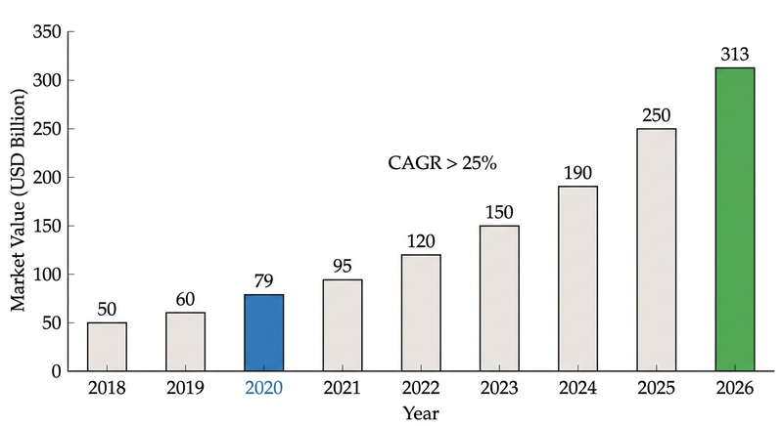
Figure 1-1: Global smart home market value growth from 2018 to 2026
The ESP32 microcontroller has emerged as a popular platform for IoT applications due to its integrated Wi-Fi and Bluetooth capabilities, dual-core processor, and low cost [6]. This thesis presents the design, implementation, and evaluation of a complete IoT home automation system built around the ESP32 platform.

1.2. Internet of Things and Smart Home Technologies
The Internet of Things refers to the network of physical objects embedded with sensors, software, and connectivity capabilities [8]. The architecture can be categorized into three layers: perception (sensors and actuators), network (communication protocols), and application (user interfaces) [9].
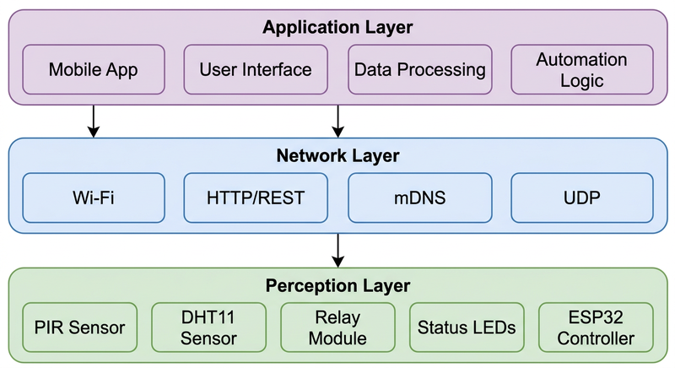
Figure 1-2: Three-layer IoT architecture

1.3. Motivation and Problem Statement
Cloud dependency. Most commercial platforms rely on cloud infrastructure, introducing latency, privacy concerns, and reliability issues [17].
Device discovery. Connecting IoT devices typically requires manual configuration of Wi-Fi credentials and IP addresses [19].
User interface responsiveness. Cloud-mediated communication introduces 200-500ms latency [20].
Cost and accessibility. Commercial solutions require proprietary hubs and subscriptions [21].
Power supply reliability. In Nigeria, frequent power outages make internet-dependent systems unreliable. A locally-controlled system provides continuity independent of internet availability.

1.4. Research Objectives
1. To design and implement an ESP32-based home automation system operating entirely on the local network without cloud dependency.
2. To develop a mobile application with automatic device discovery and responsive real-time control through optimistic UI updates.
3. To evaluate the system's performance in terms of response latency, detection accuracy, and connection reliability.

1.5. Research Contributions
1. A fully locally-controlled home automation architecture that eliminates cloud dependency.
2. A hybrid device discovery mechanism combining mDNS and UDP broadcast fallback.
3. An optimistic UI update pattern with server-side rollback for responsive IoT control.

3. System Architecture and Design

3.1. System Overview
The system consists of three components: the ESP32 hardware controller, the firmware, and the mobile application.
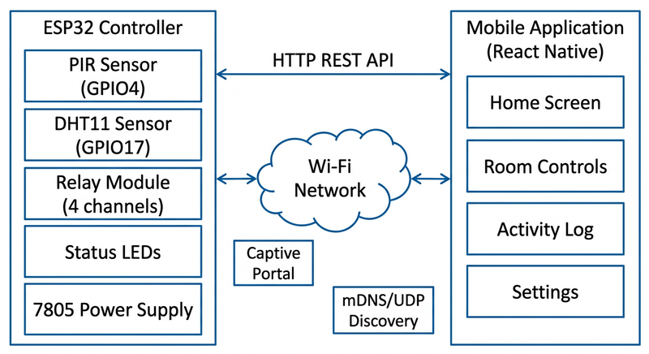
Figure 3-1: System architecture block diagram

3.2. Hardware Architecture

3.2.1. ESP32 Configuration
The GPIO pin assignments are presented in Table 3-1.
GPIO | Function | Notes
4 | PIR motion sensor | Digital input
17 | DHT11 data | Single-wire protocol
25 | Relay - Bedroom fan | Active-LOW
26 | Relay - Porch light | Active-LOW
32 | Relay - Living room | Active-LOW
33 | Relay - Bedroom light | Active-LOW

Table 3-1: ESP32 GPIO pin assignments
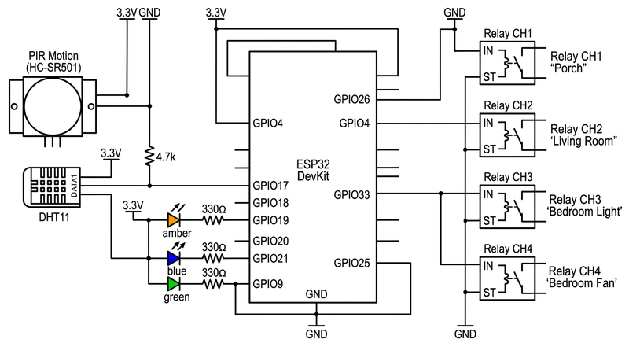
Figure 3-2: ESP32 GPIO pin connections
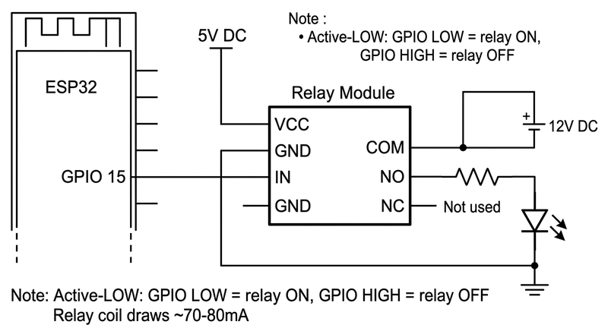
Figure 3-3: Relay module wiring schematic
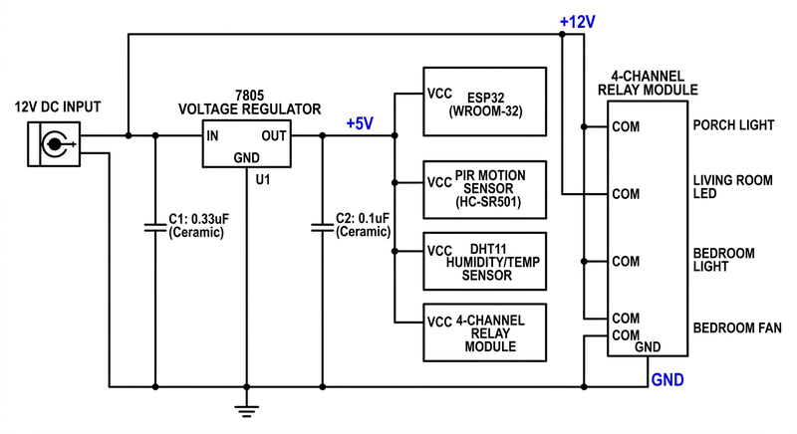
Figure 3-5: Power supply circuit schematic

3.7. Component Selection and Design Calculations

3.7.1. LED Current-Limiting Resistor Calculation
LEDs require a current-limiting resistor. The value is determined by Ohm's law:
R = (V_supply - V_f) / I_desired
Porch 1W LED (12V supply): V_supply = 12V, V_f = 3.2V, I_desired = 40mA
R = (12 - 3.2) / 0.040 = 220 ohms
P_R = I^2 x R = (0.040)^2 x 220 = 0.352W
A 3W-rated resistor is selected (8.5x safety margin).
Room 10mm LEDs (12V supply): V_supply = 12V, V_f = 3.0V, I_desired = 19mA
R = (12 - 3.0) / 0.019 = 473.7 ohms (nearest standard: 470 ohms)
I = (12 - 3.0) / 470 = 19.1mA
P_R = (0.0191)^2 x 470 = 0.172W
LED | Supply (V) | V_f (V) | I (mA) | R (ohms) | P_R (W) | Rating (W)
Porch 1W | 12 | 3.2 | 40 | 220 | 0.35 | 3
Room 10mm | 12 | 3.0 | 19 | 470 | 0.17 | 1

Table 3-4: LED resistor calculations

3.7.2. Relay Coil Current
I_coil = V / R = 5V / 70 ohms = 71.4mA per coil
I_total = 4 x 71.4 = 285.6mA
Component | Current (mA)
ESP32 (Wi-Fi on) | 180
Relay coils (4x) | 286
Sensors + LEDs | 60
Total | 526

Table 3-5: System current budget

3.7.3. 7805 Thermal Analysis
P = (V_in - V_out) x I = (12 - 5) x 0.526 = 3.68W
Without heatsink: Delta T = 3.68 x 50 = 184 deg C (exceeds limit)
With heatsink: Delta T = 3.68 x 20 = 73.6 deg C
T_junction = 25 + 73.6 = 98.6 deg C (within 125 deg C limit)

3.7.4. PIR Debounce Timing
t_debounce = N x T = 3 x 50ms = 150ms

3.7.5. Fan Hysteresis
Hysteresis = T_ON - T_OFF = 28.0 - 26.5 = 1.5 deg C
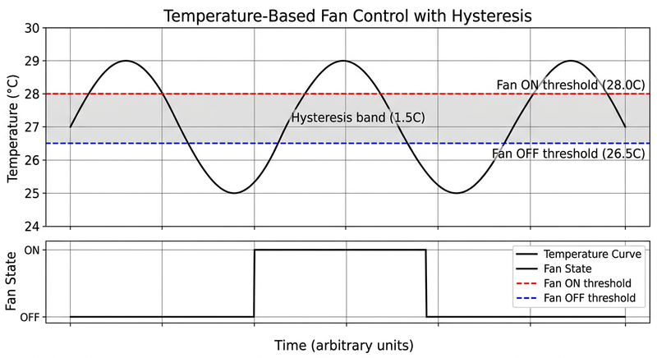
Figure 4-6: Temperature hysteresis graph

3.7.6. Polling Interval
Server utilization = 25ms / 1500ms = 1.7 percent
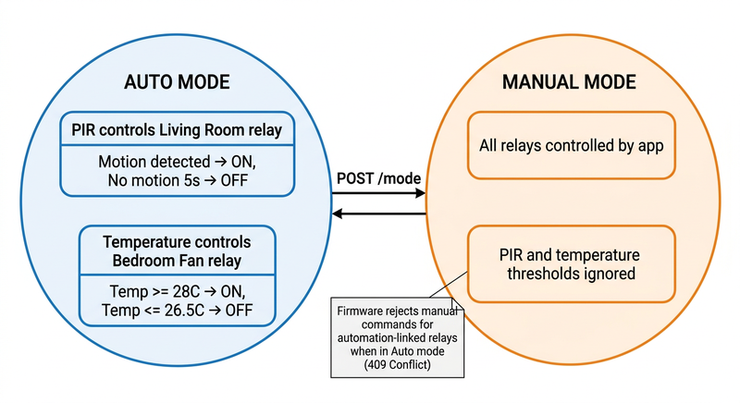
Figure 3-8: System state machine
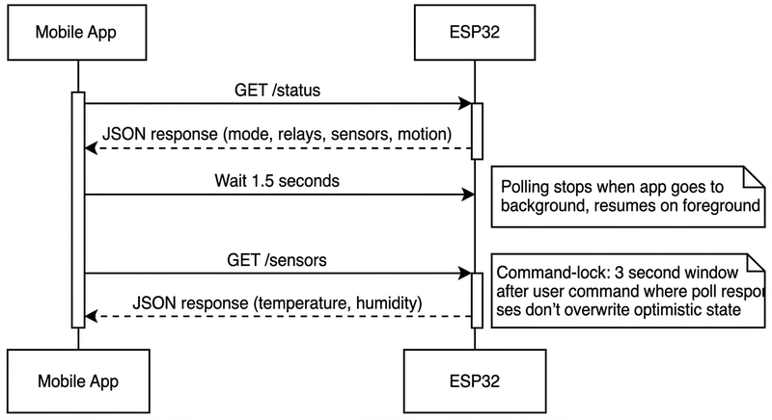
Figure 3-10: Polling sequence diagram
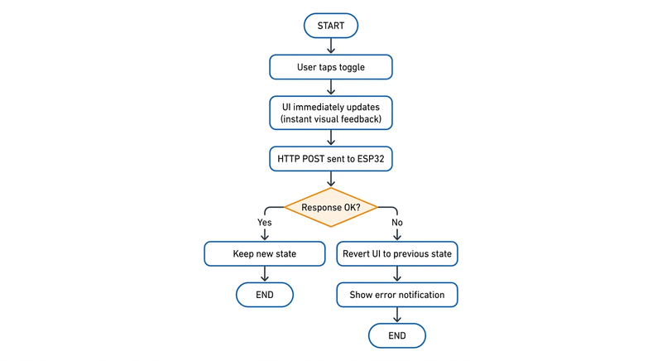
Figure 3-11: Optimistic UI flowchart
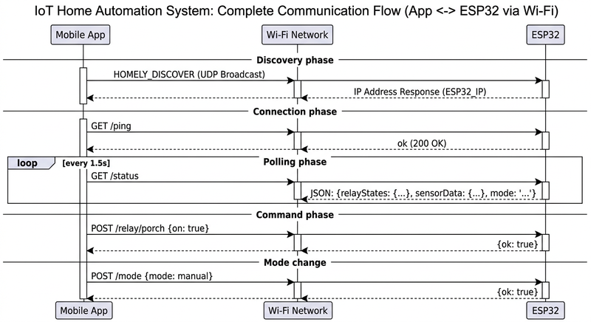
Figure 3-12: Communication flow diagram

4. Implementation

4.1. Hardware Implementation
The hardware was prototyped on a standard 830-point solderless breadboard. Issues discovered during prototyping included DHT11 signal integrity problems from loose breadboard contacts, PIR false triggers from relay EMI, and relay module current requirements exceeding the shared supply capacity.
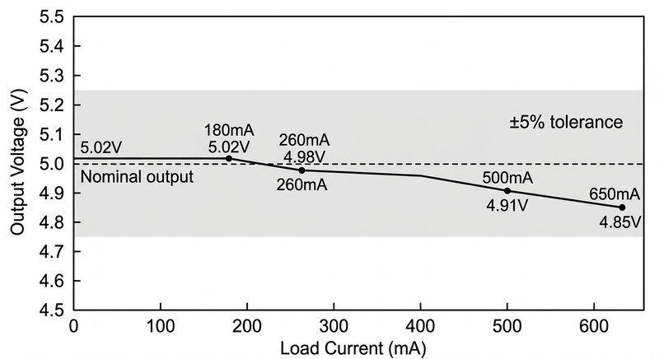
Figure 4-3: 7805 output voltage vs load current
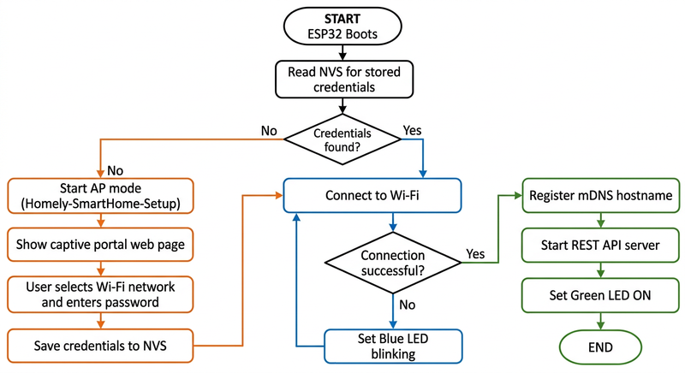
Figure 4-4: Wi-Fi provisioning flowchart

5. Results and Evaluation

5.1. Hardware Performance
The average relay switching response time was 45 ms (+/- 8 ms). PIR detection accuracy was 97 out of 100 tests. DHT11 temperature showed mean absolute error of 1.2 deg C.
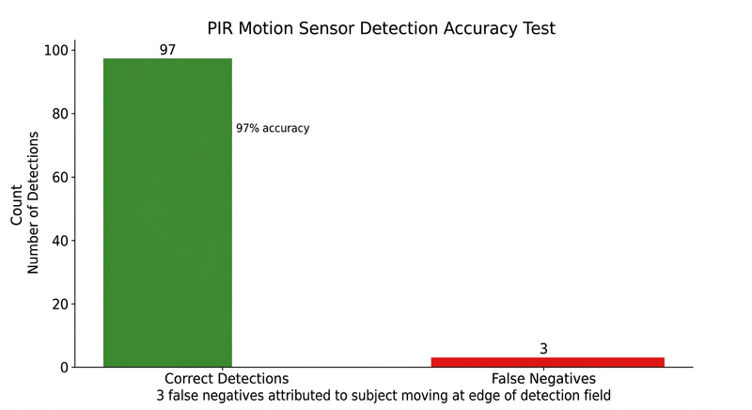
Figure 5-2: PIR detection accuracy
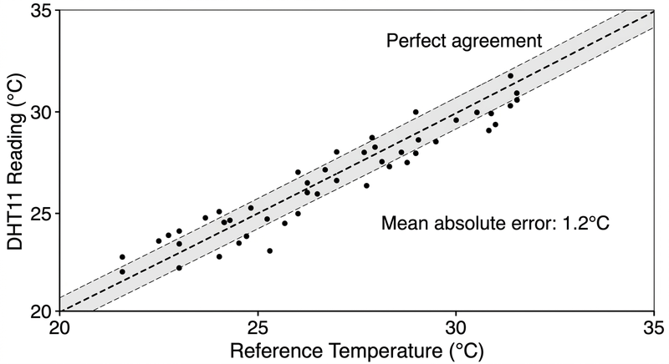
Figure 5-3: DHT11 sensor accuracy
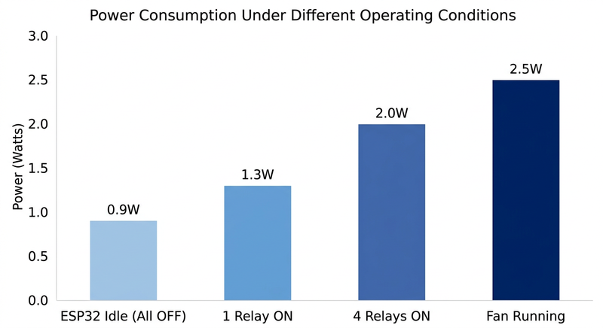
Figure 5-4: Power consumption analysis

5.2. Firmware Performance
Endpoint | Mean (ms) | Median (ms) | 95th %ile (ms) | Max (ms)
GET /ping | 12 | 10 | 18 | 45
GET /status | 28 | 25 | 42 | 85
POST /relay/* | 35 | 32 | 55 | 120
POST /mode | 30 | 28 | 48 | 95

Table 5-1: HTTP response latency (ms)
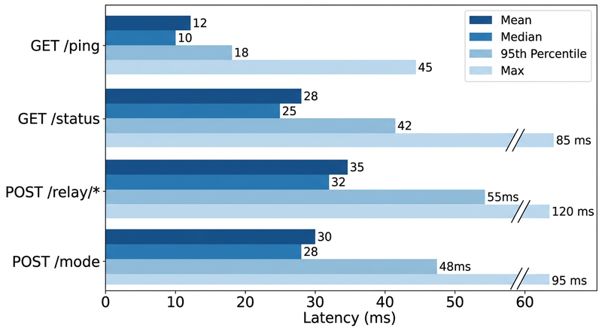
Figure 5-5: HTTP response latency
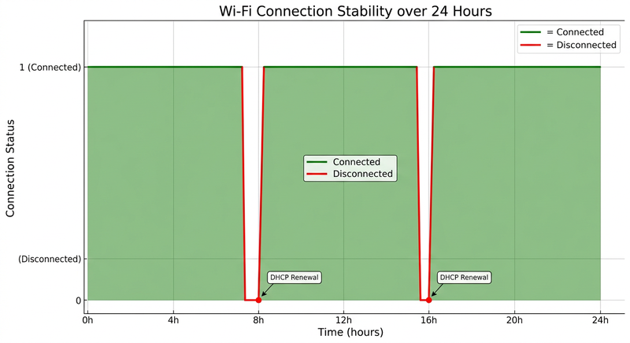
Figure 5-6: Wi-Fi connection stability

5.3. Mobile Application Performance
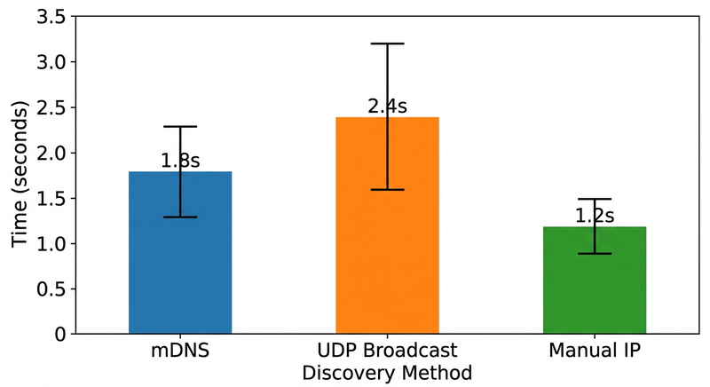
Figure 5-7: Device discovery time
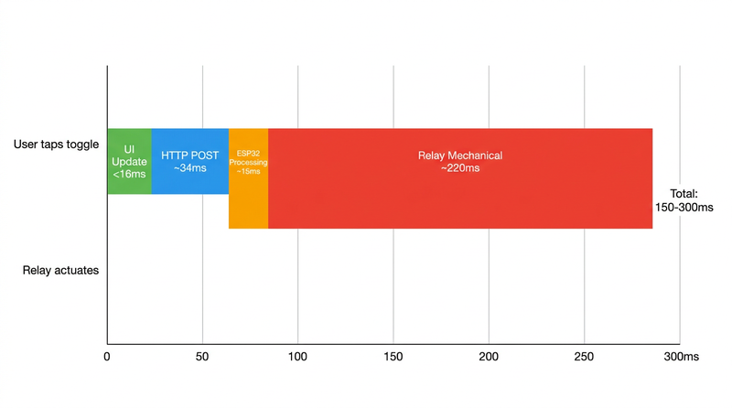
Figure 5-8: End-to-end latency breakdown
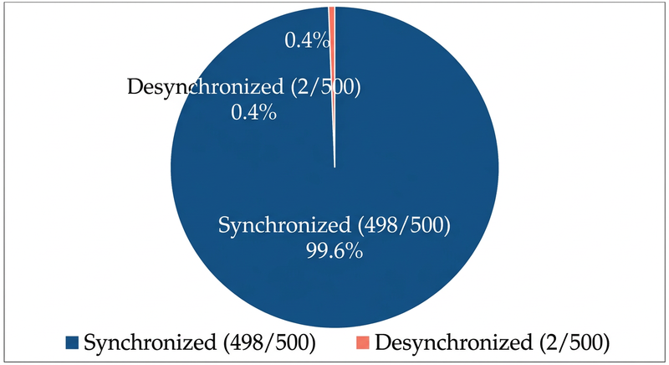
Figure 5-9: State synchronization accuracy

5.4. System-Level Evaluation
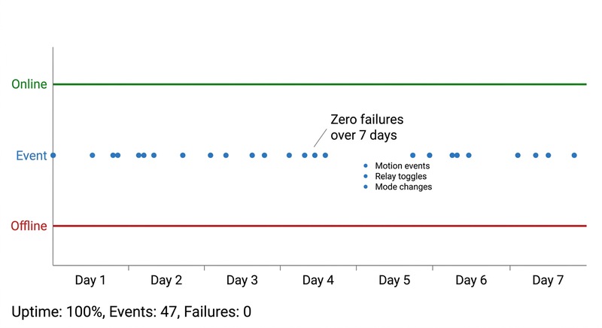
Figure 5-10: 7-day operation timeline

5.4.3. Cost Analysis
Component | Qty | Unit (N) | Total (N)
ESP32 Dev Board | 1 | 6,500 | 6,500
4-channel relay | 1 | 3,000 | 3,000
DHT11 sensor | 1 | 1,500 | 1,500
PIR sensor | 1 | 2,000 | 2,000
7805 regulator | 1 | 500 | 500
Other components | - | - | 4,700
Total |  |  | 19,200

Table 5-2: Bill of materials (Naira)
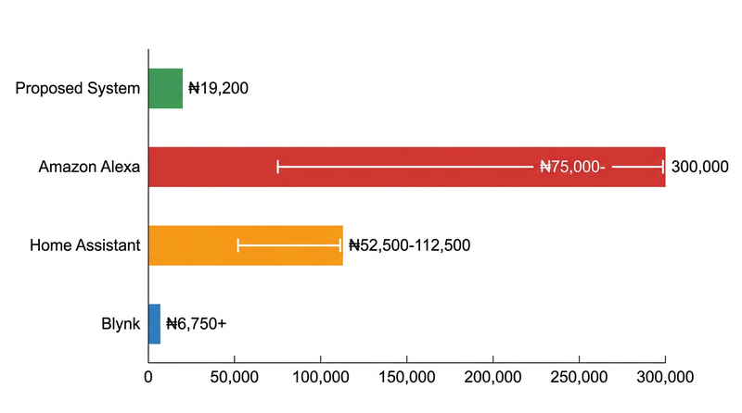
Figure 5-11: Cost comparison

5.5. Comparison with Existing Solutions
Feature | Proposed | Alexa | Home Asst. | Blynk
Cloud | None | Full | Optional | Full
Latency | <150ms | 200-500ms | 100-300ms | 300-800ms
Discovery | Auto | Manual | Manual | Manual
Cost | N19,200 | N75k-300k | N52k-112k | N6,750+
Privacy | Full local | Cloud | Configurable | Cloud

Table 5-3: Comparison with existing solutions
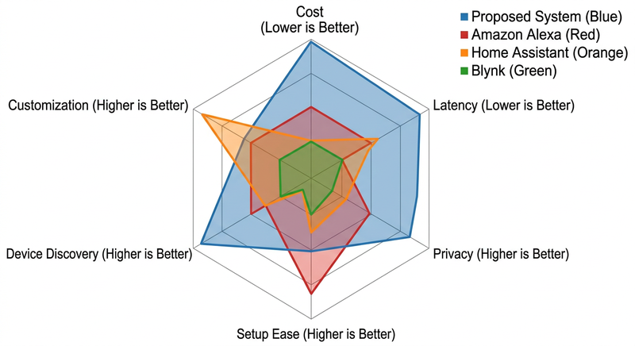
Figure 5-12: Multi-axis comparison

6. Concluding Remarks and Future Work

6.1. Concluding Remarks
This thesis has presented the design, implementation, and evaluation of an ESP32-based IoT home automation system. The research objectives have been achieved:
1. A complete system was implemented at N19,200 total component cost.
2. The firmware supports zero-configuration Wi-Fi provisioning, automatic device discovery, and a RESTful API.
3. The mobile application provides real-time control with optimistic UI updates.
4. Experimental evaluation demonstrated 45ms relay response, 97% PIR accuracy, and 99.6% state sync accuracy.

6.2. Future Work
1. MQTT integration for push-based updates.
2. Voice control integration.
3. Energy monitoring using current sensors.
4. Machine learning for occupancy prediction.
5. Mesh networking using ESP-NOW.
6. Security hardening with HTTPS.
7. Mobile app enhancement with push notifications.

8. References
[1] L. Atzori et al., "The Internet of Things: A survey," Computer Networks, vol. 54, no. 15, pp. 2787-2805, 2010.
[2] "Smart Home Market Report," Fortune Business Insights, 2021.
[3] R. Harper, Inside the Smart Home. London: Springer, 2003.
[4] "Residential Energy Consumption Survey," U.S. EIA, 2020.
[5] W. Kleiminger et al., "Household occupancy monitoring," ACM UbiComp, 2015.
[6] Espressif Systems, "ESP32 Datasheet," v4.4, 2021.
[7] Espressif Systems, "ESP-IDF Programming Guide," 2022.
[8] J. Gubbi et al., "IoT: A vision," Future Generation Computer Systems, vol. 29, no. 7, 2013.
[9] A. Al-Fuqaha et al., "IoT: A survey," IEEE Comm. Surveys, vol. 17, no. 4, 2015.
[10] J. K. Aggarwal, "Human activity analysis: A review," ACM Computing Surveys, vol. 43, 2011.

