JOSEPH SARWUAN TARKA UNIVERSITY, MAKURDI
COLLEGE OF FORESTRY AND FISHERIES
DEPARTMENT OF SOCIAL AND ENVIRONMENTAL FORESTRY
STUDENTS INDUSTRIAL WORK EXPERIENCE SCHEME (SIWES)
REPORT
BY
UGWU CHIMEREOGO JACINTA
22/57212/UE
OCTOBER, 2026

STUDENTS INDUSTRIAL WORK EXPERIENCE SCHEME (SIWES) REPORT
BY
UGWU CHIMEREOGO JACINTA
22/57212/UE
SUBMITTED TO THE DEPARTMENT OF SOCIAL AND ENVIRONMENTAL FORESTRY, COLLEGE OF FORESTRY AND FISHERIES, JOSEPH SARWUAN TARKA UNIVERSITY, MAKURDI, IN PARTIAL FULFILMENT OF THE REQUIREMENTS FOR THE AWARD OF B. FORESTRY (SOCIAL AND ENVIRONMENTAL FORESTRY) DEGREE.
OCTOBER, 2026

DECLARATION
I declare that this SIWES report is my original work and has not previously been submitted to any university or similar institution for the award of a degree or certificate.
Name of Candidate:
Signature:
Date:

CERTIFICATION
We, the undersigned, certify that this SIWES report presented by UGWU CHIMEREOGO JACINTA (22/57212/UE) has been accepted in partial fulfilment of the requirements for the award of the B. Forestry (Social and Environmental Forestry) degree of Joseph Sarwuan Tarka University, Makurdi.

SIWES Coordinator |  | Signature / Date

Head of Department |  | Signature / Date

Dean of College |  | Signature / Date

DEDICATION
I dedicate this report to God Almighty for the strength, health and guidance granted to me throughout the industrial training and the preparation of this work.

ACKNOWLEDGEMENT
I appreciate the management of Joseph Sarwuan Tarka University, Makurdi, and the College of Forestry and Fisheries for making this industrial training possible. My thanks also go to the Head of the Department of Social and Environmental Forestry, the College SIWES Coordinator and the lecturers whose teaching prepared me for the practical exercises.
I am grateful to the management and workers of Ultra Modern Timber Market, Makurdi, for allowing me to learn from their daily operations. The sawyers, timber sellers and maintenance workers patiently answered my questions and demonstrated tasks that I had previously encountered only in class.
I also thank the management and staff of EL Moringa Investment Resources, Igbor, Gwer East, for receiving us during the visit of October 2026. In particular, I appreciate Mr Agbebee Joseph, the wood technologist, for his explanations of the machines, blade repairs, timber species and forestry documents.
My sincere thanks go to the officers and rangers of Cross River National Park for the instruction, field exercises and botanical walk. Finally, I am grateful to my family for their encouragement and to my colleagues in Batch F for their cooperation, companionship and support during the fieldwork.

ABSTRACT
This report presents the Students Industrial Work Experience Scheme training conducted from June to October 2026. The attachment was undertaken to connect classroom learning with practical forestry and wood-processing work and to fulfil part of the requirements for the B. Forestry (Social and Environmental Forestry) degree. Six course areas were covered. Forest operations took place at the College forestry nursery, where the activities included site clearing, bed preparation, potting, wildling collection, seed sowing and routine seedling care. Museum and herbarium techniques involved the documentation and taxidermy of a rabbit and the identification, collection and pressing of plant specimens. Wildlife ecological survey training covered reconnaissance, transect laying, plot establishment and GPS recording. Aerial and ground survey introduced remote sensing, vegetation indices and geographic information systems. Sawmilling and wood seasoning were studied at Ultra Modern Timber Market, Makurdi, and during a visit to EL Moringa Investment Resources, Igbor. These exercises covered timber dimensions, species identification, machine parts, safety, blade repair, drying, preservative treatment and the Certificate of Hammering. Additional experience at Cross River National Park included interpretation, drill, fire safety, sanitation, ecotourism and botanical identification. The attachment improved practical confidence, observation, record keeping and safety awareness. It also showed that forestry operations require correct sequencing and attention to detail. Recommendations include better timber registers, scheduled machine maintenance, safer log handling, earlier field-visit planning and consistent field note-taking by students.
TABLE OF CONTENTS
Contents
DECLARATION i
CERTIFICATION i
DEDICATION i
ACKNOWLEDGEMENT i
ABSTRACT ii
LIST OF TABLES i
LIST OF FIGURES AND PLATES i
LIST OF ABBREVIATIONS AND ACRONYMS i
LIST OF APPENDICES i
CHAPTER ONE: INTRODUCTION 1
1.0 Students Industrial Work Experience Scheme (SIWES) 1
1.1 Historical Background of the SIWES Programme 1
1.2 Industrial Training Fund (ITF) 1
1.3 Scope and Management of SIWES 2
1.4 Functions of the Agencies 2
1.4.1 Federal Government of Nigeria 2
1.4.2 The Industrial Training Fund 2
1.4.3 National Universities Commission 3
1.4.4 National Board for Technical Education 3
1.4.5 National Commission for Colleges of Education 3
1.4.6 The Institutions 3
1.4.7 Employers of Labour 3
1.5 Objectives and Benefits of Industrial Training 4
CHAPTER TWO: INSIGHT INTO THE HOST ORGANIZATION 1
2.1 Introduction to the Organization and Its Units 1
2.1.1 Overview of the Operational Units 1
2.1.2 Organogram of the Organization 2
2.1.3 Mission and Core Values 2
2.1.4 Tasks and Projects Carried Out 2
2.2 Challenges and Solutions 3
2.3 Technical Skills Development 4
2.3.1 Skills and Knowledge Acquired 4
2.3.2 Tools, Technologies and Methodologies Learned 4
2.3.3 Application and Career Relevance 5
CHAPTER THREE: REPORT PER COURSE 6
3.0 Main Report 6
3.1 FPP 402 – Forest Operations 6
3.1.1 Introduction 6
3.1.2 Activities Related to the Course 6
3.1.3 Conclusion 8
3.2 WRM 404 – Museum and Herbarium Techniques 8
3.2.1 Introduction 8
3.2.2 Activities Related to the Course 8
3.2.3 Conclusion 12
3.3 WRM 406 – Wildlife Ecological Survey 12
3.3.1 Introduction 12
3.3.2 Activities Related to the Course 12
3.3.3 Conclusion 13
3.4 SEF 408 – Aerial and Ground Survey 13
3.4.1 Introduction 13
3.4.2 Activities Related to the Course 14
3.4.3 Conclusion 16
3.5 FPP 412 – Sawmilling 16
3.5.1 Introduction 16
3.5.2 Activities Related to the Course 16
3.5.3 Conclusion 22
3.6 FPP 414 – Wood Seasoning and Preservation 22
3.6.1 Introduction 22
3.6.2 Activities Related to the Course 23
3.6.3 Conclusion 24
3.7 Other Experience Gained 25
3.7.1 Cross River National Park, Akamkpa, Cross River State 25
CHAPTER FOUR: SUMMARY, CONCLUSION AND RECOMMENDATIONS 30
4.1 Summary 30
4.1.1 Summary of Skills Acquired 31
4.1.2 Essence of the Training 31
4.2 Conclusion 32
4.3 Recommendations 32
REFERENCES 34
APPENDICES 35
Appendix I: Certificate of Hammering 35
Appendix II: Summary of Plant Species Identified During the Attachment 35
Appendix III: Index of Plates 35

LIST OF TABLES
Table 1: Operational units of Ultra Modern Timber Market, Makurdi, and their functions ?
Table 2: Tools, technologies and methods in which instruction was received ?
Table 3: Tools used in forest operations at the JOSTUM forestry nursery and their functions ?
Table 4: Particulars recorded for the specimen taxidermised at the Wildlife and Range Management Laboratory ?
Table 5: Materials and equipment used in the taxidermy practical ?
Table 6: Main plant species collected, identified and pressed during the herbarium practical ?
Table 7: Coordinates of the corners of the sample plot established for the ecological survey (Cross River National Park; WGS84, decimal degrees; approximately 20 m × 20 m, 400 m²) ?
Table 8: Remote sensing platforms and sensors studied during the course ?
Table 9: Comparison of the vector and raster data models in a geographic information system ?
Table 10: Machines and machine parts examined at EL Moringa Investment Resources, Igbor ?
Table 11: Machine faults and the safety precautions given at the sawmill ?
Table 12: Wood species identified at EL Moringa Investment Resources, Igbor, and their characters ?
Table 13: Details recorded on the Certificate of Hammering examined at EL Moringa Investment Resources, Igbor ?
Table 14: Methods of seasoning timber studied during the course ?
Table 15: Classes of wood preservatives and how they are applied ?
Table 16: Plant species identified during the botanical rambling at Cross River National Park ?
Table 17: Index of plates reproduced in the report ?

LIST OF FIGURES AND PLATES
Figure 1: Organogram of Ultra Modern Timber Market, Makurdi ?
Plate 1: Watering seedlings at the JOSTUM forestry nursery ?
Plate 2: Watering seedlings in pots at the JOSTUM forestry nursery ?
Plate 3: Mounted rabbit specimen from the taxidermy practical ?
Plate 4: Pressed leaf specimen from the herbarium practical ?
Plate 5: Sawmill machinery during the sawmill visit ?
Plate 6: Field exercise at Cross River National Park ?
Plate 7: Elephant monument at Cross River National Park ?

LIST OF ABBREVIATIONS AND ACRONYMS
AGB | Above-Ground Biomass
CCA | Chromated Copper Arsenate
FPP | Forest Production and Products
GIS | Geographic Information System
GPS | Global Positioning System
ITF | Industrial Training Fund
JOSTUM | Joseph Sarwuan Tarka University, Makurdi
LiDAR | Light Detection and Ranging
MC | Moisture Content
NBTE | National Board for Technical Education
NCCE | National Commission for Colleges of Education
NDVI | Normalised Difference Vegetation Index
NIR | Near-Infrared
NUC | National Universities Commission
PCP | Pentachlorophenol
PPE | Personal Protective Equipment
RH | Relative Humidity
SAR | Synthetic Aperture Radar
SEF | Social and Environmental Forestry
SIWES | Students Industrial Work Experience Scheme
UAV | Unmanned Aerial Vehicle
WRM | Wildlife and Range Management

LIST OF APPENDICES
Appendix I: Certificate of Hammering ?
Appendix II: Summary of Plant Species Identified During the Attachment ?
Appendix III: Index of Plates ?

CHAPTER ONE: INTRODUCTION

1.0 Students Industrial Work Experience Scheme (SIWES)
The Students Industrial Work Experience Scheme (SIWES) gives students an opportunity to spend part of their programme in a workplace or field setting. For forestry students, this means moving beyond lectures and examinations to handle plants, survey equipment, specimens, timber and workplace records under supervision. The attachment also forms part of the requirements for the B. Forestry (Social and Environmental Forestry) degree.
The training showed why this exposure is necessary. A procedure can appear straightforward in a lecture note but become more demanding when materials, weather, machines and people are involved. Preparing a nursery bed, identifying a timber species or recording a survey plot requires careful observation as well as theoretical knowledge. SIWES therefore provided a setting for testing classroom knowledge and recognising areas requiring further guidance.

1.1 Historical Background of the SIWES Programme
The Industrial Training Fund introduced SIWES in 1973 to help students develop practical experience. The Fund withdrew from managing the scheme in 1978, and the Federal Government transferred its management to the National Universities Commission and the National Board for Technical Education in 1979 (Rivers State University, n.d.).

1.2 Industrial Training Fund (ITF)
The Industrial Training Fund was established in 1971 under the Industrial Training Fund Act. Its broad responsibility is to support the development of skilled manpower in Nigeria. SIWES is one of the programmes through which it carries out this duty. The Fund issues operational guidelines, processes placement records, supports supervision and works with institutions, supervising agencies and employers (Federal Republic of Nigeria, 1971; Industrial Training Fund, 2020).

1.3 Scope of SIWES
The scheme covers approved programmes in universities, polytechnics and colleges of education, including agriculture and natural-resource courses such as forestry. Its activities are shared among the Federal Government, ITF, the supervising education agencies, participating institutions and host employers. Government provides the policy and funding framework, while ITF coordinates the programme and maintains the relevant records. The education agencies oversee accreditation and institutional compliance within their sectors.

1.4 Bodies Involved in the Management of SIWES
Institutions arrange placement, maintain coordination units, supervise students and assess logbooks and reports. Employers provide access to suitable work, facilities and industry-based supervision. They also contribute to assessment by confirming the student’s attendance and participation. These roles are connected: a placement cannot achieve its purpose if the student is sent to a workplace without adequate supervision or if the institution does not relate the work to the course of study.

1.5 Objectives of SIWES
The main objectives of SIWES are to provide course-related practical experience, connect theory with practice, introduce students to workplace methods and equipment, ease the transition to employment and strengthen cooperation between institutions and employers. An important benefit was the opportunity to participate in tasks rather than only read about them.

1.6 Benefits of Industrial Training to Students
The attachment developed both technical and personal abilities. Technical learning included nursery work, specimen preparation, ecological survey, timber identification and wood seasoning. Personal learning included punctuality, teamwork, asking questions, recording observations and following safety instructions. The training also highlighted the difference between knowing a definition and being able to complete the activity it describes.

CHAPTER TWO: INSIGHT INTO THE HOST ORGANIZATION

2.1 Introduction to the Organisation and Its Units
The College organised the SIWES programme, which included visits to Ultra Modern Timber Market, Makurdi, Benue State, and EL Moringa Investment Resources, Igbor. The market brings together timber traders, sawyers and other workers involved in the sale and processing of wood. Logs and rough timber arrive from sawmills, after which they are measured, cut, sorted and sold to builders, carpenters, furniture makers and other buyers. The market visit provided an opportunity to observe the link between forest resources and their final users.

2.1.1 Overview of the Operational Units
Work at the market was organised around processing, maintenance, finished products and storage. Although these activities overlapped in practice, each unit had a recognisable function, as summarised in Table 1.
Table 1: Operational units of Ultra Modern Timber Market, Makurdi, and their functions
Unit | Main function | Work observed
Processing unit | Converts logs and rough timber into required dimensions. | Feeding the saw bench, cutting to length and width, and separating offcuts.
Maintenance unit | Keeps machines and blades in working condition. | Blade sharpening and setting, blade joining, and attention to motors, belts and bearings.
Finished product unit | Sorts and prepares sawn timber for buyers. | Sorting by species and size, surface dressing and stacking for collection.
Storage section | Holds timber while limiting avoidable deterioration. | Stacking with spacers, covering timber and allowing air movement.
Source: Field observation, Ultra Modern Timber Market, Makurdi, 2026.
The condition of one unit affects the others. For example, a poorly set blade can produce boards with inaccurate dimensions or rough surfaces. The problem then becomes visible during grading and sale, even though it began in maintenance or processing. This demonstrated why experienced workers paid close attention to machine condition before judging the finished boards.

2.1.2 Organogram of the Organisation
The market operated as an association of traders under a management committee. The committee dealt with general administration, while unit heads and experienced workers directed daily tasks. Technical decisions were often made at the workbench through discussion among operators.
MARKET MANAGEMENT COMMITTEE
↓
Market Chairman |  | Secretary |  | Treasurer
↓
Processing Unit | Maintenance Unit |  | Finished Product Unit |  | Storage Section
↓
Sawyers and bench operators | Saw doctors and mechanics |  | Graders and loaders |  | Stackers and watchmen
Figure 1 presents the organisational structure described in this section.
Figure 1: Organogram of Ultra Modern Timber Market, Makurdi
Most instruction was oral and practical. Learning involved watching an experienced worker, asking for clarification and repeating the task where permitted. This was different from learning through a written laboratory manual and required close attention to the sequence of each operation.

2.1.3 Mission and Core Values
The market did not display a formal mission or vision statement. Its purpose was nevertheless clear from its daily work: to provide a central place where timber could be processed into marketable sizes and sold. Three values were particularly important. The first was accurate measurement because buyers expect the stated dimensions to match the timber supplied. The second was correct species identification because different species vary in strength, durability and suitability. The third was proper stacking and storage to reduce warping, splitting and staining.

2.1.4 Tasks and Projects Carried Out
The market activities included receiving, measuring and classifying timber. Incoming pieces were examined for species, length, diameter and visible defects. Measurements were used to estimate quantity and value, while sorting was done by species, size and condition. Timber dimensions were commonly expressed in inches and feet. Sizes such as 2 × 2 inches and 2 × 4 inches were frequently encountered alongside boards and battens of other dimensions.
Species identification followed. The demonstration showed how heartwood colour, weight, grain, texture and, where distinctive, smell were used together. No single feature was treated as sufficient in every case. The intended use of the timber was also considered, since wood required for heavy construction is not selected in the same way as wood for carving or light furniture.
Other activities included feeding timber to the saw bench, separating boards and offcuts, observing stacking and preservative treatment, and learning routine machine care. Maintenance involved blade sharpening, setting and joining as well as checks on belts, pulleys, motors and bearings. These duties showed that timber quality depends on the full production process rather than on cutting alone.

2.2 Challenges and Solutions
The first challenge was inadequate record keeping. Information about a batch of timber was sometimes known only to the worker who handled it. This made later verification difficult and increased the risk of disputes or unrecorded removal. A simple register showing species, dimensions, source, date received, treatment and date sold would provide a low-cost improvement. Stock records should also be supported by proper supervision and yard security.
Irregular electricity supply was another difficulty. Power interruptions delayed sawing and could affect electric motors. A suitable standby power source, electrical protection and better planning of heavy cutting would reduce these disruptions. Machine faults, particularly blunt or poorly mounted blades, also affected production. Pre-use inspection and scheduled sharpening would help to prevent poor cuts, excessive kerf and avoidable safety risks.
Heavy-log handling presented both delay and danger where lifting equipment was limited. Winches, hooks, levers and rollers appropriate to the log size should be used, and workers should keep clear of the direction in which a log could roll. These measures require consistent enforcement rather than occasional reminders.

2.3 Technical Skills Development

2.3.1 Skills and Knowledge Acquired
By the end of the attachment, practical instruction had been received in nursery-bed preparation, potting, wildling collection, seed broadcasting and routine nursery care. The practical work also included specimen documentation, taxidermy, plant collection and pressing. Field exercises covered reconnaissance, transect laying, plot establishment and GPS recording.
At the market and sawmill, instruction covered common timber dimensions, identification of selected wood species and the functions of major machine parts. Timber stacking, drying methods, preservative classes and the Certificate of Hammering were also studied. These experiences connected classroom topics with forestry work.

2.3.2 Tools, Technologies and Methodologies Learned
Table 2 presents the information described in this section.
Table 2: Tools, technologies and methods in which instruction was received
Group | Tool, technology or method | Use during the attachment
Nursery and fieldwork | Trowel, hoe, rake, shovel, perforator, watering can and wheelbarrow | Preparing beds, filling pots, watering seedlings and moving materials.
Specimen preparation | Surgical knife, razor, needle and thread, syringe, tape, formalin, cotton wool, plant press and newsprint | Taxidermy, specimen measurement and herbarium pressing.
Ecological survey | GPS receiver, transect line, quadrat frame and plot pegs | Plot layout, corner geo-referencing and field recording.
Remote sensing and GIS | Landsat, Sentinel and MODIS imagery; LiDAR; drones; ArcGIS, QGIS, NDVI and SAVI | Land-cover interpretation, vegetation assessment and layered spatial analysis.
Sawmilling | Circular saw bench, breakdown saw, log carriage, rails, push stick, tape, winch and hooks | Log handling, timber conversion and measurement.
Maintenance | Brazing machine and iron, burner, clamps, grinding set, hand plane and sandpaper | Blade repair, sharpening and tool care.
Preservation | Creosote, pentachlorophenol, CCA, ACQ, borates, brushes and dipping tank | Selection and application of wood preservatives.
Source: Field observation and course material, 2026.

2.3.3 Application Examples
The exercises showed how small decisions affect results. The proportions in a potting mixture influence drainage and seedling growth; the arrangement of leaves in a press affects later identification; and the position of a transect determines whether a survey represents the study area. In sawmilling, blade condition influences both recovery and safety, while correct sticker placement affects drying quality.

2.3.4 Relevance to Future Career Aspirations
These lessons are relevant to social and environmental forestry. Forest-resource assessment requires accurate measurement, timber regulation requires species and document checks, and environmental monitoring increasingly uses spatial data. The attachment also demonstrated the role of extension and communication, since a technical recommendation is useful only when the people doing the work understand and accept it.

CHAPTER THREE: REPORT PER COURSE

3.0 Main Report
This chapter describes the work carried out under the six course areas and the additional experience gained at Cross River National Park. The account concentrates on activities, demonstrations and lessons from the training.

3.1 FPP 402 – Forest Operations
Forestry Nursery, Joseph Sarwuan Tarka University, Makurdi, Benue State

3.1.1 Introduction
Forest operations cover the practical work involved in establishing, tending, protecting and harvesting forest crops. Nursery practice is an early part of this process because the condition of planting stock affects survival and growth after field planting. A nursery provides controlled conditions in which seeds or wildlings can be raised until they are strong enough for transplanting.
The JOSTUM forestry nursery is an institutional nursery that raises seedlings mainly in polythene pots for teaching and planting purposes. The work requires regular attention to site hygiene, growing media, watering and weed control. These tasks may appear routine, but neglect at any stage can lead to poor germination, weak seedlings or losses from damping-off and water stress.

3.1.2 Activities Related to the Course
The practical sessions followed the general order of a nursery production cycle. The first activities included clearing weeds, undergrowth and refuse from the nursery surroundings and paths. Pruning was carried out where branches reduced the amount of sunlight reaching the beds. These operations improved access and reduced excessive shade around the seedlings.
The water reservoir was desilted to remove accumulated mud and leaves. Nursery beds were then measured and levelled. Two types were used: beds on which filled poly pots were arranged and germination beds on which seeds were sown before the seedlings were lifted. Careful levelling was necessary to prevent water from collecting in one part of a bed while another part remained too dry.
The potting mixture was prepared using four parts topsoil, one part organic manure and one part river-bed sand, giving a ratio of 4:1:1. Topsoil provided the main growing medium, manure contributed nutrients and improved water retention, and sand reduced excessive stickiness while improving drainage. The components were turned together until the mixture was reasonably uniform.
Drainage holes were made in the poly pots before filling. A hand trowel was used to fill the pots, which were then arranged on the prepared beds. Wildlings of Azadirachta indica, Gmelina arborea, Khaya senegalensis and Tectona grandis were collected with soil retained around their roots and transplanted into the pots. The exercise demonstrated that rough handling at this stage damages roots and reduces the chances of establishment.
Seeds of Gmelina arborea and Tectona grandis were broadcast by hand on the germination beds and covered lightly. Broadcasting was quicker than placing seeds individually, although it gave less even spacing. Watering and weeding continued as routine aftercare. The watering can was used carefully so that the stream did not wash away seeds or expose roots.
Table 3 presents the information described in this section.
Table 3: Tools used in forest operations at the JOSTUM forestry nursery and their functions
Tool | Use during the exercise
Wheelbarrow | Carrying potting materials and removing refuse.
Hand trowel | Filling poly pots with the growing mixture.
Small and large hoes | Weeding and preparing nursery beds.
Rake | Gathering refuse and levelling bed surfaces.
Shovel | Turning the mixture and loading the wheelbarrow.
Perforator | Making drainage holes in poly pots.
Watering can | Watering potted wildlings and germination beds.
Cutlass | Light clearing and cutting undergrowth.
Measuring tape | Measuring and laying out beds.
Source: Field observation, JOSTUM forestry nursery, 2026.
Other species seen in the nursery included Polyalthia longifolia, Delonix regia, Elaeis guineensis, Ceiba pentandra, Irvingia gabonensis, Terminalia catappa, Dacryodes edulis, Afzelia africana, Carica papaya, Mangifera indica, Moringa oleifera and Jatropha curcas. Bougainvillea spectabilis and Euphorbia milii were raised from stem cuttings.
Plate 1 shows watering seedlings at the JOSTUM forestry nursery.
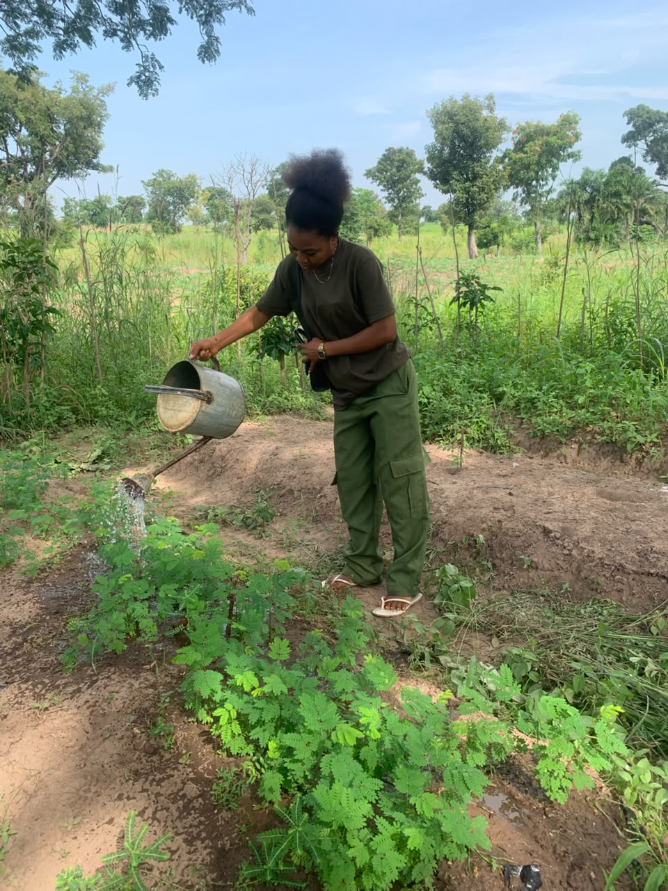
Plate 1: Watering seedlings at the JOSTUM forestry nursery
Plate 2 shows watering seedlings in pots at the JOSTUM forestry nursery.
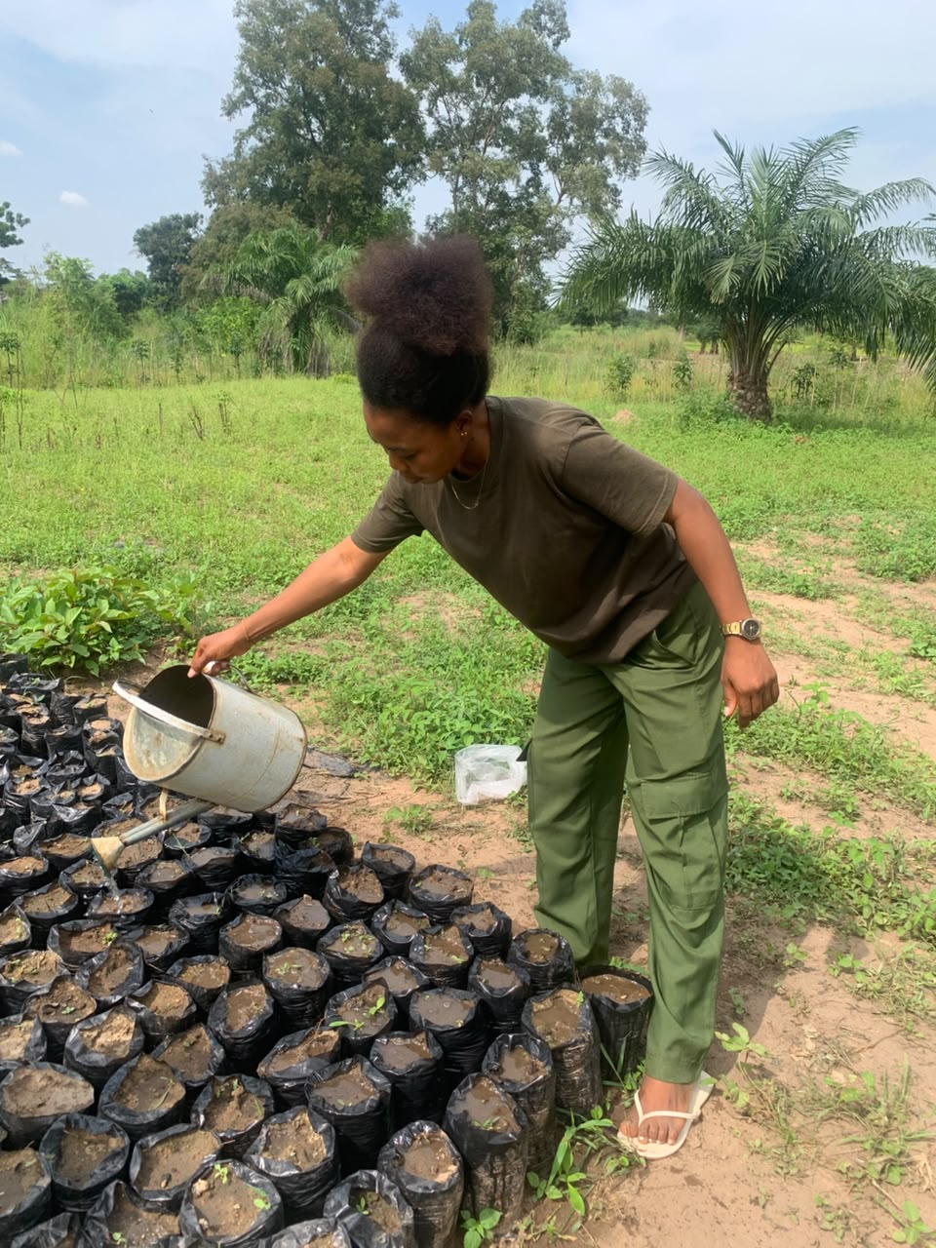
Plate 2: Watering seedlings in pots at the JOSTUM forestry nursery

3.1.3 Conclusion
The nursery exercise demonstrated the importance of following each stage carefully. A suitable mixture, adequate drainage, careful transplanting and regular watering all contribute to seedling performance. The exercise also showed that nursery work requires patience and consistency because the effect of a mistake may not become obvious until days or weeks later.

3.2 WRM 404 – Museum and Herbarium Techniques
Wildlife and Range Management Laboratory, JOSTUM, Makurdi; and Cross River National Park, Akamkpa, Cross River State

3.2.1 Introduction
Museum and herbarium techniques preserve biological specimens for teaching, reference and further study. Taxidermy retains the external form of an animal, while herbarium preparation preserves plant material in a flat, dry condition. In both cases, the specimen must be accompanied by accurate collection data. Without such information, its scientific and teaching value is greatly reduced.

3.2.2 Activities Related to the Course

3.2.2.1 Taxidermy Practical
The taxidermy exercise was carried out with a domestic rabbit at the Wildlife and Range Management Laboratory. Before any cutting began, the specimen’s identity, sex, age and body measurements were recorded. This order was important because some measurements could not be obtained reliably after skinning. The particulars are presented in Table 4.
Table 4: Particulars recorded for the specimen taxidermised at the Wildlife and Range Management Laboratory
Particular | Record
Common name | Domestic rabbit
Scientific name | Oryctolagus cuniculus
Breed | Standard Chinchilla
Sex | Male
Age | 9 months
Status when collected | Alive
Ear length | 10 cm
Shoulder height | 22 cm
Tail length | 8 cm
Head and body length | 37 cm
Source: Laboratory record, 2026.
The materials used for the practical are listed in Table 5. Protective gloves and nose masks were included because the work involved body fluids and formalin vapour. The instruments were arranged before the procedure so that each stage could be completed without unnecessary delay.
Table 5: Materials and equipment used in the taxidermy practical
Material or equipment | Purpose
Domestic rabbit | Specimen used for the practical.
Cotton wool | Stuffing the prepared skin.
Formalin | Preservation of the specimen.
Nose mask and gloves | Personal protection during the procedure.
Measuring tape | Taking measurements before skinning.
Surgical knife and razor blade | Opening the body and separating skin from flesh.
Needle and thread | Closing the opening after stuffing.
Syringe and needle | Introducing preservative where required.
Wooden board and nails | Supporting the mounted specimen.
Detergent | Cleaning the skin and removing blood.
Petrol or kerosene | Removing fatty material from the skin.
Source: Laboratory record, 2026.
After documentation and euthanasia, the abdomen was opened and the skin was carefully separated from the underlying flesh. The internal organs were removed, and blood was cleaned to reduce staining. Cotton wool treated with formalin was used to rebuild the body shape, while the opening was sewn as stuffing progressed. Additional preservative was applied with a syringe. The specimen was then mounted on a wooden board in a running position and returned to the laboratory collection.
The skinning stage was particularly demanding because excessive force could tear the skin, while insufficient separation made stuffing difficult. The exercise also showed that the final appearance depends on accurate earlier measurements. Taxidermy is therefore not simply mounting an animal; it is a sequence of documentation, preservation and reconstruction.
Plate 3 shows mounted rabbit specimen from the taxidermy practical.
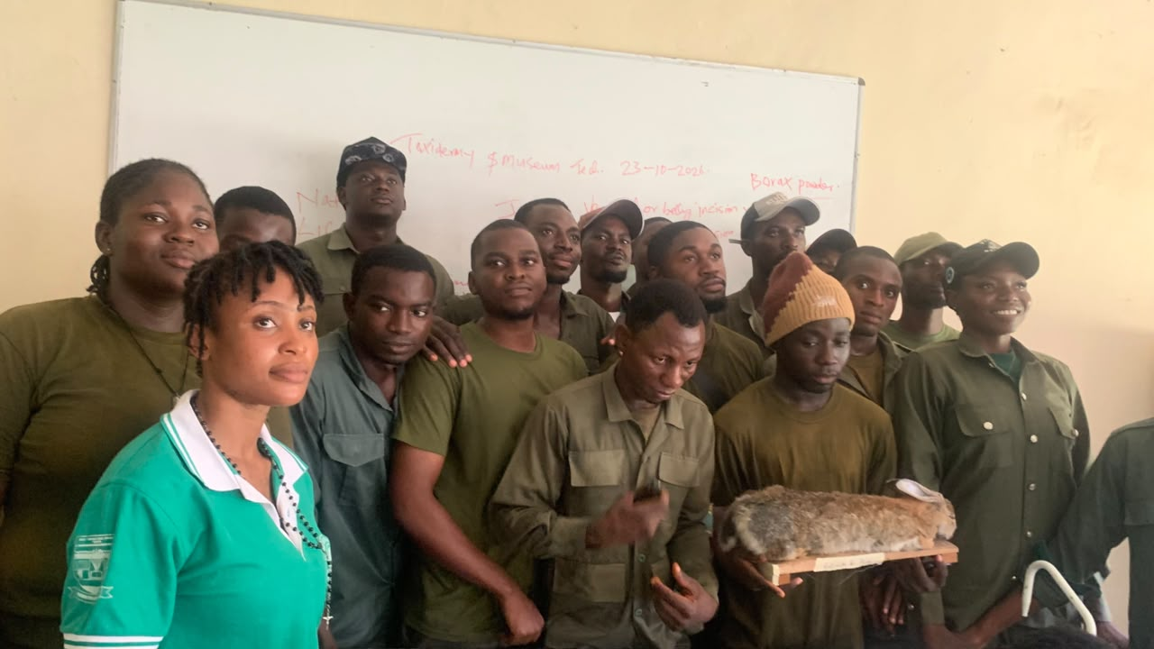
Plate 3: Mounted rabbit specimen from the taxidermy practical

3.2.2.2 Herbarium Technique
The herbarium exercise involved plant identification, collection and pressing. Identification was based on leaf arrangement, branching pattern and venation. Leaf arrangement was recorded as alternate, opposite or whorled; branching was described as monopodial or sympodial; and venation was examined for pinnate, palmate or parallel patterns. These features were useful where flowers or fruits were absent.
Suitable shoots were cut with a sharp knife or cutlass, generally retaining young and older leaves on the same specimen. Each collection was placed between sheets of newspaper. Leaves were arranged so that both upper and lower surfaces could be examined after drying, and overlapping was reduced where possible. The newspaper packets were placed between press boards and tied firmly with rope.
Correct labelling accompanied the physical preparation. The collection location, date, collector and provisional identification were recorded. The practical showed that a neat specimen without this information is less useful than an imperfect specimen with reliable field data.
Plate 4 shows pressed leaf specimen from the herbarium practical.
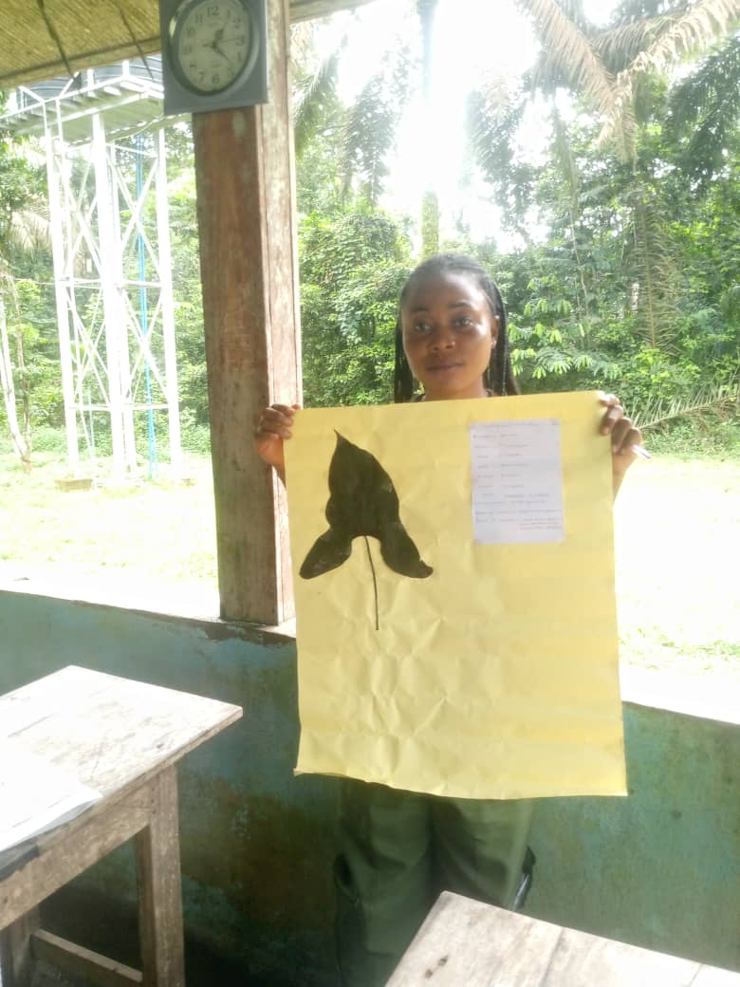
Plate 4: Pressed leaf specimen from the herbarium practical
Table 6 presents the information described in this section.
Table 6: Main plant species collected, identified and pressed during the herbarium practical
Botanical name | Family | Main uses recorded
Diospyros crassiflora | Ebenaceae | Dark, strong ebony wood for carving, musical instruments and fine furniture.
Piptadeniastrum africanum | Fabaceae | Timber for construction, flooring and canoes; bark used in traditional medicine.
Alstonia boonei | Apocynaceae | Light timber for furniture and carving; bark used for fever and malaria.
Anthocleista djalonensis | Gentianaceae | Traditional treatment for stomach complaints and malaria.
Carpolobia lutea | Polygalaceae | Traditional medicine and chewing sticks.
Harungana madagascariensis | Hypericaceae | Dye, timber and traditional medicine.
Lophira alata | Ochnaceae | Heavy construction, bridges and railway sleepers.
Milicia excelsa | Moraceae | Iroko timber for construction, furniture and boat building.
Source: Field collection at Cross River National Park, 2026; nomenclature per Keay (1989).

3.2.3 Conclusion
The two practicals demonstrated the value of specimens as records. Measurements and labels had to be completed at the correct stage, and preservation had to retain features needed for later comparison. These skills are relevant to teaching collections, field identification and reference work in wildlife and forest management.

3.3 WRM 406 – Wildlife Ecological Survey
Cross River National Park, Akamkpa, Cross River State

3.3.1 Introduction
An ecological survey provides organised information about organisms, their habitats and the conditions affecting them. It may involve direct observation, animal signs, habitat description, sampling or remotely sensed information. The purpose is not merely to produce a species list but to obtain evidence that can support management.
The exercise combined reconnaissance with a small sample plot. Reconnaissance helped establish the general vegetation, land use and visible disturbances before selecting the sampling location. A transect was then laid, and the corners of the plot were recorded with a GPS receiver.

3.3.2 Activities Related to the Course
During the initial walk through the area, the group observed grassland vegetation, evidence of farming near the site and a reduced woody component. Only one mature tree was noted within the sampled area. These observations provided context for interpreting the plot records rather than treating the plot as separate from its surroundings.
A transect line was established across the area and used as a reference for the sample plot. The four corners were geo-referenced as shown in Table 7. Recording each corner made the plot easier to describe and relocate. The coordinates also provided a basis for comparing the site with later observations.

Table 7: Coordinates of the corners of the sample plot established for the ecological survey (Cross River National Park; WGS84, decimal degrees; approximately 20 m × 20 m, 400 m²)
Corner | Latitude (°N) | Longitude (°E) | Altitude (m)
1 (NW) | 5.417000 | 8.583000 | 150
2 (NE) | 5.417000 | 8.583180 | 150
3 (SE) | 5.416820 | 8.583180 | 150
4 (SW) | 5.416820 | 8.583000 | 150
Source: Field survey, 2026.
Wildlife evidence was recorded through sightings and signs. Birds and toads were observed, while earthworm activity indicated soil biological activity. Signs of deforestation and bush burning were noted as pressures on the habitat. The exercise emphasised recording only what observation supported and distinguishing direct sightings from evidence inferred from tracks, droppings or other signs.

3.3.3 Conclusion
The exercise showed that reconnaissance is part of the survey rather than a separate informal walk. It guides plot placement and helps explain the results. Repeating the same measurements at a later date would provide more useful information about habitat change than a single visit.

3.4 SEF 408 – Aerial and Ground Survey
College of Forestry and Fisheries, Joseph Sarwuan Tarka University, Makurdi, Benue State

3.4.1 Introduction
Surveying establishes the positions of features and the distances, angles or heights relating them. Ground survey obtains these measurements on the earth’s surface, while aerial and satellite methods collect information from above. Geodetic survey accounts for the earth’s curvature and is suitable for extensive areas. Plane survey treats the surface as flat and is used where the resulting error is acceptable for a smaller area.
The course connected these methods with forestry. A forest compartment, sample plot, road or boundary must be located accurately before its resources can be described or monitored. Remote sensing can then extend observations over a larger area, while ground measurements provide detail and verification.

3.4.2 Activities Related to the Course

3.4.2.1 Remote Sensing
Remote sensing was introduced as the acquisition of information about the surface without direct contact. Passive sensors depend on reflected or emitted energy, such as sunlight recorded by satellite scanners. Active sensors transmit a signal and measure its return; radar and LiDAR are examples. The demonstrations covered the type of information each system provides and the situations in which it is useful.
The main forestry applications discussed were forest inventory, land-cover mapping, biomass estimation, forest-health assessment, fire detection and monitoring of deforestation. In wildlife management, remotely sensed data can support habitat mapping, corridor identification and some population studies. The instruction also emphasised that image results should be checked against field evidence, especially where vegetation classes appear similar.
Table 8 presents the information described in this section.
Table 8: Remote sensing platforms and sensors studied during the course
Platform | System | Resolution and repeat time | Main forestry or wildlife use
Space | Landsat series | 30 m; about 16 days | Long-term land-cover and deforestation assessment.
Space | MODIS | 250 m–1 km; daily to 2 days | Regional vegetation condition and fire detection.
Space | Sentinel-2 | 10–60 m; about 5 days | Vegetation indices and land-cover mapping.
Space | Sentinel-1 radar | About 20 m; 6–12 days | Observation during cloudy conditions and canopy assessment.
Air | Airborne LiDAR | Below 1 m | Canopy height, forest structure and biomass estimation.
Close range | Drones (UAV) | Centimetre level; on demand | Detailed small-area mapping, plant density and wildlife observation.
Source: Course material, SEF 408, 2026.
Vegetation indices were explained through the Normalised Difference Vegetation Index (NDVI):
NDVI = (NIR − Red) / (NIR + Red)
Healthy vegetation generally reflects strongly in the near-infrared and absorbs more red light. Comparisons of NDVI values can therefore help identify differences in vegetation vigour. However, an index value is not a complete diagnosis. Cloud, soil background, season and image resolution can affect interpretation, which is why ground checks remain necessary.
The limitations discussed included cost, technical skill and cloud cover. Free Landsat and Sentinel data reduce some cost barriers, while radar can provide information when optical images are affected by cloud. Training is still required to select suitable images and avoid unsupported conclusions.

3.4.2.2 Geographic Information Systems
A geographic information system (GIS) combines location with descriptive information. Its components include hardware, software, data, people and methods. The course used the layer concept to show how roads, water bodies, elevation and vegetation can be stored separately but aligned through a common coordinate reference.
Vector data represent features as points, lines and polygons, while raster data use cells or pixels. Roads and boundaries are commonly handled as vectors; satellite images and elevation surfaces are examples of raster information. Table 9 summarises the distinction.
Table 9: Comparison of the vector and raster data models in a geographic information system
Feature | Vector model | Raster model
Basic structure | Points, lines and polygons. | A grid of cells or pixels.
Suitable features | Discrete objects with identifiable boundaries. | Continuous surfaces or image-based information.
Examples | Wells, roads, land parcels and forest reserves. | Satellite images, aerial photographs and elevation models.
Boundary representation | Defined by coordinates. | Limited by cell size.
Data size | Often smaller for comparable discrete features. | Can become large as cell size decreases.
Source: Course material, SEF 408, 2026.
The demonstrations covered visualisation, measurement, query and simple analysis. For example, a roads layer can be compared with a vegetation-change layer to examine where forest loss is occurring in relation to access. This showed that GIS is not only map production; its main value is in organising evidence to answer location-based questions.

3.4.3 Conclusion
Remote sensing, ground survey and GIS serve complementary purposes. Remote sensing provides repeated coverage over broad areas, ground survey supplies precise positions and verification, and GIS brings the different datasets together. The course showed how field observations can be placed within a wider environmental assessment.

3.5 FPP 412 – Sawmilling
Ultra Modern Timber Market, Makurdi; and EL Moringa Investment Resources, Igbor, Gwer East, Benue State

3.5.1 Introduction
Sawmilling converts logs into boards, planks, battens and other usable sizes. The process involves more than passing wood through a saw. Logs must be received, inspected and measured; the cutting pattern must suit the required products; and the resulting timber must be sorted, handled and stored properly. Machine condition and operator skill influence both recovery and safety.
Sawmills may be classified by capacity, mobility and power source. The facility visited at Igbor was described as a medium-sized, fixed, electrically powered mill. The instruction also distinguished live sawing, in which parallel cuts are made through the log, from plain sawing, in which the log is turned between cuts to obtain a different grain pattern.

3.5.2 Activities Related to the Course
Instruction included a visit to Ultra Modern Timber Market in September 2026. A further visit was made to EL Moringa Investment Resources at Igbor in October 2026. The manager, Mr Olatunde Davida, received the group, while Mr Agbebee Joseph, a wood technologist, explained the technical operations.

3.5.2.1 Timber Sizes and Species Identification
Timber at the market was measured mainly in inches and feet. For example, a piece described as 1 × 10 × 12 feet referred to thickness, width and length in that order. Common sizes included 2 × 2 inches and 2 × 4 inches, in addition to wider boards and planks. Dimensions were related to use, such as battens for roofing, boards for doors and planks for heavier applications.
Species identification was based on a combination of heartwood colour, weight, density, grain, texture and smell. Common trade names were observed to be used more frequently than botanical names in daily transactions. This made experience important, but it also showed why records should include sufficient detail to reduce confusion between similar timbers.

3.5.2.2 Transport and Log Handling
Logs were transported by road, with a Bedford truck mentioned during the explanation. Loading depended on suitable leverage and secure fastening rather than manual lifting alone. Winches, hooks, levers and rods were identified as handling aids. Proper arrangement and tying were necessary to prevent round logs from shifting during transport.

3.5.2.3 Log Reception and Pre-Sawing Operations
EL Moringa Investment Resources operated in Makurdi from 2007 before moving to Igbor in 2015. During the visit, log reception was explained as the first control point in the mill. Logs were checked for species, number, length, diameter and general condition. The intended product was considered alongside taper, curvature, knots, cracks, splits and rot because these features affect the volume and quality of timber that can be recovered.
Measurements were used to estimate volume and value. Logs were then sorted by species, diameter class, length and quality before storage or conversion. The relevant forestry documents were also examined. This stage showed that a sawmill receives both raw material and information about its origin.

3.5.2.4 Sawmill Machinery and Machine Parts
The machines were discussed according to their roles in log preparation, primary breakdown, secondary sawing, edging, trimming and maintenance. Chainsaws are useful where logs cannot easily be moved. Bandsaws may be arranged horizontally for breakdown or vertically for re-sawing, while circular saws are widely used for both primary and secondary cutting.
Table 10 presents the information described in this section.
Table 10: Machines and machine parts examined at EL Moringa Investment Resources, Igbor
Machine | Part | Function
Circular sawing machine | Electric motor | Supplies power to drive the machine.
Circular sawing machine | On/off switch | Controls the electrical supply.
Circular sawing machine | Pulley and V-belt | Transmit rotation from the motor to the blade assembly.
Circular sawing machine | Shaft or arbor | Holds the blade and transmits rotation.
Circular sawing machine | Circular blade | Cuts logs and timber to the required sizes.
Circular sawing machine | Infeed and outfeed | Receive timber before cutting and support its exit.
Circular sawing machine | Push stick | Keeps the operator’s hands away from the blade when feeding short pieces.
Log breakdown machine | Blade adjustment and saw pads | Set the cut and support the area around the blade.
Log breakdown machine | Supporting frame and wheels | Carry and position the machine.
Installation and travel system | Pillars, side rails and pit | Support and guide the machine and accommodate the log and lower blade area.
Installation and travel system | Gear selector and chain | Move the machine forward or backward along its run.
Source: Field observation and on-site explanation, October 2026.
The visit made the relationship between the parts clearer. The motor, belt and arbor must transmit power smoothly for the blade to cut properly. The rails and carriage allow a large log to be handled with more control than would be possible by manual movement. During long-board cutting, coordinated feeding and receiving were necessary to keep the timber steady.
Plate 5 shows sawmill machinery during the sawmill visit.
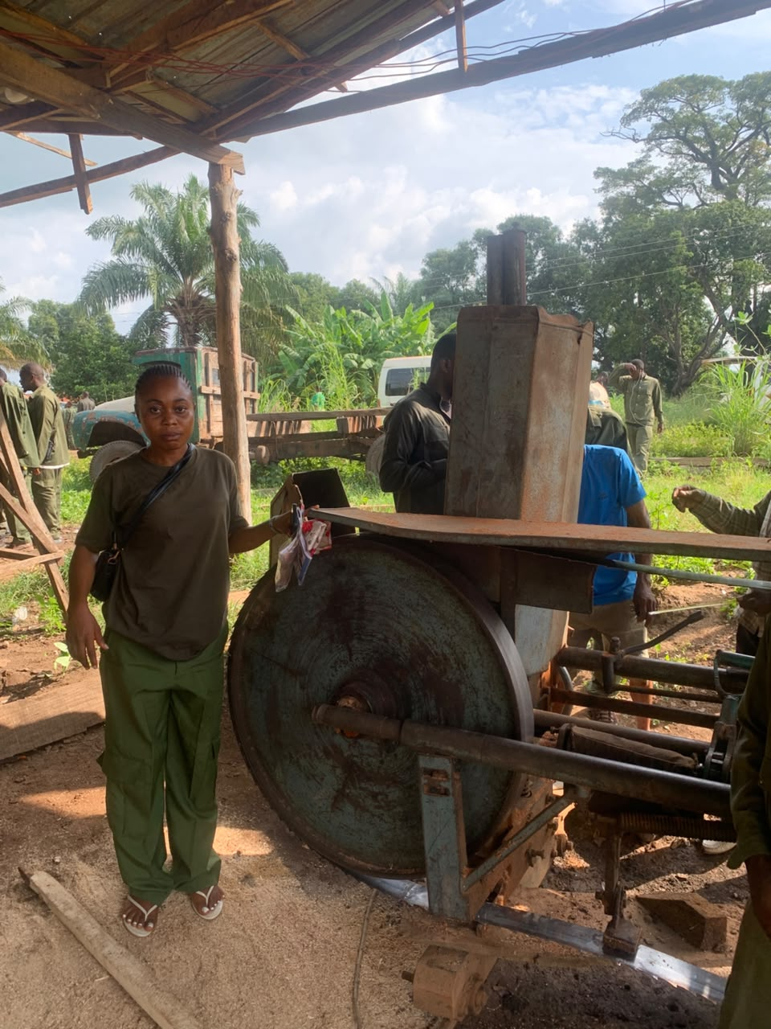
Plate 5: Sawmill machinery during the sawmill visit

3.5.2.5 Safety Practices and Machine Faults
Table 11 presents the information described in this section.
Table 11: Machine faults and the safety precautions given at the sawmill
Fault or unsafe condition | Possible consequence | Precaution
Blade improperly fixed | Blade movement, poor cutting and injury. | Have a competent person correct the installation before use.
Unstable power supply | Stalling, rough cutting and motor damage. | Refer electrical faults to qualified personnel.
Kickback | Timber thrown towards the operator. | Use correct blade height and direction, feed steadily and stand clear of the return line.
Blade rotating incorrectly | Poor cut and sudden snatching of timber. | Fit and operate the blade as specified.
No pre-use inspection | Existing faults carried into production. | Inspect the machine before every use.
Unsafe feeding | Contact with the moving blade. | Use guards and feeding devices, including a push stick.
Inadequate personal protection | Cuts, eye or ear injury and dust exposure. | Use appropriate PPE and follow mill safety rules.
Source: On-site explanation, October 2026.
Kickback received particular attention. It may occur when the blade catches the timber against the feeding direction, especially where the blade is blunt, the cut closes on the blade or feeding is unsteady. The explanation emphasised sharp blades, stable feeding and correct body position. The demonstration emphasised that speed should never take priority over control.

3.5.2.6 Saw Doctoring
Saw doctoring covers blade sharpening, setting and repair. The equipment shown or discussed included a brazing machine, brazing iron, burner, brazing powder and clamps. A dull or badly set blade increases cutting resistance, produces a rougher surface and may increase waste through an irregular kerf.
For a broken blade, the ends were prepared and chamfered before joining material was applied. The ends were aligned so that the tooth pitch remained consistent, then clamped and heated until the joint was formed. After cooling, the joint was checked. The heating period given during the demonstration was approximately fifteen to thirty minutes, depending on the blade material. Alignment was the stage that required the greatest care.

3.5.2.7 Wood Species Processed
Eight timber species or species groups were identified during the visit. Botanical names are used in Table 12 because common names can vary between markets.
Table 12: Wood species identified at EL Moringa Investment Resources, Igbor, and their characters
S/N | Botanical name | Family | Characters recorded | Uses
1 | Khaya ivorensis | Meliaceae | Reddish to dark heartwood; moderate weight. | Furniture, joinery and veneer.
2 | Khaya senegalensis | Meliaceae | Whitish to pale wood. | Construction, furniture and carving.
3 | Khaya sp. | Meliaceae | Paler wood kept separate from the two mahoganies above. | Uses similar to other Khaya timbers.
4 | Daniellia oliveri | Fabaceae | Light and relatively easy to work. | Construction, furniture and plywood.
5 | Mangifera indica | Anacardiaceae | Pale and fairly hard. | Furniture, light construction and carving.
6 | Vitellaria paradoxa | Sapotaceae | Hard, heavy and durable. | Carving, tool handles, furniture and charcoal.
7 | Diospyros sp. | Ebenaceae | Heavy, hard, dark heartwood with good decay resistance. | Carving, inlay and musical-instrument parts.
8 | Triplochiton scleroxylon | Malvaceae | Very light, soft and easy to work. | Veneer, plywood core, formwork and light furniture.
Source: Field identification and on-site explanation, October 2026; nomenclature per Keay (1989).
The comparison showed why colour alone is not enough for identification. Colour may vary with age and condition, while density, grain and other features provide additional evidence. The intended use must also be considered; a light species suitable for veneer or formwork would not automatically be appropriate for heavy structural work.

3.5.2.8 Forestry Law and the Certificate of Hammering
A Certificate of Hammering was examined during the visit (Ministry of Water Resources and Environment, Benue State, n.d.). The document referred to the Forestry Law, Chapter 44, and the Forestry Regulations of 1953. It connected a stated number of trees and planks with a named location, date and hammered number. The details recorded are shown in Table 13.
Table 13: Details recorded on the Certificate of Hammering examined at EL Moringa Investment Resources, Igbor
Particular | Entry on the certificate
Name of document | Certificate of Hammering
Legal reference | Forestry Law, Chapter 44; Forestry Regulations, 1953
Place | Mbaikyu, Igbor, Gwer East
Number of trees | 36
Number of planks produced | 68
Date hammered | October 2026
Hammered number | 07
Source: Document examined during the visit, with details recorded in October 2026.
Seeing the certificate alongside mill operations made timber traceability more understandable. The document provided information that could be checked against the material received. It also showed that forestry regulation is connected to ordinary yard procedures, not only to office-based administration.

3.5.2.9 Maintenance Practice
Maintenance was discussed under routine, preventive, corrective and predictive categories. Routine maintenance consists of regular checks and care. Preventive maintenance is scheduled before failure, such as planned blade sharpening. Corrective maintenance deals with a fault that has already occurred, including brazing a broken blade. Predictive maintenance uses observed condition to anticipate failure. The mill mainly applied the first three approaches.
Other operational concerns included timber theft, power interruption and heavy-log handling. Suggested controls were closer supervision, adequate security, reliable machine inspection, staff training and compliance with forestry regulations. These measures are linked because poor supervision can allow both unsafe practice and inaccurate records.

3.5.3 Conclusion
The sawmilling exercise followed the production sequence from log reception to sized timber. The exercise developed understanding of machine parts, species identification, blade repair and safety. The Certificate of Hammering added a regulatory dimension by showing how documents can support the tracking of timber from its stated source to the processing site.

3.6 FPP 414 – Wood Seasoning and Preservation
Ultra Modern Timber Market, Makurdi, Benue State

3.6.1 Introduction
Seasoning reduces the moisture content of timber before use. Freshly cut wood contains substantial water, and its dimensions change as drying proceeds. If this movement occurs after the wood has been fixed into a structure or furniture item, it may lead to distortion, open joints or surface defects.
Properly seasoned timber is generally lighter, more dimensionally stable and easier to machine, glue, fasten and finish. Poorly dried timber may shrink, warp, check, split or develop fungal stain. Preservation is a separate but related operation in which suitable chemicals are used to improve resistance to decay fungi, insects or other wood-destroying organisms.

3.6.2 Activities Related to the Course
The market sessions covered timber stacking, common seasoning methods, drying defects and preservative selection. Seasoning and preservation were not treated as optional finishing activities. They directly affected the appearance, durability and value of timber offered for sale.

3.6.2.1 Methods of Seasoning
Table 14 presents the information described in this section.
Table 14: Methods of seasoning timber studied during the course
Method | How it works | Conditions or moisture level | Advantages and limitations
Air drying | Timber is stacked where natural air movement removes moisture. | Commonly reaches about 20–25% moisture content. | Low cost and no power requirement, but slow and exposed to weather and uneven drying.
Accelerated air drying | Fans move air through a stack in a shed; limited heat may be added. | Faster than ordinary air drying. | Better air movement and control, but requires power and shelter.
Pre-drying | Air, temperature and humidity are controlled in an enclosed space. | About 27–38°C and 65–85% relative humidity. | More even drying, but requires equipment and operating funds.
Kiln drying | A drying schedule controls temperature, humidity and airflow in a chamber. | Final moisture content is set for the intended use. | Fast and controllable, with higher installation and running costs.
Source: Course material, FPP 414, 2026; field observation, Ultra Modern Timber Market.

3.6.2.2 Stacking Timber for Seasoning
Stickers were placed between successive layers of boards to create air passages. The stack was kept level, and stickers were aligned vertically so that the load passed through them rather than bending the boards. Even spacing helped the surfaces dry at a more similar rate.
Where stickers were omitted or poorly aligned, some surfaces dried faster than others. Uneven shrinkage could then produce warp, checks or internal stress. This demonstration made a simple operation easier to understand: a few narrow strips of wood, correctly positioned, could protect the value of an entire stack.

3.6.2.3 Drying Defects
Shrinkage occurs as water leaves the cell walls, and the amount differs between radial and tangential directions. Warping describes distortion such as bow, crook, cup or twist. Checks are separations along the grain at or near the surface, while splits may extend through the piece, often from the ends. These defects are more likely when drying is rapid or uneven.

3.6.2.4 Wood Preservation
The preservatives studied were grouped into oil-type and waterborne classes. Selection depended on the expected service conditions, the timber species and the required finish. The ability of the wood to absorb treatment also differed between sapwood and heartwood.
Table 15 presents the information described in this section.
Table 15: Classes of wood preservatives and how they are applied
Class | Examples studied | Carrier | Notes on use
Oil type | Creosote and petroleum solutions of pentachlorophenol | Oil | Used mainly for heavy outdoor or structural purposes; creosote has a strong smell and dark colour.
Waterborne | Chromated copper arsenate, alkaline copper quaternary, copper azole, borates and zinc chloride | Water | Can leave timber comparatively clean and suitable for painting, depending on the product and service condition.
Source: Course material, FPP 414, 2026; field observation, Ultra Modern Timber Market.
Pressure and non-pressure application methods were distinguished. Pressure treatment uses a closed vessel to achieve deeper or more controlled penetration. Full-cell and empty-cell processes differ in the amount of preservative retained. Non-pressure methods include brushing, dipping, soaking, steeping and diffusion.
The work observed at the market was mainly non-pressure treatment by brushing and dipping. Particular attention was given to ends and edges because end grain absorbs and releases moisture rapidly. The instruction also emphasised that treatment should follow adequate drying; applying preservative to very wet timber limits penetration and does not provide a reliable result.

3.6.3 Conclusion
The course showed that cutting timber to the correct size does not complete the production process. Drying, stacking and preservation determine how well the material performs afterwards. The correct sequence is important: stack properly, dry to a suitable condition and then apply the preservative selected for the intended use.

3.7 Other Experience Gained

3.7.1 Cross River National Park, Akamkpa, Cross River State

3.7.1.1 Introduction
Cross River National Park was established in 1991 and protects an extensive area of moist tropical lowland rainforest. The visit began on August 2026, and the group returned about two weeks later. Activities at the park added protected-area management, field discipline and interpretation to the course-based training.
The difference between a national park and a game reserve was explained in terms of permitted use. National parks place stronger restrictions on settlement, hunting and resource removal, while game reserves may allow regulated use under their management rules. This distinction helped clarify why ranger duties and community relations depend on the legal status of a protected area.
Park interpretation was presented as a management activity. Explaining the ecology, rules and value of the park helps visitors and neighbouring communities understand the reasons for protection. Enforcement remains necessary, but public understanding can reduce conflict and encourage cooperation.

3.7.1.2 Activities Carried Out
The programme began with orientation on the park, its ecology and its management. Physical exercise and drill followed, including jogging, press-ups, squats, squad formation and marching on command. Besides improving fitness, the activities required attentiveness, coordination and prompt response to instructions.
Fire demonstrations covered the effects of uncontrolled burning and basic precautions. Fire can damage regeneration, soil organisms and litter, while planned burning under suitable conditions may be used as a management tool. The precautions demonstrated included preparing a firebreak, considering wind conditions and keeping water and beating tools available.
Ammunition and cartridges were identified by calibre and type. Ballistics was introduced under internal, external and terminal components, dealing respectively with events inside the barrel, the projectile’s movement in flight and its effect at the target. Firearm stripping and assembly were demonstrated to familiarise the group with the parts and their correct order. Marksmanship instruction covered sighting, breathing, trigger control and follow-through, with safety and responsible judgement emphasised throughout.
Sanitation work involved clearing and properly disposing of refuse around the park area. This reduced unsightly conditions and addressed the risk of attracting scavenging animals to places used by people. Ecotourism was also discussed as a source of income, employment and environmental education when it is managed to limit damage and support local communities.
During the botanical walk, plants were identified using leaf arrangement, branching and venation, with their recorded uses noted. The walk provided an opportunity to apply WRM 404 in a natural forest setting. Twenty species are listed in Table 16.
Table 16: Plant species identified during the botanical rambling at Cross River National Park
S/N | Botanical name | Family | Common name | Main uses recorded
1 | Alstonia boonei | Apocynaceae | Stool wood | Furniture and carving timber; bark used for fever and malaria.
2 | Baphia nitida | Fabaceae | Camwood | Dye, tool handles and ornamental planting.
3 | Calamus deerratus | Arecaceae | Rattan palm | Baskets, mats, furniture and tying material.
4 | Carpolobia lutea | Polygalaceae | Cattle stick | Traditional medicine and chewing sticks.
5 | Ceiba pentandra | Malvaceae | Silk cotton tree | Kapok fibre and light timber for canoes and boxes.
6 | Chromolaena odorata | Asteraceae | Siam weed | Green manure and traditional uses; also invasive on farmland.
7 | Ficus capensis | Moraceae | Cape fig | Young leaves used as a vegetable; medicine and shade.
8 | Funtumia elastica | Apocynaceae | West African rubber tree | Latex and light construction timber.
9 | Gongronema latifolium | Apocynaceae | Amaranth vine | Leafy vegetable and traditional medicine.
10 | Harungana madagascariensis | Hypericaceae | African iodine tree | Dye, timber and traditional medicine.
11 | Irvingia gabonensis | Irvingiaceae | African bush mango | Edible fruit and seed; construction timber.
12 | Lophira alata | Ochnaceae | Red ironwood | Heavy construction, bridges, sleepers and shipbuilding.
13 | Milicia excelsa | Moraceae | Iroko | Construction, furniture and boat building.
14 | Musanga cecropioides | Urticaceae | Umbrella tree | Very light wood for rafts and floats; pioneer of cleared forest.
15 | Parkia bicolor | Fabaceae | African locust bean | Seed condiment and timber for planks and canoes.
16 | Pentaclethra macrophylla | Fabaceae | African oil bean | Fermented food seed, timber and medicine.
17 | Piper guineense | Piperaceae | West African black pepper | Spice and traditional medicine.
18 | Piptadeniastrum africanum | Fabaceae | African greenheart | Construction, flooring, furniture and canoes.
19 | Thaumatococcus daniellii | Marantaceae | Sweet prayer plant | Large leaves used for wrapping food, including moi moi.
20 | Xylopia aethiopica | Annonaceae | Grains of Selim | Spice, traditional medicine and light timber.
Source: Field identification, Cross River National Park, 2026; nomenclature per Keay (1989).
The species represented different forest layers and forms. They included canopy timber trees, pioneer species, climbers and plants valued for food, wrapping leaves, fibre or medicine. This variety made the walk useful beyond identification practice because it demonstrated several ways in which people depend on forest biodiversity.
Plate 6 shows field exercise at Cross River National Park.
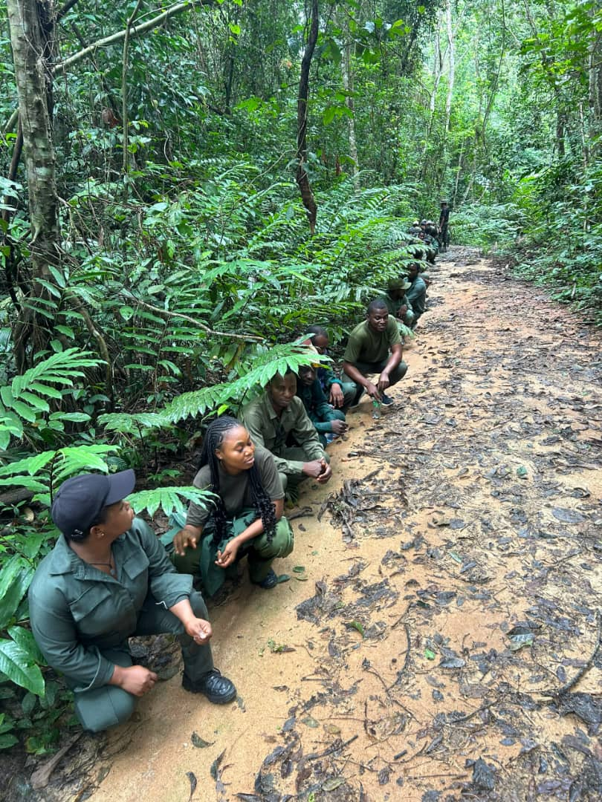
Plate 6: Field exercise at Cross River National Park
Plate 7 shows elephant monument at Cross River National Park.
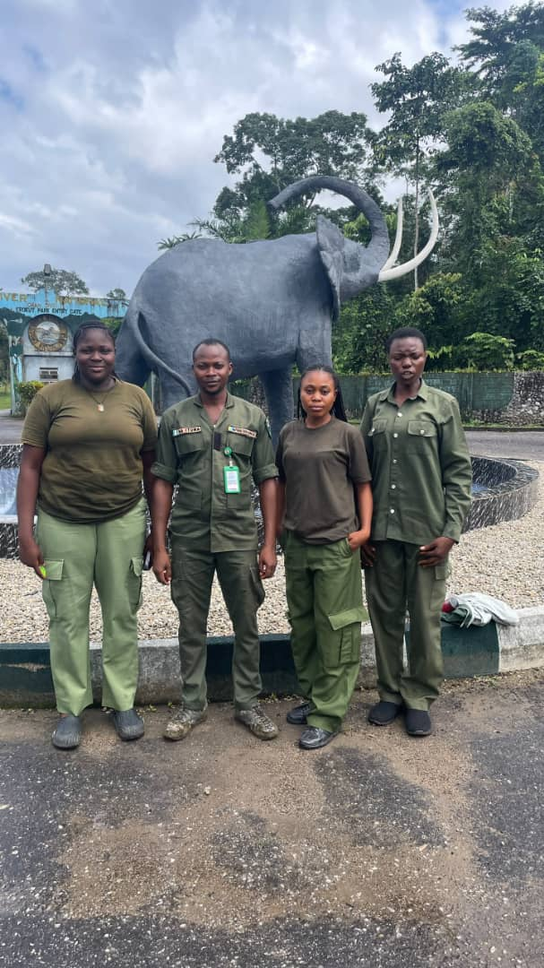
Plate 7: Elephant monument at Cross River National Park

3.7.1.3 Conclusion
The park visit showed that protected-area management combines patrol and safety skills with research, interpretation, sanitation and visitor management. No single activity was sufficient on its own. The visit also showed that long-term conservation depends on relationships with neighbouring communities as well as on enforcement within the park.

CHAPTER FOUR: SUMMARY, CONCLUSION AND RECOMMENDATIONS

4.1 Summary

4.1.1 Summary of Activities
The SIWES attachment ran from June to October 2026. Training covered six course areas and additional activities at Cross River National Park. The park programme began on August 2026, Ultra Modern Timber Market was visited on September 2026, and EL Moringa Investment Resources at Igbor was visited in October 2026.
Under FPP 402, the activities included clearing, pruning, reservoir desilting, bed preparation, potting-mixture preparation, wildling transplanting, seed broadcasting, watering and weeding. WRM 404 covered the documentation and taxidermy of a rabbit and the identification, collection and pressing of plant specimens. WRM 406 introduced reconnaissance, transect laying, plot establishment, GPS recording and the interpretation of habitat observations.
SEF 408 linked ground positions with remote sensing and GIS. The course covered sensing platforms, vegetation indices, data models and the use of layered information in forestry. FPP 412 dealt with timber dimensions, species identification, log reception, machinery, safety, blade repair, maintenance and forestry documentation. FPP 414 covered air and kiln drying, stacking with stickers, drying defects and preservative application.
At Cross River National Park, additional experience was gained in interpretation, drill, fire safety, ammunition identification, ballistics, firearm handling under supervision, sanitation and ecotourism. The botanical walk reinforced plant identification and produced a record of twenty species.

4.1.2 Summary of Challenges Encountered
The main difficulties were limited written records, power interruptions, machine faults and the handling of heavy logs with limited equipment. These problems sometimes delayed work and made it necessary to confirm information with more than one person. They also demonstrated why clear records and routine safety checks are important.

4.1.3 Summary of Skills Acquired
The principal skills acquired were nursery practice, specimen preparation, plant identification, ecological sampling, basic spatial-data interpretation, timber conversion, wood seasoning and preservative selection. The work also developed field note-taking, teamwork, safety awareness and the ability to ask relevant questions during practical work.
The skills gained are practical, and they are stated as what can now be done.
- Nursery practice: preparing beds, mixing the potting mixture to a set ratio, potting wildlings, broadcasting seed, and the day to day care of stock.
- Specimen preparation: taxidermy of a small mammal through recording data, dissection, preservation and mounting, and the collecting and pressing of plant material.
- Plant identification: using leaf arrangement, branch arrangement and venation pattern to place a plant with no flower on it in its family.
- Survey work: reconnaissance, laying a transect, setting a plot, using a GPS receiver, and recording animals by sighting and by sign.
- Spatial data: reading satellite images, working out and reading a vegetation index, and understanding layered spatial analysis in a geographic information system.
- Timber conversion: naming the parts of the machines and their work, following the order of log breakdown, measuring timber to size, and separating timber by species and grade.
- Seasoning and preservation: judging the quality of a stack, telling the drying methods apart, and choosing and brushing on a preservative that suits the species and the work.
- Reading forestry papers: reading a Certificate of Hammering and matching it to the timber it travels with.
- Field discipline: parade drill, handling firearms under supervision, and the safety rules for fire and machines.

4.1.4 Essence of the Training
The essence of the training was not the collection of techniques but the correction of one belief. Studying in an institution makes a student think that a job is understood once it can be described, and practice shows that it is understood only when it has been done. A potting ratio can be memorised in a minute and mixed correctly only after it has been mixed wrongly once.
The second part was seeing how the subjects join. Forestry as taught is divided into courses and forestry as practised is not: the Certificate of Hammering belongs to forest law, to wood technology and to social forestry at the same time, and looking at that paper on the same afternoon as looking at a saw bench made the joining real.

4.2 Conclusion

4.2.1 Reflection on the SIWES Experience
The attachment provided practical forestry experience beyond classroom lectures. The initial work included observing how experienced workers organised their tasks. As the training continued, participation, record keeping and understanding of the links between operations improved. The nursery, laboratory, market, sawmill and national park each presented different working conditions, but all required careful observation and discipline.

4.2.2 Insights from Activities, Challenges and Skills Development
One important lesson was that the order of an operation matters. Specimen measurements must be taken before skinning, plant-identifying features must be visible before pressing, and timber must be adequately dried before preservative treatment. These examples showed that a later stage cannot always correct an earlier omission.

4.2.3 Analysis of Personal and Professional Growth
The training also showed that apparently minor decisions can have significant effects. Blade condition influences timber recovery and operator safety; sticker alignment affects drying quality; and incomplete records make timber verification difficult. Practical competence therefore involves attention to detail as much as knowledge of general principles.

4.2.4 Significant Achievements and Milestones
The main achievements included completing the documented taxidermy exercise, participating in the establishment and geo-referencing of a sample plot, identifying plant species during the botanical walk and examining a Certificate of Hammering in relation to sawmill operations. Together, these experiences developed confidence and showed how technical forestry, regulation and community interests meet in the field.
The training did not make the student an expert in every activity observed. Instead, it provided a foundation on which further supervised practice can build. It also highlighted the limits of a single demonstration and the need to continue learning from experienced forestry workers.

4.3 Recommendations
Based on the challenges observed, the following measures are recommended:

4.3.1 Clear and Feasible Actionable Suggestions
- Ultra Modern Timber Market should introduce a written register in each stall or operational unit. Entries should include species, dimensions, source, date received, treatment and date sold. A responsible worker should be assigned to keep the record up to date.
- Machine operators should complete pre-use inspections and follow a schedule for blade sharpening and setting. Defective machines should not remain in production until faults become more dangerous or costly.

4.3.2 Addressing Challenges and Areas for Improvement
- Market management should improve stock security and provide suitable log-handling equipment. Workers should be trained to use winches, hooks and rollers safely and to keep clear of possible log movement.
- Timber handlers should treat correct stacking as part of production. Stickers should be sound, evenly spaced and vertically aligned, while stacks should be protected from unnecessary exposure to rain and direct sunlight.

4.3.3 Strategies for Enhancing Training Programmes
- The Department of Social and Environmental Forestry should schedule field visits early and relate them to the relevant lectures. Students should receive the report guidelines at the beginning of the attachment rather than near its completion.
- SIWES coordinators and host supervisors should arrange visits in a logical sequence so that students can follow the process from raw material to finished product. Short practical summaries after each major exercise would also improve record keeping.

4.3.4 Improving Organisational Processes
- Regulatory documents should be included deliberately in relevant field training. Students should be shown how permits, hammer marks, waybills and certificates relate to the timber being handled.
- Future students should keep a field notebook and record dates, locations, species, measurements and the names of resource persons during each exercise. Questions and uncertain observations should be noted for later clarification.

REFERENCES
Agbidye, F. S. (2026). Guidelines on the preparation of SIWES report (SEF 410 course material). Department of Forest Production and Products, Joseph Sarwuan Tarka University, Makurdi.
Bemshima, I. (2026). Introduction to geographic information systems (SEF 408 course material). College of Forestry and Fisheries, Joseph Sarwuan Tarka University, Makurdi.
Federal Republic of Nigeria. (1971). Industrial Training Fund Act No. 47 of 1971. Federal Government Press.
Industrial Training Fund. (2020). Students Industrial Work Experience Scheme (SIWES): Guidelines for participating institutions and employers. Industrial Training Fund.
Joseph Sarwuan Tarka University, Makurdi. (2026a). FPP 412: Sawmilling (course material). Department of Forest Production and Products, College of Forestry and Fisheries.
Joseph Sarwuan Tarka University, Makurdi. (2026b). FPP 414: Wood seasoning and preservation (course material). Department of Forest Production and Products, College of Forestry and Fisheries.
Joseph Sarwuan Tarka University, Makurdi. (2026c). Remote sensing in forestry and wildlife management (SEF 408 course material). College of Forestry and Fisheries.
Keay, R. W. J. (1989). Trees of Nigeria. Clarendon Press.
Ministry of Water Resources and Environment, Benue State. (n.d.). Certificate of hammering [Blank form].
National Universities Commission. (2019). Benchmark minimum academic standards for undergraduate programmes in agriculture and forestry. National Universities Commission.
Nigeria National Park Service. (2024). Cross River National Park. https://www.nigeriaparkservice.org
Rivers State University. (n.d.). Students industrial work experience scheme unit. https://www.rsu.edu.ng/students-industrial-work-experience-scheme-unit/
Ross, R. J. (Ed.). (2010). Wood handbook: Wood as an engineering material (General Technical Report FPL-GTR-190). U.S. Department of Agriculture, Forest Service. https://doi.org/10.2737/FPL-GTR-190

APPENDICES

Appendix I: Certificate of Hammering
The Certificate of Hammering examined during the sawmill visit is summarised in Table 13, Section 3.5.2.8. The entries recorded were the legal reference, location, number of trees, number of planks, date hammered and hammered number.
Sample Certificate of Hammering form (blank).


Appendix II: Summary of Plant Species Identified During the Attachment
- Twenty species recorded during the botanical walk at Cross River National Park are listed in Table 16.
- Wildlings collected and potted at the JOSTUM forestry nursery were Azadirachta indica, Gmelina arborea, Khaya senegalensis and Tectona grandis.
- Seeds broadcast on the germination beds were Gmelina arborea and Tectona grandis.
- Other species observed at the nursery were Polyalthia longifolia, Delonix regia, Elaeis guineensis, Ceiba pentandra, Irvingia gabonensis, Terminalia catappa, Dacryodes edulis, Afzelia africana, Carica papaya, Mangifera indica, Moringa oleifera and Jatropha curcas. Bougainvillea spectabilis and Euphorbia milii were raised from stem cuttings.
- The eight species pressed for the herbarium exercise are listed in Table 6.
- The eight timber species or species groups identified at EL Moringa Investment Resources are listed in Table 12.

Appendix III: Index of Plates
Table 17 presents the information described in this section.
Table 17: Index of plates reproduced in the report
Plate | Subject | Section
Plate 1 | Watering seedlings at the JOSTUM forestry nursery | 3.1 Forest Operations
Plate 2 | Watering seedlings in pots at the JOSTUM forestry nursery | 3.1 Forest Operations
Plate 3 | Mounted rabbit specimen from the taxidermy practical | 3.2 Museum and Herbarium Techniques
Plate 4 | Pressed leaf specimen from the herbarium practical | 3.2 Museum and Herbarium Techniques
Plate 5 | Sawmill machinery during the sawmill visit | 3.5 Sawmilling
Plate 6 | Field exercise at Cross River National Park | 3.7.1 Cross River National Park
Plate 7 | Elephant monument at Cross River National Park | 3.7.1 Cross River National Park
Source: Photographs taken during the attachment, 2026.

