Linked List Notes

1. Reverse a linked list :
Recursion method is very tricky.
It gives clarity to concept of recursion.

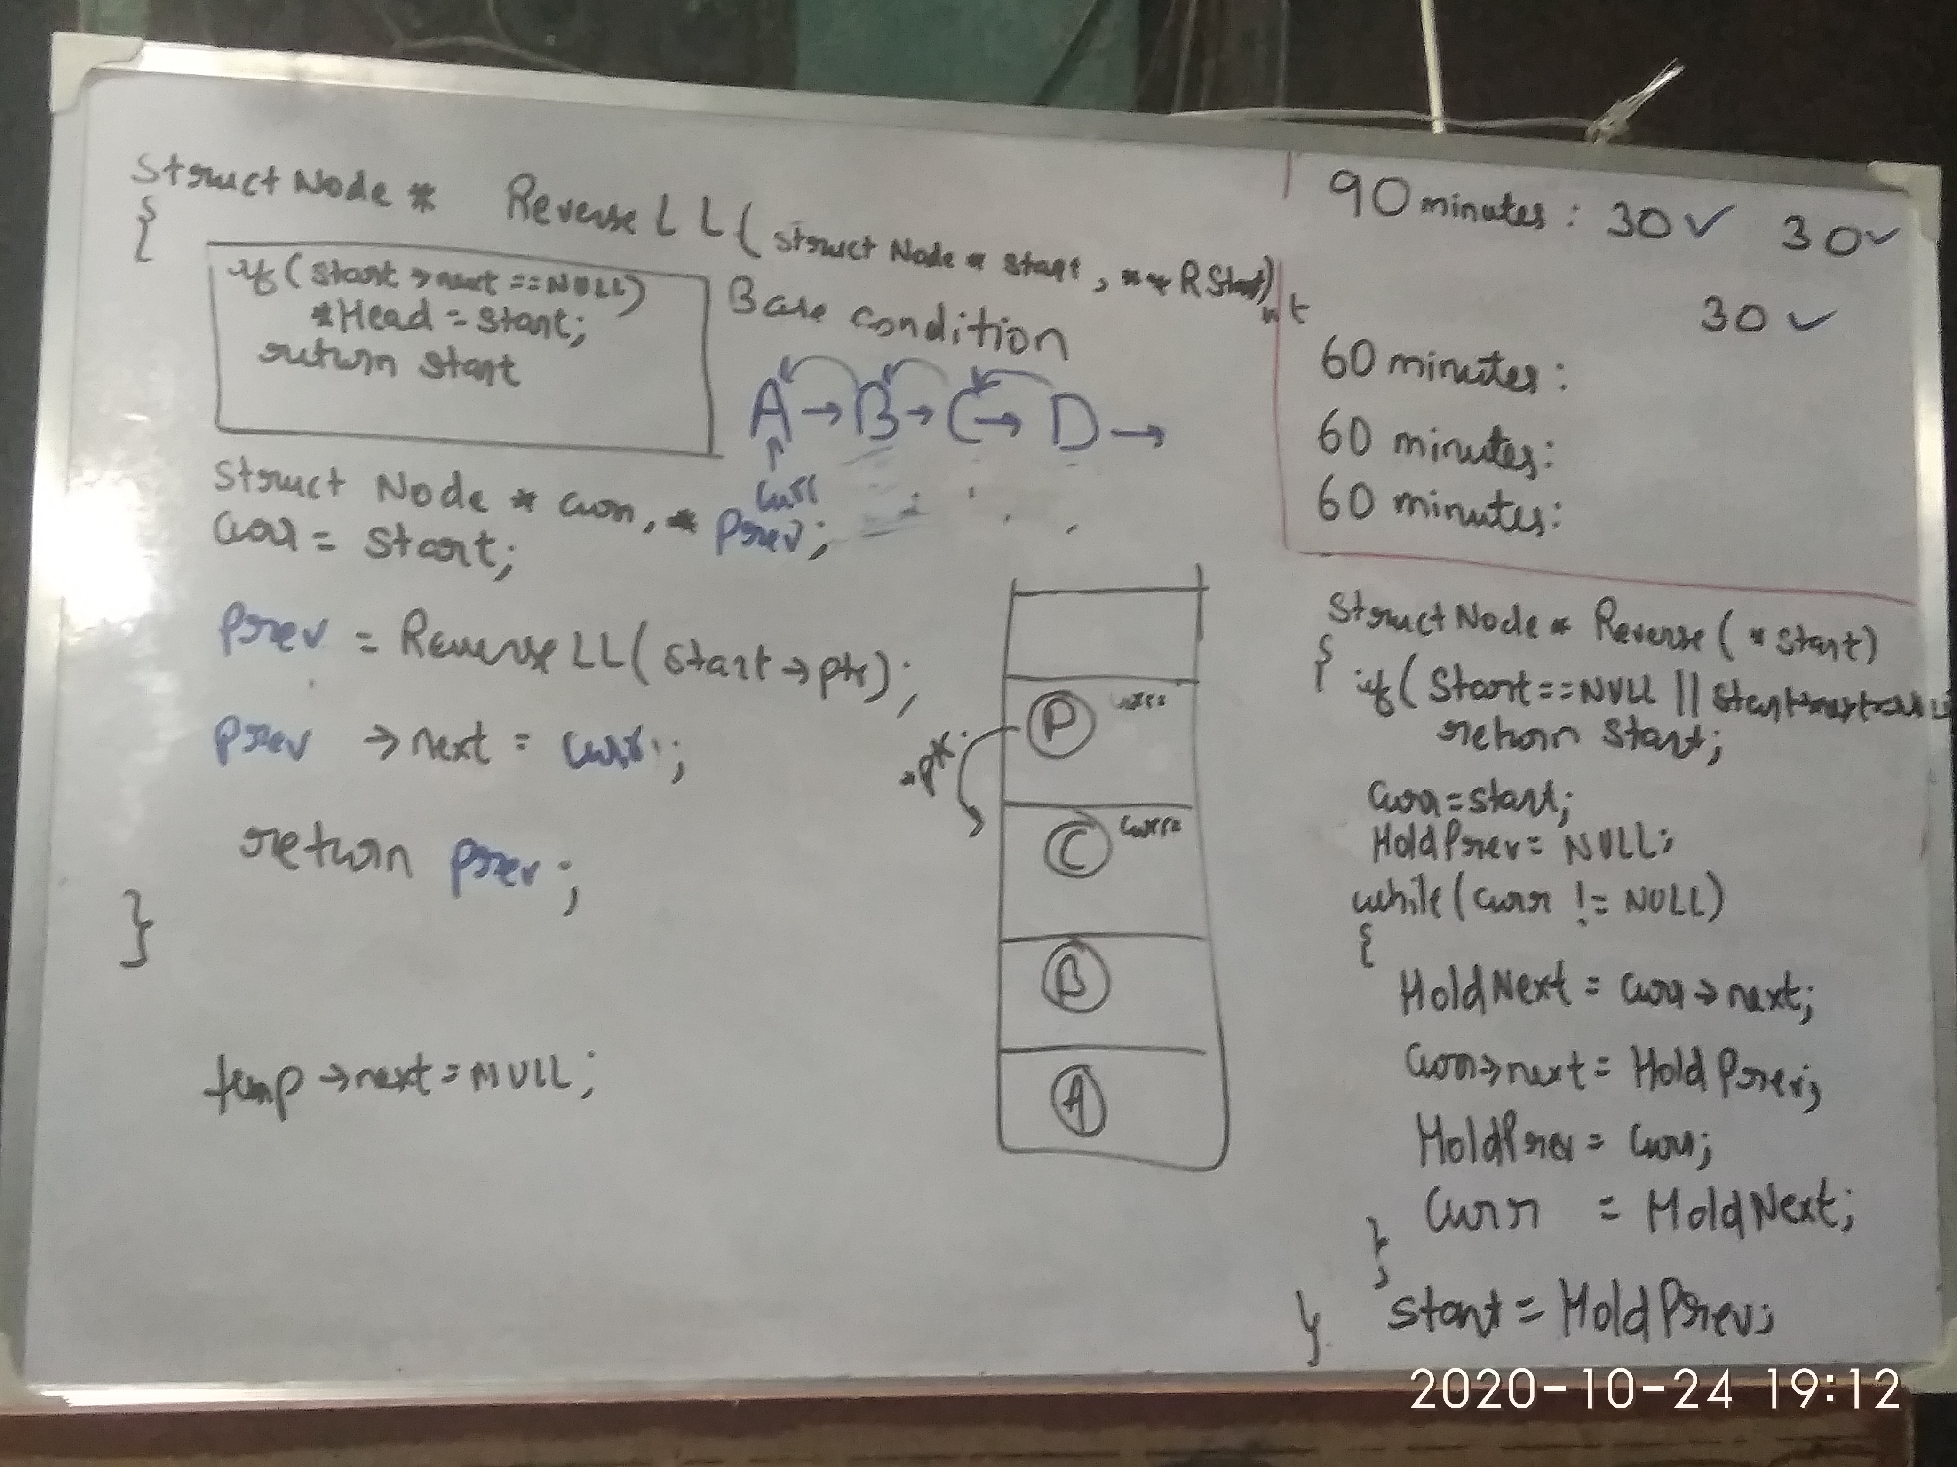
Problem with my approach, was that it was unable to get head node for reversed list.
->node was getting reversed perfectly, but to retrive head node for reversed list, I had to use
extra double pointer, which will point to starting node of reversed list or, last node of
unreserved list.
-> this problem can be solved as follows :

The recursive version is slightly trickier and the key is to work backwards. Assume that the rest of the list had already been reversed, now how do I reverse the front part? Let's assume the list is: n1 → … → nk-1 → nk → nk+1 → … → nm → Ø
Assume from node nk+1 to nm had been reversed and you are at node nk.
n1 → … → nk-1 → nk → nk+1 ← … ← nm
We want nk+1’s next node to point to nk.
So,
nk.next.next = nk;
Be very careful that n1's next must point to Ø. If you forget about this, your linked list has a cycle in it. This bug could be caught if you test your code with a linked list of size 2.
Code :
public ListNode reverseList(ListNode head) {
if (head == null || head.next == null) return head;
ListNode p = reverseList(head.next);
head.next.next = head;
head.next = null;
return p;
}
2. Find middle node of linked list
Efficient solution in Single traversal
Intuition and Algorithm
When traversing the list with a pointer slow, make another pointer fast that traverses twice as fast. When fast reaches the end of the list, slow must be in the middle.
class Solution {
public:
ListNode* middleNode(ListNode* head) {
ListNode* slow = head;
ListNode* fast = head;
while (fast != NULL && fast->next != NULL) {
slow = slow->next;
fast = fast->next->next;
}
return slow;
}
};

