**ADDING CARDS AND CONTAINERS**

1. What is Flutter Layout

* The core of Flutter’s layout mechanism is widgets. Almost everything is a widget.

1. and c. List 10 widgets with description
   * Aligning widgets – control how a row or column aligns its children using the mainAxisAlignment and crossAxisAlignment properties.
   * Sizing widgets - Widgets can be sized to fit within a row or column by using the Expanded widget.
   * Packing widgets - if you want to pack the children closely together, set its mainAxisSize to MainAxisSize.min
   * Container – add paddings, margins, borders, background color, or other decorations to a widget.
   * GridView – lays widgets out as a scrollable grid.
   * ListView – lays widgets out as a scrollable list.
   * Stack – overlaps a widget on top of another.
   * Card – organizes related info into a box with rounded corners and a drop shadow.
   * ListTile – organizes up to 3 lines of text, and optional leading and trailing icons, into a row.
   * Table – a widget that uses the table layout algorithm for its children.
2. Column, Row, Container, Card
   * Column – layout a list of child widgets in the vertical direction.
   * Row – layout a list of child widgets in the horizontal direction.
   * Container – combines common painting, positioning, and sizing widgets.
   * Card – slightly rounded corners and a shadow.

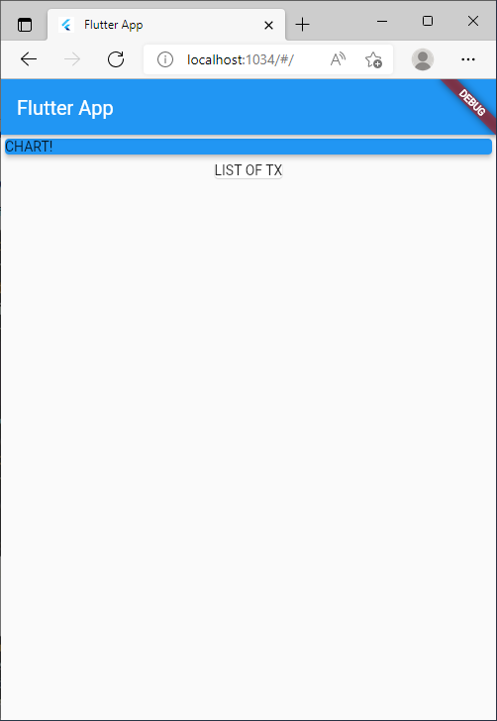

**Enhanced Card**

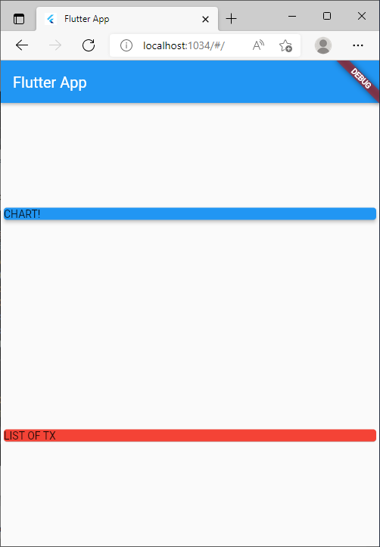

**ADDING TRANSACTIONS**

**Transaction Data**

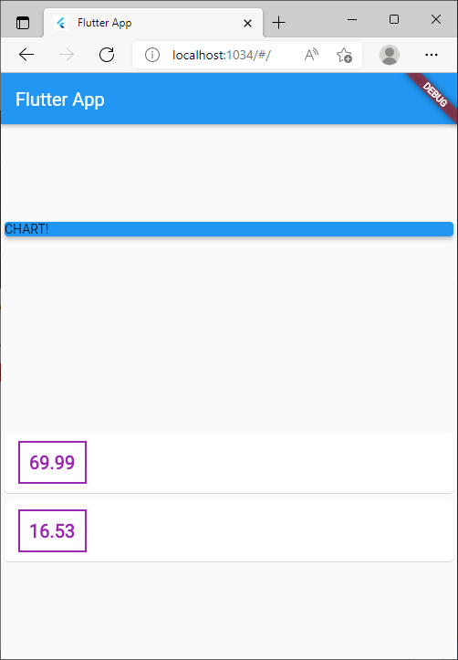

**ENHANCED TRANSACTION DATA**

