**Aim:**  Create a VI to show the TCP Communication between a Server and a Client.

**Steps:**

1. Select the String Control and attached the Create Constant for both server and Client.
2. For server, Select TCP Listen.vi, TCP write, TCP close connection files using the path Data Communication -------> Protocol --------> TCP path.
3. For Client, Select TCP open, TCP Read, TCP close connection files using the path Data Communication -------> Protocol --------> TCP path.
4. Make all the connections as shown in Block diagram of both.
5. Use While loop for both and case structure for client only.
6. Attach all the inputs and don’t forget to hide the error out file.
7. RUN the VI to send and receive the information.

**Theory:**

TCP Listen VI: Creates a listener and waits for an accepted TCP network connection at the specified **port**.

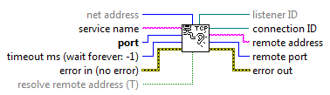

TCP Write Function: Writes data to a TCP network connection.

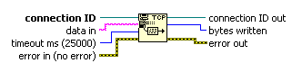

TCP Close Connection Function: Closes a TCP network connection.



TCP Open Connection Function: Opens a TCP network connection with the **address** and **remote port or service name**.

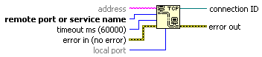

TCP Close Connection Function: Closes a TCP network connection.

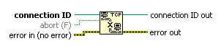

**Simulations:**

**Server Block Diagram Panel**

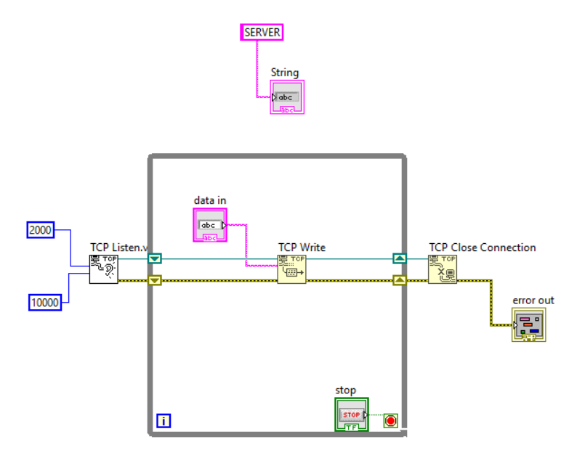

**Client Block Diagram Panel**

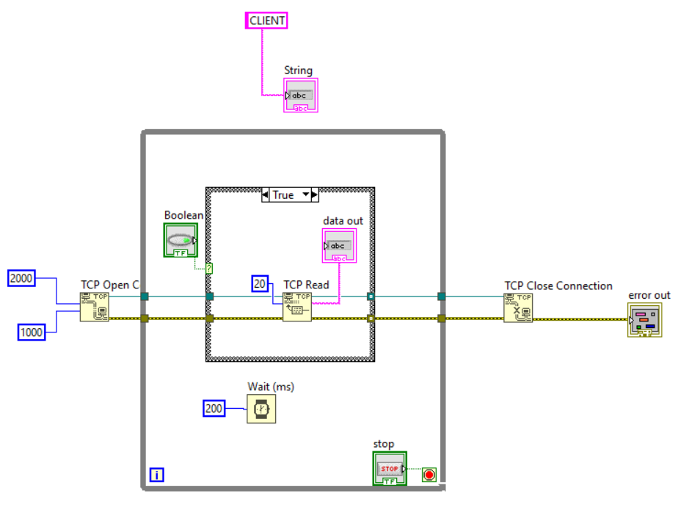

**Front Panel**

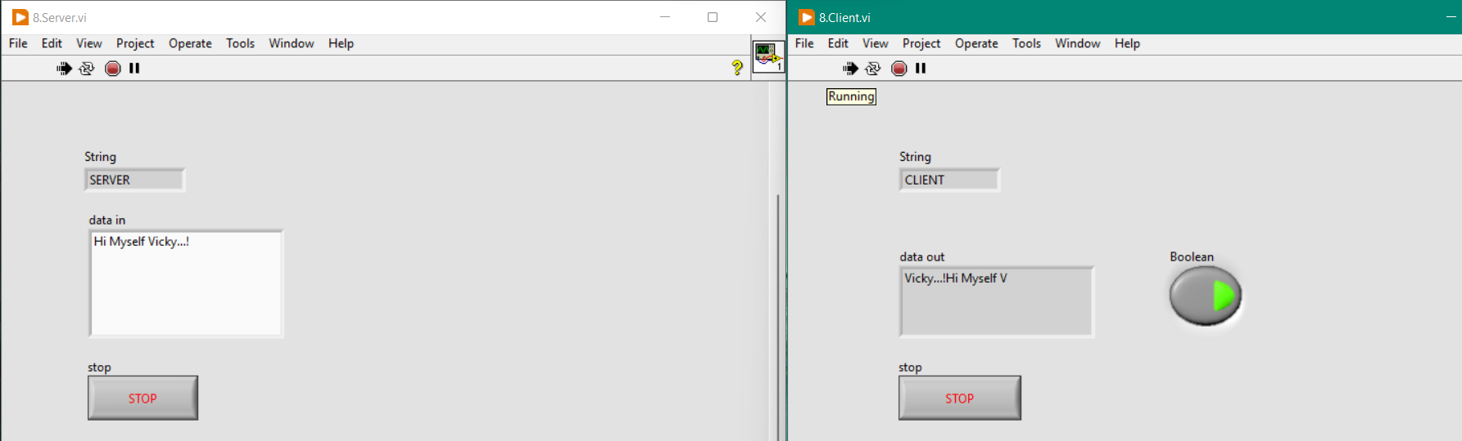

**Conclusion:** We have successfully established the TCP Communication between a Server and a Client using NI LabVIEW software.