**Aim:**  Designing automated traffic lights in LabVIEW.

**Software required:** NI LabVIEW 2020.

**Steps:**

1. Create a blank VI.

2. Drag and drop the LED lights to form two panel of traffic lights in front panel.

3. In the block diagram use the flat sequence and time delay to operate the lights.

4. Connect them as in the block diagram.

5. Run the VI

**Simulations:**

**Front Panel:**

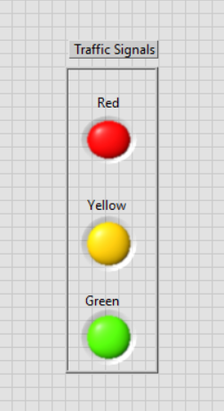

After clicking on Run continuously button

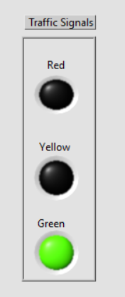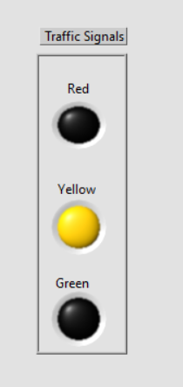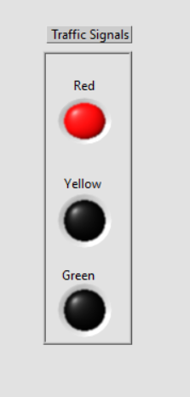

**Result and Discussion:**

* Red light glow for 2 seconds
* Yellow light glow for 2 seconds
* Green light glow for 2 seconds

**Block Diagram Panel:**

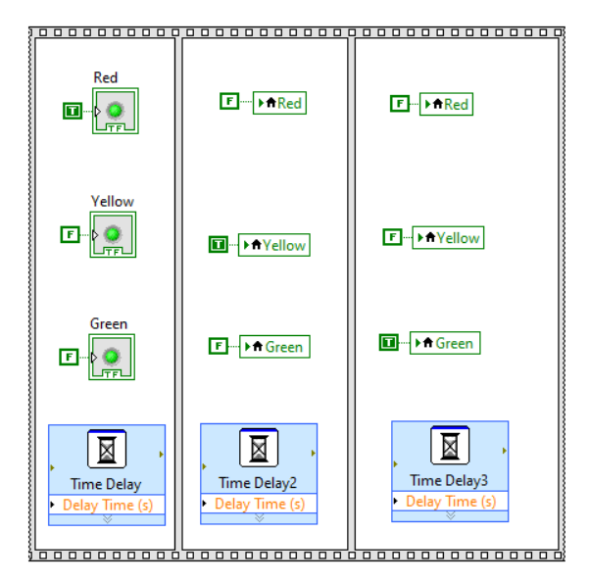

**Conclusion:** Designing automated traffic lights has been successfully executed using NI LabVIEW