***.gitignore*** file :- It is a file that let’s github

know which folders and

files we do not want to

upload to github

***requirements.txt:-*** which contains the names of all the libraries required for

this application to run. All of these libraries can be installed

at once using a single command –

***manage.py*** file:-This is one of the most important files that manage how this

application is run. This is where our normal application that

we have built so far using Flask becomes different from this.

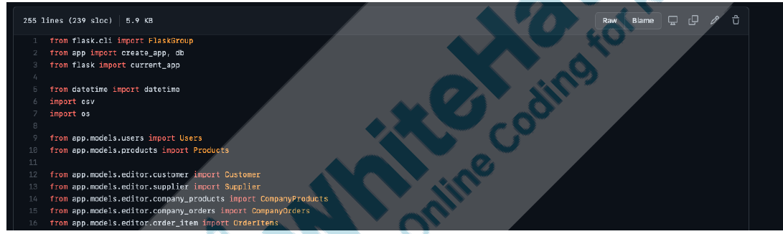

At the top of the file, we have the regular imports. Do notice

the ***app.models.\**** syntax that we have at the very

beginning too. Let’s ignore these for now, and just look at

what the code of this file contains further.

If we scroll down a little, we will see a list of dictionaries that

contains some of the seeded data of users and products

that we have already seen on the website -

©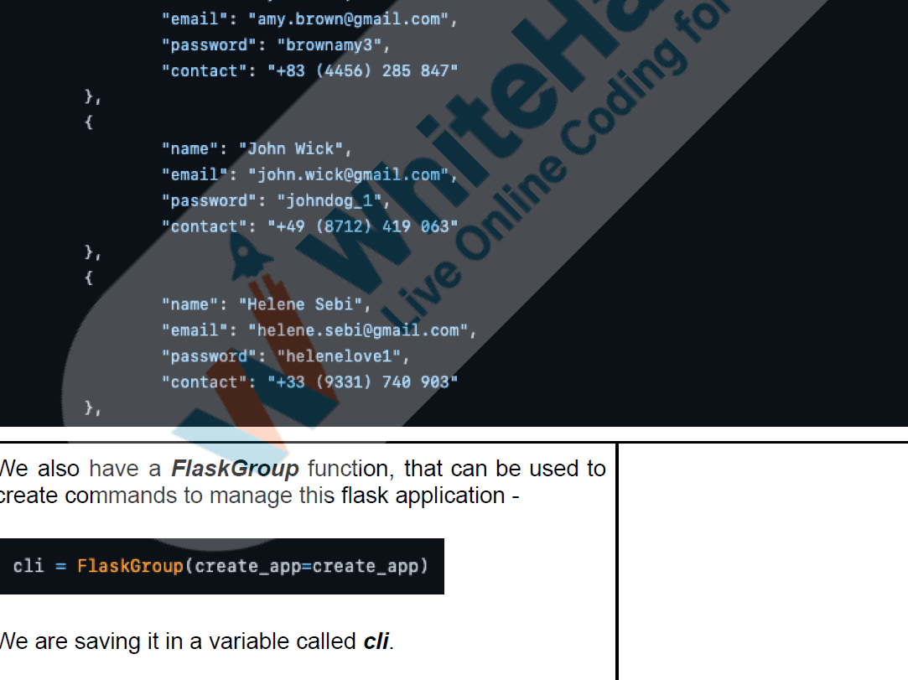

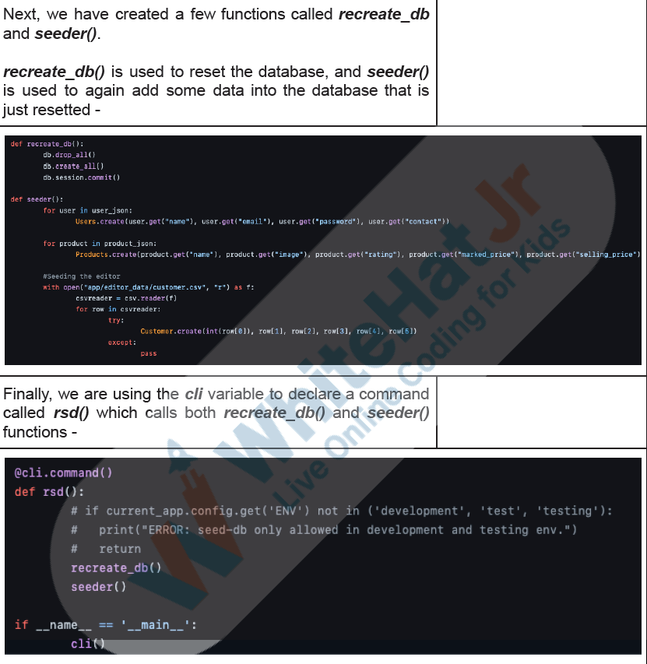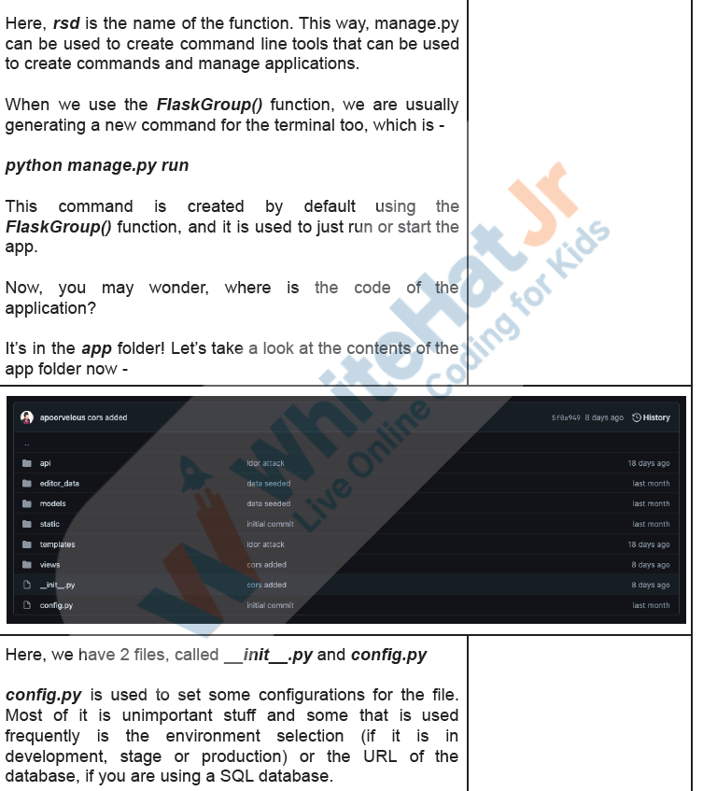

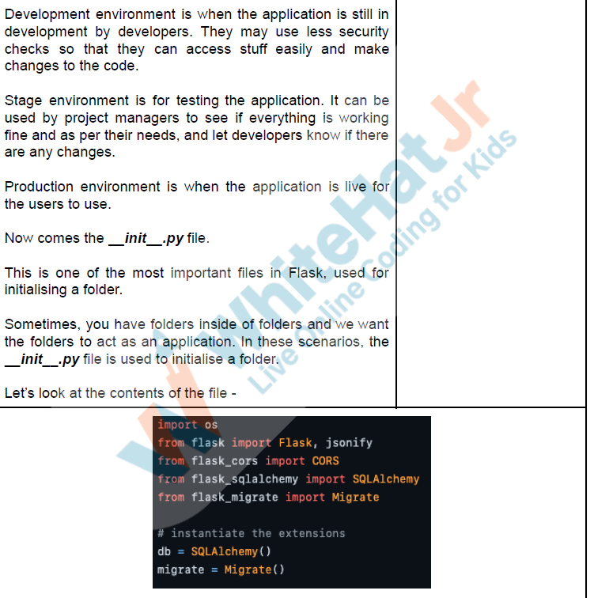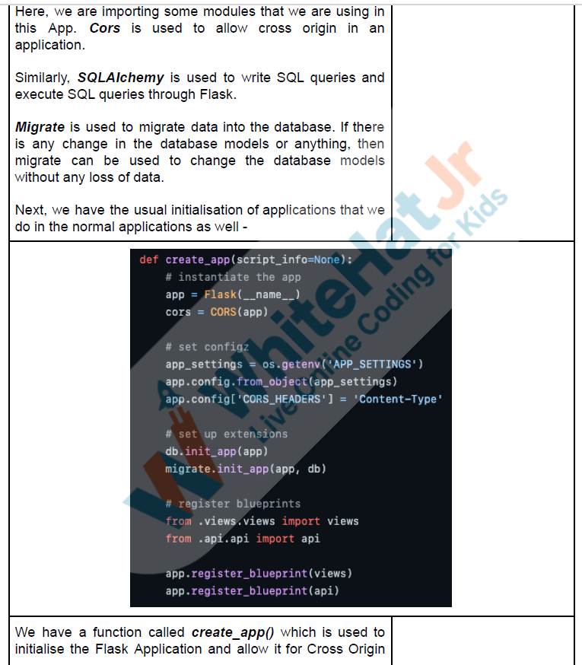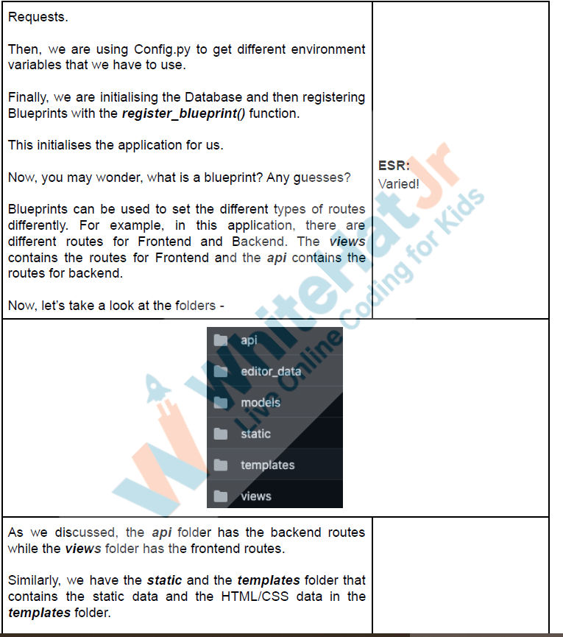

Then, we have the models folder which is used to create

models in the database. It is used to define datatypes of the

columns of the SQL table.