AtomQuest Goal Portal - Hackathon Submission
In-House Goal Setting & Tracking Portal

Submission Deliverables
# | Deliverable | Details
1 | Live / hosted demo URL | https://atomquest-907l.onrender.com/
2 | Source code repository | https://github.com/coder200412/Atomquet
3 | Architecture diagram | Included below and available at docs/architecture_diagram.png
4 | Role credentials / user journeys | Demo credentials below; public Employee/Manager signup is enabled.

Login Credentials
All seeded demo accounts use password123. Visitors can also create a new Employee or Manager account from the login screen.
Role | Email | Password
Admin / HR | admin@atomquest.local | password123
Manager | maya.manager@atomquest.local | password123
Manager | karan.manager@atomquest.local | password123
Employee | neha.employee@atomquest.local | password123
Employee | arjun.employee@atomquest.local | password123
Employee | diya.employee@atomquest.local | password123

Architecture Diagram
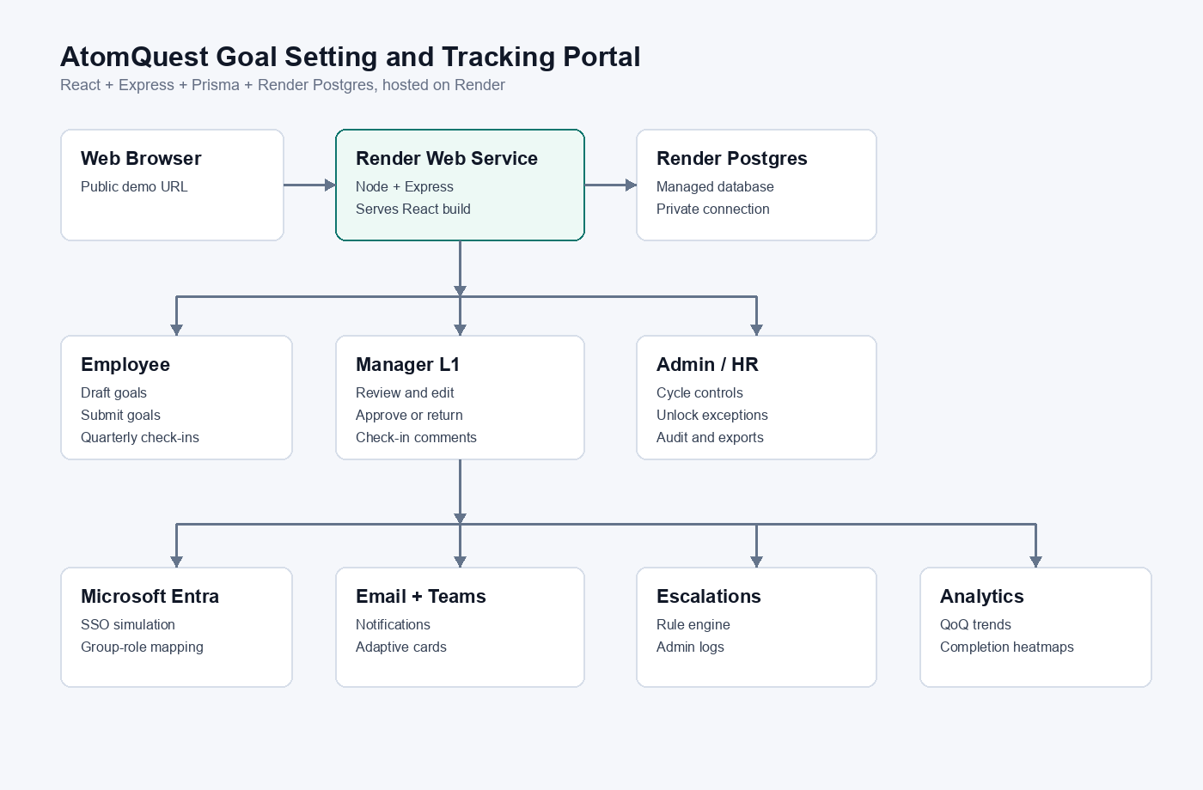

BRD Coverage Summary
Area | Implemented Coverage
Goal creation and validation | Goal title, description, thrust area, UoM, target, and weightage with 10% minimum, 8-goal maximum, and 100% total checks.
Approval workflow | Managers review submitted sheets, edit during review, approve, or return for rework. Approved sheets are locked until Admin / HR unlock.
Quarterly check-ins | Employees log actual achievements and status by quarter; managers add structured comments.
Reporting and governance | Admin dashboard, CSV export, completion tracking, audit trail, cycle override, and exception unlock.
Bonus modules | Microsoft Entra simulation, Email/Teams notifications, escalation rules, adaptive cards, QoQ trends, heatmaps, and manager effectiveness.

Render Deployment
Setting | Value
Build Command | npm install && npx prisma generate && npm run build
Start Command | npm run db:deploy && npm run start
Database | Render Postgres using DATABASE_URL internal connection string
Public Signup | Enabled for Employee and Manager accounts

