# 📌 Phase 3: Data Modeling & Relationships

## 🎯 Objective

Design the Salesforce data model (objects, fields, relationships, and layouts) to support wholesaler–retailer order management, ensuring scalability, reporting, and automation.

## 1. Standard & Custom Objects

### Standard Objects Used

• Account → Represents Retailers (B2B customers).

• Contact → Retailer contact person(s).

• Product → Product catalog for wholesalers.

• Pricebook / PricebookEntry → Product pricing management.

• Order → Tracks retailer orders.

• OrderItem → Line items within an order.

• User → Wholesaler employees, sales team, inventory managers.

### Custom Objects

1. Inventory__c → Fields: Product (Lookup to Product), Available_Quantity, Reorder_Level, Warehouse_Location.

2. Delivery__c → Fields: Order (Lookup to Order), Status (New, In Transit, Delivered), Delivery_Date, Carrier_Details, Tracking_Number.

3. Retailer_Portal_User__c (optional, if extending customer community functionality).

## 2. Fields (examples)

### Order Object Custom Fields

• Retailer__c (Lookup to Account).

• Order_Status__c (Picklist: New, Processing, Dispatched, Delivered).

• Payment_Status__c (Picklist: Pending, Paid, Overdue).

• Expected_Delivery_Date__c (Date).

### Inventory Object Fields

• Product__c (Lookup → Product).

• Available_Quantity__c (Number).

• Reserved_Quantity__c (Number).

• Warehouse_Location__c (Text).

### Delivery Object Fields

• Order__c (Lookup → Order).

• Delivery_Status__c (Picklist: New, In Transit, Delivered).

• Tracking_Number__c (Text).

• Carrier_Details__c (Text).

## 3. Record Types

• Orders: Retail Order vs. Bulk Order.

• Products: FMCG, Electronics, Pharma, Food & Beverage (industry segmentation).

## 4. Page Layouts & Compact Layouts

• Order Layout → Retailer, Products, Status, Delivery, Payment.

• Inventory Layout → Product, Available Quantity, Warehouse.

• Delivery Layout → Order, Carrier, Status, Delivery Date.

Compact Layouts → Show Order ID, Retailer, Status, Delivery Date on mobile/app headers.

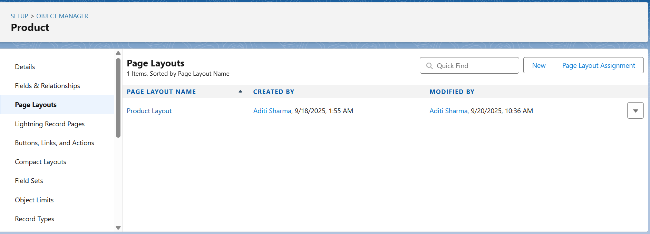

## 5. Schema Builder Relationships

• Account ↔ Order → One Account can have Many Orders.

• Order ↔ Order Item → One Order → Many Items.

• Product ↔ Order Item → One Product → Many Order Items.

• Product ↔ Inventory__c → Lookup (One Product → One Inventory Record per Warehouse).

• Order ↔ Delivery__c → Master-Detail (One Order → One/Multi Deliveries).

