DCA PROJECT REPORT

High Speed 16×16 Signed Booth-Dadda Tree Multiplier

Fifth Semester Electronics and Communication Engineering

Submitted by
Student Name:
Nagendra Kudva (240907002)
Suprit Shanbhag (240907774)
Pramit Karmakar (240907726)


SCHOOL OF ELECTRICAL ENGINEERING
MANIPAL INSTITUTE OF TECHNOLOGY
(A Constituent Institution of Manipal Academy of Higher Education)
MANIPAL – 576104, KARNATAKA, INDIA
JULY/DEC 2026

ABSTRACT

This report presents the complete structural design and Boolean derivation of a 16x16 radix-4 Booth-Dadda multiplier. The architecture combines a radix-4 Booth encoder to reduce partial products, a Modified Sign-Extension (MSE) scheme to optimize area, a Dadda reduction tree for parallel matrix compression, and a final 32-bit carry-propagate adder. The design processes 16-bit signed operands, generating eight partial-product rows. The Dadda tree reduces the peak column height of 9 down to 2 across four compression stages using 119 combinational compressors. The structural implementation emphasizes primitive gate derivation and rigorous routing

PROJECT DETAILS

INTRODUCTION

High-speed multiplication is a fundamental operation in digital signal processing and arithmetic logic units. This project implements a 16x16 signed multiplier using radix-4 Booth encoding to halve the number of partial products and a Dadda reduction tree to efficiently compress the resulting matrix. The design is fully realized using structural logic gates and rigorous routing techniques, ensuring mathematical adherence to the compression sequence.
This report shall go over all the blocks and explain their workings sequentially.

1. Radix-4 Booth Encoding and Partial Product Generation

The partial product generation stage leverages radix-4 Booth recoding, scanning the 16-bit multiplier Y two bits at a time using an overlapping 3-bit window: Y_up (next-higher bit), Y (current bit) and Y_down (previous bit).

A. Operation Mapping
Each window selects one of five operations on the multiplicand X: 0, +1X, -1X, +2X, or -2X. The encoder translates these into three control signals: Neg (sign), X1 (select ±1X), and X2 (select ±2X).
Window | Operation | Neg | X1/X2
0 0 0 | 0 | 0 | 0/0
0 0 1 | +1 ×X | 0 | 1/0
0 1 0 | +1×X | 0 | 1/0
0 1 1 | +2×X | 0 | 0/1
1 0 0 | -2×X | 1 | 0/1
1 0 1 | -1 ×X | 1 | 1/0
1 1 0 | -1 ×X | 1 | 1/0
1 1 1 | 0 | 1 | 0/0

Table 1. Complete radix-4 Booth window → operation → (Neg, X1, X2) mapping

B. Boolean Derivation of Booth encoded

B.1. Neg
The sign of the operation is fixed entirely by the window’s most-significant bit
Neg = Y_{up}
Therefore no gate is needed in the Logisim schematic, Neg is a direct wiretap from the Y_{up} input pin, confirmed by the netlist (Y_{up} feeds both the Neg output and the internal XOR/AND logic with no intervening component).

B.2. X1 single-multiplicand select
+1X and −1X occur whenever Y and Y_{down} differ (windows 001, 010, 101, 110) which is a direct XOR relationship:
X1 = Y ⊕ Y_{down}
This matches the single XOR-gate implementation in Booth encoder.

B.3. X2 double-multiplicand select
+2X and −2X occur only at windows 011 and 100 which are the two minterms where Y and Y_{down} agree but disagree with Y_{up}:
X2 = (Y ⊕ Y_{down})′ · (Y_{up} ⊕ Y)
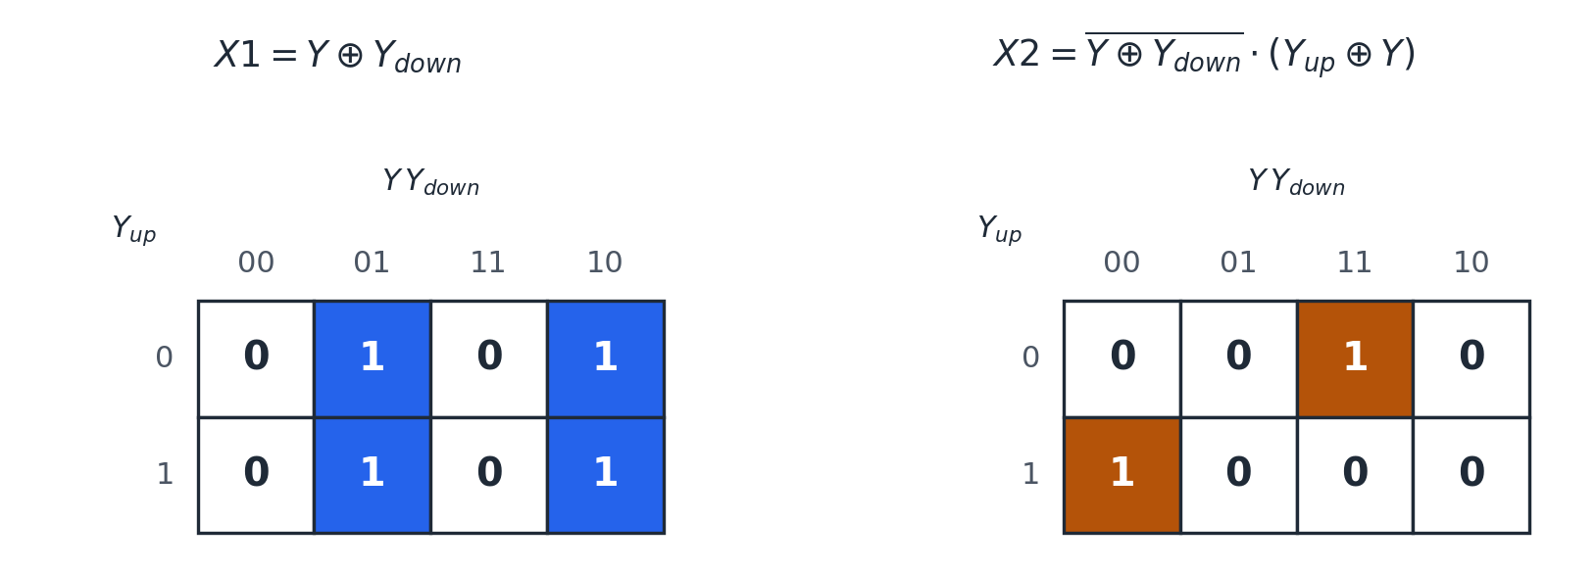
Figure 1. Karnaugh maps for X1 and X2 over (Y_up, Y, Y_down); X2 isolates exactly minterms 011 and 100.
The Logisim netlist implements this as a sum of the two minterms directly, rather than instantiating XOR/XNOR gates for simplicity: three NOT gates produce the complements of Y_up, Y, and Y_down, two 3-input AND gates form the 011 and 100 minterms, and a 2-input OR gate combines them into X2.
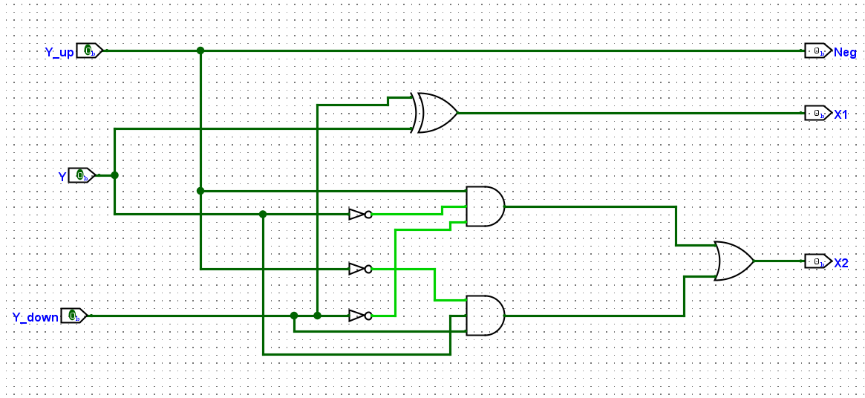
Figure 2. Booth encoder signal path, represented in logic gates

C. Boolean Derivation of 1 Bit Selector

The 1 Bit Selector produces one bit of the partial product from one bit each of X_{Current} and X_{previous} those being the bits that share the same bit position as X and the position feeding the next higher selector one row up, plus the three shared control signals from the row’s encoder

C.1. Shift Select M

A 2:1 multiplexer, selected by X2, chooses between the unshifted and the left-shifted tap of X:
M = (X_{current} · X2′) + (X_{previous} · X2)

C.2. Zero masking S

When neither X1 nor X2 is asserted (the encoded digit is 0), the bit must be forced low regardless of what the multiplexer selected:
S = M · (X1 + X2)
C.2. Sign Flip OUTPUT
A final XOR against Neg implements the one’s-complement half of two’s-complement negation:
Output = S ⊕ Neg
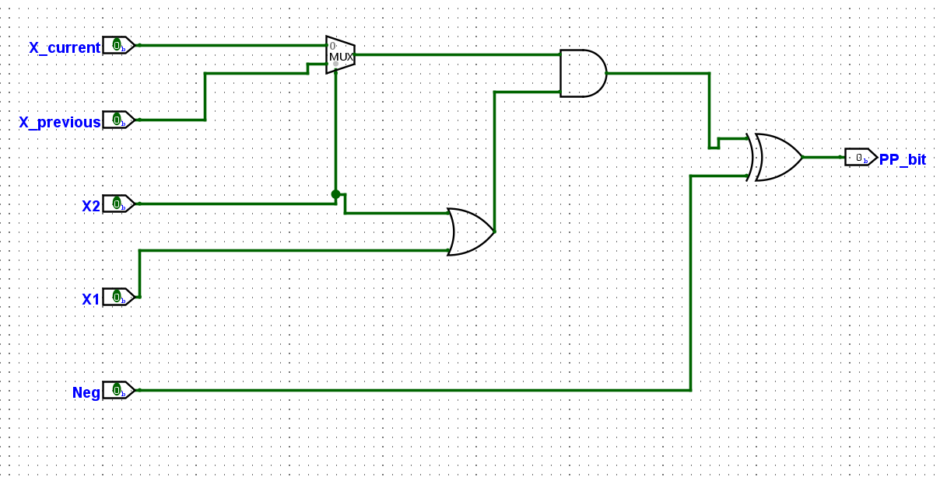
Figure 3. 1-bit selector: MUX → AND/OR zero-mask → XOR sign-flip, matching the four gates in Booth_selector_1bit.

D. Structural Composition of Row Generator

The row generator has no logic equation of its own: it is comprised of one Booth encoder wired to 17 parallel 1 Bit Selectors, all sharing the encoder’s Neg/X1/X2 outputs. Each successive selector’s X_previous input taps X one bit index higher than the selector before it, which is what implements the two-bit left shift between Booth groups.
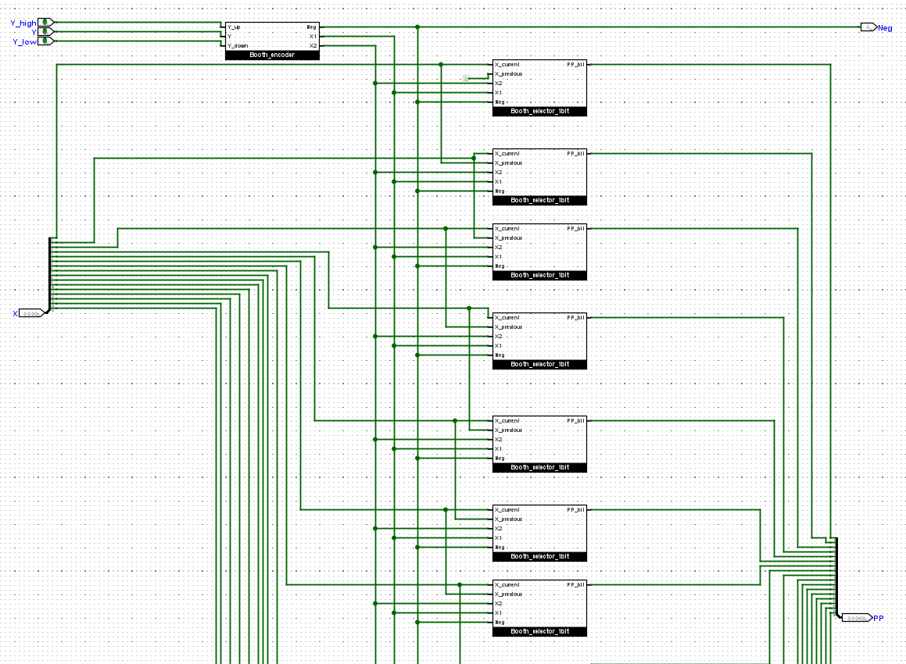
Figure 4. One shared control bus (Neg, X1, X2) fans out to 17 selectors, each tapping X at a successively shifted bit index.

2. Sign Extension, Dadda Reduction, Final Addition

A. Data Ingestion and the Eight Booth Rows

The top-level circuit takes two 16-bit inputs, X and Y. Y is split into eight overlapping 3-bit Booth windows (window 0 pads Y_{down} with a hardcoded Constant 0, since there is no bit −1). Eight parallel Booth row generator instances evaluate these windows against X, each producing a 17-bit raw partial product PP_r and a 1-bit negation/correction signal N_r. This matches the file exactly: 8 × Booth_row_generator, 8 × window-extraction splitters (one 2-bit + seven 3-bit), and a Constant 0 feeding the first window's Y_down.

B. Modified Sign-Extension (MSE)
Naively sign-extending every row to the full 32-bit product width would build a deep, redundant triangle of repeated sign bits, expensive in both delay and gate count. Instead, the design uses the standard Modified Sign-Extension technique for radix-4 Booth arrays. each row's natural sign bit is left in place, and two small correction dots are added just past it.

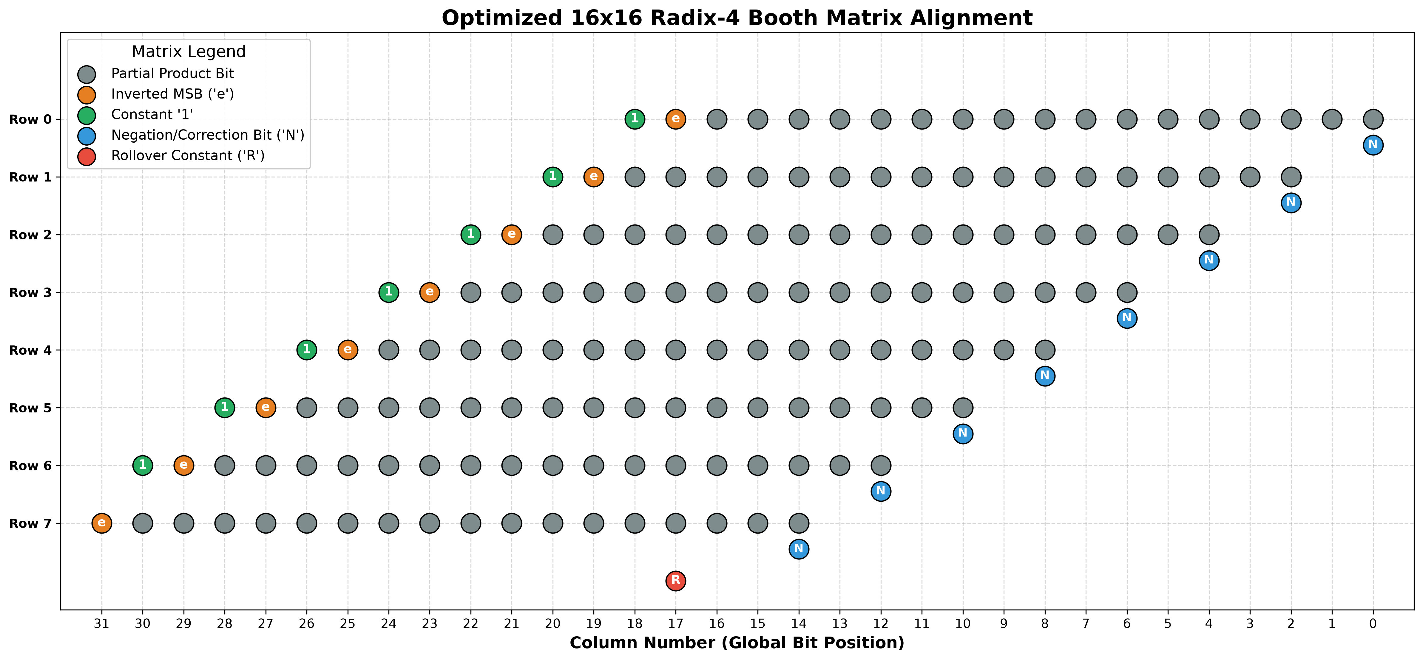
Figure 5. Initial dot matrix

As implemented for rows 0–6, the row's MSB is inverted and placed at relative bit 17, and a constant 1 is placed at relative bit 18, immediately to its left. Row 7 (the last row) needs only the inverted-MSB bit, with no trailing constant. A single standalone rollover constant 1, wired into column 17 of the global matrix, absorbs the ripple-carry deficit this trick leaves behind. Each row's own N_r negation-correction bit is dropped into the least-significant column of that row's shifted position.

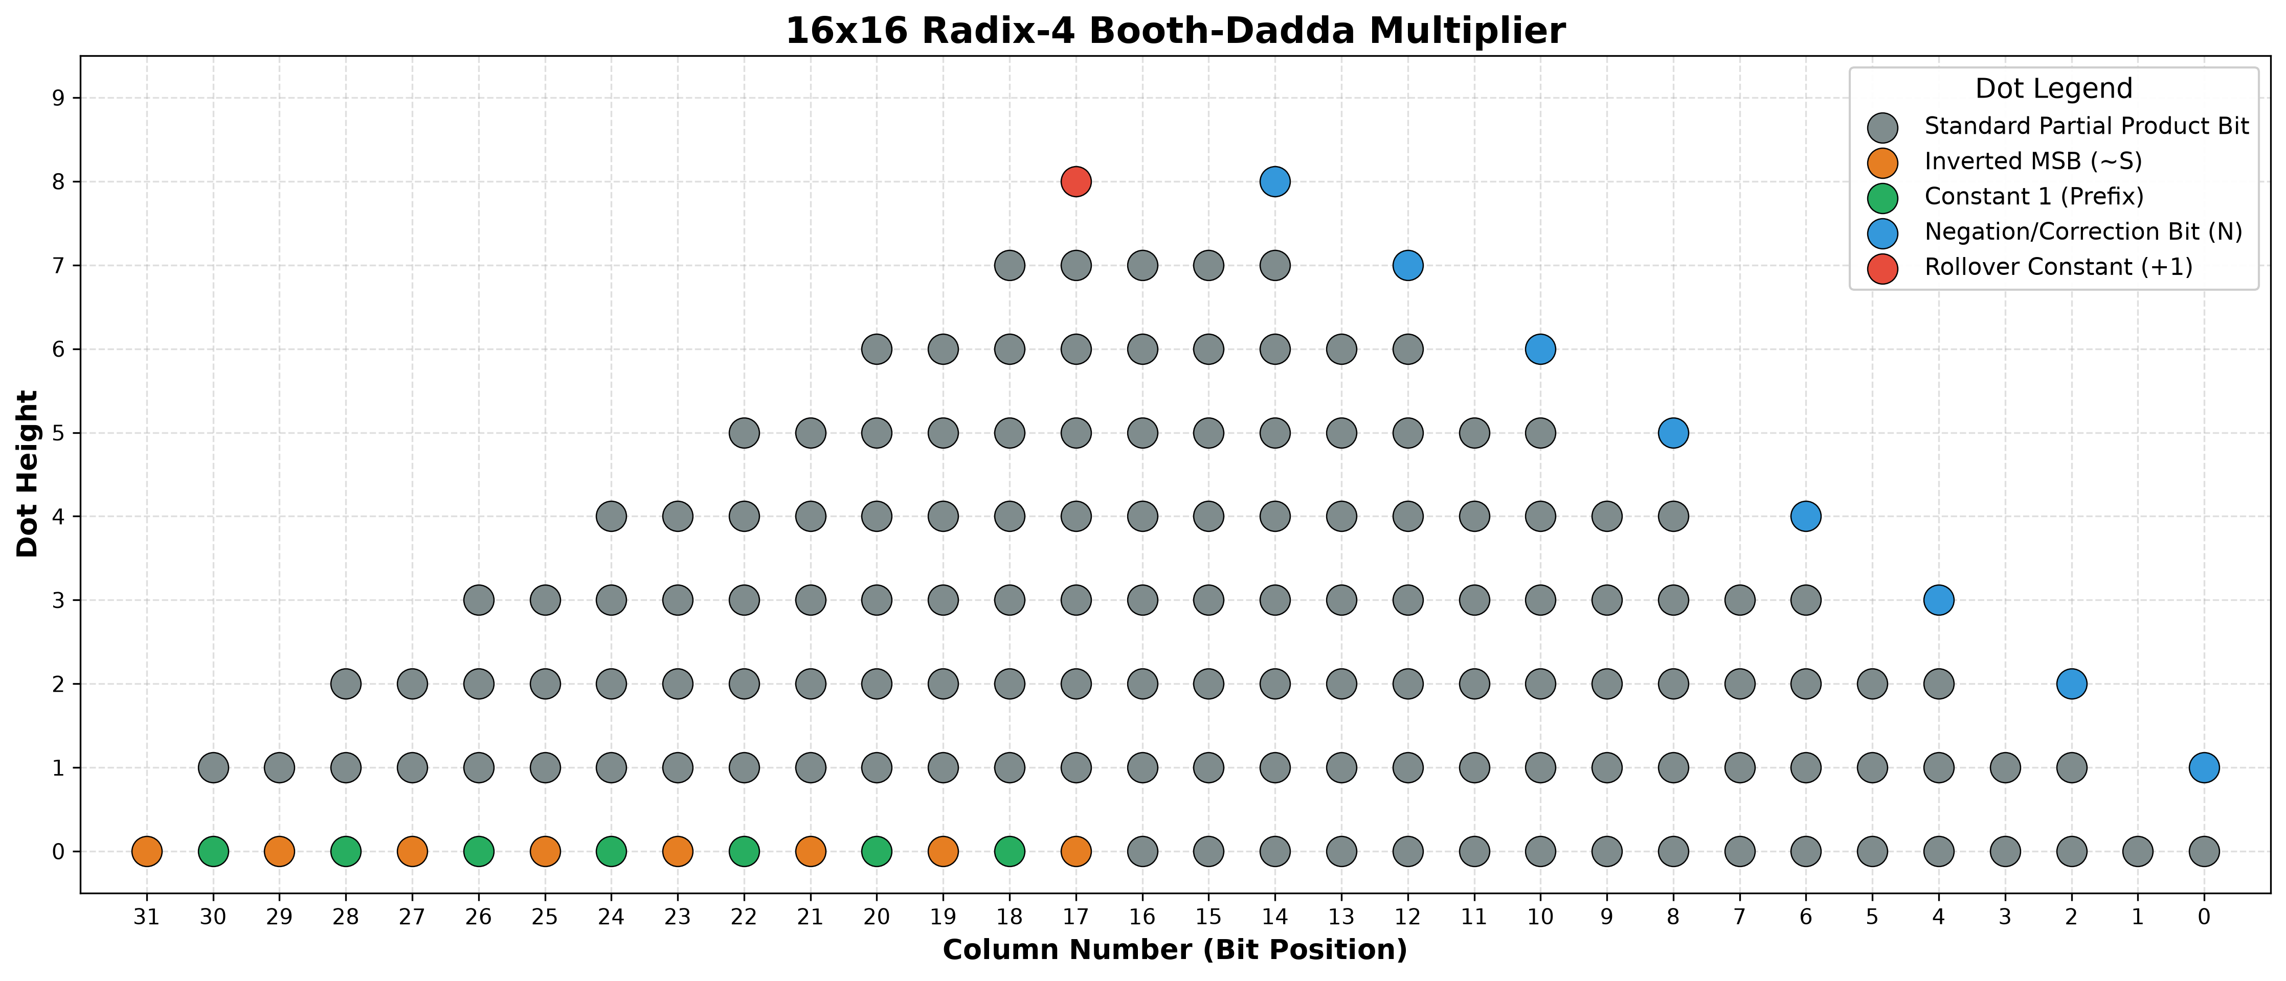
Figure 6. Per-row MSE dot pattern, redrawn from the netlist and cross-checked against the component inventory below.
C. Dadda Reduction Tree

C.1. Matrix Initialization and Reduction Sequence

The Dadda reduction algorithm minimizes the number of compression stages required to flatten a partial product matrix by strictly targeting a mathematically defined sequence of maximum column heights. In this architecture, the radix-4 Booth shifting, combined with the Modified Sign-Extension (MSE) correction bits and the standalone column 17 rollover constant, generates an initial global matrix with a peak column height of nine bits. To compress this peak down to the two rows required for standard carry-propagate addition, the Dadda methodology dictates a four-stage height reduction sequence: 9 → 6 → 4 → 3 → 2.
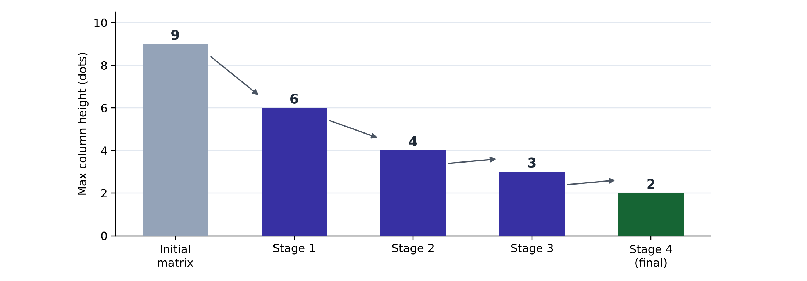
Figure 7. Target-height sequence for peak height 9

C.2. Combinational Compression Mechanism

To achieve each intermediate target height, the algorithm applies a parallel layer of combinational compressors exclusively to the specific bit-columns that exceed the stage's height limit. This compression is executed using Full Adders, which function as 3:2 counters by consuming three bits from a column to output two bits, and Half Adders, which function as 2:2 counters. During the physical routing of these components, every resulting sum bit drops vertically into its original column index, while every carry bit routes diagonally one column to the left to propagate to the subsequent compression stage.

C.3. Stage-by-Stage Hardware Allocation

The complete reduction of the 16x16 matrix utilizes exactly 119 discrete compressors, comprising 97 Full Adders and 22 Half Adders. The first stage targets the densest central columns, utilizing 17 Full Adders and 10 Half Adders to compress the initial peak height of nine down to six. The second stage deploys 32 Full Adders and 6 Half Adders to level the resulting expanded plateau, achieving a uniform maximum height of four. The third stage applies 22 Full Adders and 3 Half Adders to perform a flat ripple reduction, bringing the matrix height to three. The fourth and final compression stage utilizes 26 Full Adders and 3 Half Adders to sweep across the remaining columns, successfully yielding exactly two remaining wires - a Sum vector and a Carry vector - across the entire 32-bit span.

C.4. Structural Implementation and Routing

Within the schematic environment, each Full Adder is instantiated as a structural subcircuit built from two Half Adders and an OR gate, rather than an optimized primitive cell. To manage the immense routing complexity between the four Dadda stages, every intermediate sum and carry wire is routed through uniquely named tunnels. This requires 667 distinct tunnel connections across the canvas to maintain a visually traceable, column-labelled layout without crossed wires. While this rigorous structural approach maximizes the underlying primitive gate footprint, it guarantees mathematically strict adherence to the Dadda compression sequence before the vectors are passed to the final 32-bit Adder.

D. Final Carry-Propagate Addition

After the reduction tree, every column holds at most 2 bits. These are gathered into two 32-bit vectors by two 32-wide merging splitters those being a Sum vector and a Carry vector, with any column that produced only a single bit padded with a Constant 0 so neither vector has a floating bit. The two vectors are added by one 32-bit Adder component.

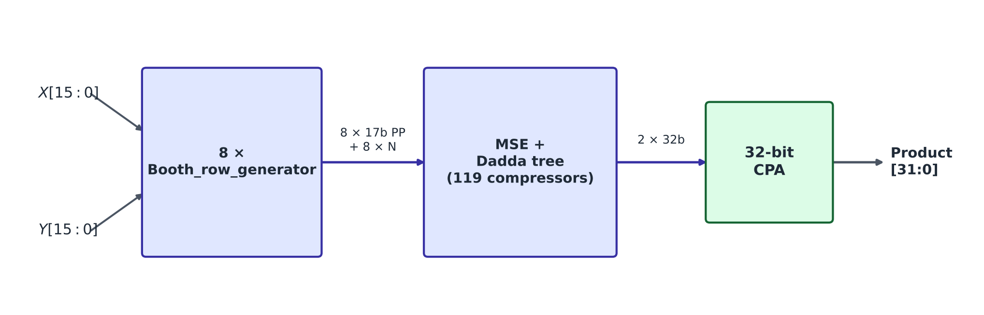
Figure 8. Complete 16×16 radix-4 Booth–Dadda multiplier

