Attention Metrics and Asset Price Dynamics in Financial Time Series
Atharva Shinde · Georgia Institute of Technology · 4/22/2026

1. Introduction
Higher attention may reflect increased investor interest and trading activity in an asset. These signals may also capture shifts in investor sentiment that are associated with subsequent return dynamics. In particular, sudden changes in attention may reflect abrupt shifts in sentiment and may help forecast future volatility. The goal is to test whether investor attention, proxied by Google Trends, can improve model performance when predicting asset shocks and returns.

Hypothesis: Attention signals contain statistically significant information about realized returns and volatility.

2. Dataset Description
Attribute | Price / ETF Data | Attention Data
Source | Yahoo Finance (yfinance library) | Google Trends (Pytrends library)
Asset/Term | SPY, BTC-USD, TSLA | Various related keywords
Period | 1/1/2021–4/21/2026 | 1/1/2021–4/21/2026
Frequency | Daily | Daily
Key Vars | Open, Close, High, Low, Volume | Trend index (0-100)

Keyword trends analyzed for SPY (general market): 'stock market', 'stock market crash', 'inflation’, 'interest rates' ,'recession’, ‘oil prices’, ‘crude oil’, ‘economy'

Keyword trends analyzed for BTC-USD (Bitcoin): 'bitcoin price’, ‘crypto crash' ,'crypto', 'cryptocurrency’, ‘buy bitcoin', 'bitcoin ETF’, ‘inflation hedge’, ‘risk off’, ‘altcoin', 'bitcoin mining'

Keyword trends analyzed for TSLA (Tesla): 'tesla stock', 'elon musk','self driving car', 'electric vehicles', 'AI stocks', 'tesla crash', 'battery technology', 'lithium price'

3. Data Processing

3.1 Cleaning & Alignment
- Trend and stock series merged, days with missing values dropped; [N] observations post-merge
- Attention resampling
  - Pytrends provides daily trend data for a maximum of 6-month window per query
  - Trend index is normalized such that the peak value in the window is 100
  - Queries cover 6-month windows with 2-month overlap, index is rescaled using shared periods and then stitched into full trend dataset
- Outliers: Extreme values were retained as informative rather than treated as errors.

3.2 Feature Engineering
Feature | Formula / Method | Notes
Log Return | rₜ = ln(Pₜ / Pₜ₋₁) | Close-to-close, daily (asset data)
Rolling Volatility | $σ_{t,10}$ = StdDev($r_{t},r_{t-1},…r_{t-9}$) | Window = 10 days (asset data)
Attention Difference | ΔAₜ = Aₜ − Aₜ₋₁ | Change in daily trend index (attention data)
Rolling Shock | zₜ = (rₜ − ${\overline{r}}_{t,10}$) / $σ_{t,10}$ | Rolling z-score of returns (asset and attention data)

4. Exploratory Data Analysis

4.1 Time-Series Processing for Plotting
Double line graphs of asset data and attention data was generated for each asset variable (return, volatilitiy, shock), and attention variable (trend index, difference, shock). The series were downsampled by plotting every 10th observation to reduce visual clutter. Both asset data and attention data were max-min scaled so they could be compared visually on the plots The Pearson correlation coefficient was computed and displayed for each plot. . A few notable plots are shown below. The Jupyter Notebook file generates graphs and stores them in the “/plots”.

4.2 Representative Plots

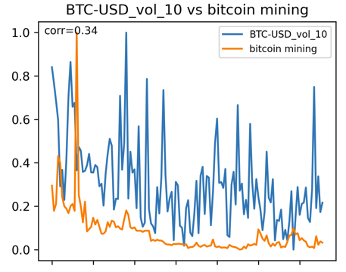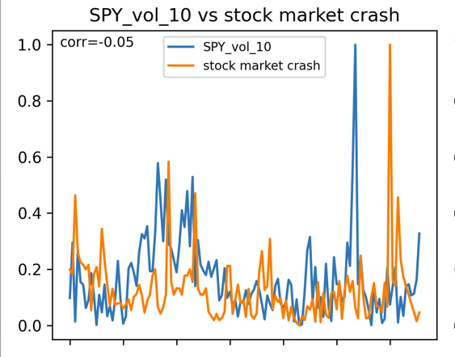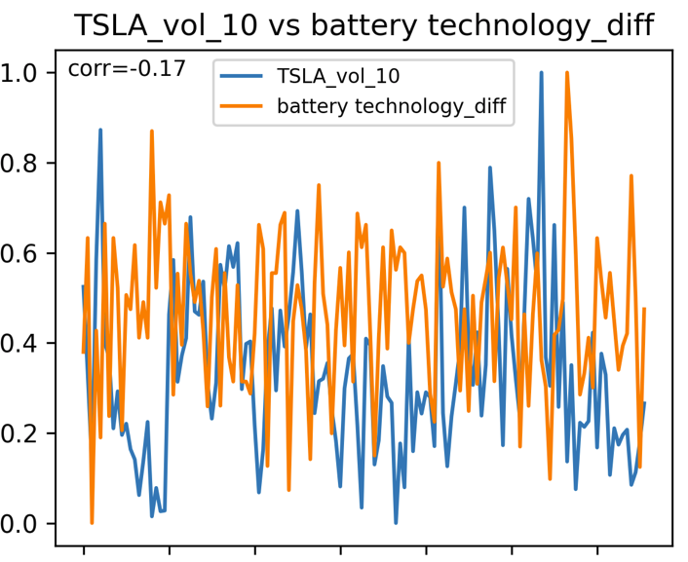
Figure 1 Figure 2 Figure 3

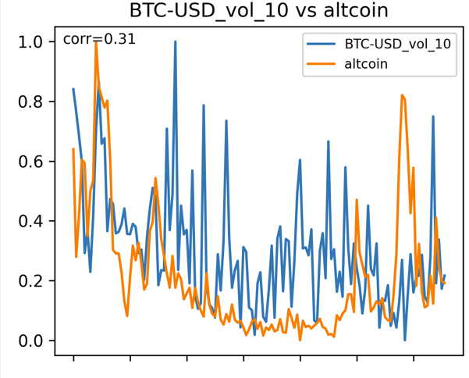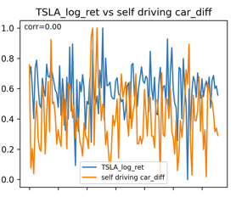
Figure 4 Figure 5

4.3 Visual Data Analysis
Figures 1 and 4 show some of the plots with the highest Pearson correlation coefficients at R=0.34 and R=0.31 respectively. This shows that the strongest attention metrics have weak to medium correlations to actual asset data. The line for bitcoin mining in Figure 1 has a much lower scale than BTC-USD rolling volatility but appears to peak and trough at similar times.

Figure 2 shows the search trend for “stock market crash” appears to slightly lag rolling volatility of SPY. This might indicate a delayed public attention shift to “stock market crash” in reaction to market volatility rather than the other way around.

Figure 3 shows two lines with high variance, rolling TSLA volatility and change in daily “battery technology” searches. The plots look to follow closely at some timeframes but are overall loosely inversely correlated at R=-0.17. Some of the plots similarly have high variability and are difficult to analyze visually. More quantitative analysis will be needed for these attention metrics.

Many of the graphs looked like Figure 5 with very low Pearson Coefficient and now visual relationship. Keywords with low correlation to asset data were therefore excluded to reduce noise and improve model relevance.

5. Modeling

5.1 Train / Test Split
A strict temporal split is used to prevent look-ahead bias: 01/01/2021–12/31/2025 for training and 01/01/2026-04/17/2026 for testing.

5.2 Baseline Model
The baseline model captures normalized shock persistence without attention variables:
$$z_{t+1}=α_{0}+β_{1}z_{t}+β_{2}z_{t-1}+β_{3}z_{t-2}+ε_{t+1}$$
where z is normalized shock. The model was fit using OLS.

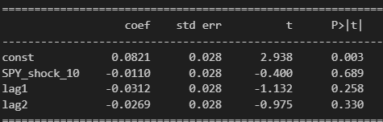 Figure 1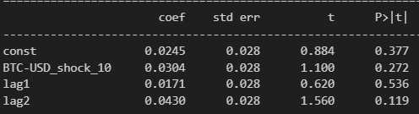 Figure 2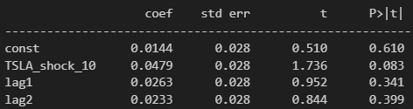 Figure 3

Figure 1 shows the model summary for SPY where R^2 was 0.002. Figure 2 shows the model summary for BTC-USD where R^2 was 0.003. Figure 3 shows the model summary for TSLA where R^2 was 0.004. Predicting the normalized shock for all three assets using lags is difficult. For SPY, the lags don’t seem to have a reliable on shock as the highest |t| is 1.13. For BTC-USD, the lags seem to be slightly more reliable with a highest |t| of 1.56. The lags for TSLA seemed to have slightly higher coefficients. The 2 day lag shock was the most reliable with a t value of 1.736.

5.3 Augmented Model (Attention-Enhanced)
The augmented model adds contemporaneous and lagged attention variables:
$$z_{t+1}=α_{0}+β_{1}z_{t}+β_{2}z_{t-1}+β_{2}z_{t-2}+β_{3}A_{t}+β_{4}{∆A}_{t}+β_{5}z_{t}^{A}+ε_{t}$$
where A_{t} is the trend index, ΔAₜ is the change in trend index, and zₜᵃ is the normalized trend index shock. After testing performance of each keyword-metric pair independently, the top 5 metrics were used together in the final model for each asset.

5.4 Model Comparison

SPY
Metric | Baseline (AR) | Augmented | Improvement
Test-Set MSE | 1.06185 | 0.98692 | 7.06%
Test-Set MAE | 0.81087 | 0.77723 | 4.15%
In-Sample R² | 0.003 | 0.048 | 1500%
Table 1: Out-of-sample performance comparison. Improvement = % reduction/increase

BTC-USD
Metric | Baseline (AR) | Augmented | Improvement
Test-Set MSE | 0.95723 | 0.89368 | 6.64%
Test-Set MAE | 0.78659 | 0.76764 | 2.41%
In-Sample R² | 0.003 | 0.069 | 2200%
Table 2: Out-of-sample performance comparison. Improvement = % reduction/increase
TSLA
Metric | Baseline (AR) | Augmented | Improvement
Test-Set MSE | 1.07532 | 0.99586 | 7.39%
Test-Set MAE | 0.81361 | 0.78177 | 3.91%
In-Sample R² | 0.003 | 0.080 | 2567%
Table 3: Out-of-sample performance comparison. Improvement = % reduction/increase

6. Conclusion
The results provide evidence that models with parameters for attention can yield subtle but consistent improvements compared to autoregression. The augmented model performed 2-7% better out-of-sample across all three assets. This suggests that attention metrics may be viable as a source of information when predicting asset pricing behavior. Further investigation on the usefulness of attention metrics could be done on whether other sources of attention metrics such as Twitter and Reddit are also useful as parameters for predicting asset pricing behavior.

Furthermore, using rolling normalization for calculating shocks makes it less sensitive to sudden market changes. The shock variable is likely more stable than the accurate market and does not perfectly reflect it. Future work could build on this by using realized variance data as a dependent variable and attempt to predict sudden changes in pricings through attention metrics.

