

UNIVERSITY OF COMPUTER STUDIES, YANGON

Tour Booking System

Covered By

**DATABASE TRANSACTION MANAGEMENT**

Faculty of Information Science

University of Computer Studies, Yangon

Submitted By Semester – VI

September, 2025

Group Members

|  |  |  |
| --- | --- | --- |
| Roll No. | Name | Role |
| YKPT – 21871 | Htet Nadi | Leader |
| YKPT – 21924 | Ye Wont Aung | Co-Leader |
| YKPT – 22461 | Than Thar Linn Latt | Member |
| YKPT – 21809 | Phu Phu May Maung | Member |
| YKPT – 21442 | Shwe Sin Phoo Lwin | Member |
| YKPT – 21727 | Pan Kay Thwel Oo | Member |
| YKPT – 22543 | May Thin Nwe | Member |

**Contents**

**Chapter 1: Introduction**

1.1 Project Description 1

1.2 Objectives 1

**Chapter 2: Database Management System**

2.1 Entity Relationship (ER) Diagram 2

2.2 Data Dictionary 3

2.3 Data Insertion in Relational Tables 5

2.3.1 Table Creation 5

2.3.2 Data Insertion 9

**Chapter 3: Functionality**

3.1 Functionalities that Admin can perform 12

3.1.1 Procedure for Admin 12

3.1.2 Function for Admin 13

3.1.3 Trigger for Admin 14

3.2 Functionalities that Customer can perform 16

3.2.1 Procedure for Customer 16

3.2.2 Function for Customer 18

3.2.3 Trigger for Customer 19

3.3 Query Execution with MySQL 20

3.3.1 Index Query 20

3.3.2 Query Evaluation Plans 21

3.3.3 Implementing Transformations Based Optimizations 23

**Chapter 4: Conclusion**

4.1 Conclusion 27

4.2 References 27

**Chapter 1**

**Introduction**

* 1. **Project Description**

The Tour Booking System is a comprehensive database-driven system designed to manage tour packages, customer bookings, and payment processing for a travel agency. The system provides an organized and scalable way to handle administrative tasks, customer interactions, and financial transactions while ensuring data integrity, efficiency, and security.

This database system enables administrators to manage tour packages, monitor bookings, and track payments, while customers can view available tours, make reservations, and check booking details. The system enforces role-based access control, ensuring that only authorized administrators can modify packages or confirm payments, while customers have restricted access for making bookings and viewing their own records.

* 1. **Objectives**

The objectives of the Tour Booking System are:

1. Efficient Tour Package Management
2. Streamlined Booking Process
3. Secure Payment Management
4. Role-Based Access Control
5. Data Integrity and Validation

**Chapter 2**

**Database Management System**

**2.1 Entity Relationship (ER) Diagram**

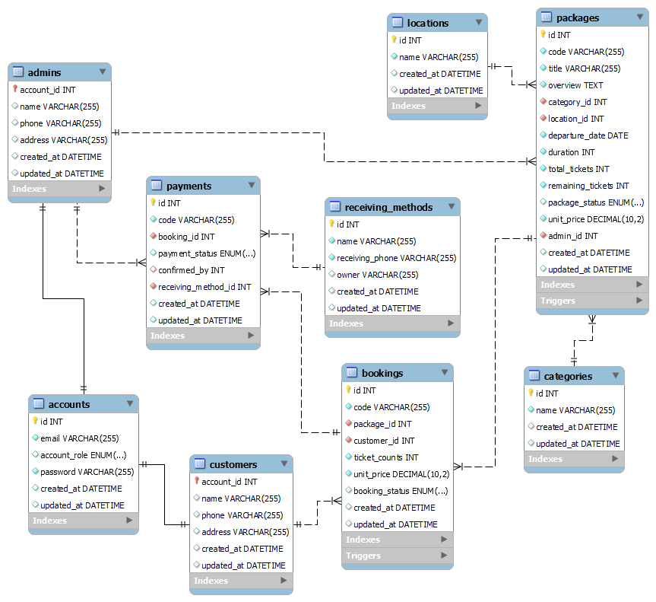

**Figure 2.1 ER Diagram**

**2.2 Data Dictionary**

|  |  |  |  |  |  |  |
| --- | --- | --- | --- | --- | --- | --- |
| Tour Booking System | | | | | | |
| Table | Field | Type | Null | Default | Key | Foreign Key Table |
| accounts | id | int | No |  | PK |  |
| email | varchar(255) | No |  | UNI |  |
| account_role | enum | Yes | CUSTOMER |  |  |
| password | varchar(255) | No |  |  |  |
| created_at | datetime | Yes | current_timestamp |  |  |
| updated_at | datetime | Yes | current_timestamp |  |  |
|  |  |  |  |  |  |  |
| admins | account_id | int | No |  | PK/FK | accounts |
| name | varchar(255) | Yes |  |  |  |
| phone | varchar(255) | Yes |  |  |  |
| address | varchar(255) | Yes |  |  |  |
| created_at | datetime | Yes | current_timestamp |  |  |
| updated_at | datetime | Yes | current_timestamp |  |  |
|  |  |  |  |  |  |  |
| customers | account_id | int | No |  | PK/FK | accounts |
| name | varchar(255) | Yes |  |  |  |
| phone | varchar(255) | Yes |  |  |  |
| address | varchar(255) | Yes |  |  |  |
| created_at | datetime | Yes | current_timestamp |  |  |
| updated_at | datetime | Yes | current_timestamp |  |  |
|  |  |  |  |  |  |  |
| categories | id | int | No |  | PK |  |
| name | varchar(255) | No |  | UNI |  |
| created_at | datetime | Yes | current_timestamp |  |  |
| updated_at | datetime | Yes | current_timestamp |  |  |
|  |  |  |  |  |  |  |
| locations | id | int | No |  | PK |  |
| name | varchar(255) | No |  | UNI |  |
| created_at | datetime | Yes | current_timestamp |  |  |
| updated_at | datetime | Yes | current_timestamp |  |  |
|  |  |  |  |  |  |  |
| packages | id | int | No |  | PK |  |
| code | varchar(255) | No |  | UNI |  |
| title | varchar(255) | No |  |  |  |
| overview | text | Yes |  |  |  |
| category_id | int | No |  | FK | categories |
| location_id | int | No |  | FK | locations |
| departure_date | date | No |  |  |  |
| duration | int | No |  |  |  |
| total_tickets | int | No |  |  |  |
| remaining_tickets | int | No |  |  |  |
| package_status | enum | No | AVAILABLE |  |  |
| unit_price | decimal(10.2) | No |  |  |  |
| admin_id | int | No |  | FK | admins |
| created_at | datetime | Yes | current_timestamp |  |  |
| updated_at | datetime | Yes | current_timestamp |  |  |
|  |  |  |  |  |  |  |
| bookings | id | int | No |  | PK |  |
| code | varchar(255) | No |  | UNI |  |
| package_id | varchar(255) | No |  | FK | packages |
| customer_id | int | No |  | FK | customers |
| ticket_counts | int | No |  |  |  |
| unit_price | decimal(10.2) | No |  |  |  |
| booking_status | enum | Yes | PENDING |  |  |
| created_at | datetime | Yes | current_timestamp |  |  |
| updated_at | datetime | Yes | current_timestamp |  |  |
|  |  |  |  |  |  |  |
| receiving_methods | id | int | No |  | PK |  |
| name | varchar(255) | No |  | UNI |  |
| receiving_phone | varchar(255) | No |  |  |  |
| owner | varchar(255) | No |  |  |  |
| created_at | datetime | Yes | current_timestamp |  |  |
| updated_at | datetime | Yes | current_timestamp |  |  |
|  |  |  |  |  |  |  |
| payments | id | int | No |  | PK |  |
| code | varchar(255) | No |  | UNI |  |
| booking_id | int | No |  | FK | bookings |
| payment_status | enum | Yes | PENDING |  |  |
| confirmed_by | int | Yes | NULL | FK | admins |
| receiving_method_id | int | No |  | FK | receiving_methods |
| created_at | datetime | Yes | current_timestamp |  |  |
| updated_at | datetime | Yes | current_timestamp |  |  |

**2.3 Data Insertion in Relational Tables**

**2.3.1 Table Creation**

create table accounts (

id int auto_increment primary key,

email varchar(255) not null unique,

account_role enum('ADMIN', 'CUSTOMER') default 'CUSTOMER',

password varchar(255) not null,

created_at datetime default CURRENT_TIMESTAMP,

updated_at datetime default CURRENT_TIMESTAMP on update CURRENT_TIMESTAMP

);

create table admins (

account_id int primary key,

name varchar(255),

phone varchar(255) null,

address varchar(255) null,

created_at datetime default CURRENT_TIMESTAMP,

updated_at datetime default CURRENT_TIMESTAMP on update CURRENT_TIMESTAMP,

foreign key (account_id) references accounts (id)

);

create table customers (

account_id int primary key,

name varchar(255),

phone varchar(255) null,

address varchar(255) null,

created_at datetime default CURRENT_TIMESTAMP,

updated_at datetime default CURRENT_TIMESTAMP on update CURRENT_TIMESTAMP, foreign key (account_id) references accounts (id)

);

create table categories (

id int auto_increment primary key,

name varchar(255) not null unique,

created_at datetime default CURRENT_TIMESTAMP,

updated_at datetime default CURRENT_TIMESTAMP on update CURRENT_TIMESTAMP

);

create table locations (

id int auto_increment primary key,

name varchar(255) not null unique,

created_at datetime default CURRENT_TIMESTAMP,

updated_at datetime default CURRENT_TIMESTAMP on update CURRENT_TIMESTAMP

);

create table packages (

id int auto_increment primary key,

code varchar(255) not null unique,

title varchar(255) not null,

overview text not null,

category_id int not null,

location_id int not null,

departure_date date not null,

duration int not null,

total_tickets int not null,

remaining_tickets int not null,

package_status enum('AVAILABLE', 'UNAVAILABLE', 'FINISHED') default 'AVAILABLE',

unit_price decimal(10, 2) not null,

admin_id int not null,

created_at datetime default CURRENT_TIMESTAMP,

updated_at datetime default CURRENT_TIMESTAMP on update CURRENT_TIMESTAMP,

foreign key (category_id) references categories (id),

foreign key (location_id) references locations (id),

foreign key (admin_id) references admins (account_id),

check (remaining_tickets <= total_tickets)

);

create table bookings (

id int auto_increment primary key,

code varchar(255) not null unique,

package_id int not null,

customer_id int not null,

ticket_counts int not null,

unit_price decimal(10, 2) not null,

booking_status enum('PENDING', 'REQUESTING', 'RESERVED', 'CANCELLED') default 'PENDING',

created_at datetime default CURRENT_TIMESTAMP,

updated_at datetime default CURRENT_TIMESTAMP on update CURRENT_TIMESTAMP,

foreign key (package_id) references packages (id),

foreign key (customer_id) references customers (account_id)

);

create table receiving_methods (

id int auto_increment primary key,

name varchar(255) not null unique,

receiving_phone varchar(255) not null,

owner varchar(255),

created_at datetime default CURRENT_TIMESTAMP,

updated_at datetime default CURRENT_TIMESTAMP on update CURRENT_TIMESTAMP

);

create table payments (

id int auto_increment primary key,

code varchar(255) not null unique,

booking_id int not null,

payment_status enum('PENDING', 'SUCCESS', 'FAIL') default 'PENDING',

confirmed_by int null,

receiving_method_id int not null,

created_at datetime default CURRENT_TIMESTAMP,

updated_at datetime default CURRENT_TIMESTAMP on update CURRENT_TIMESTAMP,

foreign key (booking_id) references bookings (id),

foreign key (confirmed_by) references admins (account_id),

foreign key (receiving_method_id) references receiving_methods (id)

);

**2.3.2 Data Insertion**

**Create Admin Accounts**

INSERT INTO accounts (email, password, account_role) VALUES

('admin1@gmail.com', 'password', 'ADMIN'),

('admin2@gmail.com', 'password', 'ADMIN');

INSERT INTO admins (account_id, name, phone, address) VALUES

(1, 'admin1', '09999888777', 'Yangon'),

(2, 'admin2', '09999888666', 'Mandalay');

**Create Customer Accounts**

INSERT INTO accounts (email, password, account_role) VALUES

('aung@gmail.com', 'password', 'CUSTOMER'),

('su@gmail.com', 'password', 'CUSTOMER'),

('moe@gmail.com', 'password', 'CUSTOMER'),

('hla@gmail.com', 'password', 'CUSTOMER');

INSERT INTO customers (account_id, name, phone, address) VALUES

(3, 'Aung Aung', '09777888777', 'Yangon'),

(4, 'Su Su', '09777888666', 'Mandalay'),

(5, 'Moe Moe', '09777888555', 'Bagan'),

(6, 'Hla Hla', '09777888444', 'Inle Lake');

**Create Categories**

INSERT INTO categories (name) VALUES ('Relaxation'), ('Pagoda'), ('Beach'), ('History');

**Create Locations**

INSERT INTO locations (name) VALUES

('Yangon'), ('Bagan'), ('Chaung Tha'), ('Mandalay'), ('Naypyitaw'), ('Inle Lake');

**Create Packages**

INSERT INTO packages

(code, title, overview, category_id, location_id, departure_date, duration, total_tickets, remaining_tickets, unit_price, admin_id, package_status)

VALUES

-- Category 1 (Relaxation)

('PKG-001', 'Adventure in Mountains', 'Explore the majestic mountains with guided tours.', 1, 1, '2025-10-01', 5, 20, 18, 500.00, 1, 'AVAILABLE'),

('PKG-002', 'Mountain Hiking Challenge', 'A thrilling hiking experience for adventure seekers.', 1, 2, '2025-11-05', 7, 15, 12, 650.00, 1, 'AVAILABLE'),

-- Category 2 (Pagoda)

('PKG-003', 'Beach Relaxation Getaway', 'Relax on pristine beaches with all-inclusive amenities.', 2, 3, '2025-09-15', 4, 30, 29, 400.00, 1, 'AVAILABLE'),

('PKG-004', 'Sunset Cruise Escape', 'Enjoy sunset cruises and beach parties.', 2, 4, '2025-10-20', 3, 25, 24, 350.00, 1, 'AVAILABLE'),

-- Category 3 (Beach)

('PKG-005', 'City Cultural Tour', 'Discover historical landmarks and local culture.', 3, 5, '2025-12-01', 6, 20, 18, 300.00, 1, 'AVAILABLE'),

('PKG-006', 'Nightlife Exploration', 'Experience the vibrant city nightlife and local cuisine.', 3, 6, '2025-12-10', 5, 15, 15, 320.00, 1, 'AVAILABLE'),

-- Category 4 (History)

('PKG-007', 'Ancient Pagoda Tour', 'Visit historic pagodas and learn about Burmese history.', 4, 2, '2025-11-12', 4, 25, 25, 450.00, 1, 'AVAILABLE'),

('PKG-008', 'Historical Yangon Walk', 'A walking tour through Yangon''s historical sites.', 4, 1, '2025-12-05', 3, 20, 20, 280.00, 1, 'AVAILABLE'),

-- Extra Package: UNAVAILABLE

('PKG-009', 'Hidden Lakes Adventure', 'A secret journey to hidden lakes with full bookings.', 1, 6, '2025-11-20', 3, 10, 0, 600.00, 1, 'UNAVAILABLE'),

-- Extra Package: FINISHED

('PKG-010', 'Old Kingdom Exploration', 'Historic kingdom tour, already departed.', 4, 2, '2025-08-01', 4, 12, 5, 700.00, 1, 'FINISHED');

**Create Bookings**

INSERT INTO bookings

(code, package_id, customer_id, ticket_counts, unit_price, booking_status)

VALUES

('BOOK-001', 1, 3, 2, 500.00, 'PENDING'),

('BOOK-002', 3, 4, 1, 400.00, 'RESERVED'),

('BOOK-003', 2, 3, 3, 650.00, 'REQUESTING'),

('BOOK-004', 5, 4, 2, 300.00, 'PENDING'),

('BOOK-005', 4, 3, 1, 350.00, 'CANCELLED');

**Create Receiving Methods**

INSERT INTO receiving_methods (name, receiving_phone, owner) VALUES

('KBZ Pay', '09990001111', 'Admin1'),

('Wave Pay', '09990002222', 'Admin1'),

('AYA Pay', '09990003333', 'Admin2');

**Create Payments**

INSERT INTO payments

(code, booking_id, payment_status, confirmed_by, receiving_method_id)

VALUES

('PAY-001', 1, 'PENDING', NULL, 1),

('PAY-002', 2, 'SUCCESS', 1, 2), -- admin1 confirmed

('PAY-003', 3, 'FAIL', 2, 1), -- admin2 handled

('PAY-004', 4, 'PENDING', NULL, 3),

('PAY-005', 5, 'SUCCESS', 1, 2); -- admin1 confirmed

**Chapter 3**

**Functionality**

**3.1 Functionalities that Admin can perform**

**3.1.1 Procedure for Admin**

**Confirming the payment and updating the booking status**

DELIMITER //

CREATE PROCEDURE ConfirmPayment(

IN paymentId INT,

IN adminId INT

)

BEGIN

DECLARE bookingId INT;

DECLARE currentStatus varchar(10);

-- 1. Get current payment info

SELECT booking_id, payment_status

INTO bookingId, currentStatus

FROM payments

WHERE id = paymentId;

-- 2. Only proceed if payment is PENDING

IF currentStatus = 'PENDING' THEN

-- 3. Update payment status to SUCCESS and record admin who confirmed

UPDATE payments

SET payment_status = 'SUCCESS',

confirmed_by = adminId,

updated_at = NOW()

WHERE id = paymentId;

-- 4. Update related booking status to RESERVED

UPDATE bookings

SET booking_status = 'RESERVED',

updated_at = NOW()

WHERE id = bookingId;

ELSE

-- Optional: raise an error if payment already confirmed or failed

SIGNAL SQLSTATE '45000'

SET MESSAGE_TEXT = 'Payment is not in PENDING status';

END IF;

END;

//

DELIMITER ;

-- Example: Admin with ID 1 confirms payment with ID 2

CALL ConfirmPayment(2, 1);

**3.1.2 Function for Admin**

**Function for getting booking count of a package**

DELIMITER //

CREATE FUNCTION GetBookingCount(p_id INT)

RETURNS INT

DETERMINISTIC

BEGIN

DECLARE total INT;

SELECT COUNT(*)

INTO total

FROM bookings

WHERE package_id = p_id;

RETURN total;

END;

//

DELIMITER ;

-- Example: Get the total bookings for package with ID 1

SELECT GetBookingCount(1) AS total_bookings;

**3.1.3 Trigger for Admin**

**Check if account is admin before inserting package**

DELIMITER //

CREATE TRIGGER CheckAdminRoleBeforePackage

BEFORE INSERT ON packages

FOR EACH ROW

BEGIN

DECLARE user_role ENUM('ADMIN','CUSTOMER');

-- Get the role of the account creating the package

SELECT account_role INTO user_role

FROM accounts

WHERE id = NEW.admin_id;

-- If not an ADMIN, throw an error

IF user_role <> 'ADMIN' THEN

SIGNAL SQLSTATE '45000'

SET MESSAGE_TEXT = 'Only admins can create packages!';

END IF;

END;

//

DELIMITER ;

-- Example 1: Admin creating a package (succeeds)

INSERT INTO packages

(code, title, overview, category_id, location_id, departure_date, duration, total_tickets, remaining_tickets, unit_price, admin_id, package_status)

VALUES

('PKG-011', 'New Adventure', 'Exciting new tour.', 1, 1, '2025-11-25', 4, 20, 20, 500.00, 1, 'AVAILABLE');

-- Example 2: Non-admin trying to create a package (fails)

INSERT INTO packages

(code, title, overview, category_id, location_id, departure_date, duration, total_tickets, remaining_tickets, unit_price, admin_id, package_status)

VALUES

('PKG-012', 'Unauthorized Tour', 'Should fail.', 1, 1, '2025-12-01', 5, 15, 15, 400.00, 3, 'AVAILABLE');

**3.2 Functionalities that Customer can perform**

**3.2.1 Procedure for Customer**

**Update remaining tickets and packages status from packages when a booking is cancelled**

DELIMITER //

CREATE PROCEDURE CancelBooking(IN bookingId INT)

BEGIN

DECLARE pkgId INT;

DECLARE tickets INT;

DECLARE current_status varchar(15);

DECLARE pkg_remaining INT;

-- 1. Get booking info

SELECT package_id, ticket_counts, booking_status

INTO pkgId, tickets, current_status

FROM bookings

WHERE id = bookingId;

-- 2. Only proceed if booking is not already cancelled

IF current_status <> 'CANCELLED' THEN

-- 3. Update booking status to CANCELLED

UPDATE bookings

SET booking_status = 'CANCELLED', updated_at = NOW()

WHERE id = bookingId;

-- 4. Add tickets back to the package

UPDATE packages

SET remaining_tickets = remaining_tickets + tickets,

updated_at = NOW()

WHERE id = pkgId;

-- 5. Check and update package status

SELECT remaining_tickets INTO pkg_remaining

FROM packages

WHERE id = pkgId;

-- If remaining tickets > 0 and departure date in future, set to AVAILABLE

IF pkg_remaining > 0 THEN

UPDATE packages

SET package_status = 'AVAILABLE',

updated_at = NOW()

WHERE id = pkgId;

END IF;

-- 6. Reset related payments

UPDATE payments

SET payment_status = 'PENDING',

confirmed_by = NULL,

updated_at = NOW()

WHERE booking_id = bookingId;

ELSE

-- Optional: raise an error if already cancelled

SIGNAL SQLSTATE '45000'

SET MESSAGE_TEXT = 'Booking is already cancelled';

END IF;

END;

//

DELIMITER ;

CALL CancelBooking(3);

**3.2.2 Function for Customer**

**Calculate the total price of a booking**

DELIMITER //

CREATE FUNCTION TotalBookingPriceByBooking(b_id INT)

RETURNS DECIMAL(10,2)

DETERMINISTIC

BEGIN

DECLARE unit DECIMAL(10,2);

DECLARE tickets INT;

DECLARE total DECIMAL(10,2);

-- Get unit price and ticket count from bookings table

SELECT unit_price, ticket_counts

INTO unit, tickets

FROM bookings

WHERE id = b_id;

-- Calculate total price

SET total = unit * tickets;

RETURN total;

END;

//

DELIMITER ;

-- example

SELECT

b.id AS booking_id,

b.code AS booking_code,

c.name AS customer_name,

p.title AS package_title,

b.ticket_counts,

b.unit_price,

TotalBookingPriceByBooking(b.id) AS total_price,

b.booking_status

FROM bookings b

JOIN customers c ON b.customer_id = c.account_id

JOIN packages p ON b.package_id = p.id

ORDER BY b.id;

**3.2.3 Trigger for Customer**

**Check if account is customer before booking**

DELIMITER //

CREATE TRIGGER CheckCustomerRoleBeforeBooking

BEFORE INSERT ON bookings

FOR EACH ROW

BEGIN

DECLARE user_role ENUM('ADMIN','CUSTOMER');

-- Get the role of the account making the booking

SELECT account_role INTO user_role

FROM accounts

WHERE id = NEW.customer_id;

-- If not a CUSTOMER, throw an error

IF user_role <> 'CUSTOMER' THEN

SIGNAL SQLSTATE '45000'

SET MESSAGE_TEXT = 'Only customers can create bookings!';

END IF;

END;

//

DELIMITER ;

--example

-- Assuming account_id = 1 is an ADMIN

INSERT INTO bookings (code, package_id, customer_id, ticket_counts, unit_price)

VALUES ('BOOK-007', 1, 1, 1, 500.00);

**3.3 Query Execution with MySQL**

**3.3.1 Index Query**

**(1) Create Index**

CREATE INDEX idx_packages_category ON packages(category_id);

CREATE INDEX idx_bookings_package ON bookings(package_id);

**(2) Query Cost Before Adding Index**

EXPLAIN ANALYZE SELECT * FROM packages WHERE category_id = 1;

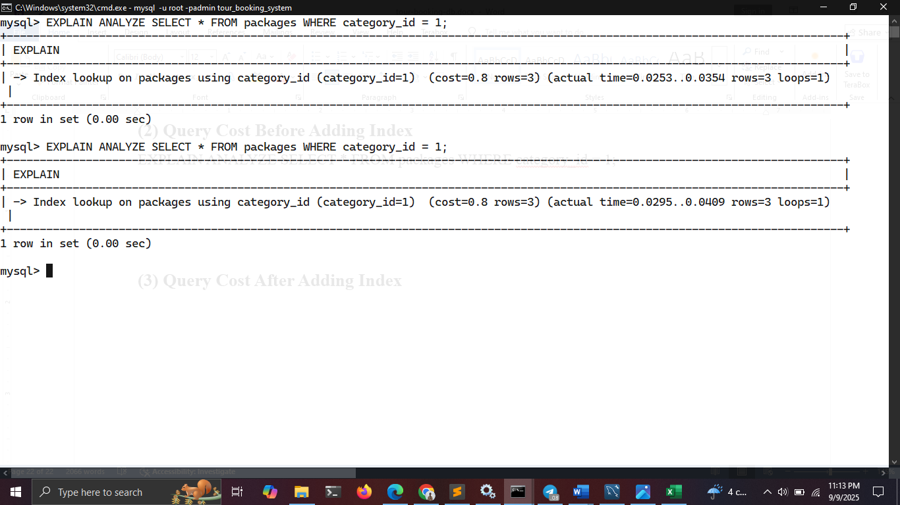

EXPLAIN ANALYZE SELECT * FROM bookings WHERE package_id = 1;

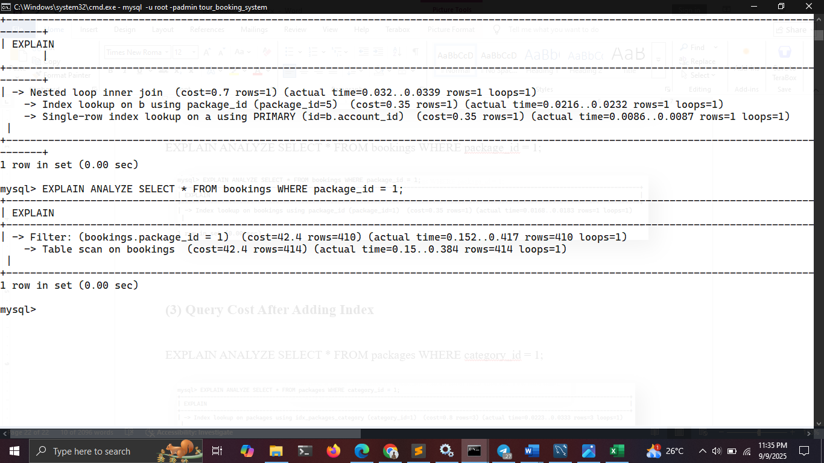

**(3) Query Cost After Adding Index**

EXPLAIN ANALYZE SELECT * FROM packages WHERE category_id = 1;

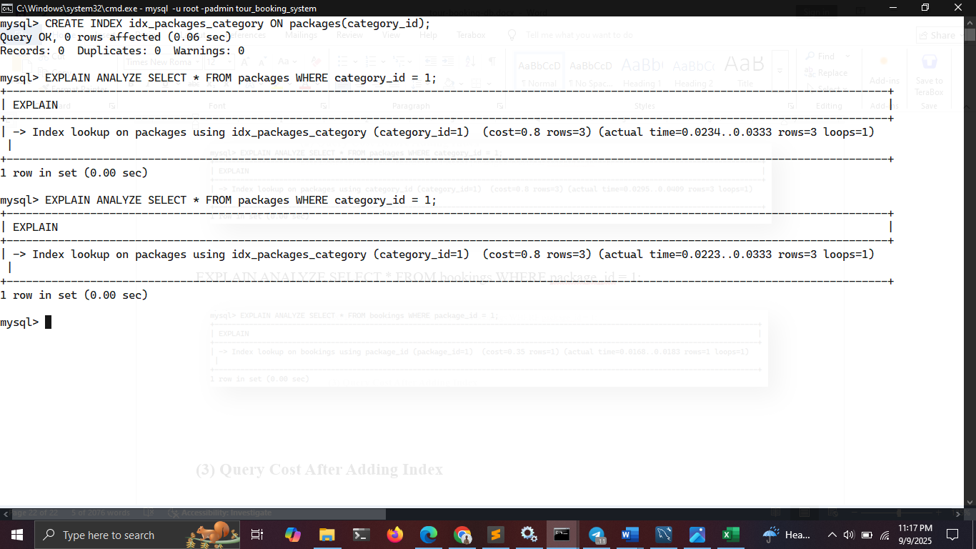

EXPLAIN ANALYZE SELECT * FROM bookings WHERE package_id = 1;

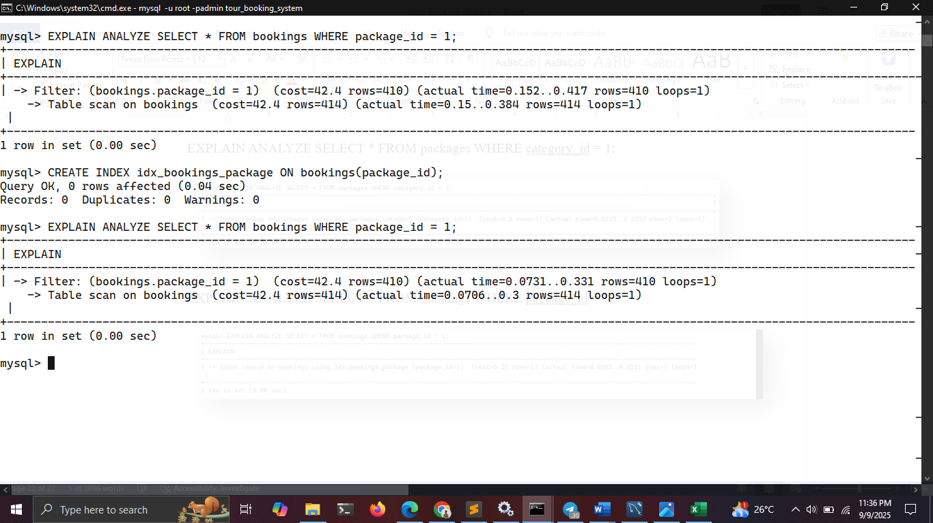

**3.3.2 Query Evaluation Plans**

**Queries for Admin**

1. **View All Packages With Booking Counts**

SELECT

p.id AS id,

p.code AS code,

p.title AS title,

p.package_status AS status,

COUNT(b.id) AS booking_count,

SUM(b.ticket_counts) AS tickets_booked,

p.total_tickets,

p.remaining_tickets

FROM packages p

LEFT JOIN bookings b ON p.id = b.package_id

GROUP BY p.id, p.code, p.title, p.package_status, p.total_tickets, p.remaining_tickets;

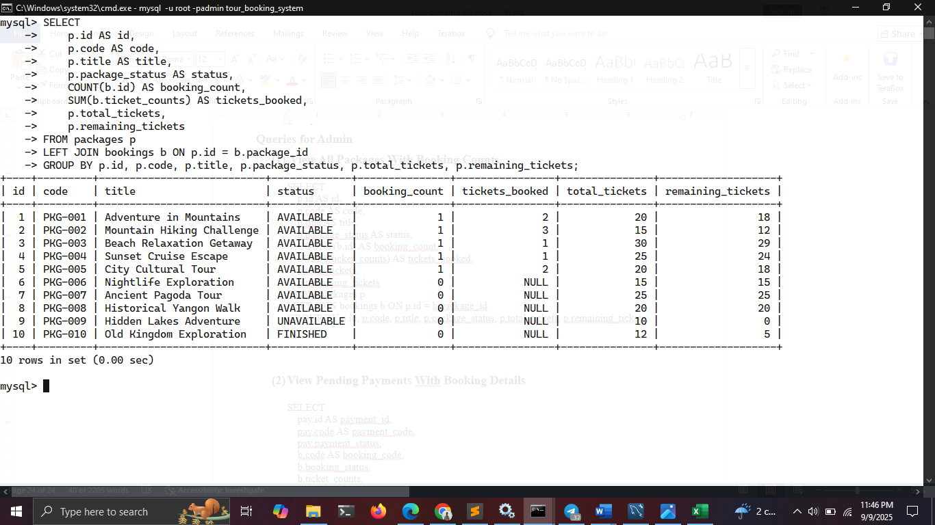

1. **View Pending Payments with Booking Details**

SELECT

pay.code AS payment_code,

pay.payment_status,

b.code AS booking_code,

b.ticket_counts as tickets,

b.unit_price,

c.name AS customer,

p.title AS package

FROM payments pay

JOIN bookings b ON pay.booking_id = b.id

JOIN customers c ON b.customer_id = c.account_id

JOIN packages p ON b.package_id = p.id

WHERE pay.payment_status = 'PENDING';

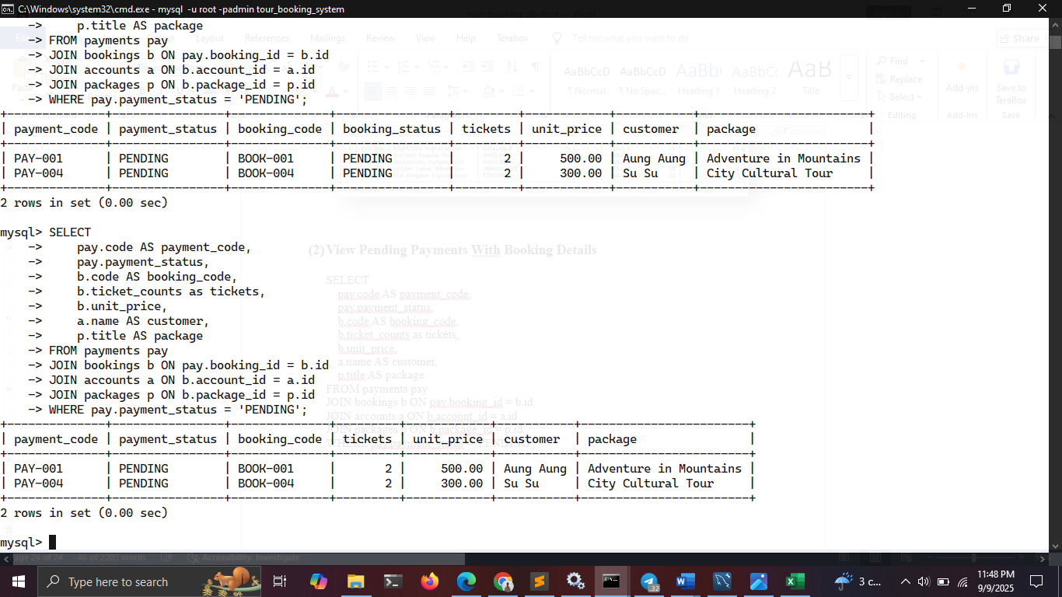

**Queries for Customer**

1. **View All My Bookings with Package Info**

SELECT

b.code AS booking_code,

p.title AS package_title,

b.ticket_counts,

b.unit_price,

(b.ticket_counts * b.unit_price) AS total_price,

b.booking_status,

p.departure_date

FROM bookings b

JOIN packages p ON b.package_id = p.id

WHERE b.customer_id = 3; -- replace with logged-in customer’s account_id

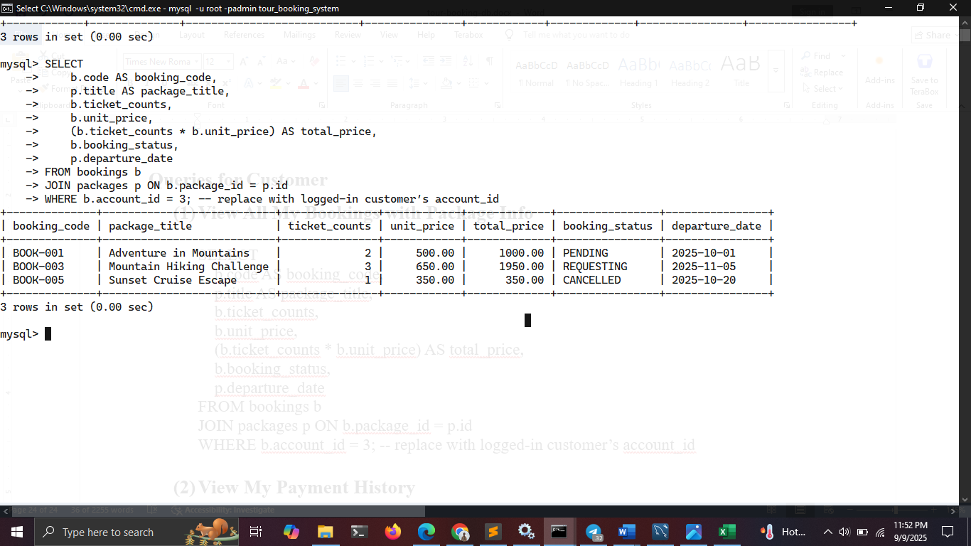

1. **View My Payment History**

SELECT

pay.code AS payment_code,

pay.payment_status,

b.code AS booking_code,

b.booking_status,

rm.name AS receiving_method,

rm.receiving_phone,

pay.created_at

FROM payments pay

JOIN bookings b ON pay.booking_id = b.id

JOIN receiving_methods rm ON pay.receiving_method_id = rm.id

WHERE b.customer_id = 3; -- replace with logged-in customer’s account_id

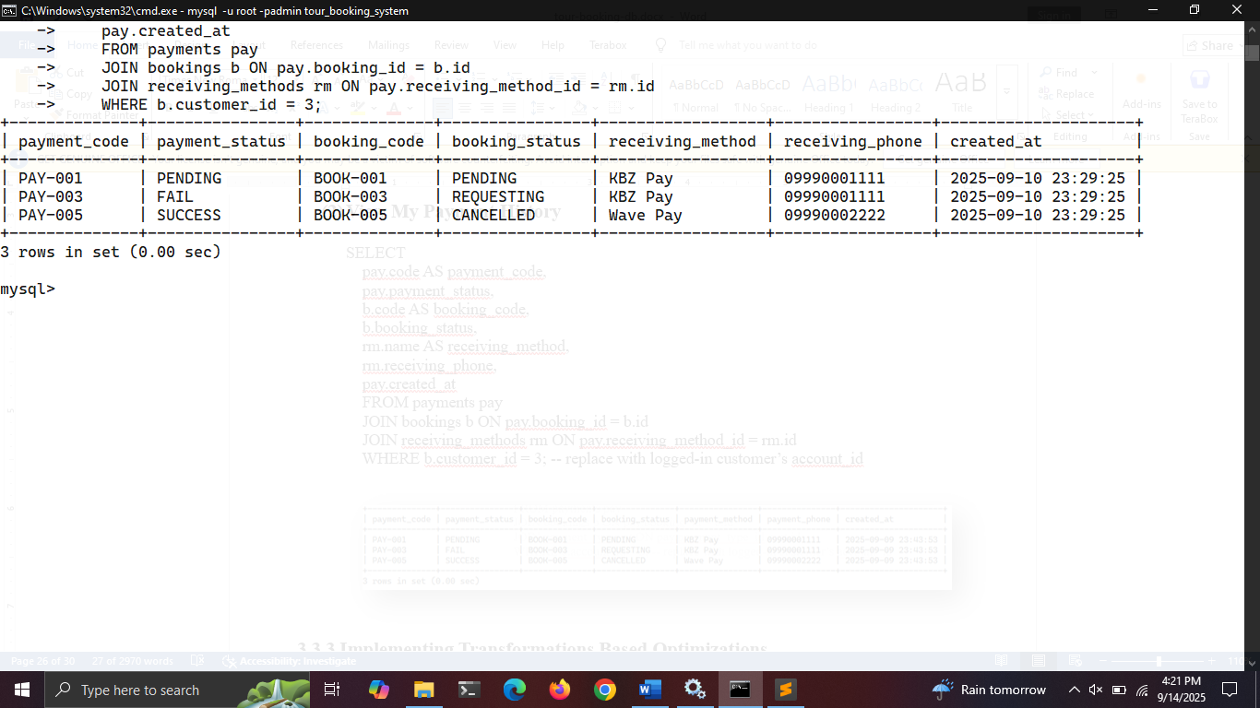

**3.3.3 Implementing Transformations Based Optimizations**

**Query Optimizing for Admin**

**View All Reserved Bookings with Package & Customer Info**

**Before Optimizing**

SELECT

b.id AS booking_id,

b.code AS booking_code,

c.name AS customer_name,

p.title AS package_title,

b.ticket_counts,

b.unit_price,

(b.ticket_counts * b.unit_price) AS total_price,

b.booking_status

FROM bookings b

JOIN customers c ON b.customer_id = c.account_id

JOIN packages p ON b.package_id = p.id

WHERE b.booking_status = 'RESERVED'

AND p.category_id = 2;

**After Optimizing**

SELECT

b.id AS booking_id,

b.code AS booking_code,

c.name AS customer_name,

p.title AS package_title,

b.ticket_counts,

b.unit_price,

(b.ticket_counts * b.unit_price) AS total_price,

b.booking_status

FROM (

SELECT id, package_id, customer_id, code, ticket_counts, unit_price, booking_status

FROM bookings

WHERE booking_status = 'RESERVED'

) b

JOIN customers c ON b.customer_id = c.account_id

JOIN (

SELECT id, title, category_id

FROM packages

WHERE category_id = 2

) p ON b.package_id = p.id;

**Relational Algebra Representation**

**Before Optimizing**

π b.id, b.code, c.name, p.title, b.ticket_counts, b.unit_price, total_price, b.booking_status

( σ b.booking_status='RESERVED' ∧ p.category_id=2

( (bookings ⋈ b.customer_id=c.account_id customers) ⋈ b.package_id=p.id packages )

)

**After Optimizing**

π b.id, b.code, c.name, p.title, b.ticket_counts, b.unit_price, total_price, b.booking_status

( (σ b.booking_status='RESERVED' (bookings)

⋈ b.customer_id=c.account_id customers)

⋈ b.package_id=p.id (σ p.category_id=2 (packages)) )

**Query Optimizing for Customer**

**View Own Bookings with Package Titles**

**Before Optimizing**

SELECT b.id, b.code, b.booking_status,

(SELECT p.title FROM packages p WHERE p.id = b.package_id) AS package_title

FROM bookings b

WHERE b.customer_id = 3;

**After Optimizing**

SELECT b.id, b.code, b.booking_status, p.title AS package_title

FROM bookings b

JOIN packages p ON b.package_id = p.id

WHERE b.customer_id = 3;

**Relational Algebra Representation**

**Before Optimizing**

π b.id, b.code, b.booking_status, (π title (σ p.id = b.package_id (packages)))

(σ b.customer_id = 3 (bookings b))

**After Optimizing**

π b.id, b.code, b.booking_status, p.title

( σ b.customer_id = 3 (bookings b)

⋈ b.package_id = p.id

(packages p) )

**Chatper 4**

**Conclusion**

**4.1 Conclusion**

The Tour Booking System Database efficiently manages tours, packages, bookings, payments, and user accounts while ensuring data integrity through constraints, foreign keys, and enumerated types.

With functions, procedures, and triggers, key business rules are automated, such as restricting bookings to customers, limiting package creation to admins, and updating booking/package statuses on cancellations or payments.

Query optimizations using joins, predicate pushdown, and indexing improve performance, while relational algebra illustrates the theoretical foundation for query evaluation.

Overall, the system provides a robust, scalable, and maintainable database ready to support a full-featured tour booking application.

**4.2 References**

* <https://www.geeksforgeeks.org/dbms/how-to-design-a-database-for-booking-and-reservation-systems/?utm_source=chatgpt.com>
* <https://www.geeksforgeeks.org/how-to-design-er-diagrams-for-travel-and-tourism-booking-systems/?utm_source=chatgpt.com>
* <https://www.slideshare.net/slideshow/database-system-for-online-travel-booking-system/85379695?utm_source=chatgpt.com>