

Mobile App for lifeblink.com

Version 1.0

Date: 26 November 2014

Table of Contents

Purpose of Document 3

Project Objective: 3

Project Scope: 3

1.Splash Screen: 3

2.Registration/ Login Screen: 3

3.Login with social media account: 4

4.Create Account: 4

5.Home/ Blink Feed Screen: 5

6.‘More’ Icon: 6

7.Add a Blink: 7

8.Detail View of Blink: 7

9.Profile Screen: 8

10.Lifeblink Pages: 10

11.Settings: 11

Proposed Technology: 14

Total Ballpark Estimated Time 14

Costs 15

Payment Terms: 15

Technical Deliverables: 15

Project Plan: 15

12.Designing: 15

13.Development: 15

14.Testing: 15

15.Verification: 15

16.Delivery: 15

17.Communication: 15

Other Features 16

1.Website Compliances: 16

18.Our Other Services: 16

Thank Note: 17

# Purpose of Document

This document outlines the general scope of your project based on the requirement provided and discussions to date. The main objective at this stage is to ensure that all parties agree upon the general scope, budget and schedule of the project prior to commencing work on subsequent stages.

Clients are urged to ensure that all the details contained within this document are clear and fully meet their requirements before further work commences. Timescales mention only cover the scope listed, if this changes, costs and timings will change accordingly.

Once you are happy contact us and we will progress into the next stages. This may include further detailing requirements and functionality or it may go straight into design. This will depend on the nature of the project.

# Project Objective:

This Project is to develop a mobile application for iPhone and Android to provide access of all features of [www.lifeblink.com](http://www.lifeblink.com/). This application will allow users to register and to create their profile on the portal. User can share their life moment that to be called ‘Blink’ with other members and also can follow other users and can see their blink feeds.

# Project Scope:

Application will have following major features and functionality:

## Splash Screen:

When a user will open the application then this screen will show for few seconds. This screen will contain logo of the application.

## Registration/ Login Screen:

After Splash screen user will be redirected to this screen. On this screen user will find following two options:

* 1. Registration:

New user will be able to register on the portal and will provide following information in order to get register:

* First Name
* Last Name
* Email Address
* Password
* Confirm Password
  1. Login

This option will allow registered users to get login into their account and will redirect to a new screen. User will find following options on this screen:

* Username/ Email ID
* Password
* Forgot Password

## Login with social media account:

User will also able to login via different social media accounts like:

* Facebook
* Google
* Linked-In

## Create Account:

After a successful login a new user will redirect to his account and need to create his account by submitting some basic information like:

* Name
* Profile Picture
* Banner Image
* About You
* Privacy Policy
* Gender

## Home/ Blink Feed Screen:

After the login, existing user will redirect to this screen. On this screen user will find following things:

* 1. List of Blink Feed:

This section will show a list of latest feeds of the lives those are following by user and can see its details and can perform following actions:

* Like it
* Share
* Comment
  1. Top Bar:

There will be a top bar that will contain following options:

* More Icon
  + Popular Lives
  + Celebrity Lives
  + Popular Blinks
  + Life of Honor
* Logo
* Search Icon

This Top bar will remain constant on all screens.

* 1. Add a Life blink Icon:

There will be an icon to “Add a Life Blink”. User will be able to add a life blink directly by tapping on this option.

* 1. Notifications Icon:

This icon will show number of notification and by clicking on this icon user can see list of notifications.

* 1. Bottom Tab Bar

There will be a Bottom Tab bar that will have options like:

* Home
* Profile
* Lifeblink Pages
* Settings

## ‘More’ Icon:

There will be a more icon that will show list of following Screens:

* 1. Popular Lives:

On this screen user will find a list of popular member’s profile thumbnails. User can see any user detail profile and can follow him.

* 1. Celebrity Lives:

This screen will show a list of celebrities profile thumbnails. User can see their detail profile and can follow them.

* 1. Popular Blinks:

This section will show a list of popular blinks.

* 1. Life of Honor:

This section will show a list if members who lost their lives while serving their country.

## Add a Blink:

User will be able to add a life moment to his profile. User will fill following information to add a blink:

* Select a Moment
* Story (Text box)
* Date
* Location
* Upload a Photo
* Post a Video (you tube link)
* Add a link
* Privacy Settings
  + Public
  + Family and Followers
  + Family Only
  + Private

## Detail View of Blink:

On a detail view of a blink, user will be able to see following information:

* Date of Blink
* Story of the Blink
* Images
* Like button
* Share on social media
  + Facebook
  + Twitter
  + Google +
  + Pinterest
  + Email
* All comments
* Make Comments

## Profile Screen:

By tapping on Profile (Bottom Tab Bar) user will redirect to this screen. User will able to see complete information about his profile and also can edit profile information. User will find following things on this screen:

* Cover Image
* Profile Image
* Name of User
* User Description
* Some Tabs
  + Blinks (with number of blinks)

When user will tap on this tab, he can see all listed blinks. This list of blink will have thumbnail for each blink with following options:

* + - Add a Blink
    - Date of posting
    - Title of the Blink
    - Image (if any)
    - Like button
    - Share Button
    - Comment button

By tapping on any blink user can see detail view of that blink.

* + Family (with number of Family member):

This tab will show a list of Family members profile thumbnail with following options:

* + - Add a Family Member
    - Name of the member
    - Number of Lifeblinks
    - Number of Follower
    - Profile Inage and blinks images
    - Unfollow (button)
  + Followers (with number of people who are following to user):

This Tab will show a list of all followers with their profile thumbnails with following options:

* + - Name of the member
    - Number of Lifeblinks
    - Number of Follower
    - Profile Inage and blinks images
  + Following (with numbers of other members and pages that are following by user):

This tab will show a list of pages and members who are following by user with information like:

* + - Name of the member
    - Number of Lifeblinks
    - Number of Follower
    - Profile Inage and blinks images
    - Unfollow (button)

## Lifeblink Pages:

By tapping on Lifeblink Pages (on the Bottom Tab Bar), user will redirect to this screen. On this screen user will find a list previously created pages. User will also able to create new pages and to manage previously pages:

* 1. Create a Lifeblink Profile Page:

User will submit following information in order to create new Lifeblink page:

* First Name
* Last Name
* Custom URL
* Profile Picture
* Banner
* About you
* Location
* Profile Privacy
* Gender
  1. Manage Lifeblinks Pages:

On this screen user will find list of pages with the following options to manage:

* Edit
* Privacy Settings
* Allow Comments
* Transfer Lifeblink Page ( transfer the page to another member)
* Delete

## Settings:

In this section user will find following information:

* 1. Account Info:

User can edit account info like:

* Email Address
* Password
* Location
* D.B.O.
* Gender

* 1. Email Notifications:

In this section user will be able to manage email notifications for following actions:

* Receive notification for new followers
* Receive notification for comments
* Receive notification when a friend joins
* Receive notification when a friend adds a new Blink
* Receive notification when a family member adds a new Blink
* Receive notification to add you as a family member
* Receive notification to follow your private Lifeblink page
  1. Manage Notifications:

In this section user will be able to manage notifications:

* Show notifications History
  + View Notifications
  + Delete
* Show Notifications From:
  + Family and Followers
  + Family Only
  + No One
* Show Notifications for:
  + When someone comments on your blink
  + When someone follows you
  1. Manage Social Media Accounts:

User will be able to manage his social media accounts:

* Login with Facebook
* Link to Timeline
* Login with Linked in
* Login with Google
  1. Invite Friends:

User will able to invite his friends by sending an invitation email on their email addresses.

* 1. Logout:

By tapping on this option user will be exit from his account and will redirected to login screen.

* 1. Static Screens:

There will be some following static screens:

* About us
* Terms
* Privacy
* Contact

# Proposed Technology:

# Total Ballpark Estimated Time

Estimation Breakdown

|  |  |  |  |
| --- | --- | --- | --- |
| S. No. | Modules/Tasks/Particulars | Estimated Time |  |
| 1 | **Application Design + Web services** | 5 man days | |
|  |  | **iPhone** | **Android** |
| 2 | Splash Screen | 0.5 man day |  |
| 3 | Registration and Login Screen | 1 man day |  |
| 4 | Login with Social Media accounts | 2 man days |  |
| 5 | Create Account | 1 man day |  |
| 6 | Home/ Blink feeds | 1.5 man day |  |
| 7 | ‘More’ icon and its screens | 2 man days |  |
| 8 | Add a blink | 1 man day |  |
| 9 | Detail view of blink | 3 man days |  |
| 10 | Profile Screen | 3 man days |  |
| 11 | Lifeblink Pages | 2 man days |  |
| 12 | Settings | 3 man days |  |
| Total Estimated Time | |  |  |
| Total Estimated Time In Days: | | | |
| Total Estimated Time In Weeks: | | | |

*\*\*The exact speed of design & development will be affected by client turnaround times, for example responding to designs, how much feedback is given (etc).*

# Costs

UK OFFICE

# Payment Terms:

UK OFFICE

# Technical Deliverables:

# Project Plan:

**please modify as per the requirements.

## Designing:

We will start designing by creating PSD’s and will share the same with you. Once verified we will do the slicing i.e. XHTML. The design of the website will be responsive in nature and will be compatible with mobile devices like iPhone, iPads, Android Phones, Tablets etc. After the designing phase we will put all designs onto our development server so that all details can be centralized between the team (Designer, developer, tester, PM).

## Development:

The development of the project will start by integrating the custom design with the Magento. We will divide the development phases into various modules/tasks and section and details of each will be put on our project management system i.e. DSP ([www.projects.dotsquares.com](http://www.projects.dotsquares.com/)) so that you can track the progress of the system each day.

## Testing:

Once the development of a module is done then a tester is allocated into the project and he/she will be responsible for testing the overall site in terms of performance, load, stress etc.

## Verification:

After testing we allow our industry leader i.e. our project managers and senior business analyst to check the website and match the developed features with the initial requirements.

## Delivery:

After all major phases we deliver the system to the client. We are responsible for uploading the website. Client just needs to provide the domain and hosting details.

## Communication:

We play the best role in communication as we offer a dedicated team for your project and you will be in direct contact with him via **Skype/Email/DSP or VOIP.**

# Other Features

Some additional features you might like to include can be found in the "Website Compliances" section below, unless mentioned in the estimate above they are not currently included. Please let us know if any of these features are required:

## Website Compliances:

EU cookie compliance:This gives a viewer the option of not installing cookies, In-line with European privacy laws.

PCI Compliance, Payment Card Industry security certificate**:** The industry required security certificate, this checks the website, database and server are all secure and free from vulnerabilities and is independently verified by a third party.

W3C Compliance, the HMTL standard authority**:** Why bother making your site compatible with specific browsers when you can achieve W3C compliance and make it compatible with all.

Hosting**:** Once development is complete you will also need a web server to host the site on. We can offer very competitive hosting services (managed and unmanaged).

Testing:The work is tested by the developer during development, but this does not cover the same things as dedicated testing (unit testing, stress testing etc).

AAA Compliance:Another W3C service, help users with visual disabilities to navigate and read your site.

## Our Other Services:

Except Website Development we provide with following additional services to help our customers to get all the IT support services under one roof.

SEO: Social media has become a platform that is easily accessible to anyone with internet access. Most of the Businesses are now available online through website and help their clients to reach them instantly.  But creating a Website is not the enough steps to increase business presence. A website should be easily accessible to users that will be possible only by marketing the website that will create Brand Awareness.  So here it comes the SEO it stands for Search Engine and it is the process of improving the volume or quality of traffic to a web site from search engines.

We are experts in Internet Marketing and have significant experience in the promotion of web sites. We offer our clients a range of Search Engine Optimization plans and Pay-per-Click management. We have proven successes and can help your site to get more well-targeted visitors.

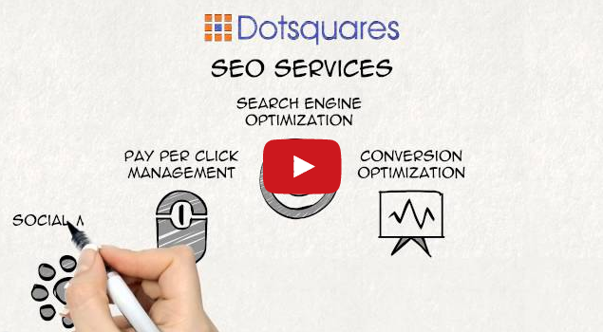

**Mobile Applications:** In today’s era Mobile Apps have become valuable Business Tools. Apps are the new way to keep customers engaged, connect with them instantly at their demand and generate new customers. Dotsquares have been at the forefront of mobile application development and have some of the most experienced developers in the business. We have an expert team to develop Android, iPhone and Windows Mobile Applications. We develop custom applications to suit your precise business needs. Our solutions are cost effective and optimized to your requirements.

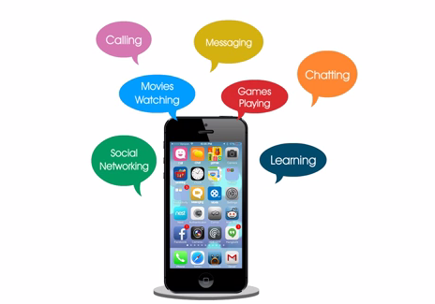

Game Development:

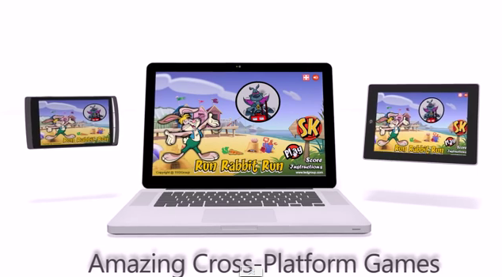

Network Support: Network Services offered by our company are:

* Domain Registration
* Server Management
* System Backup & Restore
* Emergency Support
* Network Troubleshooting
* Remote Installation

# Thank Note:

We thank you for providing a chance to show our quality work. Looking forward to work and would like to maintain a long working relationship with you.

Best Regards,  
Team Dotsquares