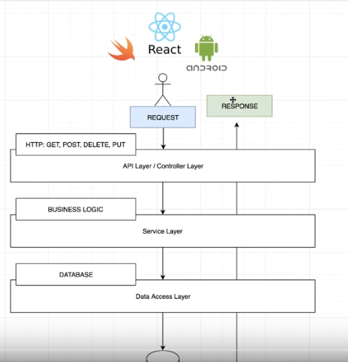

Setup:
-start.spring.io --> configure spring boot framework. Here we can select programming language (Java/Kotlin), versions, build management tools(Maven/Gralde), versions, Dependencies etc…
- I dont think u can currently add GraphQLs dependency on the setup so we will have to do so manually (2 dependencys: „graphql-spring-boot-starter“ and „graphql-java-tools“
Structure:
-initialized projekt already has main() in src/main/java/.. to run
-src/main/java/resources contains:
- staic = web-resources for webapps
- templates = templates for your webapp (who wuld've thought)
- application.properties = prop. for app, can be defined for different environments (demo, test, ...) Here we can also define the server-port by simply writing „server.port= (inser port number here)“

Create packages API, Model, Service, DAO in java folder
Create „person.graphql“ file in resource folder. This will be the schema.

Working with Spring:
Setting up the schema:
- define types in „person.graphql“-> define items and querys
-define schema & add query
We first need to define a model. -> create class in Model package (eg Person). Meaning this is what type will be in the databsae. TODO// Which database? How does this work with the specific db?
Then we need to define the interface fort he db -> create interface in dao (eg PersonDao).
Here weh ave to define methods like insert, delete and so on. Of course we also need an class to implement this interface. This class hast o actually implement the functions and add/delete from a DB. As the Service class and so on only now the intercae, we will use dependency injection. Meaning we will add the annotation @Repository to our class and add @Autowired tot he consructor oft he service(service see below). To explicitly identify the right identifier we will add a @Qualifier to the argument(the referenced PersonDAO) oft he constructor and we can name our repository and identify it with this qualifier.
//TODO What database?? How to modify it?
Next lets create a service (GraphQL) – annotated with @service. This service contains a private object graphQL, with a public getter. We need to reference to our schema by creating a resourcewith annotation: @Value(„classpath:books.graphQL“). We will load the schema something like this:
/ load schema at application start up

@PostConstruct

private void loadSchema() throws IOException {

// get the schema

File schemaFile = resource.getFile();

// parse schema

TypeDefinitionRegistry typeRegistry = new SchemaParser().parse(schemaFile);

RuntimeWiring wiring = buildRuntimeWiring();

GraphQLSchema schema = new SchemaGenerator().makeExecutableSchema(typeRegistry, wiring);

graphQL = GraphQL.newGraphQL(schema).build();
}
Of course now we also need to implement „buildRuntimeWiring()“ using datafetchers, which connects the different types to each other. Then as seen in the code above we need to make it executable and add it to the schema. To create the fetchers we will create a new package in service package and make classes fort he different fetchers implementing „datafetchers“. We will annotate the class with @Component and Autowire a reference tot he interface of a dao(eg „PersonDao“).In the PersonService code we can just autowire them.

Now lets take a look at the API (PersonController). This now has a reference to a PersonService which we will also connect with the annotation @Autowired. Gives the Interace to the outside world(with REST, here with GraphQL it gives the interface tot he schema.) of how to add/delete and handles exceptions. Furthermore we need to resolve the http requests to actual method calls here (which can also be done via annotations. We will add @Requestmapping and @Restcontroller tot he class decleration. Also we will autowire a reference to our graphQLService Then we have to define what will be done for different request. For example for a post request we will use @PostMapping with a method that gets the query as a string annotated with @RequestBody as parameter. Here we will get the graphQLservice and execute it. We will return a response entity.

