Financial Insight API - Testing Report

# 1. Project Overview

This document serves as a test report for the `financial_insight_api` project submitted as a part of the Senior Python Developer Take-Home Assignment. It includes execution results from the Swagger UI, unit tests, and verification of API endpoint behaviors.

# 2. API Endpoints Overview

Below are the available endpoints exposed by the FastAPI application:

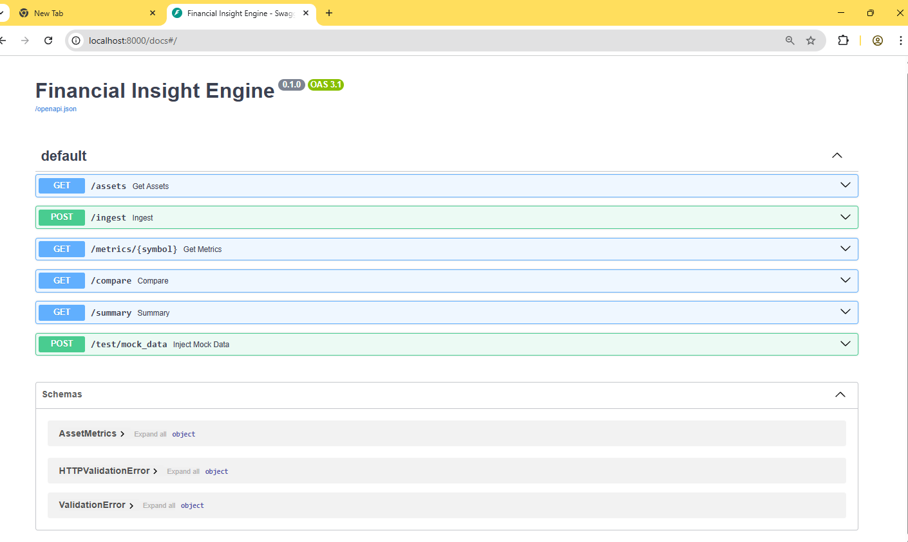

# 3. Swagger-Based Endpoint Tests

## 3.1 POST /ingest - Data Ingestion

Successfully triggered manual data ingestion.

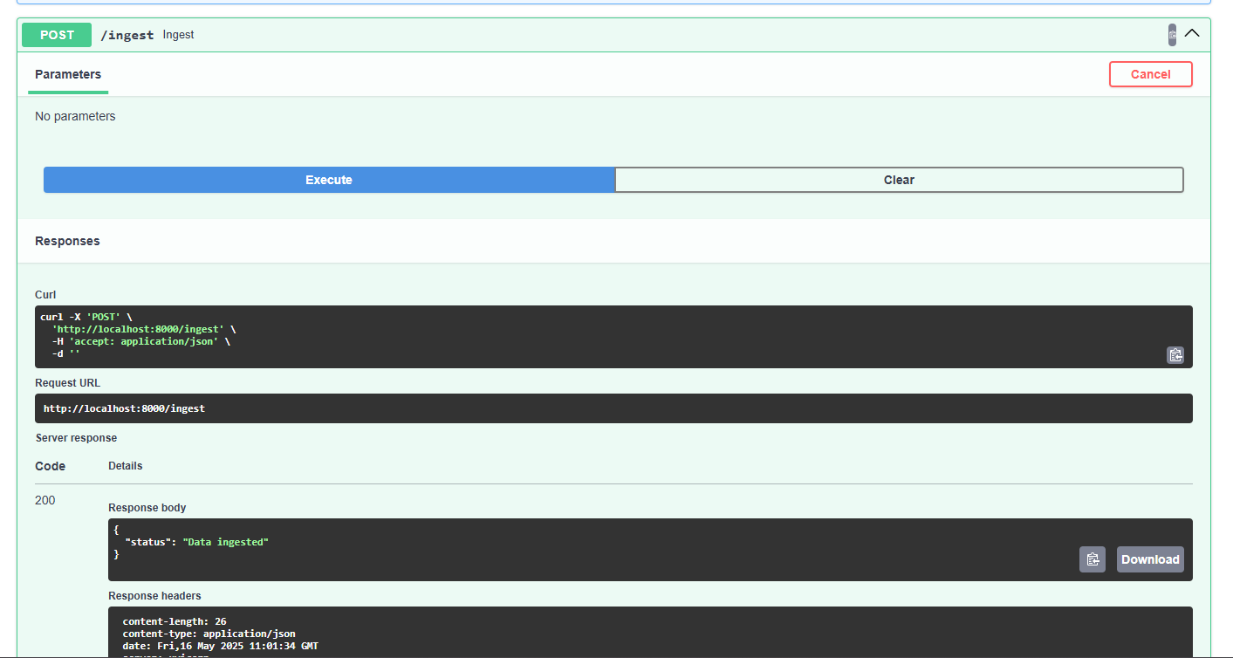

## 3.2 GET /summary - GenAI Summary

Generated a financial summary from the latest ingested data using LangChain and mocked OpenAI.

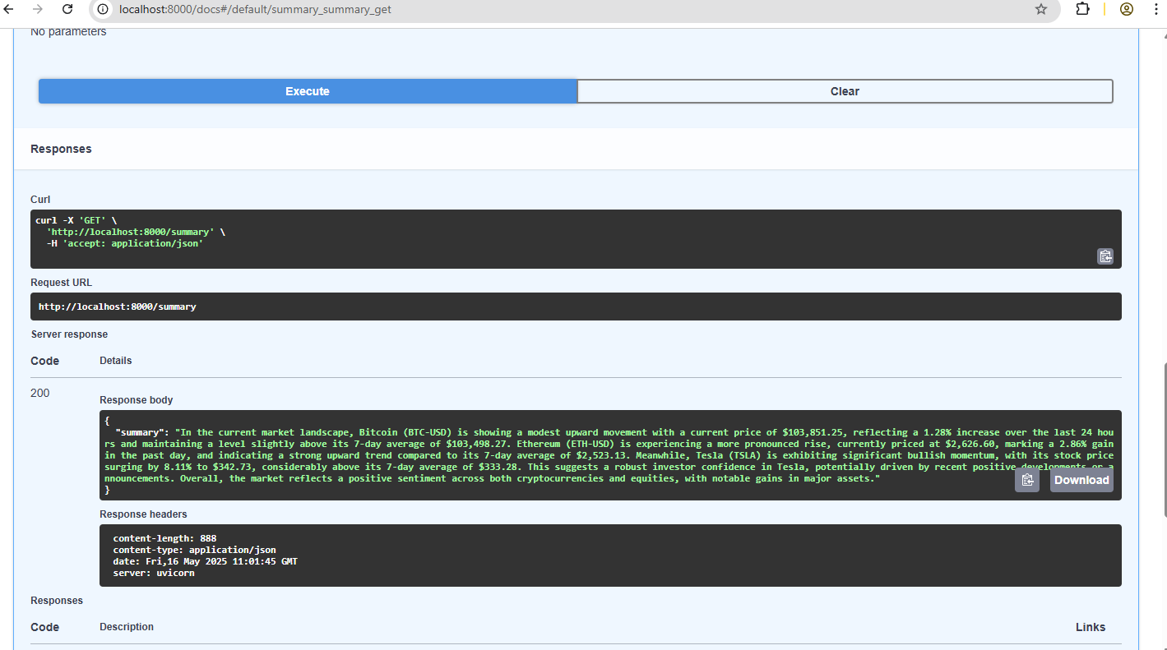

## 3.3 POST /test/mock_data - Inject Mock Data

Successfully injected mock BTC data in development mode for testing analytics logic.

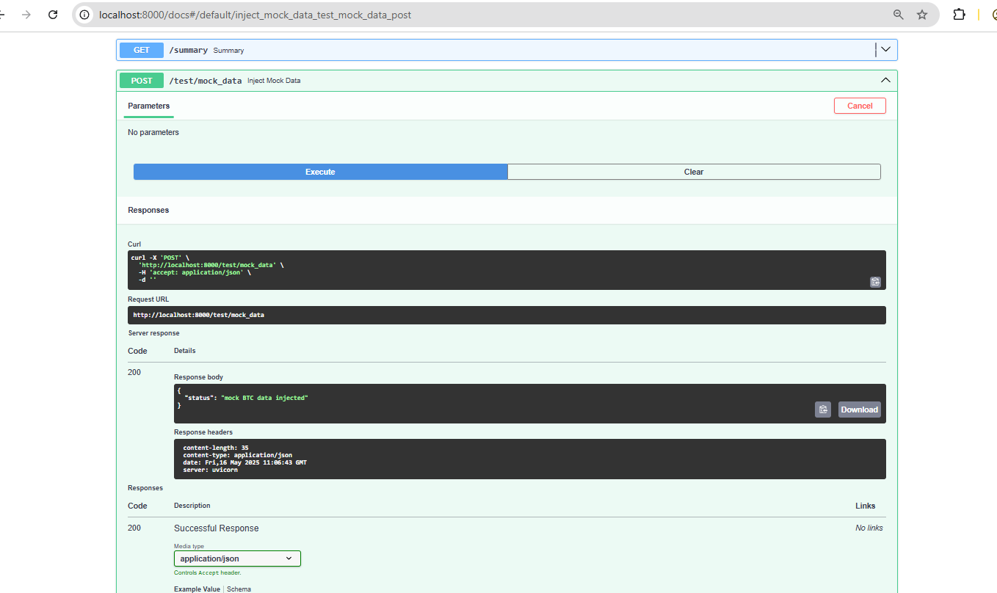

# 4. Application Run Confirmation

Confirmed the application was successfully launched and logs captured for endpoint calls.

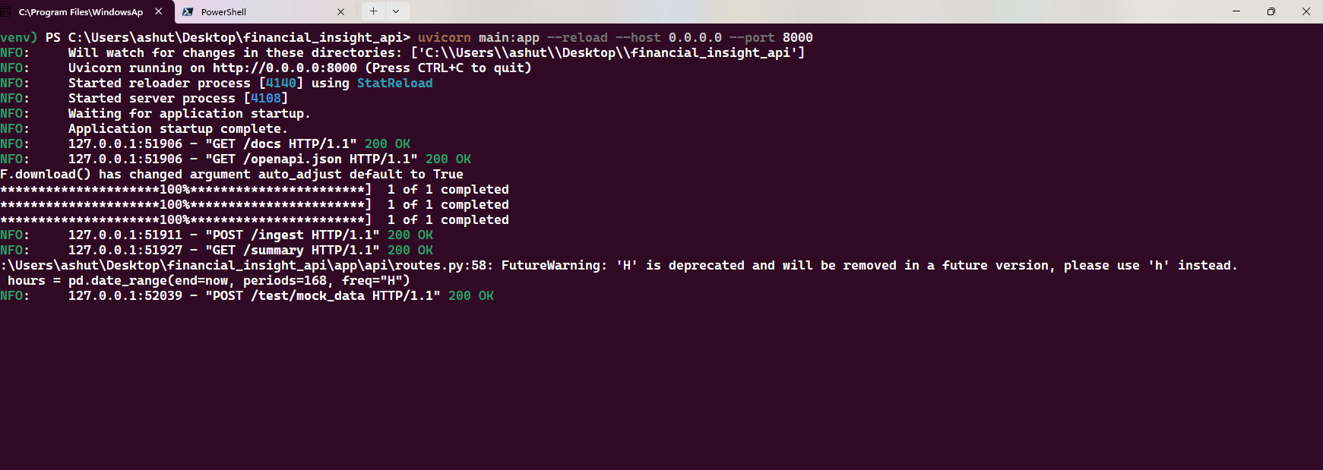

# 5. Pytest Unit and Integration Test Results

Below is the screenshot of 4 test cases (3 unit tests + 1 integration test) executed using pytest. All tests passed successfully.

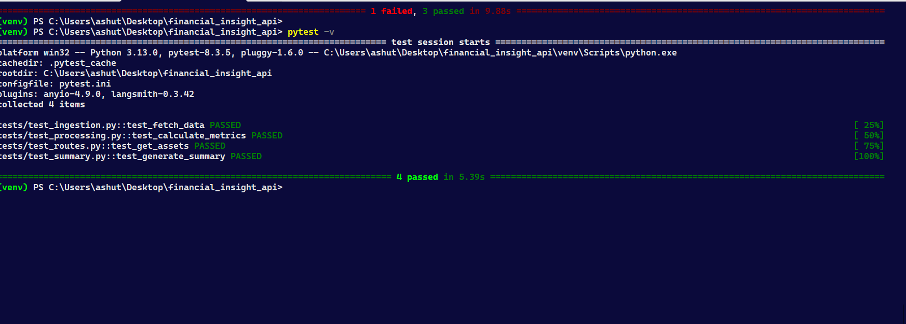

✅ test_ingestion.py::test_fetch_data  
✅ test_processing.py::test_calculate_metrics  
✅ test_routes.py::test_get_assets  
✅ test_summary.py::test_generate_summary

# 6. HLD Architecture Diagram

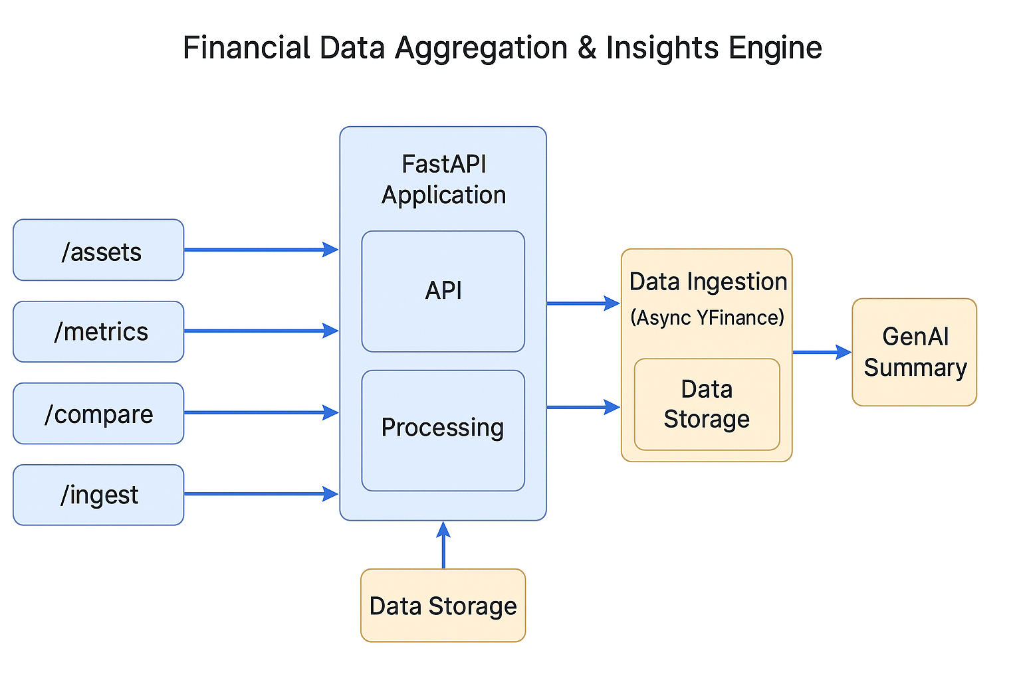

# 

# 7. Conclusion

All required endpoints were verified successfully via Swagger UI and Python unit tests. Real-time ingestion via yfinance was used for BTC-USD, ETH-USD, and TSLA. The summary generation feature uses LangChain and OpenAI (GPT-4o) to produce real-time textual insights. The project adheres to all specified requirements including modular structure, asynchronous workflows, real GenAI integration, and automated test coverage.

# 7. Additional Endpoint Verifications

## 7.1 GET /metrics/{symbol} - TSLA

Verified the /metrics endpoint for the TSLA symbol using real-time data from yfinance.

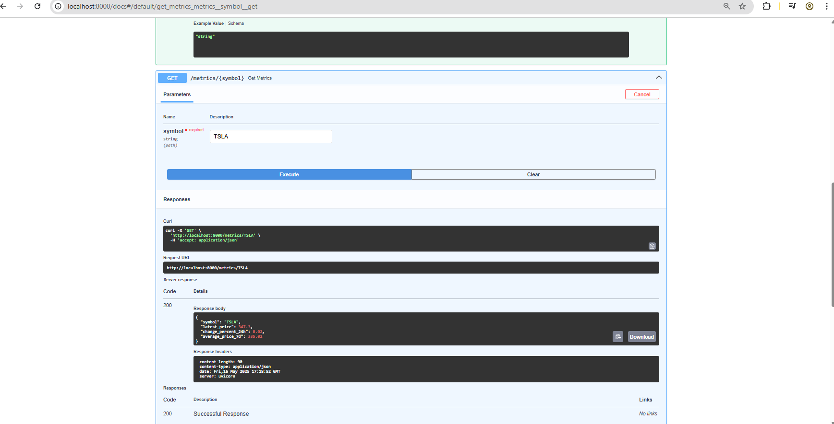

## 7.2 POST /ingest

Ingestion confirmed using POST /ingest, showing data was fetched and stored in-memory for BTC-USD, ETH-USD, and TSLA.

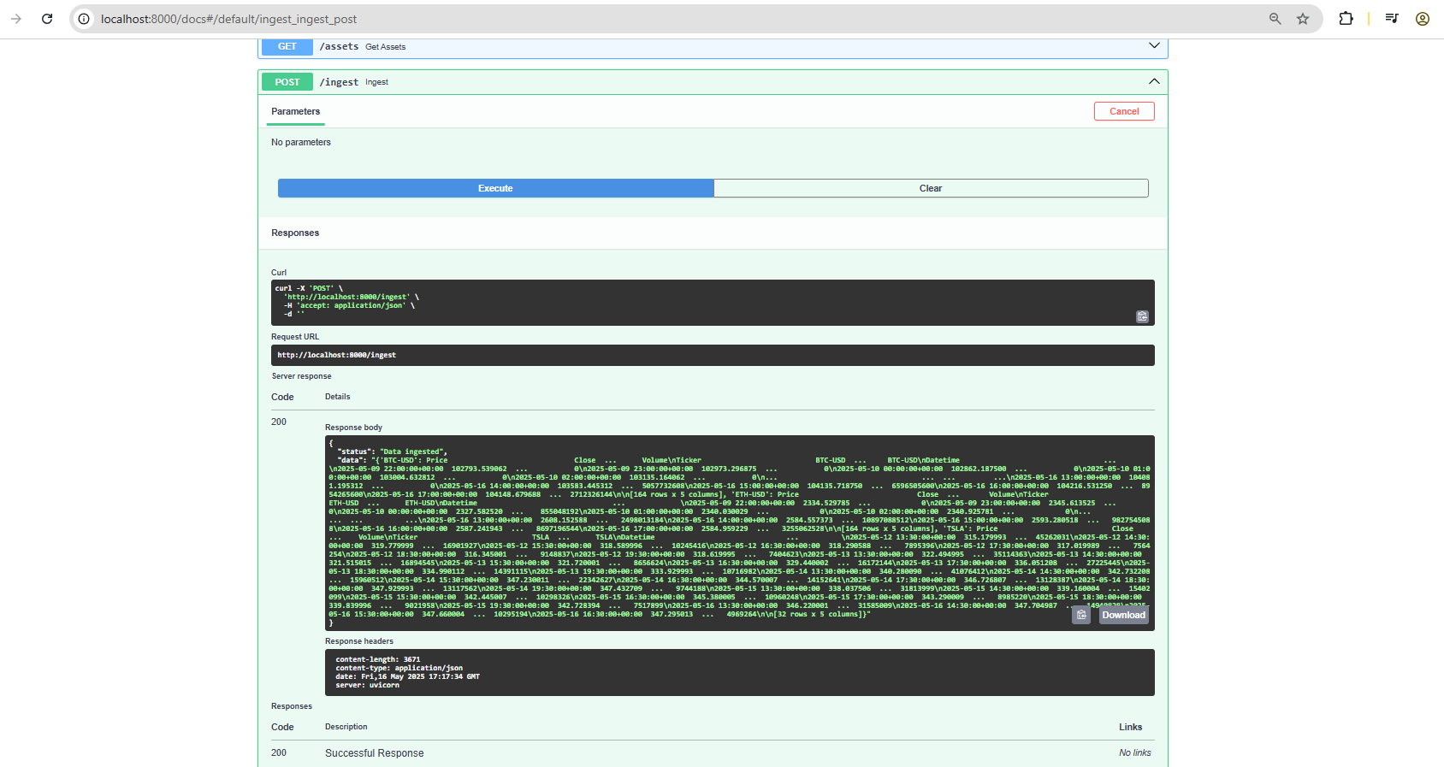

## 7.3 GET /compare

Compared BTC-USD and ETH-USD after real-time data ingestion. Comparison successful with valid metrics returned for both assets.

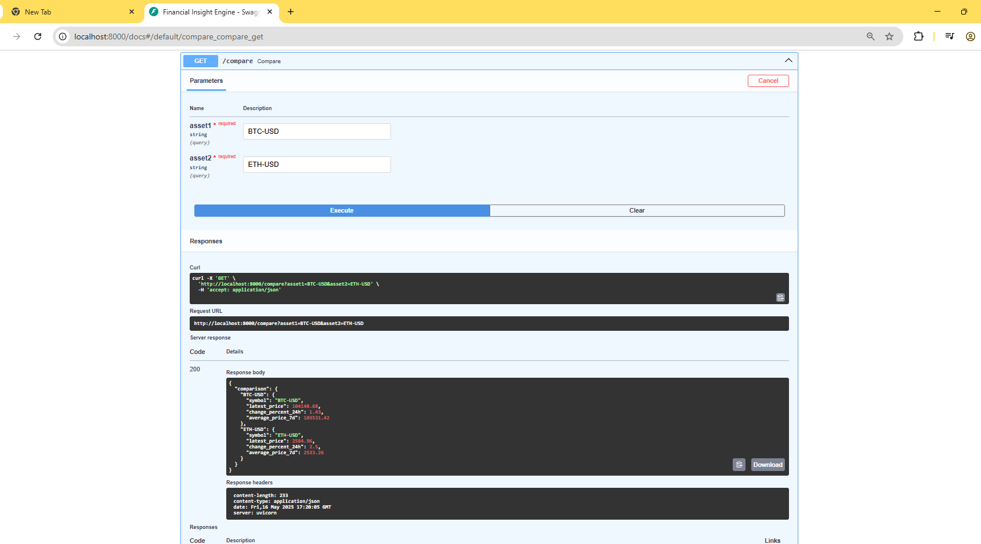

# 8. Real-Time Data Source Verification

The application uses the `yfinance` library to ingest real-time financial data. The below output confirms hourly data retrieval from Yahoo Finance for BTC-USD, ETH-USD, and TSLA.

