ROOPA SREEDHAR A
PES1UG24CS386
SEC G
Github link: https://github.com/coderRoopa/PES1UG24CS386-pes-vcs
Screenshot 1A
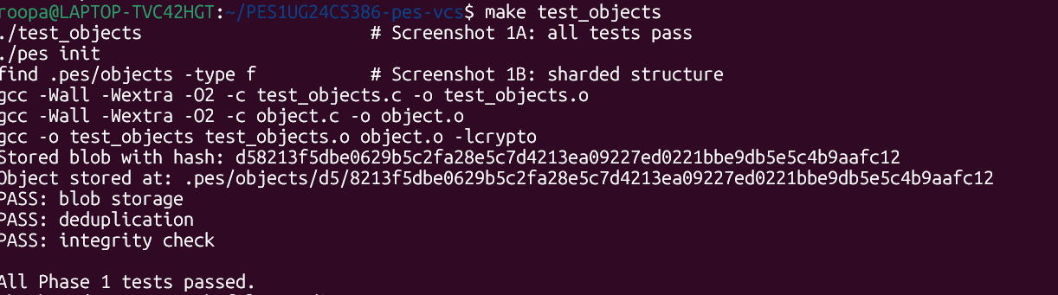

Screenshot 1B
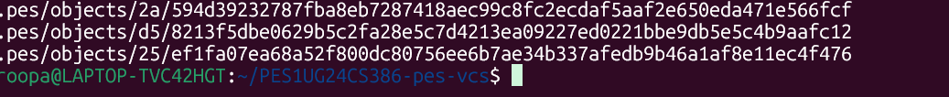
Screenshot 2A
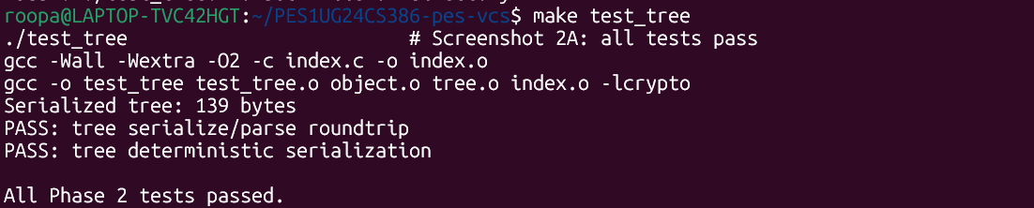
Screenshot 2B:
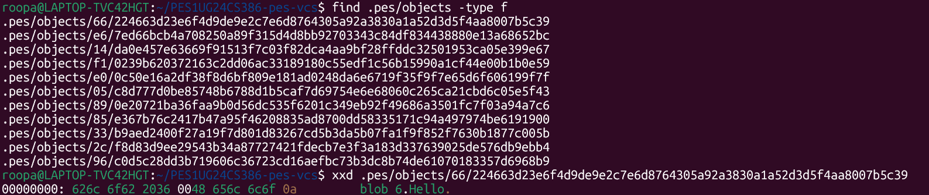
Screenshot 3A
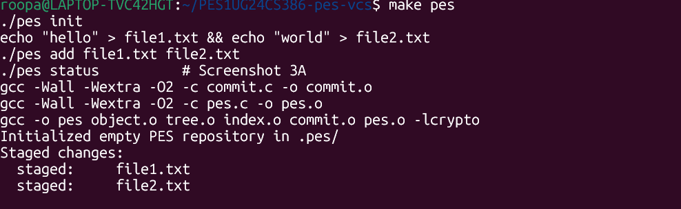
Screenshot 3B
Screenshot 4A
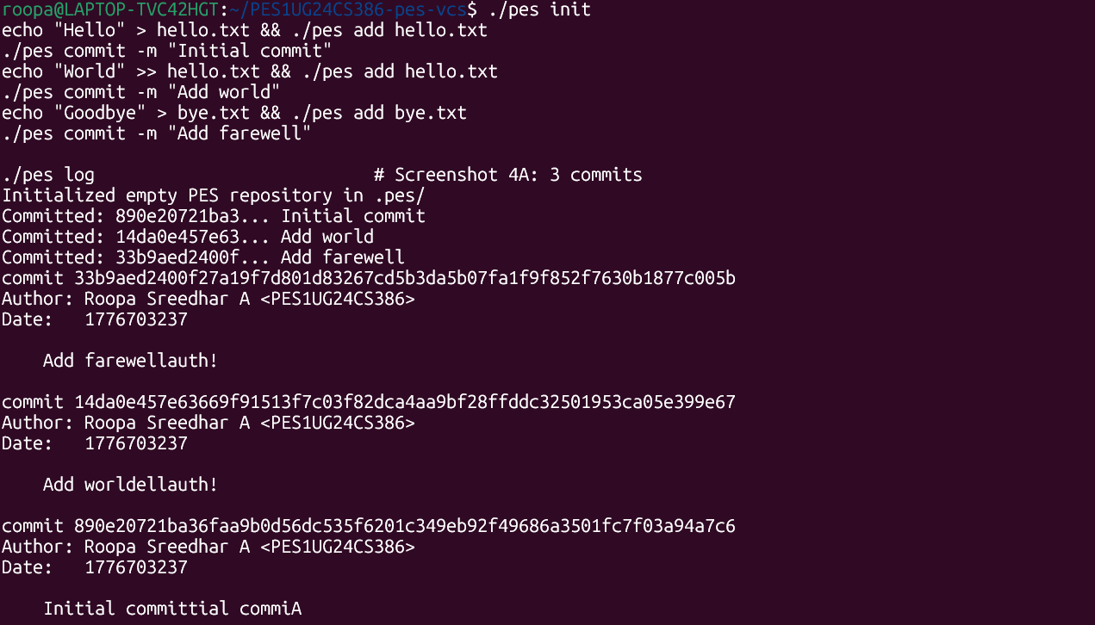
Screenshot 4B:
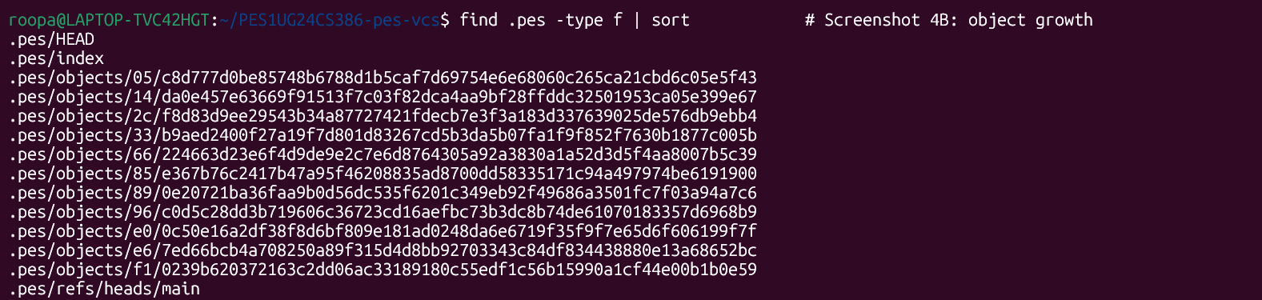
Screenshot 4C:
Final:
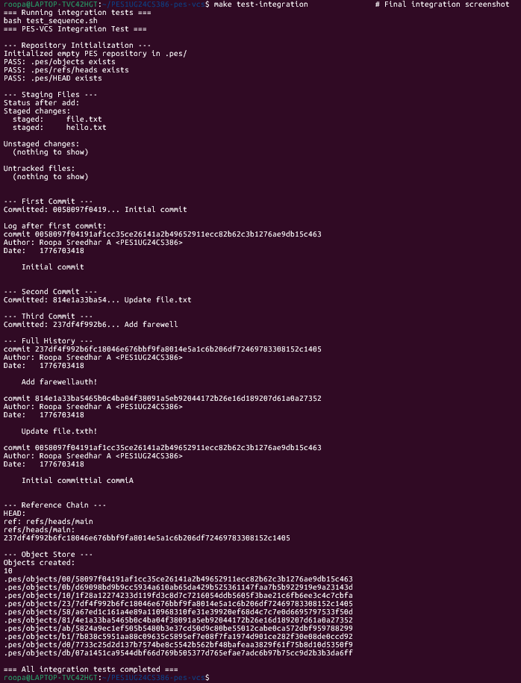
Branching and Checkout
Q5.1: A branch in Git is just a file in .git/refs/heads/ containing a commit hash. Creating a branch is creating a file. Given this, how would you implement pes checkout <branch> — what files need to change in .pes/, and what must happen to the working directory? What makes this operation complex?
To implement pes checkout <branch>:
- Read the target branch file (.pes/refs/heads/<branch>) to get its commit hash.
- Read that commit object and walk its tree to get the full file snapshot.
- Update every file in the working directory to match the tree contents (create, update, or delete).
- Update .pes/HEAD to "ref: refs/heads/<branch>\n".
- Rebuild the index to reflect the new HEAD's tree.
Complexity: if the user has modified tracked files, you must detect conflicts before touching anything . Also, files that exist in the current branch but not the target must be deleted — requiring careful bookkeeping.

Q5.2: When switching branches, the working directory must be updated to match the target branch's tree. If the user has uncommitted changes to a tracked file, and that file differs between branches, checkout must refuse. Describe how you would detect this "dirty working directory" conflict using only the index and the object store.
Walk every entry in the index. For each, compute its current on-disk blob hash (or use mtime+size as a cheap proxy). If any file's hash differs from what's in the index AND that file differs between the current and target branch trees, the checkout must refuse. The "conflict" is: index says file is at hash A, working dir has hash B, and target branch expects hash C where B ≠ A (meaning the user has local edits that would be overwritten).
Q5.3: "Detached HEAD" means HEAD contains a commit hash directly instead of a branch reference. What happens if you make commits in this state? How could a user recover those commits?
When HEAD contains a raw hash instead of a branch ref, new commits have no branch pointing to them — they dangle. To recover, the user can run pes branch rescue <hash> to create a new branch at that commit, provided they still have the hash. If they don't, they'd need to scan all objects (or the reflog in real Git) to find reachable but un-branched commits.
Garbage Collection and Space Reclamation
Q6.1: Over time, the object store accumulates unreachable objects — blobs, trees, or commits that no branch points to (directly or transitively). Describe an algorithm to find and delete these objects. What data structure would you use to track "reachable" hashes efficiently? For a repository with 100,000 commits and 50 branches, estimate how many objects you'd need to visit.
Use a mark-and-sweep approach: start from all branch refs and HEAD, walk every commit transitively (following parent pointers), then walk every tree in each commit (recursively), collecting every blob hash encountered. Store reachable hashes in a hash set. Then enumerate all objects under .pes/objects/ and delete any not in the set. For 100k commits and 50 branches: expect roughly 100k×(avg tree depth)×(avg files per dir) ≈ potentially millions of objects to visit; the hash set keeps membership tests O(1).
Q6.2: Why is it dangerous to run garbage collection concurrently with a commit operation? Describe a race condition where GC could delete an object that a concurrent commit is about to reference. How does Git's real GC avoid this?
Race: GC scans all reachable objects → decides blob X is unreachable → a concurrent pes add writes blob X to the store and an index entry pointing to it → GC deletes blob X → the next pes commit references a now-missing blob. Real Git avoids this by: (1) keeping a "grace period" — never deleting objects written in the last 2 weeks regardless of reachability; (2) using lock files; (3) considering any object written to the object store as temporarily "referenced" for the duration of GC.

